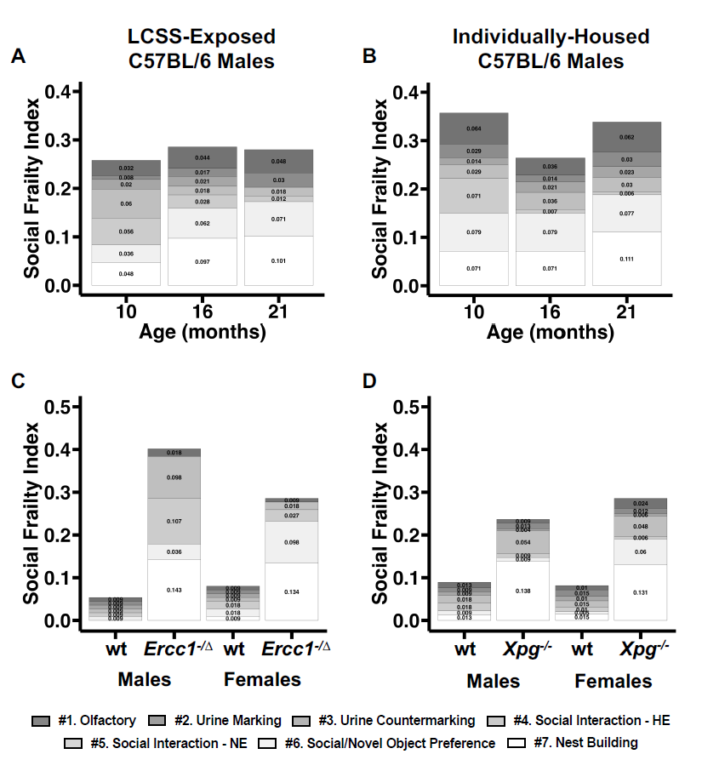

Supplementary Figure 1
A) Decomposition of mean mSFI values by contribution from each individual item per age group in LCSS-exposed mice measured at 10, 16, and 21 mo. B) Decomposition of mean mSFI values by contribution from individual items per age group in lifelong individually-housed mice measured at 10, 16, and 21 mo. C) Decomposition of mean mSFI values by contribution from individual items in Ercc1^{-/Δ} male and female mice compared to wild-type (wt) littermates at 8 wks. D) Decomposition of mean mSFI values by contribution from individual items in Xpg^{-/-} male and female mice compared to wild-type (wt) littermates at 8 wks.

