Supplementary Table 1: The sub-categories of the FI score, and their contribution to the total frailty index.
Sub-category of FI | Proportion of the total FI score (%)
Self-reported disease or condition | 26,3
General daily function | 10,5
Physical function and activity level | 21,1
Self-reported health | 10,5
Mood/State of mind | 21,1
Cognitive function (MMSE) | 10,5

Supplementary Table 2:
 | Participated in the follow-up  (N=133) |  | Participated NOT in the follow-up (N=270) |  | P-value
 | Mean/median | SD/(25p,75p) | Mean/median | SD/(25p,75p)
Female, n (%) | 64 | 48.1 | 146 | 54.1 | 0.26
Age, years | 73 | (71, 75) | 76 | (73, 79) | <0.001
BMI, kg/m² | 26.1 | 3.5 | 26.2 | 4.1 | 0.74
FI score | 0.11 | (0.07, 0.16) | 0.17 | (0.11, 0.24) | <0.001
Frail, n (%) | 4 | 3.0 | 66 | 24.4 | <0.001
Single household, n (%) | 39 | 29.3 | 98 | 36.2 | 0.16
MMSE score | 30 | (26, 30) | 27 | (25, 30) | <0.001
< 24 points, n (%) | 0 | 0 | 22 | 8.2 | <0.001
MNA score | 28.5 | (27.5, 29) | 27.5 | (26.5, 29) | <0.001
SPPB score | 12 | (11, 12) | 11 | (10, 12) | <0.001
≤ 8 points, n (%) | 0 |  | 22 | 8.2 | <0.001
Grip strength (kg), dominant | 30.9 | (22.3, 40.4) | 26.1 | (19.4, 35.7) | <0.001
Current smoker, n (%) | 5 | 3.8 | 19 | 7.0 | 0.19
CVD, n (%) | 28 | 21.1 | 86 | 31.9 | 0.02
Diabetes, n (%) | 7 | 5.3 | 12 | 4.4 | 0.72
Polypharmacy  (≥5 drugs/day), n (%) | 14 | 10.5 | 47 | 17.4 | 0.7
Normal distributed data; mean and SD, Non-normal distributed data; median (25p, 75p), categorical data; number and percent. For continuous variables: normal distributed data were tested by independent sample t-test, non-normal distributed data were tested by Wilcoxon rank-sum test. For categorical variables: Chi-square test or Fisher exact test (if the expected cell frequency was < 5).
Supplementary Table 3: Spearman’s rank Correlation between inflammatory markers
Inflammatory marker, baseline | Inflammatory marker, baseline | Spearman’s rho | P-value
Hs-CRP* | IL-6 | 0.38 | <0.001
Hs-CRP* | TNF-α | 0.27 | 0.002
IL-6 | TNF-α | 0.42 | <0.001
Gp-acetyls | CRP* | 0.36 | <0.001
Gp-acetyls | TNF-a | 0.44 | <0.001
Gp-acetyls | IL-6 | 0.34 | <0.001
Change in inflammatory marker | Change in inflammatory marker | Spearman’s rho | P-value
Hs-CRP_diff* | IL-6_diff | 0.33 | <0.001
Hs-CRP_diff* | TNF-α_diff | 0.30 | <0.001
IL-6_diff | TNF-α_diff | 0.33 | <0.001
Gp-acetyls_diff | CRP_diff * | 0.26 | 0.002
Gp-acetyls_diff | TNF- α _diff | 0.43 | <0.001
Gp-acetyls_diff | IL-6_diff | 0.40 | <0.001
Hs-CRP, high-sensitive c-reactive protein; Gp-acetyls, Glycoprotein Acetyls; IL-6, Interleukin 6; TNF-α, Tumor Necrosis Factor alfa. .” _diff” = (Level of inflammatory marker at follow-up minus the level of inflammatory marker at baseline). Statistically significant level: P-value <0.05. * hs-CRP<50 mg/dL
Supplementary Table 4: Concentration of hs-CRP divided into quartiles
Hs-CRP baseline | Mean | SD
Hs-CRP, Q1 | 0.53 | 0.17
Hs-CRP, Q2 | 1.2 | 0.21
Hs-CRP, Q3 | 2.1 | 0.36
Hs-CRP, Q4 | 4.6 | 2.1
Hs-CRP, high-sensitive c-reactive protein. Unit used; mg/L.
Supplementary Table 5: Linear regression model between quartiles of hs-CRP and change in FI score.
 | Model 1 |  |  | Model 3
Hs-CRP baseline | Beta-Coefficient | 95% CI | P-value | Beta-Coefficient | 95% CI | P-value
Hs-CRP, Q1 | 0.06 | (-0.07, 0.19) | 0.34 | 0.04 | (-0.1, 0.18) | 0.61
Hs-CRP, Q2 | 0.045 | (-0.1, 0.19) | 0.54 | 0.06 | (-0.1, 0.23) | 0.44
Hs-CRP, Q3 | (-0.03) | (-0.1, 0.04) | 0.41 | (-0.02) | (-0.1, 0.06) | 0.55
Hs-CRP, Q4 | 0.021 | (0.006, 0.04) | 0.009 | 0.02 | (0.007, 0.04) | 0.008
Hs-CRP, high-sensitive c-reactive protein. Model 1: unadjusted. Model 3: adjusted for sex, age, smoking and fat mass (%) at baseline. Statistically significant level: P-value <0.05. CRP >50mg/L was excluded from the analysis (n=1)
Supplementary Table 6: Linear regression model between body composition markers at baseline and change in FI score after 8 year follow-up.
 | Model 1 |  |  | Model 3
Variables (baseline) | Beta-coefficient | 95% CI | P-value | Beta-coefficient | 95% CI | P-value
Body weight, kg | 0.00004 | (-0.001, 0.001) | 0.95 | 0.0003 | (-0.001, 0.002) | 0.62
Fat mass, % | 0.0004 | (-0.001,0.002) | 0.60 | 0.0002 | (-0.002, 0.003) | 0.85
Fat mass, kg | 0.0006 | (-0.001, 0.002) | 0.50 | 0.0006 | (-0.001, 0.003) | 0.58
Fat-free mass, kg | (-0.0002) | (-0.002, 0.001) | 0.82 | 0.008 | (-0.002, 0.003) | 0.56
Waist, cm | 0.0001 | (-0.001, 0.001) | 0.88 | 0.0003 | (-0.001, 0.002) | 0.67
Hips, cm | 0.001 | (-0.0006, 0.003) | 0.16 | 0.001 | (-0.0006, 0.003) | 0.18
Model 1: unadjusted. Model 3: adjusted for sex, age, smoking and fat mass (%) at baseline. Statistically significant level: P-value <0.05.

Supplementary Table 7: The levels of inflammatory markers by sex
Inflammatory marker | Baseline (N=133) |  |  |  |  | Follow-Up (N=133)
 |  | Women (N=64) |  | Men (N=69) |  | Women (N=64) |  | Men (N=69) |  | P-value† | P-value‡
 |  | Mean/median | SD/(25p,75p) | Mean/median | SD/(25p,75p) | Mean/median | SD/(25p,75p) | Mean/median | SD/(25p,75p)
Hs-CRP*, mg/ml |  | 1.6 | (0.9, 2.9) | 1.3 | (0.7, 2.4) | 0.95 | (0.55, 1.95) | 0.9 | (0.5, 1.7) | <0.001 | <0.001
IL-6, pg/ml |  | 1.8 | (1.3, 2.6) | 2.1 | (1.5, 3.1) | 2.1 | (1.5, 3.1) | 2.3 | (1.6, 3.7) | 0.06 | 0.63
TNF-α, pg/ml |  | 0.82 | (0.69, 0.99) | 0.86 | (0.75, 1.12) | 0.89 | (0.71, 1.11) | 0.94 | (0.75, 1.10) | 0.03 | 0.03
Gp-acetyls, mmol/l |  | 0.88 | 0.11 | 0.85 | 0.10 | 0.86 | 0.10 | 0.82 | 0.10 | 0.10 | 0.007
Hs-CRP, High-sensitive c-reactive protein; Gp-acetyls, Glycoprotein Acetyls; IL-6, Interleukin 6; TNF-α, Tumor Necrosis Factor Alfa. Normal distributed data is presented as mean (SD); non-normal distributed data is presented as median (25, 75p). Normal distributed data are tested by paired t-test, while non-normal distributed data are tested by Wilcoxon sign rank test. Statistically significant level: P-value <0.05. * hs-CRP< 50 mg/dL (n 132 at baseline, n 133 at follow-up), P-value†: women baseline vs follow-up, P-value‡: men baseline vs follow-up.

Supplementary Table 8: Body composition by sex
 | Baseline (N=133) |  |  |  | Follow-Up (N=133) |  |  |  | P-value† | P-value‡
 | Women (N=64) |  | Men (N=69) |  | Women (N=64) |  | Men (N=69)
 | Mean/n | SD/(%) | Mean/n | SD/(%) | Mean/n | SD/(%) | Mean/n | SD/(%)
Body weight, kg | 69.0 | 10.4 | 82.1 | 11.2 | 67.3 | 11.3 | 80.3 | 11.6 | 0.001 | <0.001
Weight loss > 3 kg in the last 3 months, n (%) |  |  |  |  |  |  |  |  | 0.12 | 0.62
No | 57 | (89.1) | 61 | (88.4) | 52 | (81.3) | 57 | (82.6)
1-3 kg | 7 | (10.9) | 7 | (10.1) | 7 | (10.9) | 5 | (7.3)
>3 kg | 0 |  | 1 | (1.5) | 5 | (7.8) | 7 | (10.1)
Height, cm | 162.6 | 5.1 | 177.0 | 6.0 | 161.4 | 5.0 | 175.8 | 5.9 | <0.001 | <0.001
BMI, kg/m² | 26.0 | 3.7 | 26.2 | 3.3 | 25.8 | 4.1 | 26.0 | 3.5 | 0.33 | 0.31
Fat mass, %* | 36.4 | 5.4 | 24.5 | 6.5 | 41.0 | 6.7 | 28.2 | 6.1 | <0.001 | <0.001
Fat mass, kg* | 25.6 | 7.2 | 20.6 | 7.4 | 27.9 | 8.1 | 22.9 | 7.9 | <0.001 | <0.001
Fat-free mass, kg* | 43.6 | 4.3 | 61.5 | 6.5 | 39.1 | 5.1 | 56.7 | 6.7 | <0.001 | <0.001
FFMI, kg/m²* | 16.5 | 1.3 | 19.6 | 1.5 | 14.9 | 1.7 | 18.4 | 1.7 | <0.001 | <0.001
Low FFMI, n (%)* | 5 | 8.1 | 4 | 5.8 | 36 | 60.0 | 13 | 21.6 | <0.001 | 0.01
Waist, cm | 91.6 | 10.9 | 99.1 | 10.4 | 87.9 | 12.2 | 98.0 | 10.3 | <0.001 | 0.07
Hips, cm | 104.0 | 8.3 | 102.7 | 6.0 | 102.3 | 8.3 | 102.1 | 7.0 | 0.001 | 0.17
SD, Standard deviation, FFMI, Fat-free mass index, Low FFMI is defined as <15 kg/m² for women and < 17 kg/m² for men. Normal distributed data is presented as mean (SD), categorical variables are presented as frequencies and percent. P-values: Continuous normal distributed data were tested by paired t-test. McNemar’s test was used for categorical data. Statistically significant level: P-value <0.05. *Baseline: Women: n 62, Men: n 68; Follow-up: Women: n 60, Men: n 60; P-value†; between baseline and follow-up for women, P-value‡; between baseline and follow-up for men
Supplementary Figure 1: Flow chart of the study population
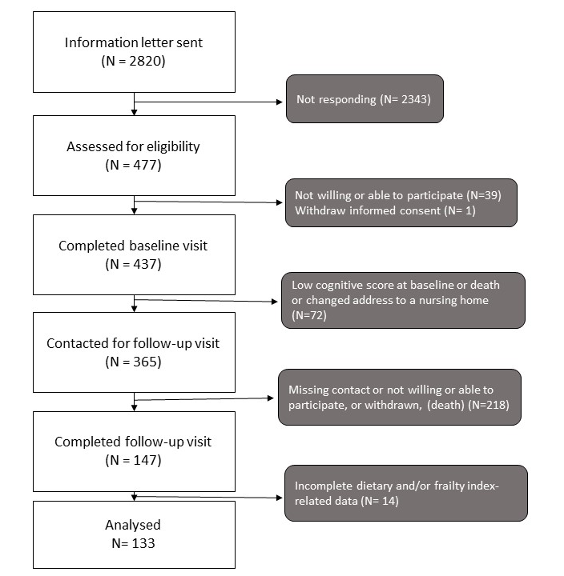

Figure text: The flow chart shows the flow from the participants invited to to the first study visit, to the number of participants included in this paper.

