Activation of the muscle-to-brain axis ameliorates neurocognitive deficits in an Alzheimer’s disease mouse model via enhancing neurotrophic and synaptic signaling

Hash Brown Taha¹, Allison Birnbaum², Ian Matthews¹, Karel Aceituno¹, Jocelyne Leon¹, Max Thorwald ¹, Jose Godoy-Lugo¹ and Constanza J. Cortes^{1*}
¹Leonard Davis School of Gerontology, University of Southern California, Los Angeles, CA 90007, USA.
²Department of Molecular, Cell and Developmental Biology, University of California, Los Angeles, Los Angeles, California, USA

*Corresponding Author

Email: cjc_149@usc.edu

Table S1. Detailed information for antibodies used in immunofluorescence and immunoblotting experiments.
Antibody | Company and Catalog # | Dilution
Immunohistochemistry
Chicken anti-GFAP | Abcam (# ab4674) | 1/200
Rat anti-IBA1 | Wako Chemicals (# 019-19741) | 1/200
Mouse monoclonal IgG1 Anti-6E10 | BioLegend (# 803001) | 1/200
Immunoblotting
Mouse monoclonal IgG1 anti-FLAG® M2 | Sigma-Aldrich (# F1804) | 1/5000
Rabbit monoclonal anti-APP | Abcam (# ab32136) | 1/1000
Rabbit anti-ADAM10 | Cell Signaling Technology (# 14194) | 1/1000
Rabbit anti-BACE1 | ProteinTech (# 12807-1-AP) | 1/1000
Rabbit anti-PSAP | ProteinTech (# 10801-1-AP) | 1/1000
Rabbit monoclonal anti-BDNF | Abcam (# ab108319) | 1/1000
Rabbit anti-NTF4 | ProteinTech (# 12297) | 1/1000
Mouse IgG2b monoclonal anti-SNAP25 | ProteinTech (# 60159) | 1/1000
Rabbit anti-synaptophysin 1 | ProteinTech (# 17785) | 1/2000
Rabbit anti-synaptotagmin 1 | ProteinTech (# 14511) | 1/500
Rabbit anti-synapsin I | ProteinTech (# 20258) | 1/1000
Rabbit anti-PSD95 | ProteinTech (# 20665) | 1/1000
Rabbit monoclonal anti-SAP97 | Abcam (# ab300481) | 1/1000
Mouse monoclonal IgG1 anti-SAP102 | BioLegend (# 832002) | 1/1000
Mouse monoclonal IgG1 anti-GluA1 | Antibodies Incorporated (# 75-327) | 1/1000
Mouse monoclonal IgG anti-ACTB | Abcam (# ab8226) | 1/10000
Mouse monoclonal IgG2a anti-saposin C | Santa Cruz (# sc-374119) | 1/1000
Chicken anti-β tubulin 3 | MyBioSource (#MBS 835547) | 1/1000

FIGURE S1. Densitometry quantification of 3x-FLAG-TFEB (Figure 1B) normalized by Total StainFree protein lane densitometry. Closed and open circles represent 4- and 8-month-old 5xFAD;cTFEB;HSACre female transgenic mice. (B) Representative merged images of 8-month-old cortex stained for Aβ plaques (6E10, magenta). (C) Representative merged images of 8-month-old hippocampus stained for Aβ plaques (6E10, white). Scale bars as shown. (D, E) Immunoblot for apolipoprotein (APP), α-secrtease (ADAM10) or β-secretase (BACE1) using 4- or 8-months-old cortical protein lysates, respectively. Total StainFree protein was used a loading control. Densitometry quantification is shown below normalized to Total StainFree densitometry. Statistical comparison was performed using independent t-tests or one-way ANOVA followed by post hoc multiple comparisons, ∗p < 0.05, ∗∗p < 0.01, ∗∗∗p < 0.001, n.s. non-significant. Data is represented as mean ± SEM.

FIGURE S2. Skeletal muscle TFEB did not alter overall locomotor activity of 5xFAD 8-month-old transgenic female mice. (A-C) Open field test evaluating distance traveled, velocity and time in center as proxies for activity levels. (D-E) Barnes maze evaluating latency to escape (D) or error rate (E) during training days. n = 8–12/group. Statistical comparison was performed using two-way ANOVA and post hoc multiple comparisons, lack of annotation indicates comparisons were not significant. Data is represented as mean ± SEM
FIGURE S3. Skeletal muscle TFEB overexpression did not alter neuroinflammation in 4-month-old 5xFAD transgenic female mice. (A) Representative merged images of the dentate gyrus stained for astrocytes (GFAP, green), microglia (IBA1, red), 6E10 (white) and Hoechst (blue). Scale bars as shown. (B) Quantification astrocyte and microglia load. (C) Volume of IBA1+ microglia. (D) Number of GFAP+ astrocytes. (E) Dot plots of the gene ontology (GO) enrichment analysis for transcripts involved in biological processes according to a neuroinflammation Nanostring panel comparing 5xFAD;cTFEB;HSACre vs. 5xFAD 8-month-old female transgenic mice (see Figure 2E). Statistical comparison was performed using one-way ANOVA and post hoc multiple comparisons, n.s. non-significant.
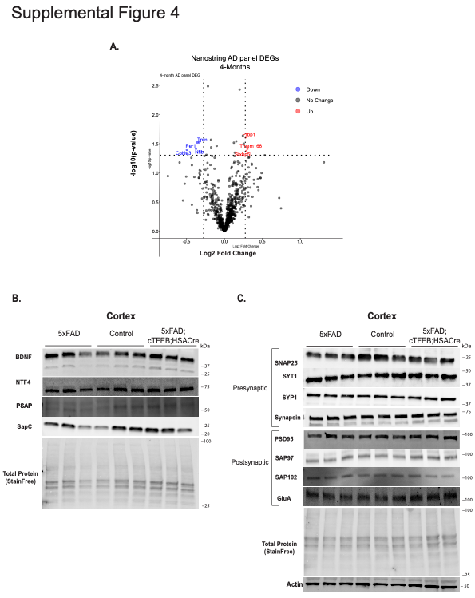
FIGURE S4. Skeletal muscle-TFEB overexpression did not alter neurotrophic signaling or synaptic integrity in brains of 5xFAD 4-month-old transgenic female mice. (A) Volcano plot of differentially expressed hippocampal transcripts quantified using a Nanostring AD panel for comparing 5xFAD;cTFEB;HSACre vs. 5xFAD 4-month-old transgenic female mice. (B-C) Immunoblot for several neurotrophic (A), pre- and post-synaptic (B) markers using 4-month-old mice cortical protein lysates. Total StainFree protein lane or actin β band was used a loading control.

FIGURE S5. No changes in synaptic markers in total cortical lysates and trending alterations in cortical synaptosomes preps from PS18-injected animals. (A) Immunoblots of total cortical protein lysates for pre- and post-synaptic markers in subcutaneously PS18- or DMSO-injected 3-month-old C57B6 /L male mice. Total StainFree protein lane or by β tubulin 3 band was used a loading control. (B) Immunoblots of cortical synaptosome-enriched protein fractions for pre- and post-synaptic markers in subcutaneously PS18- or DMSO-injected 3-month-old C57B6 /L male mice. β tubulin 3 band was used a loading control. Densitometry quantifications are shown below. Statistical comparison of groups was performed using t-test, n.s. non-significant.

