SUPPLEMENTARY INFORMATION

GeroScience

A biological age based on common clinical markers predicts health trajectory and mortality risk in dogs

Sébastien Herzig¹*, Alix Zollinger¹, Lorane Texari², James Holzwarth², Rondo P. Middleton³, Yuanlong Pan³, Pascal Steiner³ and Philipp Gut¹*

AFFILIATIONS
¹ Nestlé Institute of Health Sciences, Nestlé Research, Lausanne, Switzerland
² Nestlé Institute of Food Safety and Analytical Sciences, Nestlé Research, Lausanne, Switzerland
³ Nestlé Research St. Louis, St. Louis, MO 63164, USA
* Corresponding authors

CORRESPONDING AUTHORS
Philipp Gut, ORCID iD: https://orcid.org/0000-0002-0689-9518
Email: philipp.gut@rd.nestle.com
Sébastien Herzig, ORCID ID: https://orcid.org/0000-0002-9329-2860
Email: sebastien.herzig@rd.nestle.com

Supplementary Figures 1-6
Supplementary Table 1

Starting dataset:
28 clinical blood parameters
Petcare center monitoring of 940 dogs and 1044 cats over 12 years
Log transform skewed data
Remove extreme value (retain between 1st and 99th percentile)
829 dogs with 5329 observations
802 cats with 3475 observations
Split 3:1 into train and test sets
LASSO Cox regression on survival
with 20-fold crossvalidation
Selection of biomarkers
COX regression with individual blood marker as predictors
Compute Gompertz distribution with biomarkers. For dogs, include breed class and sex
Construction of Biological Age formula
Calculate Biological Age on training set
Test prognostic value on survival
Validate predictive value of Biological Age in dogs:
Life-long calorie restriction study
- 6 months weight loss intervention study
NHANES survey of US population
CBC and serum chemistry parameters
Dog data
Highlight species-specific predictors of mortality
Fig S1
Schematic representation of the workflow of analysis

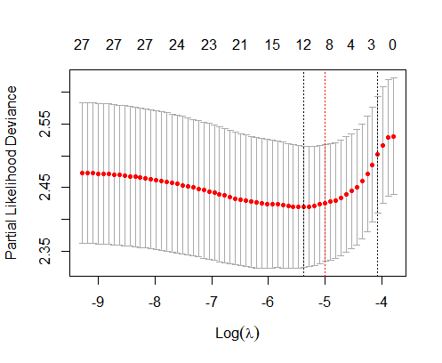
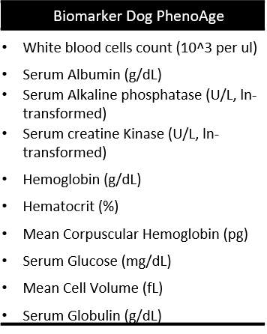
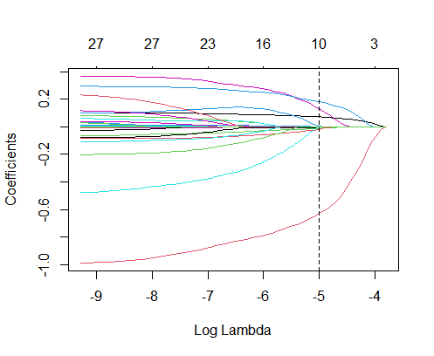
a
b
c
Fig S2
a LASSO penalized Cox regressions were used to select the optimal number of predictors of mortality in dogs. b Selection of the optimal lambda parameter was performed to minimize the number of features while retaining a good fit of data (red dashed line). c Retained parameters at the selected lambda threshold.

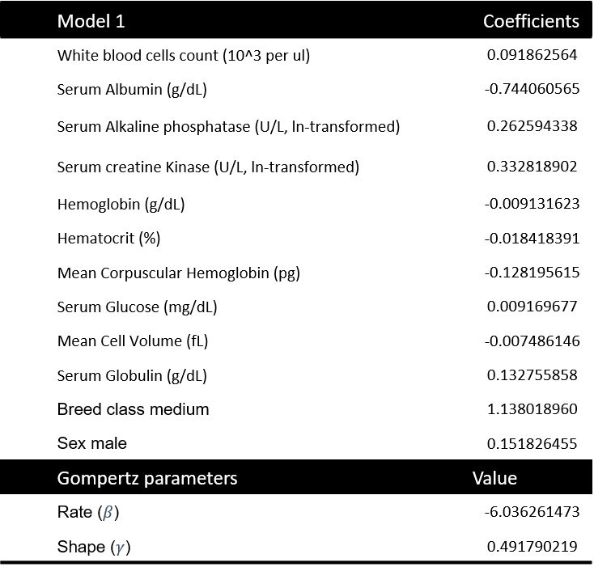
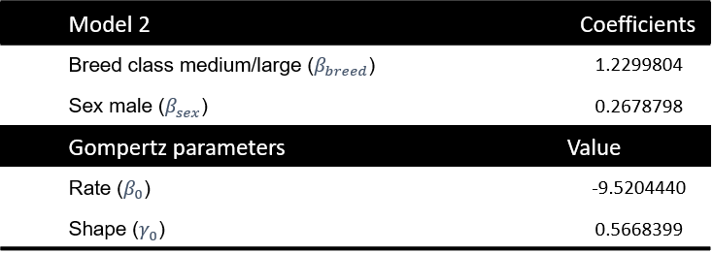
Dog p$henoage=$ $\ln\left(\frac{γ_{0}*e^{xb}*\{e^{γ*age}- 1\}}{e^{\left\{breed*β_{breed}\right\}+\left\{sex * β_{sex}\right\}+ β_{0}}* γ}+1 \right) *\frac{1}{γ_{0}}$
$xb= β$ + $\sum{(coef *value)}$
a
b
Fig S3
a: Gompertz coefficients for the dog Biological Age. B: Biological Age formula.
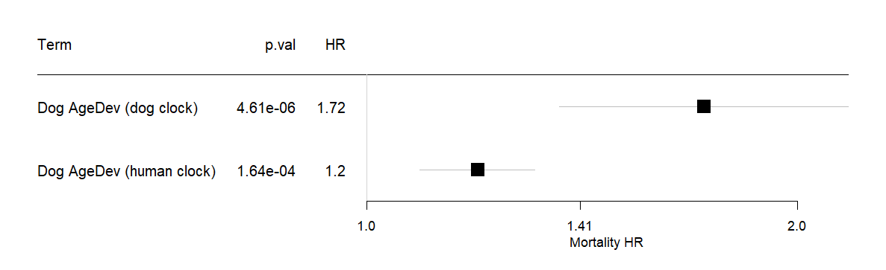
Fig S4
Analyzing the survival prediction on the dog data set with a dog-specific phenoage algorithm (developed in this manuscript) compared to the published human phenoage algorithm (truncated for parameters that are not available in routine canine laboratory analysis). HR: hazard ratio. Data indicate HR with 95% confidence intervals using cox proportional hazard model for all-cause mortality.

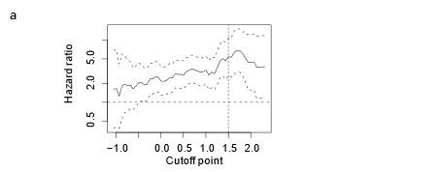
Fig S5
Evaluation of hazard ratio when AgeDev is treated as a binary outcome at different cut-off points along the range of observed values (-1 to 2).

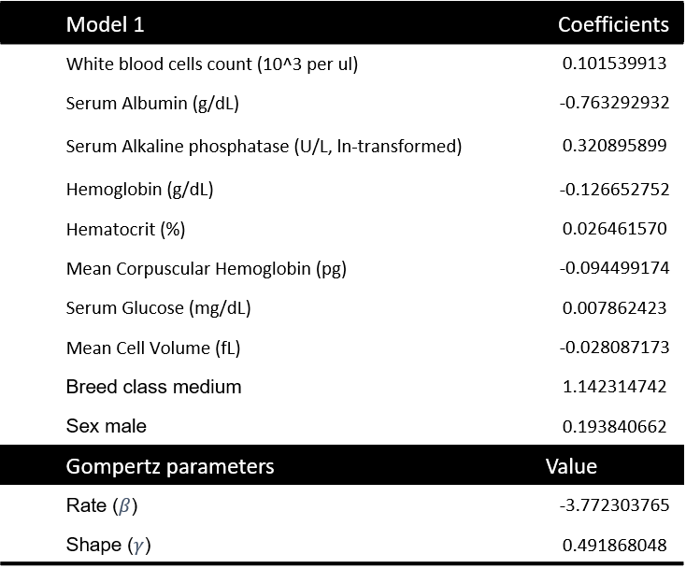
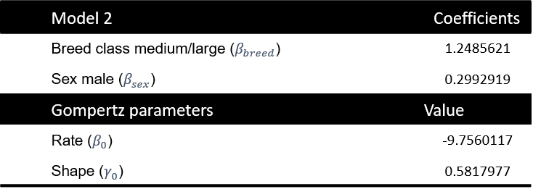
Fig S6
a: Gompertz coefficients for the reduced Biological Age model with 8 parameters.

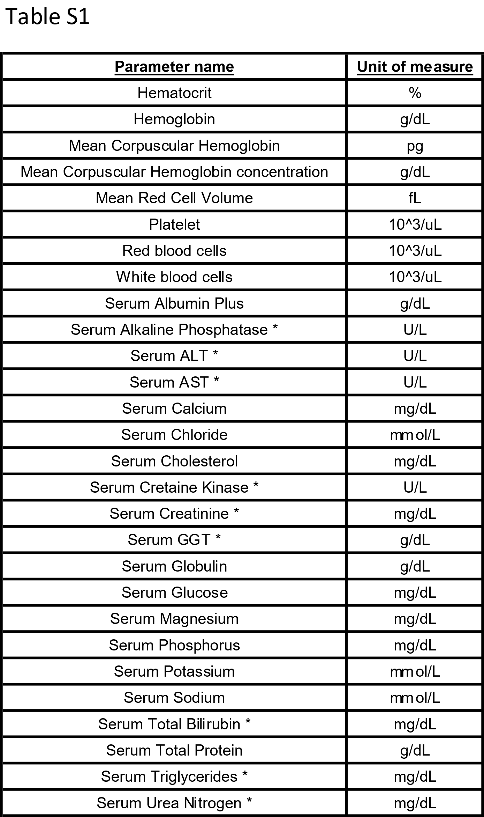

Table S1
List of parameters routinely measured in the petcare center that entered into the penalized Cox regression, along with unit of measure. Asterisks indicate parameters that were log-transformed before analysis using natural log.

