Fig. S1 Flow diagram of the methodology approach adopted for the systematic review and meta-analysis
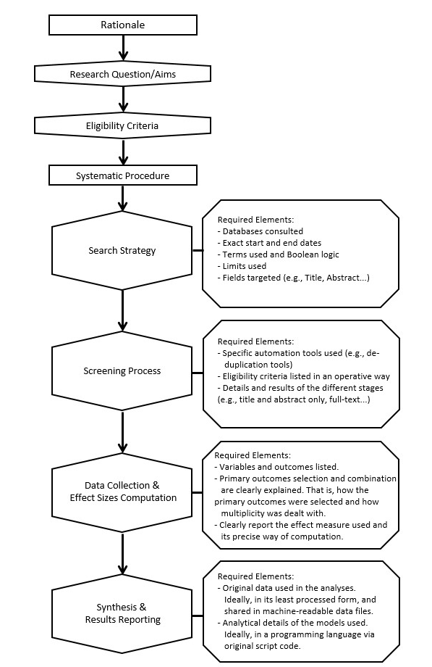
Note. Adapted from López-Nicolás et al., 2024.

Fig. S2a Quality assessment of studies on Cognitive Stimulation
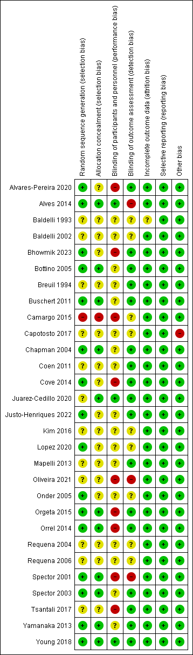

Fig. S2b Quality assessment of studies on Cognitive Training
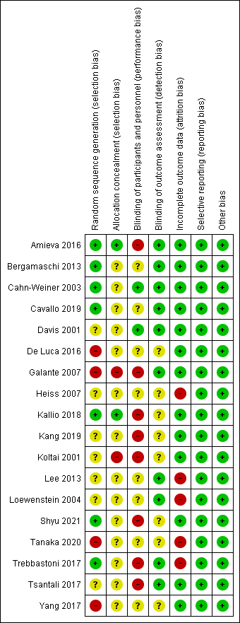

Fig. S2c Quality assessment of studies on Cognitive Rehabilitation
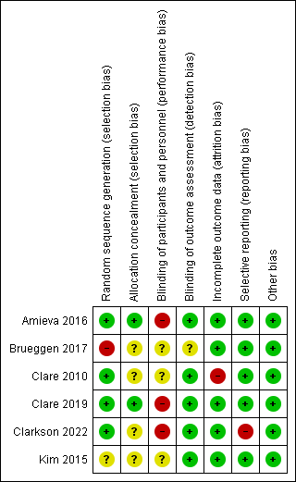

Fig. S3 Forest plot for group Cognitive Stimulation effect on ADL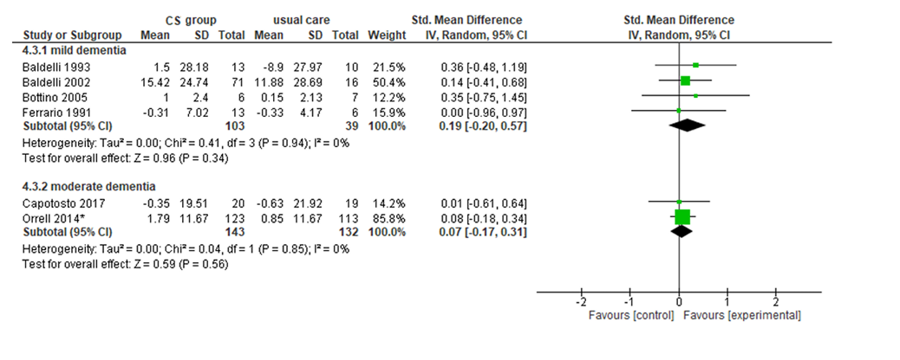Note. ADL: activities of daily living; Chi²: heterogeneity test; CI: confidence interval; CS: cognitive stimulation; df: degrees of freedom; I²: heterogeneity index; IV: inverse variance method; Random: random effects model; SD: Standard deviation; Z: test for overall standardized mean difference.
*Data calculated by the NICE Guideline working group (NG97).

Fig. S4 Forest plot for group Cognitive Stimulation effect on quality of life
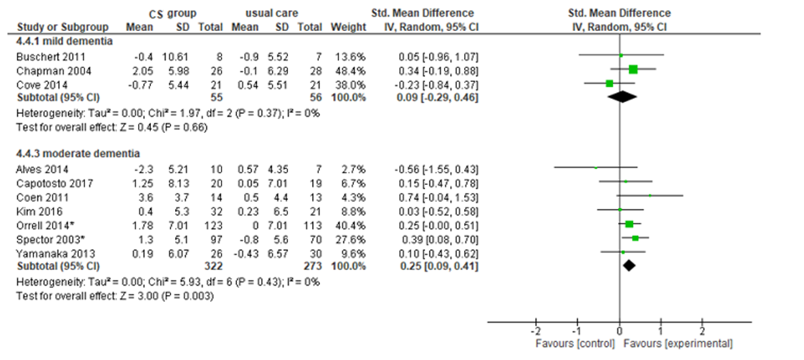Note. Chi²: heterogeneity test; CI: confidence interval; CS: cognitive stimulation; df: degrees of freedom; I²: heterogeneity index; IV: inverse variance method; Random: random effects model; SD: Standard deviation; Z: test for overall standardized mean difference.
*Data calculated by the NICE Guideline working group (NG97).

Fig. S5 Forest plot for group Cognitive Training effect on ADL
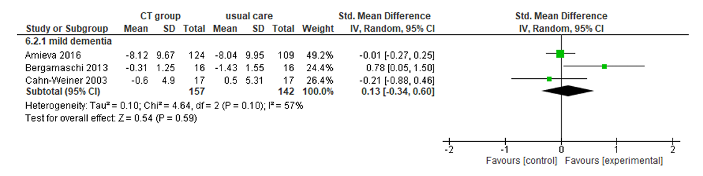Note. ADL: activities of daily living; Chi²: heterogeneity test; CI: confidence interval; CT: cognitive training; df: degrees of freedom; I²: heterogeneity index; IV: inverse variance method; Random: random effects model; SD: Standard deviation; Z: test for overall standardized mean difference.

Fig. S6 Forest plot for individual Cognitive Training effect on ADL
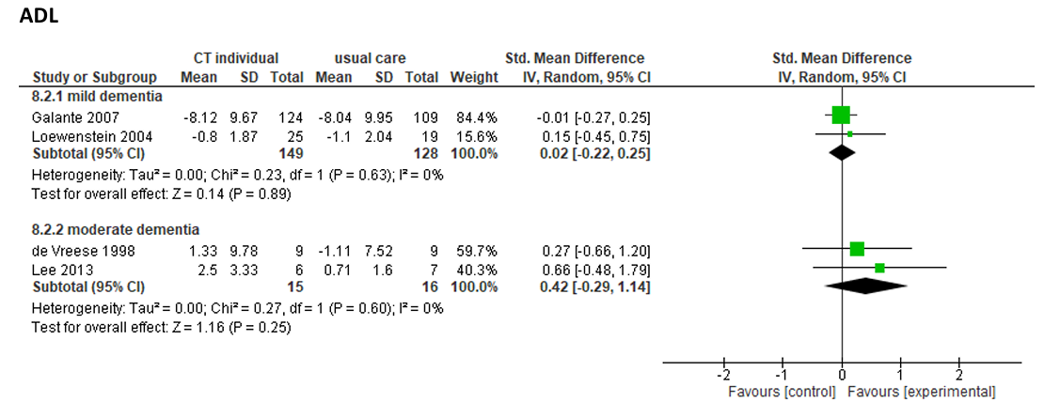Note. ADL: activities of daily living; Chi²: heterogeneity test; CI: confidence interval; CT: cognitive training; df: degrees of freedom; I²: heterogeneity index; IV: inverse variance method; Random: random effects model; SD: Standard deviation; Z: test for overall standardized mean difference.

Fig. S7 Forest plot for Cognitive Rehabilitation effect on ADL (scales with higher scores indicating better performance)
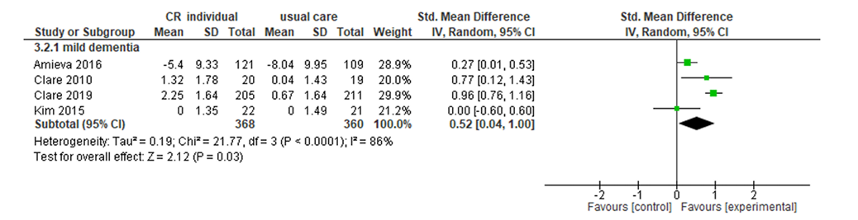Note. ADL: activities of daily living; Chi²: heterogeneity test; CI: confidence interval; CR: cognitive rehabilitation; df: degrees of freedom; I²: heterogeneity index; IV: inverse variance method; Random: random effects model; SD: Standard deviation; Z: test for overall standardized mean difference.
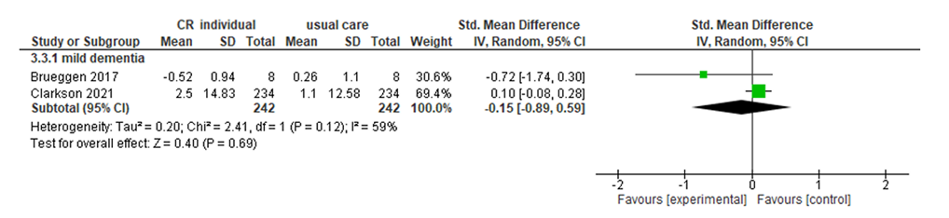
Fig. S8 Forest plot for cognitive rehabilitation effect on ADL (scales with lower scores indicating better performance)
Note. ADL: activities of daily living; Chi²: heterogeneity test; CI: confidence interval; CR: cognitive rehabilitation; df: degrees of freedom; I²: heterogeneity index; IV: inverse variance method; Random: random effects model; SD: Standard deviation; Z: test for overall standardized mean difference.

Fig. S9 Forest plot for Cognitive Rehabilitation effect on quality of life
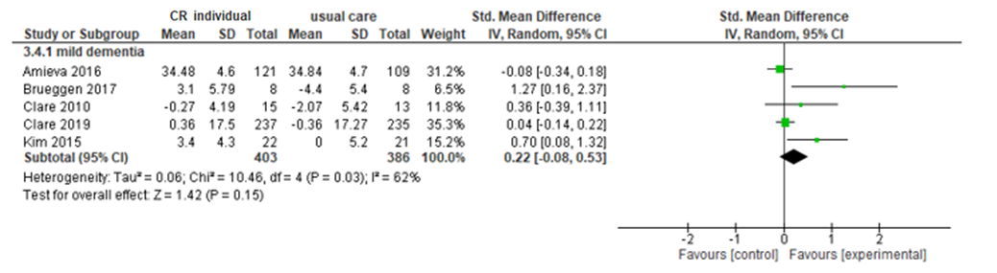
Note. Chi²: heterogeneity test; CI: confidence interval; CR: cognitive rehabilitation; df: degrees of freedom; I²: heterogeneity index; IV: inverse variance method; Random: random effects model; SD: Standard deviation; Z: test for overall standardized mean difference.

References
López-Nicolás, R., Lakens, D., López-López, J. A., Rubio-Aparicio, M., Sandoval-Lentisco, A., López-Ibáñez, C., Blázquez-Rincón, D., & Sánchez-Meca, J. (2024). Reproducibility of published meta-analyses on clinical-psychological interventions. Advances in Methods and Practices in Psychological Science, 7(1), Article 25152459231202929. https://doi.org/10.1177/25152459231202929

