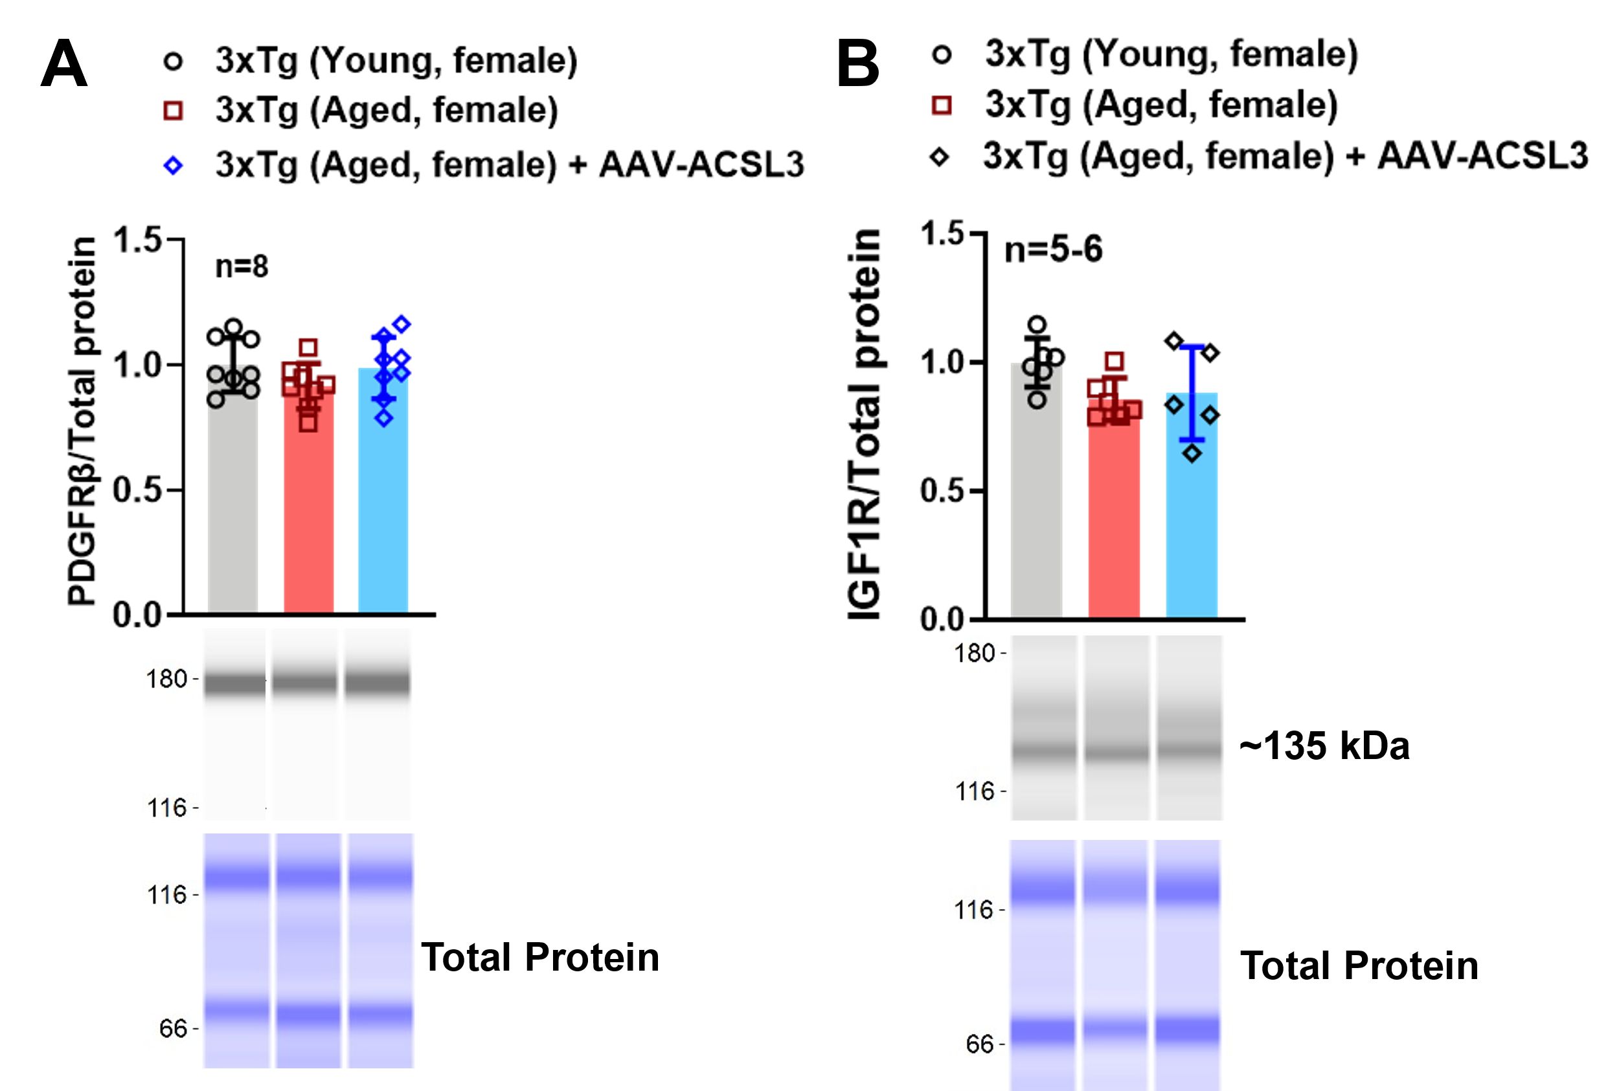
Figure S1. ACSL3 overexpression via AAV had no effect on PDGFRβ and IGF1R protein levels in aged 3xTg-AD female mice. Protein levels of PDGFRβ (A) and IGF1R (B) in the hippocampus of AD mice were measured via capillary-based immunoassay. PDGFRβ and IGF1R protein levels were normalized to total protein and presented as bar graphs. Results were analyzed via one-way ANOVA with Tukey’s post-hoc.

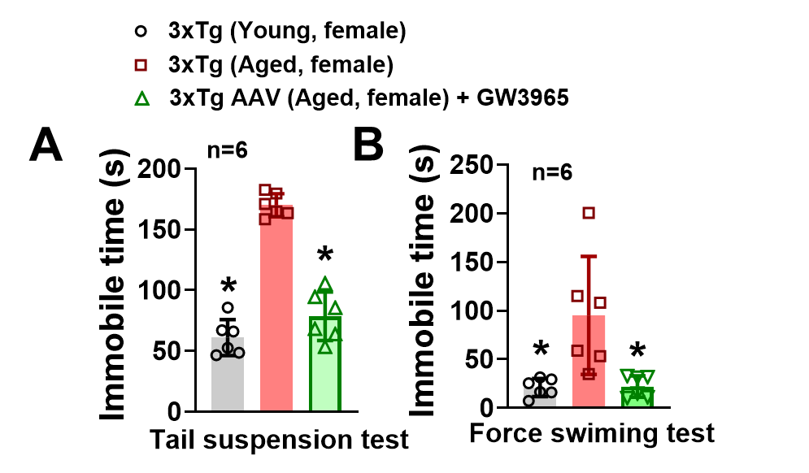
Figure S2. ACSL3 upregulation exhibits antidepressant-like effects in 3xTg-AD mice. Aged female 3xTg-AD mice (9-12 months) were treated with GW3965 (20mg/kg/day, ip). Behavioral paradigms were implemented in mice 7 days after GW3965 treatment. GW3965 observably reduced the immobility time of aged 3xTg-AD mice in TST and FST. *p≤0.05 indicates overall significantly different from aged 3xTg-AD mice, evaluated by one-way ANOVA with Tukey’s post-hoc.

