Supplementary File S1

Supplementary Table 1. List of ICD-9 codes included in the analysis

Supplementary Table 2. Demographic characteristics of the study cohort

Supplementary Figure S1. Distribution of cancer patients

Supplementary Figure S2. Analysis of survival of cancer patients

Supplementary Table 1. List of ICD-9 codes included in the analysis.
ICD-9 codes
Neoplasm diagnoses
140-149 | Lip, oral cavity, and pharynx
150, 152, 156, 158, 159 | Peritoneum and other digestive organs
151 | Stomach
153 | Colon
154 | Rectum
155 | Liver
157 | Pancreatic
160-165 | Respiratory and intrathoracic
170 | Bone
171 | Connective tissue
172, 173, 176 | Skin
174-175 | Breast
185 | Prostate
183 | Ovary
189 | Kidney
188 | Bladder
179-182, 184, 186-187 | Other genitourinary organs
190, 192-199 | Other locations and not specified
191 | Brain
200-203 | Lymphatic and hematopoietic
204-208 | Leukemia
209 | Neuroendocrine
210-229 | Benign
230-234 | In situ
235-238 | Uncertain evolution
239 | Not specified nature
Contact with health services
V580, V581 | Admission for radiotherapy or chemotherapy
Procedures
922-924, 9925, 9928 | Radiotherapy and chemotherapy

 | CENTENARIANS  (n = 649) |  | NON-CENTENARIANS  (n = 62,753)
 | CANCER+  (n = 111) | CANCER-  (n = 538) | CANCER+  (n = 25,405) | CANCER-  (n = 37,348)
Demographic data
Age | 102.03 ± 1.91 | 102.07 ± 1.9 | 78.81 ± 11.44 | 84.17 ± 10.63
Sex | 89 women  (80.18%)  22 men  (19.82%) | 468 women  (86.99%)  70 men  (13.01%) | 10,182 women  (40.08%)  15,223 men  (59.92%) | 20,738 women  (55.53%)  16,610 men  (44.47%)
Residence | 31 yes  (27.93%)  80 no  (72.07%) | 156 yes  (29%)  382 no  (71%) | 2,245 yes  (8.84%)  23,160 no  (91.16%) | 6,715 yes  (17.98%)  30,633 no  (82.02%)
Supplementary Table 2. Demographic characteristics of the study cohort.

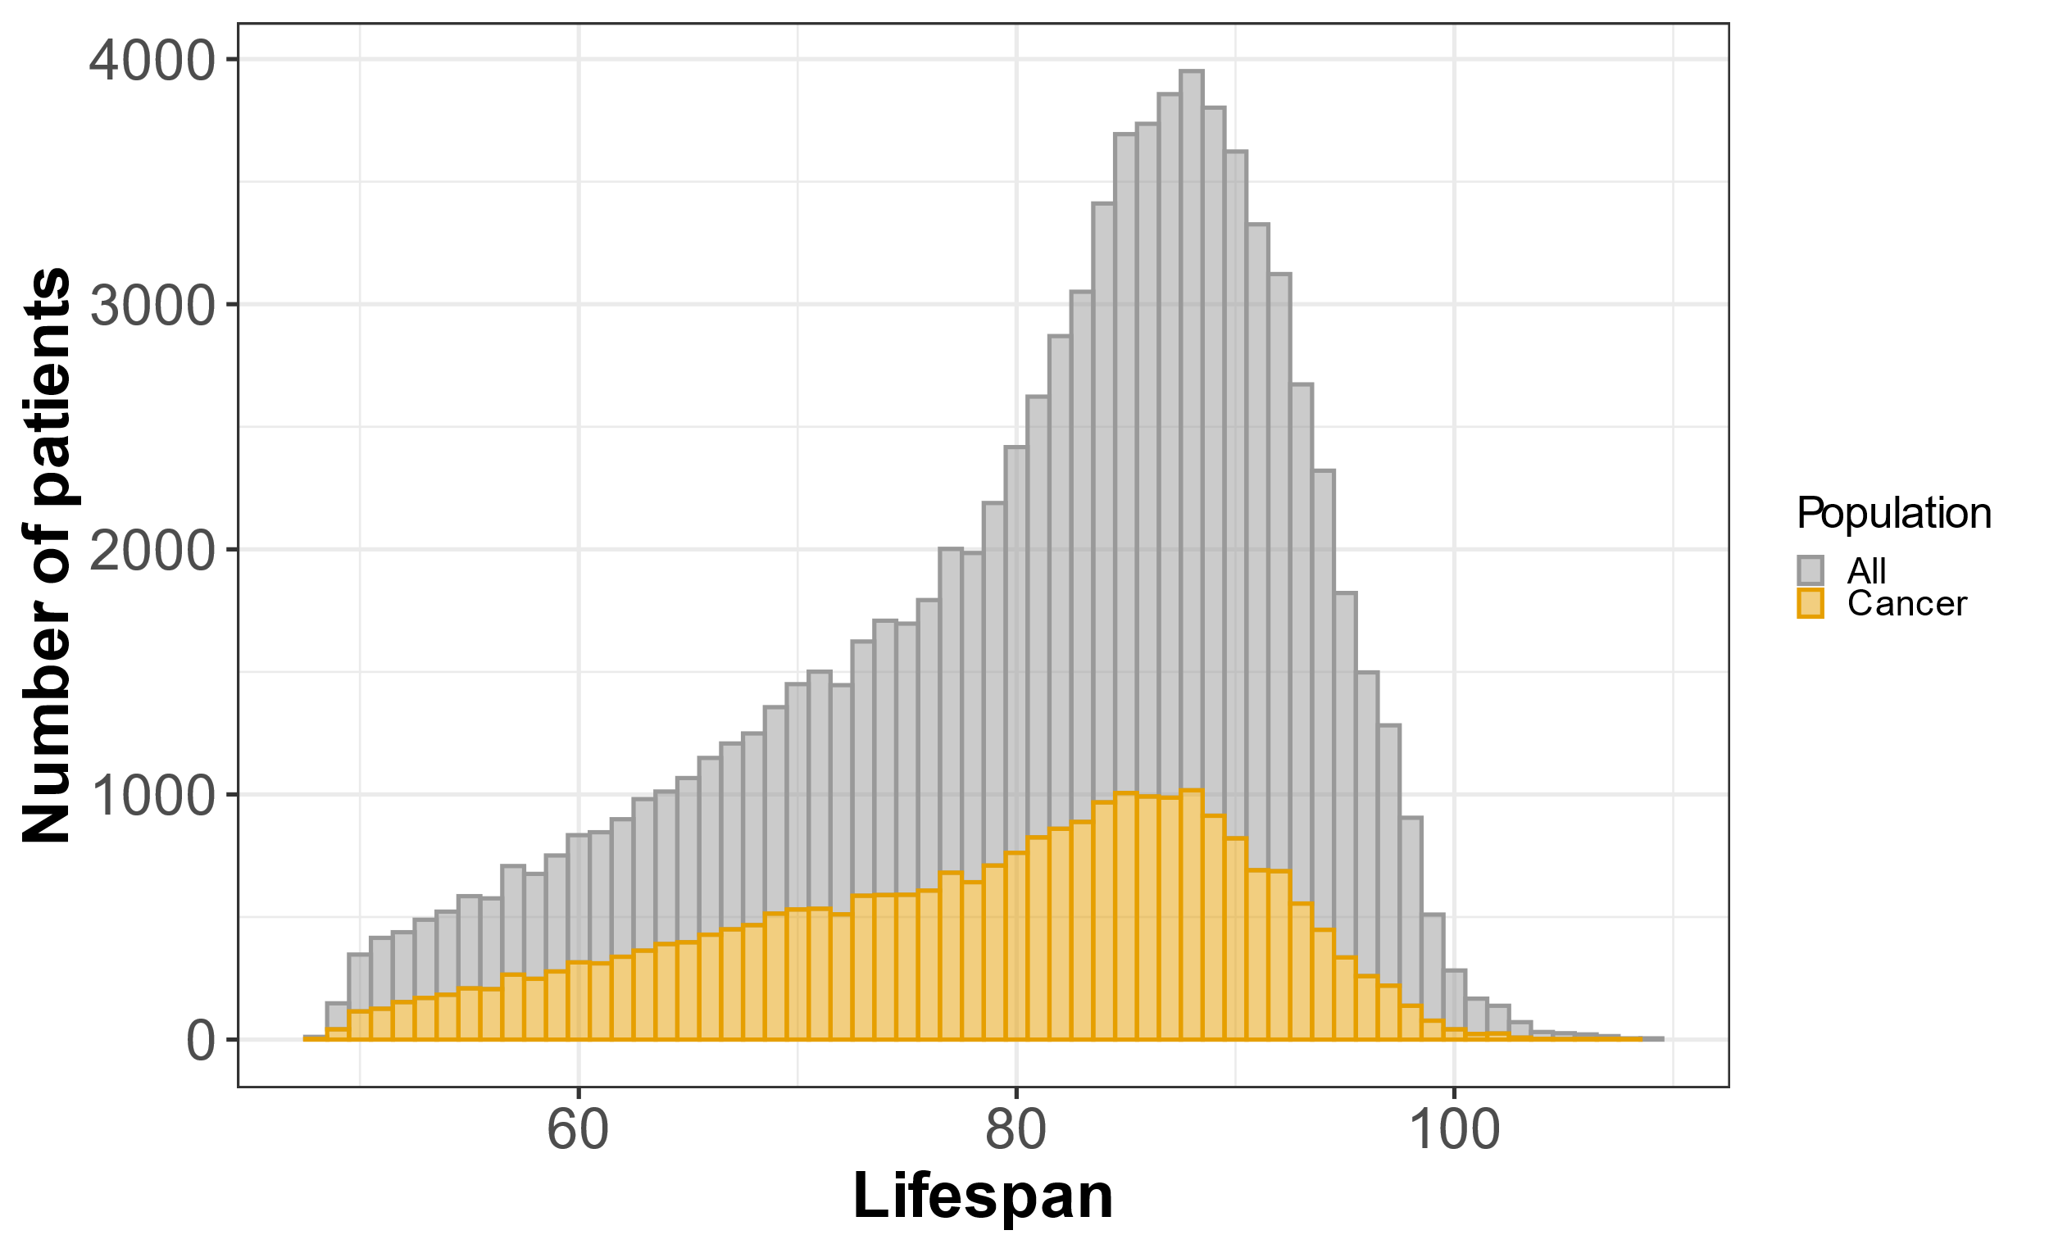
Distribution of cancer patients

Supplementary Figure Caption S1. Distribution of cancer patients.
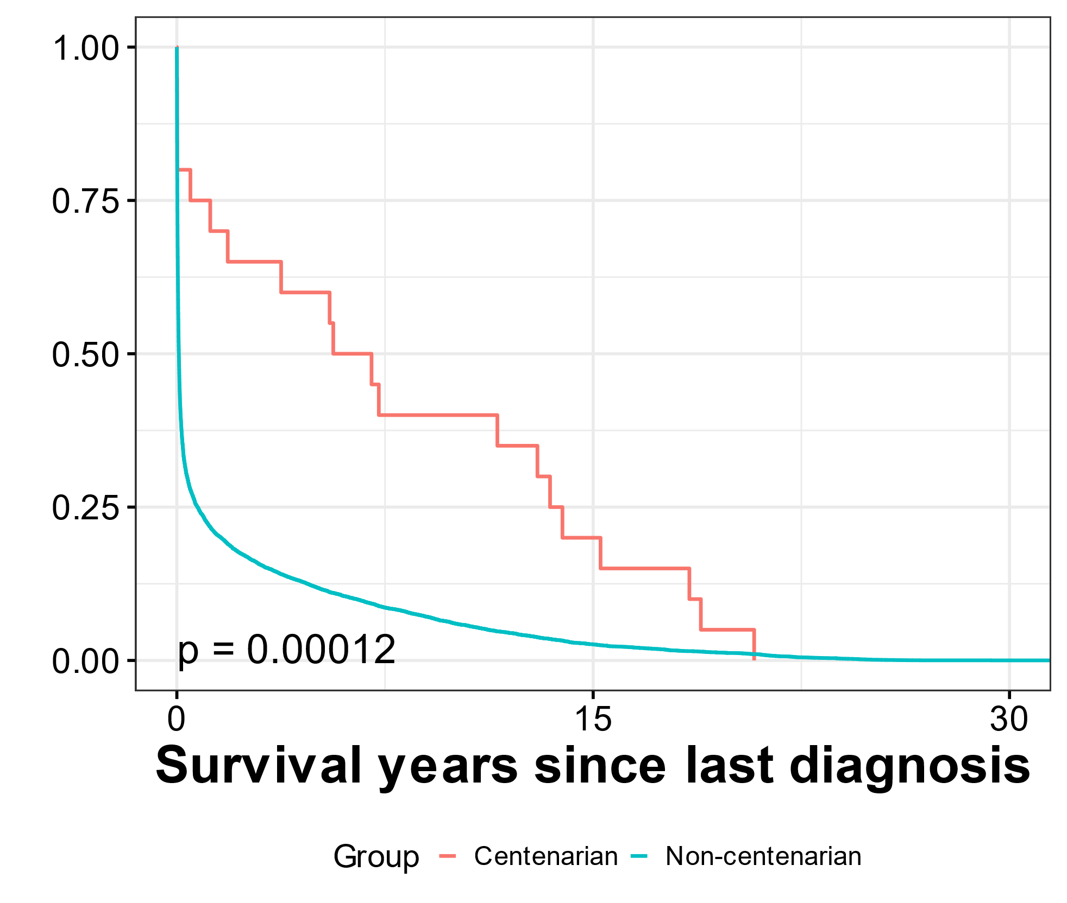
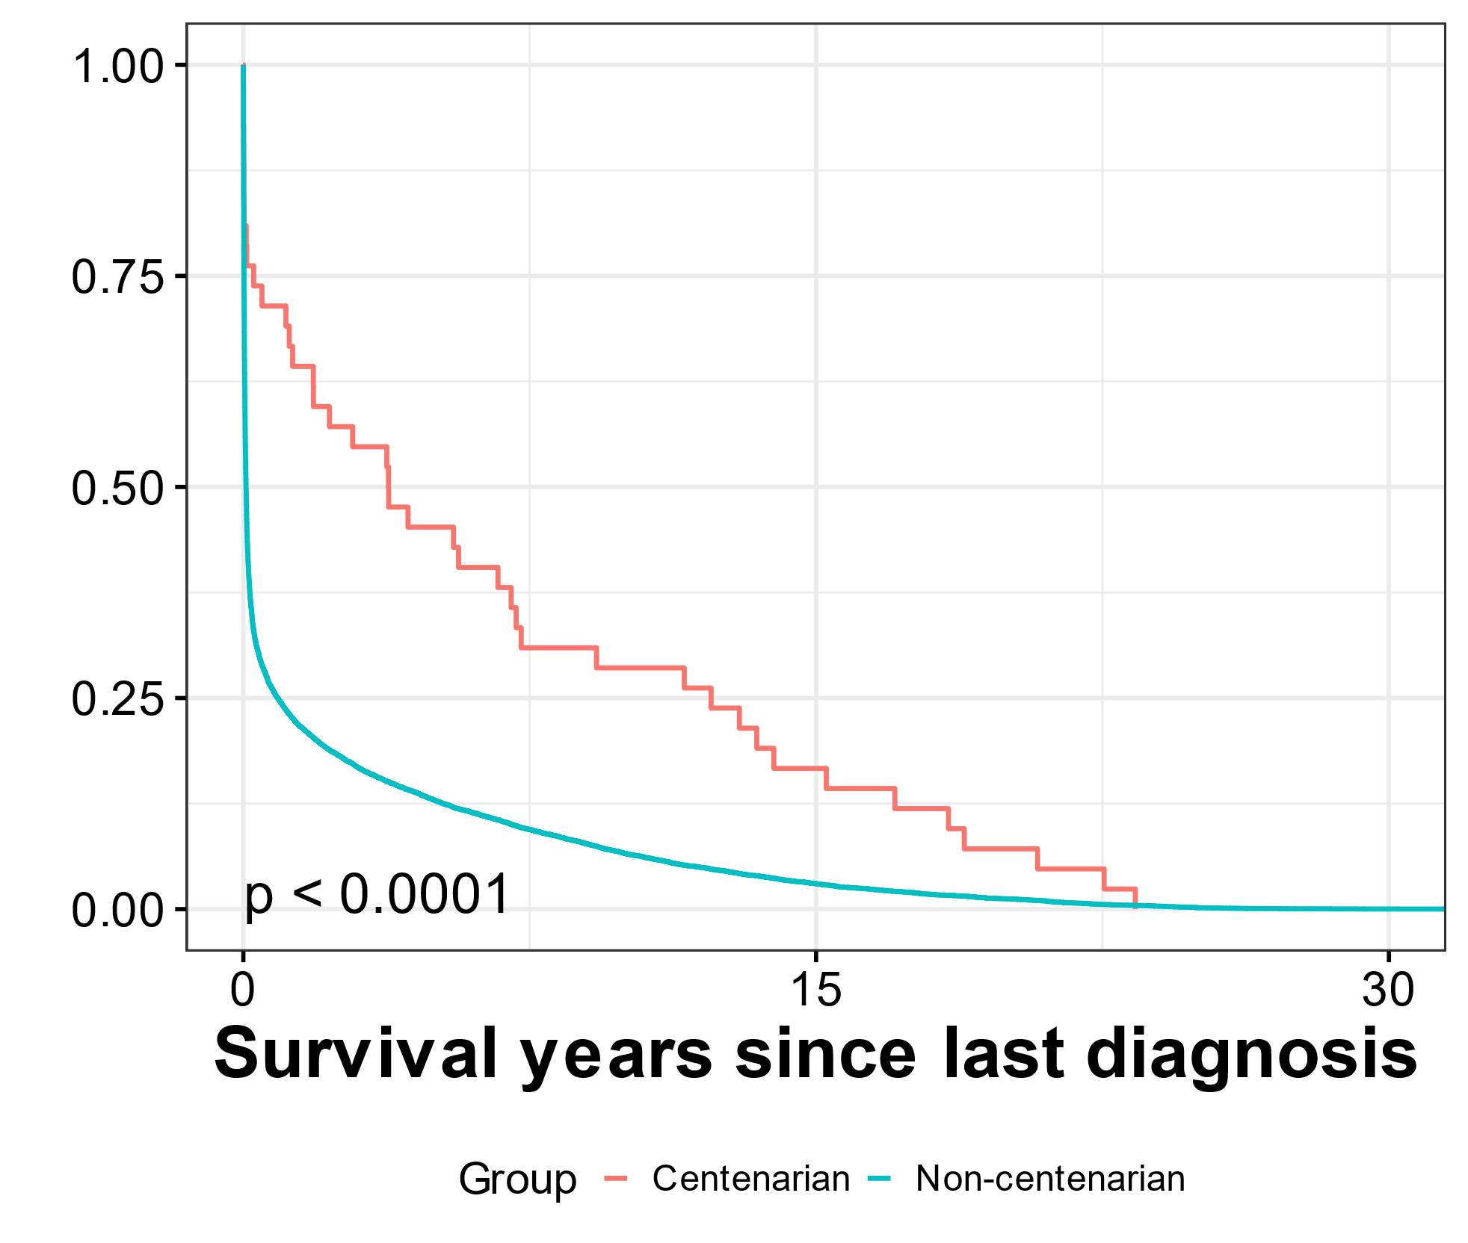
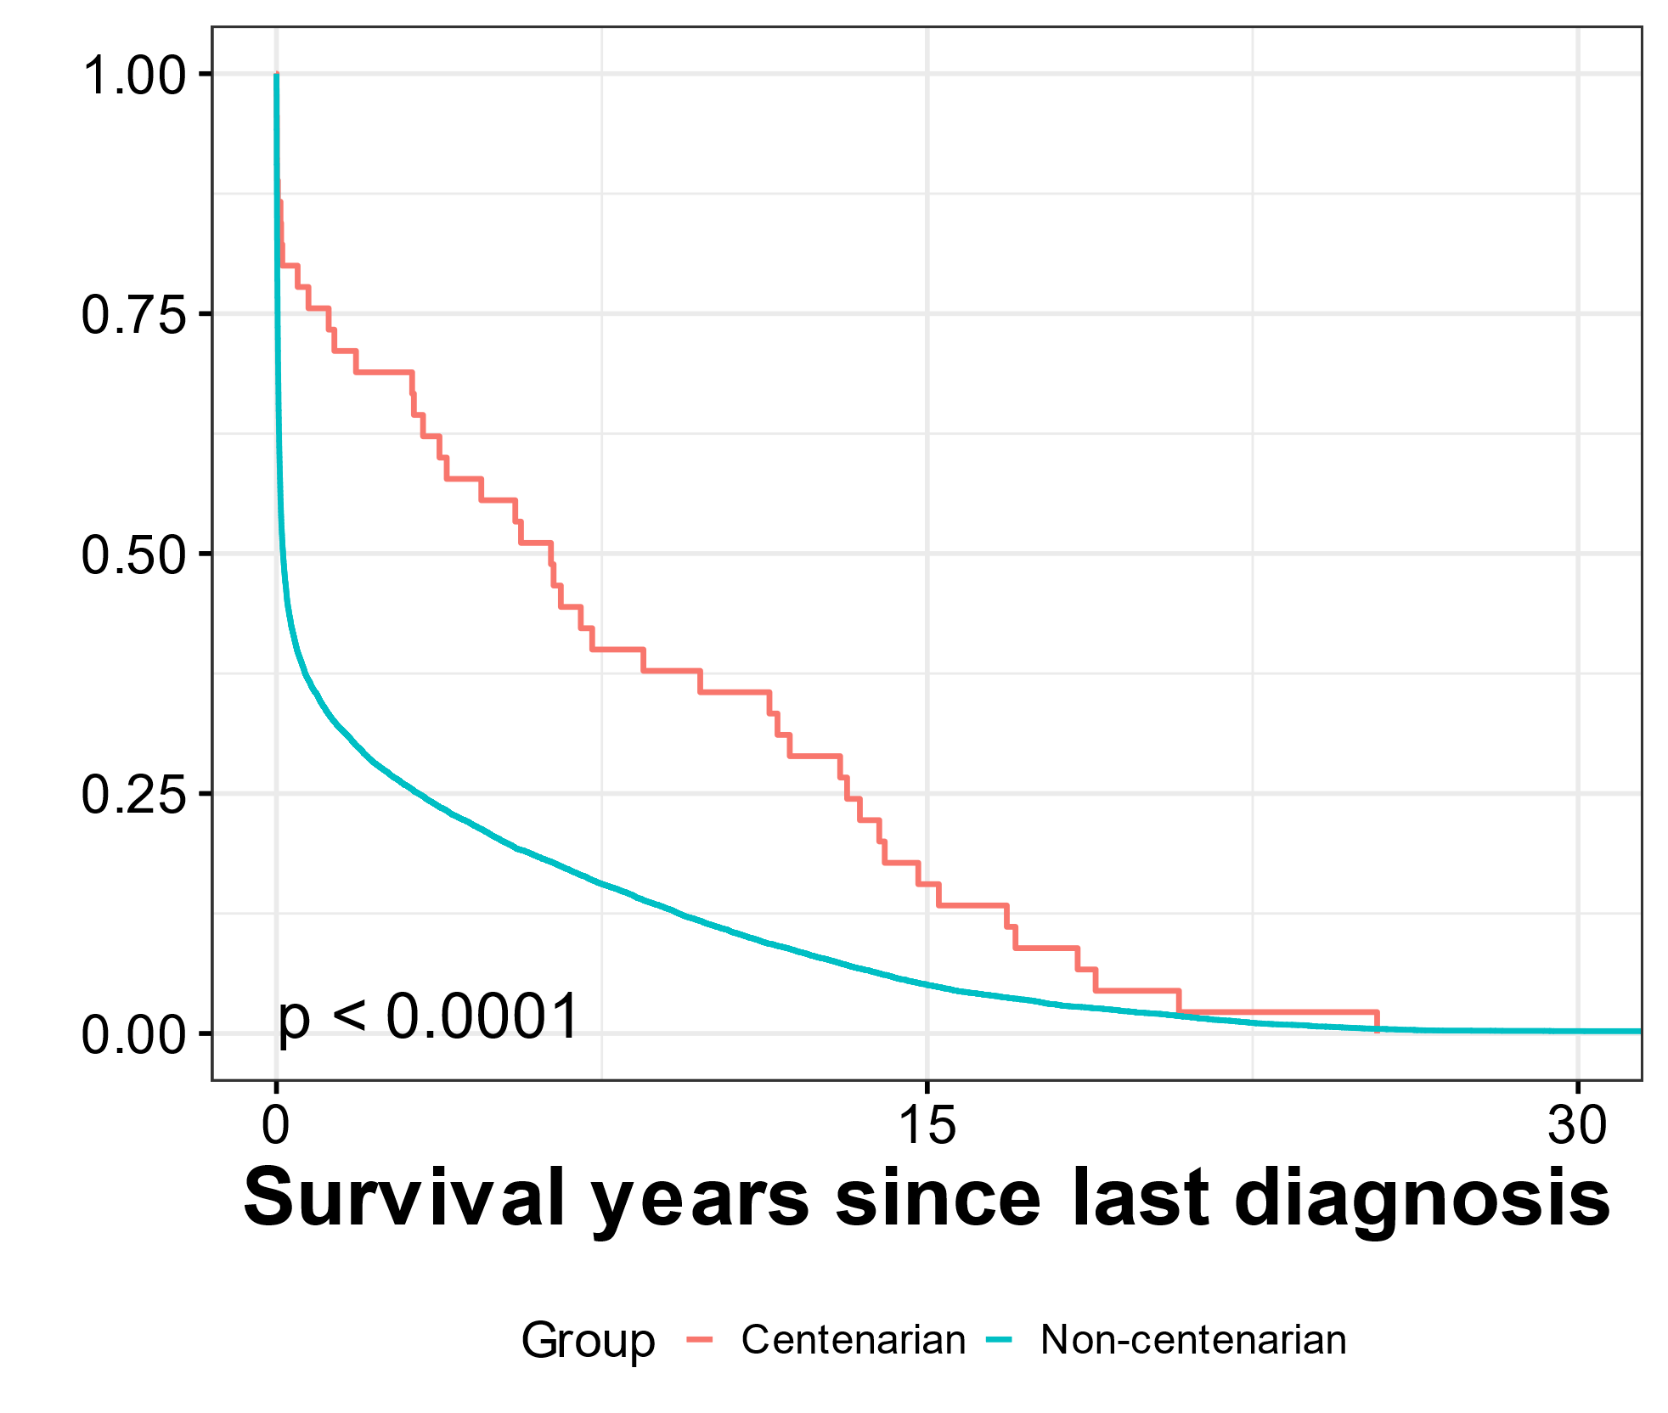
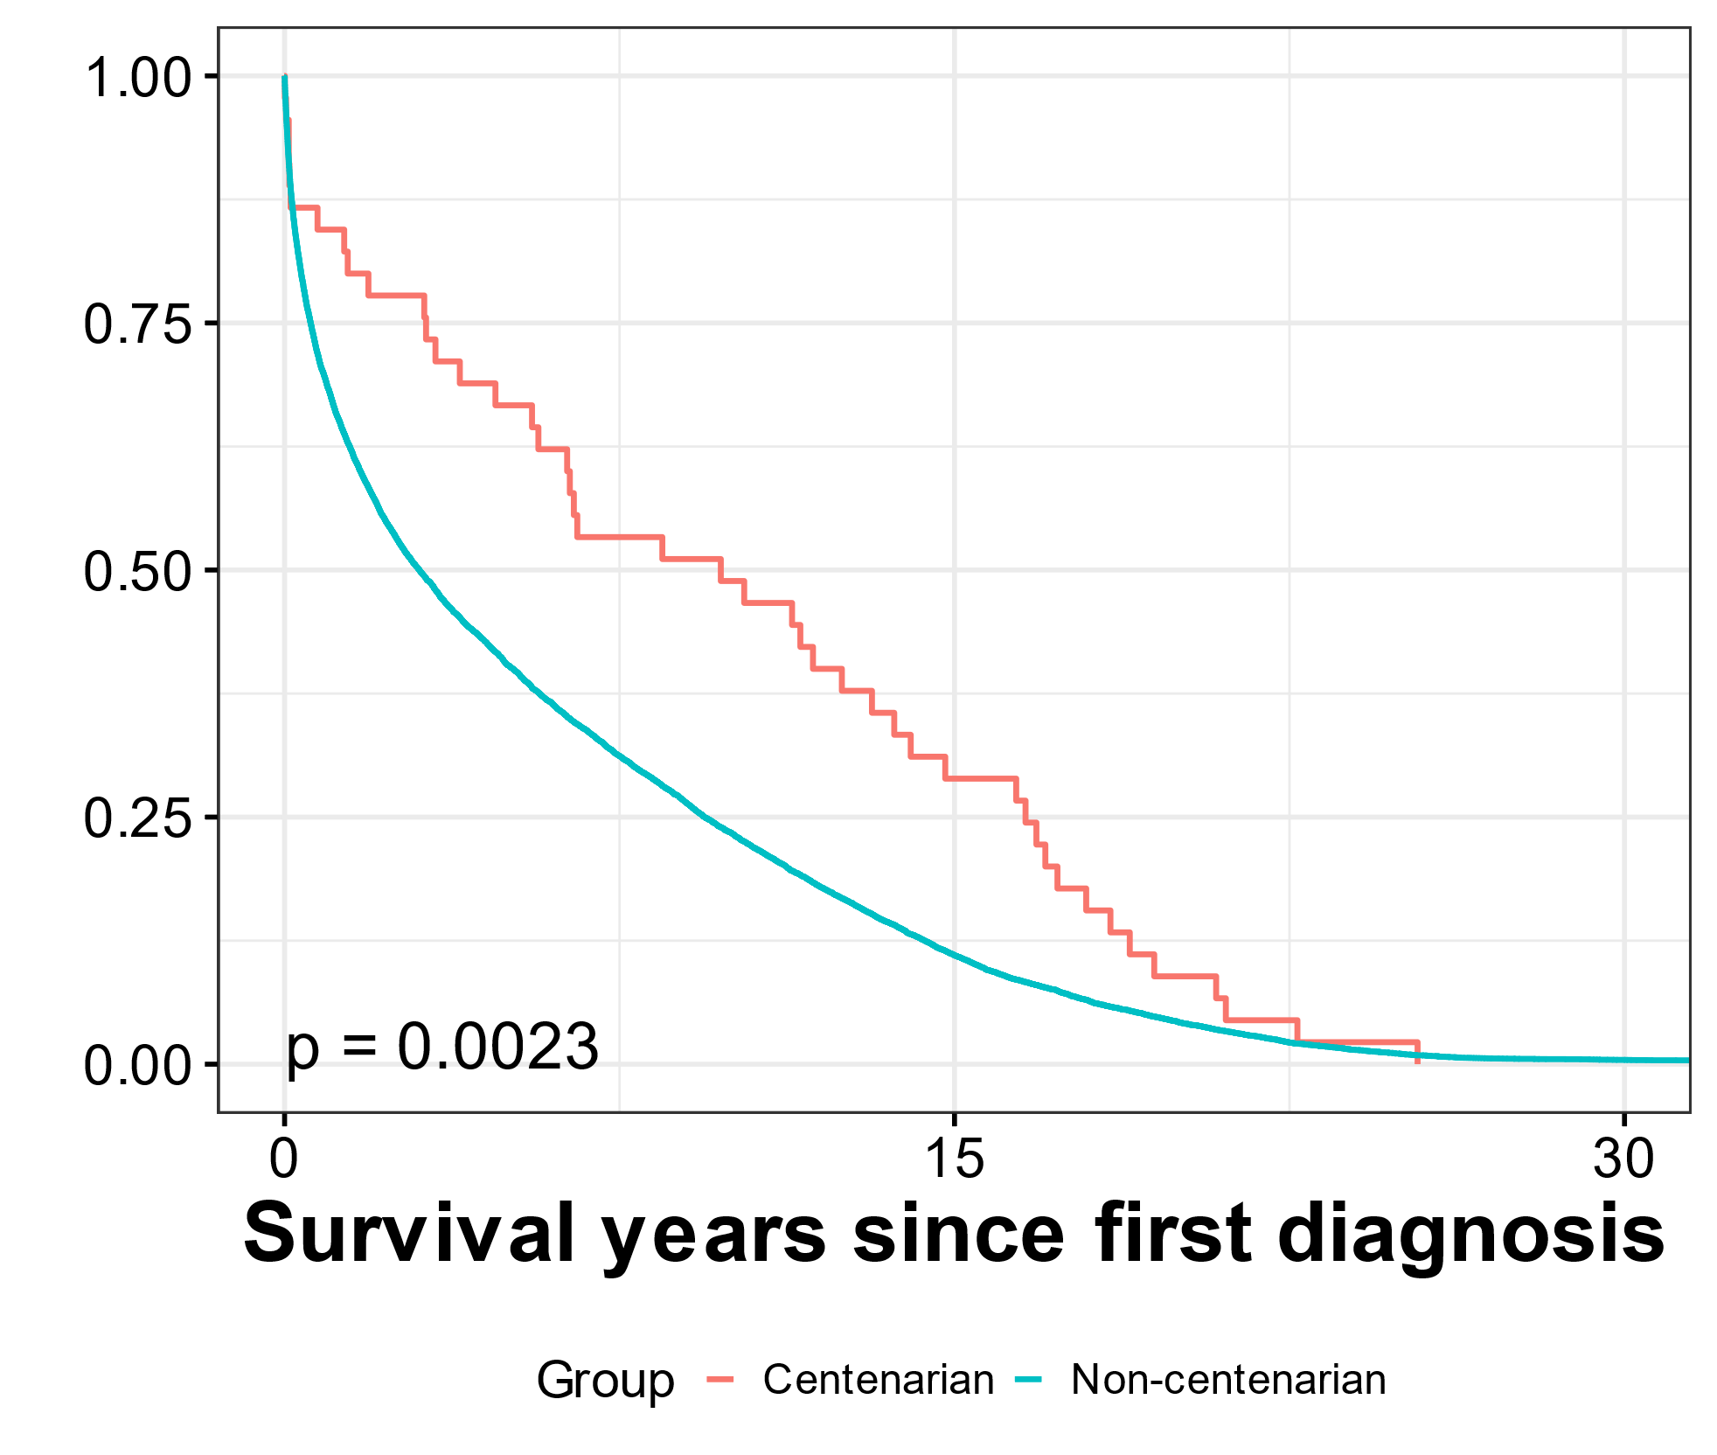
Analysis of survival of cancer patients
A
B
C
D

Supplementary Figure Caption S2. Analysis of survival of cancer patients. A) Survival of centenarians vs non-centenarians since the last cancer diagnosis until death of individuals. Only individuals with more than one cancer diagnosis were considered. B) Survival of centenarians vs non-centenarians since the first cancer diagnosis until death of individuals. Only individuals deceased before COVID-19 pandemic were considered. C) Survival of centenarians vs non-centenarians since the last cancer diagnosis until death of individuals. Only individuals deceased before COVID-19 pandemic were considered. D) Survival of centenarians vs non-centenarians since the last cancer diagnosis until death of individuals. Only individuals with more than one cancer diagnosis deceased before COVID-19 pandemic were considered.

