Supplementary material

Nocturia as a clinical marker of loss of function and resilience or risk factor for frailty in older adults? Results of the Berlin Aging Study II

Maximilian König^{1,2,#}, Carolin Malsch^{3,#}, Joany Mariño⁴, Valentin Max Vetter⁵, Yulia Komleva⁶, Ilja Demuth^{5,8,*}, and Elisabeth Steinhagen-Thiessen^{7*}

¹Department of Internal Medicine and Geriatrics, University Medicine Greifswald, Germany
²Geriatric Medicine Center, Kreiskrankenhaus Wolgast, Wolgast, Germany
³Department of Biomathematics and Statistics, Institute of Mathematics and Computer Science, University of Greifswald, Greifswald, Germany
⁴Department of Internal Medicine B, University Medicine Greifswald, Germany
⁵Department of Endocrinology and Metabolic Diseases (including Division of Lipid Metabolism), Biology of Aging working group, Charité-Universitätsmedizin Berlin, corporate member of Freie Universität Berlin and Humboldt-Universität zu Berlin, Berlin, Germany
⁶Department of Internal Medicine and Geriatrics, University Medicine Greifswald, Germany
⁷Medical Department of Endocrinology, Diabetes and Metabolic Medicine, Charité-Universitätsmedizin Berlin, Berlin, Germany
⁸BCRT-Berlin Institute of Health Center for Regenerative Therapies, Charité-Universitätsmedizin Berlin, corporate member of Freie Universität Berlin and Humboldt-Universität zu Berlin, Berlin, Germany

#,* Contributed equally

Supplementary Table 1. Characteristics of participants included and excluded from the analysis.
 | Included  1083 (64.8%) | Excluded*  588 (35.2%) | p-value
Age, mean (SD) | 67.8 (3.5) | 69.2 (3.9) | <0.001
Female sex, n (%) | 563 (52.0) | 299 (50.9) | 0.695
Nocturia, n (%) | 254 (23.6) | 168 (28.7) | 0.027
Frailty at baseline,  n (%) |  |  | 0.043
Robust | 700 (70.2) | 329 (63.9)
Pre-frail | 288 (28.9) | 181 (35.1)
Frail | 9 (0.9) | 5 (1.0)
Morbidity index at baseline,  median (IQR) | 0.97 (1.20) | 1.09 (1.28) | 0.069
Fallen in the past 12 months, n (%) | 325 (30.1) | 183 (31.4) | 0.615
Hospitalizations in the past 12 months, n (%) | 183 (16.9) | 107 (18.4) | 0.502
Subjective sleep duration in hours, median (IQR) | 7 (6-8) | 7 (6-8) | 0.782
Poor sleep quality (subj.), n (%) | 171 (17.2) | 85 (15.7) | 0.497
Notes and abbreviations: Data are presented as mean (standard deviation, SD), number of observations (percentage), or median (IQR = 25th,75th percentile); *excluded due to death or loss to follow-up.
Supplementary Table 2. Participants’ characteristics at baseline and follow-up, stratified by nocturia status (n=1083).

Baseline*
 |  |  | No Nocturia  821 (75.8%) | Nocturia*  254 (23.5%) | Missings  8 (0.7%) |  |  | p-value
Age, years |  |  | 67.6 (3.5) | 68.5 (3.3) | 0 |  |  | <0.001
Female sex, % |  |  | 438 (53.3) | 122 (48.0) | 0 |  |  | 0.158
Frailty at T0, % |  |  |  |  | 86 |  |  | 0.633
- Robust |  |  | 539 (70.9) | 158 (68.4)
- Pre-frail |  |  | 215 (28.3) | 70 (30.3)
- Frail |  |  | 6 (0.8) | 3 (1.3)
Fallen in the past 12 months, % |  |  | 250 (30.6) | 74 (29.1) | 4 |  |  | 0.723
Hospitalizations in the past 12 months, % |  |  | 122 (14.9) | 61 (24.0) | 1 |  |  | 0.001
Morbidity index |  |  | 0.91 (1.16) | 1.15 (1.32) | 97 |  |  | <0.001
Subjective sleep duration, hours |  |  | 7 (6.5-8) | 7 (6-8) | 91 |  |  | 0.015
Poor sleep quality (subj.), % |  |  | 104 (13.8) | 67 (28.8) | 91 |  |  | <0.001
Follow-up**
 | No Nocturia  656 (60.6%) |  |  | Nocturia*  423 (39.1%) |  | Missings  4 (0.4%) | p-value
Age, years |  | 75.3 (3.7) |  | 76.1 (3.8) |  | 0 | <0.001
Female sex, % |  |  | 362 (55.2) | 200 (47.3) | 0 |  |  |  | 0.013
Frailty T1, % |  |  |  |  | 13 |  |  |  | 0.005
- Robust |  |  | 330 (50.6) | 170 (41.0)
- Pre-frail |  |  | 298 (45.7) | 221 (53.3)
- Frail |  |  | 24 (3.7) | 24 (5.8)
Fallen in the past 12 months, % |  |  | 131 (25.1) | 106 (30.7) | 215 |  |  |  | 0.084
Hospitalizations in the past 12 months, % |  |  | 127 (19.8) | 117 (28.0) | 19 |  |  |  | 0.002
Morbidity index |  | 1.32 (1.53) |  | 1.52 (1.55) |  | 143 | 0.058
Notes and abbreviations: *Nocturia at baseline defined as ≥2 episodes/night; ** nocturia at follow-up; Data are presented as mean (standard deviation), number of observations (percentage), or median (IQR = 25th,75th percentile).

Supplementary Table 3. Participants’ characteristics at baseline and follow-up, stratified by frailty status (n=1083).

Baseline*
 | Robust  700 (64.6%) | Pre-frail  288 (26.6%) | Frail  9 (0.8%) | Missings  86 (7.9%) | p-value
Age, years | 67.60 (3.29) | 68.21 (3.92) | 67.00 (3.97) | 0 | 0.146
Female sex, % | 355 (50.7) | 155 (53.8) | 5 (55.6) | 0 | 0.656
Nocturia, % | 158 (22.7) | 70 (24.6) | 3 (33.3) | 8 | 0.663
Fallen in the past 12 months, % | 211 (30.2) | 90 (31.2) | 2 (22.2) | 4 | 0.823
Hospitalization in the past 12 months, % | 120 (17.1) | 45 (15.6) | 2 (22.2) | 1 | 0.766
Morbidity index | 0.88 (1.10) | 1.16 (1.33) | 1.67 (1.41) | 97 | 0.005
Subjective sleep duration, hours | 7 (6.5-8) | 7 (6-8) | 8.3 (7.3-8.9) | 91 | 0.003
Poor sleep quality (subj.), % | 93 (14.3) | 64 (24.3) | 1 (16.7) | 91 | 0.001
Follow-up**
 | Robust  502 (46.4%) | Pre-frail  520 (48.0%) | Frail  48 (4.4%) | Missings  13 (1.2%) | p-value
Age, years | 75.09 (3.76) | 75.96 (3.60) | 77.45 (4.55) | 0 | <0.001
Female sex, % | 254 (50.6) | 276 (53.1) | 28 (58.3) | 0 | 0.497
Nocturia, % | 170 (34.0) | 221 (42.6) | 24 (50.0) | 4 | 0.005
Fallen in the past 12 months, % | 95 (24.4) | 127 (29.4) | 12 (32.4) | 215 | 0.207
Hospitalization in the past 12 months, % | 104 (21.1) | 124 (24.3) | 15 (31.2) | 19 | 0.187
Morbidity index | 1.22 (1.41) | 1.45 (1.54) | 2.62 (2.16) | 143 | <0.001
Notes and abbreviations: *Frailty at baseline; ** Frailty at follow-up; Data are presented as mean (standard deviation), numbers(proportions), or median(IQR = 25th,75th percentile).

Supplementary Table 4. Transition hazards with 95% confidence intervals for nocturia, age, sex, and morbidity.
Transition | Nocturia | Age | Sex | Morbidity
Robust - prefrail | 0.99 (0.64-1.52) | 1.04 (0.96-1.12) | 0.77 (0.51-1.16) | 1.09 (0.91-1.30)
Robust - death | 1.41 (0.68-2.93) | 1.17 (1.03-1.34) | 0.87 (0.44-1.70) | 1.14 (0.88-1.48)
Prefrail - robust | 0.73 (0.35-1.51) | 0.98 (0.88-1.09) | 0.66 (0.36-1.24) | 0.95 (0.72-1.25)
Prefrail - frail | 2.21 (0.54-9.01) | 1.13 (1.00-1.27) | 0.19 (0.01-4.90) | 2.18 (1.29-3.69)
Prefrail - death | 2.21 (1.28-3.80) | 1.36 (1.25-1.48) | 0.62 (0.35-1.07) | 1.16 (0.97-1.40)
Frail - prefrail | 1.00 (0.17-5.99) | 1.06 (0.96-1.17) | 0.07 (0.00-2.23) | 1.60 (0.87-2.93)
Frail - death | 2.28 (0.09-60.72) | 0.63 (0.33-1.20) | 0.26 (0.02-3.44) | 1.21 (0.61-2.41)

Supplementary figure 1.
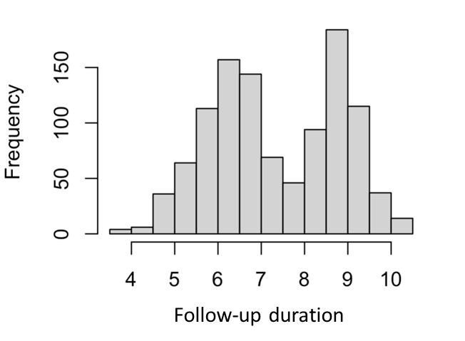

Supplementary figure 1: Bi-modal distribution of observed follow-up duration (in years).

Supplementary figure 2a.

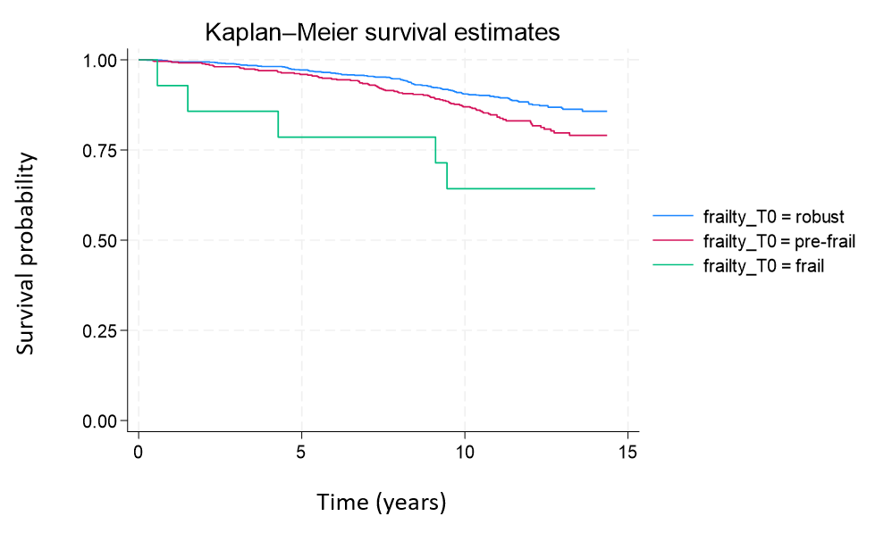

Supplementary figure 2b.

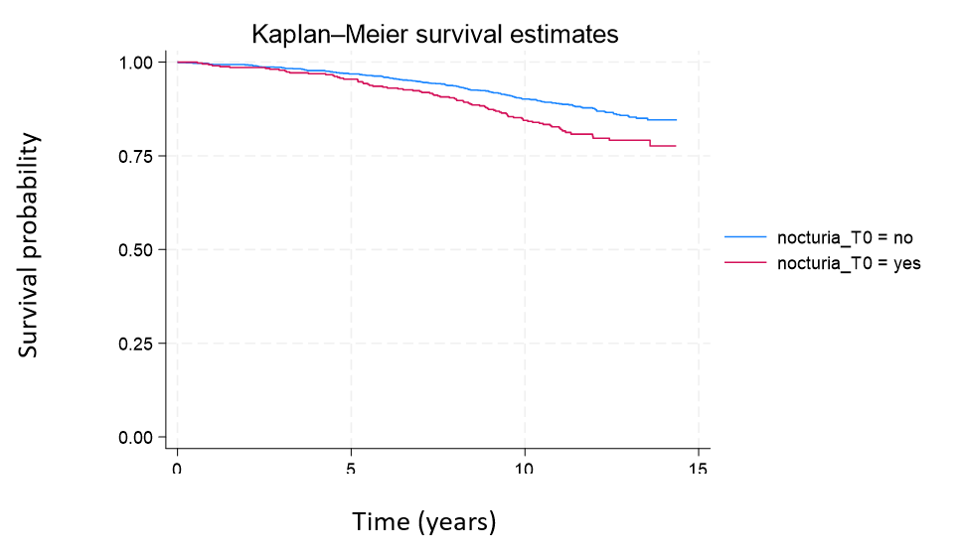

Supplementary figures 2a-b: Kaplan-Meier survival estimates for BASE-II (n=1671) by a) frailty status and b) nocturia.

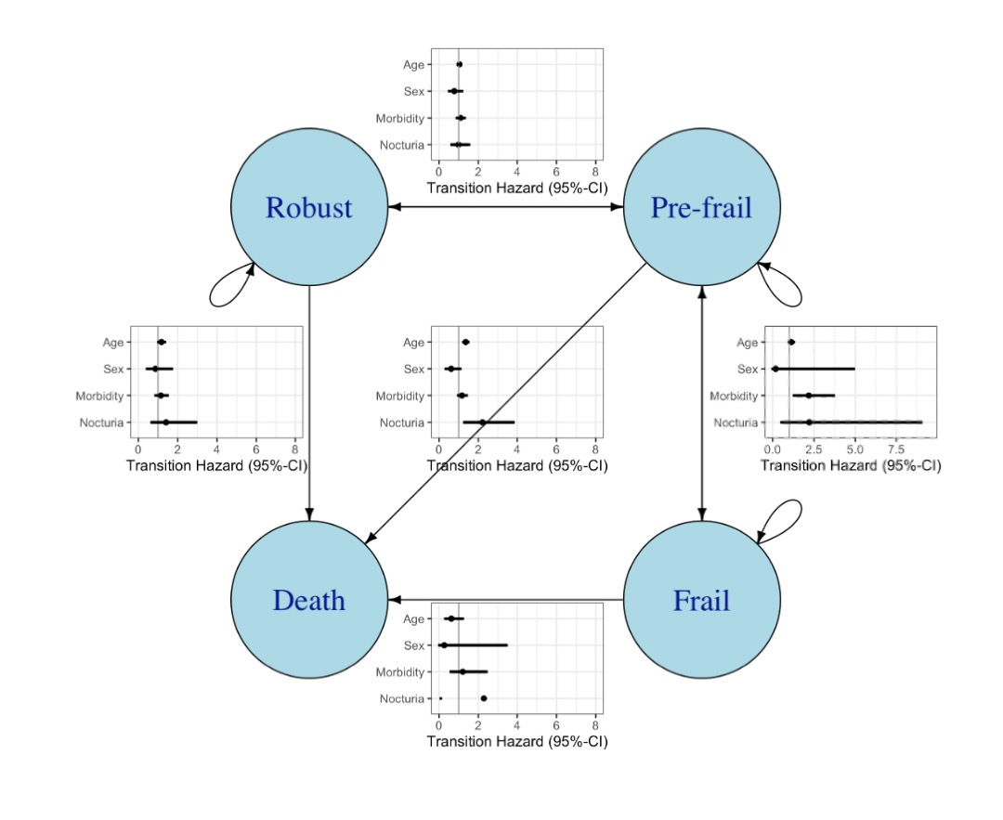
Supplementary Figure 3. Transition graph as modelled in the multi-state model, together with estimated transition hazard ratios for the covariates for all 'downward' transitions, i.e. robust to pre-frail (top), robust to death (left), pre-frail to frail (right), pre-frail to death (middle) and frail to death (bottom).

