Supplementary files

Supplementary Table S1. ROC: AUC analysis regarding 90-day mortality. The variables are adjusted as covariates in the ROC model.
90-day mortality (n=82)
Variables | AUC | P-value
METTS | 0.619 | <0.001
BMI | 0.592 | 0.007
Age | 0.710 | <0.001
Hospitalization | 0.65 | <0.001
Total number of Medications | 0.63 | <0.001
CRP | 0.66 | <0.001
sCFS | 0.63 | <0.001
sCFS + METTS | 0.67 | <0.001
sCFS + Age | 0.72 | <0.001
sCSF + Age + METTS | 0.73 | <0.001
Results are displayed by Area Under the Curve (AUC), with P-value testing whether the AUC is greater than 0.5 (indicating no discrimination). The positive outcome for 90-day mortality is 82 instead of 88, as sCFS is adjusted with a covariate that misses information for some patients. This results in a different AUC compared to evaluating the whole positive outcome (n=88).

Supplementary Table S2. Delong’s test for comparing the AUC between the sCFS-METTs model with SCFS only and METTs only for 90-day mortality.
Varible | AUC | 95% CI for AUC differences | P-value
METTs-sCFS | 0.68 | -0.078 to -0.008 | 0.015
sCFS | 0.63 | -0.078 to -0.008 | 0.015
METTs-sCFS | 0.68 | -0.102 to -0.005 | 0.032
METTs | 0.63 | -0.102 to -0.005 | 0.032
sCFS | 0.64 | -0.066 to 0.086 | 0.791
METTs | 0.62 | -0.066 to 0.086 | 0.791
Results display the differences between the AUC of two variables, with the 95% CI of the AUC differences, tested by P-value. The positive outcome is 87 instead of 88, as METTS lacks information about one patient.
Supplementary Table S3. Univariate logistic regression predicting hospitalization.

Predictor | OR | 95% CI | P-value
Frailty score (1-4)
Frailty score (5-6) | 2.648 | 1.816-3.861 | <0.001
Frailty score (7-9) | 3.751 | 1.697-8.290 | 0.001
Results are displayed as odds ratio (OR) corresponding to a 95% confidence interval (CI), and the P-value tests whether the 95% for OR contains 1.

Supplementary Table S4. ROC: AUC analysis predicting Hospitalization
Hospitalization, Positive outcomes (n=393)
Variables | AUC | P-value
METTS | 0.72 | <0.001
BMI | 0.47 | 0.268
Age | 0.68 | <0.001
sCFS | 0.61 | <0.001
Total number of Medications | 0.69 | <0.001
CRP | 0.68 | <0.001
Age + sCFS | 0.69 | <0.001
sCFS + METTS | 0.74 | <0.001
Age + sCFS + METTS | 0.77 | <0.001
METTS + Age | 0.77 | <0.001
Results are displayed by Area Under the Curve (AUC), with P-value testing whether the AUC is greater than 0.5 (indicating no discrimination).

Supplementary Figure S1. The Kaplan-Meier curve illustrates the hazard of 90-day mortality of different categories of sCFS. Log-rank tested the P-value of different categories of sCFS, illustrating a significant difference in the hazard of survival of different categories of sCFS (P-value < 0.001, tested by log-rank test). The graph was generated through the package survival, survminer in R.

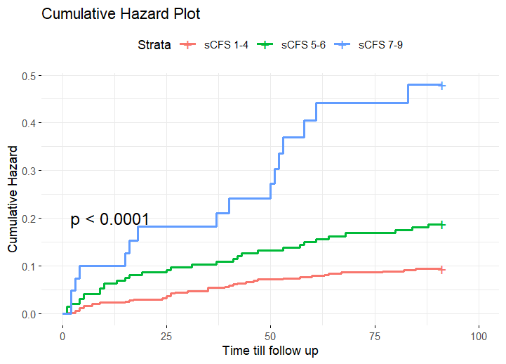

Supplementary Figure S2. ROC Curve Analysis for 90-Day Mortality. Model A illustrates the comparison of the Area Under the Curve (AUC) with 95% Confidence Intervals (CI) between the sCFS and sCFS-METTS models, with a statistically significant difference (P = 0.015, assessed using DeLong’s test). Model B demonstrates the comparison of the AUC with 95% CI between the METTS and sCFS-METTS models, also showing a statistically significant difference (P = 0.0322, assessed using DeLong’s test). This figure highlights the predictive performance of the combined sCFS-METTS model relative to the individual models.

Model A | Model B
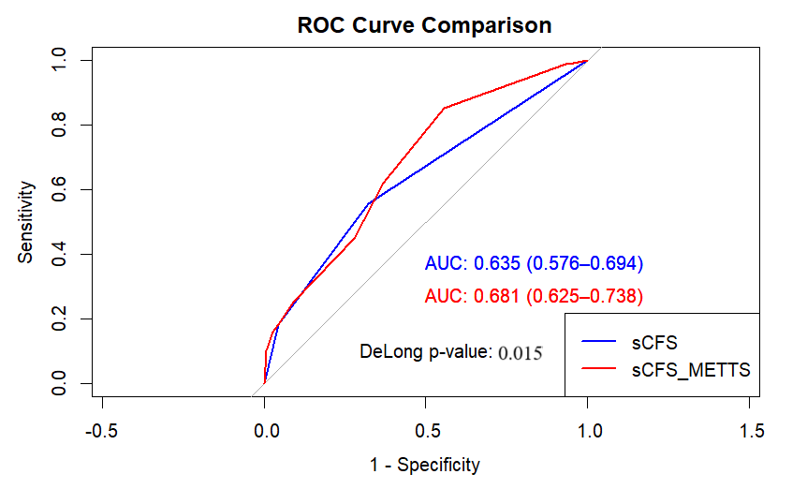 | 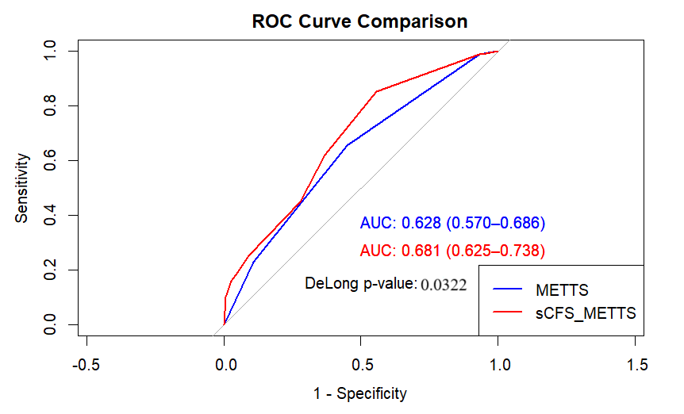

Supplementary Figure S3. Forest plot of OR for variables associated with Hospitalization corresponding to Model B and C of Table 7. This forest plot presents the OR (blue boxes), corresponding to 95% CI (horizontal blue line), for the association of selected variables with 90-day mortality, where the red vertical line corresponds to an OR of 1. Model A shows the variables adjusted without METTS. Model B shows the variables adjusted with METTS.

Model A | Model B
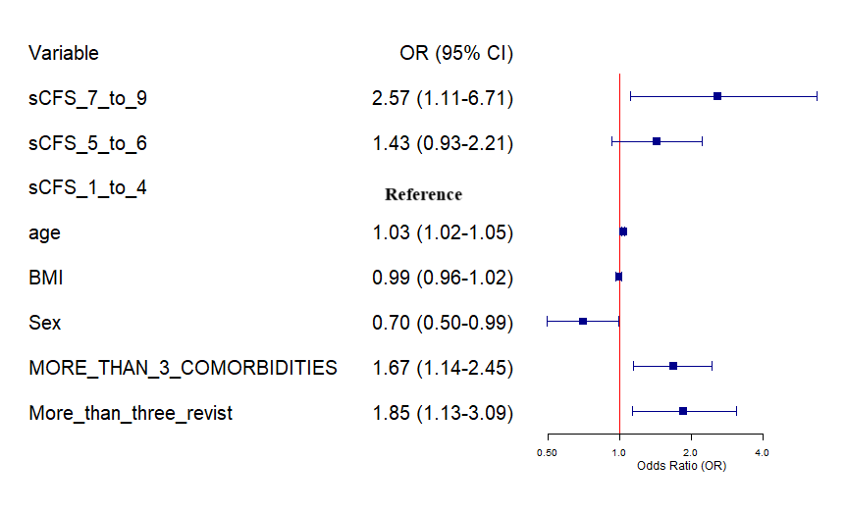 | 