Supplementary file 2: Supplementary Figures
Western Hunter-Gatherer genetic ancestry contributes to human longevity in the Italian population
Stefania Sarno*, Vincenzo Iannuzzi*, Marco Sazzini, Chiara Pirazzini, Maria Giulia Bacalini, Davide Gentilini, Giuseppe Passarino, Daniela Mari, Daniela Monti, Benedetta Nacmias, Sandro Sorbi, Davide Pettener, Donata Luiselli, Claudio Franceschi, Paolo Garagnani, Cristina Giuliani

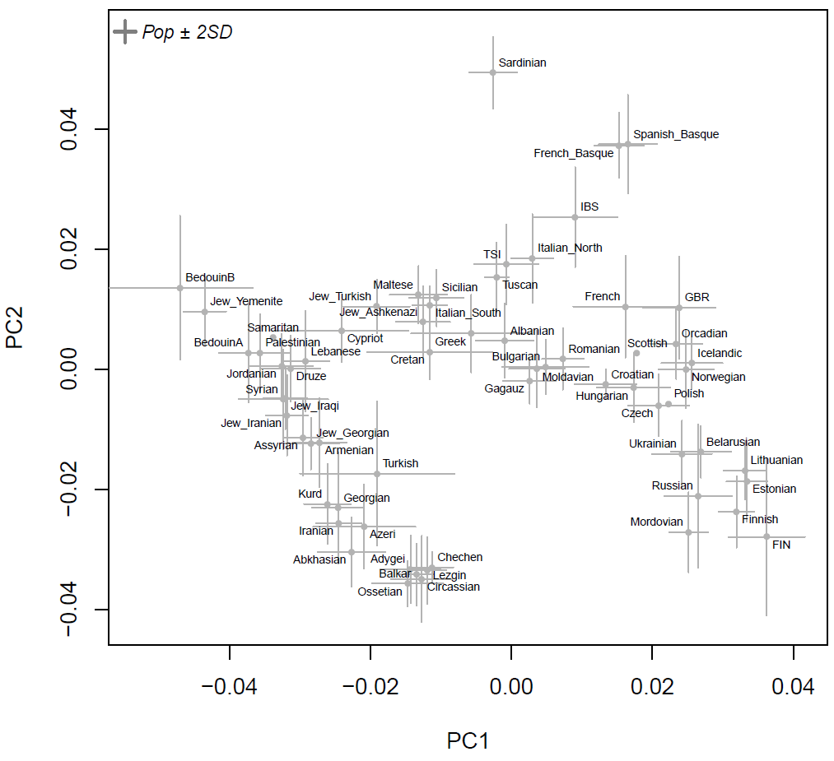
Supplementary Fig. 1. Principal component analysis on the modern Euro-Mediterranean samples extracted from the AADR HO panel that have been used as reference space in the projection analysis. Median coordinates and ± 2 standard deviations are represented for each given population.

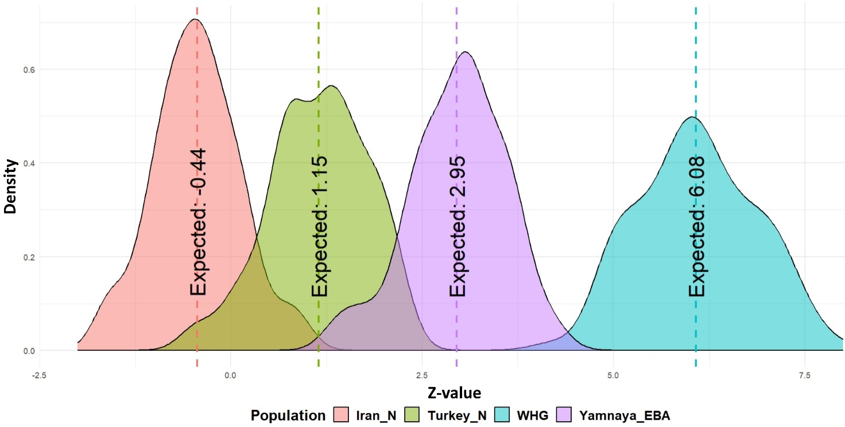
Supplementary Fig. 2. Density probability distributions of Z-values for the four ancestral populations derived from f4-statistics tests across the performed 1,000 iterations. The expected Z-values for each ancestral population are indicated by the vertical dashed lines.

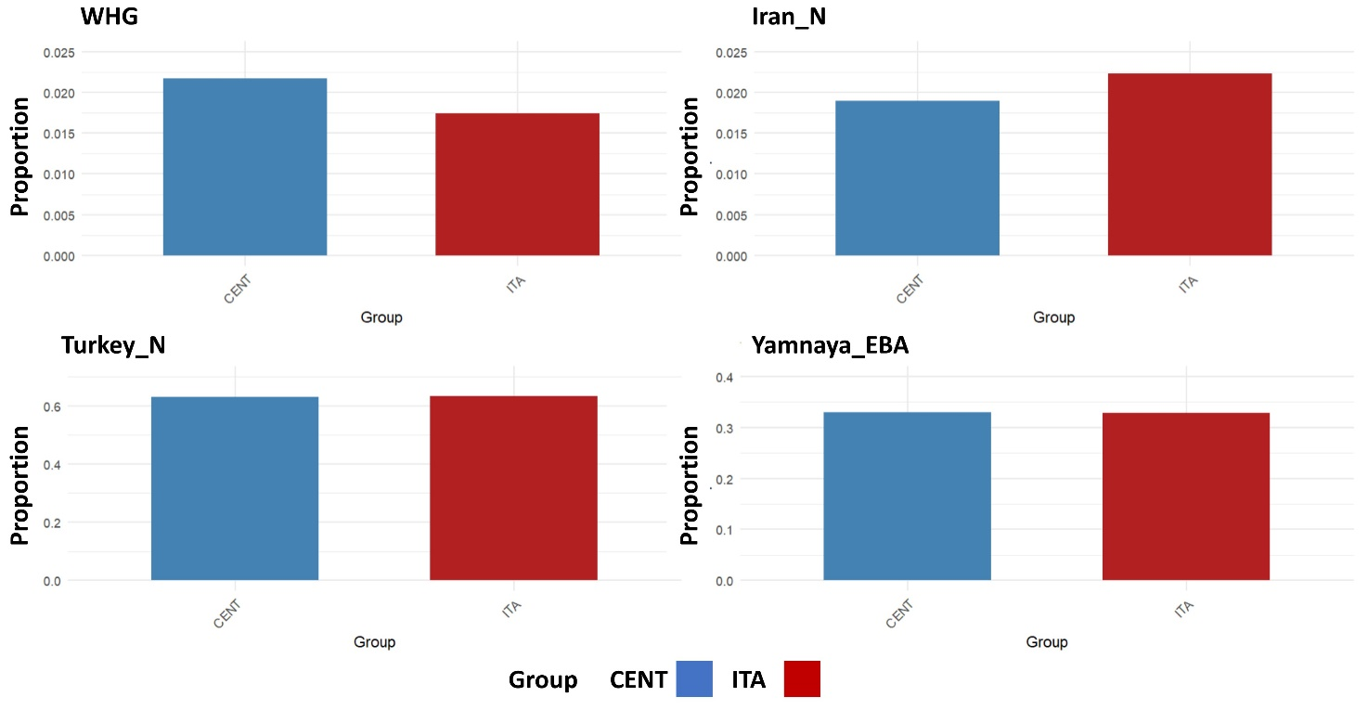
Supplementary Fig. 3. Ancestral component proportions estimated with the supervised ADMXITURE analysis for CENT and ITA using WHG, Turkey_N, Iran_N, and Yamnaya_EBA as parental components.

