Supplemental Information for
Deep neural networks and genome-wide associations reveal the polygenic architecture of local brain aging
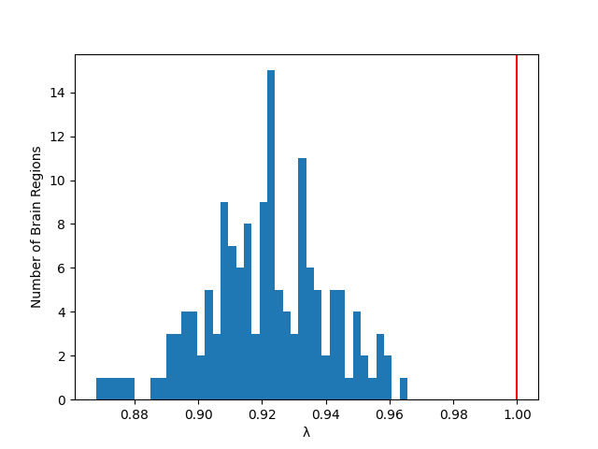
Supplementary Fig. 1 Histogram of genomic inflation factors (λ) across cortical regions. The mean λ was 0.92 (range: 0.87–0.97), indicating slight deflation of test statistics. The x-axis represents λ values and the y-axis represents the number of cortical regions.

