Supplementary Table 1. Posterior Inclusion Probabilities (PIP) of serum trace elements derived by the BKMR Model
TE | PIP*
Cu | 0.327
Fe | 0.272
I | 0.296
Mn | 0.268
Se | 0.348
Zn | 0.306
*PIP values indicate the relative importance of the variables.

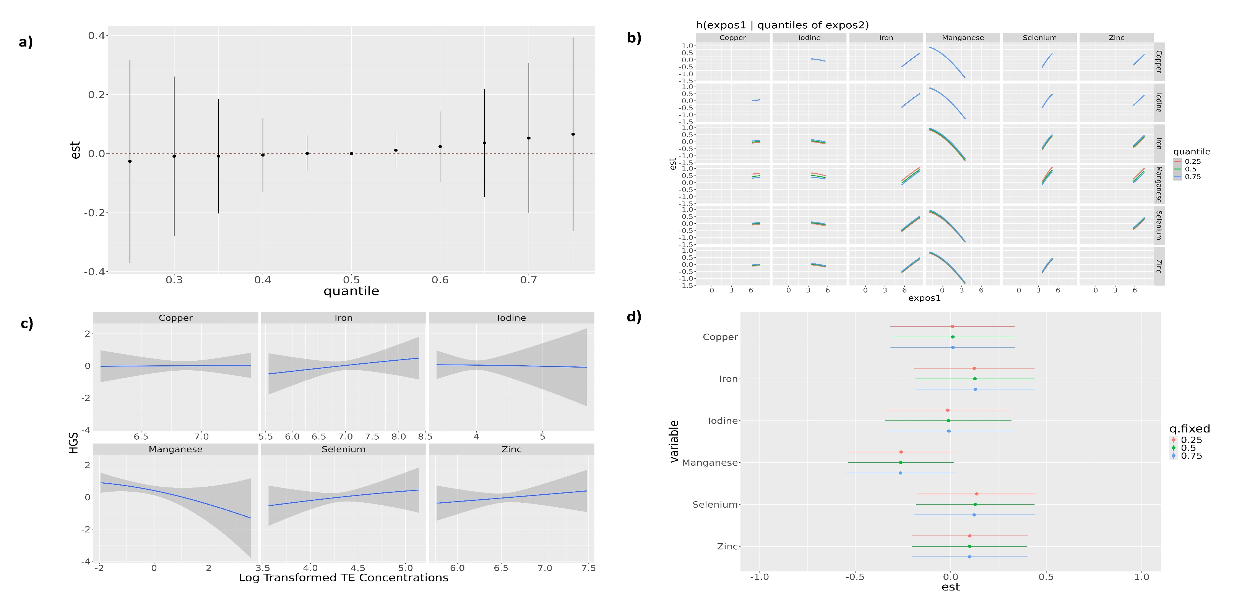
Supplementary Figure 1. Associations between serum trace elements and handgrip strength estimated by BKMR method

Models were adjusted for age, sex, educational attainment, BMI, fat free mass, smoking status, physical activity, alcohol intake, vitamin and mineral supplement use, prevalent CVD, prevalent hypertension, prevalent dyslipidemia, antihypertensive treatment and lipid-lowering treatment. a) Joint effects of TE mixture on handgrip strength at increasing percentiles compared to medians b) Bivariate exposure-response functions for each TE among six TE at varying levels (10th, 50th, 90th) of another TE, when other TE are set at their median c) Univariate exposure-response function between individual TE with handgrip strength with other TE fixed at the corresponding 50th percentiles d) Single-exposure effect of individual TE for an IQR increase on handgrip strength when other metals are fixed at their 25th, 50th, or 75th percentiles

