Supplementary Materials

Estimating the expected faces at each age
All configurations of quasi landmarks were standardized for rotation, translation and size by generalized Procrustes analysis. The dimensionality was reduced by principal components analysis, and the first 64 PCs explaining the first 96% of variation were retained. As in previous studies [1,2], the (principal component scores representing) the expected face for a given age and sex were estimated by fitting a weighted partial least-squares regression of the PC scores onto age and then evaluating the regression at the target age. All participants of the non-target sex were excluded and those of the target sex were assigned a weight according to a Gaussian weighting function centered on the target age. The result is that participants close to the target age are given more influence than those further away, and the age span of included participants is controlled by the bandwidth (standard deviation) of the Gaussian weighting function. Note that to reduce the computational burden, participants whose age was greater than 3 SDs from the target age were simply excluded as their weights were effectively zero and removing them would have a negligible effect.

Tuning the bandwidth of the weighting function is a tradeoff between over and under fitting. If the bandwidth is too small, then the expected face represents closely the data used to train it but does not generalize to the broader population. If the bandwidth is too large then the fitted kernel regression tends towards a linear regression and non-linear aspects of ageing may be overlooked. Both over and under-fitting should be evidenced in the out of sample error, i.e the distance between samples held out of training and their age and sex specific expected faces. The optimal bandwidth should be the one that in general minimizes the out of sample error. The uneven age distribution (Supplementary Figure 2, top row) presents a challenge for tuning this bandwidth; it is unlikely that a single bandwidth will be appropriate for all ages. Therefore, we adopt an approach that in difference to Matthews et al. 2018 [2] allows the bandwidth to vary as a function of the target age, but in difference to Matthews et al 2021 [1], focuses on the generalizability of the expected face only. To accomplish this, each observation was held out of the training set and their age and sex appropriate expected face was estimated for bandwidths ranging from 1-40 years in steps of one year. To measure their distances to the expected faces (their error) we used the Mahalanobis distance. To combine information from multiple participants, adjusting for the fact that some faces are simply more unusual (more distant from the expected face, regardless of bandwidth) the errors for each participant were centered on their mean value across the 40 bandwidths.

To model how this (mean-centered) out of sample error changes as a function of age and bandwidth the error of each participant at each bandwidth was treated as a separate data point and scattered as a function of age and a surface was fitted to the scattered data using a linear radial basis function interpolant (Supplementary Figure 2, second row). The variation in this surface is also plotted as an elevation map in (Supplementary Figure 2, third row). The minimum value of this curve at each age (red dotted line), indicating that the value of the bandwidth that gives the minimum error in general, was used as an initial estimate of the optimal bandwidth. Note that to reduce the computational burden of fitting a radial basis function interpolant with many nodes, only a randomly chose subsample of the participants were used in this estimation. Where the number of participants of a given age and sex in a 2.1-year age bracket exceeded 50, only 50 randomly chosen participants were included. Running this multiple times with multiple random selections had effectively no impact on the estimated bandwidth.

In general the optimal bandwidths defined in this way (Supplementary Figure 2, third row, dotted red line) follows a sensible and expected pattern; for ages where there is less data available the bandwidth is expanded to compensate. At some ages (e.g. during childhood and adolescence and at ages over 65) the choice of bandwidth has a relatively large effect, and the curve has a clear minimum. At other ages such as between 20 to 50 in females the choice of bandwidth has little effect and the minimum is not so clear, which can be seen from the minimal variation in the color-plot.

As noted in Matthews et al. 2018 using different bandwidths for males and females can introduce spurious differences between the estimated male and female trajectories [2]. To overcome this and to define a good compromise between the two estimates they were combined into a weighted average (Supplementary Figure 2, third row, solid green line). For ages where the bandwidth for one sex has a clear minimum and the other does not, more weight was given to the one with the clear minimum. This was done by weighting the average of the two curves according to the estimated precision of the bandwidth for that age and sex. This precision was simply estimated as the range of values of the interpolated surface at that age and sex (Supplementary Figure 1, third row).

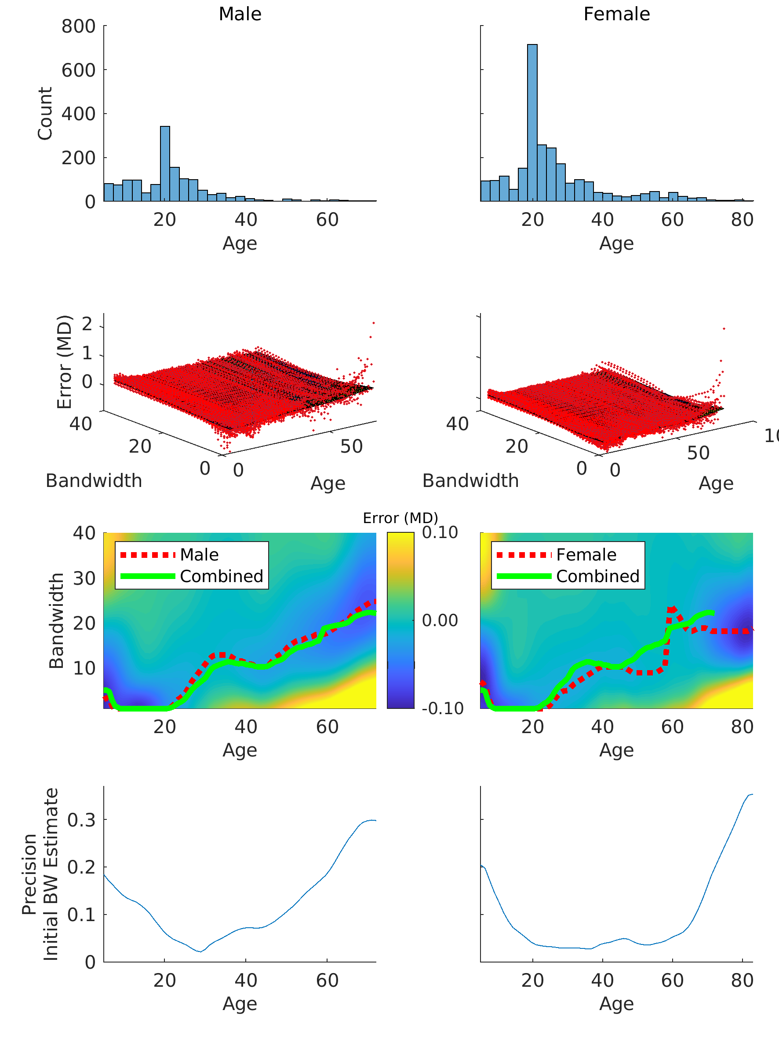
Supplementary Figure 1. Top row shows the age distributions of the participants used in this study. Second row shows the surfaces fitted to scattered out of sample error values of participants as a function of their age and the bandwidth used. This surface models how out of sample errors changes as a function of age and bandwidth. The third row shows elevation maps of the same surface. Dotted red lines indicate the initial estimates of the optimal bandwidths (the minimum value of the fitted surface for each age). Solid green lines show the final estimate combining the curves of both males and females. This curve is the same in both columns. The bottom row shows the estimated precision of the initial estimates of the optimal bandwidths per age.

Supplementary Figure 2 illustrates the relationship between bandwidth (the "width" of the kernel function) and age for both males and females. The varying bandwidth has an impact on the composition of the data used in the local linear regression. Larger bandwidths result in a smoother estimate, essentially linearizing the aging trajectory. In extreme cases, with an infinite bandwidth, the aging trajectory would become perfectly linear, and the incremental changes between each pair of expected faces would be equal.

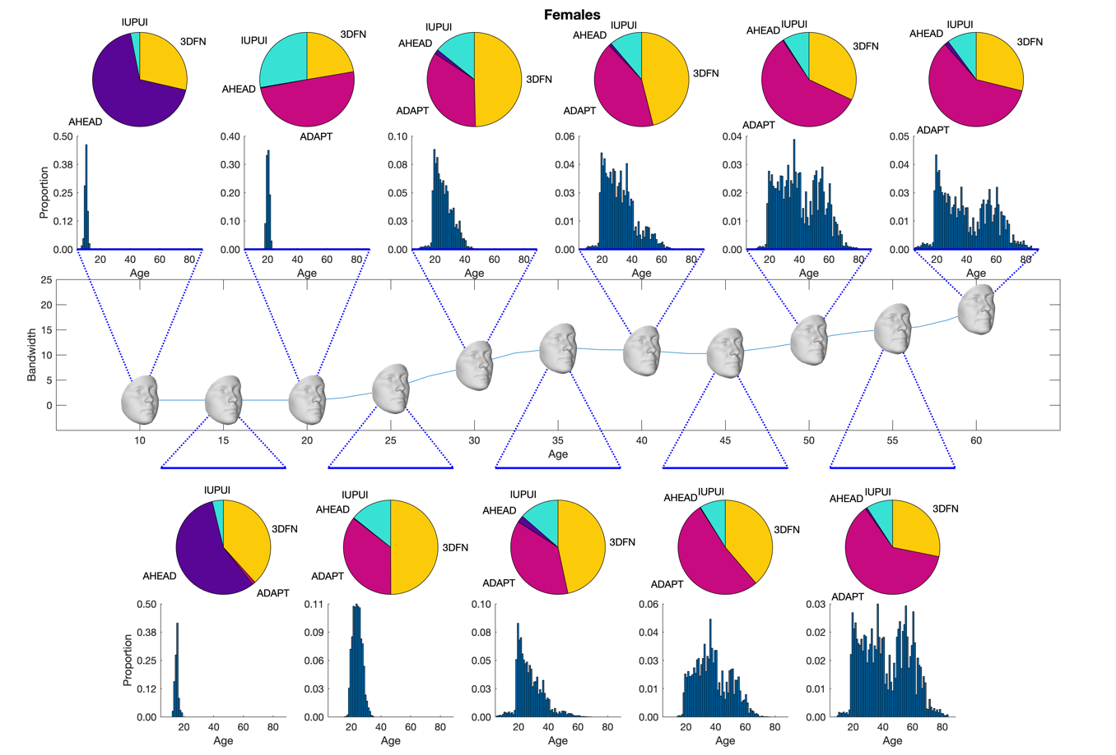
Supplementary Figure 2. Bandwidth as a function of age for females (top) and males (bottom). The middle panel in each part plots the bandwidth used to generate the weights for the local linear regression used to generate the expected face for each age. Zoomed out plots show the effective training sample for each expected face. Pie charts plot the weighted sums of samples from each data source. Histograms plot the weighted proportion of subjects from each age. For example, the expected face at age 15 for both sexes uses a narrow bandwidth of one year. As such the effective training sample is narrow in terms of age as seen in the histogram and comes primarily from the AHEAD data source, as the AHEAD collection has the largest proportion of participants under 18 years of age.

References
[1] Matthews HS, Palmer RL, Baynam GS, Quarrell OW, Klein OD, Spritz RA, et al. Large-scale open-source three-dimensional growth curves for clinical facial assessment and objective description of facial dysmorphism. Sci Rep. 2021;11(1):12175. https://doi.org/10.1038/s41598-021-91465-z

[2] Matthews HS, Penington AJ, Hardiman R, Fan Y, Clement JG, Kilpatrick NM, et al. Modelling 3D craniofacial growth trajectories for population comparison and classification illustrated using sex-differences. Sci Rep. 2018;8(1):4771. https://doi.org/10.1038/s41598-018-22752-5

