Supplementary Material

Supplementary Table S1 — Group-level summaries and study-specific effects (index outcomes).
Study | N (tACS) | Mean (tACS) | SD (tACS) | N (control) | Mean (control) | SD (control) | Outcome | Test | Hedge’s g | v_{g}
Borghini et al. (2018)  (Experiment 2) | 25 | 0.84 | SE 0.03  SD 0.15 | 25 | 0.59 | SE 0.05  SD 0.25 | Working  Memory | Retro-cue Working Memory Test performance | 1.11 | 0.06
Reinhart and Nguyen (2019)  (Experiment 2) | 28 | 86.71 | 6.58 | 28 | 80.38 | 9.97 | Working  Memory | Visual task detection task performance | 0.70 | 0.04
Klink et al. (2020) | 28 | 27.40 | 1.66 | 28 | 27.26 | 2.41 | Associative  Memory | Face-occupation Encoding Task performance | 0.06 | 0.26
Kehler et al. (2020) | 11 | 103.3 | 45.4 | 6 | 128.8 | 56.6 | Working  Memory | Wechsler Memory Scale (WMS-IV) | 0.49 | 0.09
Krebs et al. (2021) | 20 | 7.0 | 3.03 | 22 | 6.0 | 3.03 | Episodic  Memory | Vienna Test System - Delayed Recall | 0.32 | 0.06
Benussi et al. (2021) | 20 | 19.4 | 6.8 | 20 | 25.1 | 8.7 | Episodic  Memory | RAVLT | 0.69 | 0.06
Kim et al. (2021) | 20 | 55.5 | 17.1 | 20 | 66.5 | 13.1 | Executive  Functions | TMT | 0.68 | 0.02
Zanto (2021) | NP | NP | NP | NP | NP | NP | Executive  Functions | NeuroRacer performance | - | -
Benussi et al. (2022) | 60 | 25.6 | 8.4 | 60 | 18.7 | 6.3 | Episodic  Memory | RAVLT | 0.89 | 0.05
Draaisma et al. (2022) | 20 | NP | NP | NP | NP | NP | Working  Memory | N-back task | 0.48 | 0.12
Grover et al. (2022)  (Experiment 1) | 20 | 77.5 | 15.347 | 20 | 51.5 | 19.7 | Episodic  Memory | Recall task | 1.44 | 0.28
Varastegan (2022) | 8 | 11.75 | 1.58 | 8 | 9.13 | 2.94 | Episodic  Memory | RAVLT | 1.04 | 0.05
Jones et al. (2022) | 20 | NP | NP | 20 | NP | NP | Executive  Functions | Reaction time on NeuroRacer Game | 0.66 | 0.14
Jones et al. (2023) | 14 | 436.43 | 73.36 | 13 | 416.48 | 59.51 | Sustained  Attention | Performance on cognitive control, sustained attention and working memory tasks | 0.28 | 0.08
Zhou (2023) | 23 | 23.53 | SE 1.51  SD 7.24 | 27 | 29.14 | SE 2.19  SD 11.38 | Global  Cognition | MMSE | 0.56 | 0.11
Diedrich et al. (2024a) | 17 | 544.87 | 193.17 | 18 | 546.63 | 181.94 | Non-declarative learning | Alternating Serial Reaction Time (ASRT) task | 0.01 | 0.12
Diedrich et al. (2024b) | 41 | NP | NP | 44 | NP | NP | Working  Memory | N-back task | 3.88 | 0.04
Pupíková et al. (2024)  Exp. 1 (MUNI)  and  Exp. 2 (EPFL) | 19  20 | NP | NP | 19  20 | NP | NP | Working  Memory | N-back task | 0.28  0.39 | 0.04  0.04
Tang et al. (2024) | 23 | 22.43 | NP | 23 | 20.82 | NP | Global Cognition | MMSE | 0.22 | 0.08
Cid-Fernández et al. (2024) | 15 | 0.42 | 0.57 | 12 | -.013 | 0.66 | Attention | d’ - Oddball Task | 0.87 | 0.16
Uehara et al. (2025) | 21 | Δ1.85 | NP | 21 | Δ1.14 | NP | Global Cognition | ADAS-Cog | 0.10 | 0.09
Park et al. (2025) | 15 | Δ14.5 | NP | 13 | Δ10.0 | NP | Attention | TMT-A | 0.48 | 0.14
Tab. S1 - For each eligible experiment, the table reports sample size (N), group means and standard deviations (Mean, SD) for tACS and control/sham, the study-specific standardized mean difference (Hedges’ g, positive favors tACS), and its sampling variance (v_g). Statistics were taken as reported or, when unavailable, reconstructed using a prespecified hierarchy: (i) conversion from CIs/SEs/test statistics; (ii) estimation from medians and quantiles (IQR/range, including boxplots); and (iii) digitization from published figures. Where both SE and SD were provided, both are shown and SD was used in computations. Multi-experiment articles are listed by experiment. Parallel-group effects used post-intervention means/SDs (or change scores when required); crossover/paired designs used dependency-adjusted SMDs with imputed within-subject correlations. A dash indicates effects not estimable due to insufficient reporting (e.g., Zanto, 2021). Abbreviations: NP = not provided; SD = standard deviation; SE = standard error; v_{g} = variance of Hedges’ g.

Supplementary Table S2 - Univariate meta-regressions of candidate moderators (including outlier)
Moderator | k | β | SE | 95% CI | p | QM | p(QM) | τ² | I²
Population | 22 | 0.25 | 0.33 | [-0.40, 0.90] | 0.45 | 0.56 | 0.45 | 0.51 | 88.6%
On/Offline Effect | 22 | 0.46 | 0.33 | [-0.19, 1.11] | 0.16 | 1.93 | 0.16 | 0.48 | 87.9%
Computational Modeling | 22 | 0.47 | 0.32 | [-0.17, 1.10] | 0.15 | 2.10 | 0.15 | 0.47 | 87.7%
Frequency (Theta=1) | 22 | 0.33 | 0.33 | [-0.32, 0.99] | 0.32 | 0.99 | 0.32 | 0.50 | 88.4%
Tuned Frequency | 22 | -0.29 | 0.42 | [-1.11, 0.52] | 0.48 | 0.49 | 0.48 | 0.51 | 88.6%
Suppl. Tab. S2 - Mixed-effects (random-effects) meta-regressions fitted with REML using Hedges’ g as the effect size and its sampling variance (vg). Each row reports the coefficient for a single moderator (0/1 coding): Population (1=Healthy, 0=Clinical); Outcome timing (1=Online, 0=Offline); Computational modeling (1=Yes, 0=No); Frequency band (1=Theta, 0=non-Theta); Tuned frequency (1=Yes, 0=No). Columns: β (SE), 95% CI, p (two-sided), omnibus test of moderators QM (df=1) with p(QM), residual heterogeneity τ² and I², and k (studies; here k=22 across models). The intercept corresponds to the reference level (coded 0); β represents the mean difference for level 1 vs 0. Models include the statistical outlier study (Diedrich et al., 2024b). Abbreviations: CI, confidence interval; SE, standard error.
Supplementary Table S3 - Univariate meta-regressions of candidate moderators (excluding outlier)
Moderator | k | β | SE | 95% CI | p | QM | p(QM) | τ² | I²
Population | 21 | -0.06 | 0.16 | [-0.38, 0.25] | 0.68 | 0.17 | 0.68 | 0.06 | 47.7%
On/Offline Effect | 21 | 0.01 | 0.16 | [-0.31, 0.34] | 0.92 | 0.01 | 0.92 | 0.06 | 49.6%
Computational Modeling | 21 | 0.16 | 0.16 | [-0.15, 0.46] | 0.31 | 1.04 | 0.31 | 0.05 | 45.2%
Frequency (Theta=1) | 21 | 0.02 | 0.16 | [-0.30, 0.34] | 0.92 | 0.01 | 0.92 | 0.06 | 49.4%
Tuned Frequency | 21 | -0.11 | 0.18 | [-0.47, 0.25] | 0.55 | 0.36 | 0.55 | 0.06 | 48.4%
Suppl. Tab. S3 - Identical specification as Suppl. Tab. S2, but excluding the statistical outlier (Diedrich et al., 2024b). Moderator coding and columns are the same: β (SE), 95% CI, p (two-sided), QM and p(QM), τ², I², and k (here k=21 across models). The intercept reflects the reference level (coded 0), and β is the contrast for level 1 vs 0. Abbreviations: CI, confidence interval; SE, standard error.

Supplementary Figure 1 — Funnel plots assessing publication bias.
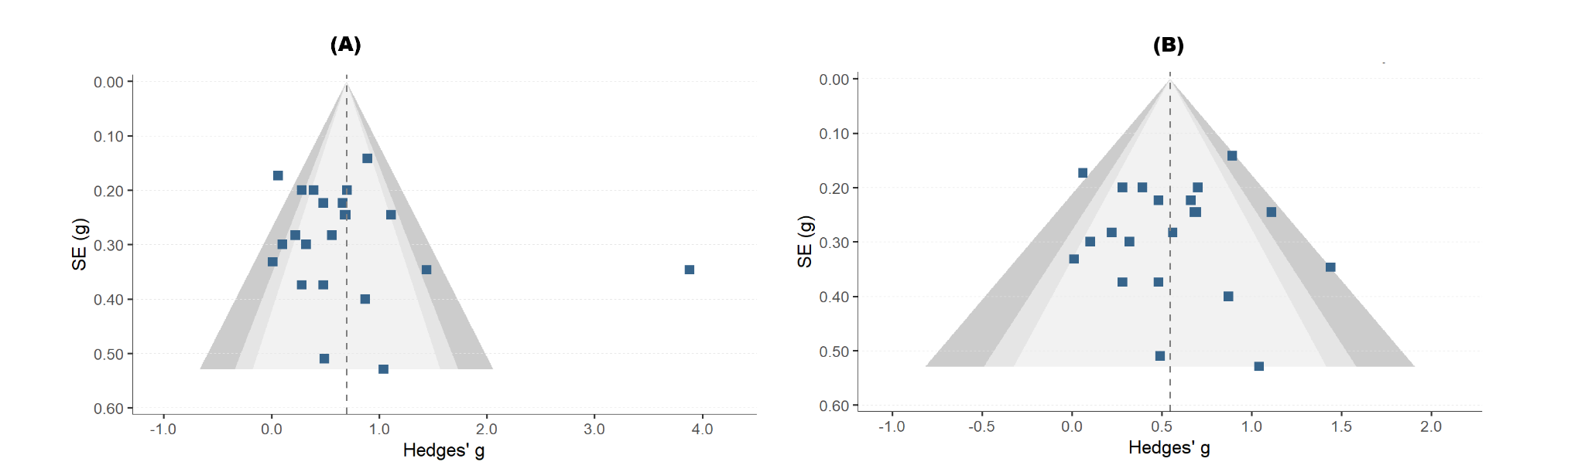
Suppl. Fig. 1 - (A) Funnel plot including all studies, with one identified outlier. (B) Funnel plot after exclusion of the outlier study. Each square represents an individual study plotted as Hedges’ g against its standard error. Shaded areas indicate significance contours at 90%, 95%, and 99%. The dashed vertical line represents the pooled effect estimate.

Supplementary Table S5. Additional sensitivity analyses of the pooled cognitive effects of tACS in older adults
Analysis | k | Hedges’ g | SE | 95% CI | Q | p(Q) | τ² | I² (%)
All studies | 22 | 0.70 | 0.17 | [0.35, 1.04] | 128.65 | <0.0001 | 0.50 | 88.5
Without outlier | 21 | 0.55 | 0.08 | [0.39, 0.71] | 38.50 | 0.0077 | 0.06 | 47.1
Without extreme-current study | 21 | 0.72 | 0.17 | [0.36, 1.08] | 126.47 | <0.0001 | 0.52 | 89.0
Randomized only | 18 | 0.70 | 0.20 | [0.27, 1.13] | 124.15 | <0.0001 | 0.63 | 90.8
Excluding high-bias studies | 21 | 0.71 | 0.17 | [0.34, 1.07] | 128.57 | <0.0001 | 0.52 | 89.3
Low-bias only | 11 | 0.80 | 0.33 | [0.07, 1.53] | 104.29 | <0.0001 | 1.06 | 93.3
Excluding graphically reconstructed studies | 20 | 0.74 | 0.18 | [0.36, 1.12] | 116.44 | <0.0001 | 0.54 | 88.8
Low-bias only without outlier | 10 | 0.52 | 0.13 | [0.23, 0.82] | 19.69 | 0.0199 | 0.08 | 53.0
Randomized only without outlier | 17 | 0.51 | 0.09 | [0.32, 0.69] | 32.56 | 0.0084 | 0.06 | 48.5
Strict combined model | 14 | 0.57 | 0.10 | [0.37, 0.78] | 23.00 | 0.0417 | 0.05 | 41.6
Suppl. Table S5. Random-effects meta-analytic sensitivity analyses examining the robustness of the pooled effect of tACS on cognition in older adults. The table presents the number of included studies/experiments (k), pooled standardized mean difference (Hedges’ g), standard error (SE), 95% confidence interval (CI), heterogeneity statistics (Q, τ², I²), and p-values for each analytic subset. Sensitivity analyses included exclusion of the influential outlier, exclusion of the extreme-current study, restriction to truly randomized studies, exclusion of high-risk studies, restriction to low-risk studies, exclusion of graphically reconstructed data, and more conservative combined subsets. Positive values indicate better cognitive performance with active tACS.

Supplementary Table S6. Sensitivity of pooled effects to the assumed within-subject correlation in crossover studies
Analysis | Assumed r | k | Hedges’ g | SE | 95% CI | p-value | τ² | I² (%)
All studies | 0.3 | 22 | 0.67 | 0.166 | [0.36, 1.01] | 0.0006 | 0.491 | 86.9
Without outlier | 0.3 | 21 | 0.51 | 0.070 | [0.36, 0.65] | 0.0000005 | 0.023 | 24.2
All studies | 0.5 | 22 | 0.70 | 0.166 | [0.35, 1.04] | 0.0004 | 0.495 | 88.2
Without outlier | 0.5 | 21 | 0.55 | 0.077 | [0.39, 0.71] | 0.0000007 | 0.054 | 45.3
All studies | 0.7 | 22 | 0.75 | 0.169 | [0.40, 1.10] | 0.0002 | 0.518 | 90.4
Without outlier | 0.7 | 21 | 0.61 | 0.090 | [0.43, 0.80] | 0.000001 | 0.113 | 67.7
Suppl. Table S6. Sensitivity analyses examining the impact of different assumed within-subject correlations (r = 0.3, 0.5, and 0.7) on the pooled cognitive effects of tACS in older adults. For each value of r, effect sizes and sampling variances were recalculated for crossover studies with sufficient arm-level data, while estimates from crossover studies lacking the required summary statistics were retained unchanged across scenarios. Random-effects meta-analyses were then repeated for the full dataset and for the outlier-excluded dataset. Positive values indicate better cognitive performance with active tACS.
Sensitivity analyses varying the assumed within-subject correlation (r = 0.3, 0.5, and 0.7) were conducted for crossover studies with sufficient arm-level data to recalculate effect sizes and sampling variances. For Draaisma et al. (2022), Pupikova et al. (2024, Experiments 1 and 2), and Uehara et al. (2025), the published reports did not provide the arm-level summary statistics required for recalculation; therefore, the originally extracted effect sizes were retained unchanged across r scenarios.

Supplementary Figure S2. Forest plot of the randomized-only sensitivity analysis excluding the influential outlier
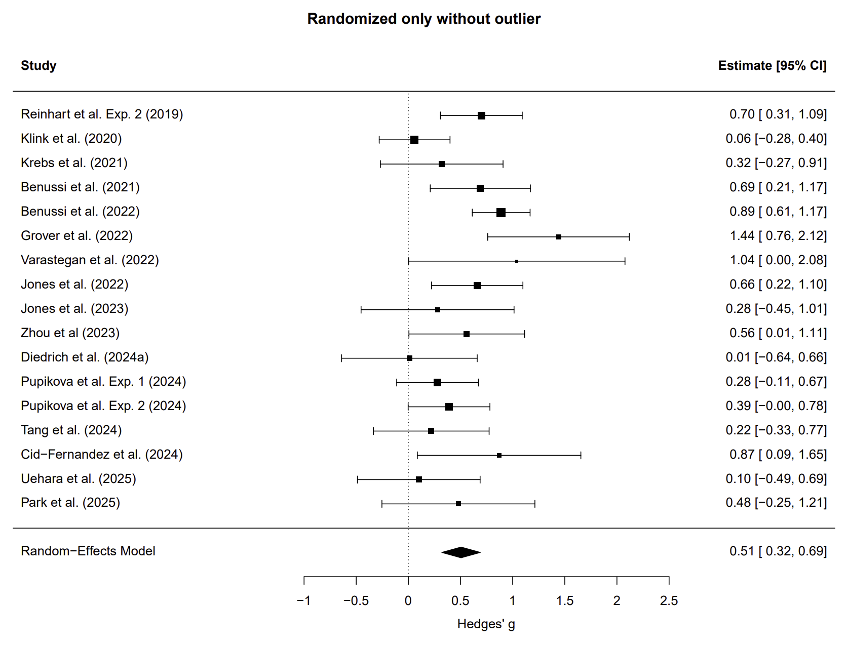
Suppl. Fig. S2. Random-effects meta-analysis restricted to truly randomized studies after exclusion of the influential outlier study (Diedrich et al., 2024b). Squares represent study-specific standardized mean differences (Hedges’ g) and horizontal lines their 95% confidence intervals (CI). The dashed vertical line marks the null effect (g = 0). The pooled effect remained significant (g = 0.51, 95% CI 0.32–0.69; k = 17), with moderate residual heterogeneity (I² = 48.5%, τ² = 0.058), indicating that the positive cognitive signal persisted under a more conservative design-restricted specification.

Supplementary Figure S3. Forest plot of the low-bias sensitivity analysis excluding the influential outlier
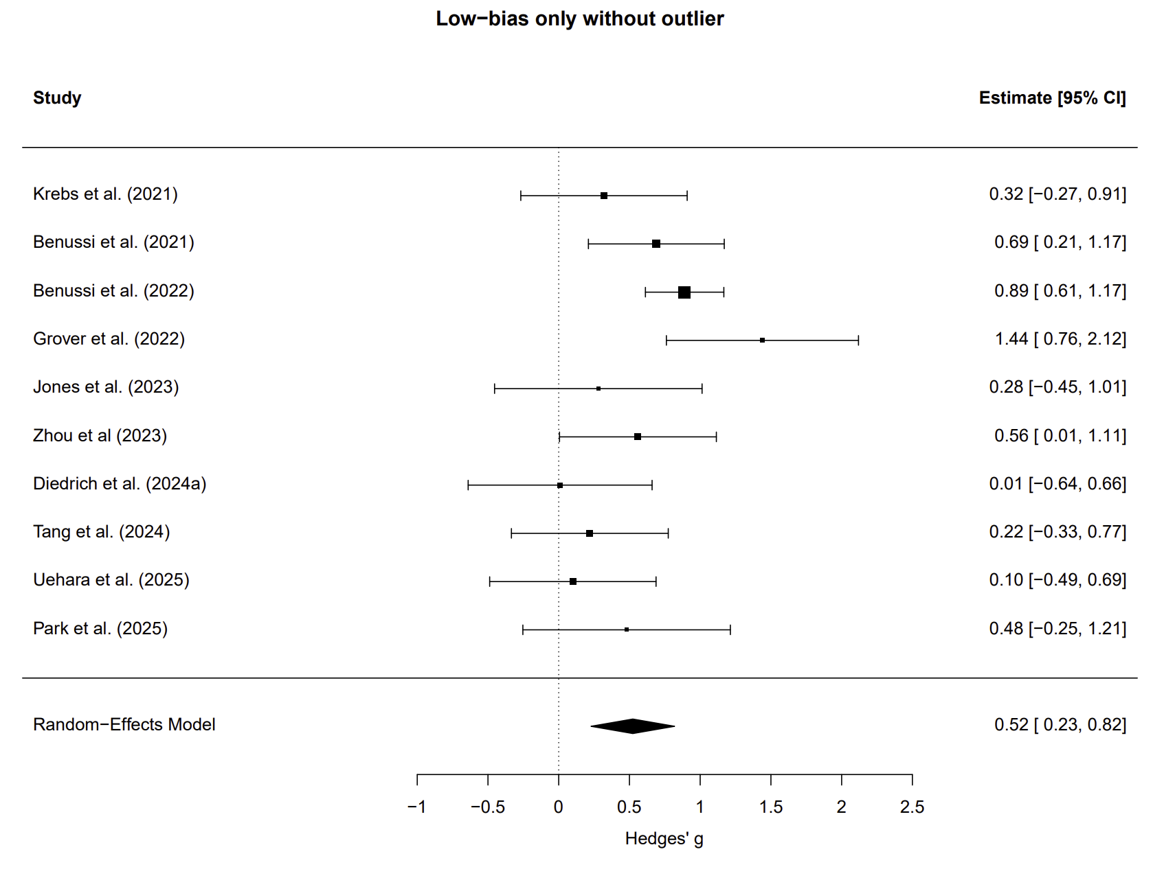
Suppl. Fig. S3. Random-effects meta-analysis restricted to studies classified as lower risk of bias after exclusion of the influential outlier study (Diedrich et al., 2024b). Squares represent study-specific Hedges’ g values and horizontal lines their 95% confidence intervals (CI). The dashed vertical line marks the null effect (g = 0). Under this more conservative specification, the pooled estimate remained significant (g = 0.52, 95% CI 0.23–0.82; k = 10), with moderate heterogeneity (I² = 53.0%, τ² = 0.084).

Supplementary Figure S4. Forest plot of the strict combined sensitivity model
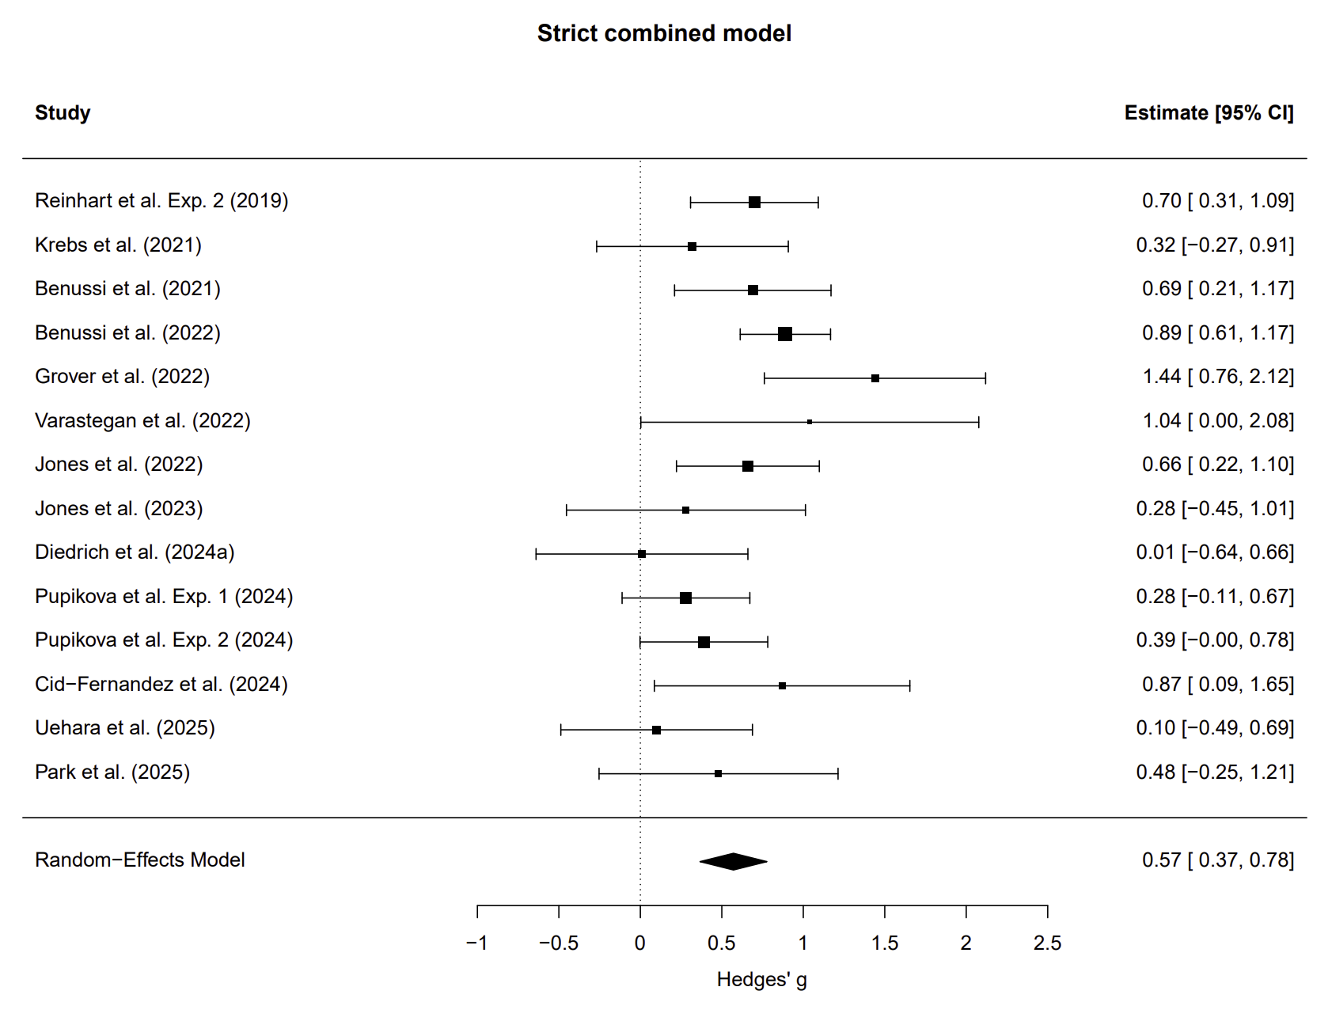
Suppl. Fig. S4. Random-effects meta-analysis under a strict combined sensitivity specification excluding the influential outlier, the extreme-current study, high-risk studies, and studies with graphically reconstructed data, while restricting the sample to truly randomized studies. Squares represent study-specific Hedges’ g values and horizontal lines their 95% confidence intervals (CI). The dashed vertical line indicates the null effect (g = 0). The pooled estimate remained significant (g = 0.57, 95% CI 0.37–0.78; k = 14), with moderate heterogeneity (I² = 41.6%, τ² = 0.046), supporting the robustness of the main finding under a substantially more conservative analytic framework.

Detailed Search Strategies for Each Database
1. PubMed/MEDLINE Search Strategy
("transcranial alternating current stimulation"[Title/Abstract] OR tACS[Title/Abstract] OR "transcranial AC stimulation"[Title/Abstract] OR "alternating current stimulation"[Title/Abstract]) AND ("Cognition"[Mesh] OR cognition[Title/Abstract] OR "cognitive function"[Title/Abstract] OR memory[Title/Abstract] OR "executive function"[Title/Abstract] OR attention[Title/Abstract] OR "cognitive enhancement"[Title/Abstract]) AND ("healthy aging"[Title/Abstract] OR "normal aging"[Title/Abstract] OR "Mild Cognitive Impairment"[Mesh] OR "mild cognitive impairment"[Title/Abstract] OR MCI[Title/Abstract] OR "Alzheimer Disease"[Mesh] OR "Alzheimer's disease"[Title/Abstract])

2. Embase Search Strategy
('older adults'/exp OR 'aged'/exp OR 'aged' OR 'aged patient' OR 'aged people' OR 'aged person' OR 'aged subject' OR 'elderly' OR 'elderly patient' OR 'elderly people' OR 'elderly person' OR 'elderly subject' OR 'senior citizen' OR 'senium' OR 'mild cognitive impairment'/exp OR 'alzheimer disease'/exp OR 'alzeimer disease' OR 'alzeimer`s disease' OR 'alzeimers disease' OR 'alzheimer dementia' OR 'alzheimer disease' OR 'alzheimers disease' OR 'alzheimer fibrillary change' OR 'alzheimer fibrillary lesion' OR 'alzheimer neurofibrillary change' OR 'alzheimer neurofibrillary degeneration' OR 'alzheimer neuron degeneration' OR 'alzheimer perusini disease' OR 'alzheimer sclerosis' OR 'alzheimer syndrome' OR 'alzheimer`s disease' OR 'cortical sclerosis, diffuse' OR 'dementia, alzheimer' OR 'diffuse cortical sclerosis' OR 'late onset alzheimer disease') AND ('transcranial alternating current stimulation'/exp OR 'tacs (transcranial alternative current stimulation)' OR 'transcranial alternating current stimulation') AND ('cognition'/exp OR 'cognition' OR 'cognitive accessibility' OR 'cognitive balance' OR 'cognitive dissonance' OR 'cognitive function' OR 'cognitive structure' OR 'cognitive symptoms' OR 'cognitive task' OR 'cognitive thinking' OR 'neurobehavioural manifestations' OR 'volition' OR 'memory'/exp OR 'item recall' OR 'memory' OR 'memory function' OR 'nonspatial memory' OR 'remembering' OR 'reminiscence' OR 'cognitive enhancement'/exp)

3. Cochrane CENTRAL Search Strategy
#1 ("transcranial alternating current stimulation" OR tACS OR "transcranial AC stimulation" OR "alternating current stimulation"):ti,ab,kw
#2 ("Aged" OR elderly OR "older adults" OR seniors OR geriatric OR "older people" OR aging):ti,ab,kw
#3 ("Cognition" OR "cognitive function" OR memory OR "executive function" OR attention OR "cognitive enhancement"):ti,ab,kw
#4 #1 AND #2 AND #3

5. ClinicalTrials.gov Search Strategy
Condition or disease: "Mild Cognitive Impairment" OR "Alzheimer Disease" OR "Cognitive Decline" OR "Healthy Aging"
Intervention: "Transcranial Alternating Current Stimulation" OR "tACS"
Study results: with results

