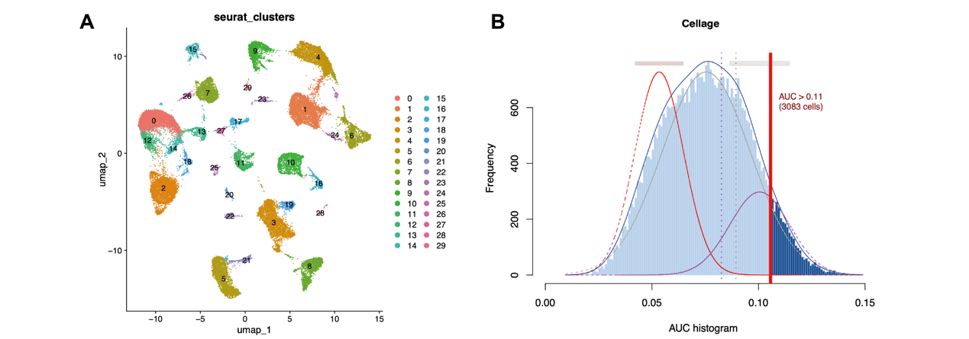
Supplementary Figure S1. Single-cell clustering and assessment of senescence activity in ovarian cancer.
(A) UMAP visualization of ovarian cancer single cells showing 30 unsupervised cellular subclusters. (B) Distribution of AUCell scores for senescence-associated gene activity. The threshold used to classify cells into senescence-active and senescence-silent groups is indicated.

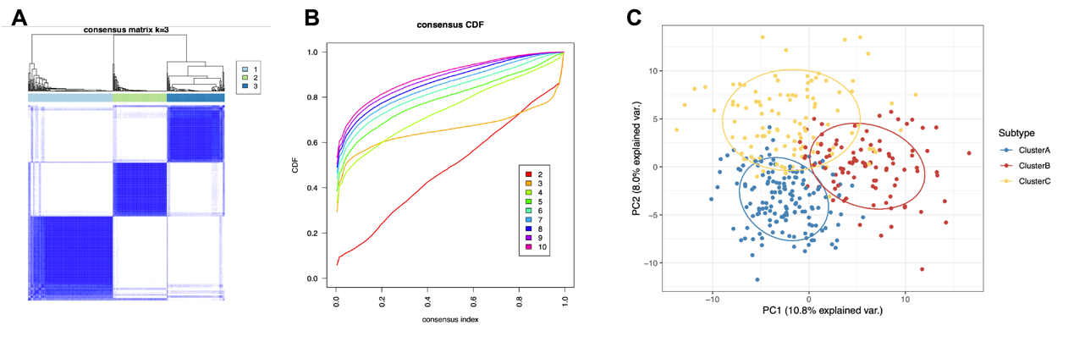
Supplementary Figure S2. Consensus clustering and transcriptomic distribution of SAG-based molecular subtypes.
(A) Consensus matrix heatmap showing the clustering stability of ovarian cancer samples when k = 3. (B) The cumulative distribution function curve is used to evaluate the optimal number of clusters. (C) Principal component analysis showing the transcriptomic distribution of Cluster A, Cluster B, and Cluster C.
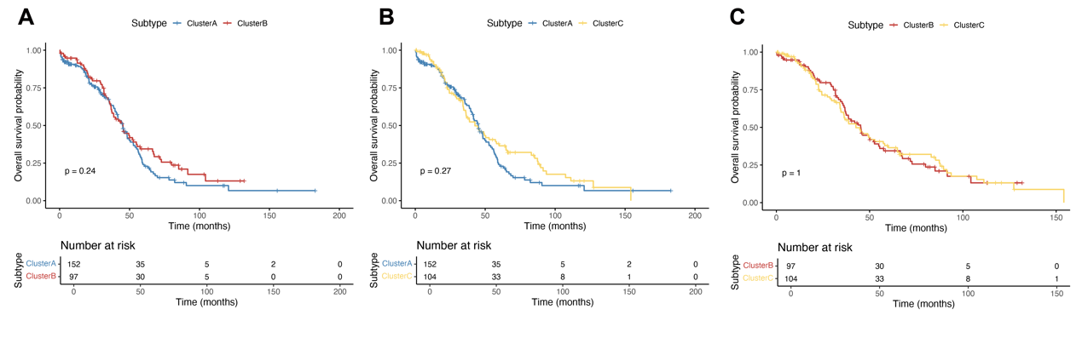
Supplementary Figure S3. Pairwise overall survival comparisons among SAG-based molecular subtypes.
(A) Kaplan–Meier analysis comparing overall survival between Cluster A and Cluster B. (B) Kaplan–Meier analysis comparing overall survival between Cluster A and Cluster C. (C) Kaplan–Meier analysis comparing overall survival between Cluster B and Cluster C. No statistically significant survival difference was observed in the pairwise comparisons, suggesting that SAG-based molecular subtyping mainly reflects biological heterogeneity rather than serving as an independent prognostic classification system.

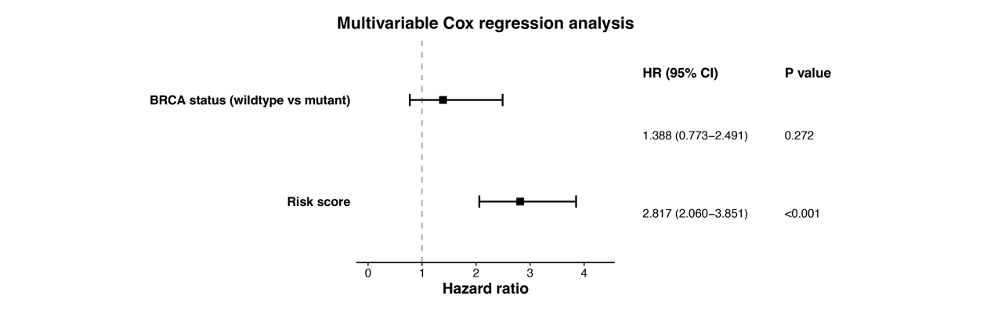
Supplementary Figure S4. Multivariable Cox regression analysis incorporating BRCA1/2 mutation status.
Multivariable Cox regression analysis was performed by incorporating the senescence-associated risk score, age, race, tumor stage, grade, new tumor event status, and BRCA1/2 mutation status. The senescence-associated risk score remained independently associated with overall survival after adjustment for BRCA1/2 mutation status and clinicopathological variables.

