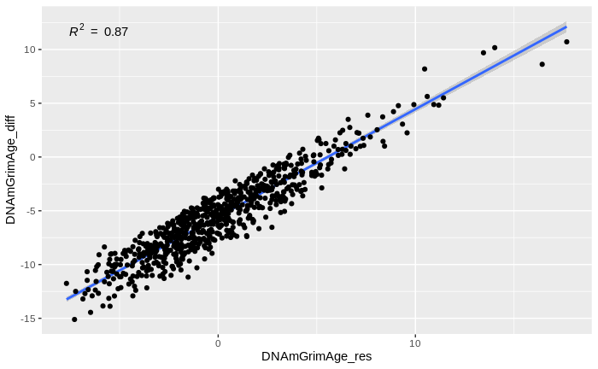
Supplementary Figure 1. Scatterplot of DiffAge (y axis) and DBAge (x axis) in AIBL calculated using the DNAm GrimAge Clock. R = 0.94.

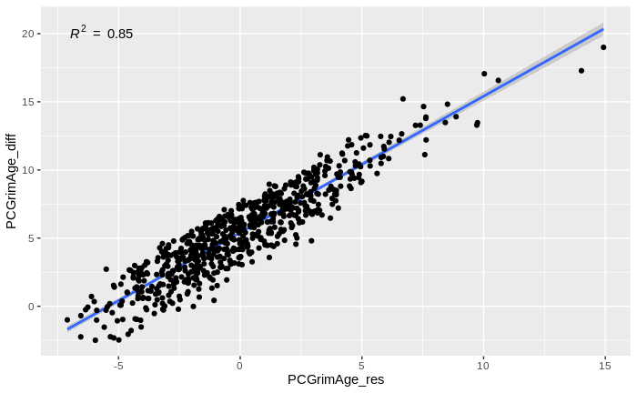
Supplementary Figure 2. Scatterplot of DiffAge (y axis) and DBAge (x axis) in AIBL calculated using the PCGrimAge Clock. R = 0.85.

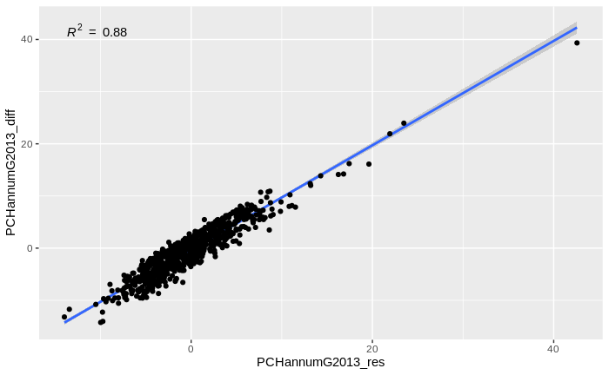
Supplementary Figure 3. Scatterplot of DiffAge (y axis) and DBAge (x axis) in AIBL calculated using the PCHannumG2013 Clock. R = 0.88.

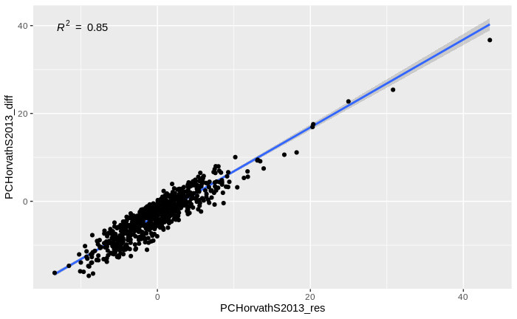
Supplementary Figure 4. Scatterplot of DiffAge (y axis) and DBAge (x axis) in AIBL calculated using the PCHorvathS2013 Clock. R = 0.85.

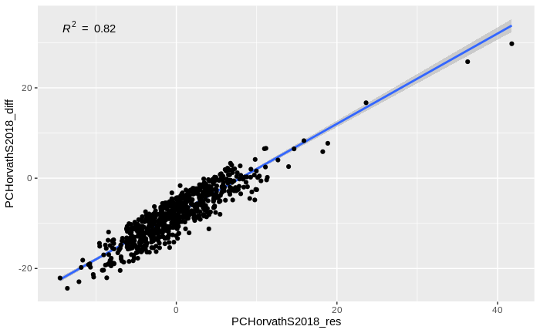
Supplementary Figure 5. Scatterplot of DiffAge (y axis) and DBAge (x axis) in AIBL calculated using the PCHorvathS2018 Clock. R = 0.82.

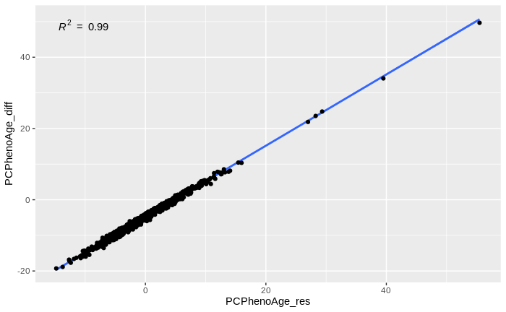
Supplementary Figure 6. Scatterplot of DiffAge (y axis) and DBAge (x axis) in AIBL calculated using the PCPhenoAge Clock. R = 0.99.

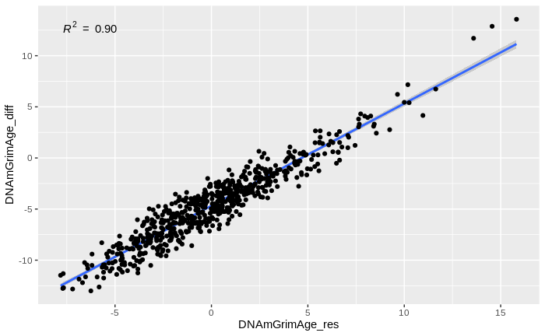
Supplementary Figure 7. Scatterplot of DiffAge (y axis) and DBAge (x axis) in ADNI calculated using the DNAmGrimAge Clock. R = 0.90.

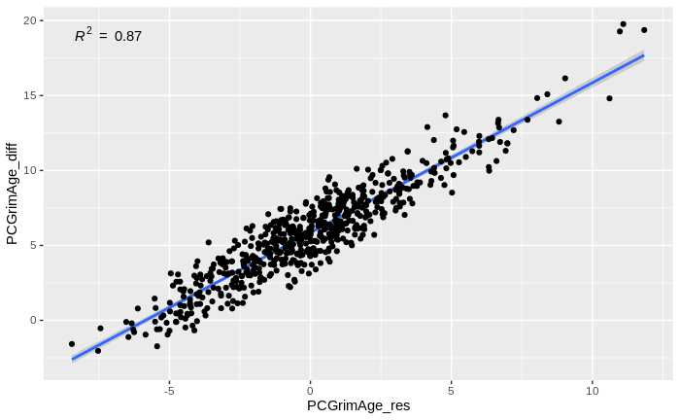
Supplementary Figure 8. Scatterplot of DiffAge (y axis) and DBAge (x axis) in ADNI calculated using the PCGrimAge Clock. R = 0.87.

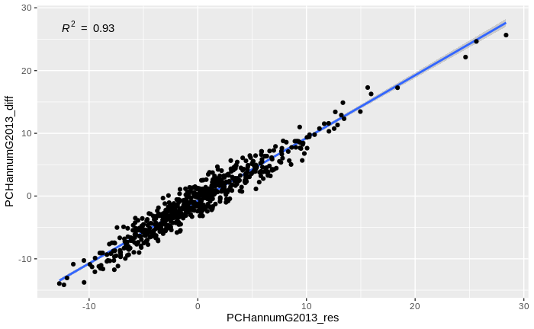
Supplementary Figure 9. Scatterplot of DiffAge (y axis) and DBAge (x axis) in AIBL calculated using the PCHannumG2013 Clock. R = 0.93.

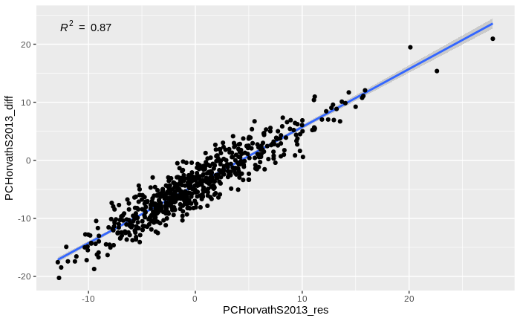
Supplementary Figure 10. Scatterplot of DiffAge (y axis) and DBAge (x axis) in ADNI calculated using the PCHorvathS2013 Clock. R = 0.87.

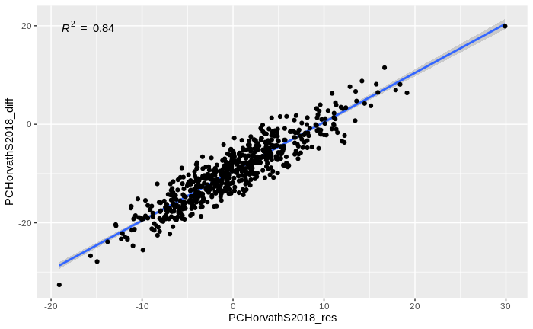
Supplementary Figure 11. Scatterplot of DiffAge (y axis) and DBAge (x axis) in ADNI calculated using the PCHorvathS2018 Clock. R = 0.84.

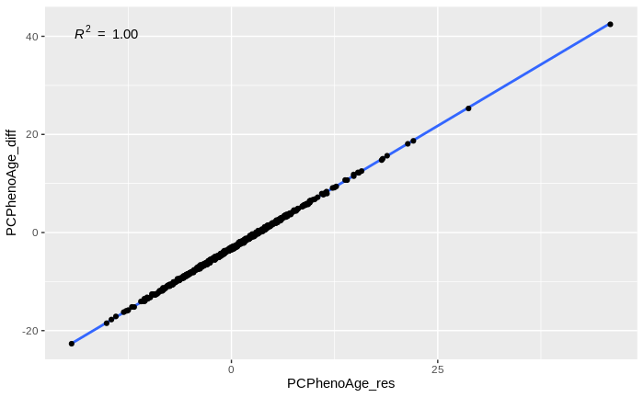
Supplementary Figure 12. Scatterplot of DiffAge (y axis) and DBAge (x axis) in ADNI calculated using the PCPhenoAge Clock. R = 1.00.

