External Validation of a US Claims-Based Frailty Indicator and Development of a Population-Specific Model for the German Healthcare System
Supplement

Supplementary Table 1: ICD-10 codes mapped from ICD-9 morbidities considered for model development
Supplement Table 2: Confusion matrix of observed vs. predicted frail individuals.
Supplement Table 3: Mean AUC of cross validation to compare different selection of models
Supplement Figure 1: Overview of the Berlin Initiative Study (BIS) population. The flowchart shows the composition of the study population. The light gray section of the figure indicates the part of the BIS study that preceded this study.
Supplement Figure 2: Using the maximized Youden Index as cut-off displaying the distribution of predicted values stratified by Frailty status
Supplement Figure 3: Calibration plot for the recalibrated prediction model of frailty risk. Predicted probabilities (x-axis) are compared with observed frequencies (y-axis). The dashed diagonal line represents perfect calibration, the solid line connects observed frequencies across risk deciles, and the shaded area shows the 95% confidence intervals around this line.
Supplement Figure 4: Using the maximized Youden Index as cut-off displaying the distribution of the recalibrated predicted values stratified by Frailty status
Supplement Figure 5: Decision curve analysis showing net benefit curves for the recalibrated CFI and the newly developed LASSO model, compared with reference strategies of always predicting frailty and never predicting frailty across a range of threshold probabilities.
Supplement Figure 6: Predictor selection using LASSO regression – LASSO coefficient paths. (1) Age, (2) Sex, (3) Anal or rectal disorders, (4) Anemia, (5) Angina, (6) Anxiety, (7) Arrhythmia, (8) Arthritis, (9) Cataract, (10) Chronic kidney disease (with Dialysis, Transplantation), (11) Cognitive impairment, (12) Chronic Obstructive Lung Disease incl. Asthma, (13) Congestive Heart Failure, (14) Delirium, (15) Depression, (16) Diabetes mellitus, (17) Falls, (18) Glaucoma, (19) Hearing problems, (20) Hyperlipidemia, (21) Hypertension, (22) Impaired mobility, (23) Irregular gait, (24) Malaise, (25) Malignant disease (Cancer), (26) Musculoskeletal problems, (27) Myocardial infarction, (28) Neurological conditions, (29) Nutritional deficiencies, (30) Paranoia, (31) Peptic ulcer disease, (32) Postural hypotension, (33) Seizure, (34) Shortness of breath (breathlessness), (35) Stroke (Cerebrovascular Disease with Stroke), (36) Syncope, (37) Thyroid disease, (38) Urinary incontinence, (39) Visual impairment, (40) CCI, (41) hospitalized, (42) Mycoses, (43) Parkinson, (44) Chronic Skin Ulcer, (45) Pneumonia, (46) Skin Softtissue Infection, (47) , (48) Gout, (49) Urinary Tract Infection
Supplement Figure 7: Using the maximized Youden Index as cut-off display the distribution of predicted values stratified by Frailty status

Supplementary Table 1. ICD-10 codes mapped from ICD-9 morbidities considered as candidate predictors for model development
ICD-10 codes mapped from ICD-9 morbidities
Morbidity | Operationalization after Mapping
Anal or rectal disorders | K59.4, K60, K61, K62
Anemia | D50, D51, D52, D53, D55, D56, D57, D58, D59, D60, D61, D62, D63, D64
Angina | I20
Anxiety | F06.4, F41, F40
Arrhythmia | I44, I45, I46, I47, I48, I49
Arthritis | M05, M06, M07, M08, M09, M12.0, M15–M19, Z87.39,
Cataract | H25, H26, H28, E08.36, E09.36, E10.36, E11.36, E13.36, Z96.1
Chronic kidney disease (with Dialysis, Transplantation) | N18, R80.0, Z94.0, Z99.2, Z49
Cognitive impairment | F00, F01, F02, F03, F04, F06.8, F07, F09, G30, G31.0, G31.1, R41.8
Chronic Obstructive Lung Disease incl. Asthma | J40–J47
Congestive Heart Failure | I50
Delirium | F05
Depression | F06.3, F32, F33, F43
Diabetes mellitus | E10–E14, R73, R81, R82.4
Falls | R29.6
Glaucoma | H40, H42, Q15
Hearing problems | H90, H91, H93.1-H93.3, Z46.1, Z01.1, H60, H61, H62, H71, H73, H74, H92
Hyperlipidemia | E78.0–E78.5
Hypertension | I10-I15
Impaired mobility | Medical Device Group 10 OR ICD10 Z74, Z99.3
Irregular gait | R26
Malaise | R53, G93.3
Malignant disease (Cancer) | C00–C97 (without C44), Z85
Musculoskeletal problems | M02, M12, M13, M14, M24, M25, M36, M46, M49, M50-M54, M67, M81, M84, M96, R29
Myocardial infarction | I21, I22
Neurological conditions | F51, G08, G21, G31.8, G36, G37, G47, G50-G58, G60-G64, G70-G73, G83, G90, G92, G93, G96, R20, R25, R26, R27, R29, R41, R43, R47, R48, R52, R83, R90, R94.0, R94.1, Z86.6, Z98.8
Nutritional deficiencies | E40-E46, E50-E64, R64, Z86.3
Paranoia | F06.0, F06.2, F20.0, F20.5, F20.8, F20.9, F22, F23, F24, F25, F28, F29, F32.3, F33.3
Peptic ulcer disease | K25, K26, K27, K28, Z87.1
Postural hypotension | I95.1, I95.8, I95.9
Seizure | G40, R56
Shortness of breath (breathlessness) | R06
Stroke (Cerebrovascular Disease with Stroke) | I60-I69
Syncope | R55
Thyroid disease | E00-E07, R94.6
Urinary incontinence | N39.3, N39.4, N31, R32, R39.8
Visual impairment | H52, H53, H54
Other candidate predictors
Predicator | Operationalization
CCI | according to Charlson et al [1, 2]
hospitalized | Hospitalization (>1 day) up to 6 months before the study visit
Mycoses | B35-B49
Parkinson | G20, G22
Chronic Skin Ulcer | L98.4
Pneumonia | J09-J18
Skin Softtissue Infection | L00-L08
Gout | M10, M11
Urinary Tract Infection | N39.0
Age | in years
Sex | female/male
race | n.a.
1. Charlson, M.E., et al., A new method of classifying prognostic comorbidity in longitudinal studies: development and validation. J Chronic Dis, 1987. 40(5): p. 373–83.
2. Charlson, M., et al., Validation of a combined comorbidity index. J Clin Epidemiol, 1994. 47(11): p. 1245–51.

Supplement Table 2: Confusion matrix of observed vs. predicted frail individuals.
 | Observed Negative (n=753) | Observed Positive  (n=398) | Accuracy
Threshold 0.12 |  |  | 0.38
Predicted Negative (n=46) | 43 | 3
Predicted Positive (n=1,105) | 710 | 395
Threshold 0.20 |  |  | 0.47
Predicted Negative (n=166) | 153 | 13
Predicted Positive (n=985) | 600 | 385
Threshold 0.25 |  |  | 0.51
Predicted Negative (n=228) | 206 | 22
Predicted Positive (n=923) | 547 | 376
Threshold 0.58  (max. Youden Index) |  |  | 0.72
Predicted Negative (n=678) | 554 | 124
Predicted Positive (n=473) | 199 | 274

Supplement Table 3: Mean AUC of cross validation to compare different selection strategies
Selection Method | AUC, mean (SD)
all | 0.78 (0.044)
CFI | 0.78 (0.036)
LASSO | 0.79 (0.033)
stepwise | 0.78 (0.041)
random forrest | 0.75 (0.054)
external validation of CFI | 0.78 (0.037)

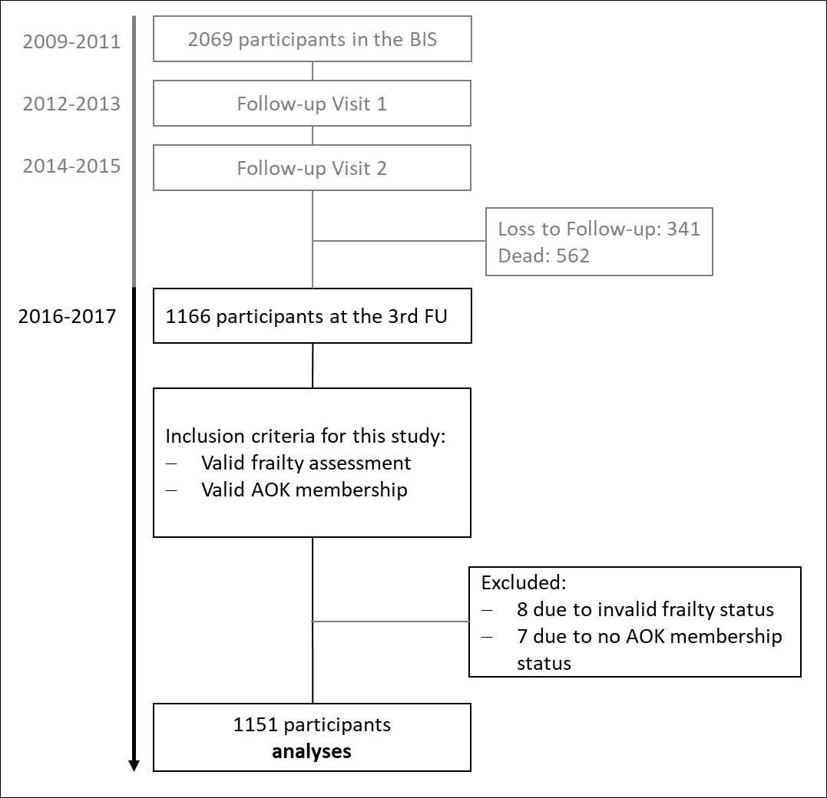
Supplement Figure 1: Overview of the Berlin Initiative Study (BIS) population. The flowchart shows the composition of the study population. The light gray section of the figure indicates the part of the BIS study that preceded this study.

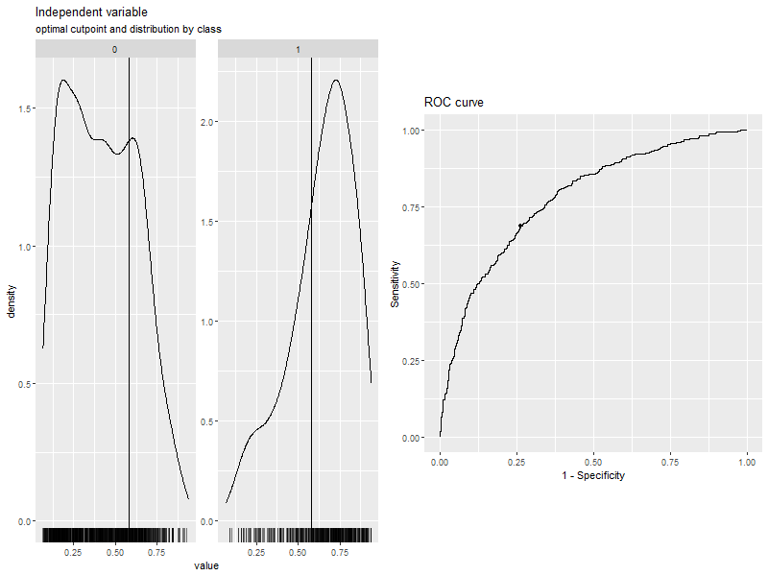
Supplement Figure 2: Using the maximized Youden Index as cut-off displaying the distribution of predicted values stratified by Frailty status
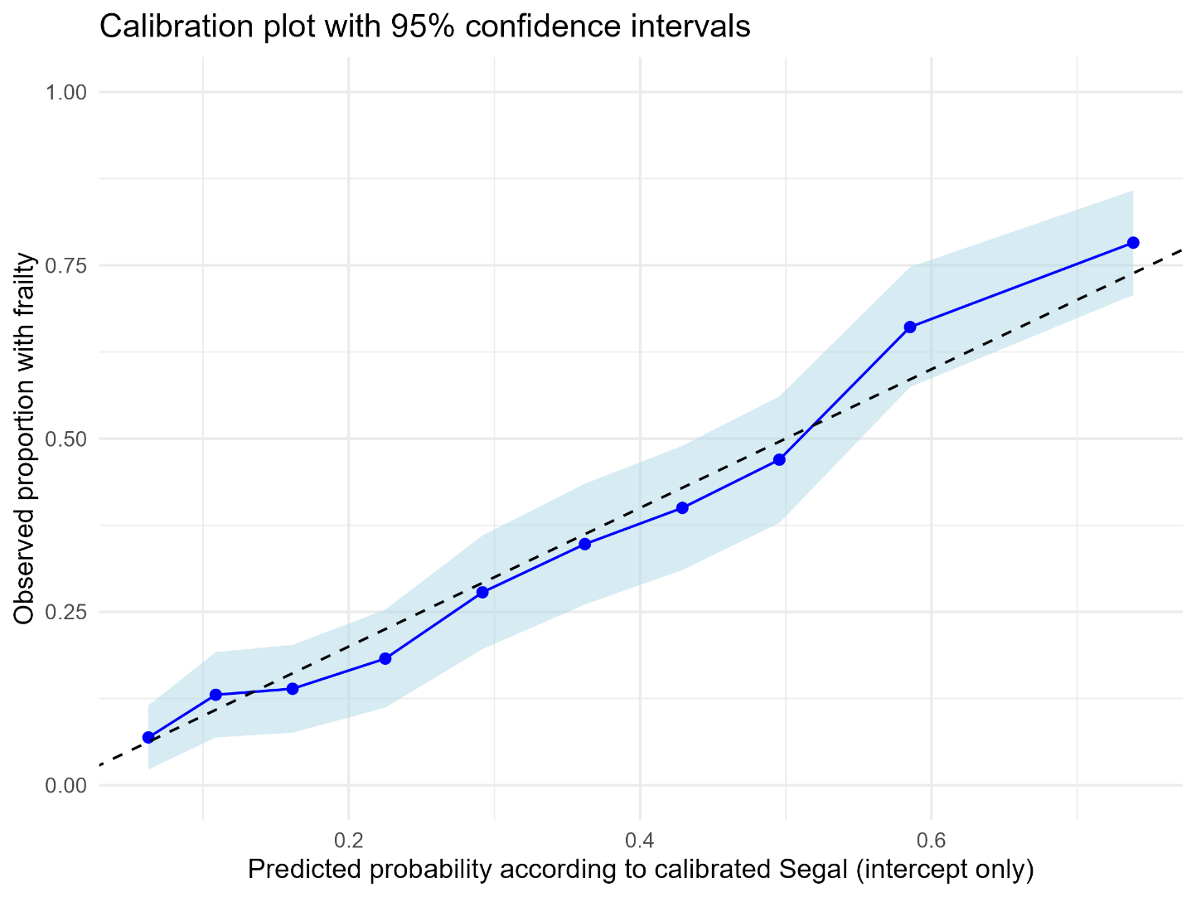

Supplement Figure 3: Calibration plot for the recalibrated prediction model of frailty risk. Predicted probabilities (x-axis) are compared with observed frequencies (y-axis). The dashed diagonal line represents perfect calibration, the solid line connects observed frequencies across risk deciles, and the shaded area shows the 95% confidence intervals around this line.

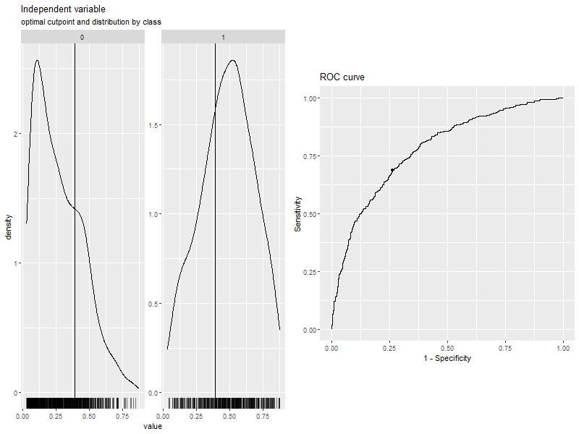
Supplement Figure 4: Using the maximized Youden Index as cut-off displaying the distribution of the recalibrated predicted values stratified by Frailty status

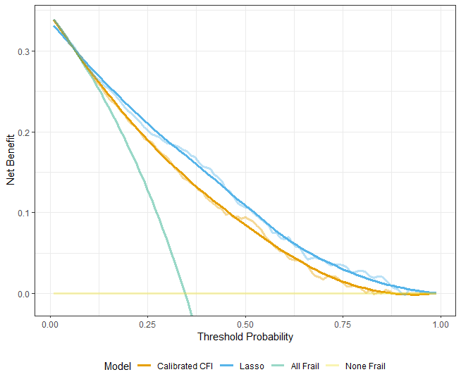
Supplement Figure 5: Decision curve analysis showing net benefit curves for the recalibrated CFI and the newly developed LASSO model, compared with reference strategies of always predicting frailty and never predicting frailty across a range of threshold probabilities.

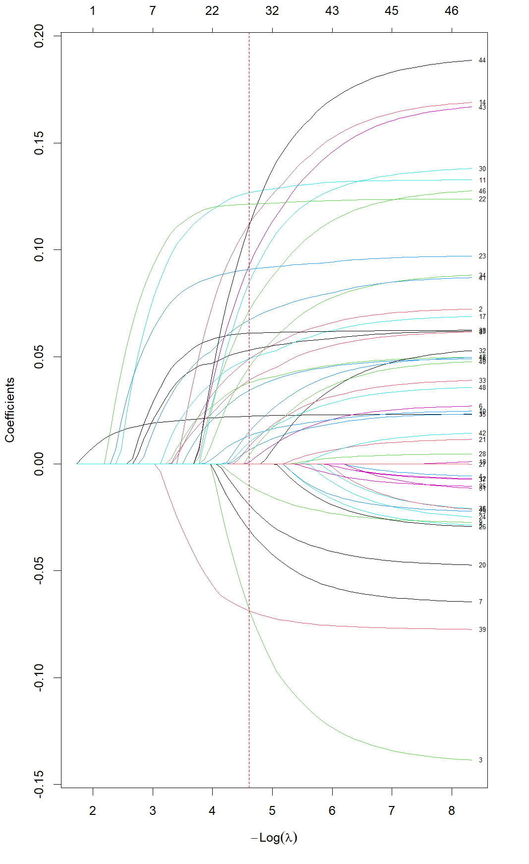
Supplement Figure 6: Predictor selection using LASSO regression – LASSO coefficient paths. (1) Age, (2) Sex, (3) Anal or rectal disorders, (4) Anemia, (5) Angina, (6) Anxiety, (7) Arrhythmia, (8) Arthritis, (9) Cataract, (10) Chronic kidney disease (with Dialysis, Transplantation), (11) Cognitive impairment, (12) Chronic Obstructive Lung Disease incl. Asthma, (13) Congestive Heart Failure, (14) Delirium, (15) Depression, (16) Diabetes mellitus, (17) Falls, (18) Glaucoma, (19) Hearing problems, (20) Hyperlipidemia, (21) Hypertension, (22) Impaired mobility, (23) Irregular gait, (24) Malaise, (25) Malignant disease (Cancer), (26) Musculoskeletal problems, (27) Myocardial infarction, (28) Neurological conditions, (29) Nutritional deficiencies, (30) Paranoia, (31) Peptic ulcer disease, (32) Postural hypotension, (33) Seizure, (34) Shortness of breath (breathlessness), (35) Stroke (Cerebrovascular Disease with Stroke), (36) Syncope, (37) Thyroid disease, (38) Urinary incontinence, (39) Visual impairment, (40) CCI, (41) hospitalized, (42) Mycoses, (43) Parkinson, (44) Chronic Skin Ulcer, (45) Pneumonia, (46) Skin Softtissue Infection, (47) , (48) Gout, (49) Urinary Tract Infection
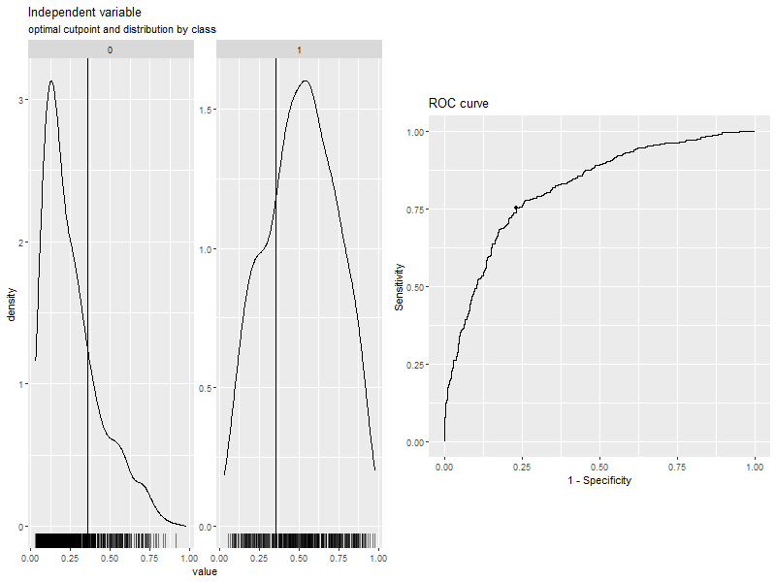

Supplement Figure 7: Using the maximized Youden Index as cut-off displaying the distribution of predicted values stratified by Frailty status

