Table S1.- Number of study participants with and without data on appendicular lean mass from centers having access to DXA deviceª
Variable | Total | Included^{b} | Non-included^{c}
Variable | n | n (%) | n (%)
Recruiting center
All centers with available DXA | 2,519 | 1,477 (58.6) | 1,042 (41.4)
Center 3 | 331 | 255 (77.0) | 76 (23.0)
Center 4 | 335 | 294 (87.8) | 41 (12.2)
Center 5 | 302 | 137 (45.4) | 165 (54.6)
Center 7 | 460 | 342 (74.3) | 118 (25.7)
Center 10^{d} | 628 | 93 (14.8) | 535 (85.2)
Center 20 | 205 | 130 (63.4) | 75 (36.6)
Center 23 | 258 | 226 (87.6) | 32 (12.4)
Abbreviations: DXA, dual energy x-ray absorptiometry.
ªData are shown as numbers (percentages). The sample of 1,474 participants come from 7 out of the 23 PREDIMED-Plus recruiting centers, as those seven centers were the only centers that had DXA scanner available. In each of these seven centers, either all participants or a sub-sample were invited to DXA scans.
^{b}Participants with data on body composition measured with DXA and included in the analysis.
^{c}Participants without DXA data excluded from the analysis.
^{d}Center #10 was the vanguard center and started the recruitment and randomization many months earlier than the other centers, therefore many participants of center #10 had had their baseline evaluation before the DXA study started.

Table S2.- Number of study participants with and without data on appendicular lean mass from centers having access to telomere length measurementsª
Variable | Included | With ALM^{b} | With ALM and telomere length^{c}
Variable | n | n (%) | n (%)
Recruiting center
All centers with available DXA | 1,088 | 435 (40.0) | 185 (42.5)
Center 7 | 460 | 342 (74.3) | 147 (43.0)
Center 10^{d} | 628 | 93 (14.8) | 38 (40.9)
Abbreviations: DXA, dual energy x-ray absorptiometry.
ªData are shown as numbers (percentages). The sample of 1,088 participants come from 2 out of the 7 PREDIMED-Plus recruiting centers with DXA scanner available. In each of these two centers telomere length measurements were performed.
^{b}Participants with data on appendicular lean mass measured with DXA.
^{c}Participants with data on appendicular lean mass measured with DXA and available data on telomere length.
^{d}Center #10 was the vanguard center and started the recruitment and randomization many months earlier than the other centers, therefore many participants of center #10 had had their baseline evaluation before the DXA study started.

Table S3.- Baseline characteristics of study participants selected and non-selected for DXA measurementsª
Characteristic | Total population (n=6,874) | Selected^{b} (n=2,519) | Non selected^{c} (n=4,355) | P- value
Sociodemographic variables
Age, mean (SD), years | 64.9 ± 4.9 | 65.4 ± 5.0 | 64.7 ± 4.9 | 0.001
Female, No. (%) | 3335 (48.5) | 1178 (46.8) | 2157 (49.5) | 0.027
Education level, No. (%)
Primary or less | 3362 (48.9) | 1212 (48.1) | 2150 (49.4) | 0.056
Secondary | 1986 (28.9) | 770 (30.6) | 1216 (27.9) | 0.056
College | 1526 (22.2) | 537 (21.3) | 989 (22.7) | 0.056
Marital status, No. (%)
Single, divorced or separated | 897 (13.1) | 338 (13.4) | 559 (12.8) | 0.375
Married | 5261 (76.5) | 1905 (75.6) | 3356 (77.1) | 0.375
Widower | 716 (10.4) | 276 (11.0) | 440 (10.1) | 0.375
Ethnicity
Caucasian | 6874 (100%) | 2519 (100%) | 4355 (100%)
African | 0 (0) | 0 (0) | 0 (0) | –
Asian | 0 (0) | 0 (0) | 0 (0) | –
Hispanic or Latino | 0 (0) | 0 (0) | 0 (0) | –
Other | 0 (0) | 0 (0) | 0 (0) | –
Disease presence or medication usage at recruitment
Type 2 diabetes, No. (%) | 2121 (30.9) | 677 (26.9) | 1444 (33.2) | 0.001
Hypercholesterolemia, No. (%) | 4813 (70.0) | 1652 (65.6) | 3161 (72.6) | 0.001
Metabolic syndrome, No. (%) | 6874 (100.0) | 2519 (100.0) | 4355 (100.0) | –
Hypertension, No. (%) | 5758 (83.8) | 2126 (84.4) | 3632 (83.4) | 0.279
Hypertriglyceridemia, No. (%) | 2862 (41.6) | 989 (39.3) | 1873 (43.0) | 0.002
Low HDL, No. (%) | 2794 (40.7) | 1164 (46.2) | 1630 (37.4) | 0.001
Hyperglycemia, No. (%) | 4572 (66.5) | 1665 (66.1) | 2907 (66.8) | 0.580
Central obesity, No. (%) | 5575 (81.1) | 1989 (79.0) | 3586 (82.3) | 0.001
Medication use, No. (%)
Insulin or other antidiabetic drugs | 1817 (26.4) | 536 (21.3) | 1281 (29.4) | 0.001
Antihypertensive agents | 5378 (78.2) | 2013 (79.9) | 3365 (77.3) | 0.010
Statins or other hypolipidemic drugs | 3560 (51.8) | 1249 (49.6) | 2311 (53.1) | 0.005
Lifestyle variables
Physical activity, mean (SD), METs per minutes per day | 351.7 ± 328.5 | 382.4 ± 325.4 | 334.0 ± 329.1 | 0.001
Sedentary time, mean (SD), hours per day | 6.0 ± 2.0 | 5.7 ± 1.9 | 6.2 ± 2.0 | 0.001
Smoking status, No. (%)
Current smoker | 857 (12.5) | 318 (12.6) | 539 (12.4) | 0.341
Former smoker | 2983 (43.4) | 1018 (44.4) | 1865 (42.8) | 0.341
Never smoker | 3034 (44.1) | 1083 (43.0) | 1951 (44.8) | 0.341
Dietary variables
Alcohol intake, mean (SD), g/d | 11.0 ± 15.0 | 11.9 ± 15.9 | 10.5 ± 14.5 | 0.001
Total energy intake, mean (SD), kcal/d | 2361 ± 550 | 2373 ± 543 | 2354 ± 553 | 0.167
Abbreviations: DXA, dual energy x-ray absorptiometry. erMedDiet, energy-restricted Mediterranean Diet. HDL, high-density lipoproteins. METs, metabolic equivalents SD, standard deviation.
ªData are presented as n (%) or mean ± SD for categorical and continuous variables, respectively. Unpaired Student’s t-test and Chi-square tests were employed for continuous and categorical variables, respectively. Significant differences (P<0.05) were highlighted in bold type.
^{b}Participants selected for potential DXA measurements
^{c}Participants non-selected for DXA measurements

Table S4- Baseline telomere length and appendicular lean mass over six years after excluding lost to follow-up participants (complete case analysis)ª
Variable | Multivariable-adjusted model
Variable | Continuous | < median | ≥ median | P-trend^{b}
Appendicular lean mass (kg)
Baseline | 0 (Ref.) | 0 (Ref.) | 0 (Ref.) | 0.014
Year 1 vs baseline | 0.62 [–0.15 to 1.38] | 0 (Ref.) | 0.72 [–0.03 to 1.46] | 0.014
Year 3 vs baseline | 0.70 [–0.06 to 1.47] | 0 (Ref.) | 0.74 [0.01 to 1.49] | 0.014
Year 6 vs baseline | 1.19 [0.42 to 1.95] | 0 (Ref.) | 1.23 [0.48 to 1.98] | 0.014
Upper limbs lean mass (kg)
Baseline | 0 (Ref.) | 0 (Ref.) | 0 (Ref.) | 0.001
Year 1 vs baseline | 0.31 [–0.06 to 0.68] | 0 (Ref.) | 0.39 [0.04 to 0.75] | 0.001
Year 3 vs baseline | 0.57 [0.20 to 0.94] | 0 (Ref.) | 0.65 [0.29 to 1.01] | 0.001
Year 6 vs baseline | 0.51 [0.14 to 0.87] | 0 (Ref.) | 0.56 [0.21 to 0.92] | 0.001
Lower limbs lean mass (kg)
Baseline | 0 (Ref.) | 0 (Ref.) | 0 (Ref.) | 0.135
Year 1 vs baseline | 0.31 [–0.31 to 0.93] | 0 (Ref.) | 0.33 [–0.28 to 0.92] | 0.135
Year 3 vs baseline | 0.13 [–0.48 to 0.75] | 0 (Ref.) | 0.10 [–0.50 to 0.70] | 0.135
Year 6 vs baseline | 0.68 [0.06 to 1.30] | 0 (Ref.) | 0.67 [0.06 to 1.27] | 0.135
Abbreviations: ALM, appendicular lean mass. CI, confidence interval.
ªTwo-level linear mixed models were fitted with random intercepts at the cluster family (as couples from the same household were randomized together) and individual participants to assess the relationship baseline telome length, modeled as a continuous variable and by predefined categories (< median and ≥ median) and appendicular lean mass (outcome) measured repeatedly over time (at each follow-up visit and for the overall follow-up period). Multivariable-adjusted models included fixed effects for an interaction term between baseline telomere length and time, as well as age (years), sex (male or female), recruiting center, intervention group (control or intervention), education level (primary or less, secondary, or college), marital status (single, divorced or separated, married, or widowed), smoking status (former, or never), diabetes prevalence (yes or no), hypertension prevalence (yes or no), hypercholesterolemia prevalence (yes or no), physical activity (metabolic equivalents in minutes per day), sedentary time (hours per day), alcohol consumption in grams per day (and adding the quadratic term), and total energy intake (kilocalories per day). Lost to follow-up participants with no information for appendicular lean mass over time were excluded. Data are presented as mean differences [95% CI]. Significant values (p<0.05) were highlighted in bold type.
^{b}P-value for the overall follow-up period.

Table S5.- Baseline telomere length and appendicular lean mass indexes after excluding lost to follow-up participants (complete case analysis)ª
Variable | Multivariable-adjusted model
Variable | Continuous | < median | ≥ median | P-trend^{b}
Appendicular lean mass to height ratio
Baseline | 0 (Ref.) | 0 (Ref.) | 0 (Ref.) | 0.022
Year 1 vs baseline | 0.18 [–0.05 to 0.42] | 0 (Ref.) | 0.22 [–0.01 to 0.45] | 0.022
Year 3 vs baseline | 0.22 [–0.02 to 0.45] | 0 (Ref.) | 0.23 [0.01 to 0.46] | 0.022
Year 6 vs baseline | 0.35 [0.12 to 0.58] | 0 (Ref.) | 0.35 [0.13 to 0.58] | 0.022
Appendicular lean mass to total body weight ratio
Baseline | 0 (Ref.) | 0 (Ref.) | 0 (Ref.) | 0.011
Year 1 vs baseline | 0.87 [–0.01 to 1.74] | 0 (Ref.) | 0.96 [0.11 to 1.81] | 0.011
Year 3 vs baseline | 0.67 [–0.20 to 1.55] | 0 (Ref.) | 0.92 [0.07 to 1.77] | 0.011
Year 6 vs baseline | 1.23 [0.35 to 2.10] | 0 (Ref.) | 1.39 [0.54 to 2.24] | 0.011
Appendicular lean mass to body mass index ratio
Baseline | 0 (Ref.) | 0 (Ref.) | 0 (Ref.) | 0.009
Year 1 vs baseline | 0.02 [–0.01 to 0.05] | 0 (Ref.) | 0.03 [0.01 to 0.05] | 0.009
Year 3 vs baseline | 0.02 [–0.01 to 0.05] | 0 (Ref.) | 0.02 [–0.01 to 0.05] | 0.009
Year 6 vs baseline | 0.03 [0.01 to 0.06] | 0 (Ref.) | 0.04 [0.02 to 0.07] | 0.009
Abbreviations: ALM, appendicular lean mass. CI, confidence interval.
ªTwo-level linear mixed models were fitted with random intercepts at the cluster family (as couples from the same household were randomized together) and individual participants to assess the relationship baseline telome length, modeled as a continuous variable and by predefined categories (< median and ≥ median) and appendicular lean mass indexes (outcome) measured repeatedly over time (at each follow-up visit and for the overall follow-up period). Multivariable-adjusted models included fixed effects for an interaction term between baseline telomere length and time, as well as age (years), sex (male or female), recruiting center, intervention group (control or intervention), education level (primary or less, secondary, or college), marital status (single, divorced or separated, married, or widowed), smoking status (former, or never), diabetes prevalence (yes or no), hypertension prevalence (yes or no), hypercholesterolemia prevalence (yes or no), physical activity (metabolic equivalents in minutes per day), sedentary time (hours per day), alcohol consumption in grams per day (and adding the quadratic term), and total energy intake (kilocalories per day). Lost to follow-up participants with no information for appendicular lean mass indexes over time were excluded. Data are presented as mean differences [95% CI]. Significant values (p<0.05) were highlighted in bold type.
^{b}P-value for the overall follow-up period.

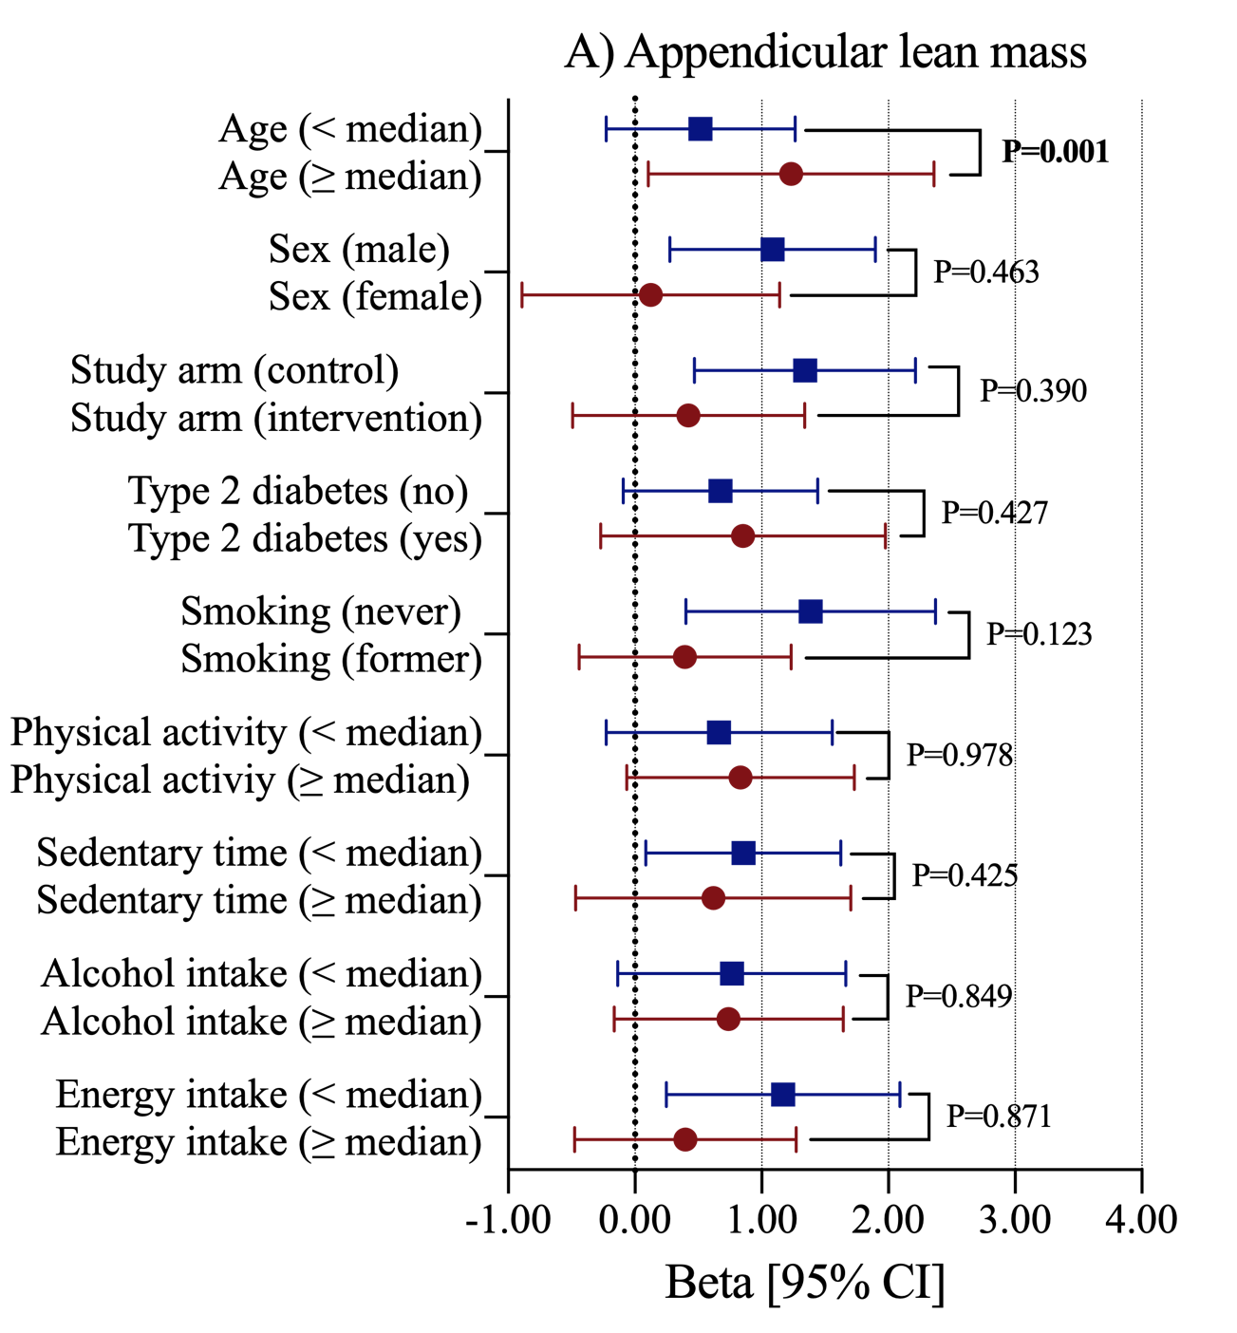
Fig. S1 A priory interaction for the relationship between baseline telomere length as continuous and appendicular lean mass over six years with multiple baseline variables of the study. Two-level linear mixed models were fitted with random intercepts at the cluster family (as couples from the same household were randomized together) and individual participants to assess the relationship between baseline telomere length as a continuous variable (exposure), and appendicular lean mass measured repeatedly over time (at each follow-up visit and for the overall follow-up period). Multivariable-adjusted models included fixed effects for an interaction term between baseline telomere length and time, as well as age (years), sex (male or female), recruiting center, intervention group (control or intervention), education level (primary or less, secondary, or college), marital status (single, divorced or separated, married, or widowed), smoking status (former or never), diabetes prevalence (yes or no), hypertension prevalence (yes or no), hypercholesterolemia prevalence (yes or no), physical activity (metabolic equivalents in minutes per day), sedentary time (hours per day), alcohol consumption in grams per day (and adding the quadratic term), and total energy intake (kilocalories per day). Data are presented as Beta standardized values [95% CI]. Significant values (p<0.05) were highlighted in bold type.

