Supplemental Materials

Supplemental Methods
1. Study population - eligibility criteria for enrollment
2. Protocol for purification of genomic DNA from human skeletal muscle
3. Preprocessing and quality control procedures for DNA methylation data
4. Modified Life’s Essential 8 scoring procedures
Supplemental Figure
1. Supplemental Figure S1. Differentially methylated positions (DMPs) and regions (DMRs) in human skeletal muscle associated with walking speed
2. Supplemental Figure S2. Differentially methylated positions (DMPs) and regions (DMRs) in human skeletal muscle associated with handgrip strength
3. Supplemental Figure S3. Differentially methylated positions (DMPs) and regions (DMRs) in human skeletal muscle associated with perceived disability
4. Supplemental Figure S4. Differentially methylated positions (DMPs) and regions (DMRs) in human skeletal muscle associated with cardiovascular and lifestyle health
5. Supplemental Figure S5. Quantile–quantile (Q–Q) plots and genomic inflation factors (λ) after genomic correction
Supplemental Tables
1. Supplemental Table S1. Skeletal muscle-based DMPs associated with physical function
2. Supplemental Table S2. Skeletal muscle-based DMRs associated with physical function
3. Supplemental Table S3. Key DMPs/DMRs and their associations with physical function phenotype
References

Supplemental Methods

1. Study Population - Eligibility Criteria for Enrollment
This study enrolled 114 participants aged 70 to 80 years and entered the follow-up stage. In the current study, after excluding 17 participants without muscle biopsy sample and 5 with missing data on physical function phenotypes, a total of 92 participants were included in the data analysis.
Inclusion criteria
- 70-80 years old
- Short Physical Performance Battery (SPPB) score ≤ 9 (Low Functioning Group) or 11-12 (High Functioning Group)
- Physically inactive lifestyle (i.e., <150 min/week of moderate-intensity aerobic exercise) and no active participation in a formal exercise program within the past 3 months (i.e., brisk walks are considered formal exercise, but leisurely walks are not)
- Ability to walk one block (400 meters)
- Mini-Mental State Examination (MMSE) score ≥ 24
- Willingness to undergo all testing procedures
Exclusion criteria
- Failure to provide informed consent
- Use of walking assistance devices such as cane, crutches, walkers
- Active treatment for cancer, stroke (< 6 months), peripheral vascular disease, coronary artery disease, myocardial infarction (< 6 months), congestive heart failure (stage III or IV), valvular heart disease, COPD
- Allergy to lidocaine
- SPPB score of 10
- Major psychiatric disease
- Malabsorption (e.g., celiac disease)
- Major gastrointestinal disorders (e.g., peptic ulcer, chronic gastritis/duodenitis, inflammatory bowel disease)
- Chronic inflammatory disorders (e.g., autoimmune disease, chronic infections)
- Splenectomy
- Hemolytic anemia, severe anemia, liver or renal disease within the past 3 years
- Diabetes (self-report) or fasting glucose > 126 mg/dL
- Severe osteoarthritis, fracture in upper or lower extremity (< 6 months), upper or lower extremity amputation
- Neuromuscular disorders including ALS, Parkinson’s disease, muscular dystrophy, multiple sclerosis
- Excessive alcohol use (i.e., > 14 drinks/week) or alcohol abuse (i.e., > 5 drinks/day for males or > 4 drinks/day for females)
- Other substance abuse within the past 3 years
- Smoking history in the past 3 years
- Current use of anabolic hormones (i.e., growth hormones or testosterone) or anticoagulants
- Unwilling or study physician’s advice not to stop antiplatelet drug 5 to 7 days before and 2 to 3 days after the muscle biopsy
- Participating in another clinical trial or has received an investigational product within 30 days prior to screening/enrollment
Temporary Exclusion criteria
- Recent bacterial/viral infection (< 3 weeks)
- Acute febrile illness in the past 2 months
- Resting heart rate > 120 bpm
- High blood pressure (i.e., ≥ 180/100 mmHg) at screening visit
- Major surgery or hip/knee replacement (< 6 months)

2. Protocol for purification of genomic DNA from human skeletal muscle
(QIAGEN: DNeasy Blood & Tissue Kit Spin-Column. REF: 69504)
Preparation:
- Buffer ATL and Buffer AL may form precipitates upon storage. If necessary, warm to 56°C until the precipitates have fully dissolved.
- Buffer AW1 and Buffer AW2 are supplied as concentrates. Before using for the first time, add the appropriate amount of ethanol (96–100%) as indicated on the bottle to obtain a working solution.
- Preheat a thermomixer, shaking water bath or rocking platform to 56°C for use in step 2. If using frozen tissue, equilibrate the sample to room temperature (15–25°C).
- Avoid repeated thawing and freezing of samples, because this will lead to reduced DNA size.
Procedure
- Cut about 25 mg tissue into small pieces, and place in a 1.5 mL Eppendorf safe-lock tube. Add 180 µl of Buffer ATL.
- Homogenize samples use “NEXT ADVANCE Bullet Blender homogenizer” in 180uL ATL
Use 1.5 mL Eppendorf safe-lock tubes and stainless-steel beads (0.5~2mm)
    - About ½ of the little white scoop is sufficient (about 20 beads)
    - On Setting 8, homogenize samples in (30sec) bouts. Remove and place on ice bucket for 5 minutes between homogenization step. (1 or 2 rounds of homogenization is often sufficient)
- Add 20 µl Proteinase K. Mix thoroughly by vortexing, place in a thermomixer and incubate at 56°C until the tissue is completely lysed. Lysis time varies depending on the type of tissue processed. Lysis is usually complete in 1–3 h or. If it is more convenient, samples can be lysed overnight; this will not affect them adversely.
Optional: If RNA-free genomic DNA is required, add 4 µl RNase A (100 mg/ml), mix by vortexing, and incubate for 2 min at room temperature (15–25°C) before continuing with step 3.
- Vortex for 15 s. Add 200 µl Buffer AL to the sample, and mix thoroughly by vortexing. Then add 200 µl ethanol (96–100%), and mix again thoroughly by vortexing. It is essential that the sample, Buffer AL, and ethanol are mixed immediately and thoroughly by vortexing or pipetting to yield a homogeneous solution. Buffer AL and ethanol can be premixed and added together in one step to save time when processing multiple samples. A white precipitate may form on addition of Buffer AL and ethanol. This precipitate does not interfere with the DNeasy procedure. Some tissue types (e.g., spleen, lung) may form a gelatinous lysate after addition of Buffer AL and ethanol. In this case, vigorously shaking or vortexing the preparation is recommended.
- Pipet the mixture from step 3 (including any precipitate) into the DNeasy Mini spin column placed in a 2 ml collection tube (provided). Centrifuge at ≥6000 x g (8000 rpm) for 1 min. Discard flow-through and collection tube. *
- Place the DNeasy Mini spin column in a new 2 ml collection tube (provided), add 500 µl Buffer AW1, and centrifuge for 1 min at ≥6000 x g (8000 rpm). Discard flow-through and collection tube. *
- Place the DNeasy Mini spin column in a new 2 ml collection tube (provided), add 500 µl Buffer AW2, and centrifuge for 3 min at 20,000 x g (14,000 rpm) to dry the DNeasy membrane. Discard flow-through and collection tube. It is important to dry the membrane of the DNeasy Mini spin column, since residual ethanol may interfere with subsequent reactions. This centrifugation step ensures that no residual ethanol will be carried over during the following elution. Following the centrifugation step, remove the DNeasy Mini spin column carefully so that the column does not come into contact with the flow-through, since this will result in carryover of ethanol. If carryover of ethanol occurs, empty the collection tube, then reuse it in another centrifugation for 1 min at 20,000 x g (14,000rpm).
- Place the DNeasy Mini spin column in a clean 1.5 ml or 2 ml microcentrifuge tube (not provided), and pipet 200 µl Buffer AE directly onto the DNeasy membrane. Incubate at room temperature for 1 min, and then centrifuge for 1 min at ≥ 6000 x g (8000 rpm) to elute. Elution with 100 µl (instead of 200 µl) increases the final DNA concentration in the eluate, but also decreases the overall DNA yield
- Recommended: For maximum DNA yield, repeat elution once as described in step 7. This step leads to increased overall DNA yield. A new microcentrifuge tube can be used for the second elution step to prevent dilution of the first eluate. Alternatively, to combine the eluates, the microcentrifuge tube from step 7 can be reused for the second elution step. Note: Do not elute more than 200 µl into a 1.5 ml microcentrifuge tube because the DNeasy Mini spin column will come into contact with the eluate.
3. Preprocessing and quality control procedures for DNA methylation data
Raw data were processed using the R packages minfi¹ (v.1.50.0) and wateRmelon² (v2.10.0). Samples were excluded if: 1) proportion of loci detection rate <95%, 2) mean intensity of methylated or unmethylated signals were three standard deviations above or below the mean, 3) bisulfite conversion efficiency <80%, 4) there was a mismatch between reported and predicted sex, or 5) detection P>0.05 in more than 1% of probes. Probes were excluded if: 1) 1% of samples with a detection P>0.05, 2) bead count <3 in 5% of the samples, 3) probes are on sex chromosomes, 4) probe sequences contain SNPs with minor allele frequency (MAF)≥0.05, or 5) they belong to previously reported cross-reactive probes. For probes mapping to the same genomic site, we retained the CpG with the highest quality (based on detection p-values and bead counts). Non-CpG sites were excluded from further analysis. The subsequent normalization of DNA methylation data was first performed using quantile normalization method implemented in the R package wateRmelon. Then we applied the beta-mixture quantile normalization (BMIQ) approach implemented in the R package wateRmelon to normalize beta values of type I and type II design probes within the Illumina arrays. Given that methylation M values (logit transformation of methylation beta values) have better statistical properties (i.e., homoscedasticity) for linear regression models, we derived M values for the downstream analysis.
4. Modified Life’s Essential 8 Scoring Procedures

Domain | Metric | Category / Definition | Points
Health Factors | Blood Pressure | - SBP <120 mmHg and DBP <80 mmHg | 100
Health Factors | Blood Pressure | - SBP 120–129 mmHg and DBP <80 mmHg | 75
Health Factors | Blood Pressure | - SBP 130–139 mmHg or DBP 80–89 mmHg | 50
Health Factors | Blood Pressure | - SBP 140–159 mmHg or DBP 90–99 mmHg | 25
Health Factors | Blood Pressure | - SBP ≥160 mmHg or DBP ≥100 mmHg | 0
Health Factors | Blood Glucose | - Fasting glucose <100 mg/dL, no history of diabetes | 100
Health Factors | Blood Glucose | - Fasting glucose 100–125 mg/dL, no history of diabetes | 60
Health Factors | Blood Glucose | - Fasting glucose ≥126 mg/dL or diabetes | 0
Health Factors | BMI | - <25.0 kg/m² | 100
Health Factors | BMI | - 25.0–29.9 kg/m² | 70
Health Factors | BMI | - 30.0–34.9 kg/m² | 30
Health Factors | BMI | - 35.0–39.9 kg/m² | 15
Health Factors | BMI | - ≥40.0 kg/m² | 0
Health Behaviors | Diet Quality (HEI-2015 score percentile) | - ≥95th percentile | 100
Health Behaviors | Diet Quality (HEI-2015 score percentile) | - 75th–94th percentile | 80
Health Behaviors | Diet Quality (HEI-2015 score percentile) | - 50th–74th percentile | 50
Health Behaviors | Diet Quality (HEI-2015 score percentile) | - 25th–49th percentile | 25
Health Behaviors | Diet Quality (HEI-2015 score percentile) | - 1st–24th percentile | 0
Health Behaviors | Physical Activity | - ≥150 min/week of moderate or vigorous activity | 100
Health Behaviors | Physical Activity | - 120–149 min/week | 90
Health Behaviors | Physical Activity | - 90–119 min/week | 80
Health Behaviors | Physical Activity | - 60–89 min/week | 60
Health Behaviors | Physical Activity | - 30–59 min/week | 40
Health Behaviors | Physical Activity | - 1–29 min/week | 20
Health Behaviors | Physical Activity | - 0 min/week | 0
Health Behaviors | Sleep Duration | - 7 to <9 hours/night | 100
Health Behaviors | Sleep Duration | - 9 to <10 hours/night | 90
Health Behaviors | Sleep Duration | - 6 to <7 hours/night | 70
Health Behaviors | Sleep Duration | - 5 to <6 hours/night or ≥10 hours/night | 40
Health Behaviors | Sleep Duration | - 4 to <5 hours/night | 20
Health Behaviors | Sleep Duration | - <4 hours/night | 0
Abbreviations: SBP, systolic blood pressure; DBP, diastolic blood pressure; BMI, body mass index; HEI-2015, Healthy Eating Index 2015.
Note: We did not include nicotine exposure and blood lipids in the LE8 calculation due to unavailability of data.

Supplemental Figure S1. Differentially methylated positions (DMPs) and regions (DMRs) in human skeletal muscle associated with walking speed.
(a) Manhattan plots showing epigenome-wide associations. Labelled are top 10 significant DMPs (five hypermethylated and five hypomethylated), ranked by beta coefficients. The dashed blue line indicates the statistical significance threshold (BACON-corrected FDR<0.05), while the red line represents the suggestive significance threshold (BACON-corrected FDR<0.1). (b) Annotations of significant DMPs by CpG island context and genomic context, with hypermethylated in red and hypomethylated in teal. (c) Annotations of significant DMRs by genomic context, with hypermethylated in red and hypomethylated in teal. (d) Venn diagram showing the number of differentially methylated genes mapped from DMPs and DMRs.
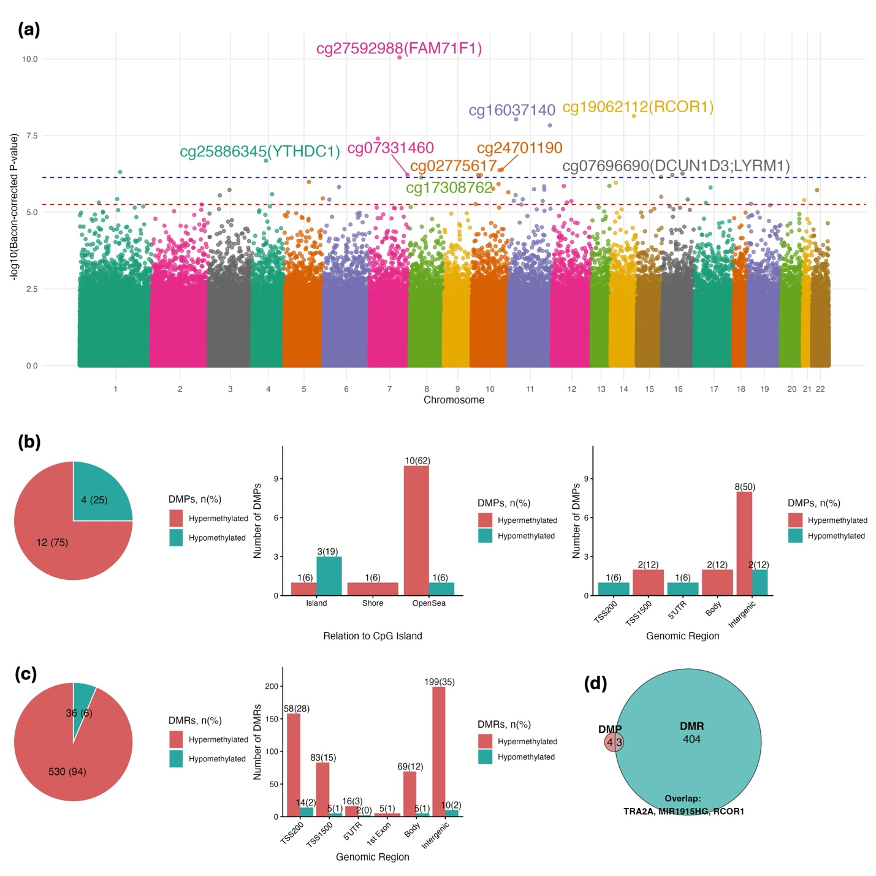

Supplemental Figure S2. Differentially methylated positions (DMPs) and regions (DMRs) in human skeletal muscle associated with handgrip strength.
(a) Manhattan plots showing epigenome-wide associations. The dashed blue line indicates the statistical significance threshold (BACON-corrected FDR<0.05), while the red line represents the suggestive significance threshold (BACON-corrected FDR<0.1). (b) Annotations of significant DMRs by CpG island context and genomic context, with hypermethylated in red and hypomethylated in teal. (c) Venn diagram showing the number of differentially methylated genes mapped from DMRs. No significant DMPs were identified.
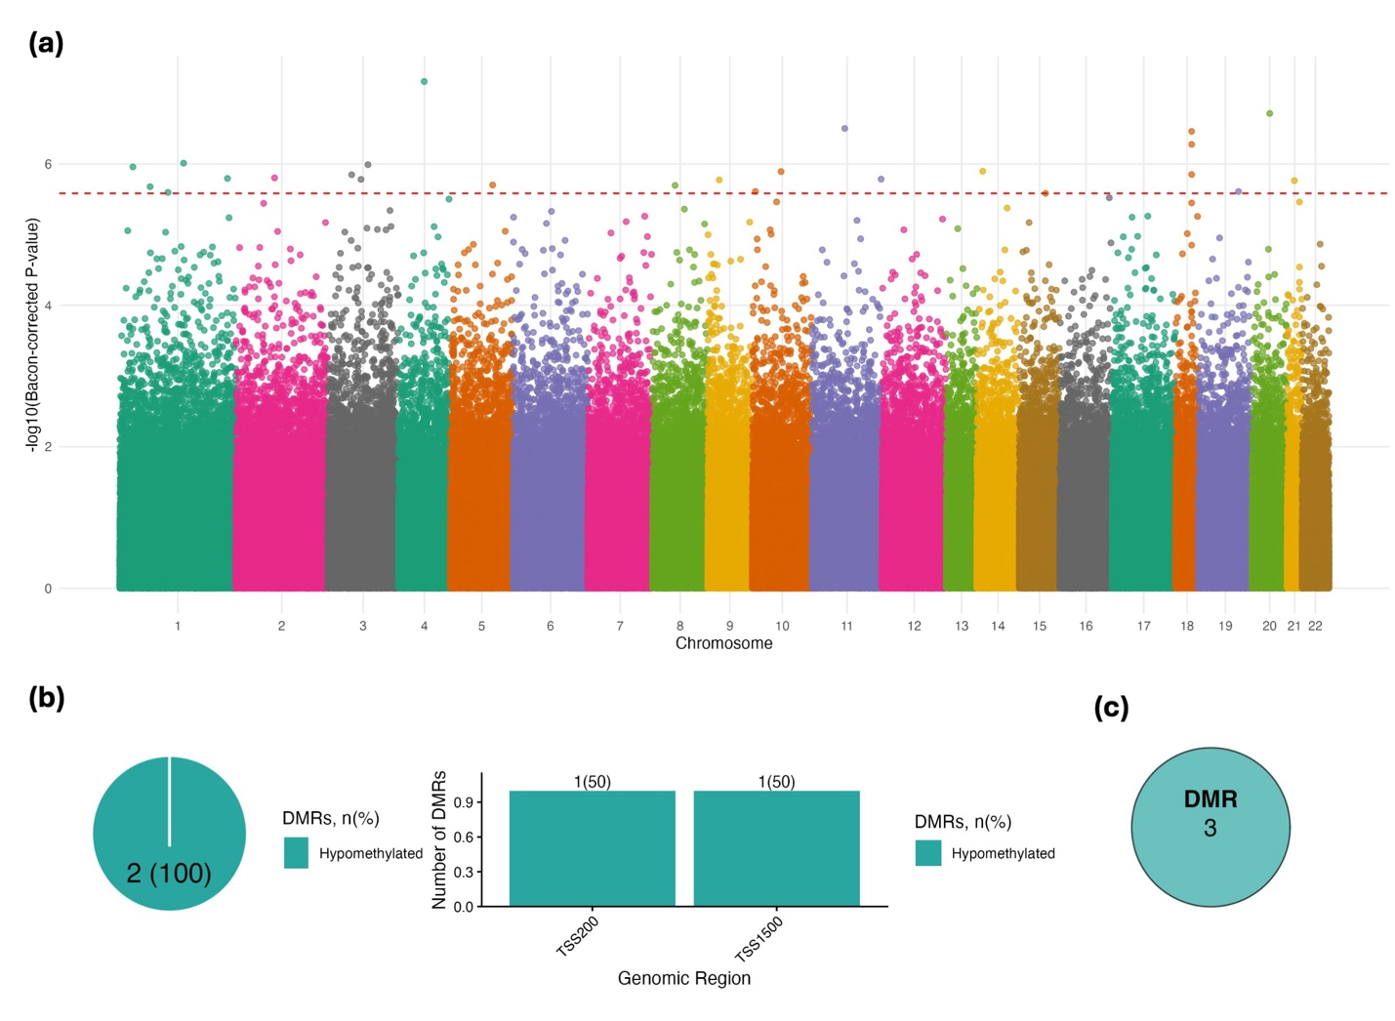

Supplemental Figure S3. Differentially methylated positions (DMPs) and regions (DMRs) in human skeletal muscle associated with perceived disability.
(a) Manhattan plots showing epigenome-wide associations. Labelled are top 10 significant DMPs (five hypermethylated and five hypomethylated), ranked by beta coefficients. The dashed blue line indicates the statistical significance threshold (BACON-corrected FDR<0.05), while the red line represents the suggestive significance threshold (BACON-corrected FDR<0.1). (b) Annotations of significant DMPs by CpG island context and genomic context, with hypermethylated in red and hypomethylated in teal. (c) Annotations of significant DMRs by genomic context, with hypermethylated in red and hypomethylated in teal. (d) Venn diagram showing the number of differentially methylated genes mapped from DMPs and DMRs.
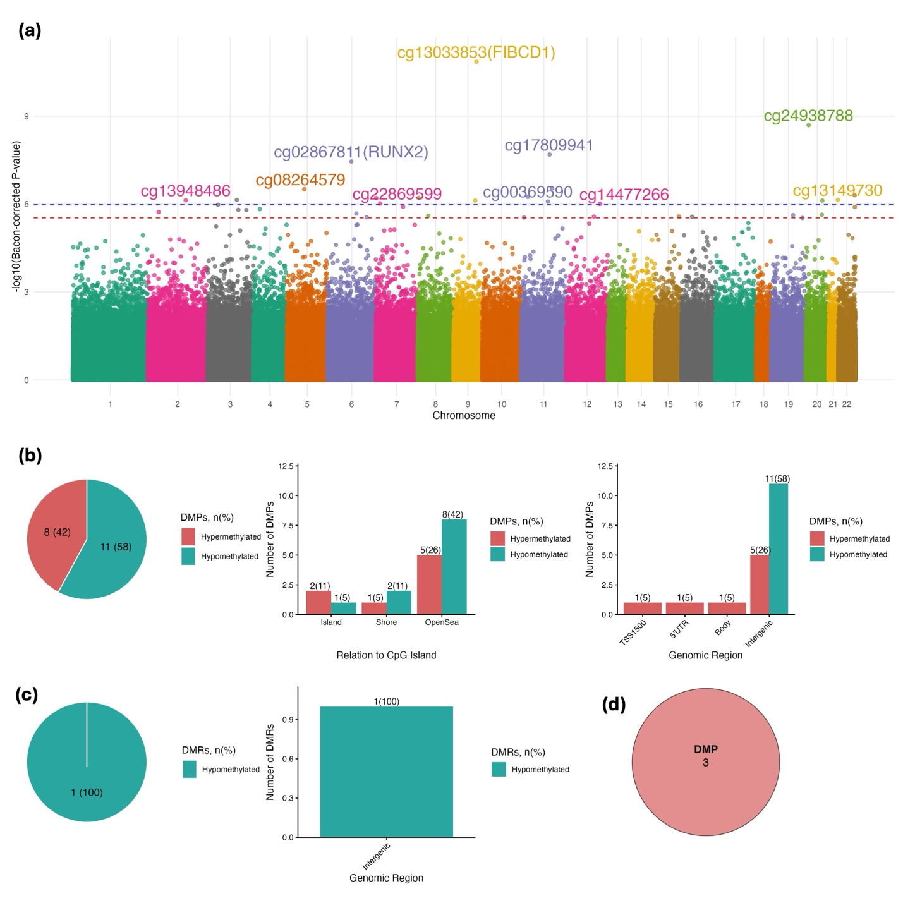

Supplemental Figure S4. Differentially methylated positions (DMPs) and regions (DMRs) in human skeletal muscle associated with cardiovascular and lifestyle health.
(a) Manhattan plots showing epigenome-wide associations. Labelled are top 10 significant DMPs (five hypermethylated and five hypomethylated), ranked by beta coefficients. The dashed blue line indicates the statistical significance threshold (BACON-corrected FDR<0.05), while the red line represents the suggestive significance threshold (BACON-corrected FDR<0.1). (b) Annotations of significant DMPs by CpG island context and genomic context, with hypermethylated in red and hypomethylated in teal. (c) Venn diagram showing the number of differentially methylated genes mapped from DMPs. No significant DMRs were identified.
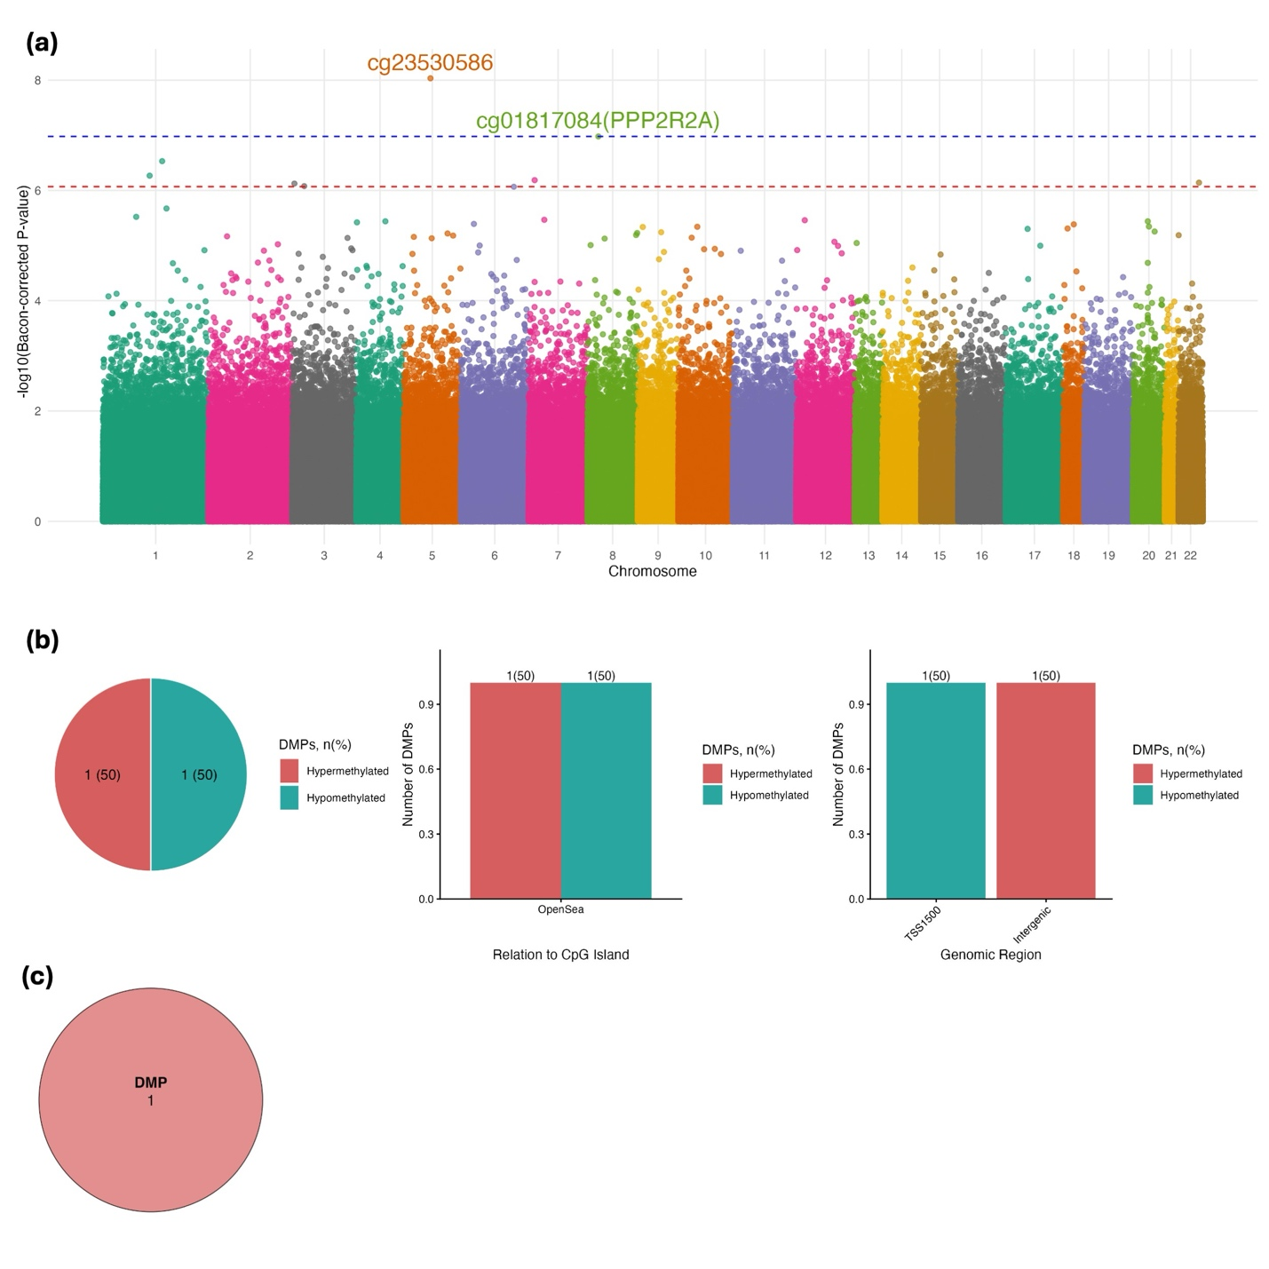

Supplemental Figure S5. Quantile–quantile (Q–Q) plots and genomic inflation factors (λ) after genomic correction.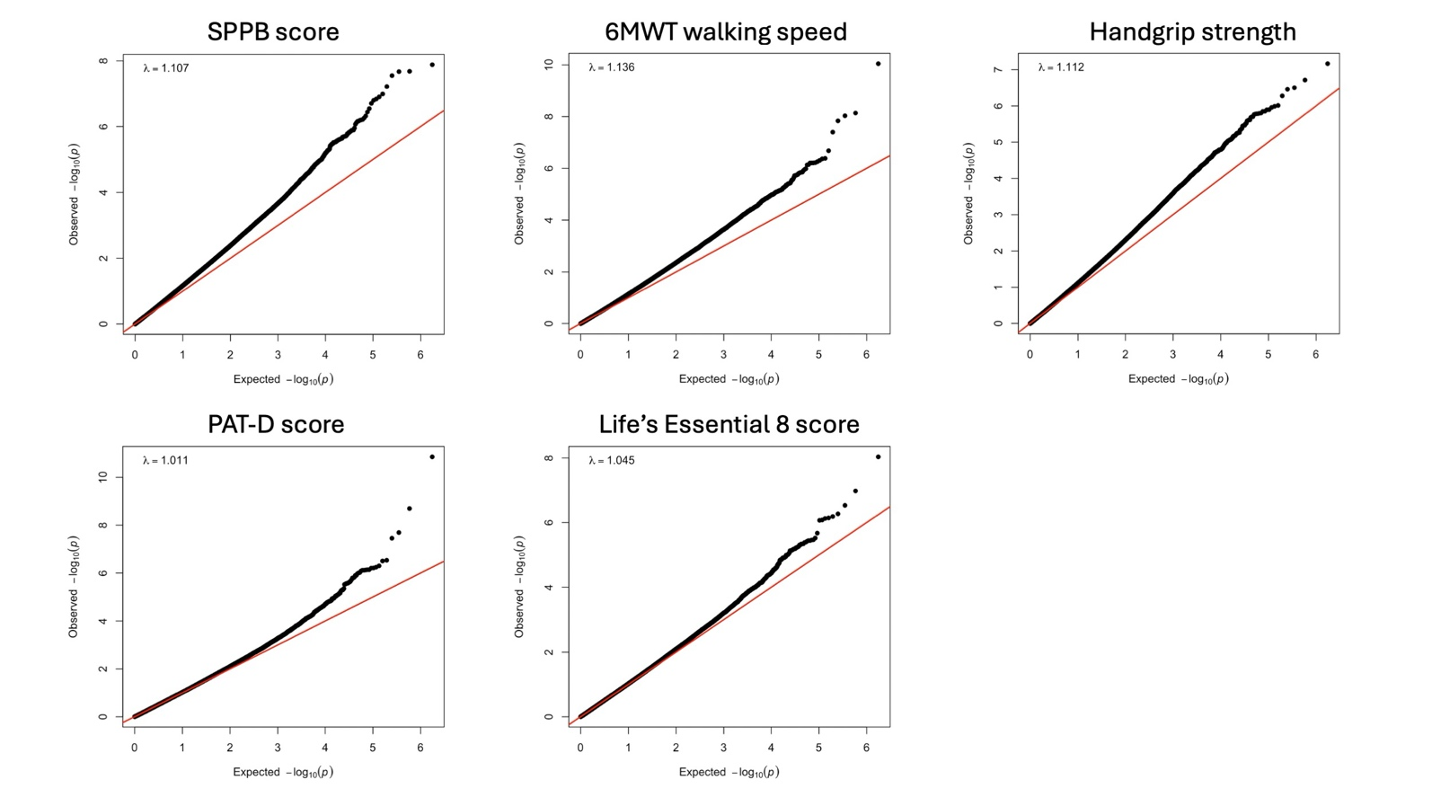

Supplemental Table S1. Skeletal muscle-based DMPs associated with physical function
 |  |  |  |  |  | Association with physical function phenotype
CpG | Chromosome | Position | Relation to CpG islands | Gene | Gene region | Beta | SE | P | FDR
SPPB score
cg13242895 | chr1 | 216632365 | OpenSea | - | - | 0.13 | 0.03 | 5.54E-07 | 0.032
cg18929316 | chr17 | 48099486 | Shore | - | - | 0.12 | 0.02 | 2.13E-08 | 0.006
cg02183588 | chr22 | 47549467 | OpenSea | - | - | 0.1 | 0.02 | 1.65E-06 | 0.045
cg19808663 | chr12 | 69584871 | Shore | CCT2;MIR3913-1 | TSS1500;TSS200 | 0.09 | 0.02 | 6.48E-07 | 0.032
cg01287200 | chr13 | 26399977 | OpenSea | - | - | 0.09 | 0.02 | 1.28E-06 | 0.045
cg13355697 | chr9 | 3469707 | OpenSea | - | - | 0.08 | 0.01 | 1.97E-07 | 0.017
cg04966255 | chr8 | 141170572 | Shelf | - | - | 0.08 | 0.02 | 2.32E-06 | 0.045
cg01409496 | chr14 | 78616558 | OpenSea | - | - | 0.07 | 0.01 | 8.54E-07 | 0.036
cg18327695 | chr2 | 101709976 | OpenSea | - | - | 0.07 | 0.02 | 3.06E-06 | 0.045
cg26262576 | chr13 | 19845888 | OpenSea | - | - | 0.06 | 0.01 | 3.62E-07 | 0.026
cg26753121 | chr2 | 8437362 | OpenSea | - | - | 0.06 | 0.01 | 1.95E-06 | 0.045
cg00930979 | chr7 | 93232464 | OpenSea | VPS50;HEPACAM2 | 5UTR;exon_1;TSS1500 | 0.06 | 0.01 | 2.78E-06 | 0.045
cg08453449 | chr12 | 108303165 | OpenSea | - | - | 0.06 | 0.01 | 2.83E-07 | 0.023
cg17318580 | chr4 | 15132956 | OpenSea | - | - | 0.06 | 0.01 | 2.67E-06 | 0.045
cg08576928 | chr11 | 75148178 | OpenSea | - | - | 0.06 | 0.01 | 3.31E-06 | 0.046
cg03171888 | chr19 | 5582689 | OpenSea | - | - | 0.05 | 0.01 | 3.06E-06 | 0.045
cg22450406 | chr2 | 234513521 | OpenSea | - | - | 0.05 | 0.01 | 1.97E-06 | 0.045
cg02922776 | chr1 | 212247290 | OpenSea | - | - | 0.05 | 0.01 | 2.47E-06 | 0.045
cg02290238 | chr1 | 48777262 | Shore | BEND5 | TSS1500 | 0.05 | 0.01 | 3.00E-06 | 0.045
cg26950885 | chr7 | 2647044 | Island | - | - | 0.05 | 0.01 | 3.74E-06 | 0.048
cg17588491 | chr22 | 24802925 | Shelf | - | - | 0.05 | 0.01 | 6.78E-07 | 0.032
cg15008085 | chr6 | 2247973 | Shelf | - | - | 0.05 | 0.01 | 2.98E-06 | 0.045
cg02794674 | chr2 | 48715065 | OpenSea | - | - | 0.05 | 0.01 | 2.55E-06 | 0.045
cg02650201 | chr17 | 62134596 | Shelf | - | - | 0.05 | 0.01 | 1.02E-07 | 0.015
cg15285463 | chr18 | 37577551 | OpenSea | - | - | 0.05 | 0.01 | 1.38E-06 | 0.045
cg07369189 | chr22 | 47388685 | OpenSea | - | - | 0.05 | 0.01 | 1.31E-08 | 0.006
cg14250419 | chr9 | 125691787 | OpenSea | - | - | 0.05 | 0.01 | 2.10E-06 | 0.045
cg02878119 | chr2 | 24793601 | Island | PTRHD1 | TSS1500 | 0.04 | 0.01 | 2.91E-06 | 0.045
cg06966462 | chr2 | 9472678 | Shore | - | - | 0.04 | 0.01 | 1.29E-06 | 0.045
cg18216010 | chr12 | 121203128 | OpenSea | - | - | 0.04 | 0.01 | 2.01E-06 | 0.045
cg09952192 | chr1 | 53464184 | Shelf | - | - | 0.04 | 0.01 | 3.60E-06 | 0.047
cg25880387 | chr6 | 29641993 | OpenSea | - | - | 0.04 | 0.01 | 3.53E-06 | 0.047
cg20660297 | chr12 | 75512523 | Shore | KRR1 | TSS1500 | -0.14 | 0.03 | 2.58E-06 | 0.045
cg25616992 | chr8 | 702342 | Shore | - | - | -0.1 | 0.02 | 2.00E-06 | 0.045
cg15542016 | chr1 | 204652124 | OpenSea | - | - | -0.1 | 0.02 | 2.09E-08 | 0.006
cg25326727 | chr1 | 164676015 | OpenSea | - | - | -0.09 | 0.02 | 1.12E-06 | 0.044
cg11362049 | chr11 | 132101462 | OpenSea | - | - | -0.08 | 0.02 | 2.32E-06 | 0.045
cg23372455 | chr19 | 6801964 | OpenSea | - | - | -0.08 | 0.02 | 4.81E-07 | 0.032
cg16060733 | chr8 | 3113531 | OpenSea | - | - | -0.08 | 0.02 | 3.40E-06 | 0.046
cg19647607 | chr20 | 13299299 | Island | ISM1 | exon_6 | -0.07 | 0.02 | 2.99E-06 | 0.045
cg05241721 | chr6 | 28574786 | OpenSea | ZBED9 | exon_5;exon_3 | -0.07 | 0.02 | 3.27E-06 | 0.046
cg04386341 | chr2 | 239355862 | OpenSea | - | - | -0.07 | 0.02 | 2.48E-06 | 0.045
cg09015232 | chr20 | 46028476 | Shore | SLC12A5 | TSS1500 | -0.07 | 0.01 | 2.39E-06 | 0.045
cg23066139 | chr10 | 131916614 | OpenSea | - | - | -0.07 | 0.01 | 1.87E-06 | 0.045
cg04760834 | chr4 | 7380663 | OpenSea | - | - | -0.07 | 0.01 | 1.53E-06 | 0.045
cg25847633 | chr6 | 35776453 | Island | CLPSL2 | TSS200 | -0.06 | 0.01 | 6.31E-07 | 0.032
cg02226847 | chr12 | 130340735 | Shore | - | - | -0.06 | 0.01 | 3.05E-06 | 0.045
cg19035815 | chr6 | 121614680 | OpenSea | - | - | -0.06 | 0.01 | 2.37E-06 | 0.045
cg24044084 | chr4 | 169612732 | Island | NEK1 | TSS200 | -0.06 | 0.01 | 2.94E-06 | 0.045
cg19516457 | chr12 | 72273927 | Shore | TRHDE-AS1 | TSS1500 | -0.06 | 0.01 | 1.42E-06 | 0.045
cg21248305 | chr6 | 30164938 | OpenSea | - | - | -0.06 | 0.01 | 3.37E-06 | 0.046
cg13274107 | chr2 | 101473909 | Island | - | - | -0.06 | 0.01 | 6.97E-07 | 0.032
cg26343043 | chr22 | 39228063 | Shelf | - | - | -0.06 | 0.01 | 2.45E-06 | 0.045
cg17826344 | chr19 | 50666403 | Island | SHANK1 | exon_23 | -0.05 | 0.01 | 7.60E-07 | 0.033
cg13272809 | chr3 | 109225077 | OpenSea | - | - | -0.05 | 0.01 | 3.84E-06 | 0.048
cg26661257 | chr14 | 61696373 | Island | HIF1A;HIF1A-AS1 | TSS1500 | -0.05 | 0.01 | 2.79E-06 | 0.045
cg23643660 | chr15 | 81331341 | OpenSea | TMC3 | 3UTR;exon_22 | -0.05 | 0.01 | 1.30E-06 | 0.045
cg25121831 | chr1 | 36081074 | Shelf | - | - | -0.05 | 0.01 | 1.25E-07 | 0.015
cg21564365 | chr2 | 235811232 | OpenSea | - | - | -0.05 | 0.01 | 2.64E-06 | 0.045
cg19724680 | chr14 | 49863183 | Island | RN7SL2 | TSS1500 | -0.05 | 0.01 | 2.82E-08 | 0.006
cg23228491 | chr7 | 55952318 | Shore | - | - | -0.05 | 0.01 | 2.11E-06 | 0.045
cg04288036 | chr11 | 62792241 | Shore | NXF1;TMEM223 | 3UTR;exon_20;exon_21;TSS1500 | -0.05 | 0.01 | 1.59E-07 | 0.015
cg25788116 | chr21 | 32569649 | Island | - | - | -0.05 | 0.01 | 6.07E-08 | 0.011
cg08188248 | chr5 | 80570803 | Shore | ANKRD34B | TSS1500 | -0.04 | 0.01 | 3.81E-06 | 0.048
cg00409965 | chr16 | 31033047 | Island | STX4 | TSS1500;TSS200 | -0.04 | 0.01 | 2.04E-06 | 0.045
cg14817043 | chr20 | 2693583 | Island | EBF4 | 5UTR;exon_1 | -0.04 | 0.01 | 6.13E-07 | 0.032
cg20977327 | chr1 | 248826260 | Island | MIR3124;SH3BP5L | TSS200;TSS1500 | -0.04 | 0.01 | 1.45E-07 | 0.015
cg09837632 | chr2 | 215311992 | Island | ATIC | TSS200 | -0.04 | 0.01 | 1.66E-06 | 0.045
cg20056914 | chr14 | 23042846 | OpenSea | PSMB11 | exon_1 | -0.04 | 0.01 | 3.40E-06 | 0.046
cg11332994 | chr5 | 70049314 | Shore | SMN2 | TSS1500 | -0.03 | 0.01 | 1.51E-06 | 0.045
6MWT walking speed
cg27592988 | chr7 | 128707747 | OpenSea | FAM71F1 | TSS1500 | 1.16 | 0.18 | 8.94E-11 | 7.83E-05
cg17308762 | chr8 | 41803604 | OpenSea | - | - | 1.07 | 0.22 | 7.41E-07 | 0.041
cg25886345 | chr4 | 68311147 | OpenSea | YTHDC1 | 3UTR;exon_17;exon_16 | 1.03 | 0.2 | 2.09E-07 | 0.03
cg16037140 | chr11 | 13215319 | OpenSea | - | - | 1.01 | 0.18 | 9.34E-09 | 0.003
cg24701190 | chr10 | 118914351 | OpenSea | - | - | 0.94 | 0.19 | 4.12E-07 | 0.039
cg10957528 | chr7 | 23532992 | Shore | TRA2A | TSS1500 | 0.77 | 0.14 | 3.98E-08 | 0.007
cg04083035 | chr1 | 116471687 | OpenSea | - | - | 0.75 | 0.15 | 4.97E-07 | 0.039
cg10540364 | chr10 | 21494610 | Island | MIR1915HG | exon_2 | 0.66 | 0.13 | 6.22E-07 | 0.039
cg06555729 | chr15 | 99384075 | OpenSea | - | - | 0.66 | 0.13 | 7.22E-07 | 0.041
cg06972967 | chr16 | 66994504 | OpenSea | - | - | 0.65 | 0.13 | 5.54E-07 | 0.039
cg07921851 | chr10 | 110455188 | OpenSea | - | - | 0.48 | 0.09 | 4.31E-07 | 0.039
cg15554005 | chr11 | 128871418 | OpenSea | - | - | 0.45 | 0.08 | 1.46E-08 | 0.003
cg07331460 | chr7 | 156116138 | OpenSea | - | - | -0.74 | 0.15 | 6.05E-07 | 0.039
cg02775617 | chr10 | 31928353 | Island | - | - | -0.65 | 0.13 | 6.17E-07 | 0.039
cg07696690 | chr16 | 20900256 | Island | DCUN1D3;LYRM1 | 5UTR;exon_1;TSS1500;TSS200 | -0.62 | 0.12 | 6.20E-07 | 0.039
cg19062112 | chr14 | 102592717 | Island | RCOR1 | 5UTR;exon_1 | -0.54 | 0.09 | 7.26E-09 | 0.003
Perceived disability
cg02867811 | chr6 | 45327631 | OpenSea | RUNX2 | TSS1500 | 1.91 | 0.35 | 3.52E-08 | 0.008
cg08264579 | chr5 | 90408016 | Shore | - | - | 1.45 | 0.28 | 3.13E-07 | 0.045
cg24938788 | chr20 | 6299417 | OpenSea | - | - | 1.26 | 0.21 | 2.01E-09 | 0.001
cg13033853 | chr9 | 130939012 | Island | FIBCD1 | 5UTR;exon_1 | 1.18 | 0.17 | 1.39E-11 | 1.21E-05
cg13948486 | chr2 | 162260663 | OpenSea | - | - | 1.15 | 0.23 | 7.47E-07 | 0.045
cg14306821 | chr9 | 128984927 | OpenSea | NUP188 | exon_20 | 0.75 | 0.15 | 7.66E-07 | 0.045
cg05511326 | chr3 | 129662169 | OpenSea | - | - | 0.54 | 0.11 | 7.24E-07 | 0.045
cg25151919 | chr3 | 44712841 | Island | - | - | 0.34 | 0.07 | 1.06E-06 | 0.049
cg14477266 | chr12 | 118052650 | OpenSea | - | - | -0.9 | 0.18 | 9.91E-07 | 0.048
cg17809941 | chr11 | 74237605 | OpenSea | - | - | -0.72 | 0.13 | 2.04E-08 | 0.006
cg00369590 | chr11 | 70744064 | OpenSea | - | - | -0.57 | 0.12 | 8.19E-07 | 0.045
cg22869599 | chr7 | 4235751 | OpenSea | - | - | -0.55 | 0.11 | 9.53E-07 | 0.048
cg13149730 | chr21 | 46315066 | OpenSea | - | - | -0.49 | 0.1 | 7.20E-07 | 0.045
cg22460512 | chr11 | 83312166 | OpenSea | - | - | -0.46 | 0.09 | 2.93E-07 | 0.045
cg03901910 | chr8 | 1640733 | Shore | - | - | -0.44 | 0.09 | 6.14E-07 | 0.045
cg10502963 | chr7 | 379946 | Island | - | - | -0.4 | 0.08 | 6.25E-07 | 0.045
cg12330031 | chr22 | 49930490 | Shore | - | - | -0.37 | 0.07 | 5.00E-07 | 0.045
cg16013757 | chr11 | 10583420 | OpenSea | - | - | -0.31 | 0.06 | 5.69E-07 | 0.045
cg09870201 | chr20 | 51378294 | OpenSea | - | - | -0.3 | 0.06 | 7.65E-07 | 0.045
Cardiovascular and lifestyle score
cg23530586 | chr5 | 100595733 | OpenSea | - | - | 0.01 | 0 | 9.23E-09 | 0.008
cg01817084 | chr8 | 26292049 | OpenSea | PPP2R2A | TSS1500 | -0.01 | 0 | 1.05E-07 | 0.046

Abbreviations: DMP, differentially methylated position; SPPB, Short Physical Performance Battery; 6MWT, 6-Minute Walk Test.
Supplemental Table S2. Skeletal muscle-based DMRs associated with physical function
 |  |  |  |  | Association with physical function phenotype
Chromosome | Genomic Coordinates | N CpGs | Gene | Gene region | Mean beta | Combined FDR
SPPB score
chr11 | 67605481-67605643 | 3 | NDUFV1 | TSS1500 | 0.012 | 0.008
chr22 | 45226922-45227185 | 4 | - | - | 0.009 | 2.88E-04
chr1 | 44721879-44722274 | 5 | RNU5F-1 | TSS1500;exon_1;TSS200 | 0.008 | 0.001
chr1 | 3658140-3658435 | 3 | - | - | 0.007 | 3.20E-05
chr6 | 30743784-30744025 | 10 | IER3;FLOT1 | 3UTR;exon_2;TSS1500 | 0.006 | 0.017
chr5 | 103562449-103563257 | 11 | NUDT12 | TSS200;5UTR;exon_1;TSS1500 | 0.006 | 0.006
chr16 | 67943962-67944547 | 10 | LCAT;SLC12A4 | TSS200;3UTR;exon_24;exon_23;exon_1;TSS1500 | 0.006 | 3.71E-04
chr5 | 138875060-138875495 | 9 | LRRTM2;CTNNA1 | exon_1;5UTR;TSS1500;TSS200 | 0.005 | 0.008
chr12 | 108302785-108303505 | 4 | - | - | 0.005 | 3.10E-06
chr10 | 88952868-88953250 | 7 | ACTA2 | TSS1500;TSS200 | 0.004 | 0.001
chr8 | 141222853-141223606 | 6 | - | - | 0.004 | 4.55E-05
chr10 | 104274714-104275410 | 11 | GSTO2 | TSS200;5UTR;exon_2;TSS1500 | 0.003 | 0.002
chr1 | 3650844-3651681 | 18 | TP73;WRAP73 | TSS1500 | 0.003 | 0.01
chr6 | 31740449-31740735 | 6 | MSH5;MSH5-SAPCD1 | exon_2 | 0.002 | 4.44E-05
chr17 | 1604349-1605791 | 11 | SLC43A2 | exon_1;5UTR;TSS1500;TSS200 | -0.01 | 0.002
chr22 | 29313975-29314542 | 4 | RASL10A | exon_2 | -0.007 | 2.14E-04
chr5 | 81301324-81302009 | 13 | CKMT2-AS1;ZCCHC9 | exon_1;TSS200;5UTR;TSS1500 | -0.006 | 0.002
chr1 | 101847052-101847115 | 3 | OLFM3 | TSS200 | -0.005 | 0.001
chr17 | 43125677-43126889 | 14 | BRCA1;NBR2 | TSS1500;exon_1 | -0.005 | 0.001
chr6 | 28615878-28616687 | 17 | ZBED9 | TSS200;TSS1500;5UTR;exon_1 | -0.004 | 0.001
chr6 | 32095776-32097065 | 31 | TNXB | exon_3 | -0.004 | 0.011
chr22 | 31662133-31662824 | 10 | PISD | exon_1;5UTR;TSS200;TSS1500 | -0.003 | 2.88E-04
6MWT walking speed
chr5 | 136079169-136080924 | 19 | VTRNA2-1 | TSS200;TSS1500;exon_1 | 0.126 | 1.85E-04
chr1 | 114099885-114100239 | 3 | - | - | 0.114 | 3.36E-04
chr18 | 74498194-74499978 | 8 | CNDP2 | exon_1;exon_2;exon_4;5UTR;exon_3;TSS1500;TSS200 | 0.111 | 8.61E-05
chr2 | 113235117-113235736 | 8 | PAX8-AS1;PAX8 | TSS1500;exon_9;TSS200;exon_1 | 0.109 | 0.018
chr2 | 3605056-3605893 | 6 | COLEC11 | TSS1500;TSS200 | 0.105 | 0.001
chr2 | 130288549-130288978 | 4 | - | - | 0.104 | 0.002
chr20 | 32792069-32792762 | 4 | DNMT3B | exon_8;exon_7;exon_9 | 0.101 | 0.001
chr12 | 50222317-50222479 | 3 | LIMA1 | exon_4;exon_1;5UTR;exon_5 | 0.099 | 0.02
chr15 | 39976543-39977013 | 3 | EIF2AK4 | exon_12 | 0.097 | 0.01
chr1 | 55944024-55944335 | 3 | LINC01755 | TSS1500 | 0.096 | 0.003
chr17 | 83103203-83105373 | 14 | - | - | 0.095 | 0.005
chr2 | 240983361-240983938 | 4 | - | - | 0.086 | 0.005
chr16 | 86578084-86578845 | 8 | FOXL1 | exon_1;5UTR;TSS1500;TSS200 | 0.086 | 0.007
chr11 | 14905234-14906003 | 5 | - | - | 0.085 | 2.97E-04
chr13 | 99565670-99566759 | 7 | - | - | 0.083 | 0.001
chr4 | 173535353-173536793 | 6 | - | - | 0.081 | 4.67E-04
chr22 | 45226922-45227185 | 4 | - | - | 0.08 | 0.001
chr11 | 58424250-58424591 | 3 | - | - | 0.08 | 9.89E-05
chr3 | 15287391-15287806 | 4 | - | - | 0.079 | 0.001
chr5 | 1413268-1413905 | 3 | - | - | 0.078 | 0.001
chr18 | 57622565-57622593 | 3 | NARS1 | TSS1500 | 0.077 | 0.001
chr13 | 99316862-99317019 | 3 | - | - | 0.073 | 1.26E-04
chr2 | 176158234-176159566 | 9 | - | - | 0.073 | 0.011
chr14 | 91396469-91396563 | 4 | - | - | 0.073 | 0.002
chr2 | 176163128-176164731 | 11 | HOXD3 | 5UTR;exon_2 | 0.072 | 0.01
chr8 | 29905341-29905618 | 3 | - | - | 0.072 | 1.57E-04
chr18 | 63489832-63490606 | 6 | - | - | 0.07 | 0.001
chr2 | 176123475-176124211 | 6 | HOXD9 | exon_1;exon_2;3UTR | 0.07 | 0.01
chr15 | 100910487-100910634 | 3 | - | - | 0.069 | 3.94E-04
chr11 | 78561221-78561697 | 3 | - | - | 0.068 | 3.68E-05
chr7 | 151590759-151590951 | 3 | - | - | 0.066 | 0.002
chr10 | 21509769-21510466 | 4 | - | - | 0.065 | 0.001
chr6 | 169577298-169578291 | 5 | - | - | 0.064 | 0.002
chr7 | 129169259-129169601 | 5 | TSPAN33 | exon_8;3UTR | 0.063 | 0.005
chr15 | 40106798-40106900 | 3 | BMF | TSS1500;TSS200 | 0.063 | 0.002
chr4 | 84503042-84503316 | 3 | - | - | 0.062 | 0.001
chr21 | 35048967-35049815 | 9 | RUNX1 | 5UTR;exon_1;TSS1500;TSS200 | 0.062 | 2.40E-04
chr17 | 80891287-80892554 | 10 | RPTOR | exon_14;exon_18 | 0.061 | 0.003
chr1 | 2922240-2922655 | 5 | - | - | 0.06 | 0.001
chr3 | 128142045-128142208 | 4 | - | - | 0.059 | 0.001
chr7 | 102933787-102934057 | 3 | LRRC17 | exon_2;5UTR | 0.059 | 0.003
chr2 | 20595685-20596152 | 3 | - | - | 0.059 | 5.59E-05
chr3 | 128075376-128076551 | 9 | RUVBL1-AS1 | TSS1500;TSS200;exon_1 | 0.058 | 0.001
chr19 | 822842-823856 | 4 | PLPPR3 | TSS1500 | 0.058 | 3.50E-04
chr1 | 107139554-107139680 | 3 | NTNG1 | TSS1500 | 0.058 | 0.002
chr13 | 52739760-52740091 | 5 | CNMD | exon_1;5UTR;TSS1500;TSS200 | 0.057 | 0.007
chr10 | 76051269-76051662 | 3 | - | - | 0.056 | 0.001
chr3 | 137642684-137643086 | 3 | - | - | 0.056 | 3.99E-05
chr22 | 50547252-50548533 | 7 | KLHDC7B | exon_1 | 0.056 | 0.001
chr6 | 158626112-158626333 | 4 | - | - | 0.056 | 0.001
chr2 | 176149281-176153069 | 33 | HOXD4;MIR10B | TSS1500;TSS200;exon_2;exon_1;3UTR | 0.056 | 0.006
chr2 | 9631939-9632246 | 3 | YWHAQ | TSS1500 | 0.056 | 0.001
chr14 | 58919298-58919546 | 3 | - | - | 0.056 | 1.95E-05
chr1 | 63012361-63012500 | 3 | LINC01739 | exon_1;TSS1500;TSS200 | 0.056 | 4.29E-04
chr1 | 153549183-153549525 | 6 | S100A3 | 5UTR;exon_1;TSS200;TSS1500 | 0.055 | 0.008
chr22 | 45503412-45503856 | 3 | - | - | 0.055 | 0.002
chr1 | 3771240-3771693 | 4 | CCDC27;SMIM1 | exon_12;3UTR;TSS1500 | 0.054 | 0.002
chr11 | 114294939-114296970 | 9 | NNMT | TSS1500;TSS200 | 0.054 | 1.18E-05
chr5 | 37835446-37835599 | 4 | GDNF | TSS1500;TSS200;5UTR;exon_1 | 0.053 | 0.026
chr4 | 8392440-8392970 | 5 | ACOX3 | exon_11;exon_10 | 0.053 | 0.004
chr10 | 71766472-71766907 | 3 | - | - | 0.053 | 8.74E-05
chr17 | 59840901-59841269 | 4 | VMP1;MIR21 | exon_12;3UTR;exon_13;exon_11;exon_10;TSS200;exon_1;TSS1500 | 0.053 | 3.54E-04
chr1 | 119711554-119711707 | 4 | PHGDH | TSS1500 | 0.053 | 9.40E-05
chr16 | 87065518-87066623 | 5 | - | - | 0.052 | 2.91E-04
chr19 | 6730702-6730723 | 3 | - | - | 0.052 | 3.52E-04
chr10 | 131260594-131260725 | 4 | - | - | 0.052 | 4.17E-04
chr9 | 127353865-127354139 | 3 | GARNL3 | exon_19;exon_18 | 0.052 | 0.002
chr4 | 171639462-171639642 | 3 | LINC02174 | TSS1500 | 0.051 | 2.56E-04
chr1 | 91736928-91737430 | 4 | - | - | 0.051 | 1.57E-04
chr2 | 44949844-44950104 | 3 | - | - | 0.051 | 1.78E-04
chr4 | 151227670-151227912 | 3 | SH3D19 | TSS1500;TSS200;5UTR;exon_1 | 0.051 | 0.008
chr1 | 201648218-201648725 | 6 | NAV1 | TSS1500;exon_5;exon_4;exon_1 | 0.051 | 0.02
chr11 | 59811041-59811202 | 4 | MRPL16 | TSS1500 | 0.05 | 0.001
chr7 | 73742887-73743687 | 5 | - | - | 0.05 | 0.001
chr1 | 83860502-83861743 | 12 | LOC101927560;LINC01725 | TSS200;exon_1;TSS1500 | 0.05 | 0.001
chr10 | 131616652-131617753 | 6 | - | - | 0.05 | 0.003
chr5 | 83720811-83721365 | 8 | HAPLN1 | TSS1500;5UTR;exon_1;TSS200 | 0.049 | 0.004
chr16 | 14370358-14370518 | 4 | LINC02130 | TSS200;TSS1500 | 0.049 | 2.52E-04
chr6 | 30154746-30155684 | 9 | - | - | 0.049 | 0.005
chr15 | 77144143-77144783 | 4 | - | - | 0.049 | 0.002
chr16 | 67277628-67278010 | 3 | PLEKHG4 | TSS1500;TSS200 | 0.049 | 0.003
chr16 | 87044980-87045707 | 5 | - | - | 0.049 | 0.002
chr2 | 112541078-112541373 | 3 | TTL;POLR1B | exon_7;3UTR;TSS1500 | 0.049 | 2.69E-04
chr3 | 46406335-46406643 | 3 | CCRL2 | TSS1500 | 0.049 | 1.59E-04
chr14 | 61546612-61547298 | 3 | - | - | 0.048 | 3.39E-04
chr10 | 92690299-92692723 | 17 | HHEX | exon_1;exon_2;exon_3 | 0.048 | 3.04E-04
chr8 | 681217-682172 | 3 | - | - | 0.048 | 2.29E-05
chr1 | 156149629-156150188 | 5 | SEMA4A | TSS1500;TSS200 | 0.048 | 0.008
chr16 | 30473975-30474645 | 6 | ITGAL | exon_2 | 0.048 | 0.003
chr4 | 173528337-173528865 | 6 | HAND2-AS1;HAND2 | exon_1;TSS1500;TSS200 | 0.048 | 0.006
chr21 | 42562055-42562450 | 5 | SLC37A1 | exon_12;exon_13 | 0.048 | 0.005
chr12 | 51392254-51393018 | 4 | GALNT6 | TSS1500 | 0.048 | 0.003
chr19 | 55537890-55538457 | 4 | SBK2 | TSS1500 | 0.047 | 2.83E-04
chr8 | 120125894-120126078 | 3 | - | - | 0.047 | 0.001
chr11 | 112166379-112166950 | 5 | TEX12 | TSS1500 | 0.046 | 2.58E-04
chr9 | 135700643-135701165 | 3 | SOHLH1;KCNT1 | TSS1500 | 0.046 | 1.50E-04
chr10 | 99233268-99233905 | 9 | - | - | 0.045 | 0.025
chr2 | 3656398-3657681 | 8 | ALLC | TSS1500 | 0.045 | 4.52E-04
chr16 | 66842944-66843035 | 3 | CA7 | TSS1500 | 0.045 | 0.002
chr20 | 32806322-32806498 | 3 | DNMT3B | exon_22;exon_21 | 0.045 | 0.002
chr1 | 6520050-6520465 | 6 | PLEKHG5 | TSS200;TSS1500;5UTR;exon_1 | 0.045 | 0.002
chr1 | 3940065-3940684 | 8 | LINC01346 | TSS1500;TSS200;exon_1 | 0.044 | 0.002
chr11 | 13215319-13216653 | 4 | - | - | 0.044 | 6.58E-07
chr17 | 12990072-12990331 | 3 | ARHGAP44 | 3UTR;exon_21;exon_20;exon_22;exon_18 | 0.044 | 2.85E-05
chr15 | 61365143-61365271 | 3 | - | - | 0.044 | 0.001
chr8 | 1989401-1989757 | 4 | - | - | 0.044 | 0.001
chr5 | 1003389-1004664 | 7 | - | - | 0.043 | 0.001
chr16 | 81899378-81899865 | 4 | - | - | 0.043 | 1.01E-04
chr6 | 75202000-75202468 | 5 | - | - | 0.043 | 0.007
chr8 | 26041323-26041741 | 4 | - | - | 0.043 | 0.009
chr7 | 46969297-46969428 | 3 | - | - | 0.043 | 0.001
chr3 | 128553880-128554278 | 3 | - | - | 0.043 | 1.77E-04
chr4 | 8228326-8229120 | 6 | SH3TC1 | exon_12;exon_10 | 0.043 | 0.001
chr22 | 37735414-37736090 | 3 | TRIOBP | exon_9 | 0.042 | 3.87E-04
chr22 | 43516029-43516199 | 4 | EFCAB6-AS1 | TSS200;TSS1500 | 0.042 | 0.001
chr10 | 117131466-117132195 | 7 | VAX1 | 3UTR;exon_4 | 0.042 | 0.006
chr10 | 121263166-121263268 | 4 | - | - | 0.042 | 6.66E-05
chr10 | 76112326-76112858 | 4 | - | - | 0.042 | 0.002
chr19 | 1065185-1066350 | 10 | ARHGAP45;ABCA7 | TSS1500;TSS200;exon_47 | 0.042 | 0.001
chr18 | 54827850-54828173 | 4 | RAB27B | TSS1500 | 0.042 | 2.06E-04
chr11 | 43920385-43921132 | 6 | ALKBH3-AS1 | exon_1;TSS200 | 0.041 | 3.31E-04
chr10 | 132124389-132124702 | 3 | - | - | 0.041 | 0.001
chr21 | 45544429-45544735 | 4 | - | - | 0.041 | 0.006
chr19 | 44613396-44613597 | 5 | IGSF23 | TSS200;5UTR;exon_1 | 0.041 | 0.001
chr18 | 78543815-78544675 | 6 | - | - | 0.041 | 3.87E-04
chr2 | 190406794-190407838 | 5 | MFSD6 | TSS1500;TSS200 | 0.04 | 0.001
chr5 | 176135111-176136016 | 3 | - | - | 0.04 | 2.85E-05
chr15 | 63596321-63597072 | 5 | FBXL22 | TSS1500 | 0.04 | 0.003
chr8 | 23572480-23573501 | 5 | SLC25A37 | exon_4;3UTR;exon_5 | 0.04 | 2.18E-04
chr19 | 8392452-8392875 | 3 | - | - | 0.039 | 1.90E-04
chr1 | 155972294-155972551 | 4 | - | - | 0.039 | 0.001
chr11 | 119920940-119921107 | 3 | - | - | 0.039 | 6.15E-05
chr5 | 180138041-180138362 | 3 | RASGEF1C | exon_2 | 0.039 | 0.001
chr19 | 2550867-2551327 | 3 | - | - | 0.039 | 1.89E-05
chr17 | 37745038-37745373 | 8 | HNF1B | TSS1500;TSS200;exon_1;5UTR | 0.039 | 0.006
chr11 | 134503266-134503733 | 5 | - | - | 0.039 | 2.46E-04
chr12 | 112410854-112411333 | 3 | RPL6 | TSS1500;5UTR;exon_2;exon_1 | 0.039 | 0.001
chr4 | 173510579-173510771 | 4 | - | - | 0.039 | 0.002
chr5 | 61265824-61266057 | 3 | LINC02057 | TSS1500 | 0.039 | 0.001
chr9 | 33443167-33443979 | 3 | AQP3 | exon_3 | 0.039 | 3.74E-04
chr16 | 87067855-87068441 | 7 | - | - | 0.039 | 0.017
chr11 | 118636455-118636726 | 3 | - | - | 0.038 | 0.001
chr8 | 42843793-42844140 | 4 | THAP1 | TSS1500 | 0.038 | 1.81E-04
chr14 | 95312370-95312815 | 3 | - | - | 0.038 | 2.29E-04
chr22 | 20966704-20967775 | 7 | AIFM3 | TSS1500;5UTR;exon_1;TSS200 | 0.038 | 3.64E-04
chr8 | 141222853-141223606 | 6 | - | - | 0.038 | 5.63E-05
chr1 | 190474765-190475536 | 4 | - | - | 0.038 | 1.54E-04
chr6 | 101398197-101400360 | 21 | GRIK2 | 5UTR;exon_1;exon_2;TSS200;TSS1500 | 0.038 | 0.005
chr16 | 4371097-4371653 | 8 | VASN | TSS1500;TSS200 | 0.038 | 0.003
chr3 | 48371400-48372217 | 4 | FBXW12 | TSS200;TSS1500 | 0.038 | 4.67E-05
chr22 | 30408837-30409228 | 5 | SEC14L2 | exon_4;exon_5;exon_6 | 0.037 | 0.001
chr22 | 37904594-37905229 | 4 | MICALL1 | TSS1500 | 0.037 | 0.002
chr4 | 40514623-40514874 | 4 | RBM47 | TSS1500;TSS200 | 0.037 | 3.17E-04
chr1 | 95139959-95140628 | 3 | - | - | 0.037 | 1.79E-04
chr6 | 31772060-31772514 | 3 | - | - | 0.037 | 0.001
chr11 | 37278555-37278853 | 3 | - | - | 0.037 | 2.05E-04
chr18 | 35355340-35355771 | 3 | - | - | 0.037 | 9.85E-05
chr4 | 4861951-4863175 | 15 | MSX1 | exon_2;3UTR | 0.037 | 0.012
chr7 | 151012098-151012448 | 3 | ATG9B;NOS3 | exon_18;exon_17;exon_24 | 0.036 | 0.003
chr11 | 6497033-6497347 | 10 | DNHD1 | TSS1500;TSS200;5UTR;exon_1 | 0.036 | 0.011
chr10 | 84540831-84541196 | 3 | - | - | 0.036 | 1.09E-04
chr13 | 114115286-114116081 | 8 | - | - | 0.036 | 2.21E-04
chr21 | 42367362-42367716 | 4 | TFF1 | TSS1500 | 0.036 | 0.001
chr22 | 50012625-50012985 | 5 | IL17REL | TSS1500;5UTR;exon_1;TSS200 | 0.036 | 0.005
chr1 | 58703585-58704253 | 5 | - | - | 0.036 | 0.002
chr12 | 75390761-75391515 | 11 | GLIPR1L2;CAPS2 | TSS200;exon_1;TSS1500;5UTR | 0.036 | 0.009
chr2 | 69770093-69770464 | 3 | - | - | 0.036 | 3.46E-04
chr18 | 77248673-77249538 | 16 | GALR1 | TSS1500 | 0.036 | 0.006
chr16 | 86565186-86565862 | 5 | FOXC2;FOXC2-AS1 | TSS1500;exon_2 | 0.035 | 3.88E-04
chr5 | 74684214-74684591 | 3 | HEXB | TSS1500 | 0.035 | 3.46E-05
chr5 | 138874861-138875060 | 5 | LRRTM2;CTNNA1 | exon_1;5UTR;TSS1500;TSS200 | 0.035 | 1.00E-04
chr15 | 90929937-90930281 | 7 | UNC45A;HDDC3 | 5UTR;exon_1;3UTR;exon_4;TSS200;TSS1500 | 0.035 | 0.003
chr1 | 32881627-32882514 | 4 | - | - | 0.035 | 3.40E-05
chr18 | 32772542-32773736 | 11 | KLHL14 | TSS200;TSS1500;5UTR;exon_1 | 0.035 | 0.012
chr19 | 51724056-51724795 | 6 | HAS1 | TSS200;TSS1500 | 0.035 | 0.001
chr3 | 141367978-141368521 | 6 | ZBTB38 | TSS200;5UTR;exon_1;TSS1500 | 0.035 | 0.005
chr11 | 117824657-117825300 | 6 | FXYD2 | TSS200;TSS1500;exon_1 | 0.035 | 0.001
chr7 | 1326109-1326232 | 3 | - | - | 0.035 | 0.004
chr1 | 22965290-22965673 | 3 | LACTBL1 | exon_3 | 0.035 | 2.61E-04
chr12 | 120314325-120314467 | 3 | - | - | 0.035 | 5.10E-05
chr19 | 41362592-41363504 | 3 | TMEM91;B9D2 | TSS1500;exon_2 | 0.034 | 1.39E-05
chr17 | 35448760-35449664 | 10 | SLFN13 | TSS200;TSS1500;5UTR;exon_1 | 0.034 | 0.003
chr22 | 50085257-50086112 | 14 | MLC1 | exon_1;5UTR;exon_2;TSS1500;TSS200 | 0.034 | 0.002
chr2 | 176112074-176113045 | 5 | - | - | 0.034 | 0.001
chr3 | 15634422-15635487 | 3 | BTD | exon_2;exon_4;exon_3 | 0.034 | 5.81E-05
chr12 | 2284505-2285017 | 4 | - | - | 0.034 | 3.64E-04
chr1 | 79006299-79007232 | 12 | ADGRL4 | exon_1;5UTR;TSS200;TSS1500 | 0.034 | 3.51E-04
chr1 | 9827753-9827926 | 3 | - | - | 0.034 | 1.84E-04
chr6 | 170253240-170254459 | 4 | LOC154449 | exon_3 | 0.034 | 2.94E-05
chr11 | 125082877-125083244 | 5 | - | - | 0.034 | 0.002
chr15 | 81225200-81225417 | 5 | IL16 | 5UTR;exon_2 | 0.034 | 4.97E-04
chr16 | 11316236-11317110 | 7 | - | - | 0.033 | 2.02E-04
chr11 | 65297436-65298897 | 5 | POLA2 | exon_18;3UTR | 0.033 | 0.001
chr8 | 81631184-81631659 | 3 | IMPA1P1 | exon_1;TSS1500;TSS200 | 0.033 | 0.002
chr1 | 200036091-200037119 | 5 | - | - | 0.033 | 1.69E-04
chr2 | 176121225-176121931 | 6 | HOXD9 | TSS1500 | 0.033 | 0.003
chr3 | 11225279-11225386 | 3 | HRH1 | TSS1500 | 0.033 | 1.46E-04
chr17 | 9360744-9360848 | 3 | - | - | 0.033 | 0.001
chr12 | 53753977-53754499 | 5 | - | - | 0.033 | 7.76E-05
chr4 | 2287077-2287849 | 4 | - | - | 0.033 | 0.001
chr1 | 224457048-224457674 | 3 | - | - | 0.033 | 2.10E-05
chr4 | 184001229-184001493 | 5 | STOX2 | exon_2 | 0.033 | 0.001
chr16 | 4788376-4788905 | 7 | SMIM22;SEPTIN12 | 5UTR;exon_1;TSS1500;TSS200 | 0.033 | 0.01
chr6 | 10418783-10419167 | 3 | - | - | 0.033 | 0.002
chr1 | 35869556-35869791 | 6 | AGO1 | 5UTR;exon_1;TSS200;TSS1500 | 0.033 | 3.15E-05
chr10 | 1464943-1465364 | 3 | - | - | 0.032 | 0.002
chr11 | 67346273-67346658 | 3 | - | - | 0.032 | 2.56E-04
chr14 | 77142127-77142800 | 4 | ZDHHC22 | TSS1500 | 0.032 | 0.004
chr8 | 1676515-1676656 | 4 | DLGAP2 | exon_11 | 0.032 | 3.30E-04
chr22 | 31626304-31626767 | 3 | - | - | 0.032 | 9.65E-05
chr16 | 1430301-1430991 | 7 | PERCC1 | TSS1500;TSS200 | 0.032 | 0.008
chr9 | 133422167-133422289 | 3 | ADAMTS13 | TSS200;TSS1500 | 0.032 | 2.29E-04
chr12 | 130086701-130086797 | 3 | - | - | 0.032 | 4.26E-05
chr8 | 23356449-23357045 | 6 | - | - | 0.032 | 6.20E-05
chr2 | 176105780-176106627 | 5 | HOXD11 | TSS1500 | 0.032 | 0.001
chr12 | 118015695-118016221 | 3 | RFC5 | TSS1500 | 0.032 | 1.84E-04
chr2 | 199471710-199471957 | 3 | SATB2-AS1;SATB2 | exon_2;TSS1500 | 0.032 | 2.15E-04
chr6 | 34556318-34557249 | 6 | SPDEF | TSS200;TSS1500;5UTR;exon_1 | 0.032 | 0.005
chr6 | 52552058-52552312 | 4 | - | - | 0.032 | 0.001
chr17 | 31094147-31094512 | 3 | NF1;MIR4733 | TSS1500;TSS200 | 0.032 | 0.004
chr17 | 78979862-78980298 | 9 | LGALS3BP | TSS200;TSS1500;5UTR;exon_1 | 0.032 | 0.006
chr16 | 50719277-50719362 | 3 | - | - | 0.031 | 0.001
chr1 | 202189450-202189719 | 3 | - | - | 0.031 | 7.92E-05
chr20 | 41340852-41341409 | 6 | LPIN3 | 5UTR;exon_1 | 0.031 | 0.009
chr12 | 52010466-52010892 | 4 | TAMALIN | 5UTR;exon_1;exon_2;exon_3;TSS200 | 0.031 | 0.007
chr16 | 1336074-1336289 | 4 | BAIAP3 | TSS200;5UTR;exon_1 | 0.031 | 1.63E-04
chr10 | 683771-684016 | 4 | - | - | 0.031 | 0.002
chr10 | 101666057-101666299 | 3 | - | - | 0.031 | 0.001
chr3 | 100114449-100114949 | 3 | FILIP1L;CMSS1 | 5UTR;exon_1;TSS1500;TSS200 | 0.031 | 2.36E-04
chr11 | 69470865-69471584 | 10 | - | - | 0.031 | 0.011
chr10 | 44999358-45000639 | 8 | ZNF22-AS1;ZNF22 | exon_2;TSS1500;exon_1;exon_3 | 0.031 | 0.005
chr20 | 54028793-54029012 | 4 | BCAS1 | exon_4 | 0.031 | 4.92E-04
chr5 | 172778407-172778869 | 3 | - | - | 0.031 | 2.54E-05
chr11 | 117817941-117818428 | 4 | DSCAML1 | TSS1500 | 0.031 | 0.002
chr20 | 57524668-57525087 | 5 | CTCFL | 5UTR;exon_1;exon_2;TSS1500;TSS200 | 0.031 | 0.004
chr17 | 83109862-83110272 | 3 | - | - | 0.031 | 4.51E-04
chr4 | 15938715-15939274 | 4 | FGFBP1 | TSS200;TSS1500;5UTR;exon_1 | 0.031 | 4.74E-04
chr11 | 2902928-2904639 | 16 | SLC22A18AS;SLC22A18 | TSS1500;TSS200;exon_2;5UTR | 0.031 | 9.95E-05
chr5 | 139665265-139665716 | 3 | CXXC5 | 5UTR;exon_2 | 0.031 | 1.99E-04
chr6 | 150876798-150876850 | 3 | - | - | 0.031 | 0.001
chr6 | 41784484-41785031 | 4 | PRICKLE4 | exon_5 | 0.03 | 2.58E-05
chr17 | 79919247-79919505 | 5 | LINC01978;LINC01979 | exon_1;exon_5;TSS200 | 0.03 | 0.001
chr12 | 132277231-132277657 | 4 | LOC100130238 | exon_3 | 0.03 | 0.004
chr19 | 40341620-40342071 | 3 | - | - | 0.03 | 0.001
chr20 | 37258014-37258076 | 3 | - | - | 0.03 | 3.22E-04
chr7 | 5351762-5351838 | 3 | TNRC18 | exon_17 | 0.03 | 1.14E-04
chr19 | 56838216-56838728 | 6 | PEG3 | TSS1500 | 0.03 | 0.006
chr13 | 28049444-28049640 | 3 | FLT3 | exon_8;exon_7 | 0.03 | 2.69E-04
chr8 | 143950469-143950771 | 5 | PLEC | exon_1;5UTR | 0.03 | 2.05E-04
chr7 | 113144620-113144862 | 3 | - | - | 0.03 | 6.57E-05
chr1 | 16018041-16018996 | 10 | HSPB7 | exon_1;5UTR;TSS1500;TSS200 | 0.03 | 4.05E-04
chr5 | 55852451-55853146 | 6 | IL31RA | TSS1500 | 0.03 | 1.59E-04
chr19 | 43820595-43821443 | 11 | LYPD5 | TSS200;5UTR;exon_1;TSS1500 | 0.029 | 0.001
chr17 | 49013676-49014159 | 5 | - | - | 0.029 | 0.005
chr2 | 234676972-234678179 | 3 | - | - | 0.029 | 2.13E-05
chr4 | 84496459-84497431 | 6 | - | - | 0.029 | 0.009
chr3 | 170811821-170812169 | 3 | - | - | 0.029 | 3.12E-05
chr6 | 44222512-44222759 | 3 | SLC29A1 | TSS1500 | 0.029 | 0.006
chr22 | 19953572-19953820 | 3 | - | - | 0.029 | 4.83E-04
chr10 | 131675910-131676530 | 6 | - | - | 0.029 | 3.49E-04
chr7 | 100603054-100603694 | 5 | PCOLCE-AS1;PCOLCE | exon_2 | 0.029 | 1.89E-05
chr6 | 30205839-30206484 | 7 | - | - | 0.029 | 0.003
chr20 | 62707925-62708523 | 5 | NTSR1 | TSS1500 | 0.029 | 0.002
chr11 | 128941906-128942567 | 3 | - | - | 0.029 | 0.001
chr20 | 58851076-58853418 | 58 | GNAS;GNAS-AS1 | TSS1500;5UTR;exon_1;TSS200 | 0.029 | 3.23E-05
chr10 | 14972310-14972526 | 4 | MEIG1 | exon_3 | 0.029 | 3.94E-04
chr1 | 15440164-15440434 | 3 | - | - | 0.029 | 0.001
chr22 | 31140445-31141010 | 6 | PLA2G3 | exon_1;5UTR;TSS200;TSS1500 | 0.029 | 0.003
chr2 | 143776205-143776713 | 6 | - | - | 0.029 | 0.001
chr10 | 123150195-123150524 | 3 | HMX2 | exon_2;3UTR | 0.029 | 1.75E-04
chr6 | 28259049-28259704 | 12 | NKAPL;ZKSCAN4 | TSS200;5UTR;exon_1;TSS1500 | 0.029 | 0.003
chr6 | 33804010-33804589 | 8 | MLN | TSS200;TSS1500 | 0.028 | 0.004
chr21 | 42351011-42351555 | 6 | TFF2 | TSS1500;TSS200 | 0.028 | 0.002
chr14 | 95713982-95714510 | 8 | LOC107984703;TCL1A | TSS1500;TSS200;exon_1;5UTR | 0.028 | 0.004
chr12 | 45923074-45923337 | 3 | SCAF11 | exon_13 | 0.028 | 1.59E-05
chr17 | 46841488-46841915 | 3 | - | - | 0.028 | 3.03E-04
chr1 | 153566582-153566928 | 3 | S100A2 | TSS1500 | 0.028 | 0.002
chr19 | 53912237-53912911 | 7 | CACNG7 | 5UTR;exon_2 | 0.028 | 0.001
chr6 | 28922142-28922292 | 3 | - | - | 0.028 | 0.022
chr19 | 39684398-39684603 | 3 | - | - | 0.028 | 9.89E-05
chr1 | 171257563-171258126 | 5 | FMO1 | TSS200;exon_1;exon_2;5UTR;TSS1500 | 0.028 | 3.87E-04
chr16 | 89048068-89048511 | 6 | - | - | 0.028 | 0.002
chr14 | 64842262-64842627 | 3 | - | - | 0.028 | 2.83E-04
chr19 | 18907821-18908097 | 3 | - | - | 0.028 | 5.59E-05
chr2 | 233379977-233380337 | 4 | - | - | 0.028 | 4.34E-04
chr1 | 164576462-164576906 | 6 | - | - | 0.028 | 0.001
chr11 | 556889-557803 | 6 | LMNTD2;LMNTD2-AS1 | exon_8;exon_7;TSS1500 | 0.028 | 0.001
chr10 | 132146882-132147816 | 9 | - | - | 0.027 | 0.003
chr9 | 136052646-136053188 | 4 | - | - | 0.027 | 0.002
chr2 | 232901162-232901578 | 5 | - | - | 0.027 | 0.001
chr16 | 85351168-85351715 | 3 | - | - | 0.027 | 1.63E-05
chr15 | 83285067-83286097 | 13 | BNC1 | TSS1500 | 0.027 | 3.03E-04
chr1 | 203154016-203154561 | 4 | - | - | 0.027 | 4.06E-05
chr5 | 1551756-1552573 | 7 | - | - | 0.027 | 0.003
chr12 | 2999059-2999449 | 3 | - | - | 0.027 | 2.36E-05
chr10 | 113665834-113666140 | 3 | - | - | 0.027 | 1.08E-04
chr17 | 39687338-39687906 | 6 | PGAP3;ERBB2 | exon_1;TSS1500;TSS200 | 0.027 | 0.011
chr1 | 20358686-20359125 | 3 | VWA5B1 | exon_22;3UTR | 0.027 | 7.60E-05
chr12 | 66678989-66679531 | 8 | GRIP1 | TSS200;exon_1;5UTR;TSS1500 | 0.027 | 0.001
chr12 | 130186215-130186317 | 3 | - | - | 0.027 | 2.29E-05
chr20 | 5150860-5151011 | 3 | - | - | 0.027 | 2.69E-04
chr15 | 93900798-93901354 | 4 | LINC01579 | TSS1500;TSS200 | 0.027 | 2.23E-04
chr19 | 2048354-2049404 | 3 | - | - | 0.027 | 1.45E-04
chr6 | 6320819-6320976 | 4 | F13A1 | TSS200;TSS1500 | 0.027 | 0.009
chr18 | 75428245-75428830 | 3 | SMIM21 | TSS1500 | 0.027 | 0.001
chr11 | 78063821-78063998 | 3 | THRSP | exon_1;TSS200 | 0.027 | 0.001
chr12 | 119364725-119365140 | 3 | - | - | 0.027 | 0.001
chr12 | 130069648-130070650 | 8 | LINC02419 | TSS1500 | 0.027 | 0.007
chr2 | 10121557-10121892 | 3 | RRM2 | TSS1500 | 0.027 | 8.20E-05
chr6 | 11779584-11779708 | 3 | ADTRP | TSS1500 | 0.026 | 0.002
chr2 | 136390397-136391168 | 4 | - | - | 0.026 | 4.84E-05
chr17 | 83028991-83029697 | 4 | - | - | 0.026 | 1.80E-04
chr11 | 68010148-68011031 | 8 | ALDH3B1 | TSS200 | 0.026 | 2.77E-04
chr22 | 29204781-29205630 | 4 | EMID1 | TSS1500 | 0.026 | 1.01E-05
chr2 | 218832413-218832597 | 3 | PRKAG3 | TSS1500 | 0.026 | 0.029
chr12 | 52192002-52192851 | 7 | KRT80 | TSS200;TSS1500;exon_1;5UTR | 0.026 | 0.001
chr7 | 157150945-157151183 | 3 | - | - | 0.026 | 0.001
chr5 | 122310858-122311624 | 7 | SNCAIP | TSS1500;TSS200 | 0.026 | 0.002
chr16 | 3022571-3023190 | 4 | HCFC1R1;THOC6 | exon_3;exon_5;exon_4;TSS1500;3UTR | 0.026 | 0.001
chr12 | 6548652-6549459 | 7 | IFFO1 | exon_6;exon_5 | 0.026 | 0.001
chr1 | 2475182-2475356 | 4 | PLCH2 | TSS1500 | 0.026 | 0.001
chr12 | 56996191-56996916 | 4 | GPR182 | exon_2;3UTR | 0.026 | 4.61E-04
chr16 | 31371301-31371815 | 6 | ITGAX | exon_16;exon_17 | 0.026 | 0.001
chr13 | 110870304-110870638 | 5 | PRECSIT | TSS1500;exon_1 | 0.026 | 0.005
chr11 | 13357938-13358465 | 3 | ARNTL | exon_7;exon_8;exon_6;exon_9;5UTR | 0.026 | 2.86E-04
chr2 | 61145091-61145329 | 4 | C2orf74;C2orf74-DT | TSS200;5UTR;exon_1;TSS1500 | 0.026 | 0.003
chr9 | 128733195-128733711 | 11 | ZDHHC12-DT;ZER1 | exon_2;exon_15;exon_14 | 0.025 | 0.015
chr5 | 136058354-136058698 | 3 | - | - | 0.025 | 0.002
chr12 | 64627212-64627756 | 3 | - | - | 0.025 | 1.99E-05
chr8 | 22994487-22995315 | 4 | RHOBTB2 | exon_3;TSS1500 | 0.025 | 2.47E-04
chr1 | 209704596-209705044 | 6 | HSD11B1 | TSS1500;TSS200;exon_2;exon_1 | 0.025 | 3.18E-05
chr10 | 132817093-132817882 | 7 | - | - | 0.025 | 0.001
chr13 | 99991604-99992403 | 9 | - | - | 0.025 | 0.009
chr12 | 121858904-121859502 | 5 | HPD | TSS1500;TSS200;5UTR;exon_3 | 0.025 | 0.001
chr7 | 97021799-97022803 | 6 | DLX5 | exon_2 | 0.025 | 7.35E-05
chr1 | 110870103-110870258 | 3 | CD53 | TSS1500 | 0.025 | 2.13E-05
chr19 | 1112328-1112733 | 3 | - | - | 0.025 | 0.001
chr4 | 150581783-150582075 | 6 | MAB21L2 | TSS1500;TSS200 | 0.025 | 0.001
chr7 | 45921235-45922361 | 28 | IGFBP3 | TSS1500;exon_1;5UTR | 0.024 | 0.014
chr22 | 29745064-29745189 | 3 | - | - | 0.024 | 0.001
chr6 | 82247888-82248607 | 9 | IBTK | TSS200;TSS1500 | 0.024 | 0.001
chr3 | 194369403-194370463 | 9 | LRRC15 | TSS1500;TSS200;5UTR;exon_1 | 0.024 | 0.002
chr6 | 28590229-28590336 | 4 | - | - | 0.024 | 0.006
chr1 | 230714263-230715086 | 7 | AGT | TSS1500;TSS200 | 0.024 | 0.001
chr11 | 6362522-6363187 | 6 | - | - | 0.024 | 3.48E-04
chr1 | 6276179-6276683 | 3 | - | - | 0.024 | 1.30E-04
chr17 | 74417606-74418102 | 3 | - | - | 0.024 | 1.97E-04
chr3 | 57170078-57170769 | 8 | IL17RD | TSS200;TSS1500 | 0.024 | 0.002
chr1 | 201112254-201112558 | 4 | CACNA1S | TSS200;exon_1 | 0.024 | 0.001
chr1 | 1010719-1011963 | 9 | - | - | 0.024 | 2.31E-05
chr5 | 6707651-6708247 | 5 | LINC02102 | TSS1500;TSS200;exon_1 | 0.024 | 1.99E-05
chr1 | 175067267-175068223 | 7 | TNN | 5UTR;exon_1;TSS1500 | 0.024 | 4.29E-04
chr22 | 24494362-24495698 | 17 | ADORA2A-AS1;UPB1 | exon_1;TSS1500;TSS200;5UTR | 0.024 | 0.002
chr18 | 46412551-46412795 | 3 | - | - | 0.024 | 0.001
chr10 | 75043512-75044167 | 5 | DUSP29 | exon_3;exon_4 | 0.024 | 0.001
chr12 | 52248922-52249334 | 5 | KRT7-AS | TSS1500 | 0.024 | 0.001
chr4 | 184808590-184808811 | 3 | ACSL1 | TSS1500;TSS200 | 0.024 | 0.011
chr10 | 97583554-97584407 | 7 | HOGA1;ANKRD2 | TSS1500;exon_8;exon_9;3UTR;TSS200;5UTR;exon_1 | 0.024 | 4.67E-05
chr11 | 117877107-117877521 | 11 | FXYD6;FXYD6-FXYD2 | TSS1500;TSS200;5UTR;exon_1 | 0.024 | 0.006
chr10 | 21494162-21495001 | 6 | MIR1915HG | exon_2 | 0.024 | 9.55E-06
chr12 | 6963113-6963211 | 3 | MIR141;MIR200C;MIR200CHG | TSS1500;TSS200 | 0.024 | 0.001
chr5 | 59356776-59357122 | 4 | PDE4D | TSS200;exon_1 | 0.023 | 0.002
chr17 | 1761825-1762009 | 5 | SERPINF1 | TSS1500;TSS200 | 0.023 | 0.003
chr16 | 69356331-69356528 | 4 | TERF2 | 3UTR;exon_10 | 0.023 | 2.42E-05
chr8 | 66179345-66179847 | 3 | CRH | TSS1500 | 0.023 | 0.005
chr9 | 74887601-74888126 | 9 | TRPM6 | TSS1500;TSS200;exon_1;5UTR | 0.023 | 0.004
chr16 | 81532010-81532149 | 3 | - | - | 0.023 | 2.44E-04
chr6 | 31733234-31733511 | 4 | - | - | 0.023 | 0.002
chr5 | 14410143-14410543 | 4 | - | - | 0.023 | 0.002
chr11 | 115627773-115627980 | 4 | - | - | 0.023 | 1.01E-05
chr16 | 10559160-10559323 | 3 | - | - | 0.023 | 0.002
chr1 | 247315186-247315312 | 3 | - | - | 0.023 | 3.45E-05
chr4 | 106367254-106367556 | 4 | GIMD1 | exon_2 | 0.023 | 1.06E-05
chr11 | 128687370-128688234 | 5 | LOC101929538 | TSS1500 | 0.023 | 1.82E-04
chr10 | 75395618-75395787 | 3 | - | - | 0.023 | 4.56E-04
chr16 | 1954675-1955061 | 7 | RPL3L | exon_1;5UTR;TSS1500;TSS200 | 0.023 | 0.001
chr8 | 144046281-144047097 | 9 | SPATC1 | exon_4;3UTR;exon_5 | 0.023 | 0.007
chr4 | 153781429-153781654 | 3 | SFRP2 | 3UTR;exon_3 | 0.023 | 3.67E-05
chr12 | 52043398-52044434 | 6 | - | - | 0.022 | 0.004
chr3 | 50277626-50278454 | 5 | LSMEM2 | TSS1500 | 0.022 | 0.007
chr16 | 11269642-11270522 | 4 | TNP2 | TSS1500 | 0.022 | 1.63E-05
chr1 | 1330487-1331401 | 8 | TAS1R3 | TSS200;5UTR;exon_1;TSS1500 | 0.022 | 0.001
chr15 | 33067994-33069069 | 12 | FMN1 | exon_1;5UTR;TSS1500;TSS200 | 0.022 | 0.013
chr1 | 155192931-155193414 | 7 | MUC1 | TSS200;TSS1500 | 0.022 | 0.002
chr16 | 85286253-85286550 | 5 | - | - | 0.022 | 0.001
chr9 | 90915884-90916409 | 3 | - | - | 0.022 | 2.62E-04
chr4 | 139891044-139891116 | 3 | - | - | 0.022 | 4.15E-04
chr6 | 28943982-28944389 | 10 | LINC01556 | exon_1 | 0.022 | 0.017
chr1 | 40978906-40979208 | 8 | CTPS1 | TSS1500 | 0.022 | 0.004
chr17 | 35147357-35148012 | 5 | UNC45B | TSS1500;TSS200;5UTR;exon_1 | 0.022 | 0.001
chr8 | 80687249-80687334 | 3 | ZNF704 | exon_4 | 0.022 | 0.002
chr7 | 100102598-100103464 | 5 | MCM7;AP4M1 | TSS1500;exon_5;exon_3;exon_4 | 0.022 | 3.15E-05
chr4 | 83598065-83598361 | 4 | GPAT3 | exon_11;exon_10 | 0.021 | 1.09E-04
chr2 | 74513111-74513619 | 5 | TLX2 | TSS1500 | 0.021 | 0.004
chr20 | 62352866-62352950 | 3 | LAMA5-AS1 | TSS200 | 0.021 | 5.98E-05
chr12 | 53050093-53050178 | 3 | TNS2 | 5UTR;exon_1 | 0.021 | 0.004
chr1 | 18890978-18891718 | 4 | ALDH4A1 | TSS200;TSS1500 | 0.021 | 0.001
chr5 | 110737572-110738594 | 9 | SLC25A46 | TSS1500;TSS200;5UTR;exon_1 | 0.021 | 4.61E-04
chr1 | 37556715-37557393 | 12 | DNALI1 | TSS200;exon_1;5UTR;TSS1500 | 0.021 | 0.007
chr3 | 52834966-52836527 | 10 | MUSTN1 | TSS1500;exon_1;5UTR;TSS200 | 0.021 | 0.001
chr11 | 115128421-115129084 | 3 | - | - | 0.021 | 1.09E-04
chr19 | 48719635-48720588 | 10 | MAMSTR;RASIP1 | TSS1500;3UTR;exon_12;TSS200;5UTR;exon_1 | 0.021 | 0.002
chr12 | 132719638-132720012 | 4 | - | - | 0.021 | 5.10E-05
chr19 | 45781725-45782806 | 6 | DMPK | TSS1500;exon_1;5UTR | 0.021 | 1.16E-04
chr7 | 150955697-150956107 | 9 | KCNH2 | exon_1;5UTR;TSS200;TSS1500 | 0.02 | 0.006
chr6 | 30752030-30752714 | 9 | - | - | 0.02 | 0.002
chr1 | 50047494-50047989 | 7 | ELAVL4 | TSS200;TSS1500 | 0.02 | 2.98E-04
chr19 | 2255420-2256674 | 14 | JSRP1 | TSS200;TSS1500 | 0.02 | 0.003
chr21 | 39451687-39452093 | 6 | SH3BGR | TSS1500;TSS200;5UTR;exon_1 | 0.02 | 0.001
chr21 | 29130410-29131154 | 8 | MAP3K7CL | 5UTR;exon_6;exon_3;exon_2;exon_8;TSS200;exon_1;TSS1500 | 0.02 | 0.001
chr11 | 73646351-73646696 | 3 | PLEKHB1 | TSS1500;TSS200 | 0.02 | 0.007
chr7 | 18086836-18087880 | 8 | HDAC9 | 5UTR;exon_1 | 0.02 | 5.34E-05
chr1 | 111982827-111983142 | 6 | - | - | 0.02 | 0.004
chr7 | 23532992-23533046 | 3 | TRA2A | TSS1500 | 0.02 | 1.37E-06
chr1 | 109622416-109623471 | 5 | AMPD2 | TSS1500 | 0.02 | 0.001
chr12 | 123944342-123944748 | 7 | CCDC92 | 5UTR;exon_3;exon_2;exon_4 | 0.02 | 0.004
chr3 | 189907838-189908123 | 3 | - | - | 0.02 | 2.95E-04
chr1 | 87151004-87152386 | 12 | - | - | 0.02 | 0.002
chr18 | 63476693-63477106 | 8 | SERPINB5 | TSS1500;5UTR;exon_1;TSS200 | 0.02 | 1.50E-04
chr6 | 28988449-28989027 | 18 | HCG15 | exon_3;exon_5 | 0.02 | 0.009
chr6 | 166691113-166691438 | 5 | - | - | 0.019 | 1.17E-04
chr6 | 148972523-148972956 | 3 | - | - | 0.019 | 4.71E-05
chr15 | 49169435-49170463 | 14 | GALK2;MIR4716 | 5UTR;exon_1;TSS1500;TSS200 | 0.019 | 0.003
chr2 | 239483623-239484654 | 5 | - | - | 0.019 | 6.86E-05
chr3 | 77096767-77097076 | 3 | - | - | 0.019 | 2.01E-05
chr16 | 75267464-75268483 | 9 | BCAR1 | TSS1500;TSS200 | 0.019 | 3.87E-04
chr3 | 35678810-35679138 | 5 | ARPP21 | TSS1500;TSS200 | 0.019 | 0.005
chr11 | 72081160-72081634 | 3 | NUMA1 | TSS1500 | 0.019 | 4.95E-04
chr19 | 6463938-6464264 | 10 | CRB3 | 5UTR;exon_1;TSS200;TSS1500 | 0.019 | 0.001
chr15 | 78234771-78235068 | 3 | ACSBG1 | TSS1500 | 0.019 | 0.001
chr1 | 153627003-153627680 | 15 | S100A1;S100A13 | TSS1500;TSS200;5UTR;exon_1;exon_2 | 0.019 | 0.02
chr10 | 49322512-49323193 | 5 | C10orf71 | exon_3;5UTR | 0.019 | 0.002
chr4 | 40195735-40196509 | 5 | RHOH | TSS1500 | 0.019 | 0.001
chr8 | 144503005-144504154 | 12 | GPT | TSS1500;5UTR;exon_1;TSS200;exon_2 | 0.019 | 0.004
chr11 | 125937990-125938344 | 3 | - | - | 0.019 | 7.48E-05
chr12 | 112175752-112176025 | 3 | HECTD4 | exon_66 | 0.019 | 3.64E-04
chr2 | 176099220-176099860 | 10 | HOXD12 | TSS200;TSS1500;exon_1 | 0.019 | 0.003
chr11 | 69703073-69704005 | 8 | FGF19 | exon_1;5UTR;exon_2 | 0.018 | 8.28E-05
chr22 | 25351429-25352200 | 4 | - | - | 0.018 | 1.30E-04
chr1 | 228207538-228208397 | 10 | OBSCN | 5UTR;exon_1;TSS200;TSS1500 | 0.018 | 0.003
chr2 | 11398751-11399163 | 5 | - | - | 0.018 | 3.34E-04
chr8 | 133102811-133103187 | 5 | SLA | TSS1500 | 0.018 | 0.001
chr10 | 84244525-84244948 | 5 | RGR | TSS200;TSS1500 | 0.018 | 3.48E-04
chr20 | 47061826-47062166 | 3 | - | - | 0.018 | 0.001
chr11 | 2898459-2899946 | 18 | SLC22A18;SLC22A18AS | TSS1500;exon_3;TSS200 | 0.018 | 0.001
chr2 | 105438533-105439276 | 9 | FHL2 | TSS1500;TSS200 | 0.018 | 0.003
chr16 | 2212128-2212292 | 4 | PGP;BRICD5 | 3UTR;exon_2;TSS1500 | 0.018 | 3.61E-04
chr3 | 119677879-119678107 | 4 | COX17 | TSS1500 | 0.017 | 3.84E-04
chr5 | 177356737-177357351 | 4 | RGS14 | TSS1500 | 0.017 | 2.69E-05
chr11 | 1870168-1871378 | 10 | LSP1 | 5UTR;exon_1;TSS200;TSS1500 | 0.017 | 0.003
chr13 | 32314886-32315378 | 8 | ZAR1L;BRCA2 | 5UTR;exon_1;TSS200;TSS1500 | 0.017 | 0.001
chr6 | 29627522-29627714 | 5 | GABBR1 | exon_6;exon_1;exon_5 | 0.017 | 0.014
chr7 | 151186916-151188314 | 14 | ASB10 | exon_1;TSS1500;TSS200;5UTR | 0.017 | 0.002
chr17 | 57685083-57685645 | 3 | - | - | 0.017 | 2.17E-05
chr15 | 70094878-70096343 | 10 | TLE3 | TSS1500;TSS200;exon_2 | 0.017 | 0.001
chr16 | 31457989-31458500 | 9 | ARMC5 | exon_1;TSS1500;5UTR;TSS200 | 0.017 | 0.004
chr10 | 84201268-84201891 | 5 | CDHR1 | exon_7 | 0.017 | 4.25E-04
chr2 | 3256805-3257596 | 9 | EIPR1 | exon_5;exon_4 | 0.017 | 0.001
chr1 | 160190316-160190976 | 10 | CASQ1 | TSS200;exon_1;TSS1500 | 0.017 | 0.007
chr6 | 33205441-33205804 | 8 | HSD17B8 | exon_4;exon_5 | 0.017 | 0.005
chr2 | 234171164-234171738 | 5 | - | - | 0.016 | 2.13E-05
chr4 | 103076730-103077340 | 9 | SLC9B2 | TSS200;5UTR;exon_1;TSS1500 | 0.016 | 0.009
chr4 | 52018640-52018906 | 3 | - | - | 0.016 | 1.86E-04
chr16 | 12091155-12091651 | 3 | - | - | 0.016 | 2.61E-04
chr5 | 135578952-135579398 | 11 | SLC25A48;CXCL14 | 5UTR;exon_1;TSS1500;TSS200 | 0.016 | 0.002
chr13 | 113453395-113453697 | 7 | ADPRHL1 | exon_1;5UTR;TSS200;TSS1500 | 0.016 | 0.001
chr2 | 152334098-152334884 | 3 | FMNL2 | TSS1500 | 0.016 | 2.13E-05
chr1 | 3706936-3707490 | 4 | - | - | 0.015 | 0.002
chr1 | 228512185-228512882 | 8 | BTNL10 | exon_2 | 0.015 | 0.001
chr7 | 11832217-11832447 | 7 | THSD7A | TSS200;TSS1500 | 0.015 | 0.002
chr2 | 127025237-127025592 | 3 | - | - | 0.015 | 0.002
chr12 | 131753087-131753244 | 3 | SFSWAP | exon_8 | 0.015 | 4.71E-05
chr21 | 43946702-43946910 | 5 | - | - | 0.015 | 0.001
chr15 | 32673072-32673338 | 5 | SCG5-AS1 | TSS200;TSS1500 | 0.015 | 0.001
chr17 | 81821273-81822171 | 20 | - | - | 0.015 | 0.005
chr1 | 35560593-35561010 | 3 | NCDN | exon_4;exon_3 | 0.014 | 3.23E-04
chr10 | 97571857-97572532 | 5 | ANKRD2 | 5UTR;exon_1;TSS1500;TSS200 | 0.014 | 3.22E-04
chr15 | 99384010-99384075 | 3 | - | - | 0.014 | 6.45E-06
chr4 | 85827621-85827887 | 6 | ARHGAP24 | TSS200;TSS1500 | 0.014 | 0.002
chr8 | 66505505-66505640 | 3 | VXN | exon_3 | 0.014 | 5.10E-05
chr15 | 101055001-101055160 | 4 | LRRK1 | exon_27 | 0.013 | 4.80E-05
chr4 | 88708596-88708993 | 3 | FAM13A-AS1 | TSS1500 | 0.013 | 1.44E-05
chr12 | 114697081-114697801 | 18 | - | - | 0.013 | 0.017
chr16 | 910527-911018 | 3 | LMF1 | exon_5;5UTR;exon_4 | 0.013 | 0.017
chr19 | 48455407-48455786 | 8 | GRWD1;KCNJ14 | exon_7;3UTR;TSS200;5UTR;exon_1 | 0.013 | 0.001
chr1 | 1757111-1757573 | 5 | NADK | exon_6;exon_4;exon_2 | 0.013 | 1.99E-05
chr8 | 133212298-133212647 | 4 | - | - | 0.013 | 8.58E-05
chr14 | 50397288-50397697 | 9 | CDKL1 | TSS1500;5UTR;exon_1;TSS200 | 0.013 | 3.42E-04
chr11 | 1275239-1275593 | 3 | TOLLIP | 3UTR;exon_5;exon_6;exon_3 | 0.013 | 3.16E-04
chr4 | 134201563-134201952 | 7 | PABPC4L | 5UTR;exon_1;TSS200 | 0.012 | 0.007
chr7 | 88306664-88307388 | 10 | STEAP4 | 5UTR;exon_1;TSS200;TSS1500 | 0.012 | 0.002
chr2 | 144691008-144691368 | 3 | - | - | 0.012 | 4.80E-05
chr7 | 73736531-73736721 | 3 | ABHD11 | 3UTR;exon_5;exon_4;exon_6 | 0.012 | 2.45E-05
chr10 | 131956387-131956460 | 3 | PPP2R2D | exon_10;3UTR;exon_9 | 0.012 | 1.09E-04
chr11 | 10801501-10801712 | 3 | SNORD97;EIF4G2 | exon_1;exon_14;TSS200 | 0.012 | 1.72E-04
chr10 | 49679426-49679888 | 9 | C10orf53 | TSS200;5UTR;exon_1;TSS1500 | 0.012 | 0.002
chr17 | 77287349-77288111 | 6 | SEPTIN9 | TSS1500;5UTR;exon_1;TSS200 | 0.012 | 1.68E-04
chr11 | 118887795-118888283 | 6 | - | - | 0.011 | 0.002
chr15 | 99975632-99976155 | 3 | ADAMTS17 | exon_21 | 0.011 | 1.01E-05
chr11 | 120239835-120240178 | 8 | POU2F3 | TSS1500;TSS200;5UTR;exon_1 | 0.011 | 0.001
chr17 | 44170197-44170990 | 9 | ASB16 | TSS1500;exon_1;5UTR;TSS200 | 0.011 | 0.005
chr19 | 48755548-48756195 | 8 | FGF21;FUT1 | 5UTR;exon_2;TSS1500;exon_1;TSS200 | 0.011 | 2.72E-05
chr6 | 52994309-52994577 | 5 | RN7SK | TSS1500 | 0.011 | 0.048
chr1 | 3643004-3643543 | 6 | - | - | 0.011 | 2.85E-05
chr2 | 235534864-235535763 | 8 | - | - | 0.011 | 2.95E-05
chr11 | 120125676-120125759 | 3 | TRIM29 | exon_4 | 0.01 | 0.004
chr6 | 32069320-32069513 | 3 | - | - | 0.01 | 1.86E-04
chr3 | 93979387-93979924 | 5 | ARL13B | TSS1500 | 0.01 | 0.001
chr10 | 119911945-119912128 | 3 | SEC23IP | exon_6;exon_5 | 0.01 | 2.85E-05
chr6 | 28864344-28864895 | 14 | LINC01623 | TSS1500 | 0.009 | 0.005
chr1 | 1914501-1915359 | 11 | CALML6 | TSS1500;TSS200 | 0.009 | 0.006
chr6 | 99607786-99608251 | 5 | - | - | 0.008 | 0.005
chr11 | 36399751-36400044 | 3 | PRR5L | TSS1500 | 0.008 | 2.04E-04
chr6 | 28903599-28903958 | 3 | TRIM27 | 3UTR;exon_8 | 0.008 | 1.17E-04
chr4 | 3317184-3317942 | 7 | RGS12 | exon_2 | 0.007 | 4.67E-05
chr11 | 66852416-66852547 | 3 | PC | exon_14;exon_15;exon_13 | 0.006 | 2.18E-04
chr11 | 45650550-45651005 | 3 | CHST1 | exon_4 | 0.006 | 3.63E-04
chr6 | 52361956-52362462 | 6 | PAQR8 | TSS200 | 0.006 | 0.002
chr17 | 74893685-74893981 | 5 | FADS6 | TSS1500;TSS200 | 0.006 | 0.004
chr11 | 441983-442753 | 8 | ANO9 | TSS200;exon_1;5UTR;TSS1500 | 0.005 | 0.002
chr1 | 228006335-228006775 | 3 | WNT3A | TSS1500 | 0.005 | 0.002
chr11 | 40293068-40293428 | 5 | LRRC4C | TSS1500;exon_1;TSS200 | 0.004 | 1.70E-05
chr12 | 100142567-100143489 | 10 | UHRF1BP1L | TSS200;exon_1;5UTR;TSS1500 | 0.004 | 0.001
chr11 | 106077689-106078379 | 16 | AASDHPPT;KBTBD3 | 5UTR;exon_1;TSS1500 | 0.003 | 3.87E-04
chr6 | 165661326-165662267 | 7 | PDE10A | exon_1;5UTR | 0.003 | 8.41E-05
chr7 | 97731709-97732447 | 10 | TAC1 | 5UTR;exon_1;TSS1500;TSS200 | 0.003 | 0.001
chr7 | 97016677-97016980 | 3 | - | - | 0.002 | 0.001
chr16 | 89422234-89422555 | 4 | - | - | 0.002 | 2.64E-05
chr6 | 31971967-31972690 | 29 | DXO;STK19 | 5UTR;exon_1;exon_2;TSS1500;TSS200;exon_3 | 0.002 | 0.001
chr4 | 76147992-76148420 | 4 | NUP54 | TSS200 | 0.001 | 2.13E-05
chr6 | 29680384-29682030 | 22 | ZFP57 | 5UTR;exon_1;TSS200;TSS1500 | -0.146 | 0.011
chr16 | 86681393-86681804 | 3 | - | - | -0.109 | 0.002
chr5 | 93573282-93574346 | 6 | - | - | -0.08 | 0.009
chr2 | 118848734-118849819 | 9 | EN1 | TSS1500 | -0.072 | 0.04
chr5 | 93595107-93596339 | 8 | - | - | -0.07 | 0.011
chr21 | 29193289-29193317 | 3 | LINC00189 | TSS200;TSS1500 | -0.068 | 0.001
chr14 | 35369207-35370019 | 6 | - | - | -0.064 | 0.001
chr11 | 5596058-5596626 | 8 | TRIM6-TRIM34;TRIM6 | TSS200;TSS1500;5UTR;exon_1 | -0.061 | 0.016
chr16 | 997460-998327 | 8 | - | - | -0.053 | 0.004
chr13 | 112641878-112642133 | 4 | - | - | -0.051 | 0.001
chr3 | 157089590-157089902 | 5 | LINC00881 | TSS200;exon_1;TSS1500 | -0.044 | 0.001
chr6 | 30110855-30111885 | 17 | TRIM31;TRIM31-AS1 | exon_3 | -0.044 | 0.009
chr2 | 118842426-118843680 | 8 | EN1 | 3UTR;exon_2 | -0.043 | 0.016
chr13 | 113323017-113323348 | 4 | LAMP1 | exon_9;3UTR | -0.037 | 4.59E-05
chr22 | 46364065-46364608 | 3 | CELSR1 | exon_33;exon_34 | -0.036 | 0.001
chr20 | 37520365-37520559 | 9 | BLCAP;NNAT | 5UTR;exon_1;TSS1500;TSS200 | -0.03 | 0.018
chr7 | 27103427-27103715 | 4 | HOXA2 | TSS1500 | -0.03 | 0.002
chr6 | 151807883-151808265 | 5 | ESR1 | exon_1;exon_2;exon_3;TSS1500;5UTR | -0.03 | 0.003
chr5 | 139848021-139848477 | 3 | NRG2 | exon_8;exon_10;exon_11 | -0.029 | 0.002
chr16 | 55478812-55479503 | 10 | MMP2 | 5UTR;exon_1;TSS1500;TSS200 | -0.027 | 0.021
chr2 | 241735632-241736040 | 4 | - | - | -0.026 | 0.002
chr8 | 141421202-141421834 | 5 | PTP4A3 | 5UTR;exon_1;exon_2;TSS200 | -0.026 | 0.002
chr1 | 74732898-74733497 | 13 | TYW3;CRYZ | exon_1;TSS1500;5UTR;TSS200 | -0.024 | 0.023
chr19 | 55461424-55461971 | 8 | ISOC2 | TSS1500;TSS200;5UTR;exon_1 | -0.023 | 0.01
chr11 | 75717865-75718101 | 5 | MOGAT2 | 5UTR;exon_1 | -0.018 | 3.68E-04
chr13 | 20232400-20233236 | 10 | GJB6 | TSS1500;TSS200 | -0.017 | 0.004
chr17 | 35578851-35579269 | 4 | PEX12 | TSS1500 | -0.017 | 0.001
chr1 | 43952824-43953111 | 4 | - | - | -0.014 | 0.001
chr18 | 41954455-41954689 | 3 | PIK3C3 | TSS1500 | -0.013 | 0.001
chr10 | 31927982-31928637 | 5 | - | - | -0.012 | 3.34E-05
chr20 | 38033046-38033908 | 7 | RPRD1B;TTI1 | TSS200;TSS1500;5UTR;exon_1 | -0.01 | 0.001
chr2 | 238427463-238427836 | 3 | - | - | -0.006 | 4.25E-05
chr19 | 11481041-11482014 | 7 | ELAVL3 | TSS200;exon_1;5UTR;TSS1500 | -0.004 | 2.56E-04
chr7 | 93890543-93890871 | 8 | TFPI2;TFPI2-DT | exon_1;5UTR;TSS200;TSS1500 | -0.003 | 0.001
chr6 | 31652395-31652583 | 10 | BAG6;APOM | 5UTR;exon_1;TSS1500;TSS200 | -0.002 | 0.007
chr14 | 102592680-102592723 | 4 | RCOR1 | 5UTR;exon_1 | -0.002 | 1.01E-05
Handgrip
chr18 | 58862523-58862646 | 7 | ZNF532 | TSS1500 | -0.004 | 2.85E-06
chr20 | 37520055-37520869 | 28 | BLCAP;NNAT | 5UTR;exon_1;TSS1500;TSS200 | -0.001 | 1.72E-04
Perceived disability
chr10 | 133528366-133528714 | 3 | - | - | -0.129 | 0.001
Abbreviations: DMR, differentially methylated region; SPPB, Short Physical Performance Battery; 6MWT, 6-Minute Walk Test.

Supplemental Table S3. Key DMPs/DMRs and their associations with physical function phenotype
DMP/DMR | Chromosome | Gene | Association with physical function phenotype | Known GWAS Associations
DMP (cg24044084) | chr4 | NEK1 | Hypomethylated with higher SPPB score | Amyotrophic lateral sclerosis / neurodegeneration
DMP (cg20660297) | chr12 | KRR1 | Hypomethylated with higher SPPB score | Ribosome assembly / 40S subunit biogenesis
DMP (cg17826344) | chr19 | SHANK1 | Hypomethylated with higher SPPB score | Neurodevelopment / synaptic function
DMR (chr7: 45921235–45922361) | chr7 | IGFBP3 | Hypermethylated with faster 6MWT walking speed | Muscle mass
DMR (chr16: 86578084-86578845) | chr16 | FOXL1 | Hypermethylated with faster 6MWT walking speed | Bone mineral density / osteoporosis
DMR (chr19: 44613396-44613597) | chr19 | IGSF23 | Hypermethylated with faster 6MWT walking speed | Bone remodeling and skeletal homeostasis
DMR (chr6: 151807883-151808265) | chr6 | ESR1 | Hypomethylated with faster 6MWT walking speed | Bone mineral density / osteoporosis
DMP (cg19062112) + DMR (chr14: 102592680-102592723) | chr14 | RCOR1 | Hypomethylated with faster 6MWT walking speed | Neuronal and synaptic gene regulation
DMP (cg02867811) | chr6 | RUNX2 | Hypermethylated with higher perceived disability (PAT-D) | Bone mineral density
DMP (cg01817084) | chr8 | PPP2R2A | Hypomethylated with better Lifestyle and cardiovascular health (LE8) | Cell growth and DNA damage response
Abbreviations: DMP, differentially methylated position; DMR, differentially methylated region; LE8: Life’s Essential 8; SPPB, Short Physical Performance Battery; 6MWT, 6-Minute Walk Test.

References
1. Aryee MJ, Jaffe AE, Corrada-Bravo H, Ladd-Acosta C, Feinberg AP, Hansen KD, Irizarry RA. Minfi: a flexible and comprehensive Bioconductor package for the analysis of Infinium DNA methylation microarrays. Bioinformatics. 2014;30:1363-1369. doi: 10.1093/bioinformatics/btu049
2. Pidsley R, Y Wong CC, Volta M, Lunnon K, Mill J, Schalkwyk LC. A data-driven approach to preprocessing Illumina 450K methylation array data. BMC Genomics. 2013;14:293. doi: 10.1186/1471-2164-14-293

