Supplementary figure 1. Heat map of behavioral, histopathological and neuropeptide-related parameters. Spearman’s rank correlation heat map illustrating relationships between behavioral measures, dopaminergic cell counts, and stress-related neuropeptide variables across all experimental animals. Color intensity reflects the strength of correlation. Behavioral parameters include motor performance and sucrose preference, while histopathological measures comprise region-specific cell counts assessed across multiple brain areas. Neuropeptide-related variables represent transcript and peptide density measures obtained from hypothalamic, limbic, and midbrain regions. Correlation coefficients are presented as Spearman’s p values, while corresponding ρ values are provided in the Figure 4 of the article.

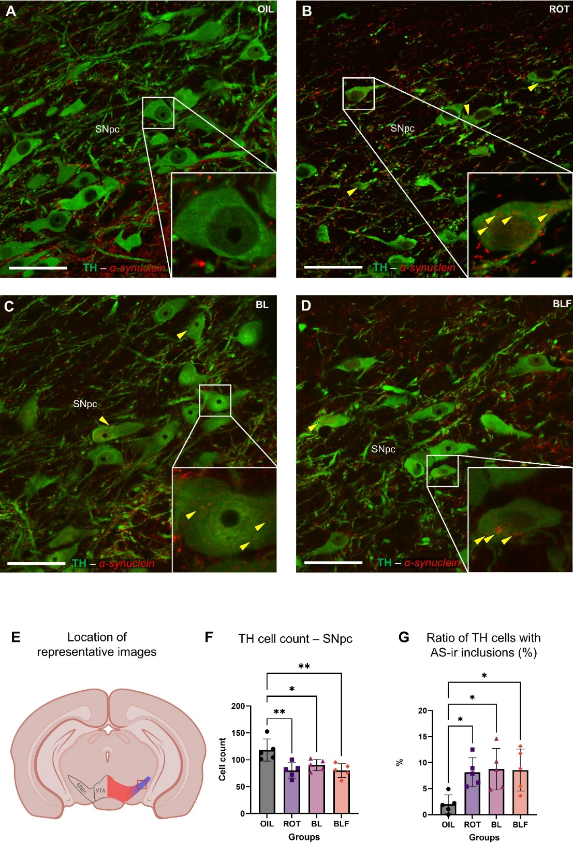
Supplementary figure 2. Stereological assessment of dopaminergic neurodegeneration and α-synuclein pathology in the substantia nigra pars compacta in the rotenone model. Representative confocal images of tyrosine hydroxylase (TH; green) and α-synuclein (α-synuclein; red) double immunolabelling in the substantia nigra pars compacta (SNpc) of (A) vehicle-treated (OIL), (B) rotenone-treated (ROT), (C) benserazide/L-DOPA-treated (BL), and (D) benserazide/L-DOPA plus fluoxetine-treated (BLF) animals. Insets show higher magnification images of representative dopaminergic neurons. Yellow arrowheads indicate intracytoplasmic α-synuclein-immunoreactive inclusions resembling Lewy body-like structures. (E) Schematic illustration indicating the anatomical location of representative images (A-D) within the SNpc at Bregma -5.5 mm. (F) Quantification of stereologically assessed TH-positive neurons in the SNpc. (G) Quantification of the ratio of TH-positive neurons containing α-synuclein (AS)-immunoreactive inclusions. *p<0.05, **p<0.01, according to Tukey’s post hoc test. Scale bar: 50 µm.

Supplementary figure 3. Schematic summary illustrating interactions among CRH, UCN1, UCN2, and UCN3 systems and CRH receptors. The peptides bind to two metabotropic transmembrane receptors; corticotropin-releasing hormone receptors 1 (CRHR1) and 2 (CRHR2). CRH at physiological concentrations acts on CRHR1, while at pharmacological doses it can also activate CRHR2, in contrast to UCN1, which shows the same binding potential towards both receptors. The later discovered UCN2 and UCN3 mediate their action through type 2 CRH receptors only. Arrows sizes represent the binding potential to CRH receptors. CRH-binding protein (CRH-BP) only interacts with CRH and UCN1. Classically, it was believed that the activation of CRH-receptor 1 promotes anxiogenic and anorexigenic effects, while the activation of CRH-receptor 2 has antagonistic functions, such as anxiolytic and orexigenic action. Recent studies underlined that this dualistic view of mechanism is somewhat outdated and the current view highlights that the evoked effect is not solely dependent on the receptor, but also on the localization, modulating factors, signaling pathways, desensitization and structural plasticity of the receptors.

Examined variable | F (df1, df2) | p | η²
Rotarod performance test | F(3, 32) = 12.36 | <0.0001 | 0.537
Sucrose preference test | F(3, 32) = 4.549 | 0.0105 | 0.336
TH-ir cell count SNpc | F(3, 20) = 7.161 | 0.0029 | 0.573
N of Crh-expressing cells – PVN | F(3, 16) = 4.893 | 0.0134 | 0.478
Crh mRNA SSD – PVN | F(3, 32) = 72.99 | <0.0001 | 0.890
CRH peptide SSD – PVN | F(3, 32) = 39.30 | <0.0001 | 0.819
N of Ucn2-expressing cells – PVN | F(3, 29) = 12.44 | <0.0001 | 0.640
N of Ucn2 transcripts – PVN | F(3, 30) = 13.07 | <0.0001 | 0.641
N of Ucn3-expressing cells – LHA | F(3, 29) = 8.721 | 0.0004 | 0.502
Ucn3 mRNA SSD – LHA | F(3, 30) = 8.660 | 0.0006 | 0.553
N of Crh-expressing cells – CeA | F(3, 29) = 0.237 | 0.8696 | 0.025
Crh mRNA SSD – CeA | F(3, 30) = 0.254 | 0.8581 | 0.026
CRH peptide SSD – CeA | F(3, 29) = 1.282 | 0.2998 | 0.121
N of Crh-expressing cells – BNSTov | F(3, 32) = 1.222 | 0.3223 | 0.128
Crh mRNA SSD – BNSTov | F(3, 29) = 0.758 | 0.5282 | 0.083
CRH peptide SSD – BNSTov | F(3, 28) = 1.442 | 0.2543 | 0.148
N of Ucn3-expressing cells – MeA | F(3, 29) = 8.901 | 0.0003 | 0.507
Ucn3 mRNA transcript SSD – MeA | F(3, 30) = 0.313 | 0.8155 | 0.035
N of Ucn1-expressing cells – EWcp | F(3, 30) = 8.936 | 0.0002 | 0.480
Ucn1 mRNA SSD – EWcp | F(3, 29) = 18.71 | <0.0001 | 0.667
α-Synuclein/TH cell ratio – SNpc | F(3, 16) = 4.893 | 0.0134 | 0.478

Supplementary Table 1. Detailed results of one-way ANOVA analyses for all behavioral and histological outcome measures. The table includes the F statistic with corresponding degrees of freedom (F(df₁, df₂)), p value, and η² (eta squared) effect size for each analysis. Statistical significance was assessed using one-way ANOVA followed by Tukey's multiple comparisons test. Abbreviations: OIL, vehicle-treated controls; ROT, rotenone-treated; BL, benserazide/L-DOPA-treated; BLF, benserazide/L-DOPA plus fluoxetine-treated; PVN, paraventricular nucleus of the hypothalamus; LHA, lateral hypothalamic area; CeA, central nucleus of amygdala; BNST, bed nucleus of the stria terminalis; MeA, medial nucleus of amygdala; EWcp, centrally projecting Edinger–Westphal nucleus.

Brain region | Marker | Parameter | ROT vs OIL | BL vs OIL | BLF vs OIL
PVN | CRH | Cell number | ↔ | ↔ | ↔
PVN | CRH | mRNA density | ↓ | ↓ | ↓
PVN | CRH | Peptide density | ↑ | ↑ | ↑
PVN | UCN2 | Cell number | ↓ | ↓ | ↓
PVN | UCN2 | mRNA transcripts | ↓ | ↓ | ↓
LHA | UCN3 | Cell number | ↓ | ↓ | ↓
LHA | UCN3 | mRNA density | ↓ | ↓ | ↓
CeA | CRH | Cell number | ↔ | ↔ | ↔
CeA | CRH | mRNA density | ↔ | ↔ | ↔
CeA | CRH | Peptide density | ↔ | ↔ | ↔
BNST | CRH | Cell number | ↔ | ↔ | ↔
 | CRH | mRNA density | ↔ | ↔ | ↔
 | CRH | Peptide density | ↔ | ↔ | ↔
MeA | UCN3 | Cell number | ↔ | ↔ | ↔
MeA | UCN3 | mRNA density | ↓ | ↓ | ↓
EWcp | UCN1 | Cell number | ↑ | ↑ | ↑
EWcp | UCN1 | mRNA density | ↑ | ↑ | ↑
EWcp | UCN1 | Peptide density | ↑ | ↑ | ↑
Supplementary table 2. Summary of region-specific alterations in the CRH/urocortin neuropeptide systems across experimental groups. Direction of changes is shown relative to the OIL (control) group. Arrows indicate statistically significant increases (↑) or decreases (↓), whereas ↔ denotes no significant difference compared with the OIL group. Cell number refers to the number mRNA-expressing neurons, mRNA and peptide density to the mean fluorescence intensity of the corresponding transcript and neuropeptide respectively. Abbreviations: OIL, vehicle-treated controls; ROT, rotenone-treated; BL, benserazide/L-DOPA-treated; BLF, benserazide/L-DOPA plus fluoxetine-treated; PVN, paraventricular nucleus of the hypothalamus; LHA, lateral hypothalamic area; CeA, central nucleus of amygdala; BNST, bed nucleus of the stria terminalis; MeA, medial nucleus of amygdala; EWcp, centrally projecting Edinger–Westphal nucleus.

