Supplementary materials
Supplementary Table 1. Baseline characteristics of LASI-DAD participants with DNAm data at Visit 1, by sex
Characteristic | Overall (N=934) | Men (N=471) | Women (N=463) | p-value
Demographics, lifestyle and clinical characteristics
Age (years) | 69.58 ± 7.07 | 69.62 ± 6.68 | 69.54 ± 7.46 | 0.865
Education (years) | 3.36 ± 4.31 | 4.84 ± 4.63 | 1.84 ± 3.35 | <0.001
Body mass index (BMI, kg/m2) | 22.19 ± 4.79 | 21.39 ± 3.94 | 23.01 ± 5.41 | <0.001
Kidney function eGFR (mL/minute/1.73 m²) | 74.17 ± 29.71 | 72.09 ± 20.15 | 76.29 ± 36.90 | 0.087
Comorbidity index | 0.65 ± 0.84 | 0.64 ± 0.88 | 0.66 ± 0.80 | 0.615
Smoking  Never  Former  Current | 684 (72.2%)  65 (7.2%)  173 (20.7%) | 249 (53.3%)  55 (12.0%)  146 (34.7%) | 435 (91.4%)  10 (2.2%)  27 (6.4%) | <0.001
Alcohol use (past 3 months) | 67 (8.0%) | 59 (14.0%) | 8 (1.9%) | <0.001
Rural | 624 (73.9%) | 311 (74.9%) | 313 (72.8%) | 0.458
Region  Region 1  Region 2  Region 3  Region 4 | 365 (41.8%)  176 (18.1%)  228 (23.7%)  153 (16.4%) | 188 (43.8%)  73 (15.5%)  108 (22.7%)  81 (18.0%) | 177 (39.7%)  103 (20.8%)  120 (24.6%)  72 (14.9%) | 0.112
One-carbon metabolism status
B12 (pg/mL) | 347.38 ± 282.53 | 334.69 ± 287.35 | 360.28 ± 277.28 | 0.169
Folate (ng/mL) | 6.23 ± 3.60 | 5.80 ± 3.46 | 6.66 ± 3.68 | <0.001
Homocysteine (µmol/L) | 23.12 ± 14.03 | 26.16 ± 16.80 | 20.03 ± 9.58 | <0.001
B12 deficient | 321 (35.2%) | 171 (38.4%) | 150 (32.0%) | 0.046
Folate deficient | 129 (14.7%) | 81 (18.8%) | 48 (10.6%) | 0.001
Hyperhomocysteinemia | 621 (67.7%) | 343 (76.1%) | 278 (59.1%) | <0.001
DNAm-based aging measures
DunedinPACE | 1.23 ± 0.11 | 1.25 ± 0.11 | 1.21 ± 0.11 | <0.001
GrimAge2 | 74.62 ± 6.73 | 77.01 ± 6.03 | 72.19 ± 6.54 | <0.001
SystemsAge | 76.61 ± 13.51 | 78.26 ± 13.84 | 74.94 ± 12.97 | <0.001
DNAm PhenoAge | 66.91 ± 9.58 | 67.86 ± 9.24 | 65.94 ± 9.83 | 0.003
GrimAge2 acceleration | -0.00 ± 4.88 | 2.36 ± 4.69 | -2.41 ± 3.78 | <0.001
SystemsAge acceleration | 0.00 ± 13.06 | 1.63 ± 13.74 | -1.66 ± 12.13 | <0.001
DNAm PhenoAge acceleration | -0.00 ± 8.01 | 0.92 ± 7.55 | -0.94 ± 8.36 | 0.001
Notes: Values are survey-weighted means (SD) for continuous variables and weighted counts (percentages) for categorical variables. P values were calculated using survey-weighted tests.

Supplementary Table 2. Distribution of one-carbon metabolism markers, one-carbon status, and Phenotypic Age by smoking status, CKD and region among LASI-DAD participants at Visit 1
2A: By smoking status
Characteristic | Smoking: Never  (N=1,460) | Smoking: Former  (N=119) | Smoking: Current  (N=368) | p-value
Folate (ng/mL) | 6.51 ± 3.72 | 6.08 ± 3.04 | 5.33 ± 3.31 | <0.001
Homocysteine (µmol/L) | 21.52 ± 12.08 | 22.89 ± 18.86 | 25.93 ± 14.72 | <0.001
B12 (pg/mL) | 359.34 ± 297.26 | 365.24 ± 302.33 | 347.45 ± 277.33 | 0.761
Folate deficient | 171 (12.0%) | 12 (11.5%) | 66 (20.2%) | <0.001
Hyperhomocysteinemia | 903 (61.2%) | 82 (70.8%) | 249 (75.8%) | <0.001
B12 deficient | 502 (34.1%) | 38 (34.2%) | 117 (36.3%) | 0.748
PhenoAge (years) | 77.08 ± 12.71 | 78.76 ± 11.44 | 77.97 ± 11.46 | 0.198

2B: By prevalent CKD
Characteristic | CKD: No  (N=1,523) | CKD: Yes  (N=424) | p-value
Folate (ng/mL) | 6.31 ± 3.64 | 6.07 ± 3.62 | 0.213
Homocysteine (µmol/L) | 21.63 ± 12.32 | 25.32 ± 15.71 | <0.001
B12 (pg/mL) | 342.01 ± 281.67 | 412.90 ± 328.15 | <0.001
Folate deficient | 194 (13.5%) | 55 (13.7%) | 0.897
Hyperhomocysteinemia | 908 (61.4%) | 326 (76.0%) | <0.001
B12 deficient | 540 (36.5%) | 117 (27.4%) | <0.001
PhenoAge (years) | 75.09 ± 11.42 | 85.46 ± 12.46 | <0.001

2C: By region
Characteristic | Region 1  (N=727) | Region 2  (N=347) | Region 3  (N=473) | Region 4  (N=400) | p-value
Folate (ng/mL) | 5.99 ± 3.40 | 6.79 ± 3.68 | 6.97 ± 3.99 | 5.45 ± 3.34 | <0.001
Homocysteine (µmol/L) | 23.13 ± 12.79 | 25.16 ± 19.08 | 21.61 ± 11.11 | 19.78 ± 8.81 | <0.001
B12 (pg/mL) | 335.46 ± 288.46 | 273.37 ± 232.63 | 448.36 ± 335.99 | 363.03 ± 268.96 | <0.001
Folate deficient | 90 (13.4%) | 36 (9.7%) | 46 (10.5%) | 77 (20.6%) | <0.001
Hyperhomocysteinemia | 453 (65.8%) | 250 (69.7%) | 291 (61.6%) | 240 (61.5%) | 0.054
B12 deficient | 267 (38.8%) | 180 (51.2%) | 116 (24.5%) | 94 (23.9%) | <0.001
PhenoAge (years) | 78.26 ± 11.93 | 76.80 ± 12.38 | 76.87 ± 12.94 | 76.74 ± 12.60 | 0.109
Notes: Values are survey-weighted means ± standard deviations for continuous variables and unweighted frequencies with survey-weighted percentages for categorical variables. P-values were estimated using survey-weighted linear regression for continuous variables and survey-weighted chi-square tests for categorical variables.

Supplementary Figure 1. Correlations between chronological age and biological aging measures at Visit 1.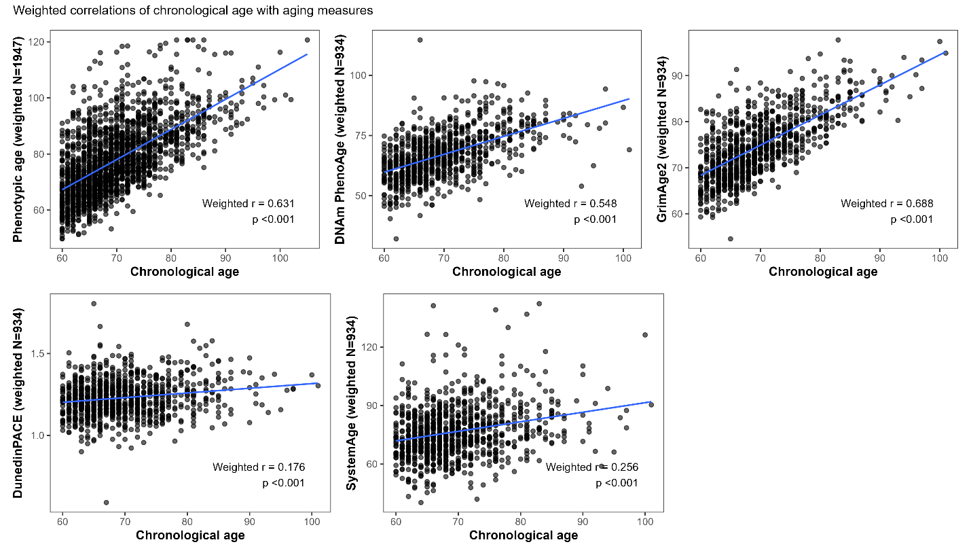
Note: Panels show the weighted correlations between chronological age and each biological age measure at Visit 1. Points represent individual participants, and blue lines indicate fitted linear trends. Reported correlation coefficients are survey-weighted Pearson correlations.

Supplementary Table 3. Cross-sectional associations of one-carbon metabolism biomarkers with Phenotypic Age acceleration at Wave 1
Biomarkers | Models with all covariates | Additionally adjusted for lnCRP
Vitamin B12 | −0.722 (−1.188, −0.256), p=0.002, FDR=0.002 | −0.942 (−1.393, −0.491), p<0.001, FDR<0.001
Folate | −1.050 (−1.635, −0.466), p<0.001, FDR<0.001 | −0.875 (−1.447, −0.302), p=0.003, FDR=0.003
Homocysteine | 3.393 (2.671, 4.114), p<0.001, FDR<0.001 | 3.634 (2.941, 4.327), p<0.001, FDR<0.001
Notes: Estimates are survey-weighted linear regression coefficients (β) with 95% confidence intervals and represent the difference in Phenotypic Age acceleration, in years, per doubling of biomarker concentration. Biomarkers were log₂-transformed. FDR values were calculated using the Benjamini–Hochberg procedure.

Supplementary Table 4. Longitudinal associations of changes in one-carbon metabolism biomarkers with changes in Phenotypic Age acceleration
Biomarkers | Models with all covariates | Additionally adjusted for lnCRP
B12 | −0.152 (−0.787, 0.483), p=0.639, FDR=0.639 | −0.145 (−0.773, 0.484), p=0.652, FDR=0.652
Folate | −1.100 (−1.861, −0.339), p=0.005, FDR=0.007 | −1.095 (−1.851, −0.340), p=0.004, FDR=0.007
Homocysteine | 3.167 (2.009, 4.325), p<0.001, FDR<0.001 | 3.196 (2.061, 4.332), p<0.001, FDR<0.001
Notes: Estimates are survey-weighted linear regression coefficients (β) with 95% confidence intervals and represent the difference in change in Phenotypic Age acceleration, in years, associated with a one-unit increase in the change in log₂-transformed biomarker concentration. FDR values were calculated using the Benjamini–Hochberg procedure.

Supplementary Table 5. Non-linear association of baseline folate with Phenotypic Age acceleration at Wave 1
Model | Estimate (95% CI), p
linear folate | -5.113 (-7.761, -2.464), p=<0.001
quadratic folate / non-linear test | 0.836 (0.309, 1.363), p=0.002
Notes: Models included both linear and quadratic terms for log₂-transformed baseline folate. Estimates represent adjusted regression coefficients and 95% confidence intervals using the same covariate adjustment set as the primary cross-sectional Phenotypic Age acceleration analysis.

Supplementary Table 6. Non-linear association of folate change with change in Phenotypic Age acceleration
Model | Estimate (95% CI), p
folate change linear | -1.390 (-2.360, -0.420), p=0.005
folate change quadratic / non-linear test | 0.445 (-0.198, 1.087), p=0.175
Notes: Models included both linear and quadratic terms for change in log₂-transformed folate from Wave 1 to Wave 2. Estimates represent adjusted regression coefficients and 95% confidence intervals using the same covariate adjustment set as the primary longitudinal Phenotypic Age acceleration analysis.

Supplementary Figure 2. Non-linear association of baseline folate with Phenotypic Age acceleration at Wave 1.
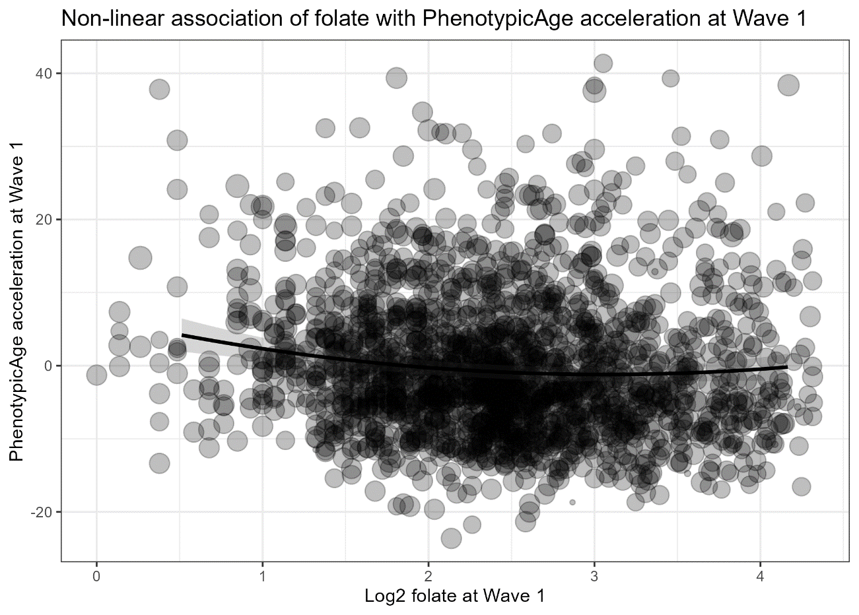
Note: Points represent individual participants. The fitted curve shows the estimated association between log₂-transformed folate at Wave 1 and Phenotypic Age acceleration at Wave 1.

Supplementary Figure 3. Non-linear association of folate change with change in Phenotypic Age acceleration.
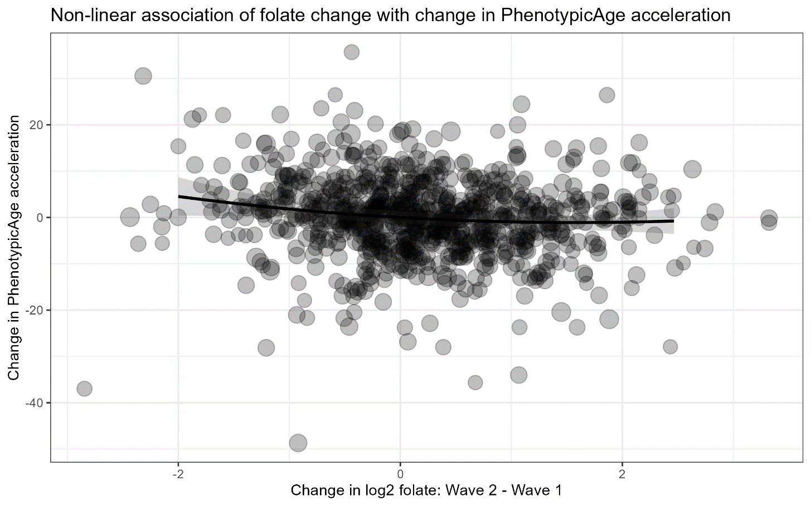
Note: Points represent individual participants. The fitted curve shows the estimated association between change in log₂-transformed folate from Wave 1 to Wave 2 and change in Phenotypic Age acceleration over follow-up.

Supplementary Figure 4. Correlations between one-carbon metabolism biomarkers and epigenetic age acceleration at Visit 1
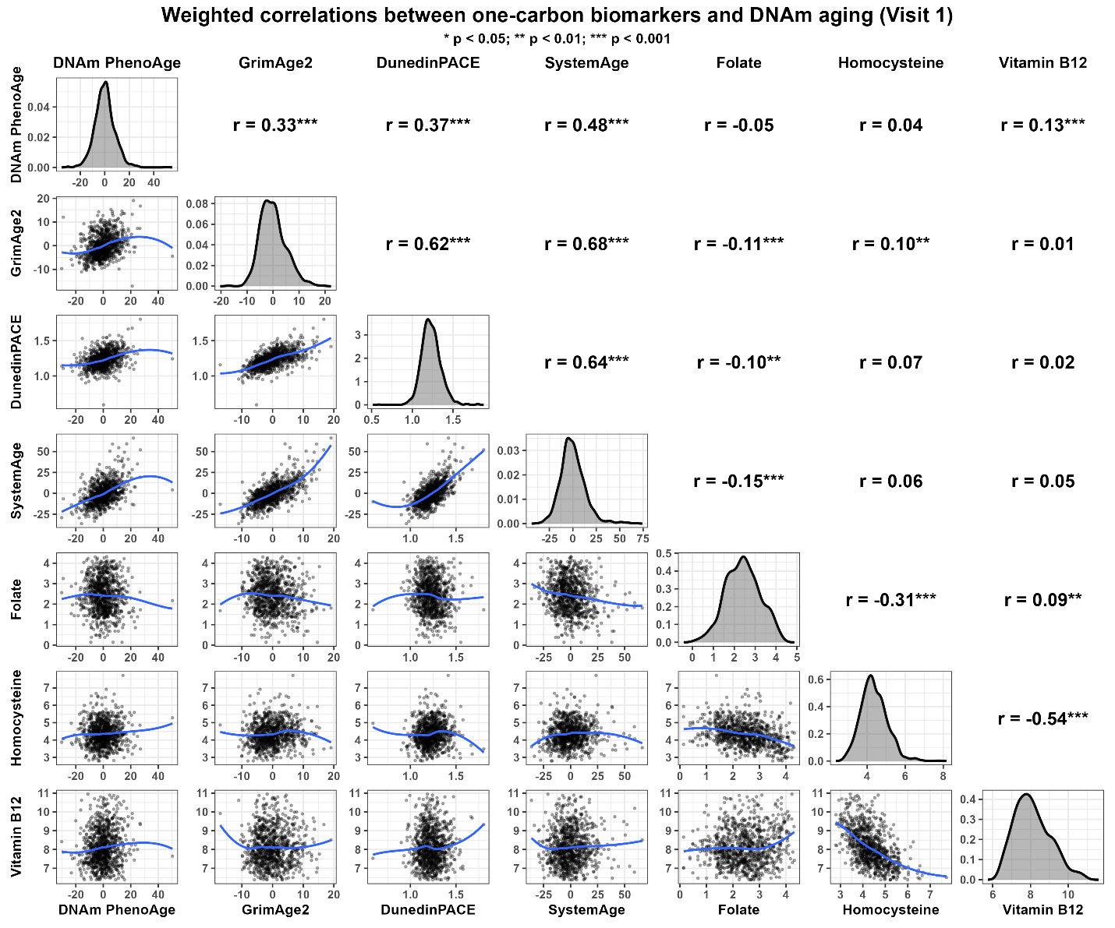
Note: Panels display pairwise relationships between biomarkers and epigenetic age acceleration (weighted N = 934). Diagonal panels show weighted kernel density estimates, lower panels show scatterplots with weighted loess smoothing, and upper panels display weighted Pearson correlation coefficients with significance levels (*p < 0.05; **p < 0.01; ***p < 0.001). Epigenetic age acceleration measures were defined as residuals from regression on chronological age, while DunedinPACE was analyzed on its original scale.

Supplementary Table 7. Cross-sectional associations of one-carbon metabolism biomarkers with DNA methylation–based measures of biological aging at Wave 1
Outcomes | Biomarkers | Models with all covariates | Additionally adjusted for lnCRP
DNAm PhenoAge Acceleration | Folate | -0.038 (-0.118, 0.043), p=0.357, FDR=0.357 | -0.025 (-0.105, 0.055), p=0.544, FDR=0.635
DunedinPACE | Folate | -0.095 (-0.173, -0.018), p=0.016, FDR=0.032 | -0.069 (-0.143, 0.004), p=0.064, FDR=0.128
GrimAge v2 Acceleration | Folate | -0.034 (-0.103, 0.036), p=0.340, FDR=0.357 | -0.016 (-0.083, 0.051), p=0.635, FDR=0.635
SystemsAge Acceleration | Folate | -0.146 (-0.223, -0.070), p=<0.001, FDR=<0.001 | -0.129 (-0.203, -0.055), p=<0.001, FDR=0.003
DNAm PhenoAge Acceleration | Homocysteine | 0.011 (-0.093, 0.115), p=0.836, FDR=0.836 | 0.024 (-0.079, 0.127), p=0.643, FDR=0.643
DunedinPACE | Homocysteine | 0.011 (-0.083, 0.104), p=0.827, FDR=0.836 | 0.037 (-0.051, 0.126), p=0.410, FDR=0.643
GrimAge v2 Acceleration | Homocysteine | -0.043 (-0.126, 0.040), p=0.313, FDR=0.836 | -0.025 (-0.106, 0.056), p=0.542, FDR=0.643
SystemsAge Acceleration | Homocysteine | 0.033 (-0.063, 0.129), p=0.504, FDR=0.836 | 0.051 (-0.043, 0.145), p=0.288, FDR=0.643
DNAm PhenoAge Acceleration | Vitamin B12 | 0.141 (0.072, 0.210), p=<0.001, FDR=<0.001 | 0.127 (0.058, 0.195), p=<0.001, FDR=0.001
DunedinPACE | Vitamin B12 | 0.018 (-0.051, 0.088), p=0.606, FDR=0.606 | -0.013 (-0.080, 0.053), p=0.695, FDR=0.927
GrimAge v2 Acceleration | Vitamin B12 | 0.023 (-0.032, 0.077), p=0.411, FDR=0.549 | 0.002 (-0.052, 0.055), p=0.947, FDR=0.947
SystemsAge Acceleration | Vitamin B12 | 0.056 (-0.012, 0.124), p=0.105, FDR=0.210 | 0.035 (-0.032, 0.102), p=0.305, FDR=0.610
Notes: Estimates are survey-weighted linear regression coefficients (β) with 95% confidence intervals and represent the difference in each DNA methylation–based aging measure per doubling of biomarker concentration. Biomarkers were log₂-transformed. FDR values were calculated across the four aging measures separately for each biomarker using the Benjamini–Hochberg procedure.

Supplementary Table 8. Longitudinal associations of changes in one-carbon metabolism biomarkers with changes in DNA methylation–based measures of biological aging
Outcomes | Biomarkers | Models with all covariates | Additionally adjusted for lnCRP
DNAm PhenoAge Acceleration Change | B12 | 0.081 (-0.020, 0.182), p=0.116, FDR=0.247 | 0.081 (-0.020, 0.183), p=0.117, FDR=0.251
DunedinPACE Change | B12 | 0.033 (-0.053, 0.119), p=0.451, FDR=0.451 | 0.032 (-0.054, 0.119), p=0.461, FDR=0.461
GrimAge v2 Acceleration Change | B12 | 0.064 (-0.017, 0.145), p=0.123, FDR=0.247 | 0.063 (-0.018, 0.144), p=0.125, FDR=0.251
SystemsAge Acceleration Change | B12 | 0.043 (-0.040, 0.125), p=0.313, FDR=0.418 | 0.042 (-0.041, 0.126), p=0.324, FDR=0.432
DNAm PhenoAge Acceleration Change | Folate | -0.022 (-0.125, 0.081), p=0.676, FDR=0.710 | -0.021 (-0.124, 0.081), p=0.685, FDR=0.781
DunedinPACE Change | Folate | -0.162 (-0.266, -0.058), p=0.002, FDR=0.004 | -0.157 (-0.260, -0.054), p=0.003, FDR=0.006
GrimAge v2 Acceleration Change | Folate | -0.018 (-0.112, 0.076), p=0.710, FDR=0.710 | -0.013 (-0.107, 0.080), p=0.781, FDR=0.781
SystemsAge Acceleration Change | Folate | -0.189 (-0.287, -0.091), p=<0.001, FDR=<0.001 | -0.184 (-0.281, -0.088), p=<0.001, FDR=<0.001
DNAm PhenoAge Acceleration Change | Homocysteine | -0.072 (-0.214, 0.069), p=0.315, FDR=0.315 | -0.072 (-0.214, 0.069), p=0.316, FDR=0.316
DunedinPACE Change | Homocysteine | 0.100 (-0.063, 0.263), p=0.230, FDR=0.307 | 0.101 (-0.060, 0.262), p=0.220, FDR=0.293
GrimAge v2 Acceleration Change | Homocysteine | -0.112 (-0.253, 0.030), p=0.123, FDR=0.307 | -0.111 (-0.252, 0.030), p=0.124, FDR=0.293
SystemsAge Acceleration Change | Homocysteine | 0.089 (-0.049, 0.227), p=0.208, FDR=0.307 | 0.090 (-0.049, 0.229), p=0.204, FDR=0.293
Notes: Estimates are survey-weighted linear regression coefficients (β) with 95% confidence intervals and represent the change in each DNA methylation–based aging measure associated with a one-unit increase in the change in log₂-transformed biomarker concentration. FDR values were calculated across the four aging measures separately for each biomarker using the Benjamini–Hochberg procedure.

Supplementary Table 9. Non-linear associations of baseline folate with DNA methylation–based aging measures at Wave 1
Outcome | Model | Estimate (95% CI), p, FDR p
DunedinPACE | linear folate | -0.244 (-0.632, 0.144), p=0.217, FDR=0.217
DunedinPACE | quadratic folate / non-linear test | 0.031 (-0.047, 0.108), p=0.435, FDR=0.435
GrimAge v2 Acceleration | linear folate | -0.298 (-0.640, 0.044), p=0.088, FDR=0.117
GrimAge v2 Acceleration | quadratic folate / non-linear test | 0.055 (-0.013, 0.123), p=0.112, FDR=0.150
SystemsAge Acceleration | linear folate | -0.460 (-0.850, -0.070), p=0.021, FDR=0.083
SystemsAge Acceleration | quadratic folate / non-linear test | 0.065 (-0.013, 0.143), p=0.100, FDR=0.150
DNAm PhenoAge Acceleration | linear folate | -0.383 (-0.752, -0.014), p=0.042, FDR=0.084
DNAm PhenoAge Acceleration | quadratic folate / non-linear test | 0.072 (-0.001, 0.145), p=0.054, FDR=0.150
Notes: Models included both linear and quadratic terms for log₂-transformed baseline folate. Estimates represent adjusted regression coefficients and 95% confidence intervals using the same covariate adjustment set as the primary cross-sectional DNA methylation clock analyses. FDR p-values were calculated using the Benjamini-Hochberg procedure across the four DNA methylation–based aging outcomes.

Supplementary Table 10. Non-linear associations of baseline folate and folate change with changes in DNA methylation–based aging measures
Outcome | effect | Estimate (95% CI), p, FDR
DunedinPACE Change | baseline folate linear | 0.016 (-0.439, 0.471), p=0.944, FDR=0.944
DunedinPACE Change | baseline folate quadratic / non-linear test | -0.033 (-0.123, 0.058), p=0.480, FDR=0.640
DunedinPACE Change | folate change linear | -0.188 (-0.303, -0.072), p=0.002, FDR=0.003
DunedinPACE Change | folate change quadratic / non-linear test | 0.055 (-0.017, 0.127), p=0.137, FDR=0.137
GrimAge v2 Acceleration Change | baseline folate linear | -0.083 (-0.523, 0.356), p=0.710, FDR=0.944
GrimAge v2 Acceleration Change | baseline folate quadratic / non-linear test | 0.010 (-0.078, 0.098), p=0.829, FDR=0.829
GrimAge v2 Acceleration Change | folate change linear | -0.036 (-0.134, 0.063), p=0.478, FDR=0.478
GrimAge v2 Acceleration Change | folate change quadratic / non-linear test | 0.042 (-0.010, 0.094), p=0.111, FDR=0.137
SystemsAge Acceleration Change | baseline folate linear | 0.070 (-0.349, 0.489), p=0.743, FDR=0.944
SystemsAge Acceleration Change | baseline folate quadratic / non-linear test | -0.035 (-0.120, 0.049), p=0.413, FDR=0.640
SystemsAge Acceleration Change | folate change linear | -0.230 (-0.338, -0.123), p=<0.001, FDR=<0.001
SystemsAge Acceleration Change | folate change quadratic / non-linear test | 0.091 (0.031, 0.152), p=0.003, FDR=0.006
DNAm PhenoAge Acceleration Change | baseline folate linear | 0.248 (-0.177, 0.673), p=0.253, FDR=0.944
DNAm PhenoAge Acceleration Change | baseline folate quadratic / non-linear test | -0.069 (-0.161, 0.023), p=0.143, FDR=0.570
DNAm PhenoAge Acceleration Change | folate change linear | -0.075 (-0.184, 0.033), p=0.174, FDR=0.232
DNAm PhenoAge Acceleration Change | folate change quadratic / non-linear test | 0.115 (0.058, 0.172), p=<0.001, FDR=<0.001
Notes: Models included linear and quadratic terms for baseline log₂-transformed folate and change in log₂-transformed folate from Wave 1 to Wave 2. Estimates represent adjusted regression coefficients and 95% confidence intervals using the same covariate adjustment set as the primary longitudinal DNA methylation clock analyses. FDR p-values were calculated using the Benjamini-Hochberg procedure across the four DNA methylation–based aging outcomes.

Supplementary Figure 5. Non-linear associations of baseline folate with DNA methylation–based aging measures at Wave 1
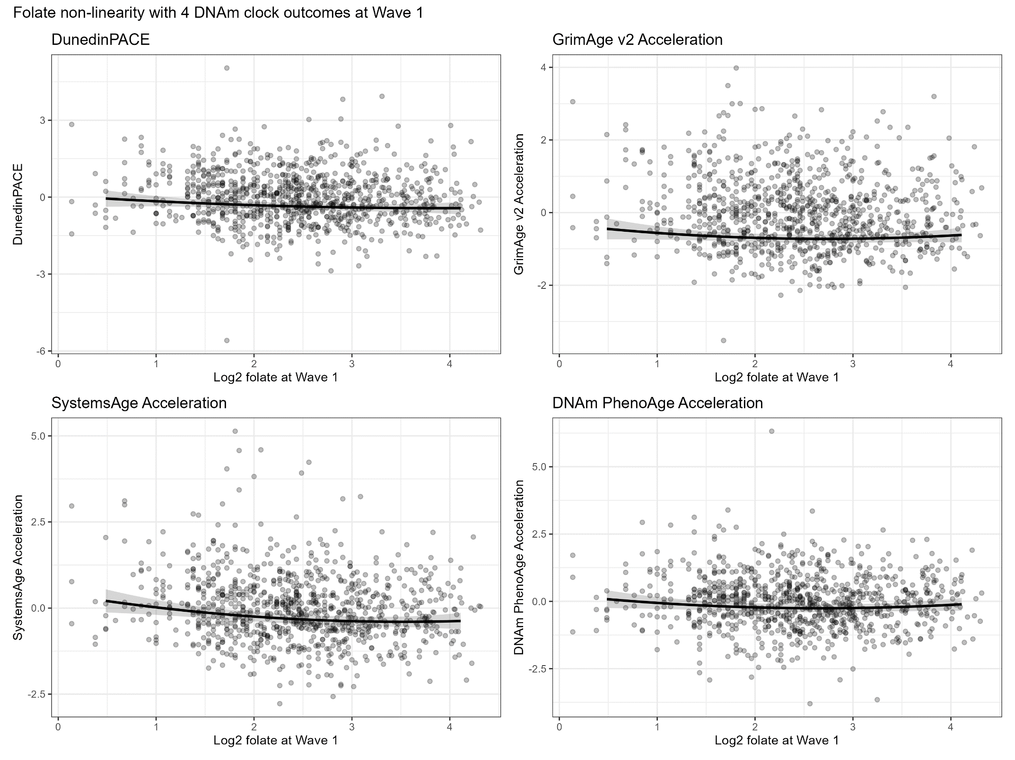
Note: Points represent individual participants. Fitted curves show the estimated associations between log₂-transformed folate at Wave 1 and each DNA methylation–based aging measure at Wave 1.
Supplementary 6. Non-linear associations of folate change with changes in DNA methylation–based aging measures.
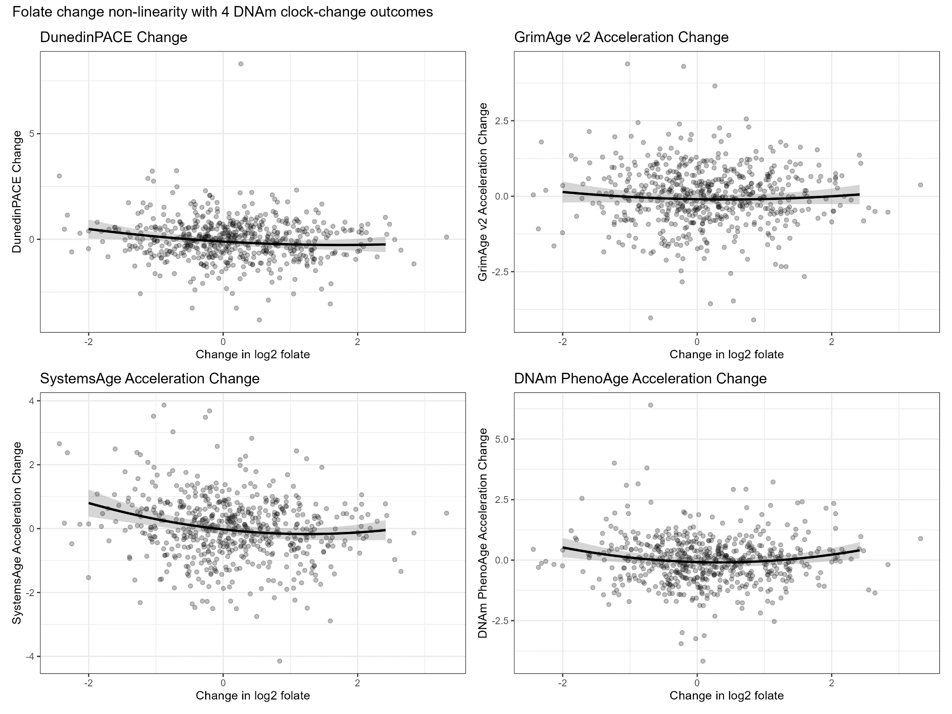
Note: Points represent individual participants. Fitted curves show the estimated associations between change in log₂-transformed folate from Wave 1 to Wave 2 and changes in DNA methylation–based aging measures over follow-up.

Supplementary Table 11. Associations of longitudinal transitions in one-carbon metabolism biomarker status with changes in Phenotypic Age acceleration
Biomarkers | Transition status | Models with all covariates | Additionally adjusted for lnCRP
B12 | Deficiency_w1 + Deficiency_w2 | 0.251 (−2.213, 2.715), p=0.842, FDR=0.842 | 0.261 (−2.203, 2.725), p=0.836, FDR=0.836
B12 | Deficiency_w1 + Normal_w2 | −0.258 (−2.149, 1.632), p=0.789, FDR=0.987 | −0.193 (−2.060, 1.674), p=0.839, FDR=0.858
B12 | Normal_w1 + Deficiency_w2 | 0.374 (−2.324, 3.071), p=0.786, FDR=0.786 | 0.460 (−2.140, 3.061), p=0.728, FDR=0.728
Folate | Deficiency_w1 + Deficiency_w2 | 1.925 (−1.104, 4.954), p=0.213, FDR=0.319 | 1.804 (−1.185, 4.792), p=0.237, FDR=0.355
Folate | Deficiency_w1 + Normal_w2 | −1.566 (−4.219, 1.087), p=0.247, FDR=0.741 | −1.613 (−4.279, 1.052), p=0.235, FDR=0.706
Folate | Normal_w1 + Deficiency_w2 | 2.984 (0.092, 5.876), p=0.043, FDR=0.129 | 2.742 (−0.124, 5.608), p=0.061, FDR=0.107
Homocysteine | Hyper_w1 + Hyper_w2 | 2.467 (0.342, 4.592), p=0.023, FDR=0.069 | 2.557 (0.447, 4.667), p=0.018, FDR=0.053
Homocysteine | Hyper_w1 + Normal_w2 | −0.018 (−2.223, 2.187), p=0.987, FDR=0.987 | 0.198 (−1.978, 2.375), p=0.858, FDR=0.858
Homocysteine | Normal_w1 + Hyper_w2 | 1.582 (−0.231, 3.395), p=0.087, FDR=0.131 | 1.628 (−0.140, 3.397), p=0.071, FDR=0.107
Notes: Estimates are survey-weighted linear regression coefficients (β) with 95% confidence intervals and represent differences in change in Phenotypic Age acceleration, in years, relative to participants with normal biomarker status at both waves. Biomarker status was defined using established clinical cut points. FDR values were calculated using the Benjamini–Hochberg procedure.

Supplementary Table 12. Associations of longitudinal transitions in one-carbon metabolism biomarker status with changes in DNA methylation–based measures of biological aging
Biomarkers | Transition status | Outcomes | Models with all covariates | Additionally adjusted for lnCRP
B12 | Deficiency_w1 + Deficiency_w2 | DNAm PhenoAge Acceleration Change | -0.067 (-0.356, 0.222), p=0.649, FDR=0.939 | -0.068 (-0.358, 0.222), p=0.644, FDR=0.953
B12 | Deficiency_w1 + Deficiency_w2 | DunedinPACE Change | -0.012 (-0.310, 0.286), p=0.939, FDR=0.939 | -0.019 (-0.312, 0.273), p=0.896, FDR=0.953
B12 | Deficiency_w1 + Deficiency_w2 | GrimAge v2 Acceleration Change | -0.047 (-0.342, 0.248), p=0.755, FDR=0.939 | -0.054 (-0.343, 0.235), p=0.713, FDR=0.953
B12 | Deficiency_w1 + Deficiency_w2 | SystemsAge Acceleration Change | 0.017 (-0.303, 0.336), p=0.917, FDR=0.939 | 0.010 (-0.307, 0.326), p=0.953, FDR=0.953
B12 | Deficiency_w1 + Normal_w2 | DNAm PhenoAge Acceleration Change | 0.194 (-0.080, 0.467), p=0.165, FDR=0.325 | 0.194 (-0.079, 0.468), p=0.164, FDR=0.308
B12 | Deficiency_w1 + Normal_w2 | DunedinPACE Change | 0.108 (-0.206, 0.422), p=0.501, FDR=0.501 | 0.110 (-0.199, 0.420), p=0.484, FDR=0.484
B12 | Deficiency_w1 + Normal_w2 | GrimAge v2 Acceleration Change | 0.267 (-0.028, 0.561), p=0.076, FDR=0.302 | 0.270 (-0.021, 0.560), p=0.069, FDR=0.275
B12 | Deficiency_w1 + Normal_w2 | SystemsAge Acceleration Change | 0.185 (-0.127, 0.498), p=0.244, FDR=0.325 | 0.188 (-0.120, 0.497), p=0.231, FDR=0.308
B12 | Normal_w1 + Deficiency_w2 | DNAm PhenoAge Acceleration Change | 0.092 (-0.329, 0.514), p=0.667, FDR=0.843 | 0.094 (-0.328, 0.516), p=0.662, FDR=0.805
B12 | Normal_w1 + Deficiency_w2 | DunedinPACE Change | 0.040 (-0.361, 0.442), p=0.843, FDR=0.843 | 0.051 (-0.352, 0.453), p=0.805, FDR=0.805
B12 | Normal_w1 + Deficiency_w2 | GrimAge v2 Acceleration Change | -0.102 (-0.462, 0.258), p=0.578, FDR=0.843 | -0.093 (-0.438, 0.252), p=0.598, FDR=0.805
B12 | Normal_w1 + Deficiency_w2 | SystemsAge Acceleration Change | -0.125 (-0.384, 0.135), p=0.346, FDR=0.843 | -0.115 (-0.371, 0.142), p=0.379, FDR=0.805
Folate | Deficiency_w1 + Deficiency_w2 | DNAm PhenoAge Acceleration Change | 0.037 (-0.349, 0.422), p=0.851, FDR=0.851 | 0.036 (-0.349, 0.421), p=0.854, FDR=0.854
Folate | Deficiency_w1 + Deficiency_w2 | DunedinPACE Change | 0.440 (-0.059, 0.939), p=0.084, FDR=0.168 | 0.430 (-0.082, 0.942), p=0.100, FDR=0.199
Folate | Deficiency_w1 + Deficiency_w2 | GrimAge v2 Acceleration Change | 0.345 (-0.207, 0.897), p=0.220, FDR=0.293 | 0.337 (-0.227, 0.901), p=0.242, FDR=0.322
Folate | Deficiency_w1 + Deficiency_w2 | SystemsAge Acceleration Change | 0.569 (0.019, 1.118), p=0.043, FDR=0.168 | 0.560 (-0.005, 1.124), p=0.052, FDR=0.199
Folate | Deficiency_w1 + Normal_w2 | DNAm PhenoAge Acceleration Change | 0.021 (-0.273, 0.315), p=0.889, FDR=0.984 | 0.022 (-0.273, 0.317), p=0.884, FDR=0.937
Folate | Deficiency_w1 + Normal_w2 | DunedinPACE Change | -0.051 (-0.401, 0.299), p=0.774, FDR=0.984 | -0.040 (-0.384, 0.304), p=0.818, FDR=0.937
Folate | Deficiency_w1 + Normal_w2 | GrimAge v2 Acceleration Change | 0.003 (-0.327, 0.334), p=0.984, FDR=0.984 | 0.013 (-0.314, 0.341), p=0.937, FDR=0.937
Folate | Deficiency_w1 + Normal_w2 | SystemsAge Acceleration Change | 0.130 (-0.187, 0.448), p=0.421, FDR=0.984 | 0.140 (-0.170, 0.450), p=0.375, FDR=0.937
Folate | Normal_w1 + Deficiency_w2 | DNAm PhenoAge Acceleration Change | 0.460 (0.095, 0.825), p=0.014, FDR=0.027 | 0.457 (0.091, 0.824), p=0.014, FDR=0.029
Folate | Normal_w1 + Deficiency_w2 | DunedinPACE Change | 0.416 (0.054, 0.778), p=0.024, FDR=0.033 | 0.387 (0.028, 0.746), p=0.035, FDR=0.046
Folate | Normal_w1 + Deficiency_w2 | GrimAge v2 Acceleration Change | 0.267 (-0.043, 0.578), p=0.092, FDR=0.092 | 0.242 (-0.071, 0.554), p=0.129, FDR=0.129
Folate | Normal_w1 + Deficiency_w2 | SystemsAge Acceleration Change | 0.710 (0.376, 1.044), p=<0.001, FDR=<0.001 | 0.684 (0.352, 1.015), p=<0.001, FDR=<0.001
Homocysteine | Hyper_w1 + Hyper_w2 | DNAm PhenoAge Acceleration Change | -0.122 (-0.441, 0.196), p=0.451, FDR=0.691 | -0.123 (-0.442, 0.195), p=0.447, FDR=0.726
Homocysteine | Hyper_w1 + Hyper_w2 | DunedinPACE Change | -0.031 (-0.298, 0.235), p=0.817, FDR=0.817 | -0.038 (-0.304, 0.228), p=0.778, FDR=0.778
Homocysteine | Hyper_w1 + Hyper_w2 | GrimAge v2 Acceleration Change | -0.202 (-0.479, 0.075), p=0.153, FDR=0.612 | -0.208 (-0.484, 0.068), p=0.139, FDR=0.556
Homocysteine | Hyper_w1 + Hyper_w2 | SystemsAge Acceleration Change | 0.093 (-0.190, 0.376), p=0.518, FDR=0.691 | 0.087 (-0.195, 0.369), p=0.544, FDR=0.726
Homocysteine | Hyper_w1 + Normal_w2 | DNAm PhenoAge Acceleration Change | 0.033 (-0.280, 0.346), p=0.836, FDR=0.836 | 0.036 (-0.276, 0.349), p=0.820, FDR=0.820
Homocysteine | Hyper_w1 + Normal_w2 | DunedinPACE Change | 0.057 (-0.238, 0.352), p=0.705, FDR=0.836 | 0.080 (-0.211, 0.370), p=0.589, FDR=0.786
Homocysteine | Hyper_w1 + Normal_w2 | GrimAge v2 Acceleration Change | 0.120 (-0.165, 0.405), p=0.407, FDR=0.836 | 0.142 (-0.140, 0.424), p=0.324, FDR=0.682
Homocysteine | Hyper_w1 + Normal_w2 | SystemsAge Acceleration Change | 0.119 (-0.174, 0.413), p=0.426, FDR=0.836 | 0.141 (-0.149, 0.431), p=0.341, FDR=0.682
Homocysteine | Normal_w1 + Hyper_w2 | DNAm PhenoAge Acceleration Change | 0.056 (-0.247, 0.359), p=0.717, FDR=0.717 | 0.055 (-0.248, 0.359), p=0.720, FDR=0.720
Homocysteine | Normal_w1 + Hyper_w2 | DunedinPACE Change | 0.387 (0.078, 0.695), p=0.014, FDR=0.056 | 0.383 (0.076, 0.691), p=0.015, FDR=0.059
Homocysteine | Normal_w1 + Hyper_w2 | GrimAge v2 Acceleration Change | 0.219 (-0.093, 0.530), p=0.168, FDR=0.224 | 0.216 (-0.088, 0.519), p=0.163, FDR=0.217
Homocysteine | Normal_w1 + Hyper_w2 | SystemsAge Acceleration Change | 0.249 (-0.082, 0.580), p=0.140, FDR=0.224 | 0.246 (-0.088, 0.580), p=0.149, FDR=0.217
Notes: Estimates are survey-weighted linear regression coefficients (β) with 95% confidence intervals and represent differences in changes in DNA methylation–based aging measures relative to participants with normal biomarker status at both waves. Biomarker status was defined using established clinical cut points. FDR values were calculated using the Benjamini–Hochberg procedure.

Supplementary Table 13. Sample sizes for longitudinal one-carbon biomarker status transitions in phenotypic aging analyses
Homocysteine | Normal_v1 + Normal_v2 | Normal_v1 + Hyper_v2 | Hyper_v1 + Normal_v2 | Hyper_v1 + Hyper_v2
Homocysteine | 245 | 76 | 168 | 397
Folate | Normal_v1 + Normal_v2 | Normal_v1 + Deficiency_v2 | Deficiency_v1 + Normal_v2 | Deficiency_v1 + Deficiency_v2
Folate | 723 | 60 | 70 | 33
Vitamin B12 | Normal_v1 + Normal_v2 | Normal_v1 + Deficiency_v2 | Deficiency_v1 + Normal_v2 | Deficiency_v1 + Deficiency_v2
Vitamin B12 | 502 | 53 | 180 | 151
Note: This table presents the number of participants included in longitudinal analyses of Phenotypic Age acceleration, stratified by two-visit status transitions for homocysteine, folate, and vitamin B12 between Visit 1 and Visit 2. Biomarker status categories were defined using established clinical cut points: homocysteine >16.2 µmol/L (hyperhomocysteinemia), folate <3.0 ng/mL (deficiency), and vitamin B12 <200 pg/mL (deficiency). Status transitions reflect persistent normal status, worsening, improvement, or persistent abnormal status across visits.

Supplementary Table 14. Sample sizes for longitudinal one-carbon biomarker status transitions in epigenetic aging analyses
Homocysteine | Normal_v1 + Normal_v2 | Normal_v1 + Hyper_v2 | Hyper_v1 + Normal_v2 | Hyper_v1 + Hyper_v2
Homocysteine | 146 | 47 | 115 | 275
Folate | Normal_v1 + Normal_v2 | Normal_v1 + Deficiency_v2 | Deficiency_v1 + Normal_v2 | Deficiency_v1 + Deficiency_v2
Folate | 466 | 47 | 47 | 23
Vitamin B12 | Normal_v1 + Normal_v2 | Normal_v1 + Deficiency_v2 | Deficiency_v1 + Normal_v2 | Deficiency_v1 + Deficiency_v2
Vitamin B12 | 321 | 33 | 119 | 110
Note: This table summarizes the number of participants included in longitudinal analyses of DNA methylation–based aging measures, stratified by two-visit status transitions for homocysteine, folate, and vitamin B12. Sample sizes differ from phenotypic aging analyses due to the availability of DNA methylation data at both visits. Biomarker cut points and transition definitions are identical to those used in phenotypic aging analyses.

Supplementary Table 15. Sex interaction effects for associations between changes in 1-C metabolism biomarkers and change in PhenoAgeAccel

Predictor | Change × Sex Effect
B12 | 0.051 (-1.089, 1.191), p=0.930
Folate | 0.479 (-0.954, 1.911), p=0.512
Homocysteine | 0.485 (-1.657, 2.627), p=0.657
Notes: Values represent regression coefficients (β) and 95% confidence intervals for the interaction term between biomarker change and sex in models examining associations with change in phenotypic age acceleration. Models were adjusted for baseline biomarker levels and covariates.

Supplementary Figure 7. Survey-weighted longitudinal associations between changes in one-carbon metabolism biomarkers and changes in PhenoAgeAccel between Visit 1 and Visit 2, overall and stratified by sex.
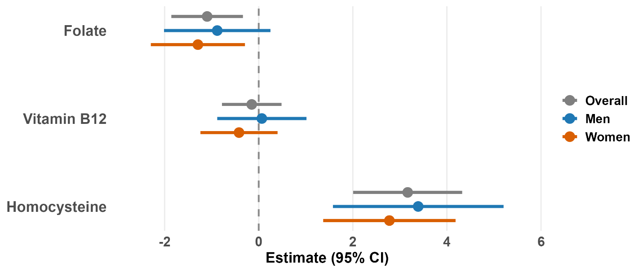
Note: Points represent survey-weighted linear regression coefficients (β), and horizontal lines indicate 95% confidence intervals for the associations between within-person changes in vitamin B12, folate, and homocysteine and changes in Phenotypic Age Acceleration (PhenoAgeAccel) from Visit 1 to Visit 2. Estimates are shown for the overall sample and stratified by sex. Models were adjusted for baseline biomarker levels and covariates.

Supplementary Table 16. Sex interaction effects for associations between changes in 1-C metabolism biomarkers and changes in EAA measures
Outcome | Folate | Homocysteine | Vitamin B12
DunedinPACE | -0.252 (-0.432, -0.073), P=0.006 | 0.164 (-0.149, 0.478), p=0.304 | 0.079 (-0.076, 0.234), p=0.320
GrimAge2 Acceleration | 0.001 (-0.158, 0.160), p=0.991 | 0.087 (-0.193, 0.368), p=0.541 | -0.055 (-0.214, 0.104), p=0.501
SystemsAge Acceleration | -0.151 (-0.325, 0.024), p=0.090 | 0.343 (0.097, 0.590), p=0.006 | -0.027 (-0.178, 0.124), p=0.726
PhenoAge Acceleration | 0.061 (-0.115, 0.236), p=0.500 | 0.159 (-0.100, 0.418), p=0.228 | -0.040 (-0.222, 0.142), p=0.665

Notes: Values represent regression coefficients (β) and 95% confidence intervals for the interaction term between biomarker change and sex in models examining associations with changes in epigenetic age acceleration measures. Models were adjusted for baseline biomarker levels and covariates. Positive β indicates a stronger association in men relative to women.

Supplementary Table 17. Sex interactions in longitudinal associations of one-carbon metabolism biomarkers with changes in Phenotypic Age acceleration
Predictor | Models with all covariates | Additionally adjusted for lnCRP
Vitamin B12 | 0.046 (−1.092, 1.185), p=0.936, FDR=0.936 | 0.086 (−1.033, 1.205), p=0.880, FDR=0.880
Folate | 0.474 (−0.958, 1.906), p=0.516, FDR=0.936 | 0.456 (−0.968, 1.880), p=0.530, FDR=0.880
Homocysteine | 0.489 (−1.653, 2.630), p=0.654, FDR=0.936 | 0.394 (−1.726, 2.513), p=0.716, FDR=0.880
Notes: Estimates are coefficients for the biomarker-change-by-sex interaction term from survey-weighted linear regression models. FDR values were calculated using the Benjamini–Hochberg procedure.

Supplementary Table 18. Sex interactions in longitudinal associations of one-carbon metabolism biomarkers with changes in DNA methylation–based measures of biological aging
Outcomes | Biomarkers | Models with all covariates | Additionally adjusted for lnCRP
DNAm PhenoAge Acceleration Change | B12 | -0.039 (-0.221, 0.143), p=0.674, FDR=0.728 | -0.037 (-0.219, 0.145), p=0.688, FDR=0.864
DunedinPACE Change | B12 | 0.079 (-0.076, 0.234), p=0.319, FDR=0.728 | 0.093 (-0.062, 0.249), p=0.240, FDR=0.864
GrimAge v2 Acceleration Change | B12 | -0.054 (-0.214, 0.105), p=0.502, FDR=0.728 | -0.042 (-0.198, 0.115), p=0.603, FDR=0.864
SystemsAge Acceleration Change | B12 | -0.027 (-0.178, 0.125), p=0.728, FDR=0.728 | -0.013 (-0.165, 0.139), p=0.864, FDR=0.864
DNAm PhenoAge Acceleration Change | Folate | 0.061 (-0.115, 0.237), p=0.499, FDR=0.665 | 0.061 (-0.115, 0.236), p=0.498, FDR=0.664
DunedinPACE Change | Folate | -0.252 (-0.433, -0.072), p=0.006, FDR=0.025 | -0.253 (-0.429, -0.077), p=0.005, FDR=0.020
GrimAge v2 Acceleration Change | Folate | 0.001 (-0.159, 0.160), p=0.992, FDR=0.992 | 0.000 (-0.158, 0.158), p=0.999, FDR=0.999
SystemsAge Acceleration Change | Folate | -0.151 (-0.326, 0.024), p=0.090, FDR=0.180 | -0.152 (-0.322, 0.019), p=0.081, FDR=0.162
DNAm PhenoAge Acceleration Change | Homocysteine | 0.158 (-0.102, 0.417), p=0.233, FDR=0.408 | 0.156 (-0.104, 0.416), p=0.238, FDR=0.461
DunedinPACE Change | Homocysteine | 0.164 (-0.150, 0.478), p=0.306, FDR=0.408 | 0.148 (-0.160, 0.456), p=0.346, FDR=0.461
GrimAge v2 Acceleration Change | Homocysteine | 0.087 (-0.194, 0.368), p=0.543, FDR=0.543 | 0.073 (-0.204, 0.349), p=0.605, FDR=0.605
SystemsAge Acceleration Change | Homocysteine | 0.343 (0.096, 0.590), p=0.007, FDR=0.026 | 0.328 (0.081, 0.575), p=0.009, FDR=0.037
Notes: Estimates are coefficients for the biomarker-change-by-sex interaction term from survey-weighted longitudinal regression models. FDR values were calculated across the four aging measures separately for each biomarker using the Benjamini–Hochberg procedure.

