Supplemental Table 1. Sample Sizes for Measurements Used in Analyses
Number with Observed Measurements Followed By Number with Missing Measurements
Variable | Overall | CLIP | EMPOWER | HALLO-P | IDEA | I’M FIT | INFINITE | MEDIFAST
Totals | 828 | 182 | 61 | 90 | 283 | 60 | 121 | 31
Weight¹ (kg) m6 | 815 | 13 | 178 | 4 | 61 | 0 | 88 | 2 | 283 | 0 | 58 | 2 | 116 | 5 | 31 | 0
CRP (mg/L) base | 693 | 135 | 166 | 16 | 29 | 32 | 82 | 8 | 236 | 47 | 50 | 10 | 105 | 16 | 25 | 6
CRP (mg/L) m6 | 815 | 13 | 178 | 4 | 61 | 0 | 88 | 2 | 283 | 0 | 58 | 2 | 116 | 5 | 31 | 0
IL6 (pg/mL) base | 694 | 134 | 166 | 16 | 29 | 32 | 82 | 8 | 236 | 47 | 50 | 10 | 106 | 15 | 25 | 6
IL6 (pg/mL) m6 | 813 | 15 | 177 | 5 | 61 | 0 | 88 | 2 | 282 | 1 | 58 | 2 | 116 | 5 | 31 | 0
Cystatin-C (mg/L) base | 693 | 135 | 166 | 16 | 29 | 32 | 82 | 8 | 237 | 46 | 50 | 10 | 104 | 17 | 25 | 6
Cystatin-C (mg/L) m6 | 814 | 14 | 178 | 4 | 61 | 0 | 88 | 2 | 282 | 1 | 58 | 2 | 116 | 5 | 31 | 0
Insulin (pmol/L) base | 695 | 133 | 167 | 15 | 29 | 32 | 82 | 8 | 237 | 46 | 50 | 10 | 106 | 15 | 24 | 7
Insulin (pmol/L m6 | 812 | 16 | 178 | 4 | 61 | 0 | 88 | 2 | 281 | 2 | 58 | 2 | 116 | 5 | 30 | 1
GDF-15 (pg/mL) base | 694 | 134 | 166 | 16 | 29 | 32 | 82 | 8 | 236 | 47 | 50 | 10 | 106 | 15 | 25 | 6
GDF-15 (pg/mL) m6 | 812 | 16 | 177 | 5 | 61 | 0 | 88 | 2 | 281 | 2 | 58 | 2 | 116 | 5 | 31 | 0
TNF-R1 (pg/mL) base | 695 | 133 | 167 | 15 | 28 | 33 | 82 | 8 | 237 | 46 | 50 | 10 | 106 | 15 | 25 | 6
TNF-R1 (pg/mL) m6 | 828 | 0 | 182 | 0 | 61 | 0 | 90 | 0 | 283 | 0 | 60 | 0 | 121 | 0 | 31 | 0

1 All participants have a baseline weight

Supplemental Figure 1a. Associations between CR and change in inflammatory markers for models containing only CR (Model 1). Beta coefficients (95% confidence intervals) for the associations between randomization to CR and change in biomarkers from model 1 where CR is a sole predictor. Estimates are shown for individual studies and pooled analysis. For the pooled analysis (overall), models were additionally adjusted for study.
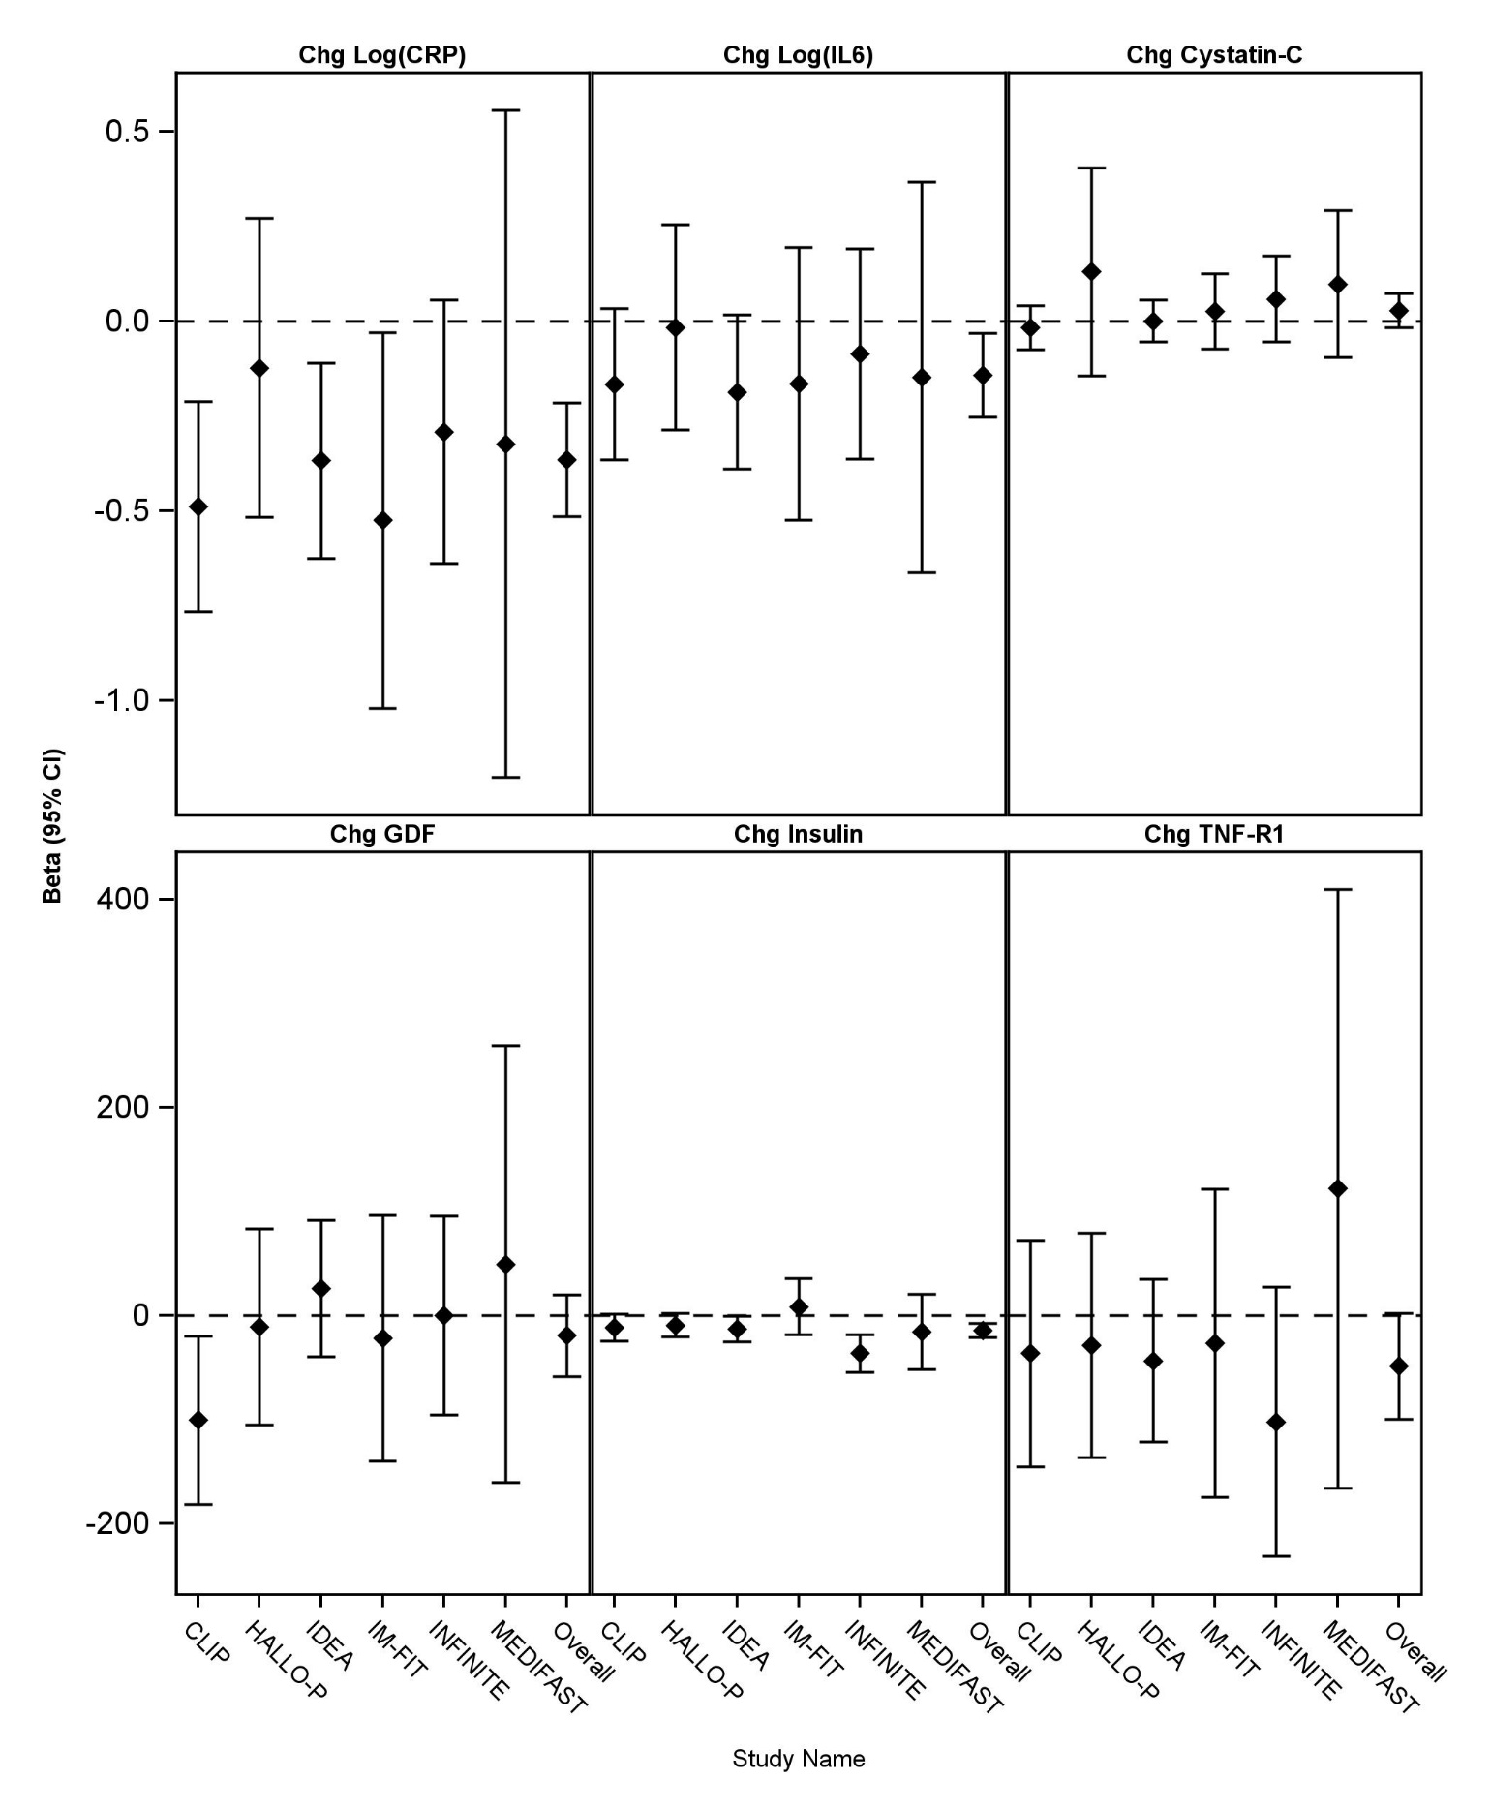
Supplemental Figure 1b. Associations between change in weight and change in inflammatory markers for models containing only change in weight (Model 2). Beta coefficients (95% confidence intervals) for the association between change in body weight and change in biomarkers from model 2 where weight change is the sole predictor. Estimates show individual studies and pooled analysis (overall) for which models were additionally adjusted for study.
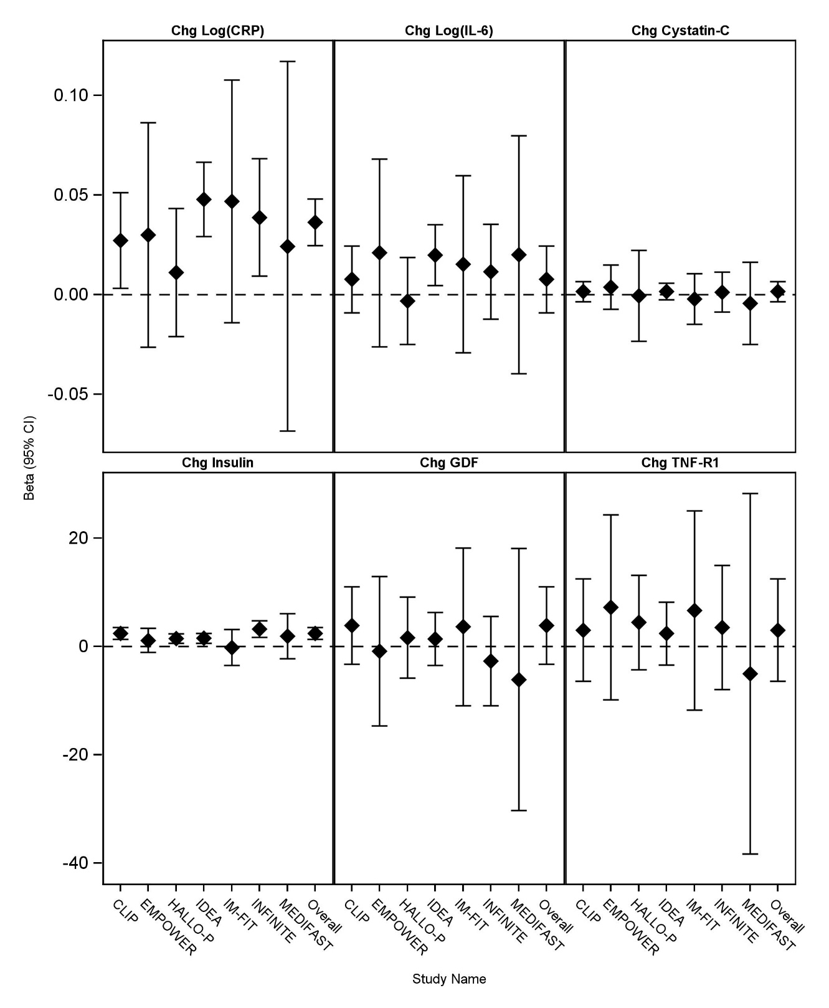

Supplemental Figure 1c. Association between CR and change in inflammatory markers for models containing both CR and change in weight (Model 3). Beta coefficients (95% confidence intervals) for the association between CR and change in biomarkers from model with both CR assignment and change in body weight. Estimates are shown for individual studies and pooled analysis (overall). For the pooled analysis (overall), models were additionally adjusted for study.

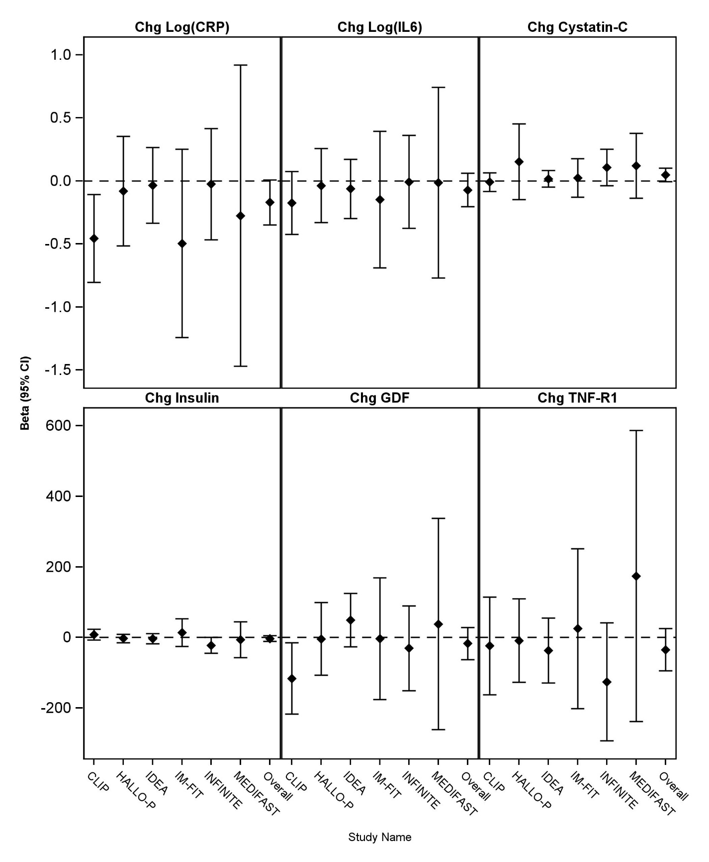

Supplemental Figure 1d. Association between change in weight and change in inflammatory markers for models containing both CR and change in weight (Model 3). Beta coefficients (95% confidence intervals) for the association between change in body weight and change in biomarkers from model with both weight change and CR assignment. Estimates are shown for individual studies and the pooled analysis (overall) that was additionally adjusted for the study.
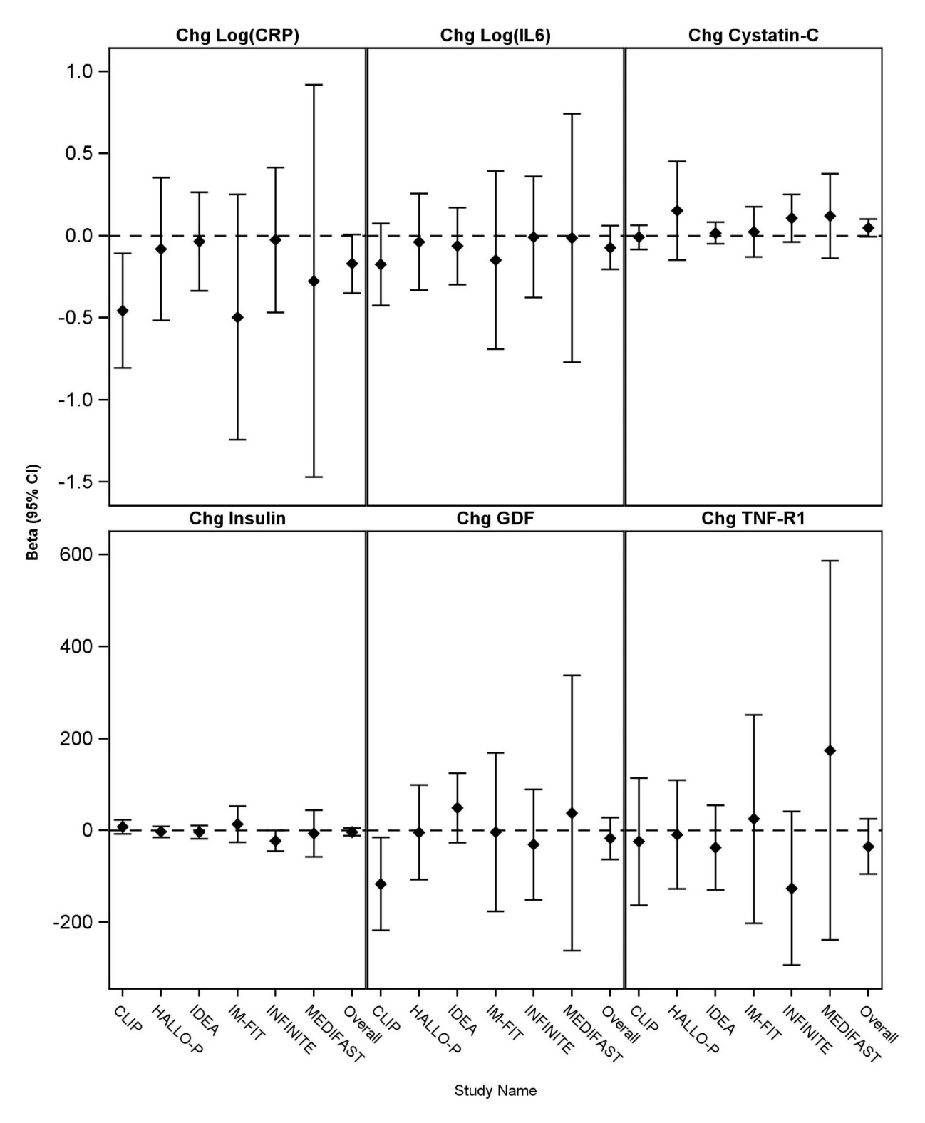

Supplemental Table 2. Analysis of Composite Biomarker Index (Quintile Rank Score).
 |  | Estimated Beta (95% CI); p-value
Predictors in Model | Study Name | No Imputation | Imputation
Each Predictor in Model Alone
Caloric Restriction (CR) | CLIP | -2.42 (-3.84, -1.00); p=<0.001 | -2.67 (-4.07, -1.27); p=<0.001
Caloric Restriction (CR) | HALLOP | -0.72 (-2.74, 1.30); p=0.479 | -1.19 (-3.13, 0.76); p=0.232
Caloric Restriction (CR) | IDEA | -2.54 (-3.69, -1.39); p=<.001 | -2.48 (-3.69, -1.28); p=<0.001
Caloric Restriction (CR) | IM-FIT | -0.05 (-2.09, 1.99); p=0.961 | -0.45 (-2.79, 1.90); p=0.710
Caloric Restriction (CR) | INFINITE | -1.93 (-3.67, -0.19); p=0.031 | -2.44 (-4.20, -0.68); p=0.007
Caloric Restriction (CR) | MEDIFAST | -1.68 (-5.79, 2.43); p=0.411 | -1.49 (-5.51, 2.52); p=0.466
Caloric Restriction (CR) | Overall | -1.99 (-2.72, -1.26); p=<0.001 | -2.21 (-2.94, -1.47); p=<0.001
Change in Wt | CLIP | 0.216 (0.09, 0.34); p=0.001 | 0.216 (0.09, 0.34); p=<.001
Change in Wt | EMPOWER | 0.032 (-0.29, 0.35); p=0.842 | 0.179 (-0.08, 0.44); p=0.177
Change in Wt | HALLOP | 0.200 (0.04, 0.36); p=0.017 | 0.169 (0.01, 0.32); p=0.032
Change in Wt | IDEA | 0.235 (0.15, 0.32); p=<.001 | 0.229 (0.14, 0.32); p=<.001
Change in Wt | IM-FIT | 0.103 (-0.18, 0.39); p=0.474 | 0.102 (-0.19, 0.40); p=0.497
Change in Wt | INFINITE | 0.233 (0.07, 0.39); p=0.005 | 0.213 (0.06, 0.37); p=0.006
Change in Wt | MEDIFAST | -.092 (-0.60, 0.41); p=0.710 | 0.102 (-0.34, 0.54); p=0.651
Change in Wt | Overall | 0.199 (0.14, 0.26); p=<.001 | 0.216 (0.09, 0.34); p=<.001
CR and Change in Wt in Model Together
CR | CLIP | -1.75 (-3.61, 0.10); p=0.063 | -1.84 (-3.61, -0.07); p=0.041
CR | HALLOP | -.793 (-2.98, 1.39); p=0.472 | -.436 (-2.52, 1.65); p=0.683
CR | IDEA | -1.41 (-2.84, 0.02); p=0.053 | -1.17 (-2.58, 0.25); p=0.105
CR | IM-FIT | 1.208 (-2.01, 4.43); p=0.454 | 0.255 (-3.24, 3.75); p=0.886
CR | INFINITE | -1.84 (-4.15, 0.48); p=0.118 | -1.50 (-3.73, 0.73); p=0.188
CR | MEDIFAST | -2.31 (-8.40, 3.79); p=0.440 | -1.31 (-6.98, 4.37); p=0.651
CR | Overall | -1.34 (-2.24, -0.44); p=0.004 | -1.15 (-2.02, -0.28); p=0.010
Change in Wt | CLIP | 0.121 (-0.04, 0.28); p=0.142 | 0.118 (-0.04, 0.27); p=0.138
Change in Wt | EMPOWER | 0.032 (-0.29, 0.35); p=0.842 | 0.178 (-0.08, 0.44); p=0.181
Change in Wt | HALLO-P | 0.175 (-0.00, 0.35); p=0.054 | 0.155 (-0.01, 0.32); p=0.072
Change in Wt | IDEA | 0.182 (0.08, 0.29); p=<.001 | 0.184 (0.08, 0.29); p=<.001
Change in Wt | IM-FIT | 0.216 (-0.20, 0.63); p=0.303 | 0.123 (-0.31, 0.56); p=0.580
Change in Wt | INFINITE | 0.135 (-0.07, 0.34); p=0.186 | 0.134 (-0.06, 0.33); p=0.175
Change in Wt | MEDIFAST | -.256 (-0.93, 0.41); p=0.436 | 0.022 (-0.59, 0.63); p=0.943
Change in Wt | Overall | 0.144 (0.07, 0.21); p=<.001 | 0.159 (0.09, 0.23); p=<.001
Note that Empower only has CR, so unable to estimate a CR effect for that study. Abbreviations: weight (Wt)
Supplemental Table 3. Study Sample Selection and Availability Summary. The first row shows total count of samples. All other frequencies represent individuals.
Total Samples Per Person | RCT | Randomization Group | A | B | C | D | E
Total Samples Per Person | RCT | Randomization Group | Total Freezer Samples Available¹  N= 1063 | Selected in Round 1 N= 60 | Selected in R1  N= 38 | Not Selected R1  N=238 | Not Selected R1,  N=765
ALL SAMPLES = paired samples + single samples |  |  | 1908 | 108 | 69 | 455 | 1345
Pair | ALL STUDIES |  | 845 | 48 | 31 | 217 | 580
 | CLIP | Control | 77 | 6 | 5 | 24 | 47
 | CLIP | Diet + Exercise | 84 | 6 | 4 | 24 | 54
 | CLIP | Exercise | 70 | 6 | 4 | 18 | 46
 | EMPOWER | Weight loss + Exercise | 25 | . | . | . | 25
 | EMPOWER | Weight loss + Exercise + Sit less | 28 | . | . | . | 28
 | EMPOWER | Weight loss + Sit less | 30 | . | . | . | 30
 | IDEA | Diet + Exercise | 120 | 7 | 6 | 32 | 81
 | IDEA | Diet Only | 103 | 7 | 3 | 38 | 58
 | IDEA | Exercise Only | 115 | 6 | 3 | 28 | 81
 | INFINITE | Aerobic exercise | 38 | 4 | 3 | 19 | 15
 | INFINITE | High caloric restriction + Aerobic exercise | 43 | 3 | 2 | 13 | 27
 | INFINITE | Moderate caloric restriction + Aerobic exercise | 47 | 3 | 1 | 21 | 23
 | MEDIFAST | Stable | 31 | . | . | . | 31
 | MEDIFAST | Weight Loss | 34 | . | . | . | 34
Single | ALL STUDIES |  | 218 | 12 | 7 | 21 | 185
 | CLIP | Control | 8 | 1 | . | 1 | 6
 | CLIP | Diet + Exercise | 4 | 1 | 1 | . | 3
 | CLIP | Exercise | 16 | 1 | 1 | 3 | 12
 | EMPOWER | Weight loss + Exercise | 28 | . | . | . | 28
 | EMPOWER | Weight loss + Exercise + Sit less | 26 | . | . | . | 26
 | EMPOWER | Weight loss + Sit less | 25 | . | . | . | 25
 | IDEA | Diet + Exercise | 20 | 2 | 1 | 3 | 15
 | IDEA | Diet Only | 34 | 3 | 2 | 4 | 27
 | IDEA | Exercise Only | 24 | 2 | 1 | 4 | 18
 | INFINITE | Aerobic exercise | 11 | 1 | 1 | 4 | 6
 | INFINITE | High caloric restriction + Aerobic exercise | 5 | 1 | . | 2 | 2
 | INFINITE | Moderate caloric restriction + Aerobic exercise | 2 | . | . | . | 2
 | MEDIFAST | Stable | 11 | . | . | . | 11
 | MEDIFAST | Weight Loss | 4 | . | . | . | 4
Total Samples Originally Available in Freezer (A)= selected (B) + not selected (D+E)
¹After removing participants with no Pepper ID or treatment group assignment and keeping last Pepper ID (last set of RCT samples for a participant)

Supplemental Table 4. Study Sample Selection and Availability Summary. The first row shows total count of samples. All other frequencies represent individuals.

Total Samples Per Person | RCT |  | E |  | F | G | H | I
Total Samples Per Person | RCT | Randomization Group | Not Selected R1  N=238 |  | Not Selected R1,  N=765 | Total  Available Samples in Freezer After Round 1  E+F | Proportion  of Total Available  by Sample Type | Number Randomly Selected from column F | Total  People Selected  For Remaining  42  plates  E+I
ALL SAMPLES = paired samples + single samples |  |  | 455 | 1345 |  | 1800 |  |  | 1134
Pair | ALL STUDIES |  | 217 | 580 |  | 797 |  |  | 515
 | CLIP | Control | 24 | 47 |  | 71 | 0.09=71/797 | 27=0.09*298 | 51=24+27
 | CLIP | Diet + Exercise | 24 | 54 |  | 78 | 0.10 | 29 | 53
 | CLIP | Exercise | 18 | 46 |  | 64 | 0.08 | 24 | 42
 | EMPOWER | Weight loss + Exercise | . | 25 |  | 25 | 0.03 | 9 | 9
 | EMPOWER | Weight loss + Exercise + Sit less | . | 28 |  | 28 | 0.04 | 10 | 10
 | EMPOWER | Weight loss + Sit less | . | 30 |  | 30 | 0.04 | 11 | 11
 | IDEA | Diet + Exercise | 32 | 81 |  | 113 | 0.14 | 42 | 74
 | IDEA | Diet Only | 38 | 58 |  | 96 | 0.12 | 36 | 74
 | IDEA | Exercise Only | 28 | 81 |  | 109 | 0.14 | 41 | 69
 | INFINITE | Aerobic exercise | 19 | 15 |  | 34 | 0.04 | 13 | 32
 | INFINITE | High caloric restriction + Aerobic exercise | 13 | 27 |  | 40 | 0.05 | 15 | 28
 | INFINITE | Moderate caloric restriction + Aerobic exercise | 21 | 23 |  | 44 | 0.06 | 16 | 37
 | MEDIFAST | Stable | . | 31 |  | 31 | 0.04 | 12 | 12
 | MEDIFAST | Weight Loss | . | 34 |  | 34 | 0.04 | 13 | 13
Single | ALL STUDIES |  | 21 | 185 |  | 206 |  |  | 104
 | CLIP | Control | 1 | 6 |  | 7 | 0.03=7/206 | 3=0.03*83 | 4
 | CLIP | Diet + Exercise | . | 3 |  | 3 | 0.01 | 2 | 2
 | CLIP | Exercise | 3 | 12 |  | 15 | 0.07 | 6 | 9
 | EMPOWER | Weight loss + Exercise | . | 28 |  | 28 | 0.14 | 11 | 11
 | EMPOWER | Weight loss + Exercise + Sit less | . | 26 |  | 26 | 0.13 | 10 | 10
 | EMPOWER | Weight loss + Sit less | . | 25 |  | 25 | 0.12 | 10 | 10
 | IDEA | Diet + Exercise | 3 | 15 |  | 18 | 0.09 | 7 | 10
 | IDEA | Diet Only | 4 | 27 |  | 31 | 0.15 | 12 | 16
 | IDEA | Exercise Only | 4 | 18 |  | 22 | 0.11 | 9 | 13
 | INFINITE | Aerobic exercise | 4 | 6 |  | 10 | 0.05 | 4 | 8
 | INFINITE | High caloric restriction + Aerobic exercise | 2 | 2 |  | 4 | 0.02 | 2 | 4
 | INFINITE | Moderate caloric restriction + Aerobic exercise | . | 2 |  | 2 | 0.01 | 1 | 1
 | MEDIFAST | Stable | . | 11 |  | 11 | 0.05 | 4 | 4
 | MEDIFAST | Weight Loss | . | 4 |  | 4 | 0.02 | 2 | 2

