Table S1a Task-evoked changes in oxygenated hemoglobin (ΔHbO₂, 5-40 s) across ROIs in HOAs and MMD
ROI | Task |  |  | Task |  |  | Group |  |  | Interaction
ROI | Task | HOA | MMD | F | p_fdr | Partial η² | F | p_fdr | Partial η² | F | p_fdr | Partial η²
Right DLPFC | SST | 0.014 (0.127) | 0.125 (0.142) | 0.197 | 0.658 | 0.004 | 2.293 | 0.712 | 0.047 | 16.062 | 0.002 | 0.246
 | CST | 0.065 (0.165) | 0.067 (0.134)
Left DLPFC | SST | 0.045 (0.116) | 0.112 (0.168) | 8.624 | 0.039 | 0.149 | 1.577 | 0.782 | 0.032 | 1.889 | 0.468 | 0.037
 | CST | 0.095 (0.159) | 0.092 (0.138)
Right FPPFC | SST | 0.050 (0.183) | 0.096 (0.147) | 1.108 | 0.476 | 0.022 | 0.490 | 0.711 | 0.010 | 0.001 | 0.978 | < 0.001
 | CST | 0.094 (0.159) | 0.117 (0.124)
Left FPPFC | SST | 0.031 (0.182) | 0.078 (0.168) | 4.585 | 0.149 | 0.085 | 0.760 | 0.720 | 0.015 | 0.762 | 0.619 | 0.015
 | CST | 0.056 (0.179) | 0.081 (0.156)
Right VLPFC | SST | 0.049 (0.108) | 0.066 (0.171) | 0.483 | 0.567 | 0.010 | 0.747 | 0.723 | 0.016 | 0.302 | 0.780 | 0.006
 | CST | 0.063 (0.160) | 0.076 (0.145)
Left VLPFC | SST | 0.047 (0.154) | 0.045 (0.156) | 2.784 | 0.271 | 0.054 | 0.220 | 0.733 | 0.005 | 3.363 | 0.291 | 0.064
 | CST | 0.081 (0.231) | 0.074 (0.133)
Right OFC | SST | 0.107 (0.156) | 0.120 (0.162) | 1.117 | 0.476 | 0.022 | 0.052 | 0.822 | 0.001 | 0.167 | 0.782 | 0.003
 | CST | 0.108 (0.190) | 0.158 (0.158)
Left OFC | SST | 0.074 (0.176) | 0.144 (0.165) | 0.470 | 0.567 | 0.010 | 0.393 | 0.742 | 0.010 | 1.355 | 0.782 | 0.027
 | CST | 0.101 (0.157) | 0.138 (0.139)
Note. DLPFC, Dorsolateral Prefrontal Cortex; VLPFC, Ventrolateral Prefrontal Cortex; FPPFC, Frontopolar Cortex; OFC, Orbitofrontal Cortex; SST; simple stepping task; CST, choice stepping task; mild-to-moderate dementia; HOA, healthy older adults; Values are mean (SD). Partial eta-squared (η²) is reported as effect size; P values were FDR-adjusted across the 8 ROIs within each comparison set; BOLD indicates p_fdr < 0.05

Table S1b Post hoc within- and between-group comparisons for ROI-based task-evoked brain activation (ΔHbO₂, 5-40 s)
Regions of interest | Task | Within-group comparisons (CST vs. SST) |  |  |  | Between-group comparisons  (MMD vs. HOA)
Regions of interest | Task | HOA group |  | MMD group
Regions of interest | Task | t value | p_bonf | t value | p_bonf | t value | p_bonf
Right DLPFC | SST | 3.181 | 0.005 | -2.494 | 0.032 | 3.164 | 0.005
Right DLPFC | CST |  |  |  |  | -0.463 | 0.863
Left DLPFC | SST | 3.080 | 0.007 | 1.094 | 0.559 | 1.757 | 0.167
Left DLPFC | CST |  |  |  |  | 0.456 | 0.852
Right FPPFC | SST | 0.732 | 0.935 | 0.756 | 0.906 | 0.604 | 0.892
Right FPPFC | CST |  |  |  |  | 0.630 | 0.806
Left FPPFC | SST | 2.155 | 0.072 | 0.887 | 0.758 | 1.140 | 0.517
Left FPPFC | CST |  |  |  |  | 0.469 | 0.851
Right VLPFC | SST | 0.890 | 0.756 | 0.101 | 1.0 | -0.575 | 0.995
Right VLPFC | CST |  |  |  |  | -1.012 | 0.632
Left VLPFC | SST | 2.503 | 0.051 | -0.116 | 1.0 | 1.210 | 0.461
Left VLPFC | CST |  |  |  |  | -0.363 | 0.995
Right OFC | SST | 0.463 | 1.0 | 1.025 | 0.620 | 0.067 | 1.0
Right OFC | CST |  |  |  |  | 0.357 | 0.995
Left OFC | SST | 1.322 | 0.385 | 0.334 | 1.0 | 1.042 | 0.602
Left OFC | CST |  |  |  |  | 0.106 | 1.0
Note. DLPFC, Dorsolateral Prefrontal Cortex; VLPFC, Ventrolateral Prefrontal Cortex; FPPFC, Frontopolar Cortex; OFC, Orbitofrontal Cortex; SST; simple stepping task; CST, choice stepping task; mild-to-moderate dementia; HOA, healthy older adults; Positive t values in within-group comparison indicate higher ΔHbO₂ during CST than SST; Positive t values in between-group comparisons indicate higher ΔHbO₂ in MMD than HOAs; P values were Bonferroni-adjusted for post-hoc comparisons; BOLD indicates p_bonf < 0.05

Table S1c Task-evoked changes in oxygenated hemoglobin (ΔHbO₂, 5-10 s) across ROIs in HOAs and MMD
ROI | Task |  |  | Task |  |  | Group |  |  | Interaction
ROI | Task | HOA | MMD | F | p_fdr | Partial η² | F | p_fdr | Partial η² | F | p_fdr | Partial η²
Right DLPFC | SST | 0.075 (0.212) | 0.215 (0.202) | 3.465 | 0.092 | 0.066 | 4.637 | 0.292 | 0.090 | 11.768 | 0.009 | 0.194
 | CST | 0.131 (0.215) | 0.142 (0.166)
Left DLPFC | SST | 0.062 (0.187) | 0.148 (0.223) | 12.865 | 0.006 | 0.208 | 0.044 | 0.780 | 0.002 | 3.797 | 0.114 | 0.072
 | CST | 0.177 (0.197) | 0.151 (0.186)
Right FPPFC | SST | 0.136 (0.229) | 0.144 (0.223) | 4.342 | 0.068 | 0.081 | 0.013 | 0.980 | 0.001 | 4.355 | 0.112 | 0.082
 | CST | 0.211 (0.214) | 0.151 (0.166)
Left FPPFC | SST | 0.084 (0.265) | 0.150 (0.249) | 6.831 | 0.030 | 0.122 | 0.036 | 0.960 | 0.001 | 4.211 | 0.079 | 0.114
 | CST | 0.146 (0.236) | 0.153 (0.218)
Right VLPFC | SST | 0.094 (0.160) | 0.128 (0.244) | 2.055 | 0.181 | 0.040 | 0.239 | 0.627 | 0.005 | 2.453 | 0.198 | 0.048
 | CST | 0.114 (0.245) | 0.143 (0.210)
Left VLPFC | SST | 0.083 (0.252) | 0.089 (0.265) | 6.460 | 0.030 | 0.116 | 0.001 | 0.980 | < 0.001 | 0.818 | 0.370 | 0.016
 | CST | 0.135 (0.322) | 0.140 (0.273)
Right OFC | SST | 0.179 (0.234) | 0.219 (0.213) | 0.801 | 0.375 | 0.016 | 0.087 | 0.780 | 0.002 | 1.593 | 0.284 | 0.031
 | CST | 0.229 (0.235) | 0.270 (0.207)
Left OFC | SST | 0.154 (0.166) | 0.193 (0.228) | 3.698 | 0.119 | 0.044 | 0.625 | 0.433 | 0.013 | 0.929 | 0.370 | 0.019
 | CST | 0.200 (0.218) | 0.231 (0.168)
Note. DLPFC, Dorsolateral Prefrontal Cortex; VLPFC, Ventrolateral Prefrontal Cortex; FPPFC, Frontopolar Cortex; OFC, Orbitofrontal Cortex; SST; simple stepping task; CST, choice stepping task; MMD, mild-to-moderate dementia; HOA, healthy older adults; Values are mean (SD). Partial eta-squared (η²) is reported as effect size; P values were FDR-adjusted across the 8 ROIs within each comparison set; BOLD indicates p_fdr < 0.05

Table S1d Post hoc within- and between-group comparisons for ROI-based task-evoked brain activation (ΔHbO₂, 5-10 s)
Regions of interest | Task | Within-group comparisons (CST vs. SST) |  |  |  | Between-group comparisons (MMD vs. HOA)
Regions of interest | Task | HOA group |  | MMD group
Regions of interest | Task | t value | p_bonf | t value | p_bonf | t value | p_bonf
Right DLPFC | SST | 3.779 | < 0.001 *** | -1.099 | 0.277 | 3.335 | 0.003 **
Right DLPFC | CST |  |  |  |  | 0.621 | 0.838
Left DLPFC | SST | 3.953 | < 0.001 *** | 1.147 | 0.257 | 0.820 | 0.973
Left DLPFC | CST |  |  |  |  | -0.423 | 1.0
Right FPPFC | SST | 2.978 | 0.009 ** | -0.002 | 0.998 | 1.015 | 0.627
Right FPPFC | CST |  |  |  |  | -0.806 | 0.846
Left FPPFC | SST | 3.332 | 0.003 ** | 0.393 | 0.696 | 0.480 | 1.0
Left FPPFC | CST |  |  |  |  | -0.841 | 0.704
Right VLPFC | SST | 2.142 | 0.074 | 0.093 | 0.927 | 0.215 | 1.0
Right VLPFC | CST |  |  |  |  | -1.102 | 0.549
Left VLPFC | SST | 2.461 | 0.035 * | 1.146 | 0.257 | 0.339 | 1.0
Left VLPFC | CST |  |  |  |  | -0.292 | 1.0
Right OFC | SST | 1.540 | 0.260 | -0.257 | 0.798 | 0.226 | 1.0
Right OFC | CST |  |  |  |  | -0.769 | 0.889
Left OFC | SST | 2.521 | 0.030 * | 1.086 | 0.283 | 1.124 | 0.530
Left OFC | CST |  |  |  |  | 0.308 | 1.0
Note. DLPFC, Dorsolateral Prefrontal Cortex; VLPFC, Ventrolateral Prefrontal Cortex; FPPFC, Frontopolar Cortex; OFC, Orbitofrontal Cortex; SST; simple stepping task; CST, choice stepping task; mild-to-moderate dementia; HOA, healthy older adults; Positive t values in within-group comparison indicate higher ΔHbO₂ during CST than SST; Positive t values in between-group comparisons indicate higher ΔHbO₂ in MMD than HOAs; P values were Bonferroni-adjusted for post-hoc comparisons; BOLD indicates p_bonf < 0.05

Table S2a Task-evoked network topology properties in HOAs and MMD
ROI | Task |  |  | Task |  |  | Group |  |  | Interaction |  |  | Age (covariable)
ROI | Task | HOA | MMD | F | p_fdr | Partial η² | F | p_fdr | Partial η² | F | p_fdr | Partial η² | F | p_fdr | Partial η²
E_{g} | SST | 0.149 (0.021) | 0.163 (0.015) | 2.016 | 0.224 | 0.04 | 0.037 | 0.848 | 0.001 | 2.096 | 0.462 | 0.041 | 7.750 | 0.008 | 0.14
 | CST | 0.149 (0.022) | 0.161 (0.015)
E_{loc} | SST | 0.235 (0.015) | 0.251 (0.014) | 1.526 | 0.224 | 0.03 | 2.628 | 0.18 | 0.05 | 0.033 | 0.857 | 0.001 | 6.624 | 0.013 | 0.13
 | CST | 0.235 (0.015) | 0.250 (0.013)
C_{p} | SST | 0.200 (0.014) | 0.215 (0.011) | 1.517 | 0.224 | 0.03 | 8.703 | 0.005 | 0.16 | 0.323 | 0.572 | 0.006 | 1.083 | 0.303 | 0.02
 | CST | 0.199 (0.015) | 0.215 (0.010)
L_{p} | SST | 1.14 (0.175) | 1.047 (0.106) | 1.41 | 0.241 | 0.03 | 0.015 | 0.902 | < 0.001 | 0.004 | 0.95 | < 0.001 | 6.732 | 0.01 | 0.14
 | CST | 1.148 (0.193) | 1.055 (0.099)
Note. SST; simple stepping task; CST, choice stepping task; mild-to-moderate dementia; HOA, healthy older adults; Values are mean (SD). Partial eta-squared (η²) is reported as effect size; P values were FDR-adjusted across the family of network topology metrics; BOLD indicates p_fdr < 0.05.

Table S2b Hierarchical multiple regression predicting CSRT in the MMD group
 | Model 1 |  |  |  | Model 2 |  |  |  | Model 3
Variable | B | SE B | β | p | B | SE B | β | p | B | SE B | β | p
Age (years) | -0.21 | 0.726 | -0.066 | 0.776 | -0.262 | 0.75 | -0.083 | 0.731 | -0.221 | 0.588 | -0.07 | 0.711
Education (years) | 0.684 | 1.602 | 0.096 | 0.674 | 0.796 | 1.655 | 0.112 | 0.637 | 1.766 | 1.341 | 0.249 | 0.205
MoCA score | -1.356 | 1.206 | -0.257 | 0.276 | -1.215 | 1.268 | -0.23 | 0.351 | -0.116 | 1.051 | -0.022 | 0.913
Right DLPFC activation (mM.mm) |  |  |  |  | 18.309 | 38.426 | 0.115 | 0.640
Prefrontal C_{p} |  |  |  |  |  |  |  |  | -1432.1 | 444.05 | -0.649 | 0.005
R² | 0.088 |  |  |  | 0.10 |  |  |  | 0.444
Adjusted R² | -0.056 |  |  |  | -0.110 |  |  |  | 0.320
ΔR² |  |  |  |  | 0.012 |  |  |  | 0.356
F change for R² |  |  |  |  | 0.227 |  |  |  | 10.40
LogLik | -95.73 |  |  |  | -95.58 |  |  |  | -90.48
AIC | 201.46 |  |  |  | 203.16 |  |  |  | 192.95
BIC | 206.91 |  |  |  | 209.71 |  |  |  | 199.5
Note. Model 1 included Age, Education, and MoCA; Model 2 additionally included right DLPFC activation; Model 3 additionally included prefrontal Cp.
B, unstandardized regression coefficient; SE, standard error; β, standardized coefficient; ΔR² and the F change test indicate the incremental variance explained when adding predictors; AIC, Akaike Information Criterion; BIC, Bayesian Information Criterion; LogLik, Log-likelihood.
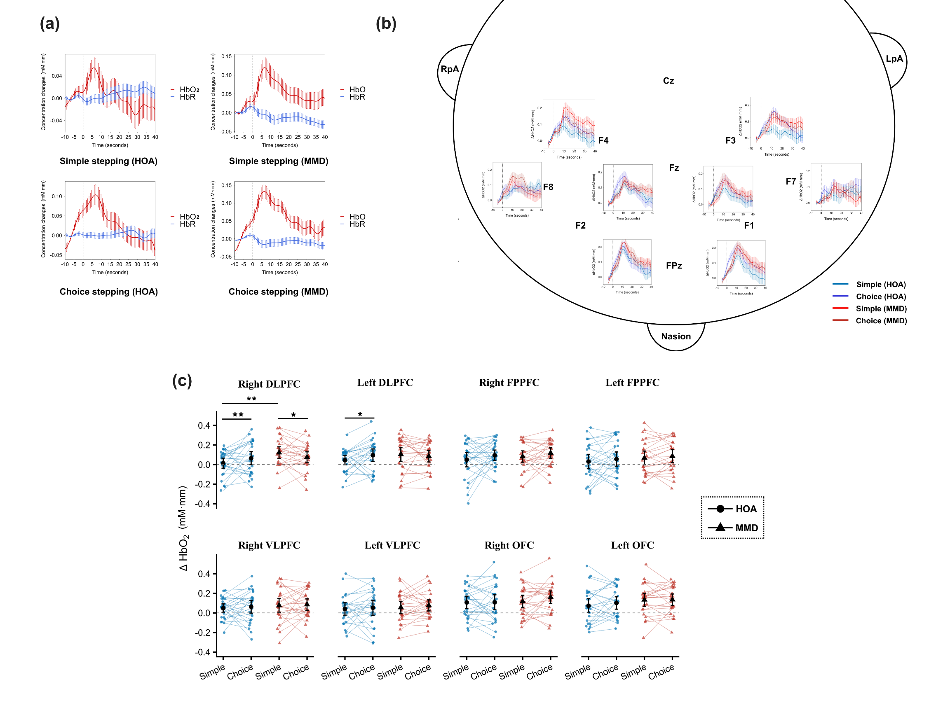
Fig. S1 Hemodynamic responses during simple and choice stepping tasks in the HOA and MMD groups. (a). Group-average time courses of oxygenated hemoglobin (HbO₂, red lines) and deoxygenated hemoglobin (HbR, blue lines) concentration changes in the overall prefrontal cortex, with means and standard errors illustrated. (b). Group-average time courses of HbO₂ changes in the eight regions of interest for both groups, with means and standard errors illustrated. (c). Scatter plot displaying the 2×2 mixed ANCOVA results; black symbols indicate the mean, and error bars represent the 95% confidence intervals. Abbreviations: DLPFC, Dorsolateral Prefrontal Cortex; VLPFC, Ventrolateral Prefrontal Cortex; FPPFC, Frontopolar Cortex; OFC, Orbitofrontal Cortex; HOA, healthy older adults; MMD, mild-to-moderate dementia; *: p < 0.05, **: p < 0.01

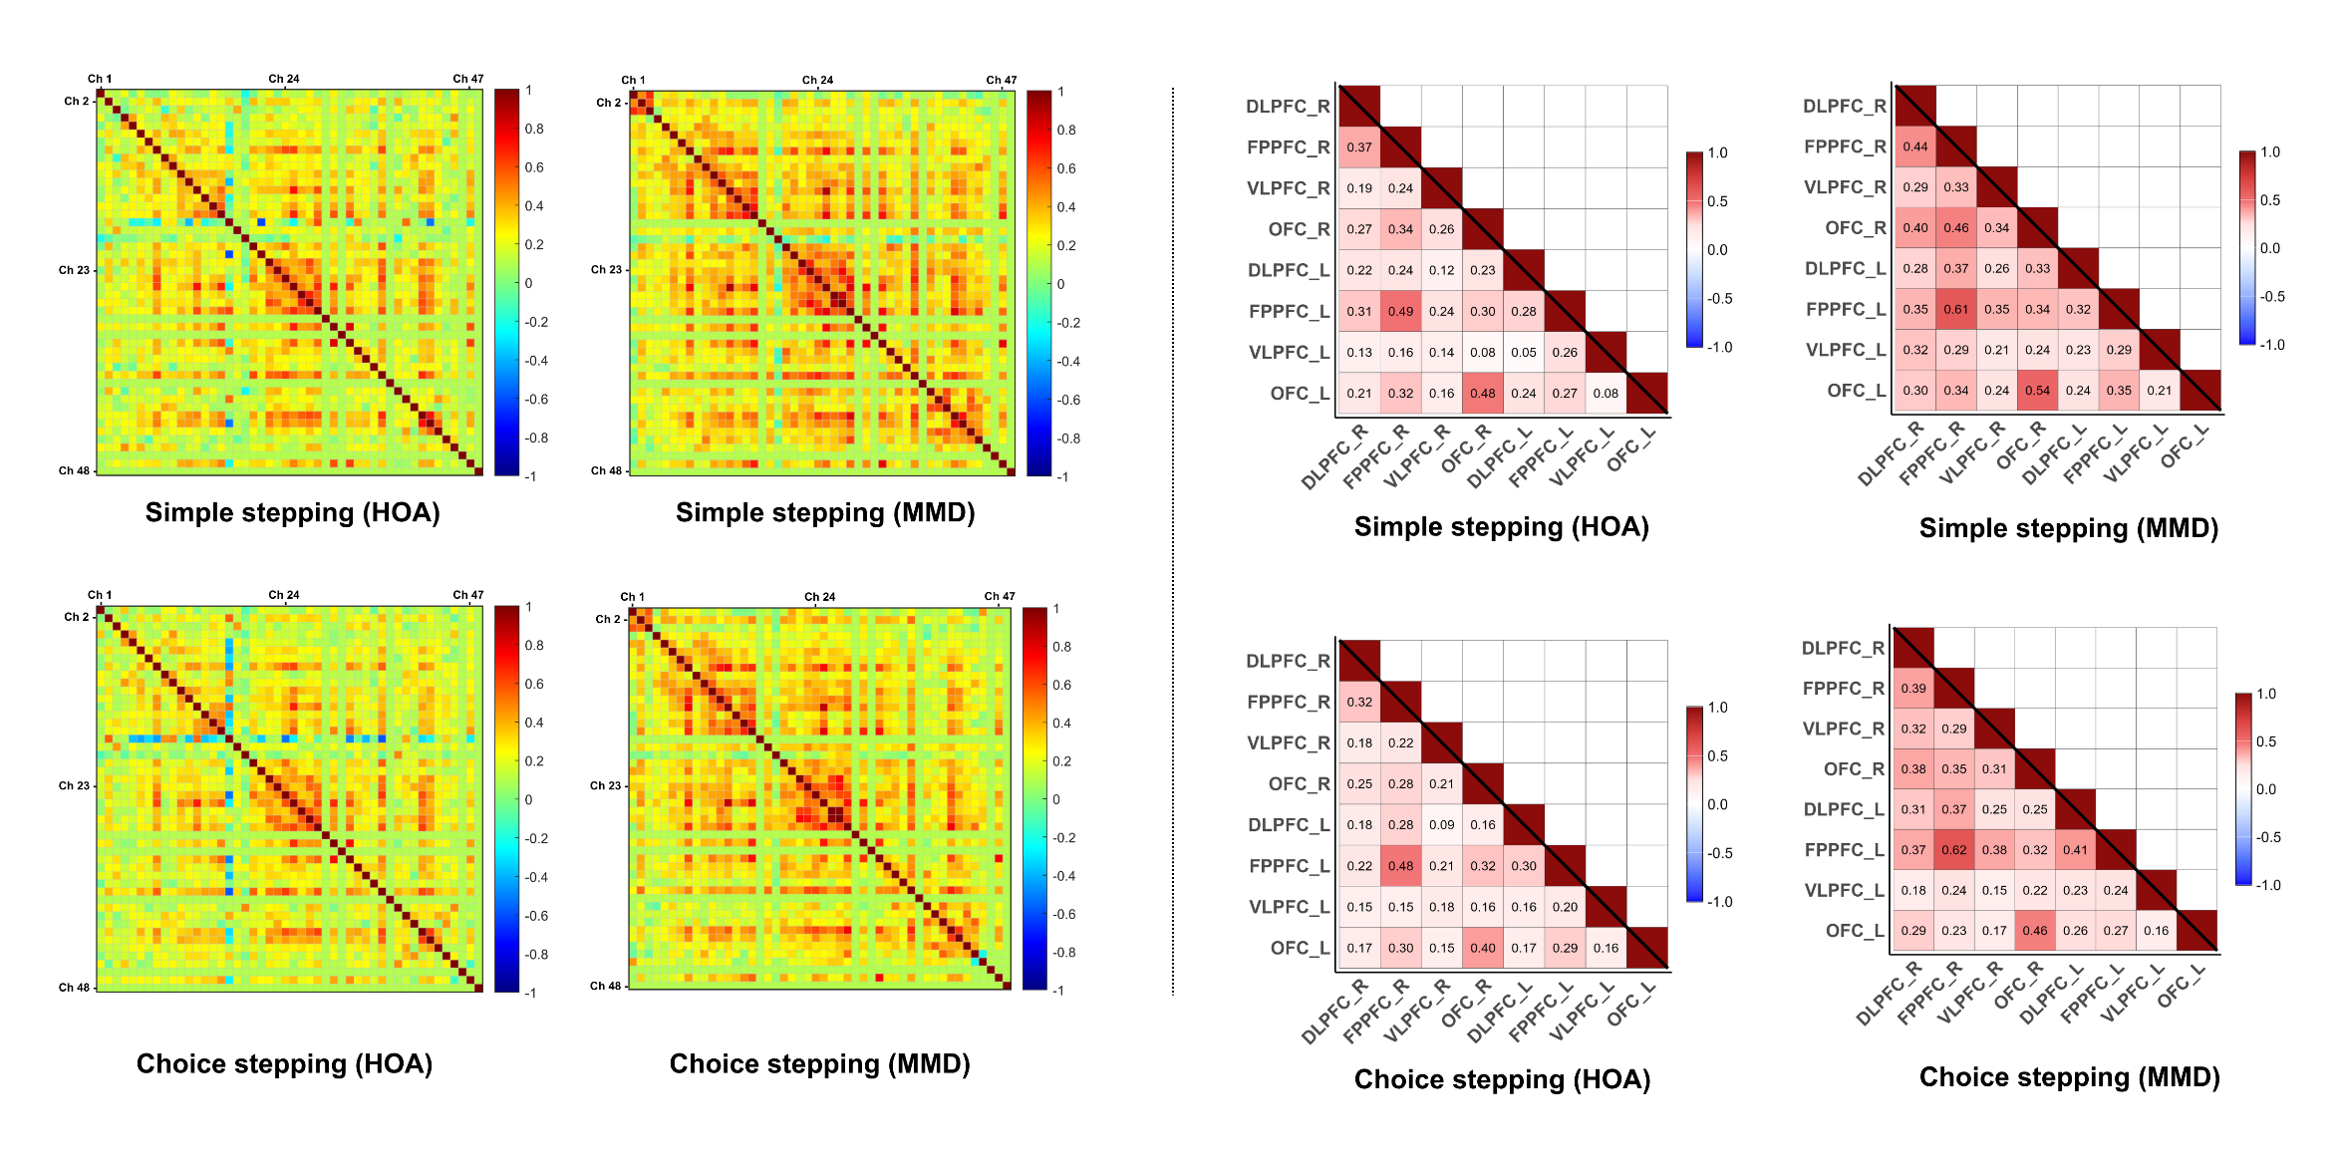
(b)
(a)
Fig. S2 Group-level functional connectivity matrices for each group and task. (a). 48 × 48 channel-level functional connectivity matrices; The color bar indicates the Pearson correlation coefficients (Pearson’s r) between channel pairs, ranging from -1 (blue) to 1 (red). (b). 8 × 8 region of interest (ROI)-level functional connectivity matrices, with specific mean Pearson’s r values illustrated. Abbreviations: R, right; L, left; DLPFC, dorsolateral prefrontal cortex; FPPFC, frontopolar prefrontal cortex; VLPFC, ventrolateral prefrontal cortex; OFC, orbitofrontal cortex; HOA, healthy older adults; MMD, mild-to-moderate dementia.
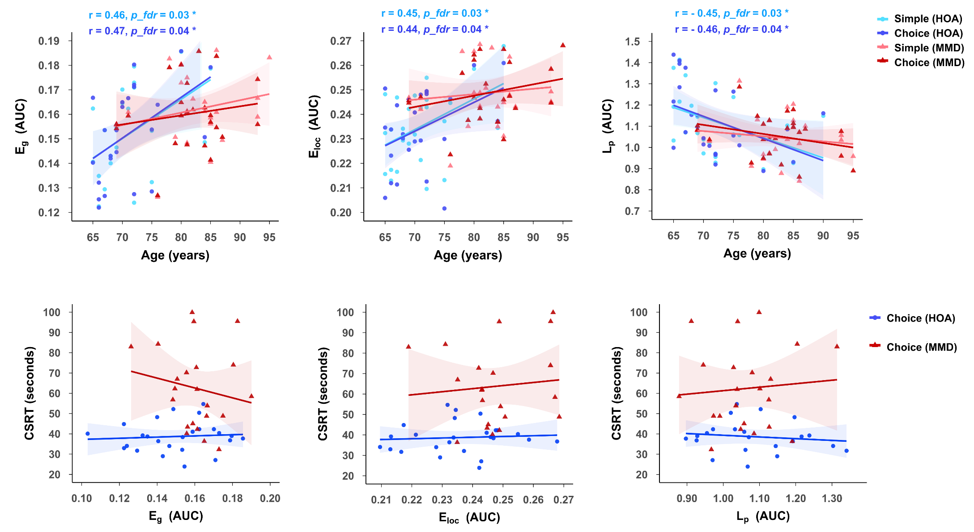
(b)
(a)
Fig. S3 Correlations among age, prefrontal network metrics, and choice stepping performance. (a). Scatter plots illustrating the relationships between age and AUC values of network metrics; Significant correlations were found only in the HOA group, with age positively correlated with Eg, Eloc, and Lp; The shaded areas indicate 95% confidence intervals. *: p < 0.05 (after FDR corrected). (b). Scatter plots showing the associations between the network metrics and Choice Stepping Reaction Time (CSRT). Abbreviations: AUC, area under the curve; r, Pearson correlation coefficient; E_{g}, global efficiency; E_{loc}, local efficiency; L_{p}, characteristic path length; HOA, healthy older adults; MMD, mild-to-moderate dementia.

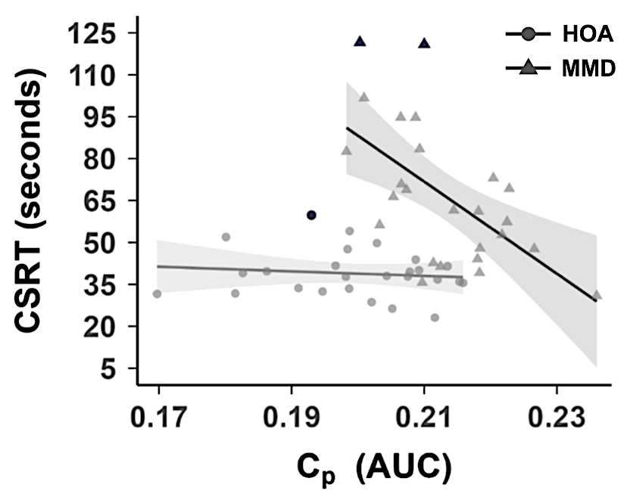
Fig. S4 Sensitivity analysis of the relationship between prefrontal Clustering Coefficient (C_{p}) and choice stepping reaction time (CSRT) retaining all statistical outliers (flagged observations are highlighted in black; HOA: n = 1, MMD: n = 2). The association in the MMD group remained significant when all flagged observations were retained (Pearson r = -0.56, p = 0.022, FDR-corrected); results were consistent using a non-parametric correlation (Spearman 𝜌 = -0.48, p = 0.039, FDR-corrected). Abbreviations: AUC, area under the curve; HOA, healthy older adults; MMD, mild-to-moderate dementia.

