Supplementary Information
Supplementary Fig. S1 Automatic segmentation of images in FIJI and manual editing of microglia masks A: Optical stack of images from ilastik were flattened by a macro in Fiji into a single two-dimensional image using maximum intensity z-projection. B: The resulting image was segmented using a trained WEKA machine learning model and was bichrome with high intensity Iba1-positive processes/soma shown in dark grey and the background shown in light gray. C: Soma were filled in (black) using FIJI, processes were rejointed where necessary, and loops caused by overlying processes were opened. Scale bars = 30 µm.

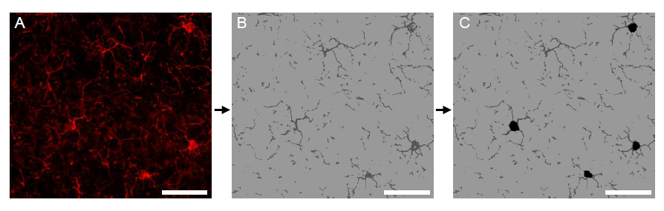

Supplementary Fig. S2 Selection of regions to be analyzed for capillary density Confocal optical stack image of the upper right quadrant of a coronal section of mouse brain. This section is labelled for Collagen IV (green) and stained with DAPI (blue). The regions for analysis are shown in red, guides for the construction of the sections are shown in white and points of interest are shown in orange. Scale bar = 500 μm.

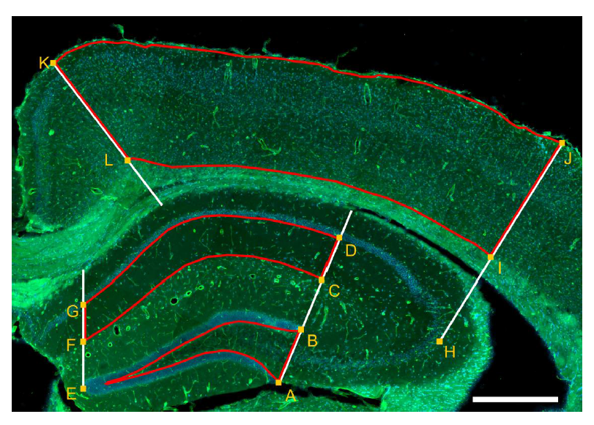

Supplementary Fig. S3 Density of cell types in the pyramidal cell layer used for analysis A: Confocal image of a mouse brain section stained with DAPI, BODIPY and neurotrace show that nearly all nuclei in the pyramidal cell layer are neurons and almost all contain lipid droplets. Neuronal lipid droplets are indicated with an arrow in the right panel. B: Confocal image of a mouse brain section stained with DAPI, BODIPY and Olig2 shows that oligodendrocytes are sparsely distributed within the pyramidal cell layer and they don’t contain lipid droplets. An oligodendrocyte outside the cell layer without lipid droplets is indicated with an arrow in the right panel. C: Confocal image of a mouse brain section stained with DAPI, BODIPY, Iba1 and GFAP. The image has an overlay of the region of interest used for lipid droplet analysis in neurons, note that the Iba1 positive cells are removed from the region of interest upon analysis. Few astrocyte somata are located inside the pyramidal cell layer region of interest. An astrocyte outside the cell layer without lipid droplets is indicated with an arrow in the right panel. D and E show the percent of GFAP positive soma in the pyramidal cell layer region of interest in the CA1 and CA3 region, respectively. The bars represent the mean value ± standard deviation. The dots represent the average value for each individual. Young mouse (light blue), middle-aged mouse (dark blue). Scale bars = 20 µm, 5 µm in excerts.

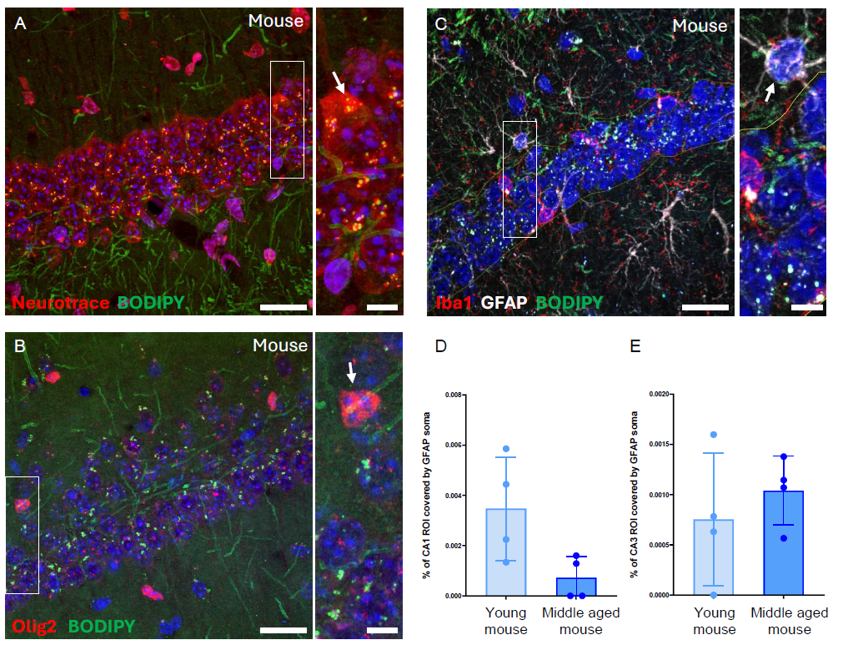

Supplementary Fig. S4 Lipid droplet accumulation in the cell layer and adjacent neuropil in CA3 The figure shows confocal optical stack images of the CA3 subfield of the hippocampus and adjacent neuropil visualized with BODIPY (green), Iba1-positive GFAP-negative microglial structures (red) and DAPI positive nuclei (blue). A: young mouse, B: middle-aged mouse, C: young NMR and D: middle aged mouse. Scale bars = 20 µm.

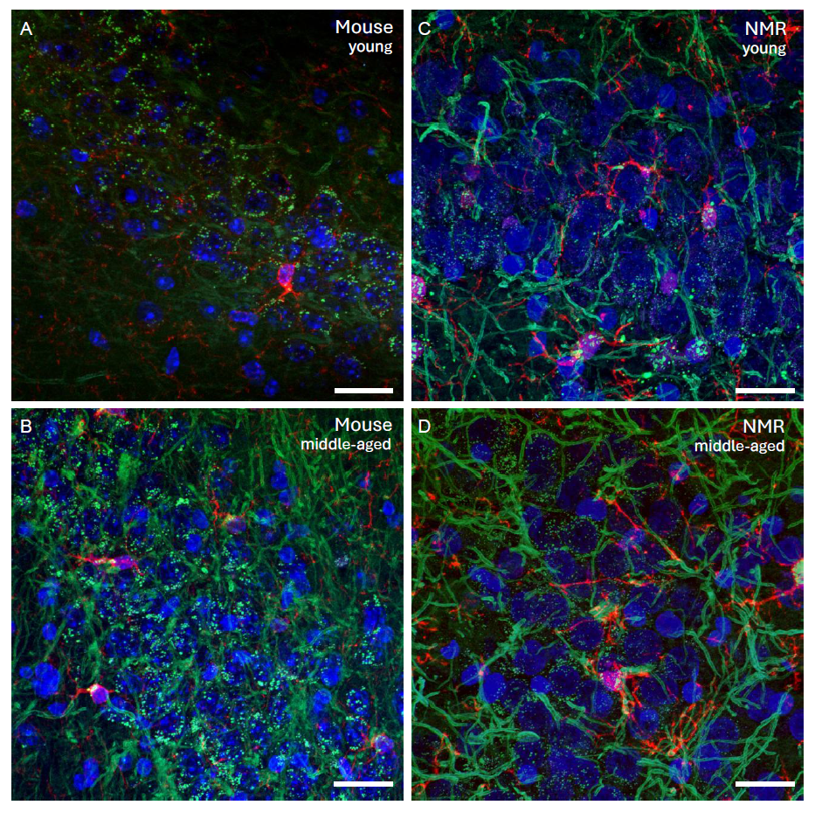

Supplementary Fig. S5 Lipid droplet accumulation in the cell layer and adjacent neuropil in CA1 The figure shows confocal optical stack images of the CA1 subfield of the hippocampus and adjacent neuropil visualized with BODIPY (green), Iba1-positive GFAP-negative microglial structures (red) and DAPI positive nuclei (blue). A: young mouse, B: middle-aged mouse, C: young NMR and D: middle aged mouse. Scale bars = 20 µm.

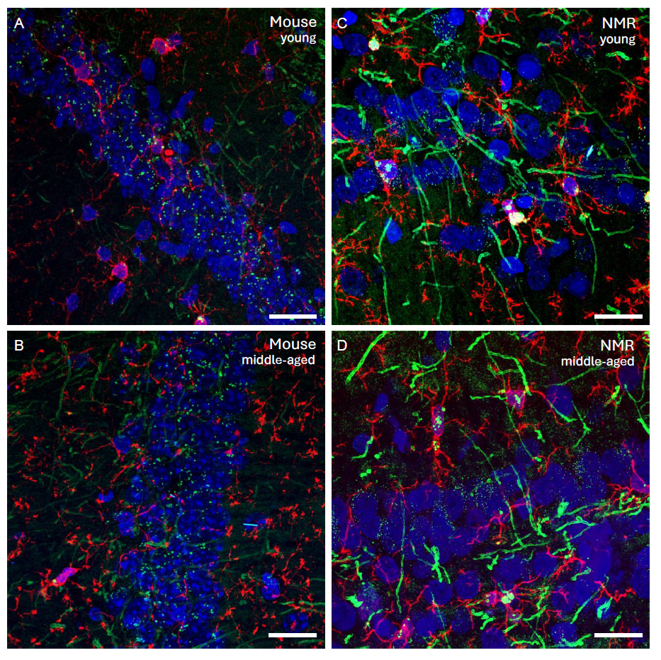

Supplementary Fig. S6 Comparison of the number of microglia analyzed in mice and NMR A: The number of microglia analyzed (microglia morphology and LD density) in the CA3 region. B: The number of microglia analyzed (microglia morphology and LD density) in the CA1 region. The bars represent the mean value ± standard deviation. The dots represent the value for each individual. Young mouse (light blue), middle-aged mouse (dark blue), young NMR (light orange), and middle-aged NMR (dark orange). Statistical test (Two-way ANOVA with Tukey’s post hoc multiple pairwise comparisons) was performed in GraphPad Prism 10. Scale bars = 20 µm.

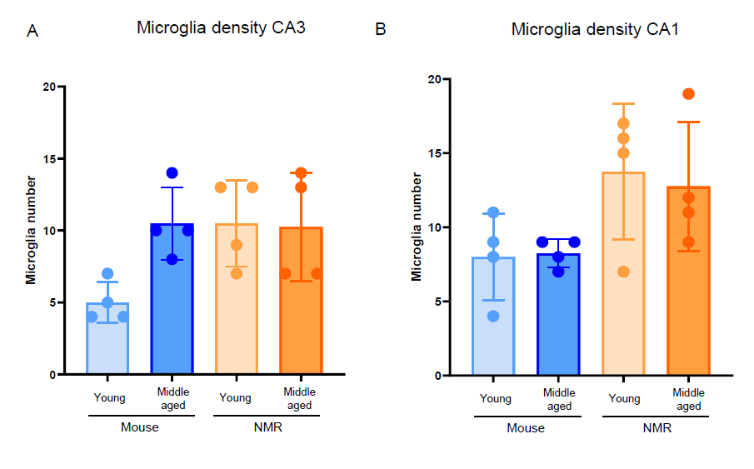

Supplementary Fig. S7 LD densities in hippocampal region vs cortex A and B: confocal images of a young mouse brain stained with DAPI, Iba1 and BODIPY, showing a larger density of lipid droplets in the CA3 region of the hippocampus (A) than in the sensory/motor cortex (B). C and D: confocal images of a middle-aged mouse brain stained with DAPI, Iba1 and BODIPY, showing larger densities of lipid droplets in the CA3 region of the hippocampus (C) than in the sensory/motor cortex (D). Scale bars: 20 µm.

