Supplementary Tables - intended for publication online

Supplementary Table 1. Descriptive information about age, diet (DDI) score, and the five clocks; PCHannum, PCHorvath1, PCPhenoAge, PCGrimAge, and the derived age acceleration measures, and DunedinPACE.

 | Baseline |  |  | Follow-up |  |  | Changeª
 | Mean | SD | Range | Mean | SD | Range | Mean | SD | Range
Chronological Age | 36.5 | 10.9 | 19.4-64.3 | 48.6 | 10.9 | 30.-75.3 | 12.1 | 0.9 | 10.1-13.9
Diet (DDI) Score | 3.7 | 0.8 | 1.8-6.0 | 4.2 | 0.9 | 1.9-6.0 | 0.6 | 0.8 | -1.3-3.2
PCHannum | 38.0 | 8.6 | 17.3-61.0 | 45.8 | 8.5 | 23.4-69.6 | 7.8 | 3.2 | -7.4-17.5
PCHannum_AgeAccel | -2.7e-09 | 3.5 | -12.6-10.8 | 9.9e-10 | 3.9 | -15.2-10.9 | 2.4e-09 | 3.0 | -15.2-8.3
PCHorvath1 | 44.0 | 7.8 | 26.3-66.2 | 51.6 | 7.4 | 33.5-72.8 | 7.6 | 2.8 | -3.1-16.5
PCHorvath1_AgeAccel | -5.1e-09 | 3.8 | -14.2-10.4 | 4.5e-09 | 4.1 | -13.6-14.5 | 8.8e-09 | 2.6 | -11.0-8.3
PCPhenoAge | 40.7 | 10.6 | 15.3-67.4 | 49.4 | 10.5 | 20.4-75.1 | 8.8 | 4.9 | -20.2-24.3
PCPhenoAge_AgeAccel | -2.3e-09 | 4.5 | -15.3-10.9 | -5.5e-10 | 5.1 | -20.4-13.2 | 1.3e-08 | 4.7 | -29.0-13.8
PCGrimAge | 51.6 | 9.9 | 32.3-81.7 | 60.3 | 10.1 | 41.5-89.7 | 8.7 | 2.6 | -2.2-16.0
PCGrimAge_AgeAccel | 5.9e-09 | 3.4 | -7.7-10.3 | 6.2e-09 | 3.9 | -9.7-11.1 | -2.7e-09 | 2.3 | -10.6-7.0
DunedinPACE | 0.8884 | 0.138 | 0.5781-1.561 | 0.8800 | 0.132 | 0.5684-1.381 | -0.008 | 0.139 | -0.6175-0.3484

ªChange = follow-up minus baseline.

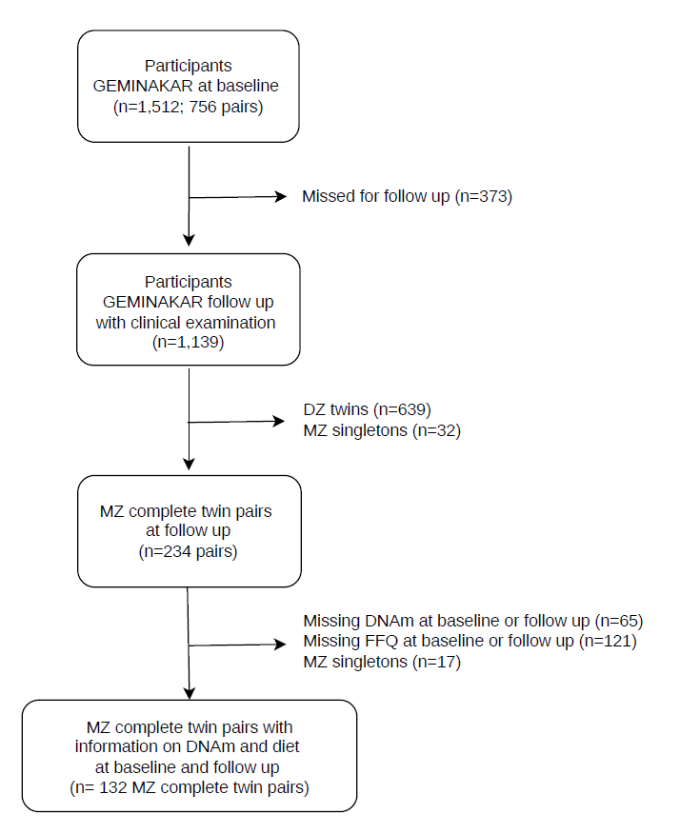
Supplementary Figures - intended for publication online

Supplementary Fig. 1. Study workflow diagram. Genome-wide DNA methylation data were generated for complete MZ twin pairs where both twins participated at baseline and follow-up.
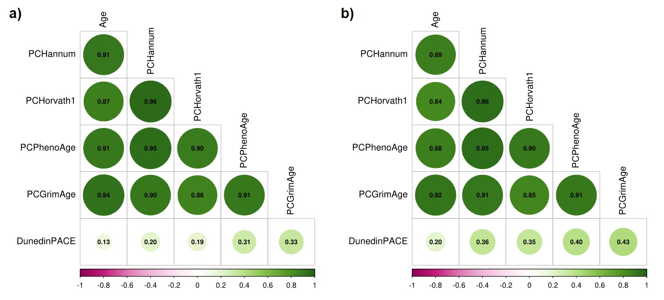
Supplementary Fig. 2. Correlations between chronological age and epigenetic age or pace of aging measures at a) baseline and b) follow-up.

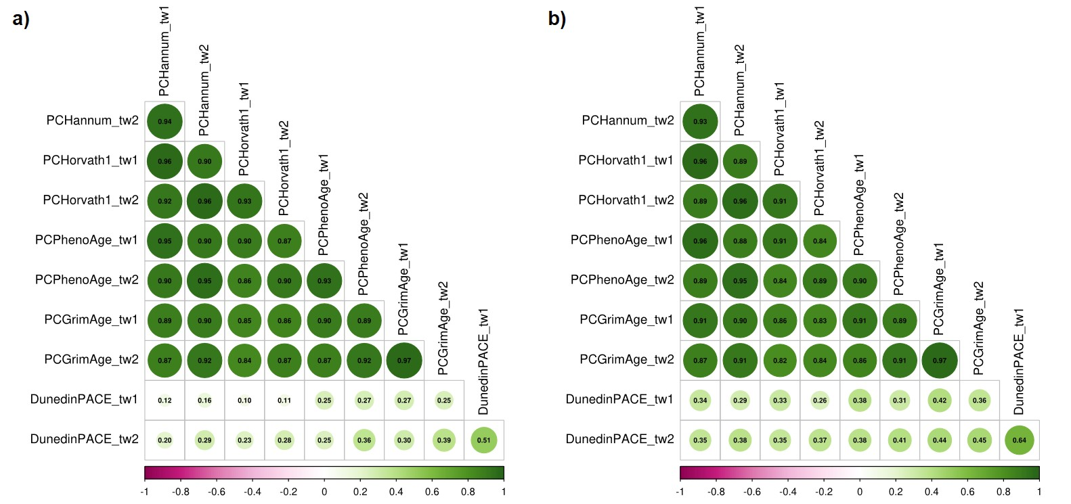
Supplementary Fig. 3. Correlations between twin 1 and twin 2 for epigenetic age or pace of aging measures at a) baseline and b) follow-up.

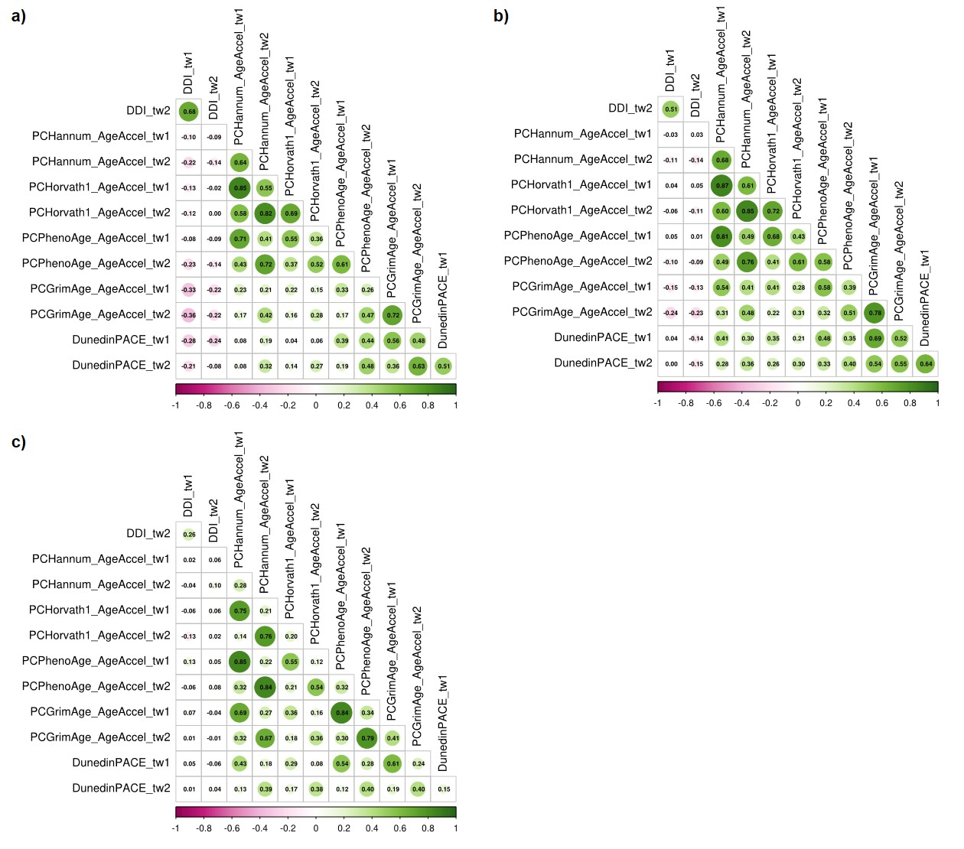
Supplementary Fig. 4. Correlations between twin 1 and twin2 for diet (DDI) score and epigenetic age acceleration or pace of aging measures at a) baseline, b) follow-up and c) change (= follow-up minus baseline).

