Electronic supplementary material

Policies and support in relation to LCA

The search for an appropriate end-of-life formula for the purpose of the European Commission Environmental Footprint initiative

Karen Allacker^{1,2} • Fabrice Mathieux¹ • David Pennington¹ • Rana Pant¹

Received: 28 April 2015 / Accepted: 28 November 2016
© Springer-Verlag Berlin Heidelberg 2016

Responsible editor: Hans-Jürgen Garvens

  - ¹European Commission - Joint Research Centre (JRC), Institute for Environment and Sustainability, Sustainability Assessment Unit, Via Fermi 2749, 21027 Ispra (VA), Italy
²KU Leuven, Faculty of Engineering Science, Department of Architecture, Kasteelpark Arenberg 1, 3001 Leuven, Belgium

 Rana Pant
rana.pant@jrc.ec.europa.eu

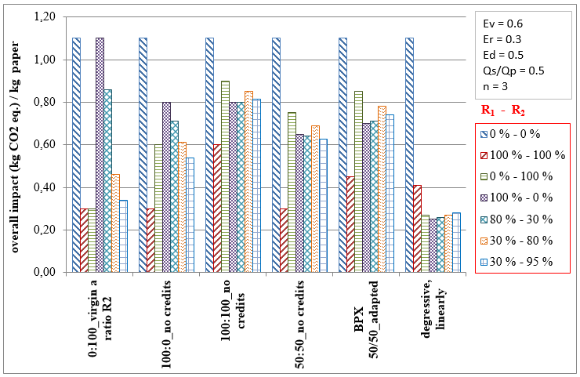
Fig. S1 Assessment result of paper for different R1/R2 scenarios, calculated with the six shortlisted (step 1) formulas

