The International Journal of Life Cycle Assessment
Supplementary Information for:
Quantifying drivers of variability in life cycle greenhouse gas emissions of consumer
products - A case study on laundry washing in Europe
S. Shahmohammadi^{a,}*, Z. Steinmannª, J. Clavreul^{b}, H. Hendrickx^{b}, H. King^{b}, M.A.J. Huijbregtsª
- Department of Environmental Science, Institute for Water and Wetland Research, Faculty of Science, Radboud University Nijmegen, PO Box 9010, 6500 GL Nijmegen, The Netherlands
- Unilever Safety and Environmental Assurance Centre, Colworth Science Park, Sharnbrook, Bedford MK44 1LQ, UK
- Unilever Discover, Colworth Science Park, Sharnbrook, Bedford MK44 1LQ, UK

Variable values used in the study

In Table 1 of the main text, we illustrated the the sample size and type of data used to assess variability in the GHG footprint of a laundry wash. In Tables S1, Table S2 and Figure S1, the corresponding values associated with each of the variables used in this study are presented.
Table S1. Country-specific parameter values used in this study (EF_{C}: GHG emission factor of electricity production in country C, EF_{PV,C}: GHG emission factor of electricity production using PV module in country C, POP_{C}: Population of country C)
Variable | EF_{c} | EF_{PV,C} | Pop_{C}
Unit | g CO₂-eq/kWh | g CO₂-eq/kWh | Million people
Reference | (Weidema et al. 2013) | (Weidema, et al. 2013) | (World Bank 2014)
Austria | 374 | 87 | 8.5
Belgium | 278 | 100 | 11.2
Bulgaria | 797 | 63 | 7.2
Switzerland | 110 | 84 | 8.2
Czech Republic | 762 | 96 | 10.5
Germany | 645 | 90 | 81
Denmark | 345 | 92 | 5.6
Spain | 477 | 69 | 46.5
Finland | 255 | 95 | 5.5
France | 119 | 74 | 66.2
Greece | 954 | 62 | 10.9
Hungary | 559 | 80 | 9.9
Ireland¹ | 637 | 101 | 4.6
Italy | 515 | 67 | 60.8
Netherlands | 560 | 88 | 16.9
Norway¹ | 37 | 90 | 5.1
Poland | 1026 | 81 | 38
Portugal | 562 | 57 | 10.4
Romania | 693 | 72 | 19.9
Sweden | 57 | 90 | 9.7
Slovakia | 499 | 74 | 5.4
Turkey¹ | 687 | 62 | 75.9
United Kingdom | 660 | 101 | 64.6
¹ The ecoinvent 3.2 database (Weidema, B.P. et. al 2013) does not provide information on the GHG footprint of Solar PV panels in Ireland, Norway and Turkey. Based on their geographical locations, we assumed the footprints in these countries to be similar to those of the UK, Sweden and Greece, respectively.

Table S2. Non-country-specific parameters used in this study. Log-normal distributions are used for all parameters.
Parameter | Notation | Unit | Geometric mean, geometric Std. | References
Detergent dosage powder | D_{1,C} | g/cycle | 66.5, 1.61 | Kruschwitz et al. 2014
Detergent dosage liquid | D_{2,C} | g/cycle | 68.6 ,1.55 | Kruschwitz et al. 2014
Detergent dosage tablet | D_{3,C} | g/cycle | 50.5, 1.54 | Kruschwitz et al. 2014
Detergent dosage capsule | D_{4,C} | g/cycle | 33.7, 1.12 | Unilever internal database
GHG emissions per unit of powder detergents (Relative value for the mean)¹ | FUP₁ | g CO₂-eq/g detergent | 1.12, 1.33 | Unilever internal database
GHG emissions per unit of liquid detergents (Relative value for the mean)¹ | FUP₂ | g CO₂-eq/g detergent | 1.00, 1.52 | Unilever internal database
GHG emissions per unit of capsule detergents (Relative value for the mean) ¹ | FUP₃ | g CO₂-eq/g detergent | 2.88, 1.06 | Unilever internal database
GHG emissions per unit of tablet detergents (Relative value for the mean) ¹ | FUP₄ | g CO₂-eq/g detergent | 2.69, 1.02 | Unilever internal database
Washing machine energy use at 30 °C or lower | EC_{<30,C} | kWh/wash | 0.37, 1.65 | Unilever internal database
Washing machine energy use at 40 °C | EC_{40,C} | kWh/wash | 0.69, 1.45 | Unilever internal database
Washing machine energy use at 50 ° C | EC_{50,C} | kWh/wash | 0.76, 1.47 | Unilever internal database
Washing machine energy use at 60 °C or higher | EC_{>60,C} | kWh/wash | 1.00, 1.58 | Unilever internal database
¹ As the absolute numbers are confidential company data, we used relative values for the Geometric means associated with GHG emissions per unit of detergents. We divided all variables by the absolute value of the Geometric mean associated with GHG emissions of liquid detergents.
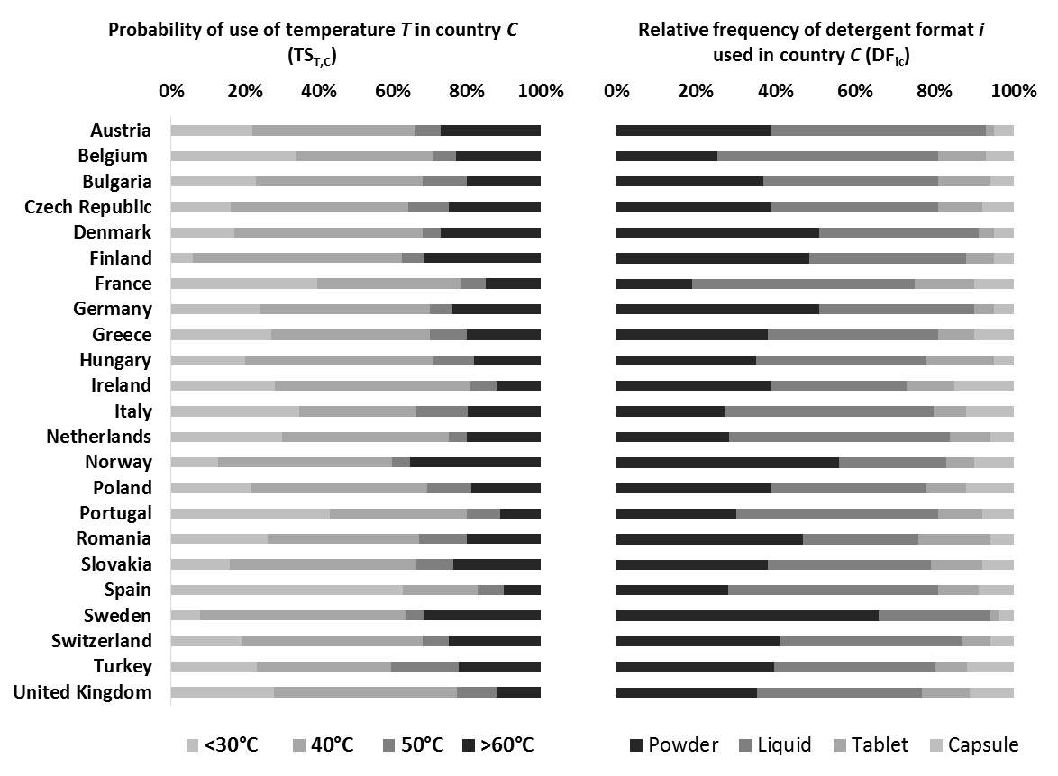
Figure S1. Relative frequency of different temperatures and different detergent formats used in European countries obtained from (A.I.S.E. 2014). The dataset contains information about six detergent formats of 1. Regular laundry powders, 2. Compact laundry powders, 3. Regular laundry liquids/gels in a bottle, 4. Concentrated laundry liquids/gels in a bottle, 5. Laundry tablets and 6. Laundry liquid tablets/pouches/liquid doses. We merged regular and compact laundry powders as well as regular and concentrated laundry liquids.

Simulation algorithm

In section 2.3 of the main text, we explained the initial steps of the model simulation. Here, the algorithm is expanded in detail:
For each country and in each iteration:
- One detergent format (i) was randomly selected based on the probability distribution related to the relative frequency of the detergents related to that country (DF_{i,C}).
- One random number was selected from the FUP_{i} distribution (GHG emission per g detergent from detergent format i) related to the selected detergent format.
- One random number was selected from the D_{i,C} distribution (dosage per wash cycle) related to the selected detergent format.
- The random number selected from step 2 was multiplied by the number selected in step 3 to derive the GHG emissions associated with the use of products per wash cycle.
- One temperature category (T) was randomly selected based on the temperature setting distribution associated with that country (${TS}_{T,C})$.
- One random number was selected from the EC_{T,C} distribution (washing machine energy use) related to the selected temperature category.
- The selected number in step 6 was multiplied by the GHG emission factor of electricity production in that country (EF_{C}) to derive the GHG emissions associated with the use of washing machines per wash cycle.
- The numbers from step 4 and step 7 were summed up to derive the Total GHG emissions per wash cycle${ (CFTotal}_{i,T,C})$, following equation 1.

Life cycle GHG emissions reported in the literature

In figure 5 of the main text we presented the Life cycle GHG emissions related to one laundry wash in different European countries. Table S3 shows some of the corresponding numbers previously reported in the literature.
Table S3. Total lifecycle greenhouse gas emissions of clothes washing and the relative share of use phase
 | Product | Countries | Results |  |  |  | Reference
 | Product | Countries |  | Use Phase % | Total (gCO2eq)
1 | Granular Laundry Detergents: Traditional and Super Compact¹ | Netherlands | Netherlands 1988 | 77 | 1257 | (Saouter, van Hoof et al. 2002)
1 | Granular Laundry Detergents: Traditional and Super Compact¹ | Netherlands | Netherlands 1998 | 83 | 918
1 | Granular Laundry Detergents: Traditional and Super Compact¹ | Sweden | Sweden 1988 | 26 | 285
1 | Granular Laundry Detergents: Traditional and Super Compact¹ | Sweden | Sweden 1998 | 44 | 153
2 | Traditional granular Laundry Detergent | Belgium | granular Detergent | 71 | 544 | (Saouter and Van Hoof 2002)
3 | Tablet and Compact powder laundry detergents |  | Tablet detergent | 64 | 614 | (Golsteijn, Menkveld et al. 2015)
3 | Tablet and Compact powder laundry detergents |  | Compact Powder detergent | 67 | 580
4 | Tablet Solid Laundry Detergents² | Europe | Tablet Solid Detergent | 62 |  | (A.I.S.E. 2013)
5 | Powder Laundry Detergent | Europe | Powder | 62 | 538 | (Medyna, Larriba et al. 2015)
6 | Regular Powder and Dilute liquid | France | Powder 1998 | 28 | 312 | (Dewaele, Pant et al. 2006)
6 | Regular Powder and Dilute liquid | France | Powder 2001 | 28 | 298
6 | Regular Powder and Dilute liquid | France | Liquid 1998 | 28 | 315
6 | Regular Powder and Dilute liquid | France | Liquid 2001 | 32 | 259
7 | Regular Powder, Compact Powder, Powder Tablet, Dilute Liquid, Compact Liquid, Liquid Unit Dose | UK | Regular Powder 1988 | 70 to 80 | 1288 | (Van Hoof, Schowanek et al. 2003)
7 |  | UK | Regular Powder 1998 | 70 to 80 | 1071
7 |  | UK | Regular Powder 2001 | 70 to 80 | 1053
7 |  | UK | Compact Powder 1992 | 70 to 80 | 1117
7 |  | UK | Compact Powder 1998 | 70 to 80 | 1018
7 |  | UK | Compact Powder 2001 | 70 to 80 | 978
7 |  | UK | Powder Tablet 2001 | 70 to 80 | 1018
7 |  | UK | Dilute Liquid 1988 | 70 to 80 | 1388
7 |  | UK | Dilute Liquid 1998 | 70 to 80 | 1035
7 |  | UK | Compact Liquid 1998 | 70 to 80 | 1029
7 |  | UK | Compact Liquid 2001 | 70 to 80 | 933
7 |  | UK | Liquid Unit Dose | 70 to 80 | 994
8 | Detergents | Germany | 46 degree | 72 | 700 | (Henkel AG & Co. KGAA 2009)
8 | Detergents | Germany | 30 degree | 56 | 450
8 | Detergents | Germany | 60 degree | 79 | 930
9 | Powder Detergent, Liquid Detergent | Europe | Powder Detergent | 62 | 536 | (Koehler and Wildbolz 2009)
9 | Powder Detergent, Liquid Detergent | Europe | Liquid Detergent | 61 | 541
¹1988: Traditional granular detergents, 1998: Super compact detergents
²Numbers are estimated from a chart.

References:
A.I.S.E. (2013) The case for the “A.I.S.E. low temperature washing” initiative, Substantiation Dossier, A.I.S.E. www.aise.eu
Dewaele J, Pant R, Schowanek D (2006) Comparative Life Cycle Assessment (LCA) of Ariel “Actif à froid”(2006), a laundry detergent that allows to wash at colder wash temperatures, with previous Ariel laundry detergents (1998, 2001) Procter & Gamble, Brussels Innovation Center, Central Product Safety-Environmental, Brussels
Golsteijn L, Menkveld R, King H, Schneider C, Schowanek D, Nissen S (2015) A compilation of life cycle studies for six household detergent product categories in Europe: the basis for product-specific AISE Charter Advanced Sustainability Profiles. Environ Sci Eur 27:1-12. Doi: 10.1186/s12302-015-0055-4.
Henkel AG & Co. KGAA (2009) CASE STUDY PERSIL MEGAPERLS: Case Study undertaken within the PCF Pilot Project Germany.
Koehler A, Wildbolz C (2009) Comparing the environmental footprints of home-care and personal-hygiene products: the relevance of different life-cycle phases. ENVIRON SCI TECHNOL 43:8643-8651
Kruschwitz A, Karle A, Schmitz A, Stamminger R (2014) Consumer laundry practices in Germany International Journal of Consumer Studies 38:265-277

Medyna, G., Larriba, A. B., Kaps, R. B., Arendorf, J., Bojczuk, K., Sims, E., Gaasbeek, A. (2015) Revision of the EU Ecolabel Criteria for: Laundry detergents and industrial and institutional laundry detergents. Preliminary Report. Institute for Prospective and Technological Studies, Joint Research Centre.
Saouter, E. and Van Hoof, G (2002). A database for the life-cycle assessment of Procter & Gamble laundry detergents. INT J LIFE CYCLE ASS 7(2): 103-114.
Saouter, E., van Hoof, G., Feijtel, T. C., & Owens, J. W. (2002). The effect of compact formulations on the environmental profile of Northern European granular laundry detergents Part II: Life Cycle assessment. INT J LIFE CYCLE ASS 7(1): 27-38.
Van Hoof G, Schowanek D, Feijtel TC, Boeije G, Masscheleyn PH (2003b) Comparative Life-Cycle Assessment of laundry detergent formulations in the UK. Part II: Time trend analysis and wash equivalent comparison (1988-2001) TENSIDE SURFACT DET 40:276-287
Weidema, B.P., Bauer, Ch., Hischier, R., Mutel, Ch., Nemecek, T., Reinhard, J., Vadenbo, C.O., Wernet, G, (2013) The ecoinvent database: Overview and methodology, Data quality guideline for the ecoinvent database version 3, www.ecoinvent.org
World Bank (2014) Total population, http://data.worldbank.org/indicator/SP.POP.TOTL

* Sadegh Shahmohammadi Email: sadeghs@science.ru.nl Tel: + 31 24 365 32 81 Fax: + 31 24 355 34 50

