electronic supplementary material

LCI methodology and databases

A tool to operationalize dynamic LCA, including time-differentiation on the complete background database

Yoann Pigné¹ • Tomás Navarrete Gutiérrez² • Thomas Gibon² • Thomas Schaubroeck² • Emil Popovici² • Allan Hayato Shimako³ • Enrico Benetto² • Ligia Tiruta-Barna³

Received: 4 December 2018 / Accepted: 21 September 2019
© Springer-Verlag GmbH Germany, part of Springer Nature 2019

Responsible editor: Yi Yang

¹Université Le Havre Normandie, 25 rue Philippe Lebon - BP 1123, 76063 Le Havre cedex
²Environmental Sustainability Assessment and Circularity (SUSTAIN) RDI Unit, Department of Environmental Research & Innovation (ERIN), Luxembourg Institute of Science and Technology (LIST), 41 Rue Du Brill, 4422 Belvaux, Luxembourg
³LISBP, Université de Toulouse, CNRS, INRA, INSA, Toulouse, France, 135 Avenue de Rangueil, 31077, Toulouse, France

 Enrico Benetto
enrico.benetto@list.lu

Principles of the temporal LCI framework
In this section, the principles of the temporal LCI model are briefly presented. More details are available in Tiruta-Barna et al. (2016).
In a process-based LCA system, the intermediary flows between processes (the exchange of products between them) are compiled in a so-called “technology” (A) matrix (where a_{ij} is the output of product i per unit of process j) and an “environmental intervention” (B) matrix (where b_{kj} is the environmental intervention of element k per unit of process j). In the matrix A, there is commonly a one-on-one relationship between products and processes, which implies that one can considers the matrix elements as process amounts and not just product amounts. One-to-one correspondence is achieved through allocation operations, in which multi-output processes are split and their inputs reallocated across their outputs. Consequently, the technology matrix A is essentially a square matrix. From a graph theory perspective, the A-matrix also represents the adjacency matrix of the process system network as the non-diagonal elements indicate the quantitative relationships between processes and products. Given such a system, a final demand f is predefined, as the vector of product quantities satisfying the “final demand”, which corresponds to the defined reference unit (specified in goal and scope phase). The scaling vector $s$, represents the total output of quantities of processes from the technology system, which are directly and indirectly needed to provide the final demand. Using the B-matrix, one can then obtain the environmental intervention amounts, characterized through a vector g, representing the LCI generated by a given f vector. The LCI is mathematically derived as follows:
 | $$s=A^{-1}f$$  $$g=Bs$$ | (1)  (2)
Life cycle system processes form a complex network, which includes loops, and respective interconnections can be easily characterized using matrix inversion. The proposed temporal LCI model of relies on the conventional inventory (matrices A and B) in order to benefit from rich LCI databases and software that are formatted in this way.
The process temporal behaviour is described (in simple terms) by several temporal parameters and functions: (i) process dynamics represented by a production function α(t) and an emission profile β(t) as well as constant parameters r, T, t₀, all defined in Table 1 and Figure 1; (ii) a supply model defined through the δ and τ parameters.
Fig. S1 Two subsequent processes: current ecoinvent inventory related data (in red); process model, supply model and their combination. Legend for variables: a_{i,j} and b_{k,j}: elements of matrix A and B (i, j are processes, k is an environmental intervention); α_{i,i} and β_{k,i,i}: production and emission functions for process i; T: functioning period for the system; t₀: evaluation’s start time; δ: supply delay period; r: production period; τ: period of supply of product 2 for process 1; φ_{2,1}: supply function from 2 to 1; α_{2,1} and β_{k,2,1}: production and emission functions for process 2 working for process 1; g_{k,2,1}: quantity of k emitted by process 2 when working for process 1 (from Tiruta-Barna et al (2016))

Table S1 Parameters for time consideration in the DyPLCA model
 | Parameter | Name | Significance
Process model (specific for  process i) | α(t) | Production function | Describes the time shape of the activity (e.g. continuous, constant, discontinuous…)
Process model (specific for  process i) | β(t) | Environmental intervention function | Describe the time shape of the emissions/resource consumptions. Usually linked to α(t)
Process model (specific for  process i) | r | Production period | Time between the earliest input (raw material) and the latest output of the activity
Process model (specific for  process i) | T | Representative period | Life time of the main infrastructure (material support) related to the activity
Process model (specific for  process i) | t₀ | Start date of the analysis | Arbitrary or calendar dependent
Supply model  Continuous or intermittent  (process link i-j) | δ | Delay | no activity takes place; delay introduced for each delivered batch
Supply model  Continuous or intermittent  (process link i-j) | τ | Supply period  only for intermittent | Interval between 2 consecutive supplies

The normalized functions α and β link the conventional inventory to the temporal model in the sense that the integral of these functions over the defined life time T of the process results in the inventory data a_{i,i} in technology matrix A and b_{k,i} in intervention matrix B:
 | $$a_{i,i}=\int_{t_{0}}^{t_{0}+T}{α_{i,i}\left(t\right)dt }$$ | (3)
 | $$b_{k,i}=\int_{t_{0}}^{t_{0}+T}{β_{k,i,i}\left(t\right)dt}$$ | (4)
where α(t) is a flow of product and is represented by the reference unit by time (e.g. kg.h⁻¹, m³.day⁻¹, kWh.s⁻¹, etc.), β(t) is the flow of the environmental intervention k (e.g. kg.year⁻¹). The coefficients a_{i,i} and b_{k,i} are spread over time throughout the complete representative period (e.g. per life time for a wastewater treatment plant) based on the respective α and β functions.
On a supply chain, each producer functions during a certain period (span₂) determined by the demand from the consumer process. The consumer demands products from the technosphere during a certain period named span₁. As such, the functioning periods (span) are inter-dependent on the supply chain. Starting from the unit function period T_{uf} (with span_{uf} = T_{uf}) the span periods can be calculated by going upstream on a graph structure. The number of batches of product (2) delivered by process (2) to process (1) σ_{2,1} is given by:
 | $$σ_{2,1}=max⁡\left(\left\lfloor \frac{{span}_{1}}{τ_{2,1}}\right\rfloor ,1\right)$$ | (5)
where $σ_{2,1}≥1$ is an integer. Consequently, the functioning duration of process (2) can be defined by:
 | $${span}_{2}= τ_{2,1}\left(σ_{2,1}-1\right)+r_{2}$$ | (6)
The supply chain model describes the schedule and quantity delivered of a producer process to a consumer. The intermediary flows between processes (equation 5) and environmental interventions flows (equation 6) are obtained through following equations:
 | $$α_{2,1}\left(t\right)=-\frac{{s_{1} a}_{2,1}}{C_{2}(t)} α_{2,2}\left(t\right)$$ | (7)
 | $$β_{k,2,1}\left(t\right)=-\frac{s_{1}{ a}_{2,1}}{C_{2}(t)} β_{k,2,2}\left(t\right)$$ | (8)
with $s_{i}$ being elements of scaling (total output) vector $s$ and $C$ a capacity factor, defined by:
- for intermittent supply: | $$C_{2}\left(t\right)= σ_{2,1}\int_{t}^{t+r_{2}}{α_{2,2}}\left(t\right) dt$$ | (9)
- for continuous supply: | $$C_{2}=a_{2,2}\frac{{span}_{1}}{T_{2}}$$ | (10)
Besides the quantities of environmental interventions (values of β), the position in time of the activity (production and emission functions) is one of the key results of the model. Functions α and β of a producer process (process 2 in figure 2) are distributed in time starting from the zero time of the consumer process, i.e. from the beginning of the activity of process (1):
$α_{2,1}\left(t\right)>0$ and $β_{k,2,1}\left(t\right)>0$
for $t∈\left[\left(t_{0,1}-r_{2}-δ_{2}+\left(x_{2,1}-1\right)τ_{2,1}\right), \left(t_{0,1}-r_{2}- δ_{2}+\left(x_{2,1}-1\right)τ_{2,1}+r_{2}\right)\right]$
with $x_{2,1}=1, …,σ_{2,1}$
$α_{2,1}\left(t\right)=0$ and $β_{k,2,1}\left(t\right)=0$ for t elsewhere (11)
In case of continuous supply, the intervals become:
$t∈\left[\left(t_{0,1}-r_{2}-δ_{2}\right), \left(t_{0,1}-r_{2}- δ_{2}+{span}_{1}+r_{2}\right)\right]$ (12)
The continuous mode can be also considered as a supply of consecutive batches without pause, i.e. a delivery interval equal to the production period r (i.e. τ_{2,1} = r₂).
The final objective of the model is to obtain the environmental interventions distributed over time, i.e. all β functions evaluated and scaled over the timeline. Their integration over time (between initial and final time values) yields the conventional inventory results, i.e. $g_{k,i,j}$quantities for each substance k and process i linked to process j, and the total integrated environmental intervention $g_{k}$ (over the full time span) of compound k:
 | $$g_{k,i,j}=\int_{t_{0,i}}^{t_{0,f}+T_{f}}{β_{k,i,j}\left(t\right) dt}$$ | (13)
 | $$g_{k}=\sum_{i=1}^{m}{\sum_{j=1}^{m}{g_{k,i,j}}}$$ | (14)
Then, these functions can be summed for a given substance k, in order to obtain the γ(t) function – its aggregated emission profile over the life cycle:
 | $$γ_{k}\left(t\right)=\sum_{i}{\sum_{j}{β_{k,i,j}\left(t\right) }}$$ | (15)
Equation (14) allows the validation of the model by comparing the resulting g_{k} values with the corresponding elements of vector g in conventional LCA, for a given case study.
The adopted numerical resolution method combines the flow balance equations above and a graph-search algorithm. The lossless analytical resolution (i.e. keeping all time-related information) of the model is not computationally possible given the complexity of the process network and wide timespans in full-scale LCA applications.

Using the DyPLCA tool

Workflows
From the features and results available through the web application, we can define several workflows for the LCA practitioner. Indeed, working with large datasets is usually time consuming and tedious. The various features of the applications are available to leverage the user tasks.
Mostly two workflows are foreseen: 1) the creation of new DyPLCA projects from classical non-dynamic data sets. This is known as the Import scenario. 2) The creation or modification of DyPLCA projects from various external sources. This is known as the upload/download scenario.
Import. This scenario is dedicated to users having access to the ecoinvent datasets and a compatible version of SimaPro. This scenario plays as follows; the user creates a classical LCA project from SimaPro using the ecoinvent data. Then, exports this project using SimaPro’s CVS output file format. On the app, the user creates a project with a given name and clicks the “import” button (see Figure 2) providing the exported SimaPro file as an input. The DyPLCA app imports all the processes, supplies emissions and interventions from the input file into the new DyPLCA project. While doing so, it also checks for default temporal parameters from the temporal database. After this import step the user has access to a complete Dynamic LCA project with default temporal values. During that process it may happen that some processes are not recognized and thus do not get corresponding default dynamic parameters. This is the case especially for foreground processes that may have been created by the user inside the SimaPro app. The user will have to edit those processes latter on whether by using the Web interface, since all the parameters of the project are accessible through the Web interface, or by using the upload/download scenario.
Upload/download. This scenario can be used from any existing DyPLCA project, whether this one has been initialized with the Import scenario or not. The user clicks the “download” button (see Figure 2) in order to retrieve an XLSX file containing all the information of the project. The user can then edit this file with a spreadsheet application like MS Excel. Using spreadsheets is a faster and more convenient way to add and format data. Finally, when the file is ready and saved, the user clicks the “upload” button and provides the modified file so that the application takes all the modifications into account. Figure 2 illustrates the principal functions of the DyPLCA app using the Data Flow Diagram (DFD) notation.
The calculation step is explained in section 2.4.

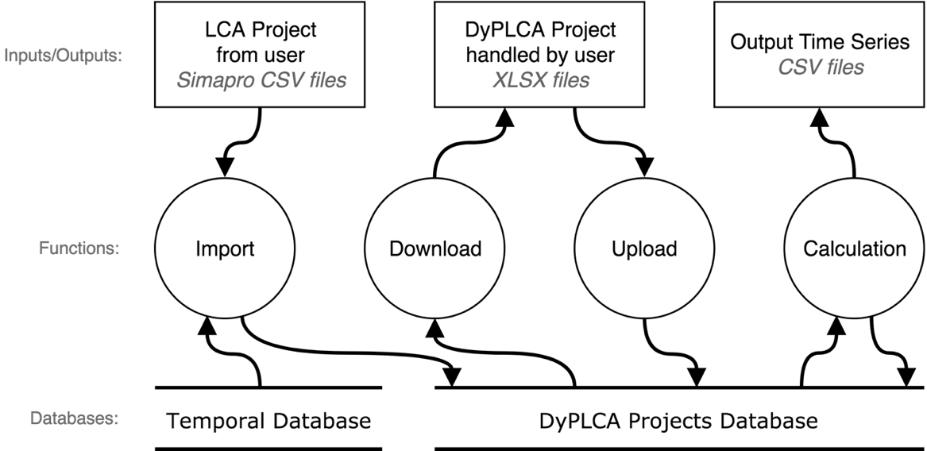
Fig. S2 Data Flow Diagram (DFD) of the main DyPLCA app data flows and actions

DyPLCA Projects Model
Information inside the DyPLCA application is managed through projects. A DyPLCA project gathers information about an LCI case study (processes, supplies, emission and interventions) supplemented by the temporal characteristics presented beforehand. A project also contains a set of parameters needed for the calculation of the environmental interventions distribution in time. Finally, after a project was successfully computed, it holds the results of this calculation as output files.
At the top level, a project can be represented as follows.

Table S2 Structure of a DyPLCA Project
Parameter Name | Type | Description | Data from
Functional Unit | Process | The functional unit of the case study. | User
Start date | Date | Start Date of the functional unit. | User
Time limit | Number | The number of years the search algorithm can go back in time during the search relatively to the start date. | User
Threshold | Number | The minimum acceptable ratio between the quantity of material demanded by one activity and the total material quantity provided by a producer (to all consumers, over the whole life cycle, corresponding to the analytical solution – static LCI). Below this ratio an activity is not considered by the search algorithm. | User
Numerical Precision | Number | Time increment used in numerical integration procedures. | User
Step Size | Number | Discretization increment used to represent time series. | User
Processes | List | List of all the processes in the case study (e.g., lines or columns headers of the A matrix). | User or database
Supplies | List | List of supplies, i.e. the production relations between producer and consumer processes (values of the non-diagonal A matrix). | User or database
Emissions | List | List of pollutants and resources involved in this case study. | User or database
Interventions | List | List of interventions involved in this case study, i.e. the relations between processes and emissions (values of the B matrix) | User or database
Results | List | List of CSV files containing the calculation results once finished computing. | User or database

Processes in a DyPLCA project represent the list of processes of this case study. As presented above (Table 2), a process also gathers temporal data such as the α function. Table 3 details the contents of a Process within a DyPLCA Project.

Table S3 Structure of a process
Parameter Name | Type | Description | Data from
Name | Text | Text used to designate to a process (e.g. Simapro® name from the “technology” A matrix). | User or database
Unit | Text | Unit of the material produced by this process as per the International System of Units, base and derived units (e.g., kg, MW, MJ, mSv, etc.) | User or database
T | Number | Representative lifespan of the process. | User or database
r | Number | Production period of this process. | User or database
α | Function | Production function expressed in process unit per unit of time (unit/year). | User or database
Service | Boolean | Whether this process is a service or not. | User or database
Market | Boolean | Whether this process is a market or not. | User or database

Supplies in a DyPLCA Project list all the production relations between processes. A Supply represents therefore a couple (producer, consumer) with a given quantity of the producer material. As for Processes, Supplies in a DyPLCA project contain temporal information (see Table 1). Table 4 represents the shape of a Supply in the DyPLCA app.

Table S4 Structure of a supply
Parameter Name | Type | Description | Data from
Producer | Process | The producing process (lines in the “technology” matrix). | database
Consumer | Process | The consumer process (columns in the “technology” matrix). | database
Continuous | Boolean | Whether this supply is continuous or intermittent. | User or database
a | Number | Produced amount of material by producer i for consumer j (a_{ij} in the “technology” matrix). | User or database
δ | Number | Production delay for this supply, in years. | User or database
τ | Function | Supply period for intermittent supplies. Expression that may refer to other parameters (T_{p}: Lifespan of the producer process, r, δ, etc.) | User or database

Emissions in a DyPLCA project are primarily a list of substances with their name, compartment, sub-compartment and unit. Table 5 shows the structure of an Emission.

Table S5 Structure of an emission
Parameter Name | Type | Description | Data from
Name | Text | Short name of the emission | User or database
Compartment | Text | Compartment the emissions belongs to (ecoinvent classification). | User or database
Sub-compartment | Text | Sub-Compartment the emissions belongs to (ecoinvent classification). | User or database
Unit | Text | Represents the quantity of this substance involved in the case study (e.g., kg, m, m², m³, etc.) | User or database

Interventions in a DyPLCA project contain the relations between producers and eco-biosphere substances within a case study. An Intervention also contains the β function that gives the emission profile of this process for that substance. Table 6 details the contents of an Intervention.

Table 6 Structure of an intervention
Parameter Name | Type | Description | Data from
Process | Process | Process participating in the intervention. | User or database
Emission | Emission | Emission/resource involved in this intervention. | User or database
b | Number | Quantity of the emission/resource involved in this intervention. | User or database
β | Function | Emission function relative to the production of the process. | User or database

DyPLCA operation and user interface
The DyPLCA tool offers a user interface, presented as a web application, that mainly allows two actions: i) creation/modification of a temporal LCA project like any regular LCA case study with added temporal parameters as per the defined model. ii) launch of the computation of the case study leading to time series of emissions other the observed time period.
A DyPLCA project can be created entirely from the web interface, adding one by one processes, supplies, emissions, and interventions with their temporal parameter. Although being fully functional, the web interface manipulation by the user is probably more adapted to the prototyping of reduced size projects or to the modification of some parameters in full size projects. The creation of realistic-size projects with thousands of processes and supplies, although possible, is not adapted to the web application interface. In order to efficiently work with large data sets, the application defines some data input and output format. Those formats correspond to actions in the DyPLCA application.
The Import action is a mean to rapidly collect large data sets from other applications directly into the DyPLCA application. The import process currently supports inputs following the SimaPro® CSV file format. Since this format does not have temporal information, an automatic import of temporal information is performed from the temporal database, provided process names in the CSV file follow the Ecoinvent 3 naming convention.
The Clone action is simply a duplication utility. It copies all the parameters, processes, emission, supplies and interventions of one project to a new one.
Upload/Download are two coupled actions that allow a complete DyPLCA project to be written to or read from a file (a spreadsheet). This original DyPLCA file format stores traditional and temporal information about a LCA project. This feature is useful to easily create new projects from various sources of information, or to retrieve existing projects in order to modify/update and upload them back to the application.

Computation and results
Once ready and configured, a DyPLCA project can be computed. The “output” tab in the web app is available for that purpose. The compute button launches the calculation on the server. The user can then observe the status of the calculation, waiting for the end of the execution. The user does not have to stay connected to the web App for the calculation to happen. As soon as the calculation terminates, results and validation data become available on the web interface. Figure 3 shows an example of result and validation data after a calculation has complete.
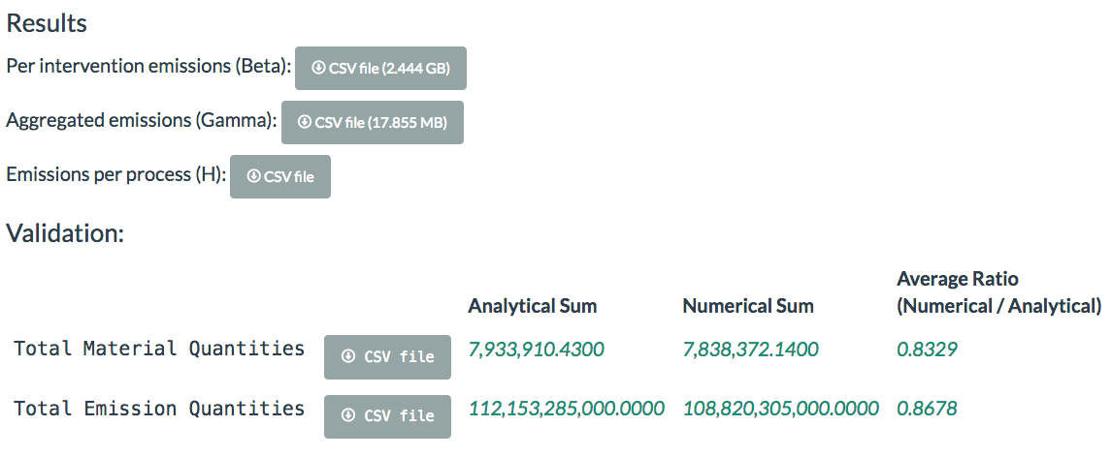
Fig. S3 Computation results on the DyPLCA Web Interace

The most important output is the “betas” file containing β(t), the time series of quantities of emissions, for each intervention. The size of this file can be important since it is in the order of the number of interventions times the number of steps. The number of steps being the span of the time horizon plus the representative lifespan of the FU (T) divided by the step size. Thus, the smaller the step size the larger the number of steps and finally the bigger the output file. The file is a text file written in comma-separated values (CSV) format.

Temporal database - Product Group Specific Rules
The ecoinvent processes can be roughly divided into four classes. For each one of these, the rules and assumptions for attributing values to time parameters are given in the table 7.

Table S7 Summary of the rules per product group for temporal parameter values assigned to ecoinvent 3.2 processes
Time parameter\product group | Industrial product manufacturing, maintenance, processing, operation and waste treatment | Biological production processes (agriculture, forestry, husbandry…) | Transportation  (Operation of transportation only) | Construction of buildings, infrastructures
T (representative function period) | This is the lifetime of the infrastructure or machinery that is used, mostly 30-50 years | This is the lifetime of the land, machinery or infrastructure that is used, mainly between 25 and 50 years. Exceptions:  - crop cultivation (open field and in greenhouses): one or two years is assumed since the basic support is the field and rotation schemes are normally at least kept constant over one or two years.  - Tree products (e.g. apple and citrus) or products with a support structure that is kept longer: the productive life span of the biological supportive function (e.g. trees; for apples from orchards 10 years is assumed).  - forestry: mainly the amount of time a complete forest management cycle takes (from plantation to clear cut), e.g. 80 years.  - Animal products (very limited amount in Ecoinvent 3.2): The average lifetime of the animal, e.g. 10 years for milk and meat from cows | This is the lifetime of the vehicle, e.g. 10 years for a bicycle or 40 years for a train | This is the amount of time needed for construction, implying the main supportive structure being the land occupation itself
r (residence time or production time) | It is assumed that these processes take not a lot of time, mostly 1 or several days is assumed but for some less is considered (more precisely 1 hour or 1 minute)  Exceptions:  - construction of machinery can take several days or months, e.g. 60 days for a certain aircraft | - Open field crop cultivation: a year divided by the number of cultivations per year. This keeps into account the downtime when no growth occurs. The period of storage is excluded.  - Cultivation in greenhouse: the period it takes to grow one batch, implying that cultivation occurs non-stop  - Forestry: This is the time it takes to grow (e.g. 4 years), if there is only clear cut then it is the complete forest management cycle.  - Animal products: for the non-meat products this is dependent on the production time (e.g. 1 day for milk); for meat products the full life time of the animal is considered (e.g. 10 years for cows) | - Freight transport:  The average distance of the transport type was derived from literature and used to calculate r (see section 2.3.4.2)  - Person & other transport:  About the time it needs to transport over a given distance (presuming only one person) at an average speed, i.e. the inverse of the speed, e.g. 1/24/90 hours for a train at 90 km/h | It takes one or several years (e.g. 10 years for a nuclear power plant)
α (time profile of production) and β (time profile of resources and emissions)  The α function is defined for the period r. It is considered that the production is cyclic (with a periodicity of r) over the life time T. | Often a constant function is assumed, considering the production does not vary over time | - Forestry: A constant function is used because tree harvest can occur any time during the year.  - Open field crop cultivation: A stepwise function is presumed in which values are assumed only for crop cultivation periods. The difference between seasons in regions have to be taken into account. The European climate is mainly considered (given the focus of Ecoinvent on Europe). The harvesting time is though different in the rest of the world. For RoW (Rest of the World) production (and thus also global processes that encompasses it), multiple productions per year are possible or even constant ones. A distinction has hence been made between processes occurring in the northern (N) and southern (S) hemisphere, and for the others an average production scheme or two times harvest is considered (G; general).. Literature information was used to identify the main producer country (mainly FAO information: http://faostat3.fao.org/browse/rankings/countries_by_commodity/E) and if more than 70% of the production occurred in the northern hemisphere it is considered to be northern, and vice versa, otherwise a general type is considered. For S, the harvest scheme of the northern was considered but with 6 months deduction. For general, both were considered. No distinction was made for variants such as organic etc. Important to note is that RoW encompasses always the countries/regions besides the specific countries for which production is specified. This approach considers the downtime period (non-usage) of the land, which implies that there is no consideration of different crop types during one year. The β function for these open fields is also considered as a constant function since biological activity continues even when there is no industrial activity on the field.  - Cultivation in greenhouse: A constant function is assumed since greenhouses can be produced out of season.  - Husbandry and animal products: A constant function is assumed (because all the products in the database are non-seasonal). | A constant function is assumed | A stepwise function is assumed per year, in which construction intensity is higher in the middle of the year and lower at the end and beginning, due to presumed seasonal effects.
Delta δ | 0 (e.g. for maintenance), or several tens of days, often 60 days. | 0 or several tens of days | 0 days | several tens of days
Tau τ (for discontinuous supply) Period between 2 successive supplies of a product.  For continuous:  τ = r of the producing process | Tau is mainly set equal to: delta (representing frequent supplies indifferent of the consuming process) or r of the consuming process (representing supply per production cycle). The latter is for example the case for a harvesting process, which is an input for an agricultural process.  If only one supply takes place in the lifetime of the process, then tau=T(consumer). This is the case for equipment or tools.  Maintenance: tau is considered equal to one year, presuming that maintenance occurs annually and not per batch. | tau equals r of the consumer process. In other words, the product is supplied at the consumer demand, considering it is available at storage.  - Open field crop cultivation: Since their production depends on the seasons, their supply does as well. Batches of the product are only provided at specific times of the year at the end of the production period. Tau is hence considered equal to r(producer).  -Cultivation in greenhouse: Contrary to open field cultivation, growing plants in greenhouses can be considered as independent of seasons, i.e. implying a possibility to supply throughout the year. Tau is therefore set equal to r(consumer), implying that it is delivered per batch of the consuming process.  - Forestry: as for cultivation in greenhouses, wood harvest can presumably occur every time of the year. Tau is therefore also considered equal to r of the consumer.  Exception: Sowing seeds: the provision of such seeds is considered to only occur once in the lifetime of an agricultural system. Therefore, tau is considered equal to T(consumer) for such processes. | delivery is currently set following the production cycle (r) of the consumer process, i.e. presuming that goods or services are transported every batch. | only one supply takes place in the lifetime of the consuming process, hence tau=T(consumer).  Note that goods needed to produce infrastructure, such as tiles and fibre boards, are appointed delta or r(consumer) as tau value.

* whether or not something is cultivated in greenhouses is not only based on the mentioning of this in the name or the description but also based on the product itself. For these product types, “Greenhouse production” is mentioned in “observations” field in database

Accuracy vs. cut-off selection
In order to investigate the trade-offs between accuracy and computation time, the process “Jute fibre {IN}| jute production, rainfed, no market” from ecoinvent 3.2 was analysed. This process was chosen as it involves a long lifecycle. Results show that calculation increases very quickly with the desired accuracy. In Figure 4, some environmental interventions are hardly ever accounted for, due to occurrences located far upstream in the network graph (the probability of being covered by the search algorithm decreases for every search step going upstream). In Figure 5, reaching a coverage of 80% (meaning that 80% of the total value of each inventory flow - i.e. the value obtained from a static approach – is accounted for) requires, in this case, a threshold of 10⁻⁴ (i.e. each material quantity is discarded if its amount is below 0.01% of the total quantity of that material in the static LCI), and a computation time of 8 minutes on a personal machine.
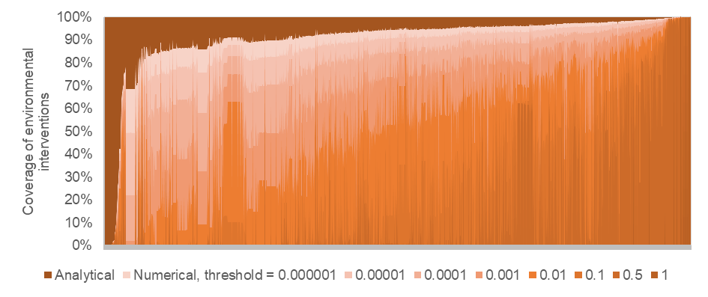
Fig. S4 Coverage (y-axis) of 2406 environmental interventions (x-axis) for the ecoinvent 3.2 process “Jute fibre {IN}| jute production, rainfed, no market”. A value of 100% indicates that the total amount of one intervention has been found by the search algorithm. A value of 0% indicates that no exchange above the given threshold has emitted/required the corresponding environmental intervention (e.g. because the emitting exchange is far too upstream in the graph, or emissions are spread over too many exchanges to be individually significant)
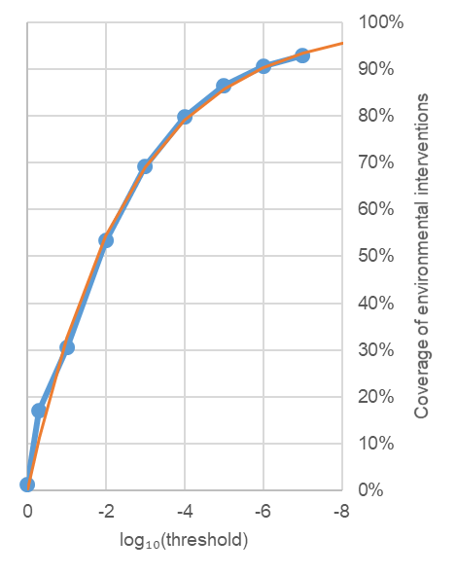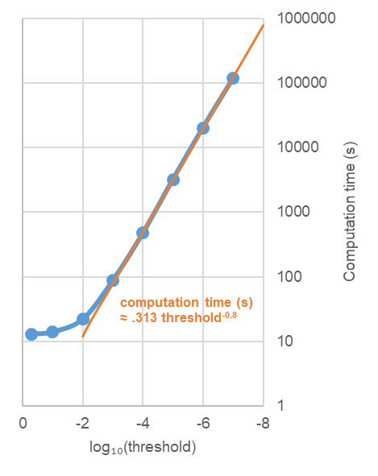
Fig. 5 (left) Coverage of environmental interventions increase with a lower threshold, the gap with full coverage decreases exponentially, (right) computation time increases exponentially with the negative power of 10 of the thresholds

