Electronic Supplementary Material to
Mineral resources in Life Cycle Impact assessment – Part II: Recommendations on application-dependent use of existing methods and on future method development needs
Markus Berger¹, Thomas Sonderegger², Rodrigo Alvarenga³, Vanessa Bach¹, Alexander Cimprich⁴, Jo Dewulf³, Rolf Frischknecht⁵, Jeroen Guinée⁶, Christoph Helbig⁷, Tom Huppertz⁸, Olivier Jolliet⁹, Masaharu Motoshita¹⁰, Stephen Northey¹¹, Claudia A. Peña¹² ,Benedetto Rugani¹³, Abdelhadi Sahnoune¹⁴, Dieuwertje Schrijvers^{15,16}, Rita Schulze⁶, Guido Sonnemann^{15,16}, Alicia Valero¹⁷, Bo P. Weidema¹⁸, Steven B. Young⁴

¹ Technische Universität Berlin, Chair of Sustainable Engineering, Office Z1, Straße des 17. Juni 135, 10623 Berlin, Germany
² Chair of Ecological Systems Design, Institute of Environmental Engineering, ETH Zurich, John-von-Neumann-Weg 9, 8093 Zurich, Switzerland
³ Department of Sustainable Organic Chemistry and Technology, Ghent University, Coupure Links 653, 9000 Ghent, Belgium
⁴ School of Environment, Enterprise and Development, University of Waterloo, 200 University Avenue West, Waterloo, Ontario, Canada, N2L 3G1
⁵ treeze Ltd., Uster, Switzerland
⁶ Institute of Environmental Sciences (CML), Leiden University, Einsteinweg 2, Leiden 2333 CC, The Netherlands
⁷ Resource Lab, University of Augsburg, Universitätsstr. 16 (Building I 2), 86159 Augsburg, Germany
⁸ RDC Environment, 57 Avenue Gustave Demey, 1160 Brussels, Belgium
⁹ School of Public Health, Environmental Health Sciences, University of Michigan, Ann Arbor, MI, USA
¹⁰ Research Institute of Science for Safety and Sustainability, National Institute of Advanced Industrial Science and Technology, Tsukuba, Ibaraki 305-8569, Japan
¹¹ Department of Civil Engineering, Monash University, Clayton VIC, Australia
¹² ADDERE Research & Technology, Alonso de Ercilla 2996, Ñuñoa, Santiago, Chile.
¹³ RDI Unit on Environmental Sustainability Assessment and Circularity (SUSTAIN), Environmental Research & Innovation (ERIN) department, Luxembourg Institute of Science and Technology (LIST), 41 Rue du Brill, L-4422 Belvaux, Luxembourg
¹⁴ ExxonMobil Chemical Company, 5200 Bayway Drive, Baytown, Texas 77520, USA
¹⁵ Université de Bordeaux, ISM, UMR 5255, 33400 Talence, France
¹⁶ CNRS, ISM, UMR 5255, 33400 Talence, France
¹⁷ CIRCE Institute-Universidad de Zaragoza, Mariano Esquillor Gómez, 15, 50018 Zaragoza, Spain
¹⁸ Danish Centre for Environmental Assessment, Aalborg University, Rendsburggade 14, 9000 Aalborg, Denmark
E-mail contact: markus.berger@tu-berlin.de Phone number: +49 (0)30 314-25084

Criteria for and interpretation of recommendation levels
As mentioned in the manuscript, the different levels of recommendation ranging from “suggested”, “interim recommended”, “recommended” to “strongly recommended” have been assigned to the most suitable method per question based on (a) the modelling approach, (b) the underlying data used, (c) the coverage of characterization factors (CFs), and (d) the degree to which existing methods are compatible with this definition of the safeguard subject. In more detail, these criteria comprised the method evaluation criteria of the Global Guidance on LCIA indicators project (Life Cycle Initiative 2019) and the evaluation results as discussed in Sonderegger et al. (2019):
- (Environmental) relevance
- Completeness
- Scientific robustness
- Documentation
- Applicability
- Level of experience
- Stakeholder acceptance
An interpretation of the levels of recommendation is summarized in Table S 1. The level “strongly recommended would equal a “shall” in a standardization process, whose terminology is avoided here. “Interim recommended” implies that the methods should be used as a default (rather then not assessing the inventory flows) until enhanced methods become available.
Table S 1: Interpretation of the recommendation levels
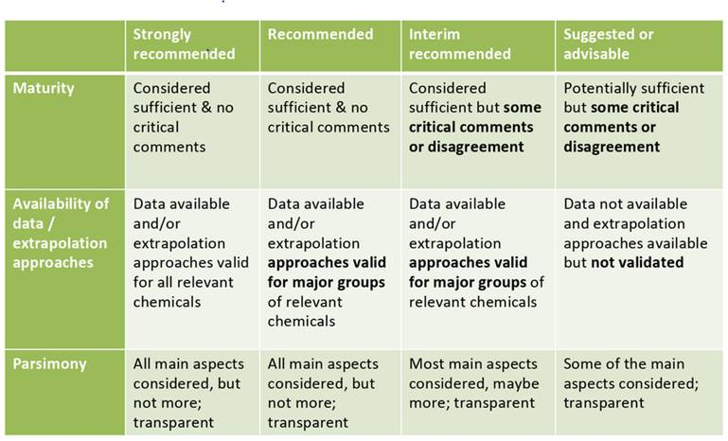

Link to the characterization factors of the recommended methods
ADP_{ultimate reserves}: https://www.universiteitleiden.nl/en/research/research-output/science/cml-ia-characterisation-factors
SOP_{URR}: https://repository.ubn.ru.nl//handle/2066/199716
LIME2_{endpoint}: http://lca-forum.org/database/impact/pdf/DF_20100709_3.xls
CEENE: https://www.ugent.be/bw/doct/en/research-groups/envoc/publications/ceene.zip
ADP_{economic reserves}:https://www.universiteitleiden.nl/en/research/research-output/science/cml-ia-characterisation-factors
ESSENZ: https://www.see.tu-berlin.de/menue/research/results/essenz/parameter/en/
GeoPolRisk: Gemechu et al. 2015; Helbig et al. 2016; Cimprich et al. 2017

Elementary flows and allocation
The definition of mineral resources as elements, minerals or aggregates poses the question of what should be the elementary flow reported in LCI databases. If the mineral or aggregate has a value as such (e.g. gypsum or sand), the mineral is considered the relevant elementary flow. If the value of the mineral is to host metals only (e.g. chalcopyrite – CuFeS₂), there are different views on what should be considered the elementary flow: with implications on the life cycle inventory due to allocation as described below.
Allocation is a controversial topic in attributional LCA. It is relevant for mining since ores usually contain several metals, some of which are co-produced within the same product system (Santero and Hendry 2016). Figure S 1 illustrates the allocation problem with the example of copper and gold extracted from the same ore.
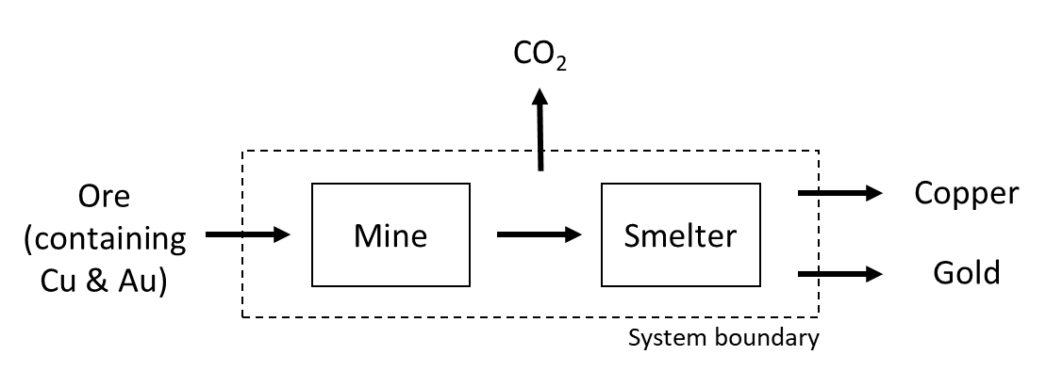
Figure S 1: Exemplary co-production of copper and gold in a multi- – output metal production system
According to ISO 14044 (2006), allocation should be avoided by describing the product system in more detail or by system expansion. The latter can be either modelled as an expansion of the functional unit (i.e., not only gold but gold and copper) or by subtracting an alternative product system providing one of the co-products (e.g. copper). In multi-metal mines it is not possible to avoid allocation by describing the multi-output process (smelter) in more detail. An expansion of the functional unit (i.e., adding the co-produced copper to e.g. a golden ring) is usually not helpful because only one of the two products is being analyzed.
Subtracting an alternative production system for one of the co-products, as suggested in (Weidema and Norris 2004), requires solving a system of linear equations with different parameters because the substituted system usually contains co-products (e.g. silver besides gold) as well. While this is possible as part of the standard matrix inversion of the product system (Heijungs & Suh 2002 and Weidema 2017), it is debated whether a system expansion with substitution is adequate in attributional LCA at all because the modelling follows a reflection that is in line with a consequential approach (Thomassen et al. 2008; Pelletier et al. 2014; Schrijvers et al. 2016, Weidema 2018). According to these authors system expansion is only relevant in attributional LCA for the part of the by-product that is consumed by the product system in equal quantities as it is produced (closed-loop recycling). Thus, they consider that it is often necessary to apply allocation in attributional LCA studies.
Currently, allocation of metals in multi-metal ores is accomplished in mainly two different ways by LCA practitioners and database providers: either the metal content of the ores entering the product system is considered the relevant elementary flow and allocated to the produced metals based on physical mass balances and the remaining inputs and outputs based on economic or other relationships, or the ore in its entirety (containing different metals and gangue) is defined as the elementary flows and allocated to the products using economic relationships. These two allocation procedures have been comprehensively discussed within the task force and no consensus could be achieved on which to prefer. Therefore, the two approaches are described in the following two subsections. Each subsection focuses on one approach only and was written by persons supporting the respective approach.

Option A: Allocation according to physical mass balances and economic relationships
In traditional and common life cycle inventory databases, primary mineral resources (metals) are reported as pure elements, sometimes accompanied with a description of the metal content in the ore and the contents of other metals in that particular ore (example from ecoinvent v. 2: “Silver, Ag 2.1E-4%, Au 2.1E-4%, in ore, in ground”). Hence, the elementary flows are considered to be the individual metals, not the ore. The main idea of Option A is to ensure a correct mass balance of the primary mineral resources (metals) extracted, which are the elementary flows of interest. The individual elements (metals) in the ore are 100 % attributed to the respective elements (metals) produced and sold by the mine. It ensures that 1 kg of metal leaving the mine requires (at least) 1 kg of metal extracted from the ground (see Figure S 2). All other elementary and intermediate flows (other than the elements extracted and sold) are allocated based on a different approach. The gangue may either be allocated according to the inverse of the concentration of the different metals in that ore times their annual production (“other relationships”) or by using the annual revenues achieved when selling the different metals (“economic relationships”). All further efforts, such as diesel consumption, process chemicals, land use and emissions of pollutants may be allocated using the same approach as for the gangue.
If mining a particular metal (gold according to the example shown in Figure S 2) would lead to reduced (natural) stocks of other metals (copper), because this copper is not sold but discharged dissipatively, the copper resource extracted would be attributed to the gold product. If however the copper is being sold or stockpiled, the copper resource extraction would not be allocated to the gold supply chain.
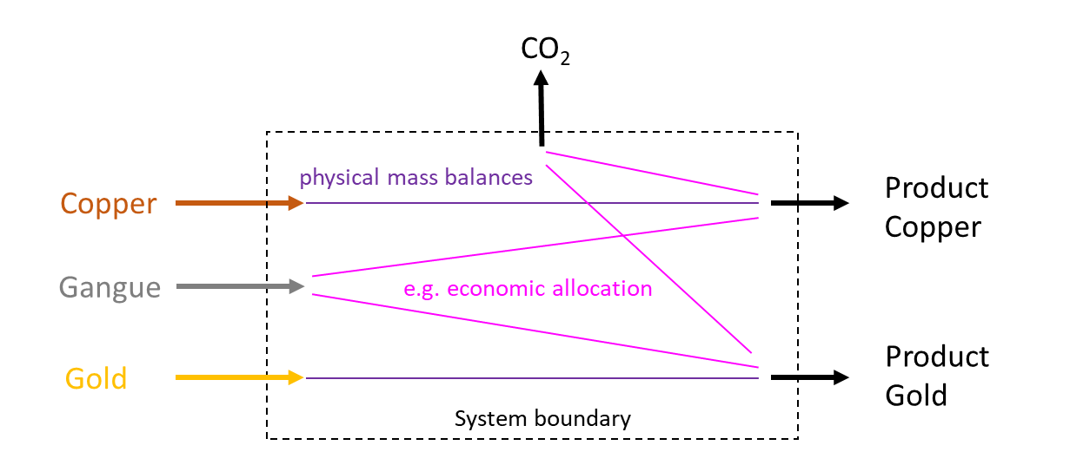
Figure S 2: Adressing the issue of co-production by allocating the metal inputs based on physical mass balances to the products and other flows based on different, e.g. economic, allocation parameters
This option is considered the preferred option by some of the task force members for several reasons:
- This option ensures a correct mass balance between inputs (elementary flows) and outputs (produced metals). Mass balance is one key requirement in life cycle inventories. The ISO standard 14044 says in clause 4.3.4.2 (Allocation procedure): “The inventory is based on material balances between input and output. Allocation procedures should therefore approximate as much as possible such fundamental input/output relationships and characteristics.”
- Databases do not report the “ores” as elementary flow inputs but the containing elements (metals) in them. Current best practice LCI databases report the amounts of metal resources crossing the system boundary between the environment and the technosphere. Hence, allocation shall be applied on these metal resources rather than on the entire ores.
- The allocation approach is consistent. It applies physical mass balances where appropriate and other relationships in all other cases. The ISO standard does not prescribe (neither explicitly nor implicitly) that all inputs and outputs of one co-production process must be allocated using one single allocation approach. It rather requires that “allocation procedures shall be uniformly applied to similar inputs and outputs of the system under consideration.” (ISO 14044, clause 4.3.4.2).

Option B: Allocation according to economic relationships
This option considers the ore as the relevant elementary flow. Thus, the ore (which contains the metals and the gangue) is allocated to the produced metals in the same way as emissions or inputs of other resources, such as land and water (Figure S 3).
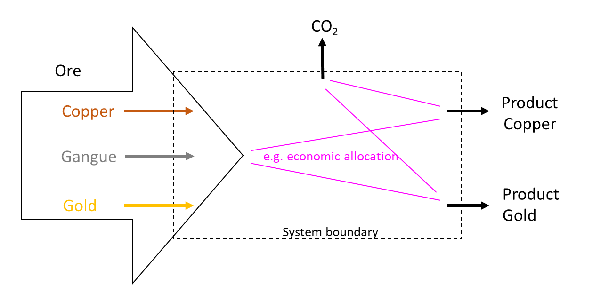
Figure S 3: Adressing the issue of co-production by allocating the ore (instead of its components) in the same way as other elementary flows to the products, e.g. via economic allocation
This procedure is considered as the preferred option by some task force members for the following reasons:
- The elementary flows entering and leaving the product system should be allocated to the metals produced. ISO defines an elementary input flow as “material or energy entering the system being studied that has been drawn from the environment without previous human transformation” (ISO 14044 2006). According to this definition, the ore should be seen as the relevant elementary flow to be allocated among the co-products, because it requires intensive “human transformation” to split the ore into its components.
- Allocating the ore to the produced metals guarantees a consistent allocation procedure within one process, since the ore is allocated in the same way (e.g. via economic allocation) as other elementary flows.
- The life cycle inventory should reflect the environmental interferences caused by the product system. Since the production of one metal inevitably leads to depletion of the stock of a mixture of metals, an allocation of the ore containing several metals seems more appropriate than allocating only the metal content.

Case study
In the following subsection, the potential impacts obtained by applying the 27 methods to the LCI of Stolz and colleagues (2016) for driving 1 km in an electric vehicle are presented. When interpreting the results it should be noted that the methods vary in the number of characterization factors provided (20-76), which partly cover different minerals. As some methods cover energy carriers in addition to mineral resources while others do not, the LCI is analyzed without energy carriers and uranium first, to support the comparability of results. As the consideration of energy carriers can have a significant influence on the results, they are included in a sensitivity analysis. First, the results of all methods are shown together before they are presented and discussed in more detail within the method categories depletion, future efforts, thermodynamic accounting, and supply risk.

Results of all methods
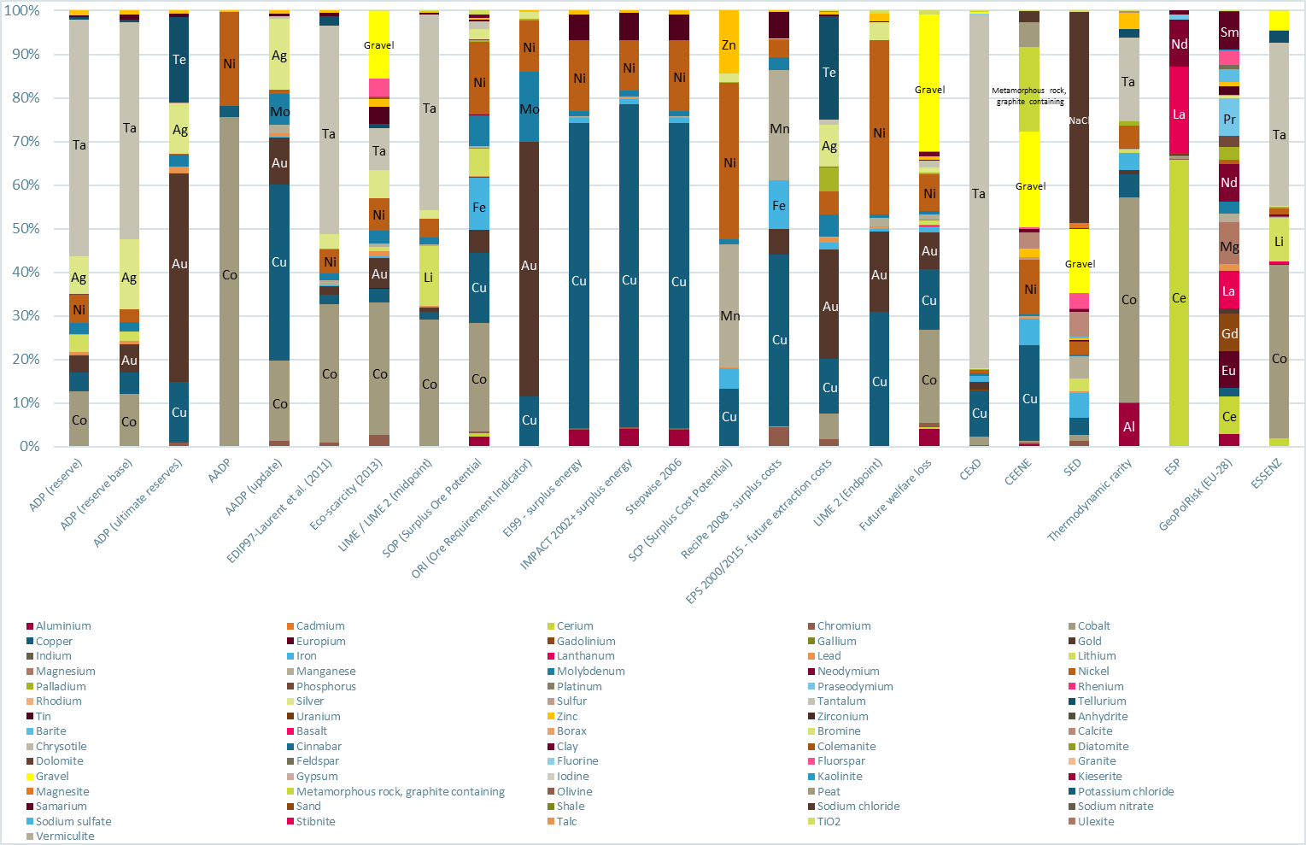
a)
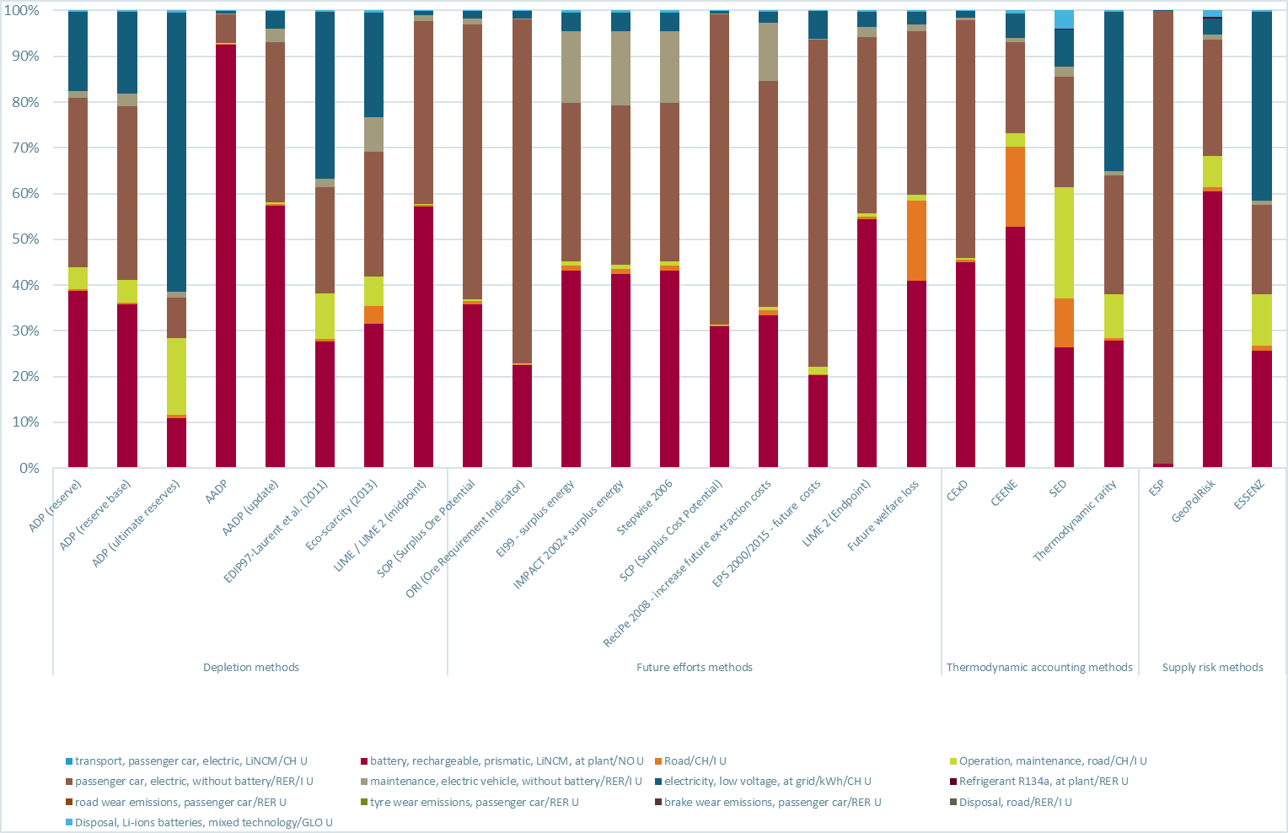
b)
Figure S 4: Impact assessment results obtained by all methods (excluding energy carriers and uranium) showing the relative contribution of a) mineral resources and b) life cycle stages
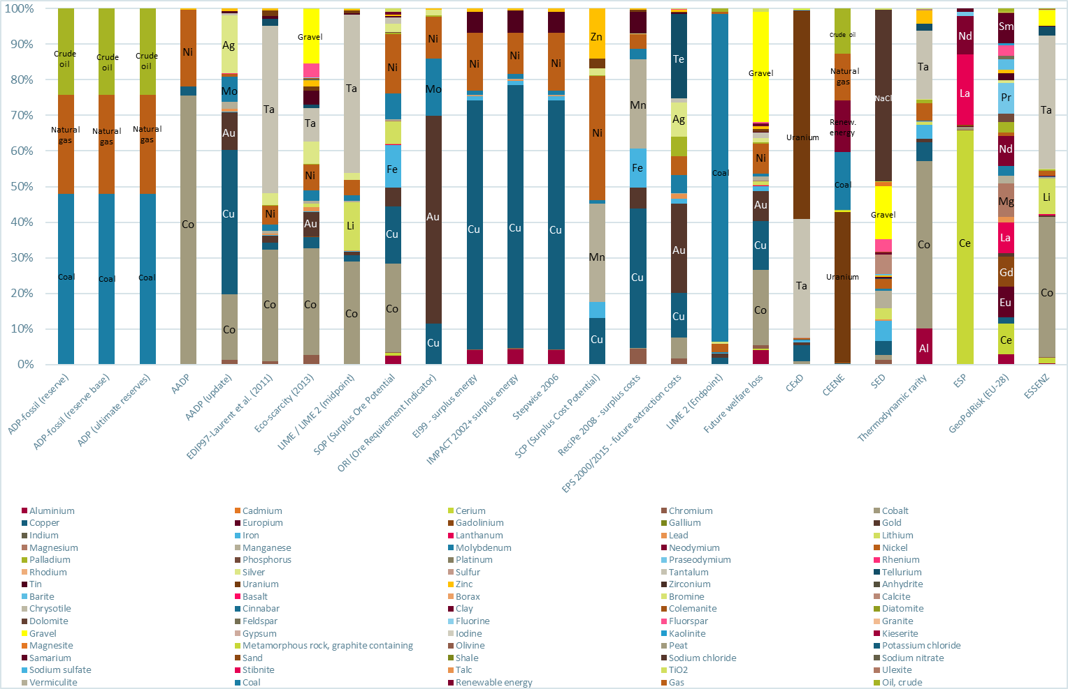
a)
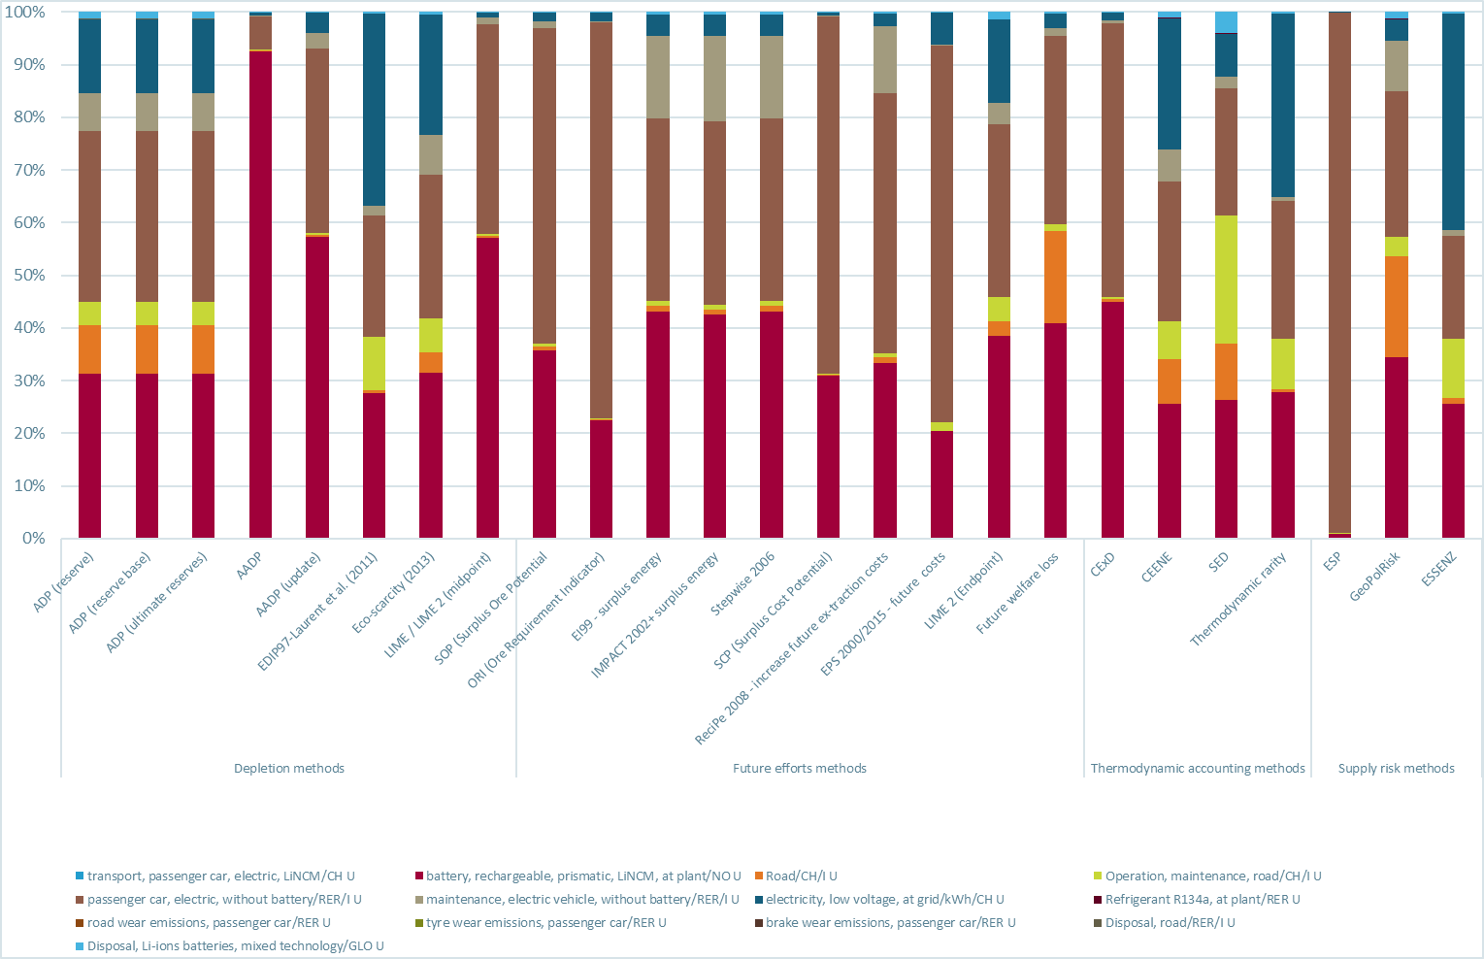
b)
Figure S 5: Impact assessment results obtained by all methods (including energy carriers and uranium) showing the relative contribution of a) mineral resources and b) life cycle stages

Results depletion methods
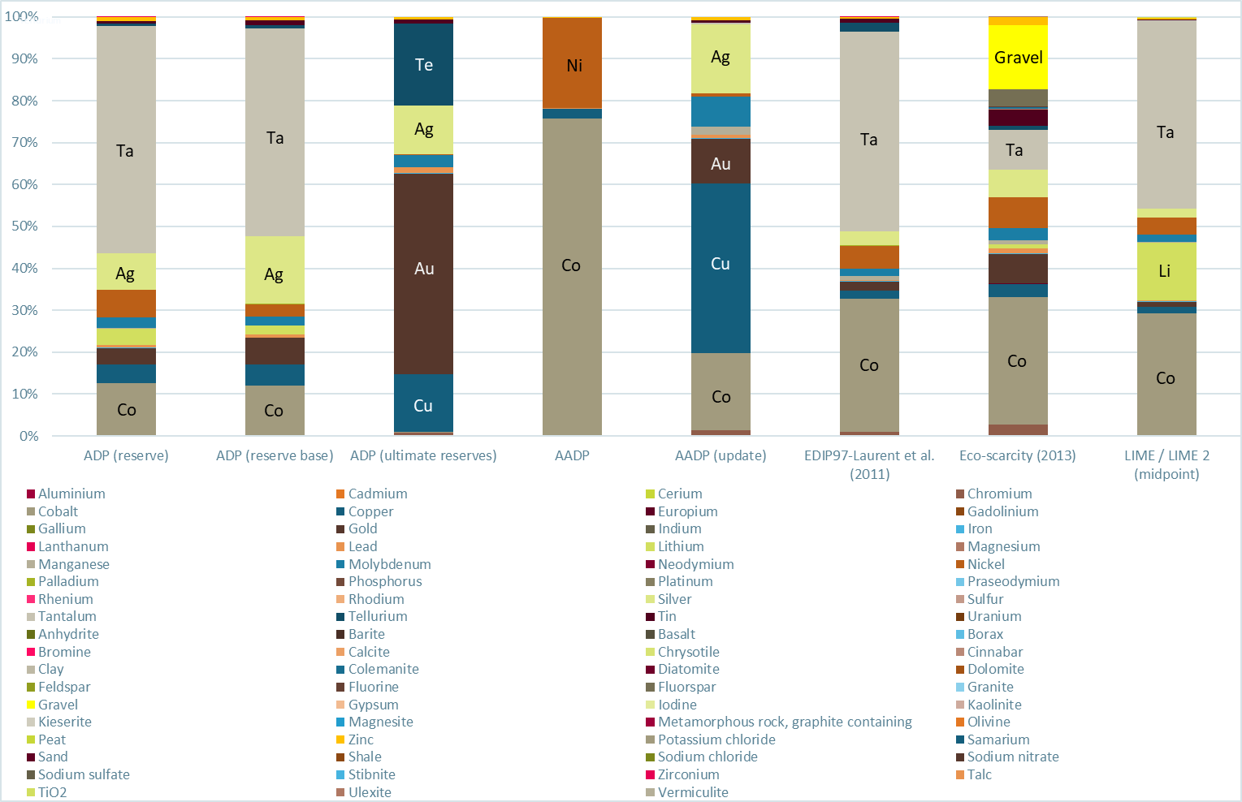
Figure S 6: Impact assessment results obtained by depletion methods – excluding energy carriers and uranium
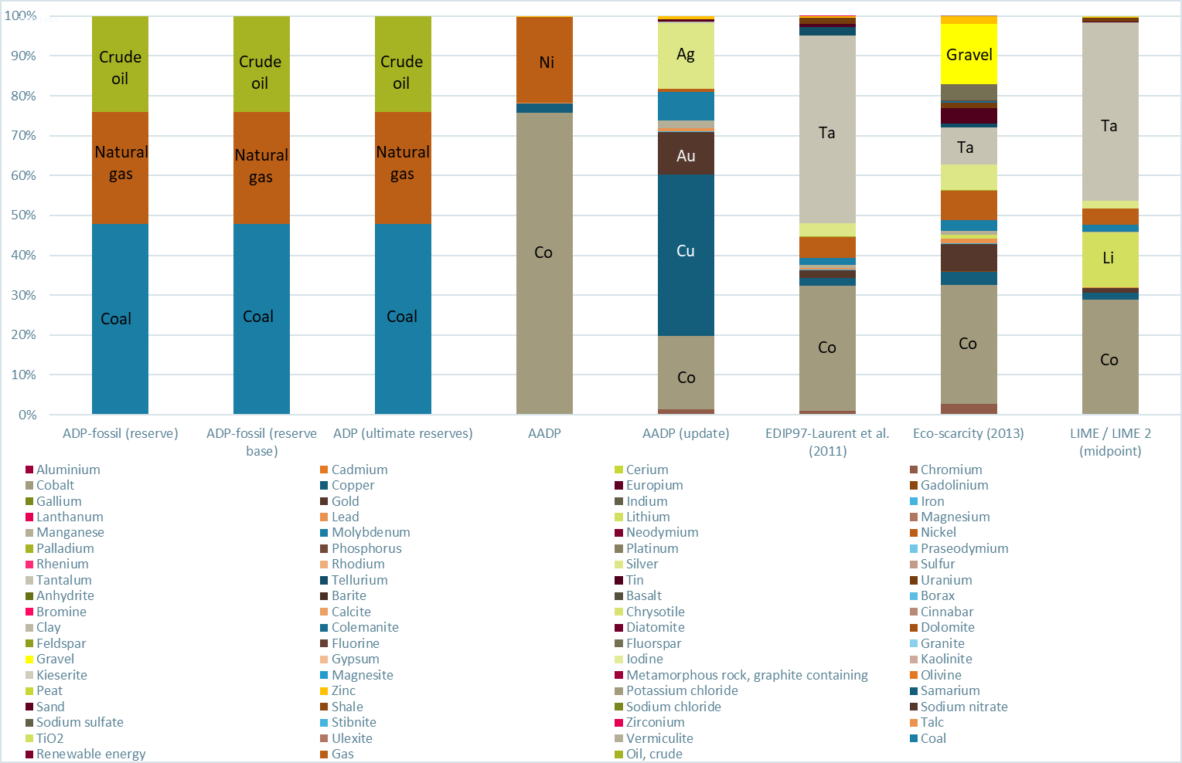
Figure S 7: Impact assessment results obtained by depletion methods – including energy carriers and uranium
The results for the depletion methods illustrate a high sensitivity to the choice of method. The results hardly differ between Figure S 8 (excluding energy carriers) and 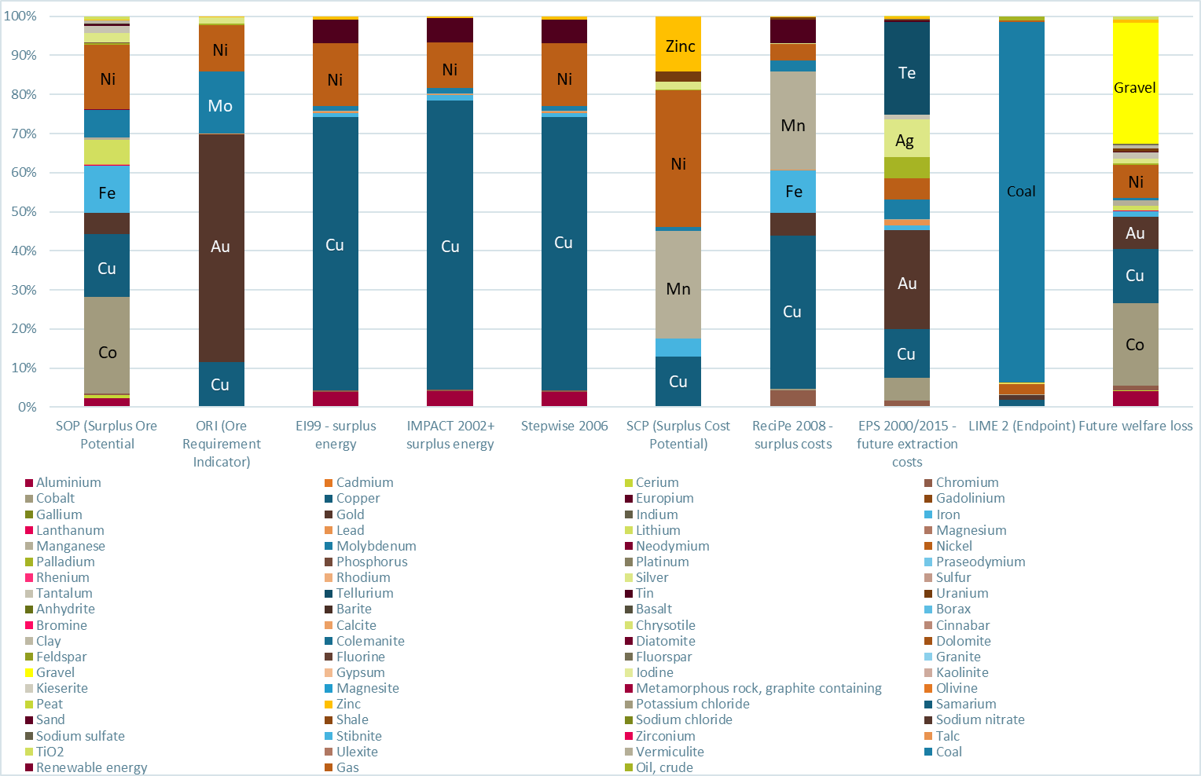
Figure S 9 (including energy carriers), since energy carriers are not characterized as part of ADP– the only difference being uranium, which is characterized in the ADP methods (ultimate reserves, economic reserve and reserve base), the LIME and Ecoscarcity methods. However, when using these methods, uranium features on position 9 (Lime) to 13 (ADP economic reserve) in terms of its contribution to the impact assessment result in the respective impact category – thus, it does not have a big impact on the results. The top 5 contributing elements for each impact assessment method are shown in Table S 1. For ADP economic reserves and LIME (midpoint), the element with the largest contribution to the LCIA results is tantalum. The results for the Ecoscarcity method show tantalum as the second largest contributor to resource depletion. This similarity is to be expected, since the Ecoscarcity method corresponds to an updated version of ADP economic reserves, with updated characterization factors. For ADP ultimate reserve, tantalum is not in the ‘top 5’, due to the different stocks used to calculate the characterization factors for the three methods. In the (original) AADP method, tantalum is not characterized – and in the updated AADP, it has the 12th highest contribution. Schneider et al. (2015) already investigated the effects of introducing anthropogenic stocks into the calculation of the CF, and found it to make a difference to the results. However, it should be highlighted that this difference between resources is due to how long they have previously been extracted only, i.e. how much geological stock has been shifted to the technosphere/anthropogenic stock, but does not reflect differences in technical accessibility of these stocks, (e.g., taking into account current recycling rates, inventories of actual anthropogenic stock, or similar information) – a generic dissipation rate of 20% has been applied to the cumulatively extracted stock (Schneider et. al., 2015).
The results calculated with the LIME method, which only takes into account stocks in the calculation of CFs, and not extraction flows, also show tantalum as the main contributor. This can maybe be explained by the fact that stocks are given higher emphasis than flows in the CF calculation formula (due to a squaring of the denominator) for both the ADP, AADP, and also the Ecoscarcity method (where the CFs are based on the ADP formula, too) (Schneider et al. 2015, citing Guinee et al. 1995).
Since the methods use different data sources, it is difficult to explain whether the differences seen in the impact assessment results are merely due to data updates, or actually due to conceptual differences inherent to the conceptual set-up of the CF calculations (i.e. different stocks used as a basis for the calculations, different choices on whether to include extraction rates). To establish the differences which are actually due to the conceptual differences of the methods, all other factors (such as data choices) would need to be kept fixed, i.e. a more detailed modelling exercise would be required (Differences in inventory modelling choices, i.e. a focus on the fraction of the extraction flow destined for dissipation, would constitute another reason for different results – however, this differentiation has not been made for this exercise).
Table S 1: Top 5 contributing elements for each “depletion method”
 | ADP ultimate reserves | ADPreserve base | ADPeconomic reserves | AADP | AADP (update) | LIME (midpoint) | Ecoscarcity (2013)
1 | gold | tantalum | tantalum | cobalt | copper | tantalum | cobalt
2 | tellurium | silver | cobalt | nickel | cobalt | cobalt | tantalum
3 | copper | cobalt | silver | copper | silver | lithium | nickel
4 | silver | gold | nickel | zinc | gold | nickel | gold
5 | molybdenum | copper | copper | iron | molybdenum | silver | silver

Results future efforts methods
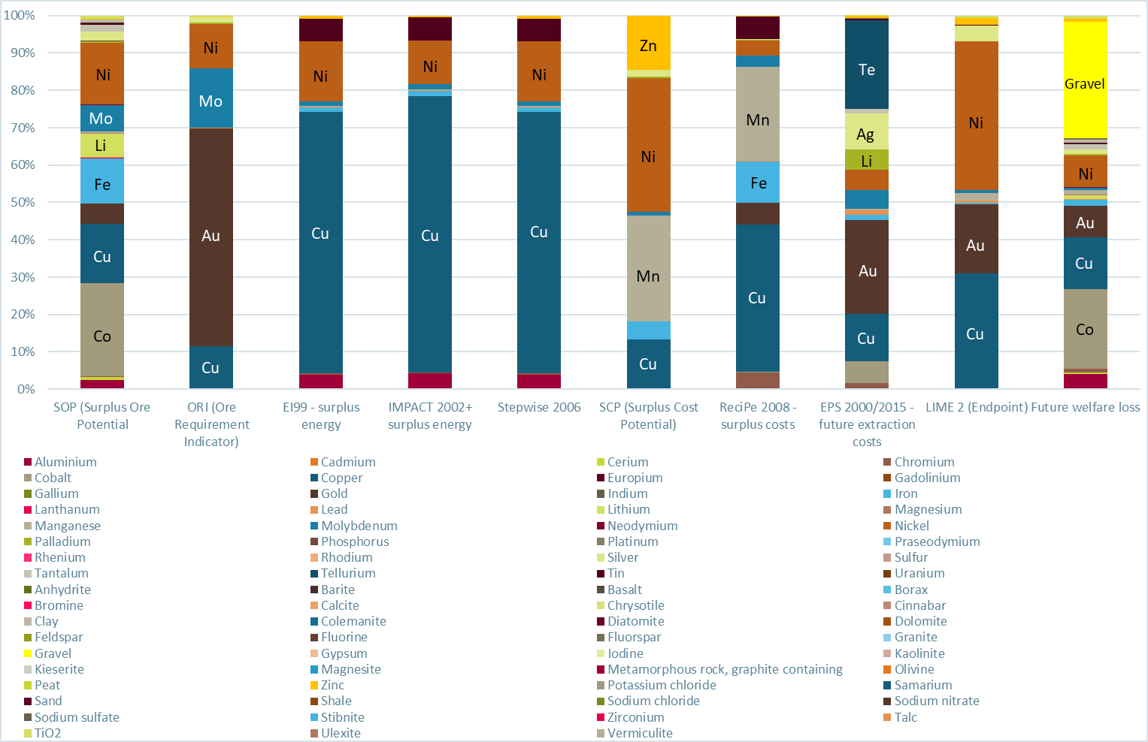
Figure S 8: Impact assessment results obtained by future efforts methods – excluding energy carriers and uranium
Figure S 9: Impact assessment results obtained by future efforts methods – including energy carriers and uranium

Results thermodynamic accounting methods
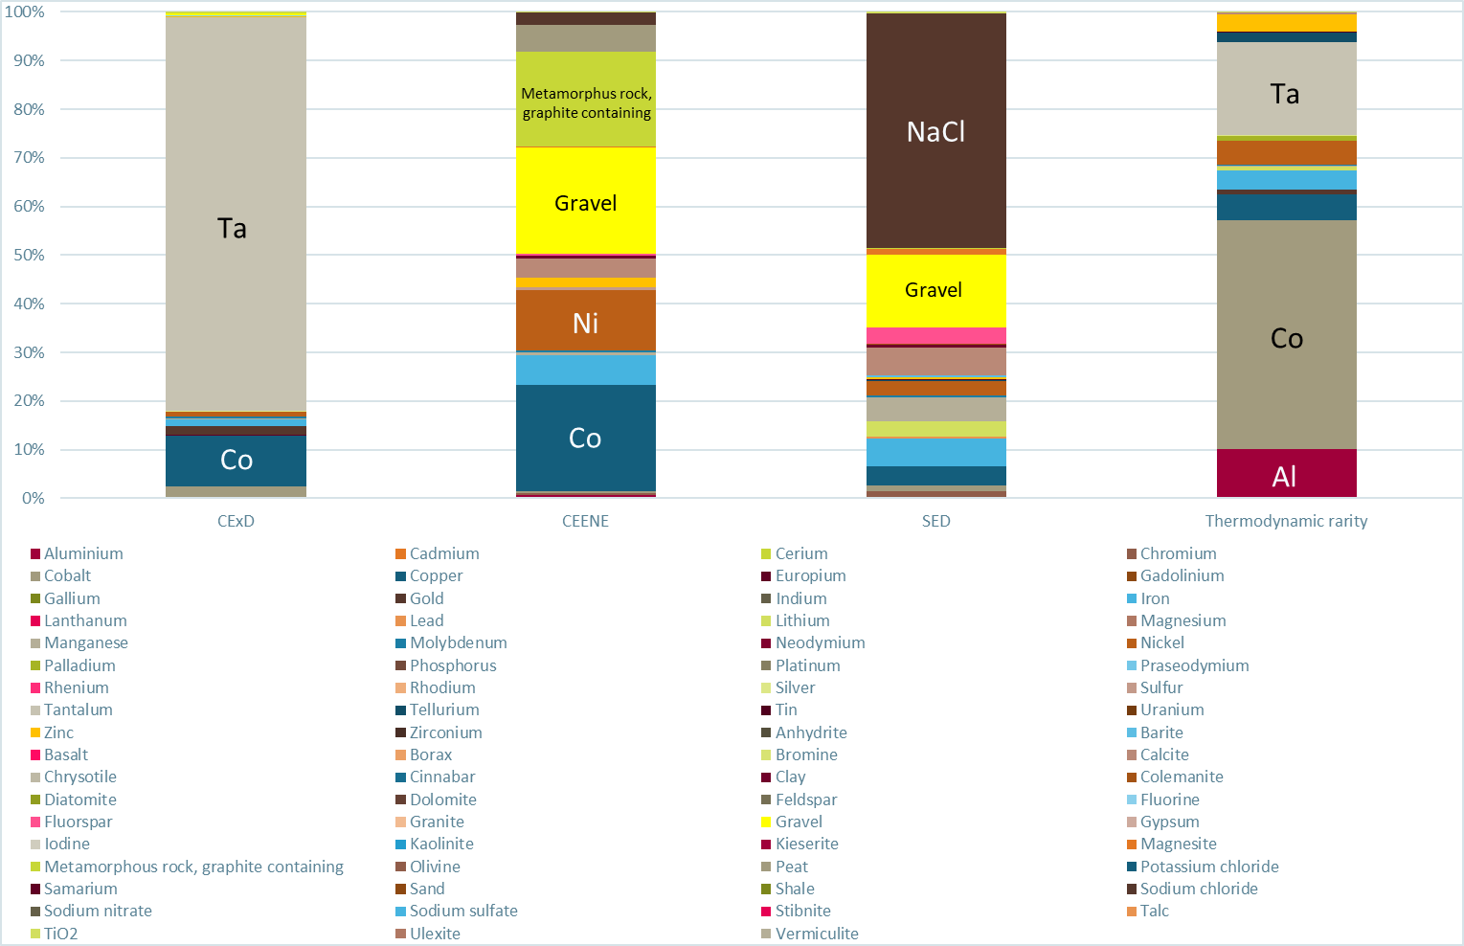
Figure S 10: LCIA results obtained by thermodynamic accounting methods – excluding energy carriers and uranium
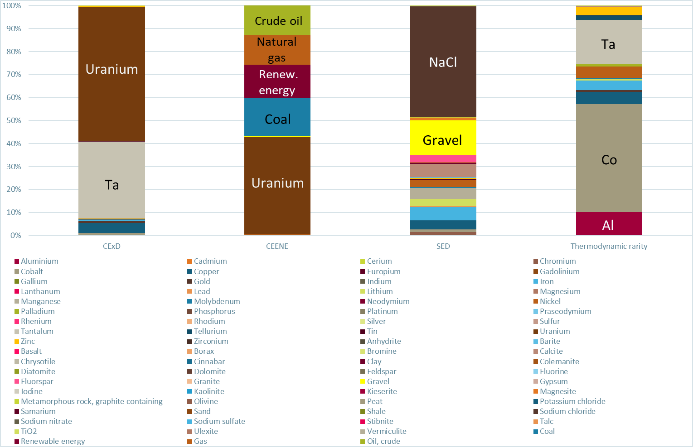
Figure S 11: LCIA results obtained by thermodynamic accounting methods – including energy carriers and uranium

Discussion of results excluding energy carriers and uranium
For CExD, Tantalum has very high CF (8.18 E+05), and dominates the results. In the CEENE, Copper, Nickel, Gravel, Metamorphous Rock play a major role, and Iron, Calcite, Peat to a lesser extent. For SED, Sodium Chloride and Gravel play a major role, and Copper, Iron, Manganese, Nickel, Calcite, Fluorspar to a lesser extent. Finally, for ERC/TR, Palladium, Platinum, Rhodium and Tellerium play a major role, and Gallium, Gold, Indium, Tantalum to a lesser extent.
Discussion of results including energy carriers and uranium
For CExD and CEENE, energy carriers play a major role (~75 and 99% of the results). Meanwhile, for SED the carriers play a minor role (~10% of results). Sodium Chloride and Gravel play a major role, and Copper, Iron, Manganese, Nickel, Calcite, Fluorspar to a lesser extent. For the Thermodynamic Rarity (or the ERC section of TR), energy carriers play a major role (~40% of results); and Palladium, Platinum, Rhodium and Tellerium play a major role, and Gallium, Gold, Indium, Tantalum to a lesser extent.
Overall discussion by method
CEENE and CExD are very driven by energy carriers. CExD has very high CF for Tantalum in comparison to CEENE. If the interest is about metals/minerals, the user of CEENE and CExD should evaluate solely the respective category (since the final results might be dominated by energy carriers). SED and TR have a more “even” valuation amongst energy carriers and metals/minerals. SED seems to be less affected when analyzing with or without energy carriers, so that metals/minerals are relatively more relevant than energy carriers. This has to do with the Emergy reflected in the CFs in the SED method, i.e., much more environmental work (in terms of solar energy inputs over time) has been required in the past (billions of years) to produce minerals and metals rather than energy carriers (millions of years in the case of fossil fuels). Accordingly, the CFs in the SED method are far from being accurate numbers, but they can help to understand how certain types of resources can have such different “ecological” demands.
ERC/TR has about 10x higher CFs than other methods (or even more) for Palladium, Platinum, Rhodium and Tellerium. This is because the ERC considers dispersion in the crust and current technologies to go from the dispersed state to the state in mines. So, if current technologies for this mineral are energy intensive, the ERC CF is high.
Overall discussion by substance (only metals/minerals, excluding uranium)
Copper, Nickel, Calcite, Iron and Gravel had high contribution in CEENE and SED. Tantalum was relevant in the CExD and ERC/TR methods only. Sodium Chloride, Manganese and Fluorspar appeared to be relevant only in SED. Peat and Metamorphous Rock were only relevant in CEENE. Finally, Palladium, Platinum, Rhodium, Tellerium, Gallium, Gold, Indium were only relevant in ERC/TR.

Results supply risk methods
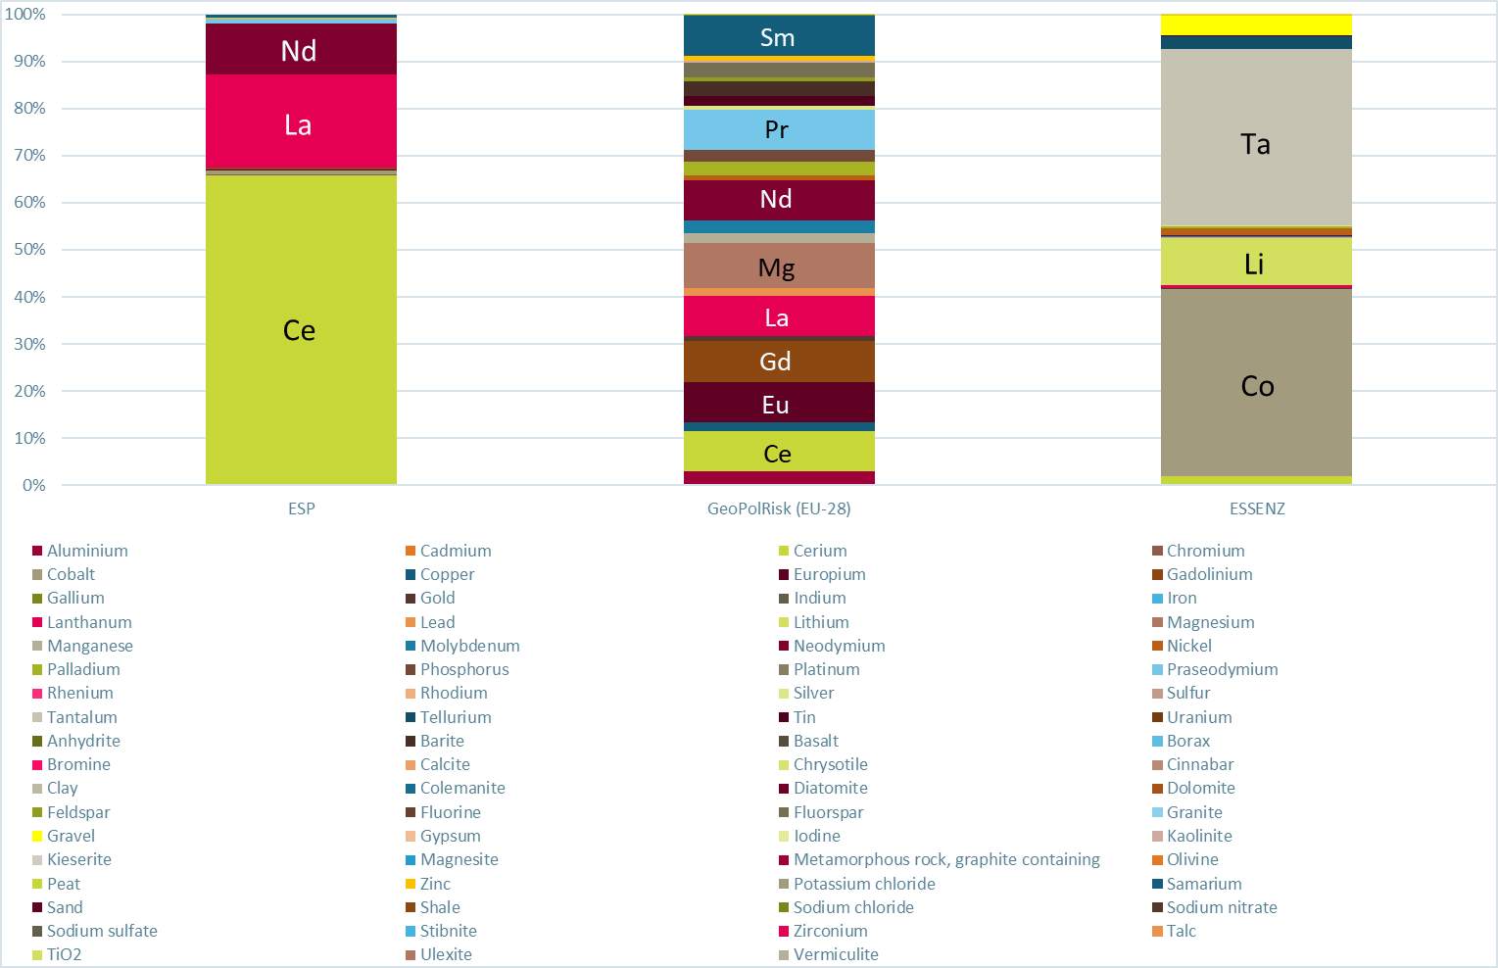
Figure S 12: LCIA results obtained by supply risk methods (without substitutability) – excl. energy carriers and uranium
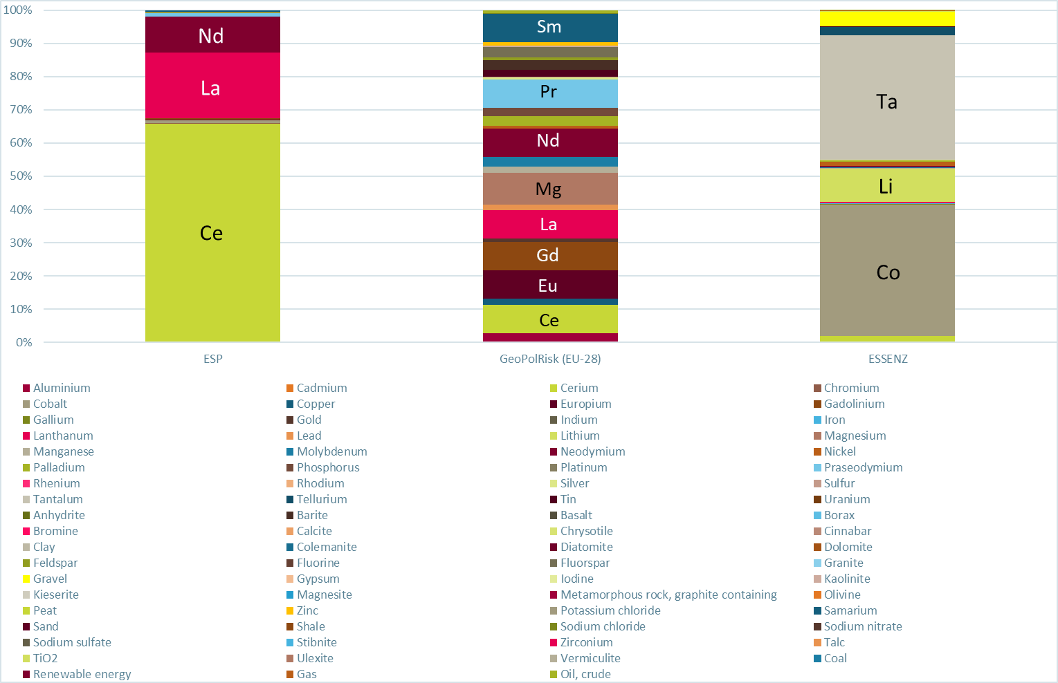
Figure S 13: LCIA results obtained by supply risk methods (without substitutability) – incl. energy carriers and uranium
A detailed presentation and discussion of the results obtained by means of the supply risk methods is presented in a separate paper published by the members of the supply risk subgroup (Cimprich et al. 2019).

References
Cimprich A, Young SB, Helbig C, et al (2017) Extension of geopolitical supply risk methodology: Characterization model applied to conventional and electric vehicles. J Clean Prod 162:754–763. doi: 10.1016/j.jclepro.2017.06.063
Cimprich A, Bach V, Helbig C, et al (2019) Resource criticality assessment as a complement to environmental life cycle assessment: examining methods for product-level supply risk assessment. J Ind Ecol accepted for publication
Gemechu ED, Helbig C, Sonnemann G, et al (2015) Import-based indicator for the geopolitical supply risk of raw materials in life cycle sustainability assessments. J Ind Ecol 20:154–165. doi: 10.1111/jiec.12279
Guinée JB, Heijungs R (1995) A proposal for the definition of resource equivalency factors for use in product life-cycle assessment. Environ Toxicol Chem 14:917–925. doi: 10.1002/etc.5620140525
Heijungs R, Suh S (2002) The Computational Structure of Life Cycle Assessment. Springer Netherlands
Helbig C, Gemechu ED, Pillain B, et al (2016) Extending the geopolitical supply risk indicator: Application of life cycle sustainability assessment to the petrochemical supply chain of polyacrylonitrile-based carbon fibers. J Clean Prod 137:1170–1178. doi: 10.1016/j.jclepro.2016.07.214
ISO (2006) ISO 14040: Environmental management - life cycle assessment - principles and framework. International Organisation for Standardisation, Geneva
Life Cycle Initiative (2016) Global Guidance for Life Cycle Impact Assessment Indicators Volume 1. Paris, FrancePelletier N, Ardente F, Brandão M, et al (2014) Rationales for and limitations of preferred solutions for multi-functionality problems in LCA: is increased consistency possible? Int J LCA. doi: 10.1007/s11367-014-0812-4
Santero N, Hendry J (2016) Harmonization of LCA methodologies for the metal and mining industry. Int J Life Cycle Assess 21:1543–1553. doi: 10.1007/s11367-015-1022-4
Schneider L, Berger M, Finkbeiner M (2015) Abiotic resource depletion in LCA - background and update of the anthropogenic stock extended abiotic depletion potential (AADP) model. Int J Life Cycle Assess 20:709–721. doi: 10.1007/s11367-015-0864-0
Schrijvers DL, Loubet P, Sonnemann G (2016) Developing a systematic framework for consistent allocation in LCA. Int. J. Life Cycle Assess. 21:976–993
Sonderegger T, Berger M, Alvarenga R, et al (2019) Mineral resources in Life Cycle Impact Assessment part I: a review. Int J Life Cycle Assess
Stolz P, Messmer A, Frischknecht R (2016) Life Cycle Inventories of Road and Non-Road Transport Services
Thomassen MA, Dalgaard R, Heijungs R, de Boer I (2008) Attributional and consequential LCA of milk production. Int J Life Cycle Assess 13:339–349. doi: 10.1007/s11367-008-0007-y
Weidema B P (2017). In Search of a Consistent Solution to Allocation of Joint Production. J Ind Ecol 22:252–262
Weidema B P (2018). Consistency check for life cycle assessments. The International Journal of Life Cycle Assessment, early on-line view 22 October. http://lca-net.com/p/3160
Weidema B P, Norris G A (2004). Avoiding co-product allocation in the metals sector. Pp. 81-87 in A Dubreuil: "Life Cycle Assessment and Metals: Issues and research directions." Pensacola: SETAC. (Proceedings of the International Workshop on Life Cycle Assessment and Metals, Montreal, Canada, 2002.04.15-17). http://lca-net.com/p/1042

An intermediate flow is a “product, material or energy flow occurring between unit processes of the product system being studied”, whereby a unit process is the “smallest element considered in the life cycle inventory analysis for which input and output data are quantified” (ISO 2006)

