Supplementary materials of:
Environmental impacts associated with the production, use, and end-of-life of a woollen garment
S.G. Wiedemann ª, L. Biggs ª, B. Nebel ^{b}, K. Bauch ^{b}, K. Laitala ^{c}, I.G. Klepp ^{c}, P.G. Swan ^{d}, K. Watson ª

S.G. Wiedemann ()
Phone: (07) 4615 4690
Email: stephen.wiedemann@integrityag.net.au

ª Integrity Ag and Environment, Toowoomba, QLD, Australia.
^{b} thinkstep, Wellington, New Zealand
^{c} Consumption Research Norway (SIFO), Oslo Metropolitan, Norway
^{d} Paul G. Swan and Associates Pty. Ltd., Australia.

Description of wool processing stages and inventory methods

The scouring stage involved the washing of greasy wool to remove wool grease contaminants such as dirt and organic matter, and the wool grease is extracted at this stage for sale as a co-product. Aggregated data were collected from scouring and top making plants predominantly located in China and India (n = 7). The clean scoured wool then passed through a top making stage (n = 7), which mechanically homogenised the wool and removed additional contaminants including vegetable matter and unsuitably short wool fibres, which are diverted into the woollen system. The wool top subsequently went through a shrink resistance treatment where a thin layer of polymer is applied to mask the scales on the fibre surface, reducing the shrinking potential of the final garment (Kettlewell et al., 2015), and then a top dyeing process using either acid or reactive dyes, depending on final colour. Dyeing was performed in China or India (n = 9). Following the top stage, the wool is ring-spun, and the yarn produced is knitted into sweaters using a flat-bed knitting machine, and is then washed and dried to remove unwanted additives and contaminants, then steam pressed as part of the finishing process. In the final stage, additional garment features are added such as tags and buttons. The warehousing stage includes garment sorting and packaging, ready for transport to retail.
Water inputs, source, losses and outflows were determined by surveying wool processing plants. Fresh water consumption was determined from the water balance at each stage of the process and represented the actual consumption during the process. Waste water treatment (WWT) processes were modelled using inventory data from wool processors, including required energy and outflow water quality. Sludge removed during the WWT process was assumed to go to landfill as a conservative approach, though sludge from scouring is also commonly applied to land. Waste water treatment for the wool scouring (cleaning) stage included an anaerobic treatment stage where gaseous emissions (predominantly methane) were determined from measured levels of biological oxygen demand (BOD) in the effluent. It was assumed that after 20% evaporation loss during the WWT process, 80% of water released to the waste water system was returned to local water ways (rivers) following treatment, with 20% being released to municipal water systems. Releases of water back to the original catchment, after water treatment, were considered a flow back to nature. Water stress for processes occurring in China were determined by applying a weighted average WSI of 0.6255 based on the most common locations of the processing plants.
Fossil fuel energy requirements were surveyed at all stages of processing and included electricity for machine operation and energy for heat or steam generation. Multiple, interchangeable energy sources were used for heat production, and the averaged natural gas, LPG, light oil and coal data in Table 2 of the main paper reflect the mix of energy sources. Where specific data were not available to determine the energy requirements to produce steam on-site, background steam processes from ecoinvent were applied. Steam was converted from kg to energy (MJ) by multiplying it by the specific enthalpy value of 2675 MJ/kg for saturated steam at atmospheric pressure.

Uncertainty data
Uncertainty data were included for all phases of the wool value chain. Background ecoinvent processes were used where possible, which include lognormal uncertainty distributions. Uncertainty values were included at the farm stage as per the previous study by Wiedemann et al. (2016). Uncertainty values were added for each processing stage. These values were assigned normal distributions with SD values calculated using the weighted average data. Uncertainty data for the shrink resistance and knitting processes were taken from the scouring and weaving processes respectively as the sample size was too small to determine uncertainty from these stages. Uncertainty was added for garment care, taking ranges from literature (predominately from Laitala et al. (2018)) and the primary consumer survey data. Normal distributions were assigned with SD values, with the exception of the wears per wash parameter, which used a triangular distribution between minimum and maximum values.

Inventory data
The water lost during each process was determined by subtracting the water output from the input and it was assumed there was a constant residual moisture content within the wool throughout the value chain. Water input and output data were provided by all the companies for the processes in which they used it. Any water loss was attributed to evaporation. Steam was not included in the water balances, as detailed information was not provided on how the steam was used. Table S1 shows an amalgamation of the chemicals used throughout the processing phases.

Table S1. Input amalgamated chemical use through the processing phases per tonne of final garment
Material / Process | Unit | Amount | Uncertainty
Dyes | kg | 33.3 | 22%
Epoxy resin (shrink resistance) | kg | 48.5 | 3%
Sodium products (bicarbonate, chloride etc.) | kg | 124.4 | 24%
Lubricating oil | kg | 18.6 | 30%
Detergent, flocculent, softener & surfactant | kg | 108.0 | 45%
Chemicals, other | kg | 130.7 | 20%

Table S2. Wastewater treatment inventory per kilolitre of water treated
 | Material / Process | Unit | Amount | Min | Max
Input | Wastewater from processing | kL | 1.0
 | Electricity | kWh | 1.6 | 1.1 | 1.6
 | Biological oxygen demand, input effluent | kg | 0.4 | 0.3 | 0.4
 | Chemical oxygen demand, input effluent | kg | 1.0 | 0.9 | 1.0
Output | Water, to river | kL | 0.64 | 0.5 | 1.0
 | Water, to municipal wastewater treatment | kL | 0.16 | 0.0 | 0.5
 | Water, evaporation to atmosphere | kL | 0.2 | 0.1 | 0.3
 | Sludge to landfill | kg | 0.5 | 0.1 | 0.5

The annual energy usage per square metre in European fashion shops was 350 kWh (CIBSE, 2012). A UK specific retail model was set up to convert this value into energy usage per garment. The annual retail sales per square metre from UK fashion giant NEXT (NEXT PLC, 2015) was divided by the UK average garment price per kg to calculate the annual quantity of garments sold per square metre. Average UK garment price per kg was calculated by dividing total 2016 UK clothing sales (ONS, 2018) by 2016 UK clothing consumption in kg (WRAP, 2017). The energy usage per square metre was divided by the quantity of garments sold per square metre to give an annual energy usage per garment in kWh.

Table S3. Retail energy and materials, transport to retail and consumer
Input / Output | Material / Process | Unit | Amount
Input | Final garment | kg | 1000.0
 | Electricity, low voltage (EU) - retail | kWh | 3621.7
 | Land occupation, industrial area | m²a | 0.1
 | Transport, transoceanic freight ship Shanghai to Rotterdam | tkm | 19492.3
 | Transport, lorry > 16t, fleet average | tkm | 874.0
 | Transport, passenger train | person.km/t | 6250.0
 | Operation, passenger car, diesel | km/t | 6250.0
Output | Final garment at consumer home (in EU) | kg | 1000.0
 | Other waste to landfill | kg | 16.1

Table S4. Liquid detergent inventory
Input / Output | Material / Process | Amount | Unit
Input | Water | 0.78 | kg
 | Surfactant - anionic | 0.1 | kg
 | Surfactant - non-ionic | 0.05 | kg
 | Fatty acid | 0.01 | kg
 | Sodium Hydroxide | 0.06 | kg
Output | Liquid washing detergent | 1 | kg
Data from Laitala et al. (2018)

Primary consumer survey data
An online consumer survey of 437 respondents was conducted between 17th November and 17th December 2018 by The Nielsen Company, as a sub-project for the LCA. Respondents were from the UK (n = 213) and Germany (n = 224). The sample was pre-stratified to represent the gender, age and geographical coverage in both countries, and subsequently weighted to represent the adult populations between 18 to 64 years old. Respondents answered a comprehensive survey on their wardrobe content. For selected clothing items, details such as lifespan, active use time, wear occasions, materials, and laundering practices were registered. To prevent respondents dropping out of the survey from fatigue, the number of clothing categories assessed in detail was limited to categories of common clothing items such as sweaters, suits, t-shirts, trousers, skirts and socks. Item-specific questions were limited to a maximum of 10 items per category per respondent. The respondent demographics for each country are given in Table S5.
The data used from the survey is provided in Table S6 to Table S11.

The following results are valid for categories:
- Jumpers / Pullovers / Sweaters / Cardigans
- Wool and wool blends includes: 100% Wool, Merino Wool, Wool Blends (i.e. Wool mixed with other synthetic or natural fibres), Cashmere
- Europe = UK and Germany

Table S5 – Demographics of consumers in the survey
 | Germany | UK | Total Europe
Number of respondents | 224 | 213 | 437
Total number of registered garments | 11705 | 9384 | 21089
Number of wool and wool blend jumpers / pullovers / sweaters / cardigans | 329 | 463 | 792
Men | 51% | 47% | 49%
Women | 49% | 53% | 51%
Age 18-29 | 19% | 22% | 20%
Age 30-49 | 45% | 52% | 48%
Age 50-64 | 36% | 26% | 32%

Table S6 - Type of washing used by consumers – woollen jumpers / pullovers / sweaters / cardigans
 | Male responses |  |  | Female responses |  |  | Total
Response | Garments | % | Adj¹ % | Garments | % | Adj¹ % | Garments | % | Adj¹ %
Hand wash it | 1120 | 17% | 25% | 1922 | 24% | 29% | 3042 | 21% | 27%
Wash it in the washing machine | 3342 | 51% | 60% | 4890 | 60% | 65% | 8232 | 56% | 63%
Send it for dry cleaning | 576 | 9% | 15% | 371 | 5% | 6% | 947 | 7% | 10%
Sometimes hand wash and sometimes machine wash | 661 | 10% |  | 666 | 8% |  | 1327 | 9%
Sometimes hand wash and sometimes dry clean | 340 | 5% |  | 168 | 2% |  | 508 | 4%
Sometimes machine wash and sometimes dry clean | 371 | 6% |  | 0 | 0% |  | 371 | 3%
Don't know | 89 | 1% |  | 113 | 1% |  | 202 | 1%
Sum | 6499 | 100% | 100% | 8130 | 100% | 100% | 14629 | 100% | 100%
1 Response contribution percentages adjusted to provide clear three preferences of hand wash, machine wash and dry clean. Equal weighting was assumed when two answers were given.

Table S7 - Number of times garment worn to date by consumers – woollen jumpers / pullovers / sweaters / cardigans
 |  | Male responses |  |  | Female responses |  |  | Total
Response | Wears | Garments | % | Adj¹ % | Garments | % | Adj¹ % | Garments | % | Adj¹ %
Never | 0 | 37 | 1% | 1% | 273 | 3% | 4% | 310 | 2% | 2%
1-2 times | 1.5 | 132 | 2% | 2% | 626 | 7% | 9% | 758 | 5% | 6%
3-4 times | 3.5 | 531 | 7% | 9% | 1274 | 15% | 17% | 1805 | 11% | 13%
5-9 times | 7 | 1265 | 18% | 21% | 1438 | 17% | 19% | 2703 | 17% | 20%
10-19 times | 15 | 1241 | 17% | 21% | 1724 | 20% | 23% | 2965 | 19% | 22%
20-49 times | 35 | 1421 | 20% | 24% | 1329 | 15% | 18% | 2750 | 17% | 21%
50-99 times | 75 | 781 | 11% | 13% | 548 | 6% | 7% | 1329 | 8% | 10%
100-199 times | 150 | 315 | 4% | 5% | 100 | 1% | 1% | 415 | 3% | 3%
More than 200 times | 250 | 266 | 4% | 4% | 77 | 1% | 1% | 343 | 2% | 3%
Don't know |  | 1213 | 17% |  | 1330 | 15% |  | 2543 | 16%
Sum |  | 7202 | 100% | 100% | 8719 | 100% | 100% | 15921 | 100% | 100%
Mean wears |  |  |  | 42.0 |  |  | 22.1 |  |  | 31.1
1 Response contribution percentages adjusted to exclude ‘Don’t know’ responses.

Table S8 - Future expectations for number of times garment to be worn by consumers – woollen jumpers / pullovers / sweaters / cardigans
 |  | Male responses |  |  | Female responses |  |  | Total
Response | Wears | Garments | % | Adj¹ % | Garments | % | Adj¹ % | Garments | % | Adj¹ %
Never | 0 | 0 | 0% | 0% | 113 | 1% | 2% | 113 | 1% | 1%
1-2 times | 1.5 | 178 | 3% | 3% | 271 | 3% | 4% | 449 | 3% | 4%
3-4 times | 3.5 | 482 | 7% | 9% | 605 | 7% | 9% | 1087 | 7% | 9%
5-9 times | 7 | 860 | 12% | 16% | 1053 | 12% | 17% | 1913 | 12% | 16%
10-19 times | 15 | 1143 | 16% | 21% | 1449 | 17% | 23% | 2592 | 16% | 22%
20-49 times | 35 | 1368 | 19% | 25% | 1399 | 16% | 22% | 2767 | 17% | 23%
50-99 times | 75 | 706 | 10% | 13% | 725 | 8% | 11% | 1431 | 9% | 12%
100-199 times | 150 | 299 | 4% | 5% | 457 | 5% | 7% | 756 | 5% | 6%
More than 200 times | 250 | 484 | 7% | 9% | 293 | 3% | 5% | 777 | 5% | 7%
Don't know |  | 1682 | 23% |  | 2355 | 27% |  | 4037 | 25%
Sum |  | 7202 | 100% | 100% | 8720 | 100% | 100% | 15922 | 100% | 100%
Mean wears |  |  |  | 52.9 |  |  | 43.5 |  |  | 47.9
1 Response contribution percentages adjusted to exclude ‘Don’t know’ responses.

Table S9 - Number of times garment is worn before washing by consumers – woollen jumpers / pullovers / sweaters / cardigans
 |  | Male responses |  |  | Female responses |  |  | Total
Response | Wears | Garments | % | Adj¹ % | Garments | % | Adj¹ % | Garments | % | Adj¹ %
After every wear | 1 | 583 | 8% | 9% | 1876 | 22% | 23% | 2459 | 15% | 17%
After every 2 wears | 2 | 941 | 13% | 15% | 2536 | 29% | 31% | 3477 | 22% | 24%
After every 3 wears | 3 | 1254 | 17% | 19% | 1201 | 14% | 15% | 2455 | 15% | 17%
After every 4 wears | 4 | 823 | 11% | 13% | 1001 | 12% | 12% | 1824 | 12% | 13%
After every 5 wears | 5 | 1096 | 15% | 17% | 742 | 9% | 9% | 1838 | 12% | 13%
After every 6-10 wears | 8 | 942 | 13% | 15% | 542 | 6% | 7% | 1484 | 9% | 10%
After every 11-19 wears | 15 | 302 | 4% | 5% | 126 | 1% | 2% | 428 | 3% | 3%
After every 20-29 wears | 25 | 288 | 4% | 4% | 42 | 1% | 1% | 330 | 2% | 2%
After every 30 wears | 50 | 269 | 4% | 4% | 64 | 1% | 1% | 333 | 2% | 2%
Never |  | 46 | 1% |  | 109 | 1% |  | 155 | 1%
Don't know |  | 656 | 9% |  | 480 | 6% |  | 1136 | 7%
Sum |  | 7200 | 100% | 100% | 8719 | 100% | 100% | 15919 | 100% | 100%
Mean wears |  |  |  | 7.3 |  |  | 3.5 |  |  | 5.2
1 Response contribution percentages adjusted to exclude ‘Never’ and ‘Don’t know’ responses.

Table S10 - Frequency of wearing garment in season by consumers – woollen jumpers / pullovers / sweaters / cardigans
 |  | Male responses |  |  | Female responses |  |  | Total
Response | Days | Garments | % | Adj¹ % | Garments | % | Adj¹ % | Garments | % | Adj¹ %
Several times a week | 3 | 1245 | 22% | 24% | 729 | 13% | 14% | 1974 | 18% | 19%
Once a week | 7 | 839 | 15% | 16% | 1723 | 31% | 32% | 2562 | 23% | 24%
Once every 2 weeks | 14 | 1126 | 20% | 21% | 1654 | 30% | 31% | 2780 | 25% | 26%
Once every 3-4 weeks | 25 | 1157 | 20% | 22% | 935 | 17% | 17% | 2092 | 19% | 20%
Once every 3 months | 91 | 704 | 12% | 13% | 177 | 3% | 3% | 881 | 8% | 8%
Once every 6 months | 183 | 112 | 2% | 2% | 44 | 1% | 1% | 156 | 1% | 1%
Less than once every 6 months | 274 | 57 | 1% | 1% | 78 | 1% | 1% | 135 | 1% | 1%
Don't know |  | 441 | 8% |  | 254 | 5% |  | 695 | 6%
Sum |  | 5681 | 100% | 100% | 5594 | 100% | 100% | 11275 | 100% | 100%
Mean days |  |  |  | 29.5 |  |  | 19.9 |  |  | 24.6
Wears per yr² |  |  |  | 12.4 |  |  | 18.4 |  |  | 14.8
1 Response percentages adjusted to exclude ‘Don’t know’ responses.
2 Wears per year calculated by dividing 365 days by the frequency of wearing garment.

Table S11 - Expected means of disposal of garment by consumers – woollen jumpers / pullovers / sweaters / cardigans
 | Male responses |  |  |  | Female responses |  |  |  | Total
Response | Garments | % | Adj¹ % | Adj² % | Garments | % | Adj¹ % | Adj² % |  | Garments | % | Adj¹ % | Adj² %
Donate to charity / clothes recycling collection | 2900 | 50% | 55% |  | 3057 | 52% | 58% |  |  | 5957 | 51% | 56%
Donate / give to family / friends | 624 | 11% | 12% |  | 814 | 14% | 16% |  |  | 1438 | 12% | 14%
Put in the Rubbish Bin at home | 1006 | 17% | 19% | 64% | 789 | 13% | 15% | 85% |  | 1795 | 15% | 17% | 71%
Recycle at home (e.g. use as cleaning cloth) | 573 | 10% | 11% | 36% | 143 | 2% | 3% | 15% |  | 716 | 6% | 7% | 29%
Sell (e.g. garage sale, eBay) | 172 | 3% | 3% |  | 468 | 8% | 9% |  |  | 640 | 5% | 6%
Other | 103 | 2% |  |  | 63 | 1% |  |  |  | 166 | 1%
Don't know | 456 | 8% |  |  | 583 | 10% |  |  |  | 1039 | 9%
Sum | 5834 | 100% | 100% | 100% | 5917 | 100% | 100% | 100% |  | 11751 | 100% | 100% | 100%
1 Response percentages adjusted to exclude ‘Other’ and ‘Don’t know’ responses.
2 Response percentages adjusted to produce split between recycling and municipal waste disposal.

In addition to the broader survey, an online diary completed between 8th January and 8th February 2019 recorded the laundry habits of 265 garment users (China, n = 156, Japan, n = 61, UK, n = 20, and Germany, n = 22). Data from countries outside of Europe were used as a result of the small sample size of UK and German respondents. These data were used to quantify the amount of water used to hand wash garments (Table S12).

Table S12 – Quantity of water used for hand washing by consumers in China, Japan, Germany and the UK
Hand Wash - Litres of Water Used | TOTAL | China | Japan | Germany | UK
Average number of litres used | 12.8 | 16.3 | 7.0 | 14.2 | 4.6
Median number of litres used | 5 | 5 | 3 | 10 | 3
Column n | 265 | 156 | 61 | 22 | 26

Single year of life

Table S13 – Impacts from a single year of garment use (i.e. 15 garment wears) before disposal
Impact category | Unit | Single year
Global warming | kg CO2-e | 16.3
Fossil energy | MJ LHV | 77.1
WSI water consumption | WSI eq l | 81.4

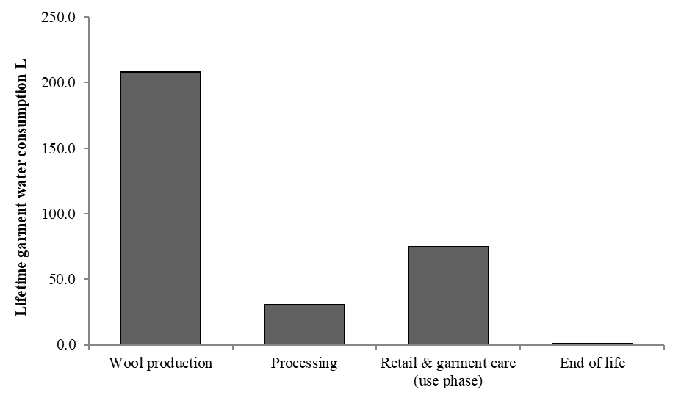
Figure S1 – Water consumption inventory over a lifetime (109 wears) of a woollen sweater

Uncertainty data results
Uncertainty analyses are shown in Figure 3.
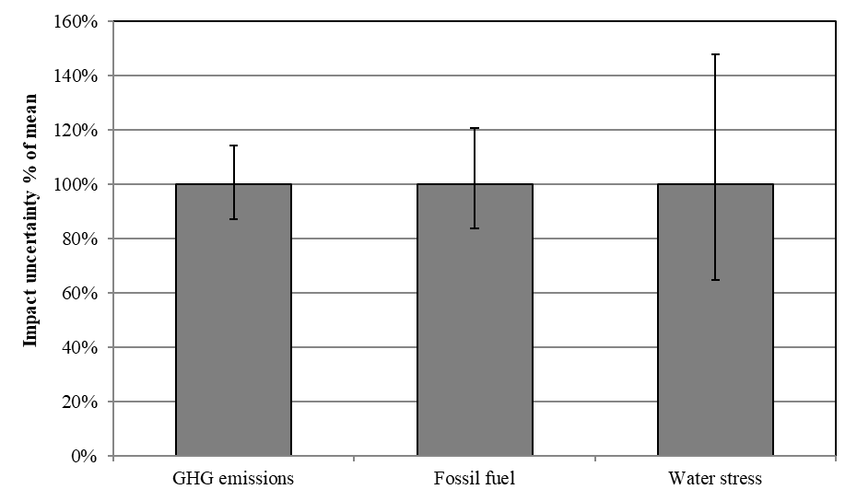
Figure S2. Excluding lifetime wear uncertainty - error bars showing 95% confidence probability for mean impact categories of greenhouse gas (GHG) emissions, fossil energy and water stress

References
CIBSE (2012) 'Benchmarks', in Cheshire, D. (ed.) GVF 2012 Guide F: Energy Efficiency in Buildings. England: Chartered Institution of Building Service Engineers (CIBSE).
Kettlewell, R., De Boos, A. and Jackson, J. (2015) '6 - Commercial shrink-resist finishes for wool', in Paul, R. (ed.) Functional Finishes for Textiles: Woodhead Publishing, pp. 193-226.
Laitala, K., Klepp, I. and Henry, B. (2018) 'Does Use Matter? Comparison of Environmental Impacts of Clothing Based on Fiber Type', Sustainability, 10(7), pp. 2524.
NEXT PLC (2015) Results for the Year Ending January 2015, UK: NEXT. Available at: http://www.nextplc.co.uk/~/media/Files/N/Next-PLC-V2/documents/reports-and-presentations/2014/full-year-results-2014.pdf.
ONS (2018) Retail sales, Great Britain: February 2018, UK: Office of National Statistics (ONS). Available at: https://www.ons.gov.uk/businessindustryandtrade/retailindustry/bulletins/retailsales/february2018.
Wiedemann, S., Yan, M.-J., Henry, B. and Murphy, C. (2016) 'Resource Use and Greenhouse Gas Emissions from Three Wool Production Regions in Australia', Journal of Cleaner Production, 122, pp. 121-132.
WRAP (2017) Valuing our clothes: the cost of UK fashion, Banbury, UK: WRAP. Available at: http://www.wrap.org.uk/sites/files/wrap/valuing-our-clothes-the-cost-of-uk-fashion_WRAP.pdf.

