Supplementay Material 1: Additional Information
1 Additional information on the methods used for developing the SIMPL approach 3
1.1 Colloborative research team 3
1.2 Overview on courses 3
1.3 Details on the co-creation of solution-oriented and transferable knowledge (phase b) 4
1.3.1 (b.1): Literature research: scientific background, available scientific knowledge 4
1.3.2 (b.2): Discussion within the research team: find common terminology, bring together knowledge and perspectives 4
1.3.3 (b.3) Courses with LCA practitioners: gain knowledge about practical requirements and identify improvement potentials through practical application 5
1.3.4 (b.4): Further development within the research team addressing unsolved issues from all three courses 8
1.3.5 (c.1): Continuous course delivery 8
2 Additional information on suggested tools 9
2.1 Illustration of CLDs with examples 9
2.1 Explanation of CCA with an example 9
3 Additional information on the SIMPL approach 12
4 Additional information on the case study 13
4.1 Integrating scenario field identification into the LCA goal and scope definition 13
4.1.1 Background on alternative jet fuels 13
4.1.2 Alternative research questions leading to alternative scenario approaches 13
4.1.3 Further examples for future changes of scope items 13
4.2 Integrating scenario development into inventory modelling 14
4.2.1 Step A: Identify relevant inventory parameters and key factors 14
4.2.2 Step B: Find assumptions for each key factor and each relevant inventory parameter 17
4.2.3 Simplifications of the illustrative example 18
5 Publication bibliography 20

Additional information on the methods used for developing the SIMPL approach

Colloborative research team
The following researchers were members of the core research team:
- pLCA experts/practitioners
  - Bernhard Steubing, CML, Leiden University, Leiden, The Netherlands
  - Christopher Mutel, Technology Assessment Group, Laboratory for Energy Systems Analysis, Paul Scherrer Institut, Villigen, Switzerland
  - Matty Janssen Environmental Systems Analysis, Chalmers University of Technology, Gothenburg, Sweden
- Foresight experts
  - Lorenz Erdmann, Fraunhofer Institute for Systems and Innovation Research ISI, Karlsruhe, Germany
  - Ariane Voglhuber-Slavinsky, Fraunhofer Institute for Systems and Innovation Research ISI, Karlsruhe, Germany
- Sustainability experts
  - Sabine Langkau, Fraunhofer Institute for Systems and Innovation Research ISI, Karlsruhe, Germany
  - Maulana Permana Ajie, Fraunhofer Institute for Systems and Innovation Research ISI, Karlsruhe, Germany

Overview on courses
Table A0 gives an overview on the courses delivered for improving and bringing into application the SIMPL approach.
Table A0: Overview on courses in which the presented approach was applied and further developed.
# | Title | Dates | Hours | Participants
1 | Prospective LCA PhD autumn school | 10/5-9/2020 | 69 | 26
2 | Professionals course on applied prospective Life Cycle Assessment (LCA) and scenario modeling | 2/1-12/2021 | 50 | 22
3 |  | 3/1-12/2021 | 50 | 39
4 | Prospective LCA autumn school | 10/10-14/2022 | 64 | 25

Details on the co-creation of solution-oriented and transferable knowledge (phase b)

(b.1): Literature research: scientific background, available scientific knowledge
- Main points summarized in the introduction, a separate publication is intended

(b.2): Discussion within the research team: find common terminology, bring together knowledge and perspectives
- In the beginning, suggestions for extensions of the 4 steps of LCA (goal and scope, inventory modelling, impact assessment, interpretation) were made.
- It was found that changing the four steps of LCA (goal and scope, inventory modelling, impact assessment, interpretation) is met with resistance by the LCA experts. Since the four steps serve as a foundation to the LCA community, an approach will rather be accepted when not changing them.
- Many ideas for parallel tracks of LCA inventory modelling and scenario development were discussed, but eventually did not seem fully convincing/practically appealing.
- Thus, it was decided that the approach needs to integrate the steps of scenario development into the exisiting four steps of LCA.
- Issues of non-uniform terminology were discussed, e.g. "what-if-scenario" is used with different meanings by the pLCA community. It was decided to use terminology as defined in a well-established reference of the foresight community.
- Relationship of scenarios and LCA uncertainty assessment were identified as an important issue, but not related to the process of scientifically sound scenario development for prospective inventory modelling itself.
- First draft of the approach suggested
  - adding time horizon and choice of scenario approach to the goal and scope
  - integrating 4 steps A - D into the inventory phase
    - step A - C were similar to the final steps A - C, but unrefined without the substeps A1 - A3 etc., distinctness-based selection was not considered
    - step D was the transfer of scenarios to the inventory models, thus preliminary inventory modelling and sensitivity analysis were not yet seen as part of step A, it was suggested to have a fixed inventory model and only transfer alternative values for parameters from the scenarios to the inventory model
    - parameters/factors were differentiated as parameters outside and inside the inventory model
    - PESTEL, CLD and CCA were already suggested as potential tools among others

(b.3) Courses with LCA practitioners: gain knowledge about practical requirements and identify improvement potentials through practical application
b.3.1 Learnings from the first course by observation of case study application and participants' feedback
- learnings:
  - most participants were eager to apply the suggested steps to a case study, an orientation for implementing scenarios into inventory models seemed generally welcome
  - the whole approach appeared to be a lot to digest, most of the participants did not have prior knowledge of the introduced steps for scenario development or the specific tools
  - application of tools revealed a few typical sources for misunderstanding
  - adapting quantitative parameters in the inventory model was found insufficient for many research problems, it showed that it is also necessary to adapt the product system, e.g. exchange parts of the process chain by alternatives to model prospective inventories of technologies, particularly emerging technologies
  - a differentiation between steps A - D for the different scenario approaches (predictive, explorative, normative) is necessary
  - the question how the scenarios can be combined with LCA uncertainty treatment was raised as an issue and discussed
  - a more detailed description of the approach is necessary, it is unclear how to apply steps A - C exactly on an operational level
- adaptations
  - "easily understandable" and "manageable/scalable effort" were added to the list of requirements for the approach
  - the initial draft contained some rather unspecific brainstorming questions --> these were removed for simplicity
  - suggested tools were reduced to PESTEL, CLD and CCA
  - explanations of the tools were adapted to avoid misunderstandings (e.g. the meaning of "-" connections in CLDs was explained in more detail
  - explanations were reformulated to be understandable without prior knowledge
  - the possibility to adapt the production system as varying between different scenarios was added to the mere possibility of adapting quantitative values in a fixed inventory model; it was suggested to organize the different adaptations hierarchical
  - step A was broken down into three substeps: A1 preliminary LCI, A2 PESTEL, A3 CLD for a better structure and more straightforward application
  - step B was broken down into B1 approaches for foreground parameters, B2 approaches for background and external parameters
  - a differentiation between steps A - D for the different scenario approaches (predictive, explorative, normative) was implemented
b.3.2 Learnings from the second course by observation of case study application and participants' feedback
- learnings:
  - some participants readily applied the approach and pushed it as far as possible, others needed more time to understand the principles before applying, two participants decided to avoid the approach in their case study
  - PESTEL required unaccustomed thinking patterns from many participants
  - CLD was seen as generally helpful for structuring the research problem by several participants, the graphical set-up seemed appealing to many participants
  - CCA explanation was still to abstract, so misunderstandings occurred and additional explanation was necessary --> it is better to leave out the theoretical background, keep the abstract description short and explain/demonstrate with examples
  - the grouping used in step B was confusing and met with resistance --> a better structure needs to be found
  - practical benefits of the approach are of high importance to LCA practitioners, more than fulfilling scientific quality requirements of the foresight community --> it is necessary to demonstrate how the pLCA results improve through the approach
  - the hierarchical structure for adaptations is confusing, the possibilities to adapt the product system are insufficient and partly conflicting with steps A - D
  - potential high number of possible scenarios leads to discussions and questions
  - publishing the approach would be helpful to have a documentation and reference for own research projects
- adaptations
  - CCA explanation was changed to a short abstract description and a long demonstration with examples, leaving the theoretical background to references
  - "necessity of practical benefits" was added to the list of requirements for the approach
  - new structure for goal and scope presentation was implemented to emphasize potential practical benefits
  - possibilities of adapting the production system and organizing the parameters hierarchically were improved
  - distinctness-based selection was added as a concept, but not yet implemented as part of the steps
b.3.3 Learnings from the third course by observation of case study application and participants' feedback
- learnings:
  - the newly implemented goal and scope presentation was not convincing regarding practical benefits
  - connections between PESTEL/CLD and the inventory model were too weak, it was not obvious to all participants how to transfer the insights from PESTEL/CLD to the inventory model
  - the hierarchical structure for adaptations was well understandable and served good possibilities to adapt the product system, but it was still partly conflicting with steps A - D
  - the potential high number of possible scenarios led to discussions and questions
  - practical benefits, specifically in overcoming biases, could be shown for several case studies
- adaptations:
  - goal and scope was presented as before the adaptations after the second course, practical benefits are explained with examples in the end of the presentation of the SIMPL approach
  - distinctness-based selection was integrated into steps B and C

(b.4): Further development within the research team addressing unsolved issues from all three courses
- Step A3 was extended: besides drawing the CLD, it requires to connect it to the inventory modelling
- Step D was removed as it appeared unnecessary, the transfer of assumptions to the inventory models is now an iterative part of steps A - C, in this way it was also possible to implement alternative options of the production system in addition to alternative values of the process parameters, using a hierarchical structure of these inventory parameters

(c.1): Continuous course delivery
- The SIMPL approach as described in the main manuscript was well accepted and applied by the participants of the course in autumn 2022.
- More examples for practical benefits could be collected at this school.
- Further improvement potentials will be rather discovered by in-depth application than in the further courses, which will now mainly help bringing the SIMPL approach into practical application and less improving it further.

Additional information on suggested tools

Illustration of CLDs with examples
The principle of CLDs will be explained with examples and Figure A1, based on (Vries 2012).
Assume B is a certain type of infection bacteria in your body and A is an antibiotic against them. With a higher number of bacteria in your body, you feel sick and start taken the antibiotic. The more severe the infection is, the higher is the dose of antibiotics described by your doctor ("+" means increase in B leads to increase in A). The antibiotic kills the bacteria, the more you take, the more are killed ("-" means an increase in A leads to a decrease in B). An uneven number of "-" leads to an overall "-", i.e. a balancing feedback cycle. Ideally, you take enough antibiotics to kill all bacteria, so the cycle ends. However, you may also reduce the amount of antibiotics too early. Then less antibiotics means that the number of bacteria increases again. ("-" means also that a decrease in A leads to an increase in B).
Now assume that F is the number of your friends and P is the number of parties you are invited to. On each party, you meet new friends. New friends invite you to new parties. ("+" means that an increase in F leads to an increase in P, also, an increase in P leads to an increase in F). An even number of "-" in a circle (in this case 0) means overall "+" or a reinforcing feedback loop. It also works the other way around. If you lose friends, you are invited to less parties ("+" also means a decrease in F leads to a decrease in P).
Correlations do not necessary occur in loops, but loops are also not rare.

Explanation of CCA with an example
The principle of CCA is explained with Figure A2, based on (Ritchey 2002). Grey fields avoid doublets. You cannot eat the cake and keep it for tomorrow, so it is a clear inconsistency (red/-3). The same holds true for the jam. Regarding eating both, one argument would be that if you already had the cake, you don't need the jam and vice versa. Another argument would be that if you eat the cake, you love sweets and can't contain yourself, so you will eat the jam as well. Still another opinion would be that the two are entirely unrelated, since jam is for breakfast and cake is for coffee time. With all these opposing opinions, it might be best to settle for neutral (0/white), meaning there is no correlation at all or meaning that no clear decision is possible. With 0/white, all combinations will have to be analyzed later on. Losing weight is more plausible if you don't eat the cake, and also if you don't eat the jam. But how strong is this correlation. Not as strong as the minus 3 ones, because you may eat both and still lose weight due to your ambitious sport program. The other way around, not eating the cake/jam makes it more plausible to lose weight, but without any further information, this seems a weak correlation. Hence, medium colors and numbers seem appropriate. As you may have noticed, these decisions depend on opinions. The CCA method cannot remove this dependency as it is connected to the inherent epistemic future uncertainty. We just don't know if you will still lose weight after eating the jam and the cake. The CCA helps to make our opinions transparent and selecting plausible scenarios supporting our decision making. In this example, scenarios containing the assumption combinations "Eat the cake" + "Keep the cake" as well as "Eat the jam" + "Keep the jam" can be excluded as impossible, so four formally possible scenarios can be excluded. All 8 remaining combinations seem possible, but can be ranged by their plausibility:
- Keep the cake, keep the jam, lose weight: most plausible
- Eat the cake, eat the jam, not lose weight: most plausible
- Eat the cake, keep the jam, not lose weight: slightly more plausible
- Keep the cake, eat the jam, lose weight: slightly more plausible
- Keep the cake, eat the jam, not lose weight: slightly less plausible
- Eat the cake, keep the jam, lose weight: slightly less plausible
- Eat the cake, eat the jam, lose weight: most implausible
- Keep the cake, keep the jam, not lose weight: most implausible

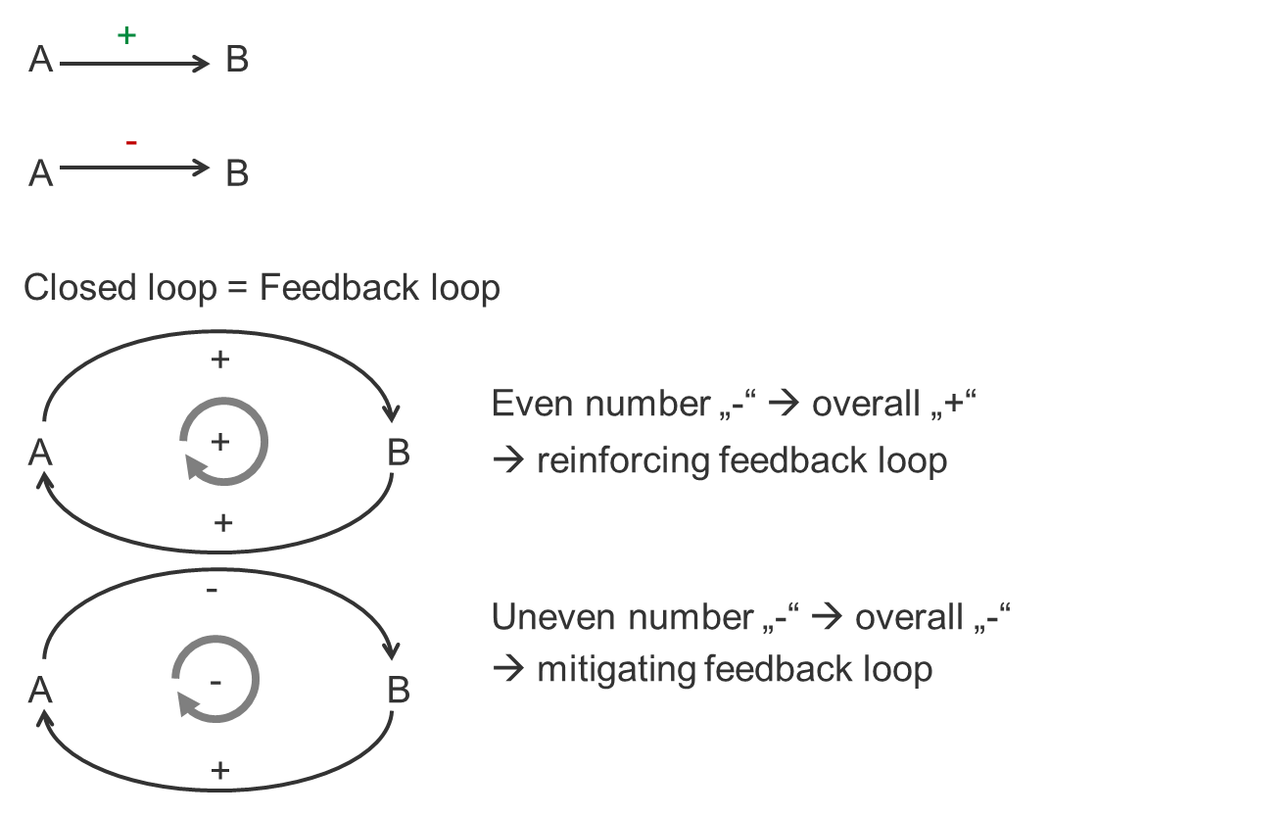
Figure A1: CLDs

 | Eat the cake | Keep the cake | Eat the jam | Keep the jam | Lose weight
Eat the cake
Keep the cake | -3
Eat the jam | 0 | 0
Keep the jam | 0 | 0 | -3
Lose weight | -2 | +1 | -1 | +1
Fig. A2: CCA

Additional information on the SIMPL approach
Table A1: Differences of the three steps (A) - (C) for different types of scenario approaches as defined by (Börjeson et al. 2006)
Scenario type | Explorative (Cornerstones) | Explorative (What-if) | Predictive | Normative
Research question (regarding the future development of a product/process/service):
 | What future developments are plausible? | What future development follows from my specific assumptions? | What future development is 'most likely'? | How can a specific vision of the future be achieved?
Steps for scenario construction:
(A) Identify relevant inventory parameters and key factors | Which inventory parameters and key factors are relevant for answering the research question?
(B) Find future assumptions for each key factor and each relevant inventory parameter | Several plausible scenarios for each key factor and each relevant inventory parameter | One specific scenario for each key factor and each relevant inventory parameter | One 'likely' scenario for each key factor and each relevant inventory parameter | Normative sub-scenarios: how should each key factor and each relevant inventory parameter develop to reach the vision
(C) Combine assumptions into future scenarios | Many formally possible combinations of assumptions --> find most plausible ones, most different ones | Either consistent or not (if not consistent, cornerstone scenario type might be needed) | Either consistent or not (if not consistent, cornerstone scenario type might be needed) | Consistent combinations of normative assumptions are plausible pathways to the vision

Additional information on the case study

Integrating scenario field identification into the LCA goal and scope definition

Background on alternative jet fuels
Regarding the production system, the two main production pathways to alternative drop-in jet fuels were chosen for comparison: bio-based jet-fuel (also referred to as 'ethanol to jet-fuel': BTJ) vs. electricity based jet-fuel ('power to jet fuel': PTJ). Other alternatives like batteries or hydrogen were not considered due to their lower energy density, making a future use for the weight-sensitive air traffic improbable. For BTJ, only second-generation biofuels based on non-food biomass technologies were considered. For simplicity, only straw was regarded as raw material in this illustrative example.

Alternative research questions leading to alternative scenario approaches
What-if scenarios could be constructed to analyze the implications of specific assumptions, in which case the research question would have to be adapted to 'Which one has the better environmental performance in 2050 assuming that...'.
An illustrative research question for normative scenarios could be: 'How can jet fuel production be improved to meet the goals of emission reduction of xx % by 2050?'.
Further, an exemplary research question for a predictive scenario would be: 'What will be the environmental impacts of conventional jet-fuel production in 2023?', the short time horizon and the mature technology potentially allowing for a 'likely' business-as-usual scenario.

Further examples for future changes of scope items
At present, it seems reasonable to define 1 kg of jet fuel as the functional unit, therewith considering jet fuel as the main product and all other products (diesel, gasoline, heat, electricity) as by-products. In the future, the byproducts might become more important, and a reasonable functional unit could then e.g. include all four products. Additionally, non-fuel-based solutions might become relevant for air traffic in the future (e.g. direct use of electricity), making a change to a functional unit of '1 km travelled by plain' more suitable.
It is conceivable that regional boundaries may change in the future and different future scenarios are plausible for them, since resources available in Germany are unlikely to meet demand. For instance, electricity-based jet-fuel demanded in Germany might be produced from hydrogen made in Northern Africa or other world regions. Likewise, ethanol for bio-based jet-fuel might be imported.

Integrating scenario development into inventory modelling

Step A: Identify relevant inventory parameters and key factors
Step A1: (Preliminary) inventory models
Literature data
For BTJ, the process chain described in (Humbird et al. 2011) was chosen for low technical improvement, as it is often referred to as the present state-of-the-art technology (Wittmann and Liao 2016). The more recently developed and environmentally improved process chain described in (Balch et al. 2020) was chosen for high technical development (Wittmann and Liao 2016). Concerning PTJ, two process descriptions suitable for low and high future technical improvement where found in (Hank et al. 2020). The preliminary inventory model was chosen in agreement with the interviewed experts and is shown in Figure A3.
Inventory model of PTJ including connections from the CLD
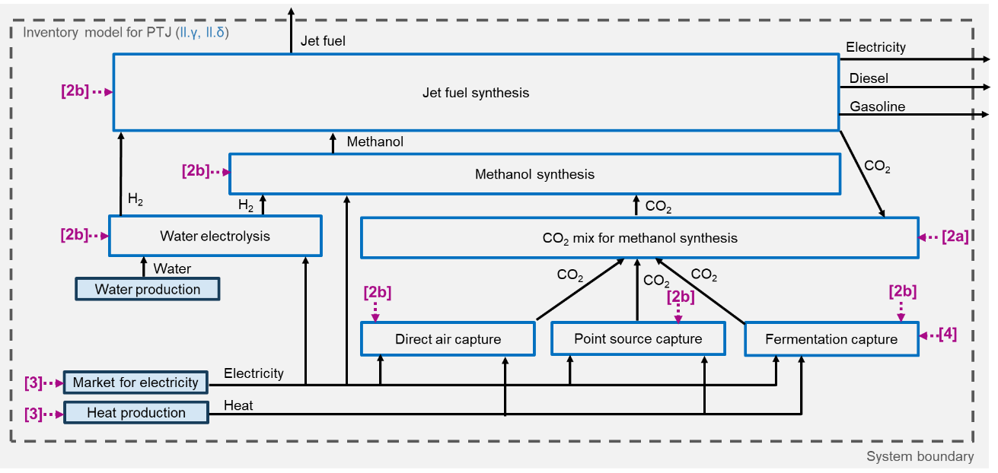
Figure A3: Inventory model for PTJ: Processes are displayed as boxes, flows as arrows. Numbers [2] to [4] mark the connections from the CLD (Figure 4a in the main manuscript).
Step A2: PESTEL
A PESTEL analysis for the research question 'Bio-based vs. electricity-based jet-fuel: Which one has the better environmental performance in 2050?' led to the following potential key factors:
- Political
  - Climate policy, R & D policy (--> e.g. funding of BTJ and PTJ technologies, incentives for companies to invest in BTJ and PTJ, share of renewable energies in the energy mix)
  - Agricultural policy (particularly as it affects straw availability for BTJ, as straw can be seen as a byproduct of cereal cultivation, but is also needed to sustain soil quality to a certain extent)
- Economic
  - Price development of alternative jet fuels and conventional jet fuels
  - Financial incentives (e.g. subsidies for alternative jet fuels, taxes for conventional jet fuels)
  - Competing applications of raw materials (electricity, straw)
- Social
  - Acceptance of new jet fuels
  - Acceptance of conventional jet fuels
  - Problem awareness of climate change
  - Willingness to abstain from jet transportation
  - Willingness to pay more for alternative jet fuels
- Technological
  - Progress of different technological options for alternative jet fuels
- Environmental
  - Climate change impact of conventional air traffic
  - Climate change impact of alternative jet fuels (or climate change mitigation potential of alternative jet fuels)
  - Land use change through alternative (and conventional) jet fuel (particularly, too high requirements on land use change can be a limitation of BTJ, though in the present case study, only the use of straw as a byproduct is considered, leading to no direct land use conflicts)
  - Other environmental impacts of conventional and alternative jet-fuels
- Legal
  - Legislation mitigating climate change
  - Agricultural legislation (e.g. regarding use of straw)
  - Potential mandatory carbon capture and storage
Step A3: CLD
Not all the factors that were identified within the PESTEL were included into the CLD (Figure 4a in the main document). Considerations on land use change or conflicts were neglected as it was assumed that straw as the biomass for BTJ is a mere byproduct. It does not seem realistic that cereal would be cultivated on additional land just to produce more straw. PTJ is not seen as connected to fundamental land use change. The discovered legal aspects could be seen as part of the political aspects. Consequently, they were left out to avoid redundancies. Some aspects were left out in Figure 4a for a better overview, as the main purpose was to explain the practical application of the tool. They are included in Figure A4.
The CLD needs to discover the interrelations between the key factors identified by the PESTEL approach (step A2) as well as their connections to inventory parameters, which were identified in step A1. In the following, we describe these interrelations.
Starting from the lower left corner, we see that the climate impact of conventional air traffic contributes to increased climate change awareness and increased climate change policy. In turn, both have the potential to reduce the climate change impact of conventional air traffic by different means. Among others, they can enhance the acceptance of BTJ and PTJ, which also makes the acceptance of BTJ and PTJ highly dependent on the climate change mitigation potential of BTJ and PTJ. Furthermore, decreasing prices for BTJ and PTJ will increase the acceptance of BTJ and PTJ. An enhanced acceptance of BTJ and PTJ can increase the technological progress of BTJ and PTJ production. This reinforcement takes place through an increment of demand for BTJ and PTJ supporting technological progress by learning effects. Additionally, a higher acceptance of BTJ and PTJ will lead to more investment into BTJ and PTJ, likewise supporting technological progress of BTJ and PTJ. Investment into BTJ and PTJ might further be supported by R & D policy and climate policy directly. Moreover, climate policy can reduce prices for BTJ and PTJ through subsidies. An enhanced technological progress of BTJ and PTJ will in turn increase demand for BTJ and PTJ and reduce prices for BTJ and PTJ, which again increases demand for BTJ and PTJ, thereby creating a reinforcing feedback-loop. Apart from that, a higher demand for BTJ and PTJ will reduce straw surplus, which is likewise limited by soil sustainment, depending on agricultural policy.
Next to the various connections between the (key) factors (green), the CLD also includes the connections to the inventory foreground parameters (light blue) and inventory background parameters (dark blue). Numbers [1] to [4] mark these connections in the CLD (Figure 4a) as well as the inventory models (Figure 4b, Figure A3). The technological progress of BTJ and PTJ determines the inventory foreground [1, 2]. It is implemented by the choice between an inventory model/production system of low or high technological progress [1a] and process efficiencies within the inventory models [1b, 2b]. Furthermore, climate policy reinforces the share of renewable technologies in the production of electricity [3]. At the same time, climate policy affects the foreground processes through its various connections to the technological progress of BTJ and PTJ explained above. Therefore, assumptions on foreground and background developments have to be consistent with each other. Ideally, these assumptions are made within harmonized scenarios during step B (Sub-scenario construction). Alternatively, they can be made within separate scenarios in step B, which then have to be checked for consistency within step C (Consistency check and combination). Moreover, climate policy can be identified as a key factor influencing several inventory parameters and requiring special attention.
Requirements on soil sustainment will influence the necessity of additional soil fertilization for straw production [4].

Step B: Find assumptions for each key factor and each relevant inventory parameter
Table A2: Derived assumptions (step B2) on technological progress of PTJ (main inventory parameter II and its subordinated inventory parameters). All values are given for production of 1 kg of jet fuel (functional unit). γ: low technological progress, δ: high technological progress. The quantitative future assumptions were derived based on literature research (Hank et al. 2020) and expert interviews.
Technological progress of PTJ (II) | Inventory model for low technological progress of PTJ (II.γ) | Inventory model for high technological progress of PTJ (II.δ) | Unit
Demand for:
Electricity | 239.67 | 212.35 | MJ
Heat | 167.06 | 40.09 | MJ
Water | 9.90 | 10.50 | kg
Byproducts:
Diesel | 0.83 | 0.83 | kg
Gasoline | 0.22 | 0.22 | kg
Electricity | 3.44 | 3.44 | MJ

Simplifications of the illustrative example
Simplifications regarding information collection
For this illustrative example, integration of experts and stakeholders into the scenario development process was rather superficial. In an actual case study, inclusion of more knowledge from experts and stakeholders would be desirable (cf. Table 1 in the main manuscript).
Simplifications regarding technological options
Many more technological options would have to be considered for a fair comparison of BTJ and PTJ, which is out of the scope of this work, where this comparison just served as an illustrative example.
Simplifications of the inventory models
Multifunctionality of the inventory models is not discussed in the main manuscript. It leads to epistemic uncertainties about methodological choices. How to combine the respective uncertainty analysis with the SIMPL approach is a subject of another study/article.
Simplifications of the CLD
Moreover, the CLD in Fig. 4a is only a simplification for explaining the principle. Figure A4 shows a more elaborate CLD. Particularly, only a limited amount of jet-fuel can be produced by BTJ due to limited straw supply. Likewise, there are limitations to PTJ production from renewable electricity in Germany. Thus, a combination of both technologies to replace as much conventional jet-fuel as possible might be the environmentally most favorable option (assuming that both are superior to conventional jet-fuel). The dependency of technological progress on availability of inputs is denoted as connections [5] and [6] in Figure A4. Availability of electricity depends on electricity production capacity and international electricity trade, which also has an impact on the electricity mix [7]. Furthermore, considering international input sources would be a necessary expansion. Incorporating other model types (e.g. material flow analysis) into the study would allow addressing these problems in more depth. It is also a shortcoming of the utilized background scenarios, especially for the green energy future, that restrictions to electricity supply are not taken into account.
Additionally, standards and regulations on technological components can influence the technological progress of BTJ and PTJ [8], [9].
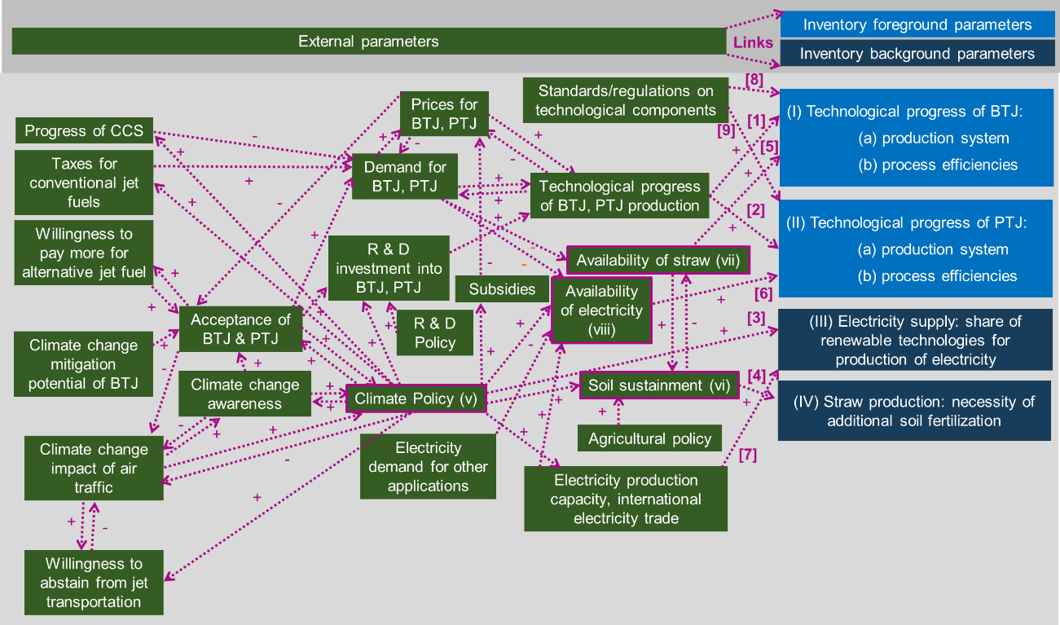
Figure A4: CLD of the illustrative example with less simplifications.

Publication bibliography
Balch, Mikayla L.; Chamberlain, Meghan B.; Worthen, Robert S.; Holwerda, Evert K.; Lynd, Lee R. (2020): Fermentation with continuous ball milling: Effectiveness at enhancing solubilization for several cellulosic feedstocks and comparative tolerance of several microorganisms. In Biomass and Bioenergy 134, Article 105468. Available online at https://doi.org/10.1016/j.biombioe.2020.105468.
Börjeson, Lena; Höjer, Mattias; Dreborg, Karl-Henrik; Ekvall, Tomas; Finnveden, Göran (2006): Scenario types and techniques: Towards a user's guide. In Futures 38 (7), pp. 723–739. DOI: 10.1016/j.futures.2005.12.002.
Hank, Christoph; Sternberg, André; Köppel, Nikolas; Holst, Marius; Smolinka, Tom; Schaadt, Achim et al. (2020): Energy efficiency and economic assessment of imported energy carriers based on renewable electricity. In Sustainable Energy Fuels 4 (5), pp. 2256–2273. DOI: 10.1039/D0SE00067A.
Humbird, D.; Davis, R.; Tao, L.; Tan, E. C. D.; Biddy, M. J.; Beckham, G. T. et al. (2011): Process Design and Economics for Biochemical Conversion of Lignocellulosic Biomass to Ethanol: Dilute-Acid Pretreatment and Enzymatic Hydrolysis of Corn Stover. Edited by NREL. National Renewable Energy Lab. Available online at https://doi.org/10.2172/1107470.
Ritchey, T. (2002): General Morphological Analysis - A general method for non-quantified modelling. In Swedish Morphological Society.
Vries, B.J.M. de (2012): Sustainability Science. Cambridge: Cambridge University Press.
Wittmann, C.; Liao, J. C. (Eds.) (2016): Advances in Consolidated Bioprocessing Using Clostridium thermocellum and Thermoanaerobacter saccharolyticum. With assistance of Lee R. Lynd, Adam M. Guss, Michael E. Himmel, Dhananjay Beri, Chris Herring, Evert K. Holwerda et al. (Industrial Biotechnology: Microorganisms, 1). Available online at https://doi.org/10.1002/9783527807796.ch10.

