The International Journal of Life Cycle Assessment
Ex-ante Life Cycle Assessment of FineFuture Flotation Technology: Case Study of Grecian Magnesite
Hazem Eltohamy¹, Giuseppe Cecere¹, Lucia Rigamonti^{1*}
¹ Department of Civil and Environmental Engineering, Politecnico di Milano,
Piazza Leonardo da Vinci 32, 20133 Milano, Italy
* Corresponding author. E-mail address: lucia.rigamonti@polimi.it
Supplementary Materials

1. Allocation Principle
The idea was assigning physical allocation factors to unit processes based on their role in fulfilling each function based on some assumptions. It was assumed that the function of waste treatment ends when the material reaches the End of Waste (EoW) state which happens after drying. Practically, after drying, the concentrate coming from FineFuture (FF) flotation is already a high-quality magnesite concentrate that cannot be labelled as waste anymore. On the other hand, the two following phases of briquetting and calcination are only needed to produce magnesia. Therefore, all the inventory of briquetting and calcination were allocated to the secondary function (i.e. production of magnesia). To allocate the inventory of previous units to briquetting, pure magnesite content mass was utilized to calculate the allocation factors instead of using the total mass of material (Figure 1). This way, the allocation factors take into account the benefits of FF flotation unit upgrade.
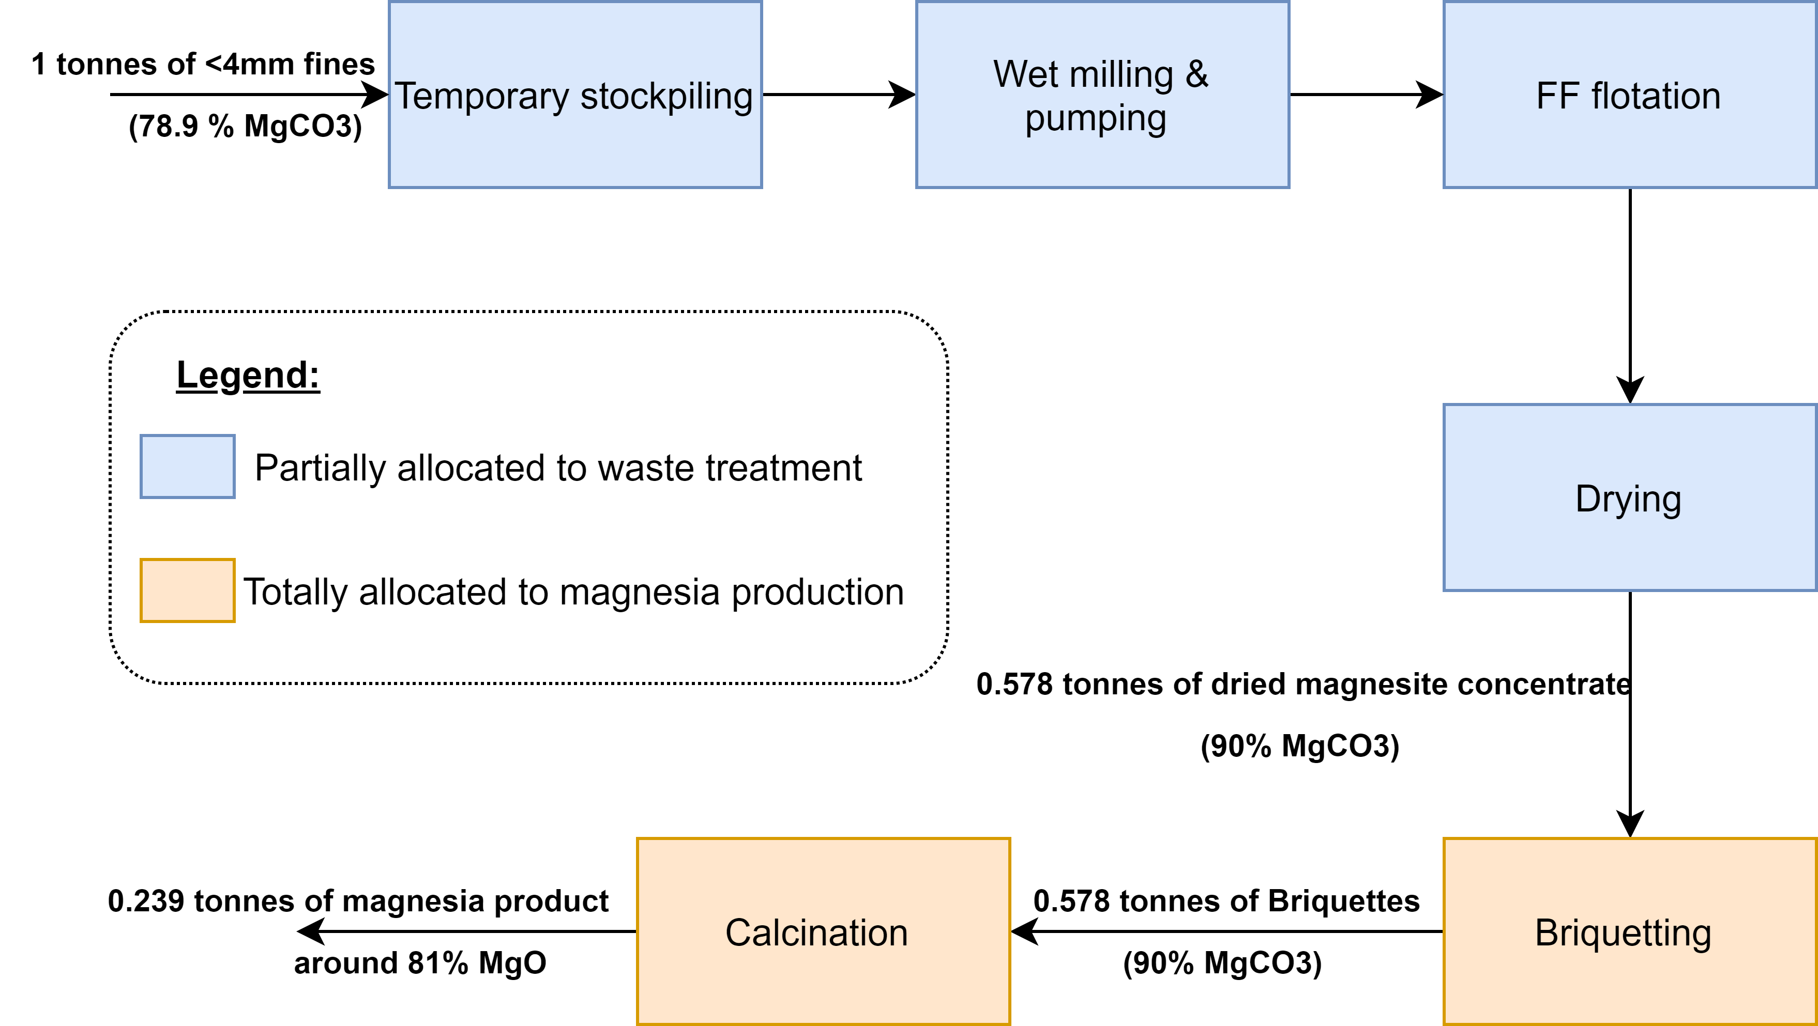
Fig 1 Assigning allocation factors

The mass of concentrate after drying is around 0.58 tonnes / tonne of input <4mm fines to the system. The MgCO₃ concentration in dried concentrate is 90% so the mass of pure magnesite is 0.522 tonnes. When the same calculation is applied to the 1 tonne input of fines before wet milling (MgCO₃ = 78.9%), 0.79 tonne of pure magnesite is obtained. The allocation factor for the treatment function was calculated mathematically by dividing 0.79/(0.79+0.522). Based on that, the final allocation factors are shown in Table 1 assuming that the <4mm fines flow represents the functional unit hence the first function of the system while the rest is allocated to the secondary function (i.e. production of magnesia).
Table 1 Allocation factors
Unit process | Function 1 (Waste treatment) | Function 2 (Magnesia production)
Transportation from Beneficiation to Temporary Stockpile | 60% | 40%
Wet milling | 60% | 40%
FF flotation | 60% | 40%
Dewatering | 60% | 40%
Drying | 60% | 40%
Briquetting | 0% | 100%
Calcination | 0% | 100%

2. Collector and Depressant
RESANOL A100 as a compound is not a single-chemical substance like the depressant (i.e. sodium hexametaphosphate), it is basically a mixture of various organic and inorganic chemicals. According to safety sheet of the product (Ekof mining and water solutions, 2021), it is composed of:
-Tall oil >50%wt
-1-Hexanol, 2-ethyl (distillation residues) <25%
-Sulfonic acids, petroleum, sodium salts <15%
-Castor oil <5.0%
With this information, a unit process was created representing the production of RESANOL A100 from its initial components (Table 2). Unfortunately, no information was available regarding direct energy consumption during manufacturing, so no energy input was considered.
The sodium hexametaphosphate which was used as depressant was also absent in ecoinvent database. Furthermore, no data was available regarding the exact energy and materials demands to produce it on industrial scale. Although qualitative description of the production process could be found, no relevant quantified data was available to enable modelling it. Therefore, sodium tripolyphosphate was used as an alternative as it was concluded from literature and ecoinvent information on sodium tripolyphosphate that the two chemicals are prepared in a similar manner (Andersen, 2001; U.S. International Trade Commission, 2018).

Table 2 Materials used to model 1 tonne of RESANOL A100 production
Input |  |  | Ecoinvent dataset
Flow | Amount | Unit | Ecoinvent dataset
Castor Oil | 0.05 | t | Soybean oil, refined {RoW}| soybean oil refinery operation | Cut-off, U  Adjusted for Castor oil¹
Tall oil | 0.55 | t | Fatty acid {GLO}| tall oil refinery operation | Cut-off, U
Sodium cumenesulphonate | 0.15 | t | Sodium cumenesulphonate {RoW}| sodium cumenesulphonate production | Cut-off, U
Ethanol | 0.25 | t | Ethanol, without water, in 99.7% solution state, from ethylene {RER}| ethylene hydration | Cut-off, U
Output |  |  | Ecoinvent dataset
Flow | Amount | Unit | Ecoinvent dataset
Resanol A100 | 1 | t | Inert waste, for final disposal {CH}| treatment of inert waste, inert material landfill | Cut-off, U
¹ Castor oil production and refining was not found in ecoinvent database, however by comparing the production explained in (Patel et al., 2016) with ecoinvent dataset on soybean oil for example, it is noticed that the production process is very similar. Thus, the ecoinvent dataset was adjusted accordingly to fit the castor oil by substituting the raw material (soybean) with (castor bean).

3. Inventory of tailing management facility
Table 3. Tailing dewatering inventory referred to 1.41 tonne of tailing input (the amount generated per F.U.)
Unit Process | Input |  |  | Ecoinvent dataset/Note | Output |  |  | Ecoinvent dataset/Note
Unit Process | Flow | Amount | Unit | Ecoinvent dataset/Note | Flow | Amount | Unit | Ecoinvent dataset/Note
Dewatering of tailing | Electric energy | 0.812 | MJ | Electricity, low voltage {GR}| market for | Cut-off, U | Water | 0.823 | m³ | Output to Nature (Water, unspecified natural origin, GR)
 |  |  |  |  | Dewatered tailing | 0.296 | m³ | Going to tailing pond
Tailing pond | Land Use | 213 | cm² | Input from Nature (Occupation, Urban, GR) | - | - | - | -

Table 4 Tailing dewatering inventory referred to 0.291 tonne of tailing input (the amount generated per F.U.)
Unit process | Input |  |  | Ecoinvent dataset/Note | Output |  |  | Ecoinvent dataset/Note
Unit process | Flow | Amount | Unit | Ecoinvent dataset/Note | Flow | Amount | Unit | Ecoinvent dataset/Note
Dewatering of tailing | Electric Energy | 0.167 | MJ | Electricity, low voltage {GR}| market for | Cut-off, U | Water | 0.17 | m³ | Output to Nature (Water, unspecified natural origin, GR)
 |  |  |  |  | Dewatered tailing | 0.061 | m³ | Going to tailing pond
Tailing pond | Land Use | 43.2 | cm² | Input from Nature (Occupation, Urban, GR) | - | - | - | -

4. Inventory of improved calcination used in S1.2 and S2.2
Table 5 Inventory of calcination department with the new fuel mix (referred to 1 tonne of magnesia product)
Unit Process | Input |  |  | Ecoinvent dataset/Note | Output |  |  | Ecoinvent dataset/Note
Unit Process | Flow | Amount | Unit | Ecoinvent dataset/Note | Flow | Amount | Unit | Ecoinvent dataset/Note
Calcination department | Loader | 0.121 | tkm | Transport, tractor and trailer, agricultural {RoW}| processing | Cut-off, U | Magnesia | 1 | t | Final Product
Calcination department | Petcoke | 113 | kg | Petroleum coke {GLO}| market for | Cut-off, U | unrecycled dust to landfilling | 112 | kg | Inert waste, for final disposal {CH}| treatment of inert waste, inert material landfill | Cut-off, U
Calcination department | HFO | 29.4 | kg | Heavy fuel oil {Europe without Switzerland}| market for | Cut-off, U | Direct emissions to air
 |  |  |  |  | CO₂, fossil | 1,27 | t | Emissions to air, low pop
Calcination department | Woodchips | 6.37 | kg | Wood chips, wet, measured as dry mass {Europe without Switzerland}| market for | Cut-off, U | CO₂, biogenic | 424 | kg | Emissions to air, low pop
Calcination department | Sawdust | 6.37 | kg | Sawdust, wet, measured as dry mass {Europe without Switzerland}| market for sawdust, wet, measured as dry mass | Cut-off, U | CO, fossil | 4.33 | kg | Emissions to air, low pop
Calcination department | New Biomass (Olive kernels + sunflower seed husk) | 229 | kg | Burden-free input* | SO₂ | 6.29 | kg | Emissions to air, low pop
Calcination department | Hydrated lime | 28 | kg | Lime, hydrated, packed {RER}| market for lime, hydrated, packed | Cut-off, U | NO₂ | 3.52 | kg | Emissions to air, low pop
Calcination department | Electric Energy | 249 | MJ | Electricity, low voltage {GR}| market for | Cut-off, U | Particulates, > 2.5 um, and < 10um | 0.129 | kg | Emissions to air, low pop
Calcination department | Transportation | 11.5 | tkm | Biomass to GM (assumed distance 50km) / Transport, freight, lorry 16-32 metric ton, EURO3 {RER}| transport, freight, lorry 16-32 metric ton, EURO3 | Cut-off, U | Antimony | 0.000123 | kg | Emissions to air, low pop
Calcination department | - | - | - | - | Arsenic | 0.000123 | kg | Emissions to air, low pop
Calcination department | - | - | - | - | Lead | 0.000123 | kg | Emissions to air, low pop
Calcination department | - | - | - | - | Chromium | 0.000123 | kg | Emissions to air, low pop
Calcination department | - | - | - | - | Cobalt | 0.000123 | kg | Emissions to air, low pop
Calcination department | - | - | - | - | Copper | 0.000123 | kg | Emissions to air, low pop
Calcination department | - | - | - | - | Manganese | 0.000123 | kg | Emissions to air, low pop
Calcination department | - | - | - | - | Nickel | 0.000123 | kg | Emissions to air, low pop
Calcination department | - | - | - | - | Vanadium | 0.000123 | kg | Emissions to air, low pop
*Sunflower seed hulls and olive kernels supply was assumed to be entering the system as burden-free flows because these products are basically waste flows of other food production systems. According to Agri-footprint 5 database (economic allocation), sunflower seed hulls are by-products of sunflower seed oil industry with no economic value (0% allocation factor). This same concept was also applied by Nikkhah et al. (2021) in their paper on LCA of olive oil recovery from olive kernels in which they took olive kernels as burden-free input.

5. Electricity sensitivity analysis results (Case 2)
Table 6 Sensitivity analysis of electric energy consumption in different scenarios: results given in single point (mPt) per functional unit
Scenario | Baseline | plus 25% | plus 50%
S2.1 | -13.2 | -13.1 | -13
S2.3 | -20.1 | -19.9 | -19.8

References
Andersen, F. A. (2001). Final report on the safety assessment of Sodium Metaphosphate, Sodium Trimetaphosphate, and Sodium Hexametaphosphate. International Journal of Toxicology, 20(SUPPL. 3), 75–89. https://doi.org/10.1080/10915810152630756
Ekof mining and water solutions. (2021). Safety data sheet of RESANOL (r) A100 (Vol. 49, Issue 1907).
Nikkhah, A., Firouzi, S., Dadaei, K., & Van Haute, S. (2021). Measuring circularity in food supply chain using life cycle assessment; refining oil from Olive Kernel. Foods, 10(3). https://doi.org/10.3390/foods10030590
Patel, V. R., Dumancas, G. G., Viswanath, L. C. K., Maples, R., & Subong, B. J. J. (2016). Castor oil: Properties, uses, and optimization of processing parameters in commercial production. Lipid Insights, 9(1), 1–12. https://doi.org/10.4137/LPI.S40233
U.S. International Trade Commission. (2018). Sodium Hexametphosphate from China.

