Supplementary Information
Environmental impact of biodegradable and fossil agricultural mulch film - a case study for Nordic conditions
Irmeline de Sadeleer*, Anna Woodhouse
¹NORSUS-Norwegian Institute for Sustainability research, Stadion 4, Fredrikstad, Norway
*Corresponding author. Tel.: +47 92137508
E-mail address: ids@norsus.no

Amount of mulch film needed for growing lettuce on 1 ha
Figure 1 illustrates a general lettuce production system with 60 000 plants/ha situated in beds with two rows in each bed with a row width of 60 cm. Because primary data was not available, literature data was used to assume the density and thickness of the films. Biodegradable mulch film was assumed to have a density of 1250 kg/m³ (Tosin et al., 2020) and non-biodegradable 925 kg/m³ (De Wilde and Deconinck, 2017). Non-biodegradable mulch film needs to be thicker than biodegradable as it needs to be collected after use without breaking. We assumed biodegradable film to have a thickness of 0.015 m and non-biodegradable 0.20 m (OWS, 2017; Hann et al., 2021). Total area of mulch film is 4980 m², see Figure 1, resulting in 93.4 and 92.1 kg of biodegradable and non-biodegradable film being used for 1 ha of land for lettuce production.
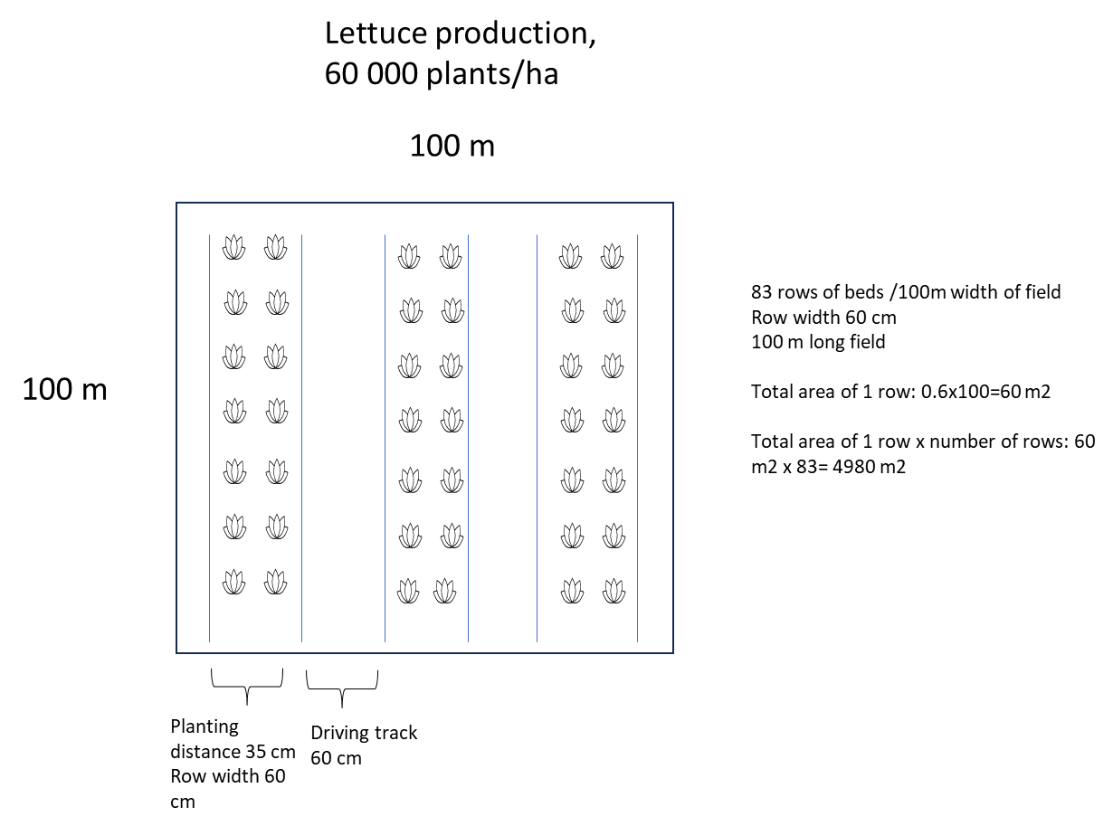

Figure 1: Figure explaining how the mulched area for 1 ha was calculated.

Detailed LCI
Table 1: Detailed LCI
 | Life cycle stage | LCI process | Input data | Unit | Reference
Production of material | LDPE | Polyethylene, low density, granulate {GLO}| market for | Cut-off, U | 1 | kg | Ecoinvent 3
Production of material | PBAT granulate | Adipic acid {RER}| adipic acid production | Cut-off, U  Purified terephthalic acid {GLO}| market for | Cut-off, U  Butane-1,4-diol {GLO}| market for | Cut-off, U  Electricity, medium voltage {RER}| market group for | Cut-off, U | 0.33  0.37  0.41  7.6 | kg  kg  kg  MJ | Brookes 2007
Production of material | PBAT/starch 70/30 | Maize starch {GLO}| market for maize starch | Cut-off, U  PBAT plastic granulate, at plant (from litterature)  Electricity, medium voltage {RER}| market group for | Cut-off, U  Heat, district or industrial, natural gas {RER}| market group for | Cut-off, U  Steam, in chemical industry {RER}| market for steam, in chemical industry | Cut-off, U | 0.3  0.7  1.45  1.85  0.94 | kg  kg  MJ  MJ  MJ | modelled and Ecoinvent 3
Production of material | PBAT/starch 30/70 | Maize starch {GLO}| market for maize starch | Cut-off, U  PBAT plastic granulate, at plant (from litterature)  Electricity, medium voltage {RER}| market group for | Cut-off, U  Heat, district or industrial, natural gas {RER}| market group for | Cut-off, U  Steam, in chemical industry {RER}| market for steam, in chemical industry | Cut-off, U  Extrusion, plastic film {RER}| extrusion, plastic film | Cut-off, U | 0.7  0.3  1.45  1.85  0.94 | kg  kg  MJ  MJ  MJ | modelled and Ecoinvent 3
Extrusion | LDPE | Extrusion, plastic film {RER}| extrusion, plastic film | Cut-off, U | 0.976 | kg | Ecoinvent 3
Extrusion | PBAT/starch 70/30 and  PBAT/starch 30/70 | Extrusion, plastic film {RER}| extrusion, plastic film | Cut-off, U | 0.976 | kg | modelled and Ecoinvent 3
Transport | LDPE film | Transport, freight, lorry 16-32 metric ton, euro6 {RER}| market for transport, freight, lorry 16-32 metric ton, EURO6 | Cut-off, U | 1600 | kgkm | Ecoinvent 3
Transport | PBAT/starch 70/30 and  PBAT/starch 30/70 film | Transport, freight, lorry >32 metric ton, EURO5 {RER}| market for transport, freight, lorry >32 metric ton, EURO5 | Cut-off, U  Transport, freight, sea, container ship {GLO}| market for transport, freight, sea, container ship | Cut-off, U | 3200  400 | kgkm | Ecoinvent 3
Field operations at farm | LDPE | Harrowing, with small tractor (orchard)/FR | 4 | h | Ecoinvent 3
Field operations at farm | PBAT/starch 70/30  PBAT/starch 30/70 | Harrowing, with small tractor (orchard)/FR  Mineralization of biodegradable plastics | 4  1.37 | h  kg CO2 eq./kg film | Ecoinvent 3  modelled
Transport to waste processing | LDPE to recycling center til Europe and Norway | Transport, freight, lorry 3.5-7.5 metric ton, EURO6 {RER}| market for transport, freight, lorry 3.5-7.5 metric ton, EURO6 | Cut-off, U | 760 | kgkm | Ecoinvent 3
Transport to waste processing | LDPE to incineration plant | Transport, freight, lorry 3.5-7.5 metric ton, EURO6 {RER}| market for transport, freight, lorry 3.5-7.5 metric ton, EURO6 | Cut-off, U | 100 | kgkm | Ecoinvent 3
Waste processing | Recycling of LDPE | Polyethylene, high density, granulate, recycled {Europe without Switzerland}| market for polyethylene, high density, granulate, recycled | Cut-off, U | 0,771 | % of LDPE film | Ecoinvent 3
Waste processing | Incineration of LDPE | Waste polyethylene {CH}| treatment of waste polyethylene, municipal incineration with fly ash extraction | Cut-off, U | 0,229 | % of LDPE film | Ecoinvent 3
Benefits beyond system boundaries | Replacement of virgin LDPE | Polyethylene, high density, granulate {GLO}| market for polyethylene, high density, granulate | Cut-off, U | 0.578 | kg/kg LDPE | Ecoinvent 3
Benefits beyond system boundaries | Replacement of heat from incineration | Replacement of heat from incineration | 7.57 | MJ/kg LDPE | Modelled

Relative LCA results

Table 2: LCA results with system expansion, relative to non-degradable film
Impact category | Non-degradable film (LDPE) | Biodegradable film (PBAT-Starch, 70/30) | Biodegradable film (PBAT-Starch,30/70)
Climate change | 100 % | 116 % | 167 %
Acidification | 100 % | 132 % | 151 %
Particulate matter | 100 % | 137 % | 168 %
Eutrophication, marine | 100 % | 138 % | 132 %
Eutrophication, freshwater | 100 % | 149 % | 207 %
Eutrophication, terrestrial | 100 % | 131 % | 132 %
Human toxicity, cancer | 100 % | 160 % | 235 %
Human toxicity, non-cancer | 100 % | 126 % | 152 %
Photochemical ozone formation | 100 % | 101 % | 117 %
Ionising radiation | 100 % | 142 % | 202 %
Land use | 100 % | 208 % | 178 %
Ozone depletion | 100 % | 593 % | 1243 %
Resource use, fossils | 100 % | 88 % | 127 %
Resource use, minerals and metals | 100 % | 144 % | 168 %
Water use | 100 % | 429 % | 478 %
Ecotoxicity, freshwater | 100 % | 235 % | 161 %

Table 3: LCA results without system expansion, relative to non-degradable film
Impact category | Non-degradable film (LDPE) | Biodegradable film (PBAT-Starch, 70/30) | Biodegradable film (PBAT-Starch,30/70)
Climate change | 100 % | 106 % | 154 %
Acidification | 100 % | 122 % | 139 %
Particulate matter | 100 % | 118 % | 145 %
Eutrophication, marine | 100 % | 134 % | 129 %
Eutrophication, freshwater | 100 % | 149 % | 206 %
Eutrophication, terrestrial | 100 % | 126 % | 127 %
Human toxicity, cancer | 100 % | 172 % | 253 %
Human toxicity, non-cancer | 100 % | 123 % | 148 %
Photochemical ozone formation | 100 % | 95 % | 110 %
Ionising radiation | 100 % | 157 % | 223 %
Land use | 100 % | 217 % | 186 %
Ozone depletion | 100 % | 594 % | 1246 %
Resource use, fossils | 100 % | 70 % | 101 %
Resource use, minerals and metals | 100 % | 129 % | 150 %
Water use | 100 % | 399 % | 444 %
Ecotoxicity, freshwater | 100 % | 230 % | 158 %

LCA results for all impact categories of EF 3.1, with system expansion. The red dot represents the net total results.

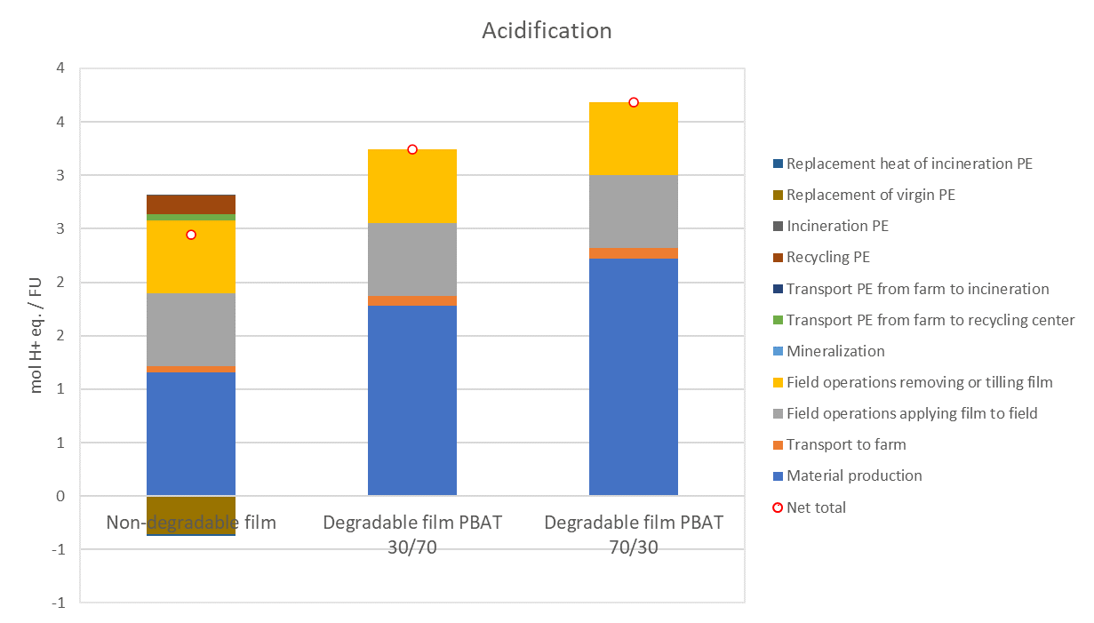
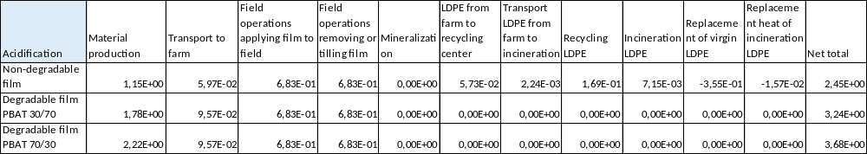
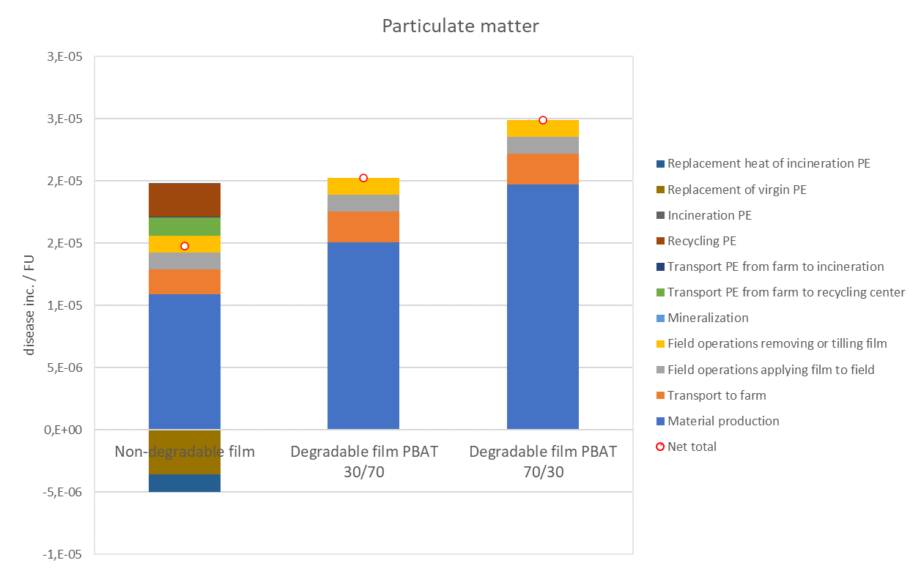
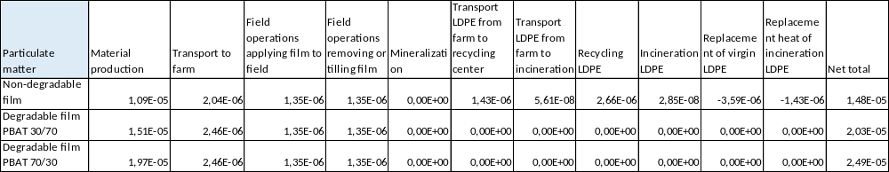
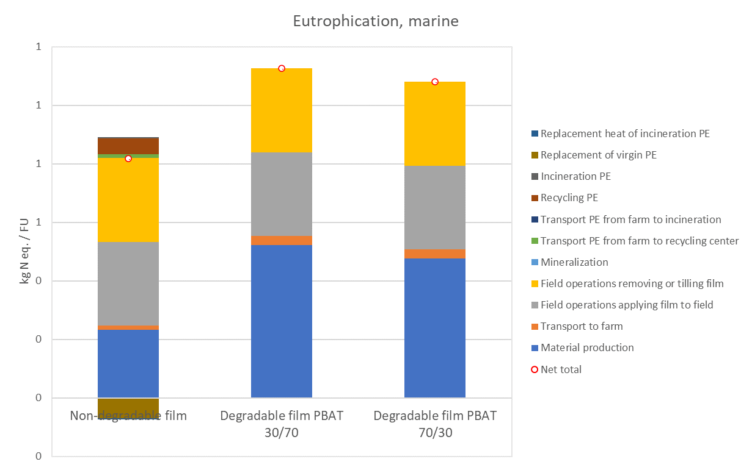
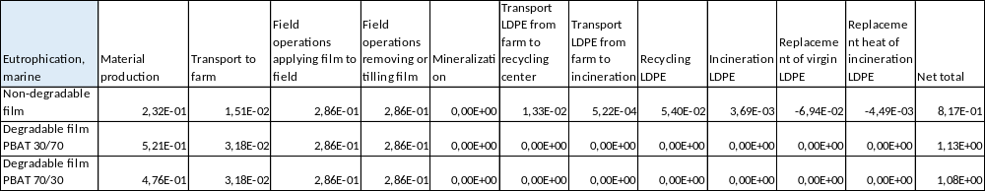
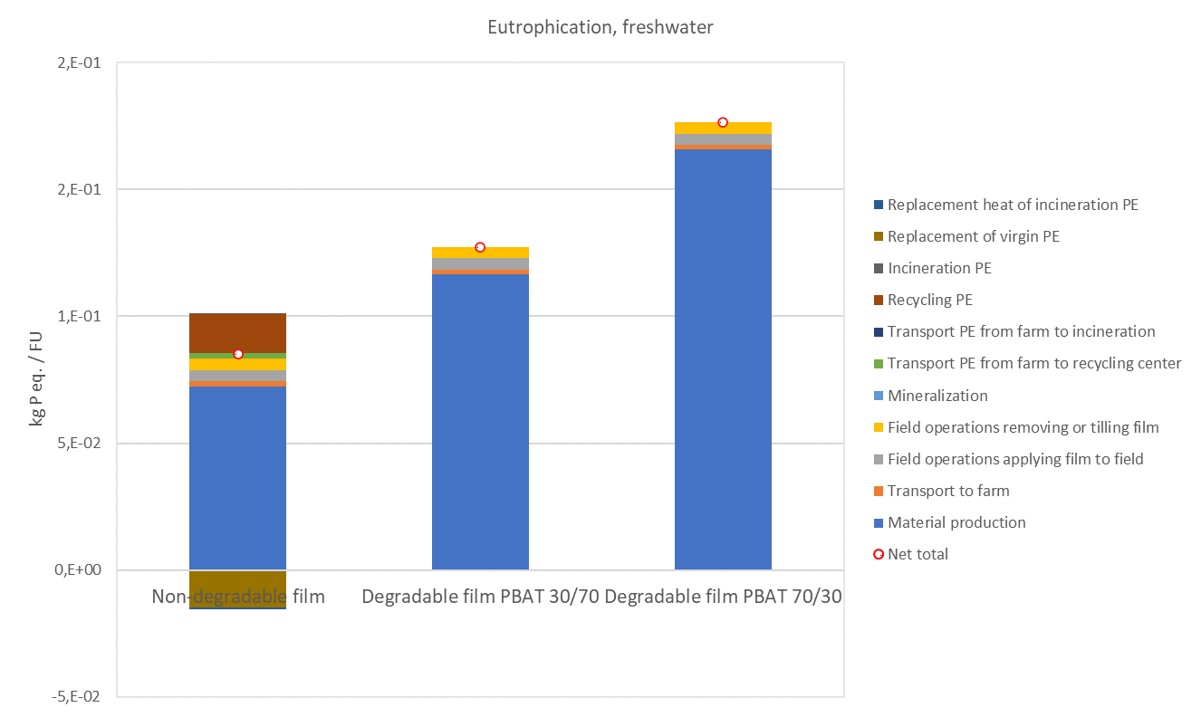
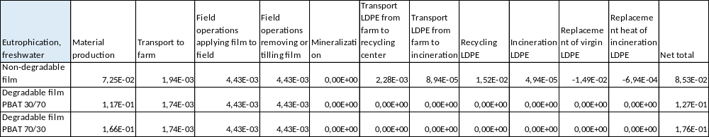
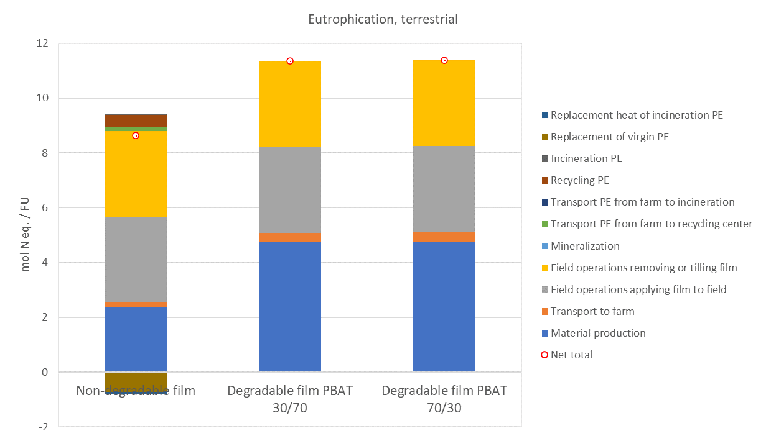
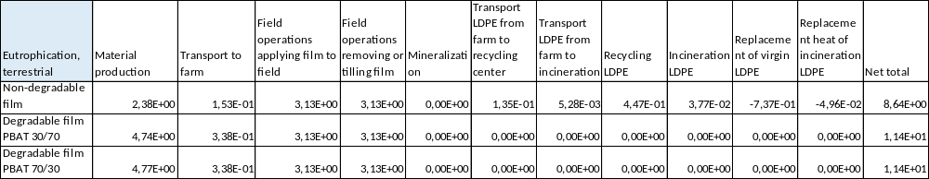
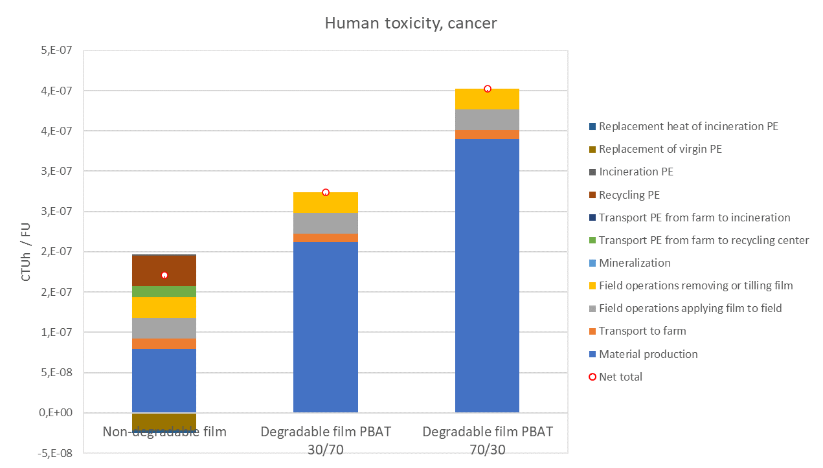
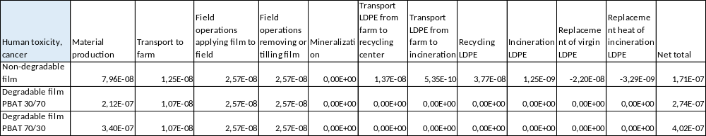
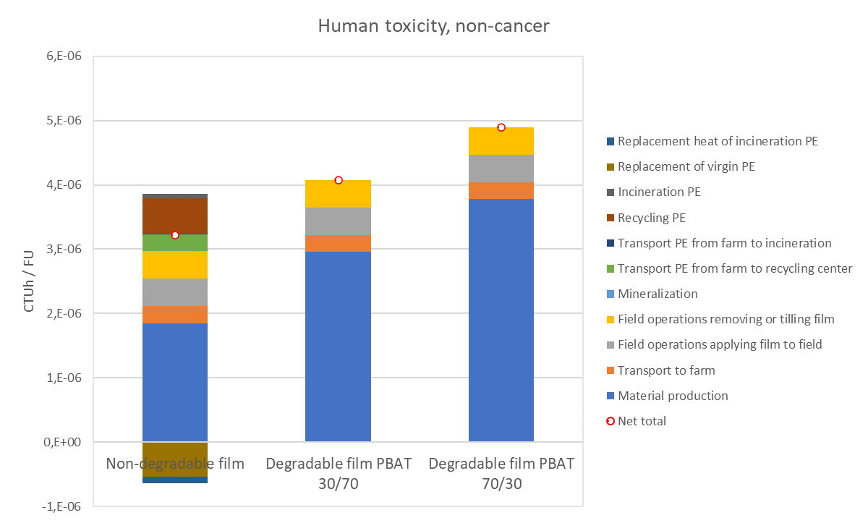
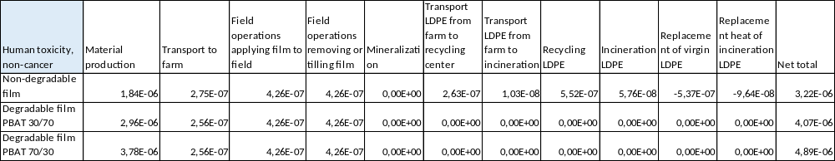
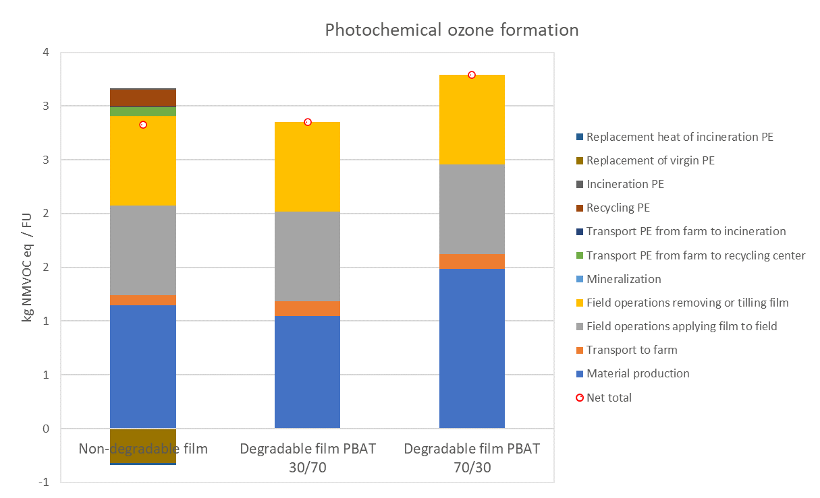
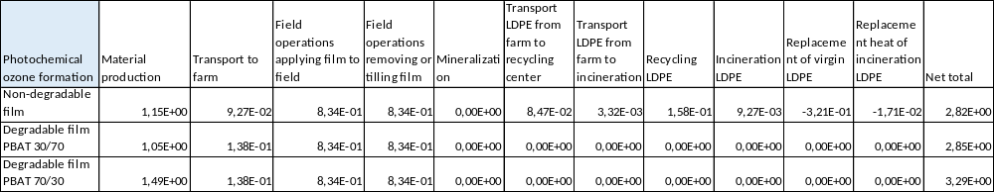
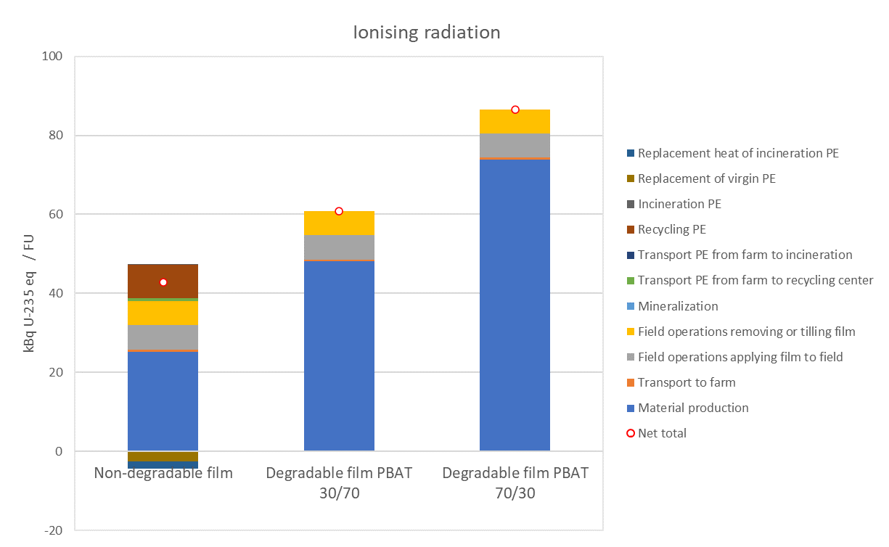
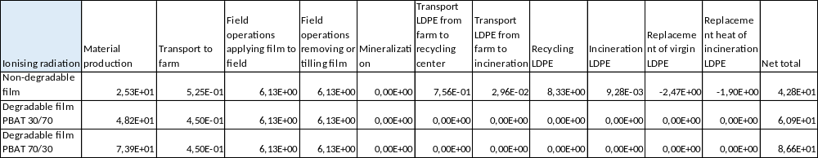
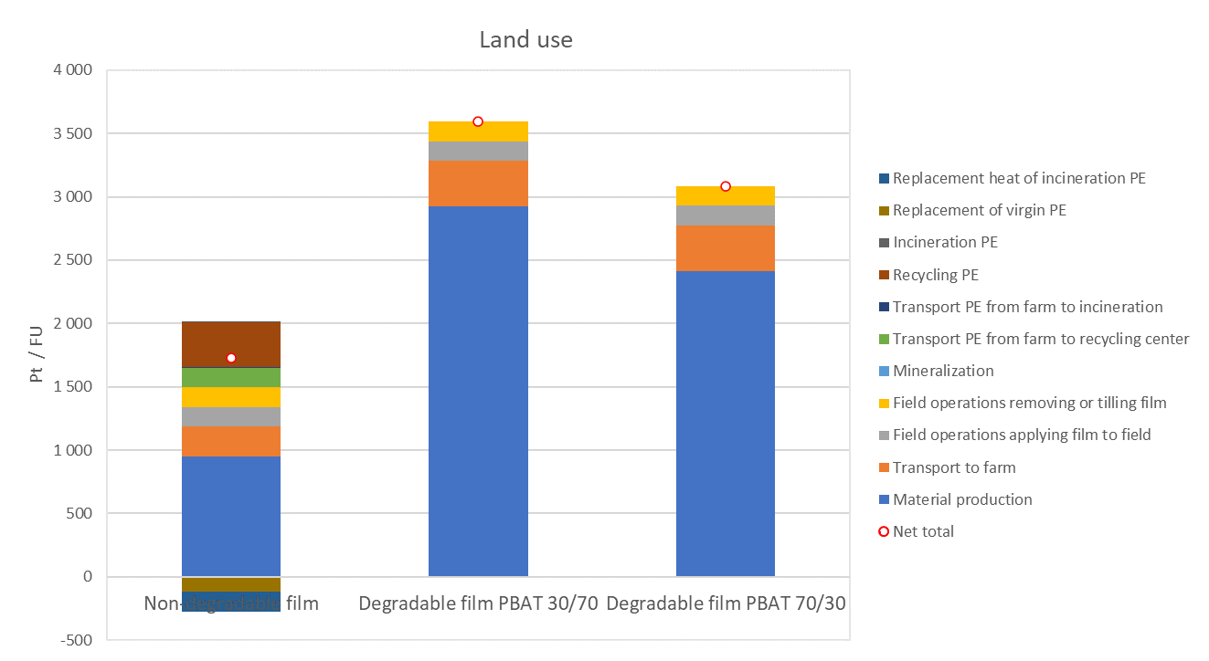
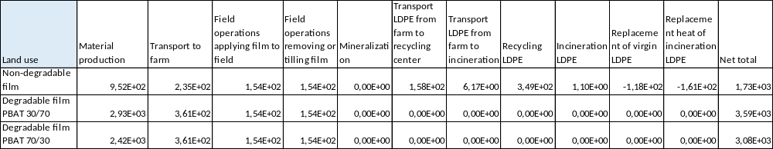
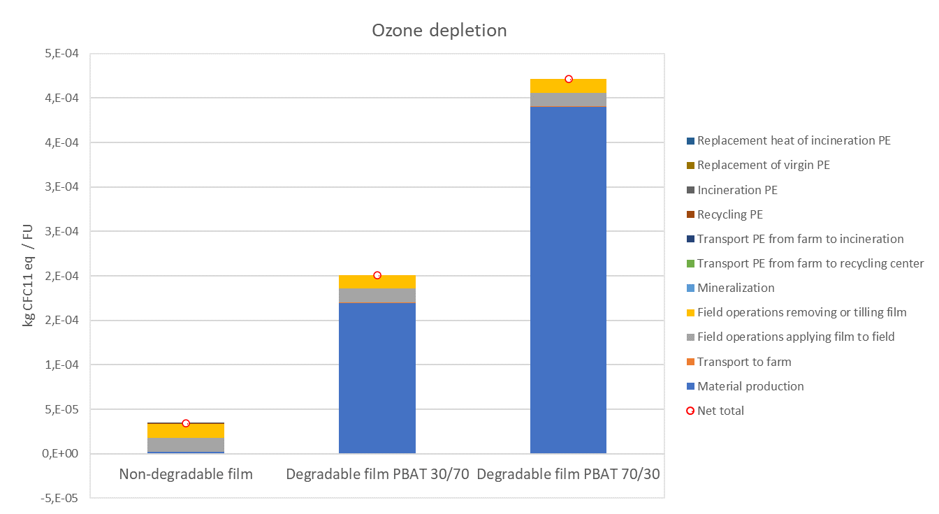
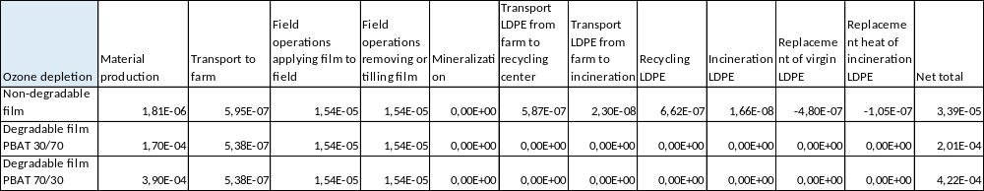
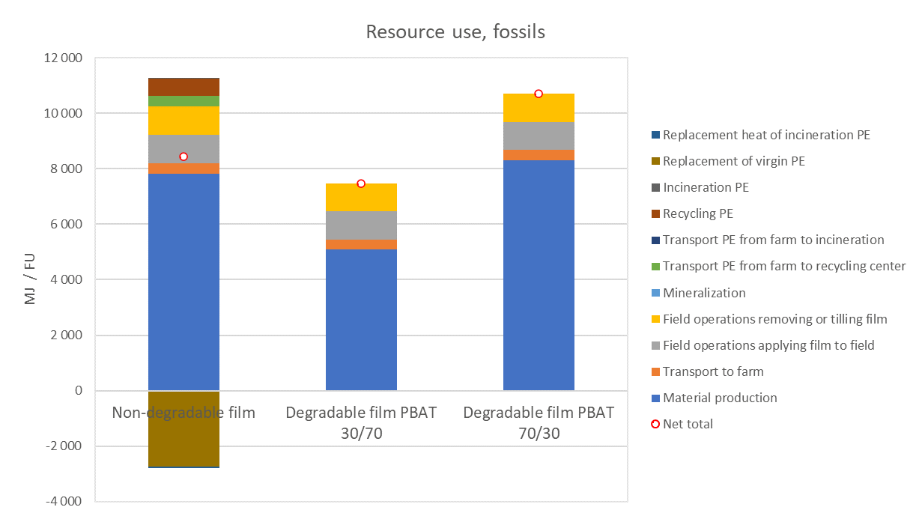
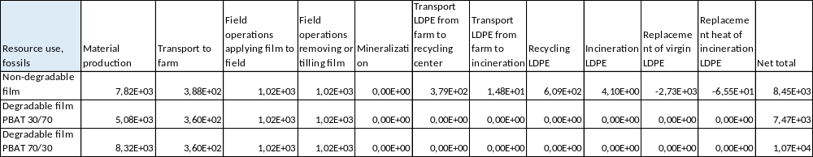
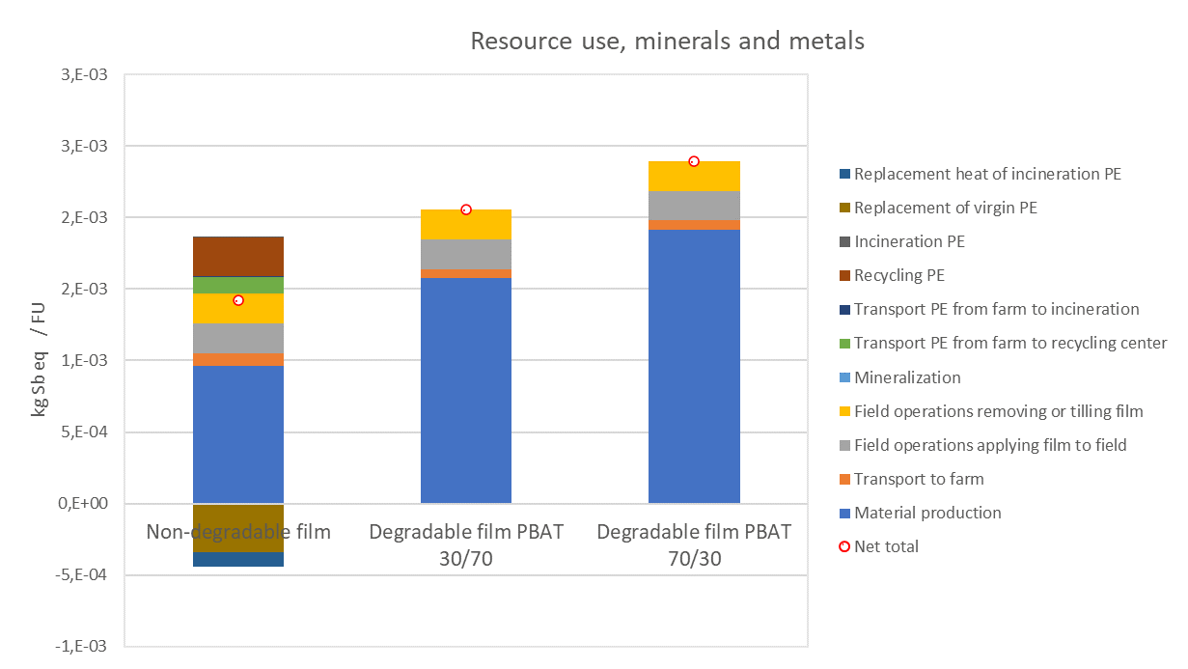
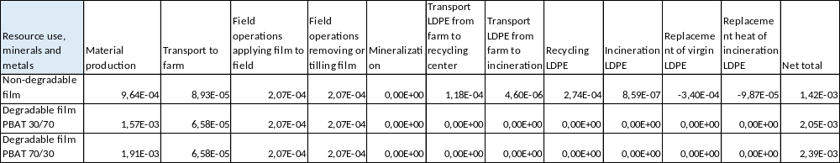
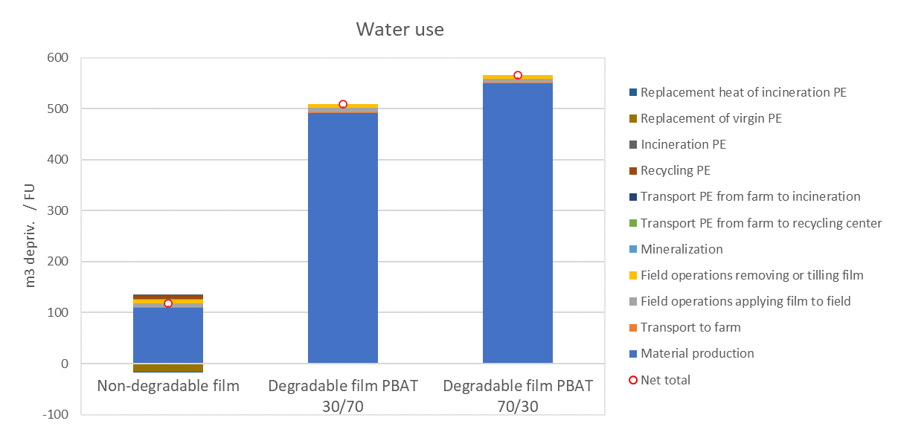
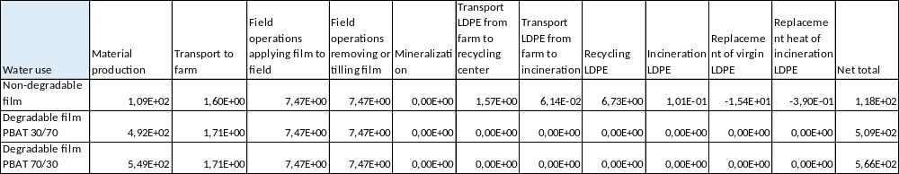
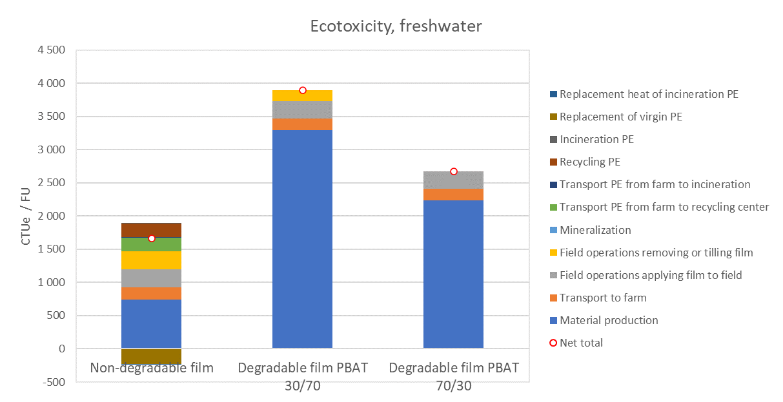
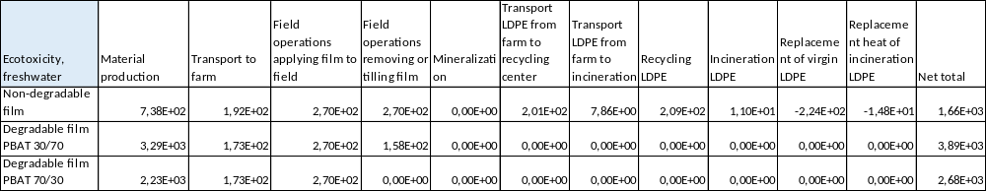

References

DE WILDE., B., % DECKONINK, S., 2017.Expert Statement, (Bio)degradable Mulching Films. OWS, https://docs.european-bioplastics.org/publications/OWS_Expert_statement_mulching_films.pdf

HANN, S., FLETCHER, E., MOLTENO, S., SHERRINGTON, C., ELLIOTT, L., KONG, M.-A., SASTRE, S. & MARTINEZ, V. 2021. Relevance of Conventional and Biodegradable Plastics in Agriculture. For the European Commission DG Environment. Project conducted under Framework Contract No ENV.B1/FRA/2018/0002 Lot 1.

OWS 2017. Expert statement on biodegradable mulch films. https://docs.europeanbioplastics.org/publications/OWS_Expert_statement_mulching_films.pdf.

TOSIN, M., BARBALE, M., CHINAGLIA, S. & DEGLI-INNOCENTI, F., 2020. Disintegration and mineralization of mulch films and leaf litter in soil. Polym. Degrad. Stab, 179, 109309.

