Supplementary Information

Environmental sustainability of Finnish pork production: Life cycle assessment of climate change and water scarcity impacts
Sanna Hietala^{a*}, Kirsi Usva, Marja-Liisa Vieraankivi, Virpi Vorne, Jouni Nousiainen, and Ilkka Leinonen

*Corresponding author: sanna.hietala@luke.fi
ªNatural Resources Institute Finland (Luke), Sustainability science and indicators, Oulu, Finland

Table 1. Heating systems on surveyed Finnish pig farms. The total number of respondents was 193, and a combination of several types was allowed.
Heating system | n, farms | %
Woodchips | 125 | 49.0%
Fuel oil | 42 | 16.5%
Pellets (peat, wood, oat hull) | 24 | 9.4%
Peat | 14 | 5.5%
Geothermal heat | 12 | 4.7%
Electric heating | 11 | 4.3%
Combustible (wood) waste | 8 | 3.1%
Wood heating | 8 | 3.1%
Manure heat recovery | 4 | 1.6%
Air-source heat pump | 5 | 2.0%
District heating | 1 | 0.4%
No heating | 1 | 0.4%
TOT | 255 | 100%

Table 2. Characteristics of fattening pig farms categorised according to their main protein source in diets (n = 20). LW = live weight, CW = carcass weight, DM = dry matter, BPF = barley protein feed.
 | Main protein source
 | BPF ª | Legumes ^{b} | Compound feed
Fattening pig, kg LW | 119.7 | 120.4 | 120.1
Fattening pig, kg CW | 89.2 | 89.7 | 89.5
Slaughter quantity, average n/year/farm | 4,461 | 1,542 | 1,874
Feed consumption, average kg DM per kg CW | 3.0 | 3.0 | 2.7
Compound feeds and meals, per kg CW | 36% | 38% | 56%
Farm grown grain and legumes, per kg CW | 25% | 21% | 40%
Purchased grain and pulses, per kg CW | 4% | 30% | 4%
Barley protein feed | 25% | 7% | -
Other sidestreams (whey, mash) | 10% | 3% | -
Diet dry matter content, average | 65% | 84% | 85%
^{a Barley protein feed}
^{b Faba bean, pea, soybean}

Table 3. Feed use of sows and weaned piglets on farms based on survey data.
 | Sows | Weaned piglets
Barley and barley-based fractions | 55.2% | 42.9%
Wheat and wheat-based fractions | 9.8% | 20.4%
Dairy production sidestreams | 5.6% | 1.1%
Premixes, minerals, and amino acids | 2.9% | 10.1%
Faba bean | 0.2% | 0.9%
Soybean meal and protein | 4.5% | 15.8%
Oat and oat-based fractions | 13.0% | 5.2%
Turnip rape/rapeseed, meal and pressed | 1.6% | 0.5%
Turnip rape oil/palm oil | 0.9% | 1.9%
Sunflower seed meal | 1.1% | –
Molasses | 4.2% | 1.2%
Potato | 0.4% | –
Maize grain | 0.5% | 0.02%
Fish meal | – | 0.04%

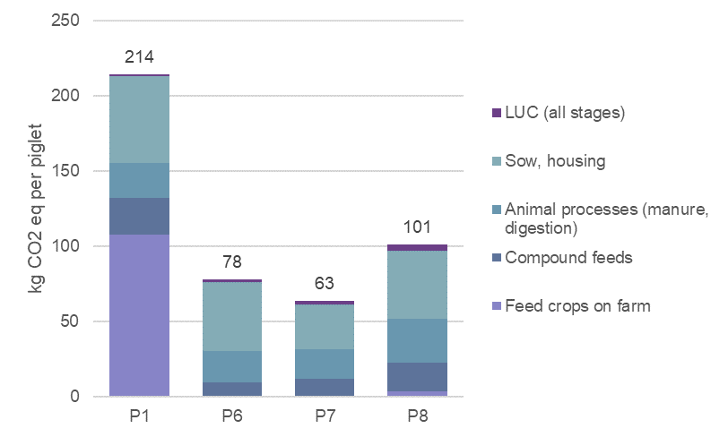
Fig. 1. Global warming potential of piglet production on specialised farms.

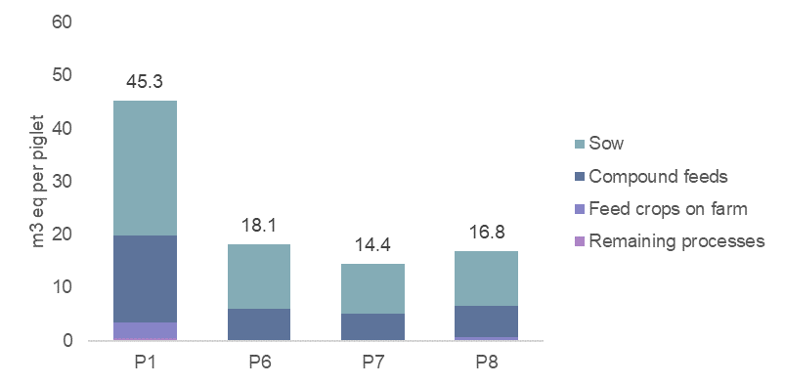
Fig. 2. Water scarcity impact of piglet production on specialised farms.

