Electronic Supplementary Material to
Dissipation based life cycle impact assessment of mineral resource use in LCA –
A review, case study, and outlook

Markus Berger¹
¹University of Twente, Enschede, The Netherlands
E-mail contact: m.berger@utwente.nl

Table S1: Dissipation rates in use and waste management phases determined based on MFA data provided in Helbig et al. (2020), data for molybdenum assumed to be equal to nickel due to its predominant use as alloying element in steel.

 | Entering use-phase (t) | Dissipation in in-use phase (t) | Ratio dissipation in-use per tonne entering use phase | Dissipation in waste management and recycling (t) | Ratio dissipation in waste management per tonne entering use phase
Al | 6.65E+07 | 0.00E+00 | 0.00% | 4.20E+06 | 6.32%
Mo |  |  | 0.00% |  | 15.10%
Co | 5.32E+04 | 0.00E+00 | 0.00% | 3.79E+04 | 71.15%
Ni | 1.57E+06 | 0.00E+00 | 0.00% | 2.38E+05 | 15.14%
Cu | 2.09E+07 | 4.50E+05 | 2.16% | 5.90E+06 | 28.30%
Zn | 1.30E+07 | 1.10E+06 | 8.46% | 5.40E+06 | 41.54%

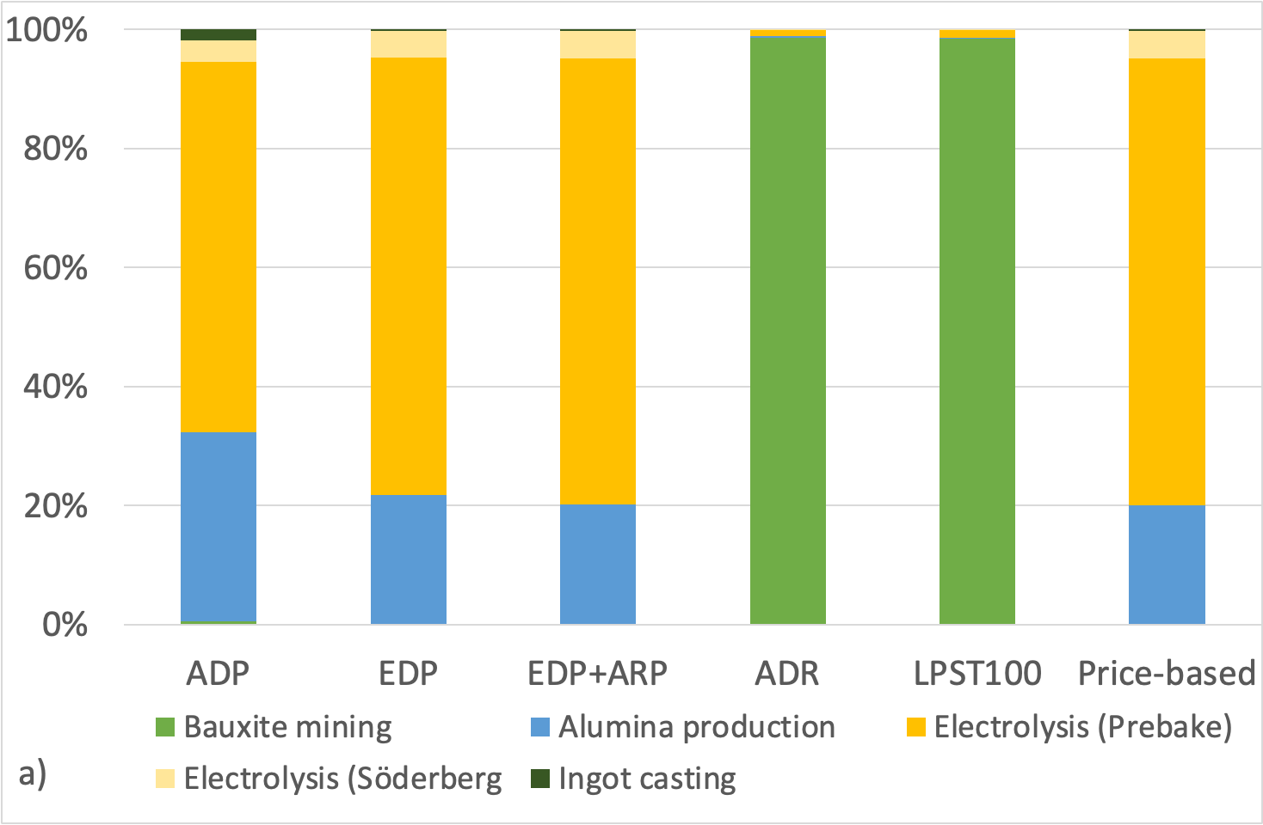
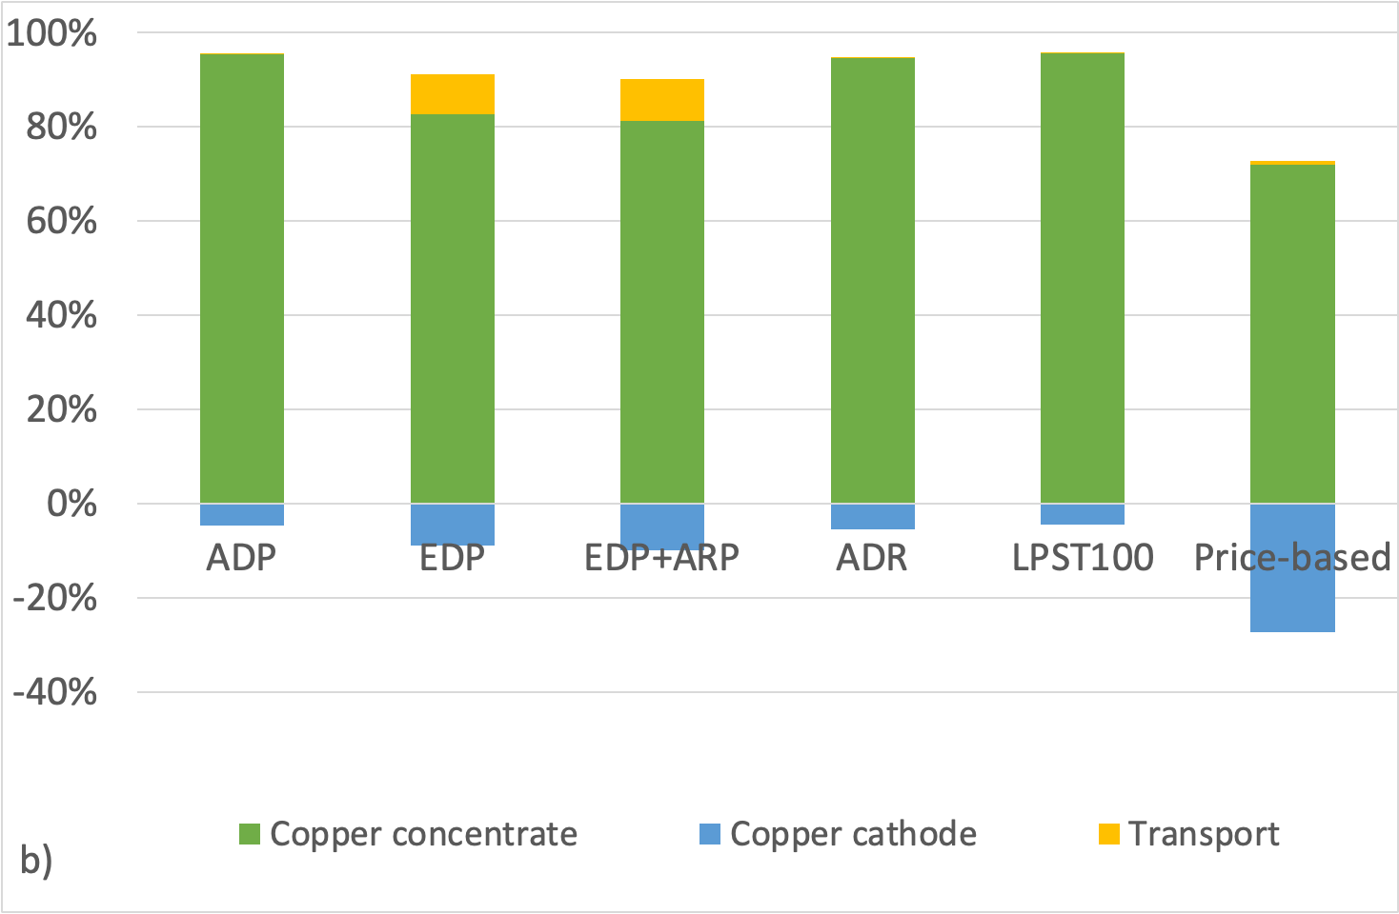
Fig. S1: Contribution of production stages to toal LCIA results for the production of aluminium (a) and copper (b)

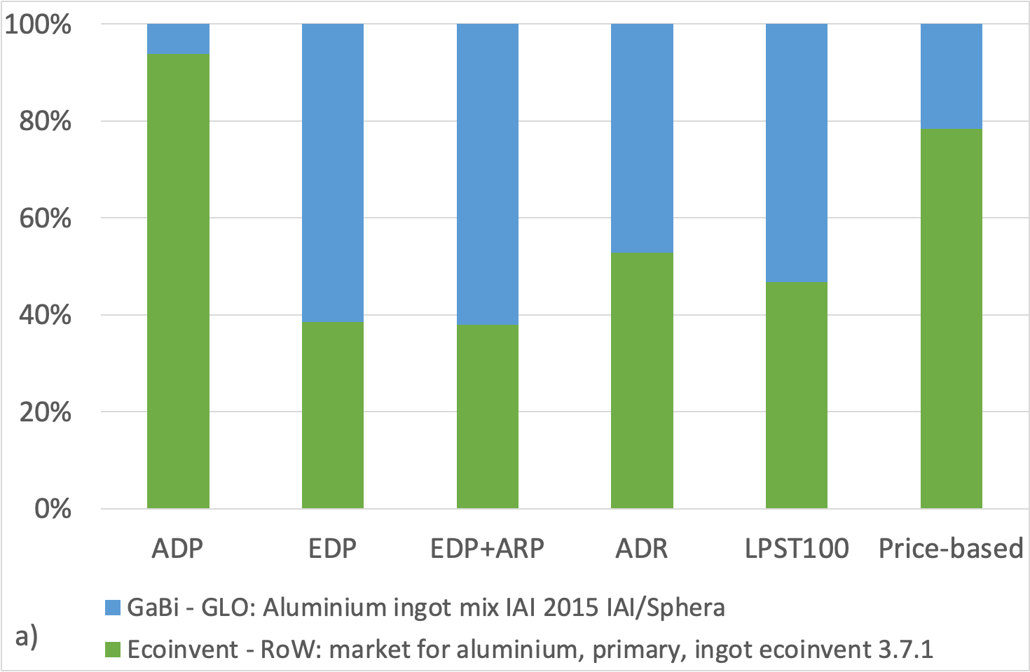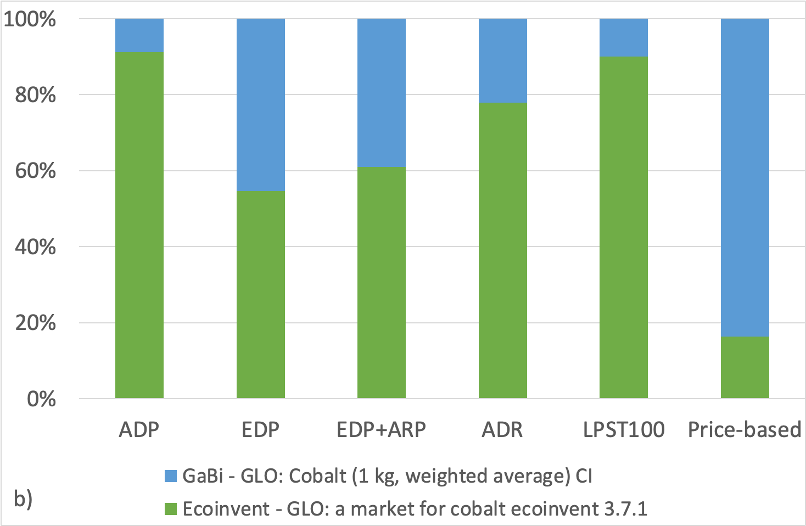
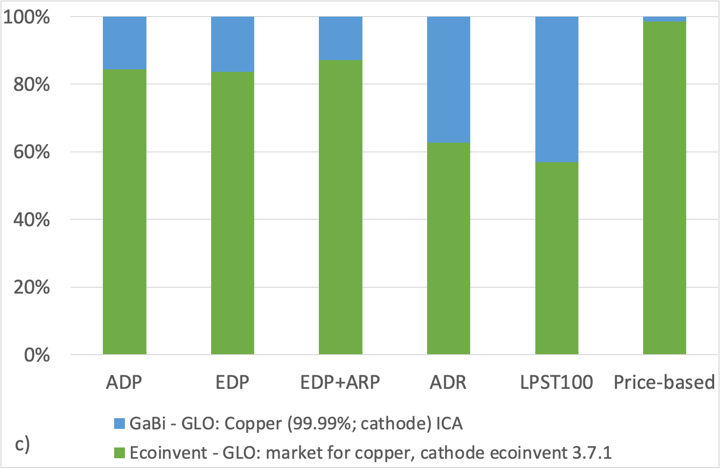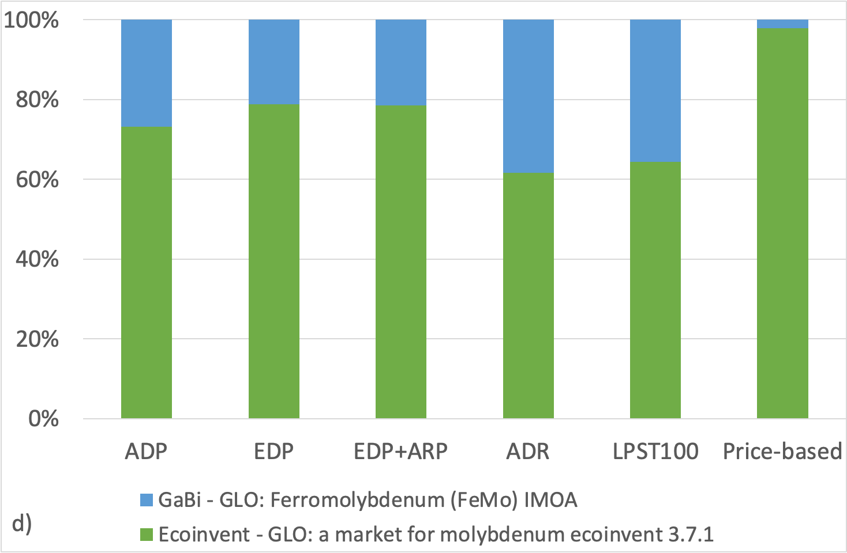
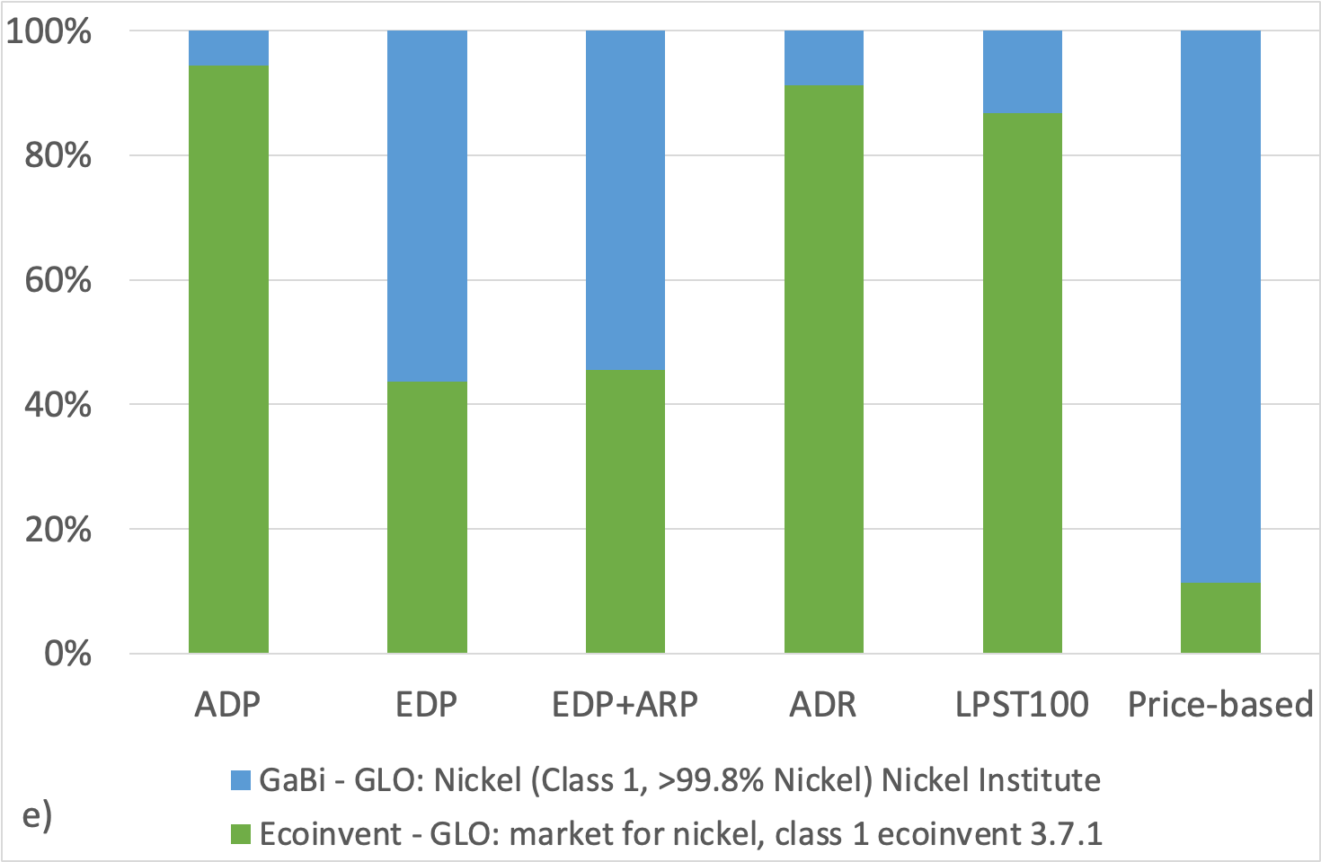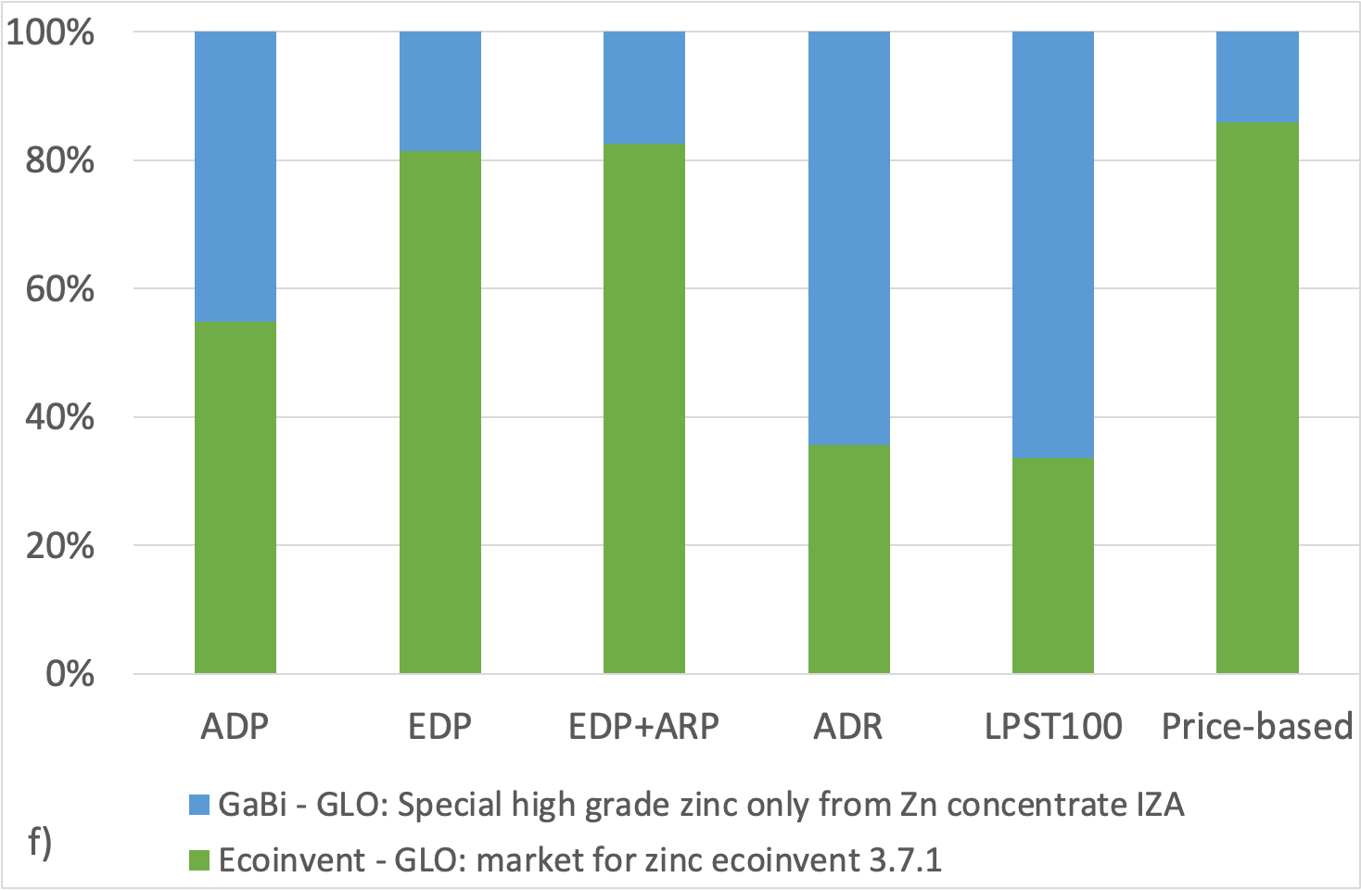
Fig. S2. Relative comparison of metal datasets derived from the ecoinvent (green) and GaBi (blue) database for aluminium (a), cobalt (b), copper (c), molybdenum (d), nickel (e), and zinc (f)

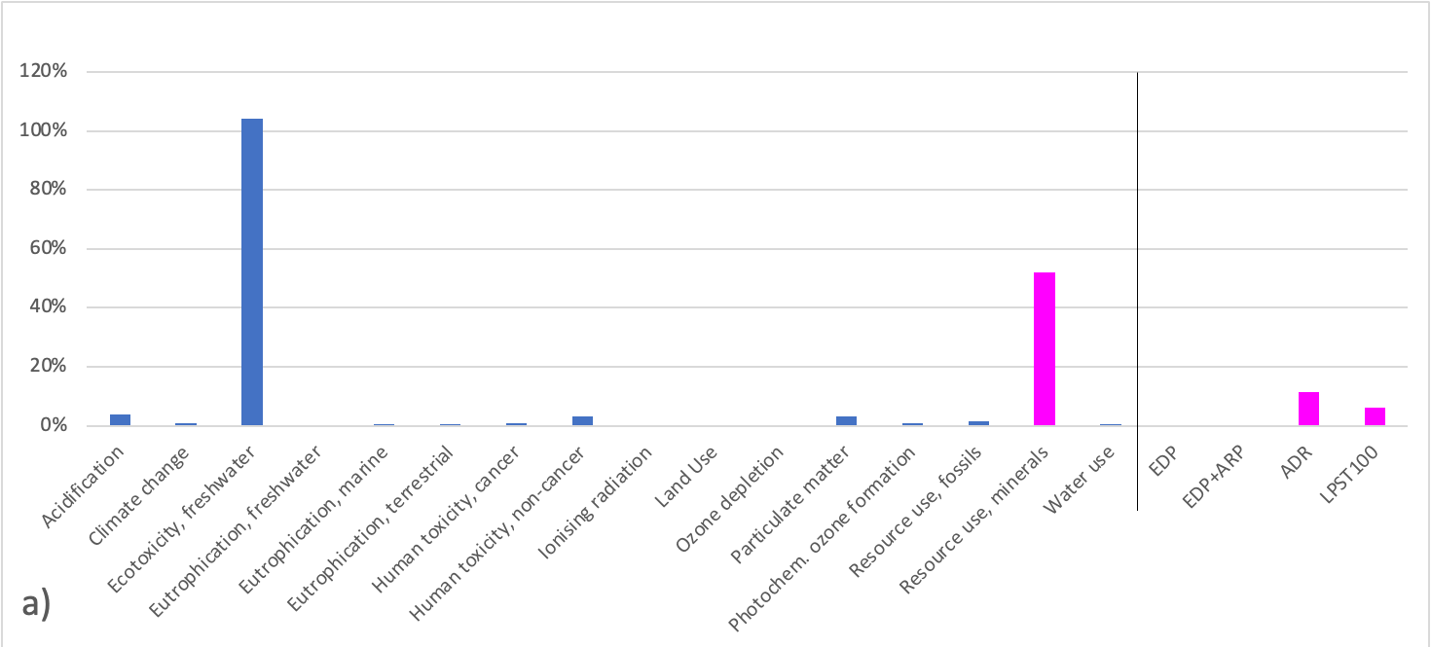
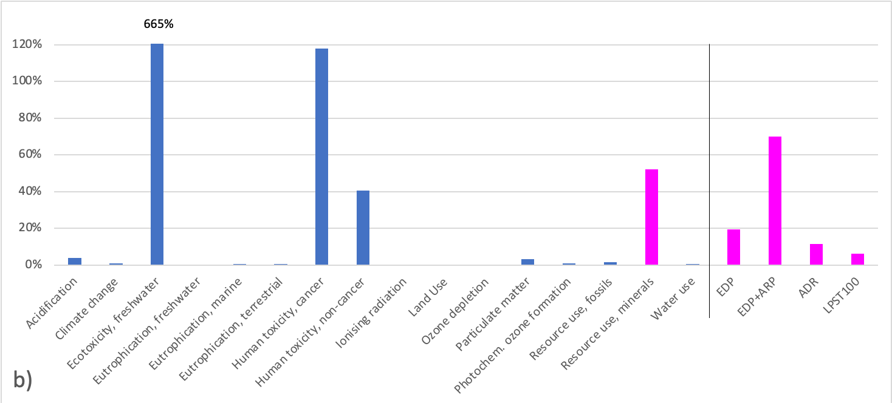
Fig. S3: Normalized LCIA results of the theoretical product (life cycle) in the 16 PEF impact categories with mineral resource use measured by means of ADP in the default setting (left pink bar) and by the dissipation based EDP, EDP+ARP, ADR, and LPST100 models (right pink bars) considering average dissipative losses in the use and end-of-life phases (a) and full dissipative loss of the product’s entire metal content (b)

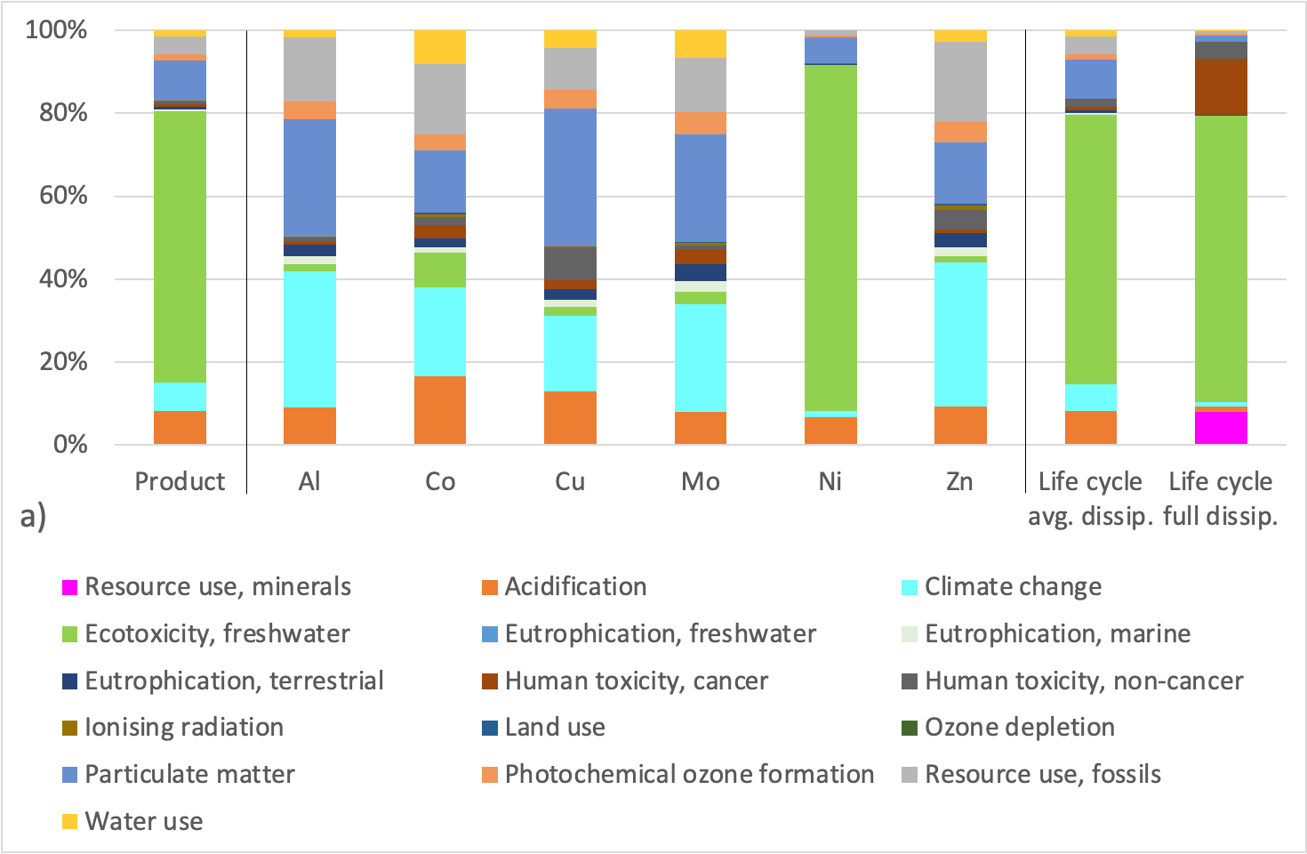
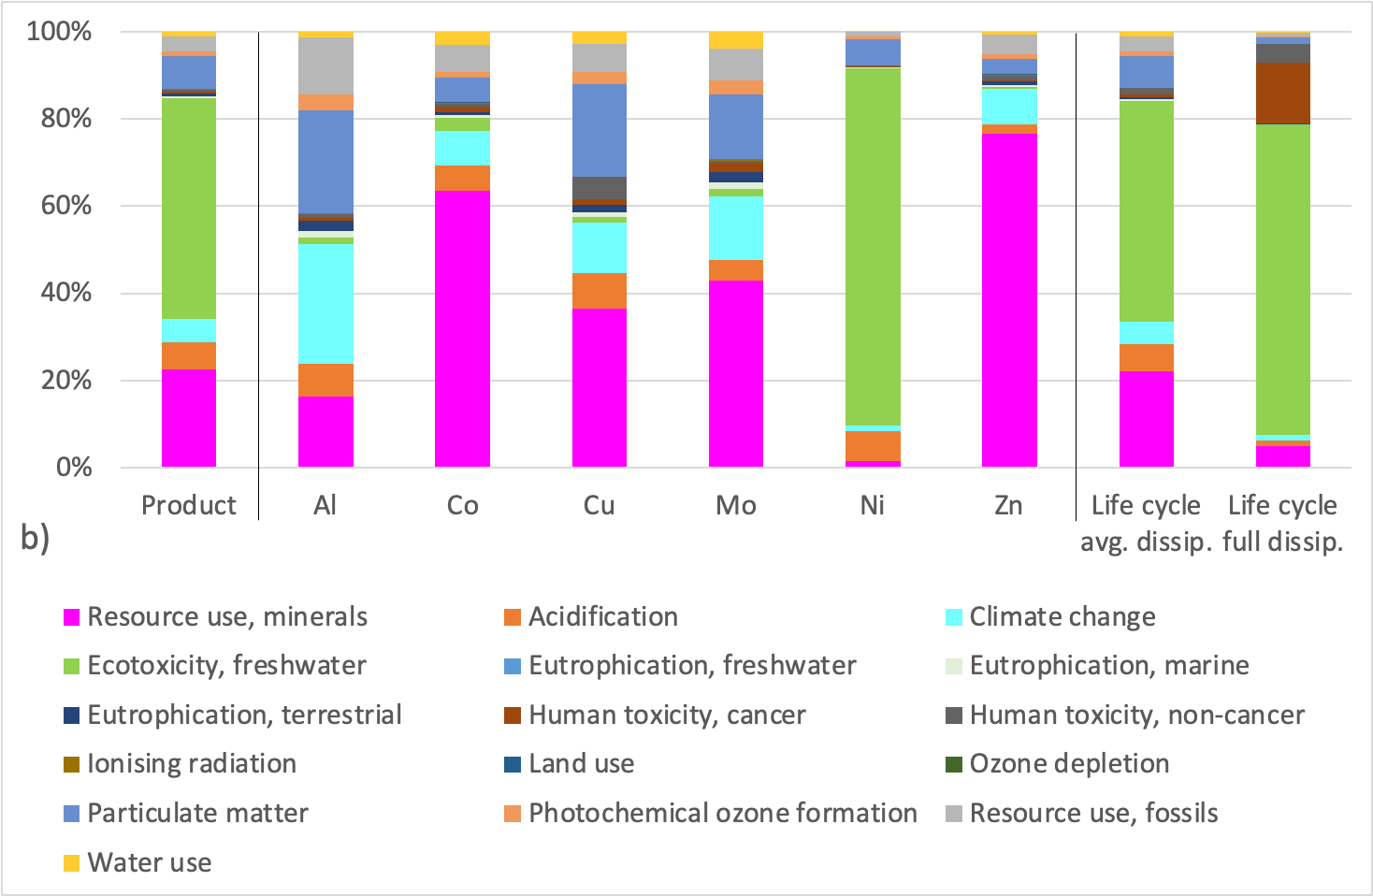
Fig. S4: Weighted and aggregated normalized results in the 16 PEF impact categories with the category mineral resource use assessed by means of the dissipation-based models EDP (a) and ADR (b)

