SOCIAL RISKS ASSESSMENT OF THE SUPPLY CHAIN OF AN ALUMINIUM SEMI-FINISHED PROFILE FOR WINDOW Authors: Paolo ${DI GIORGIO}^{1;2}$ Manuela ${D'EUSANIO}^{1*}$, Monica ${SERRELI}^{1}$, Luigia ${PETTI}^{1}$

SUPPLEMENTARY MATERIALS

Results of the product system
The following figures show some examples of result presentation in Italy (as screenshots from openLCA):

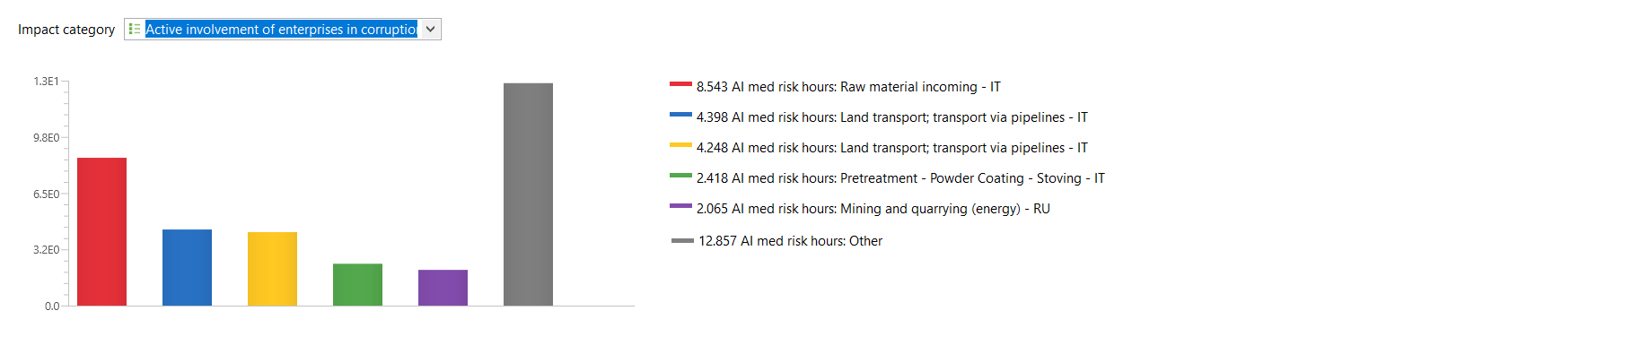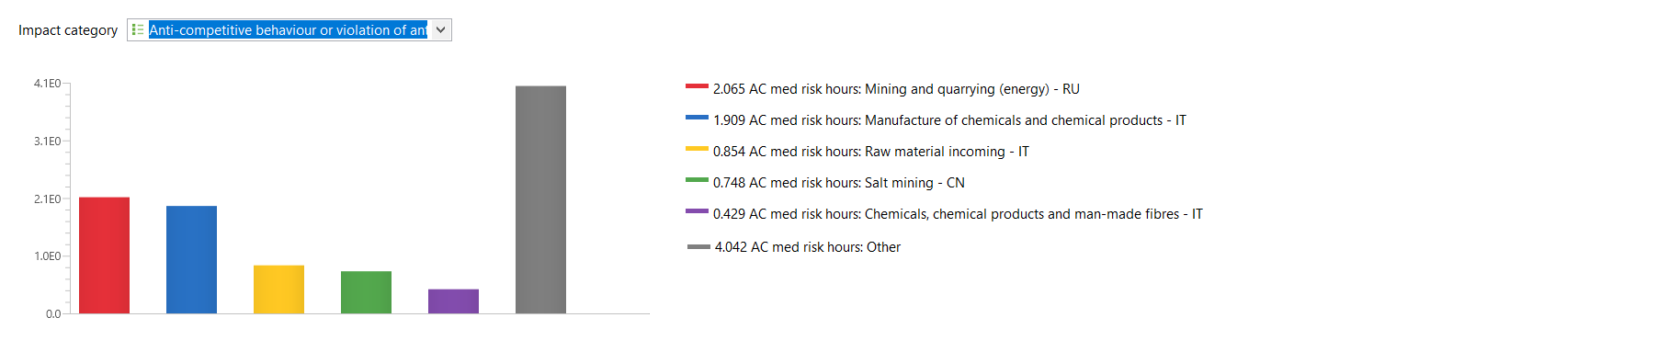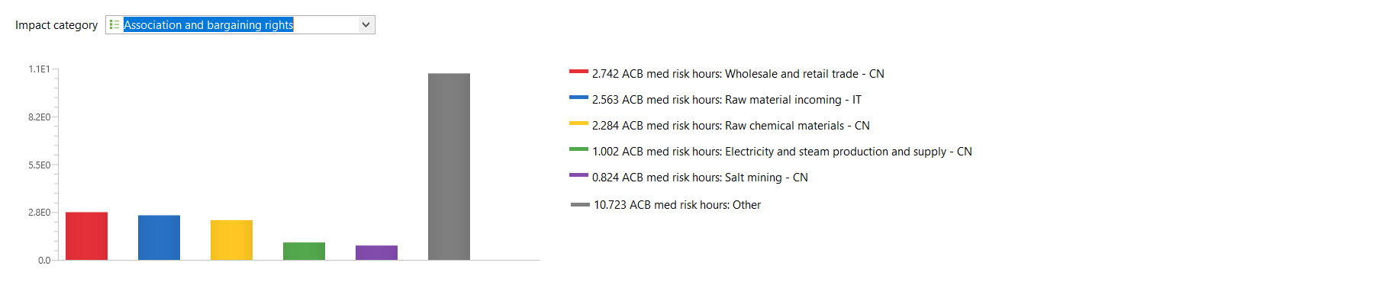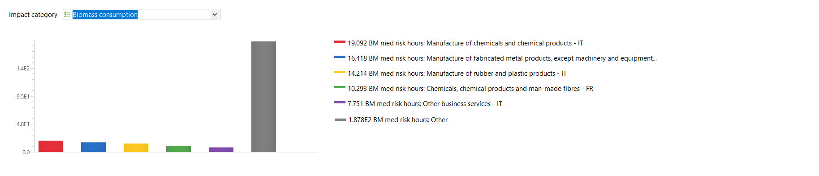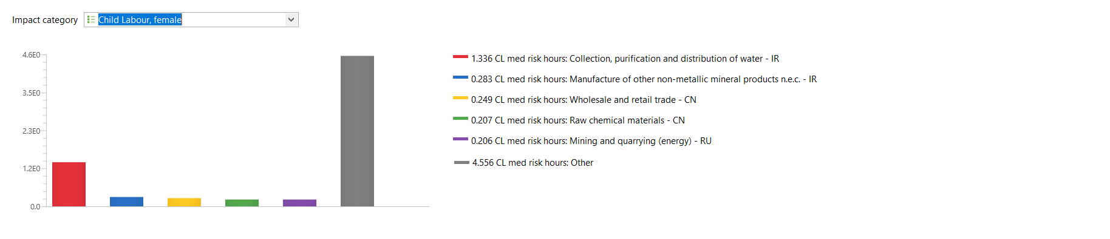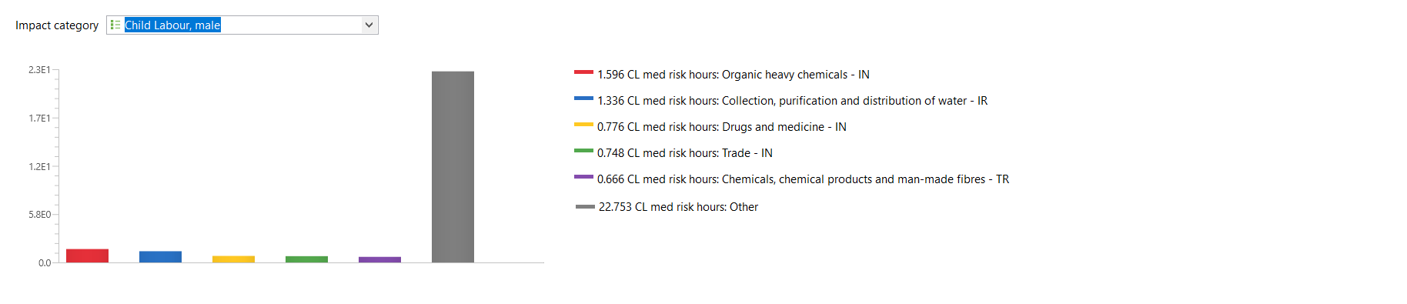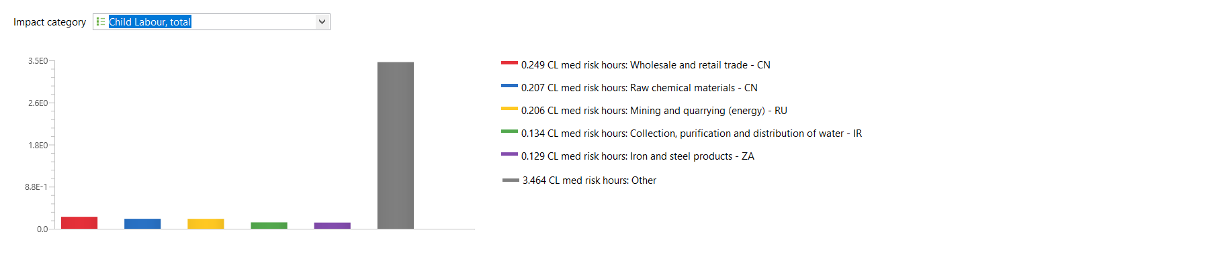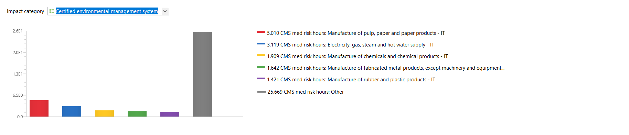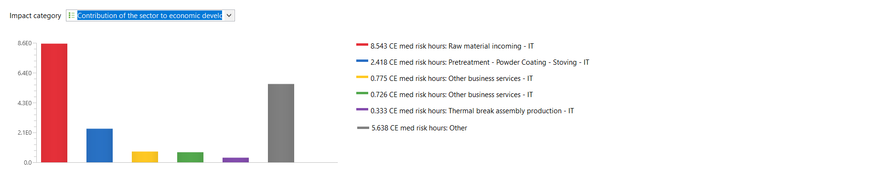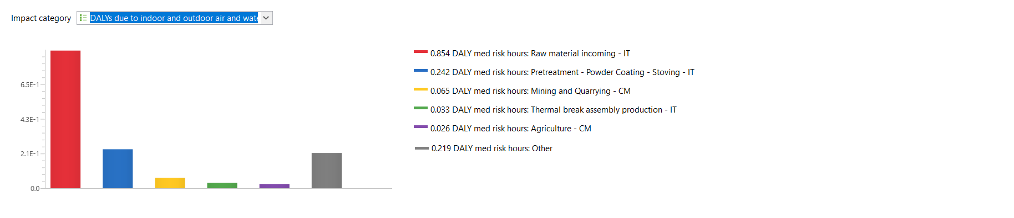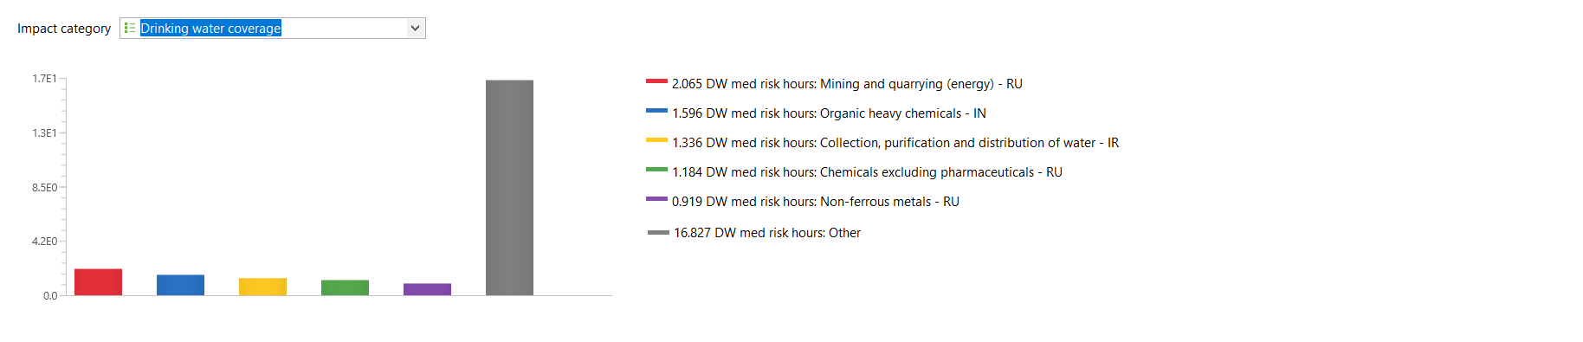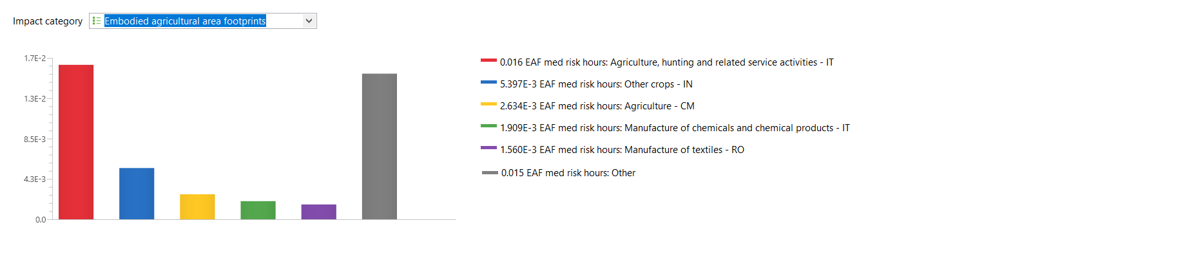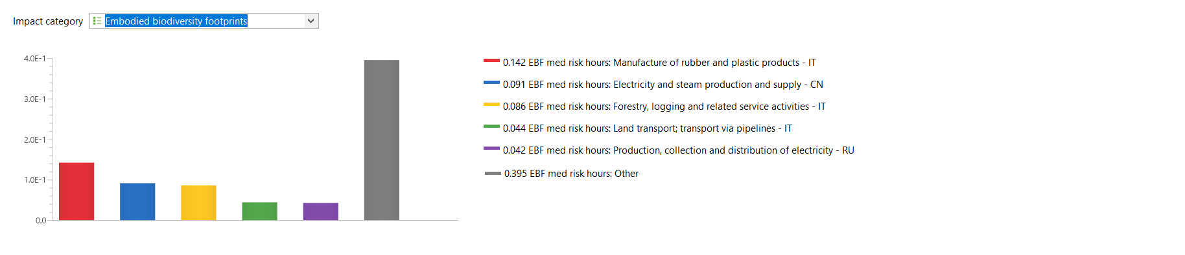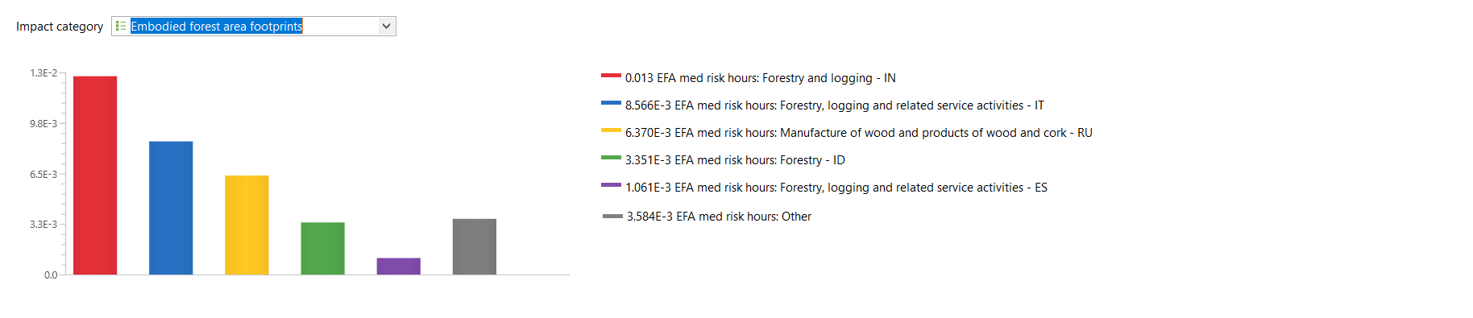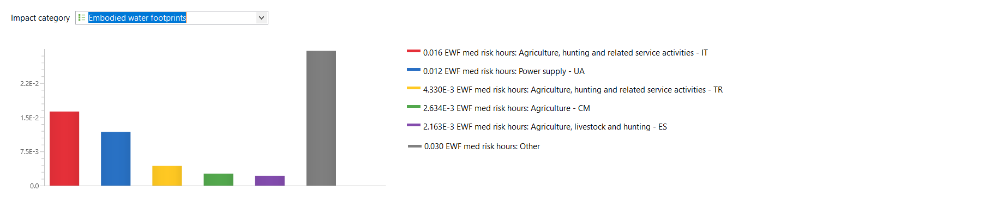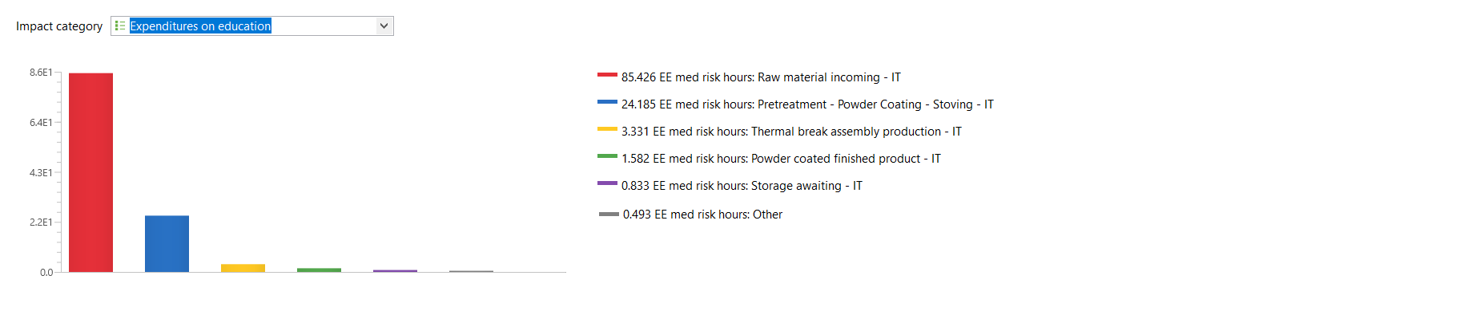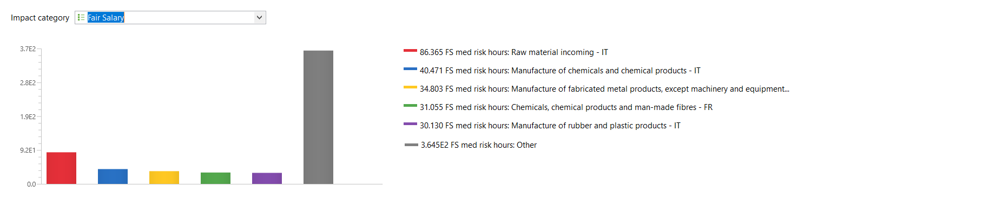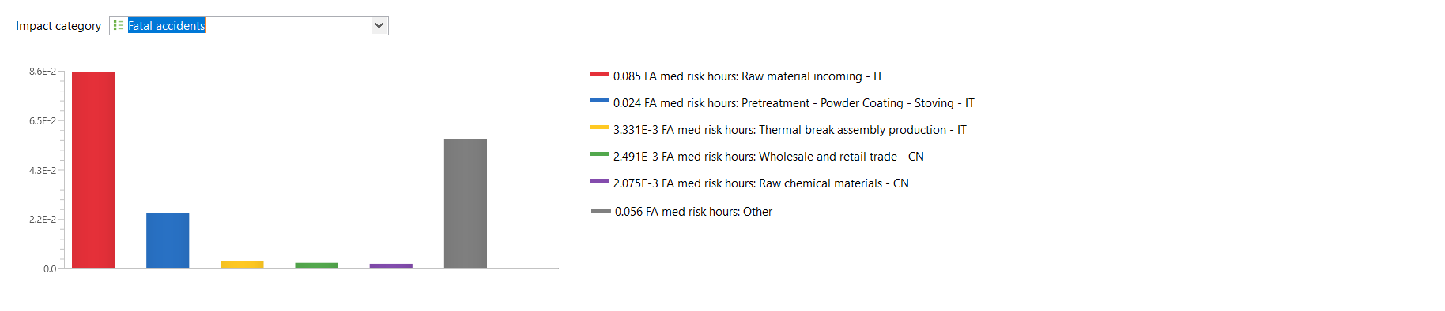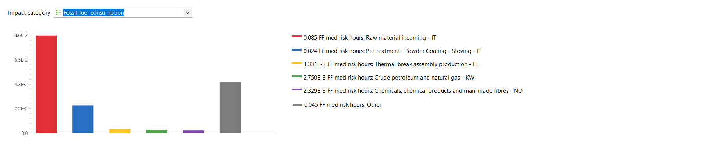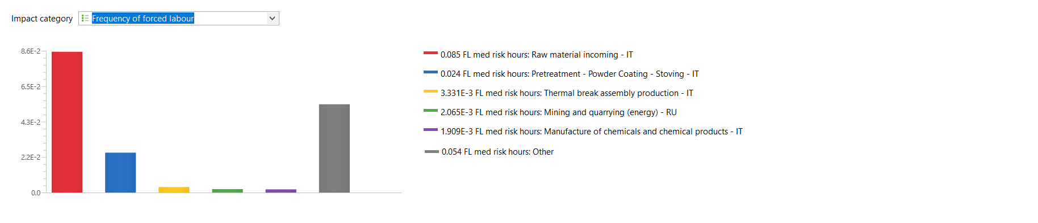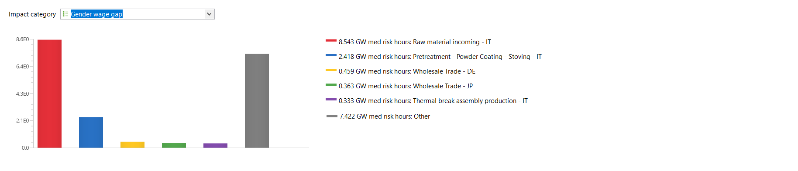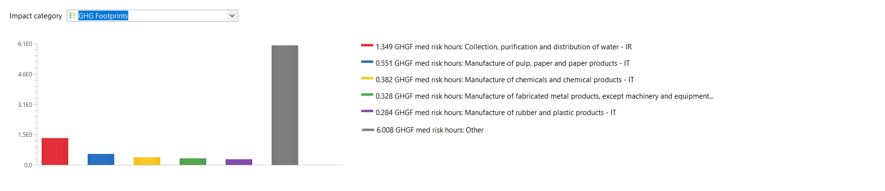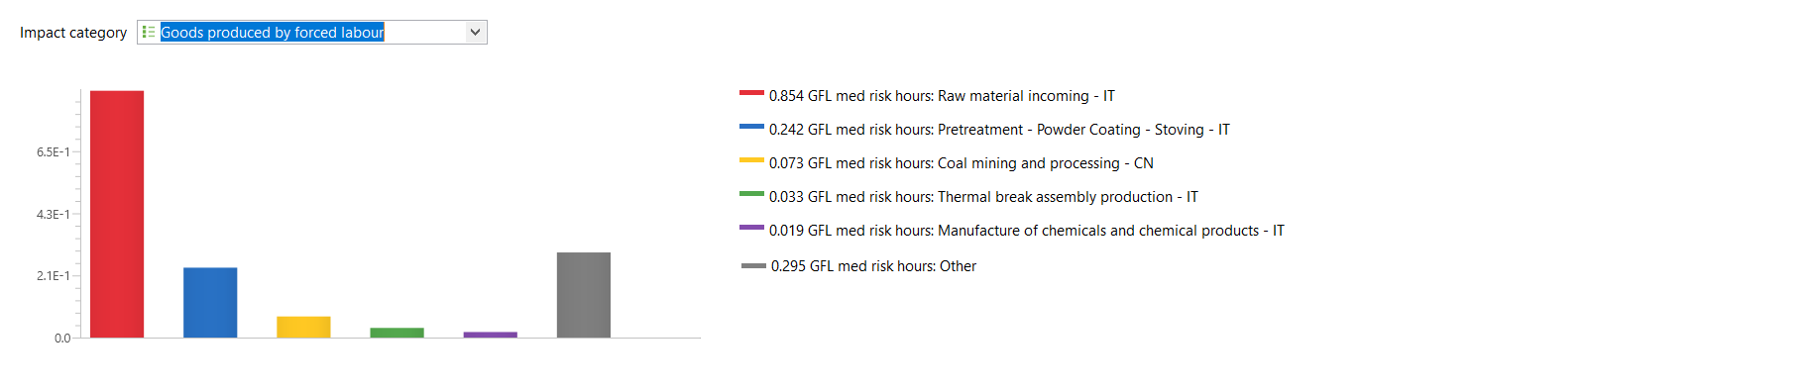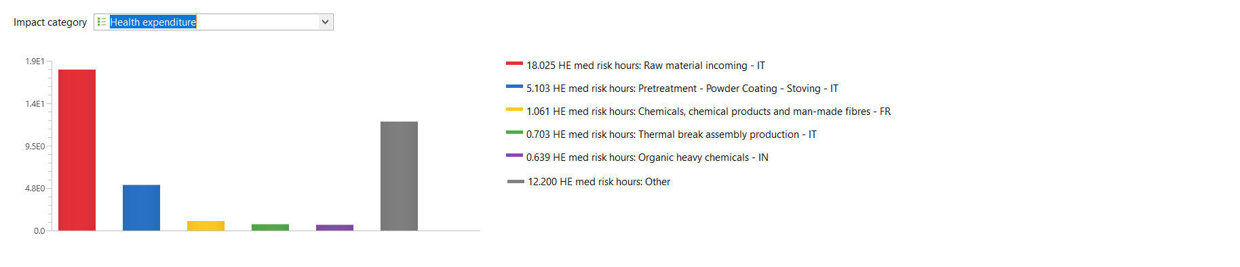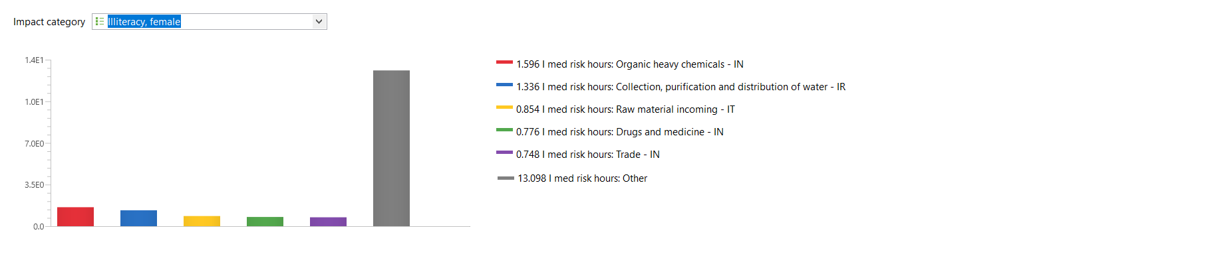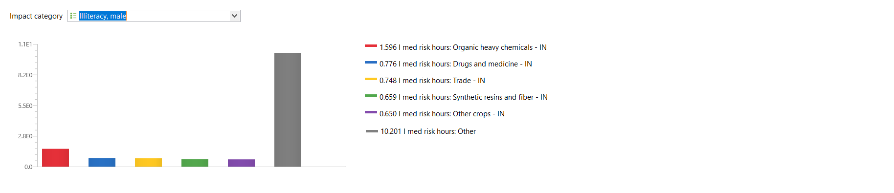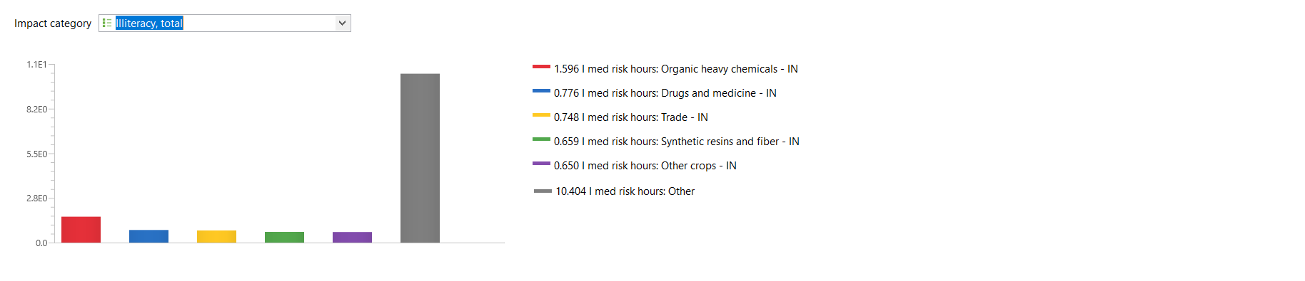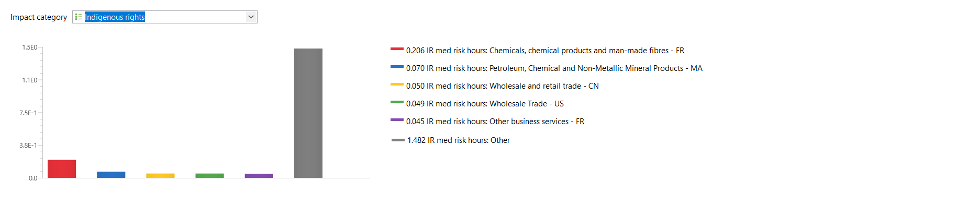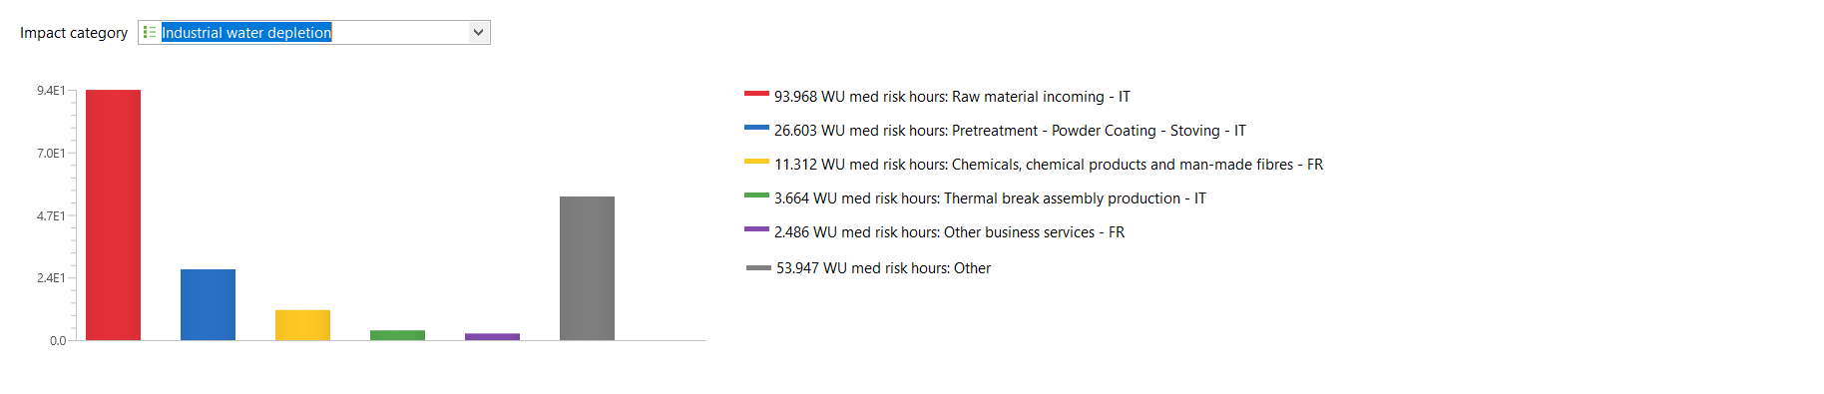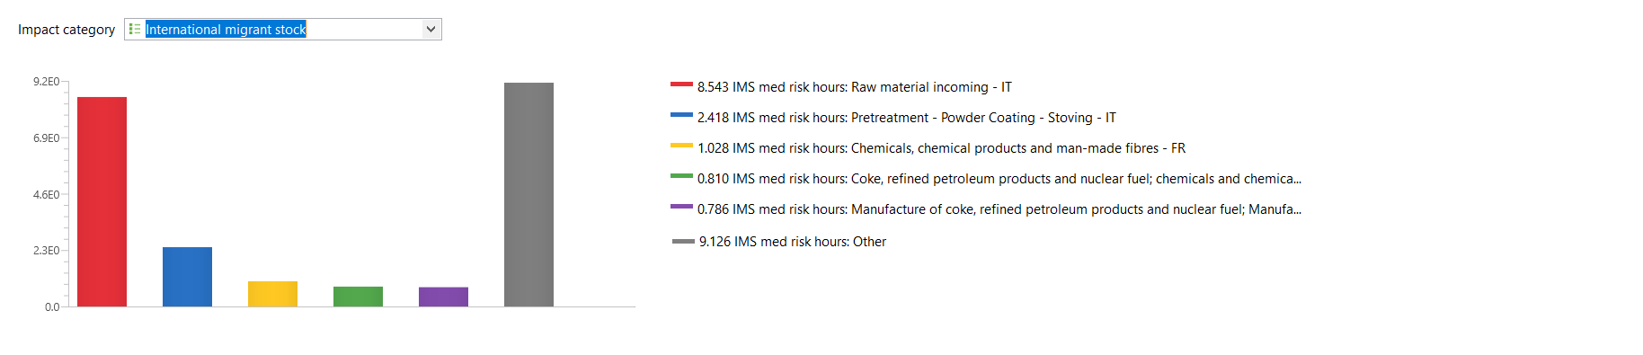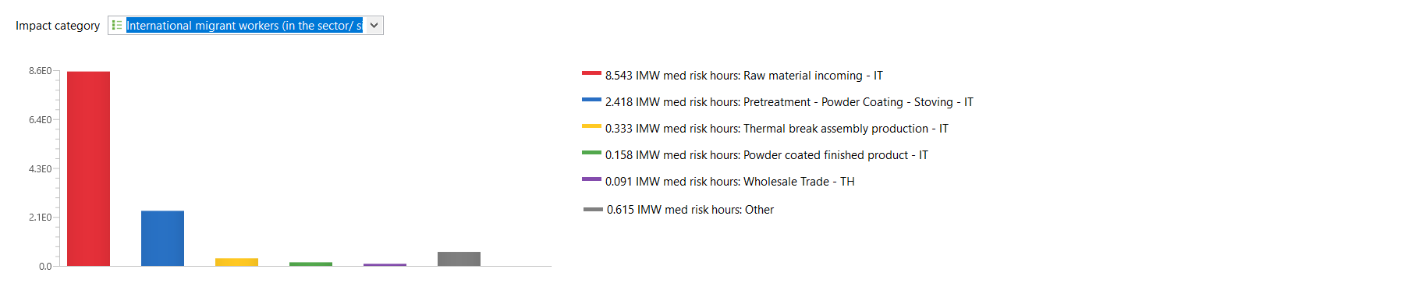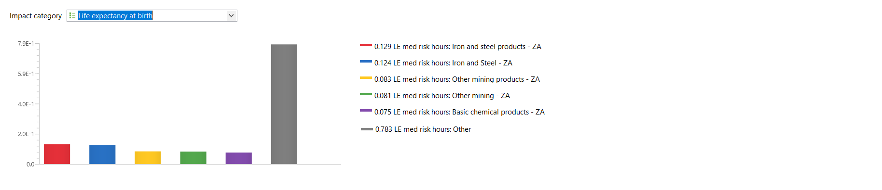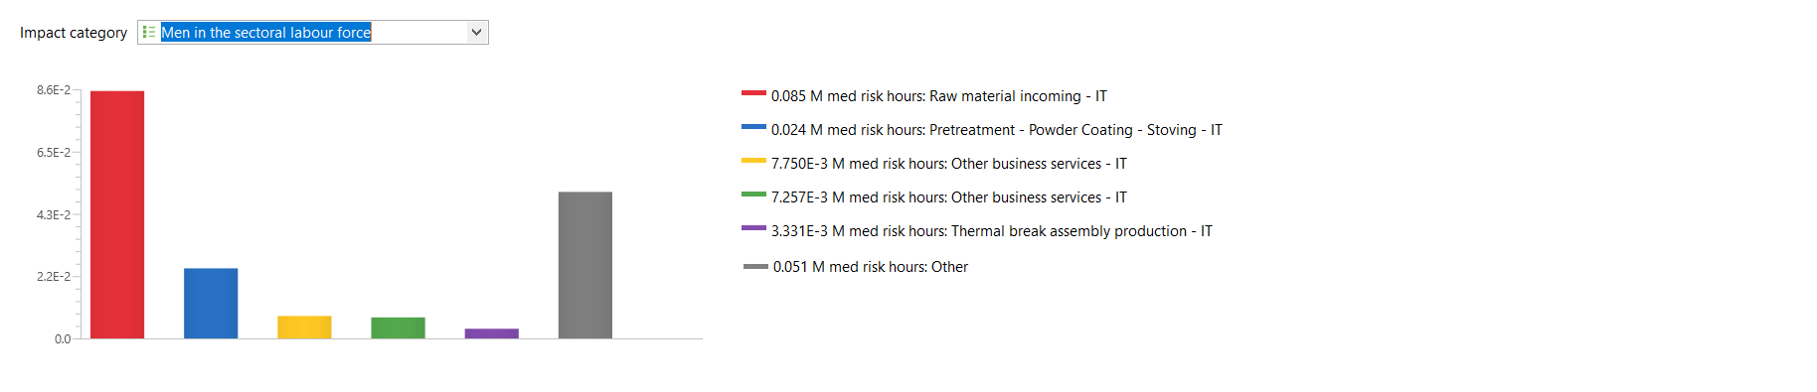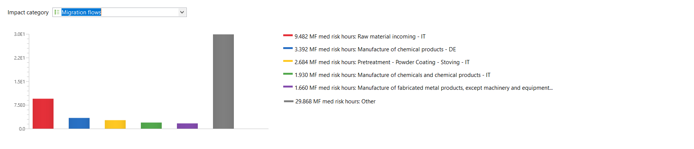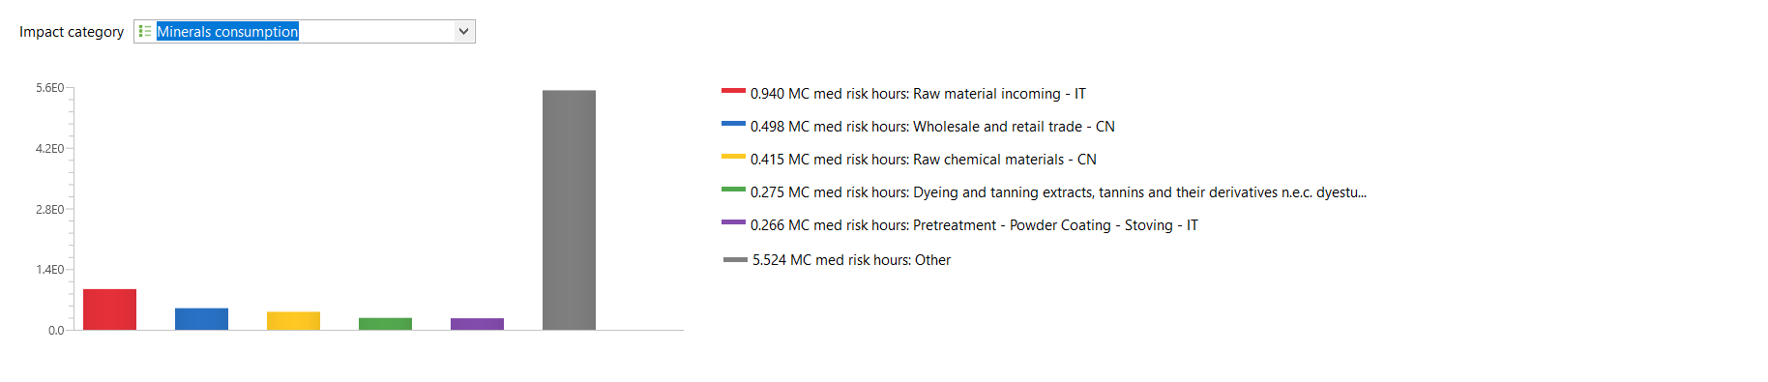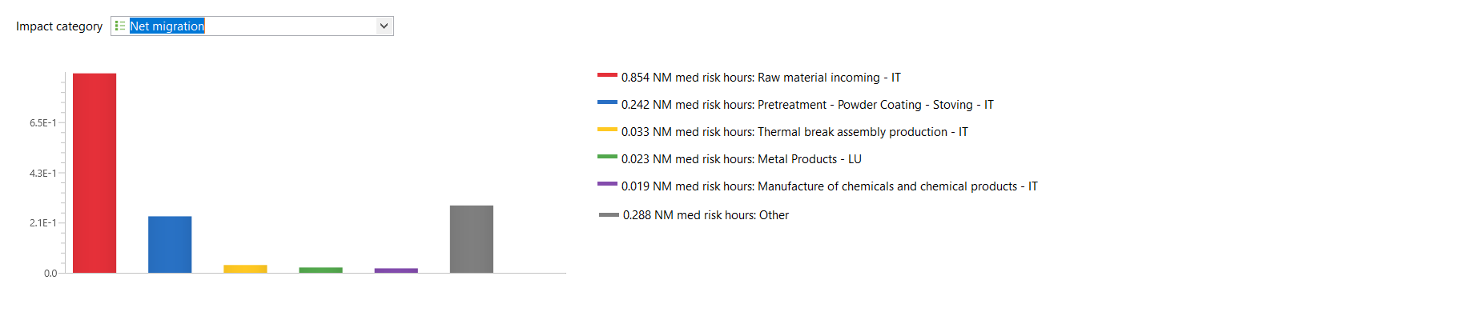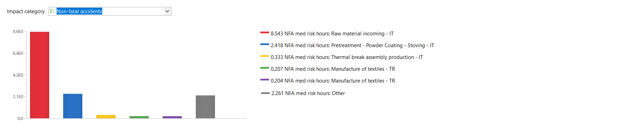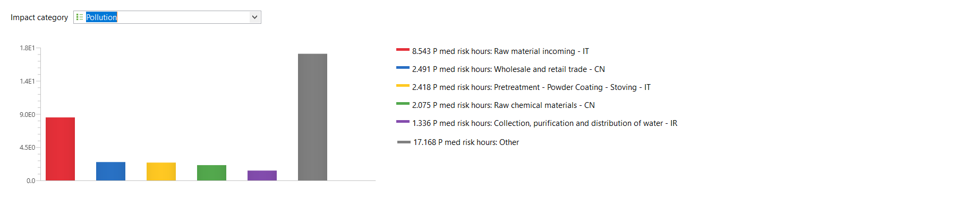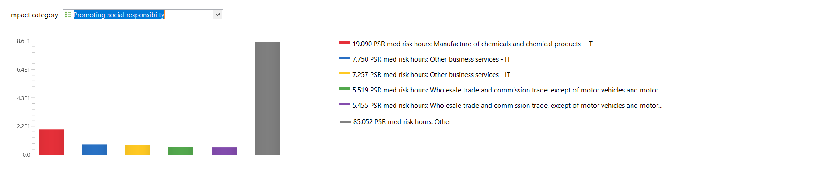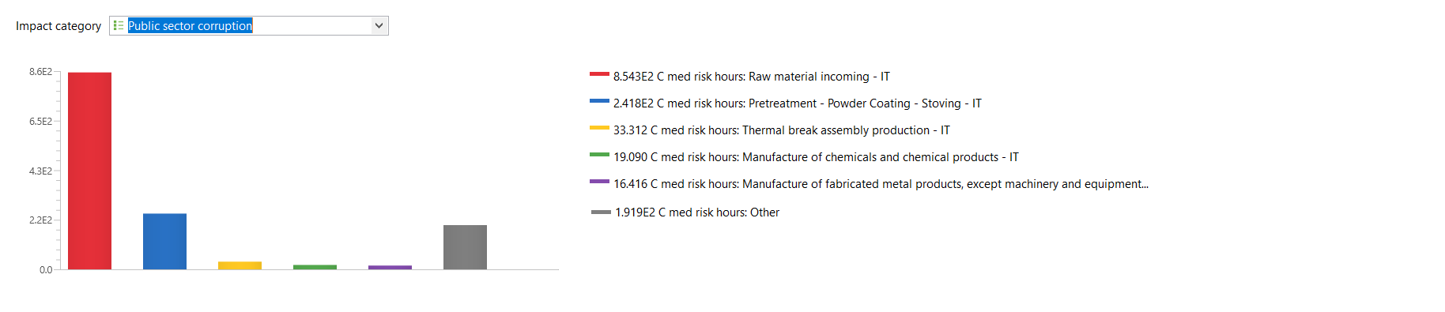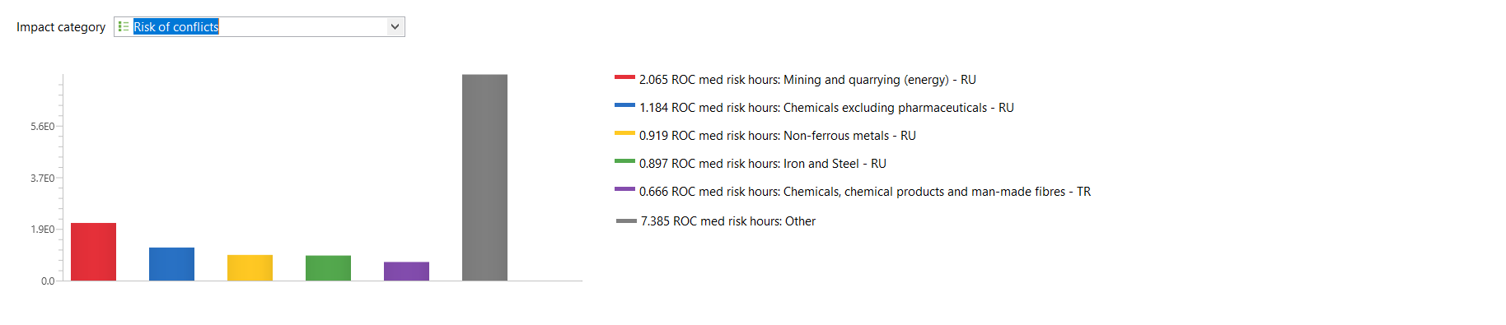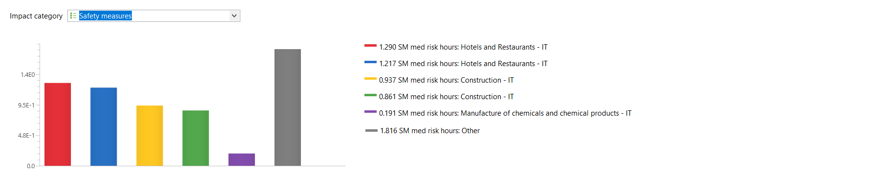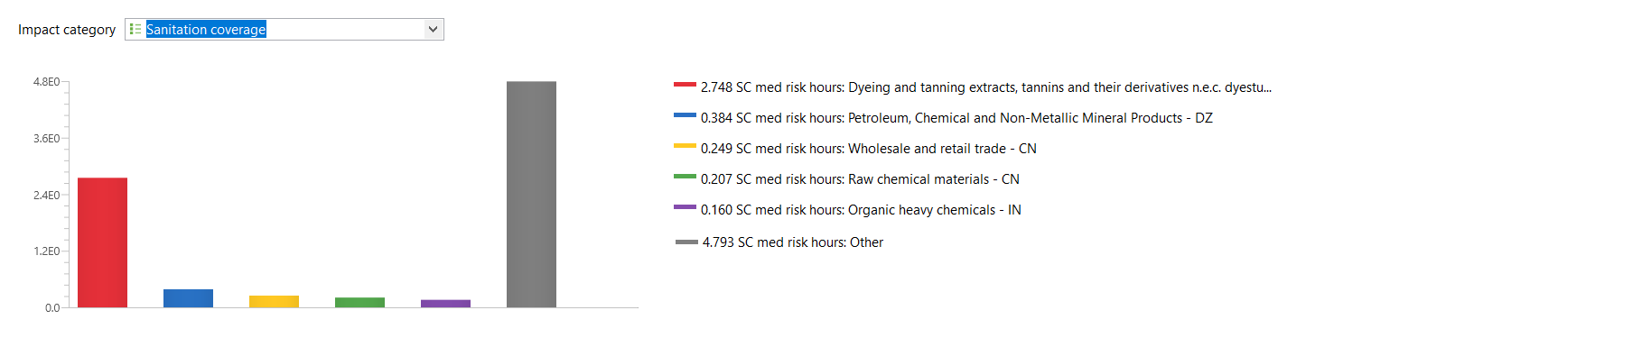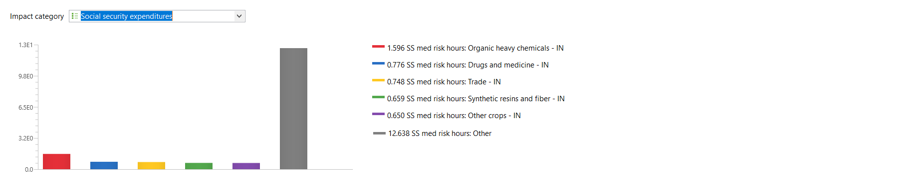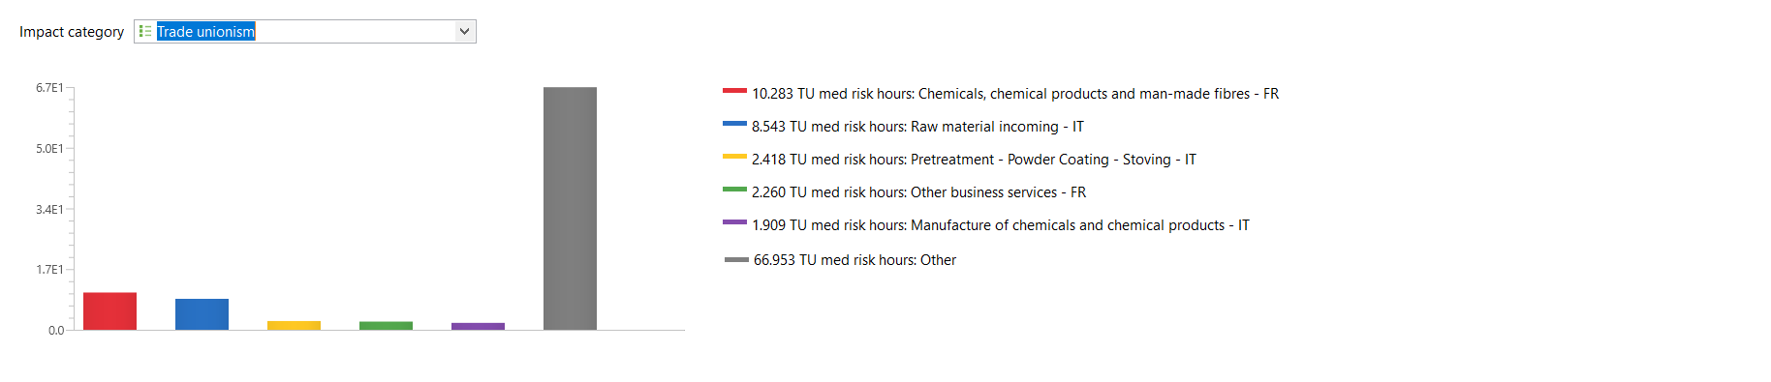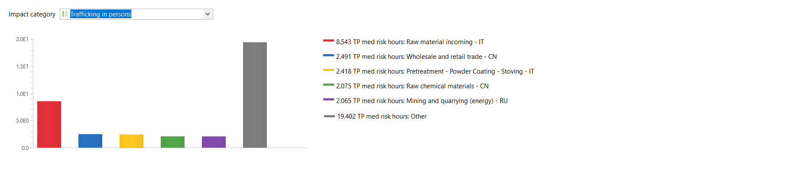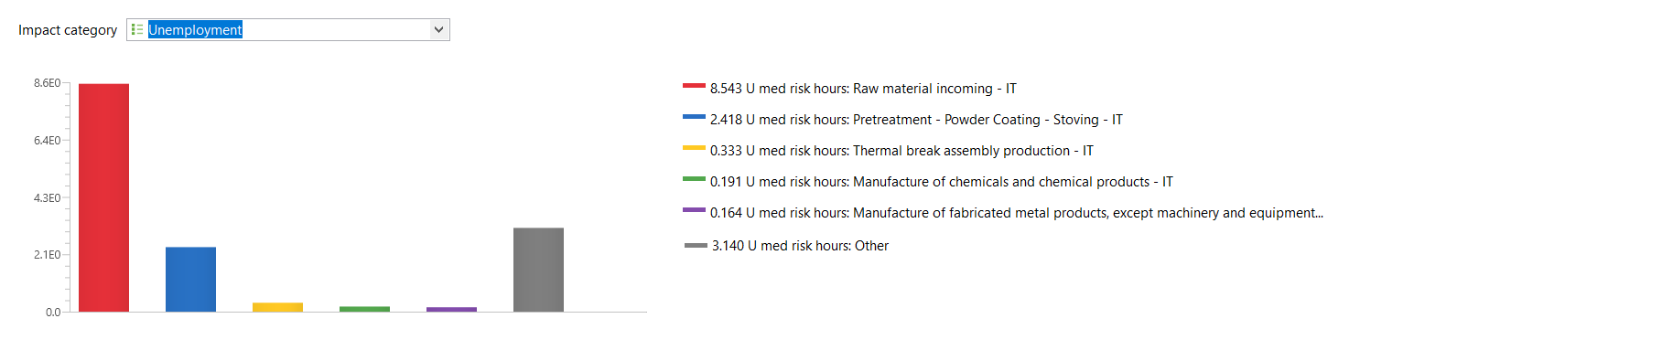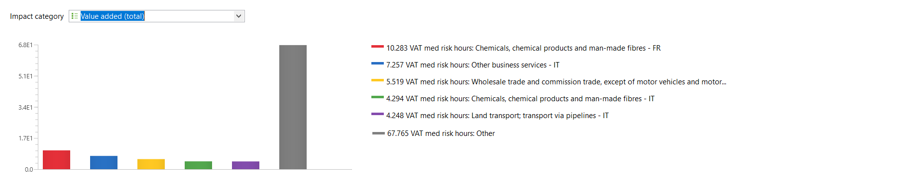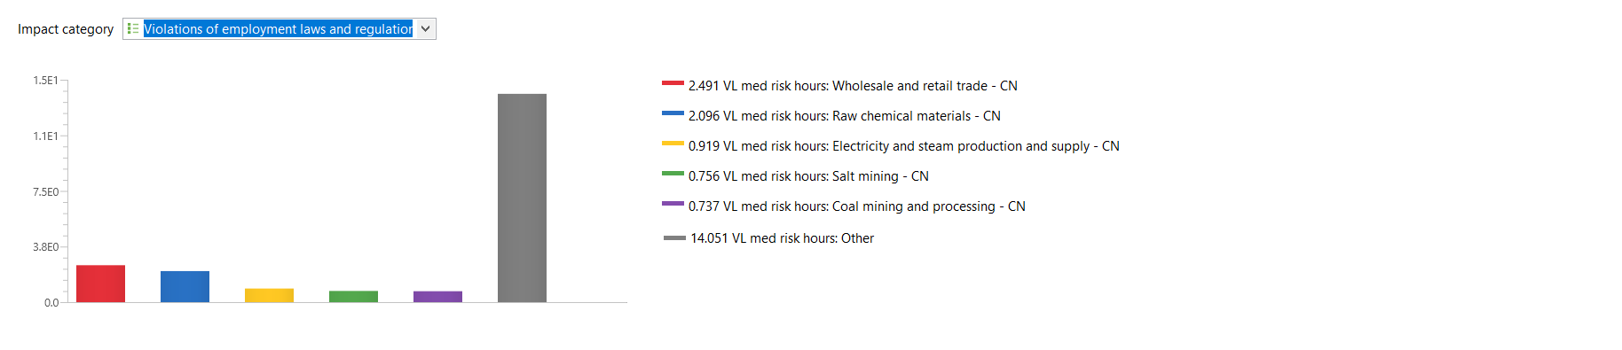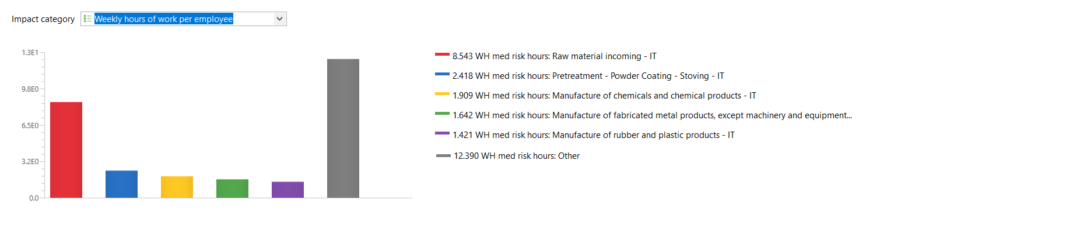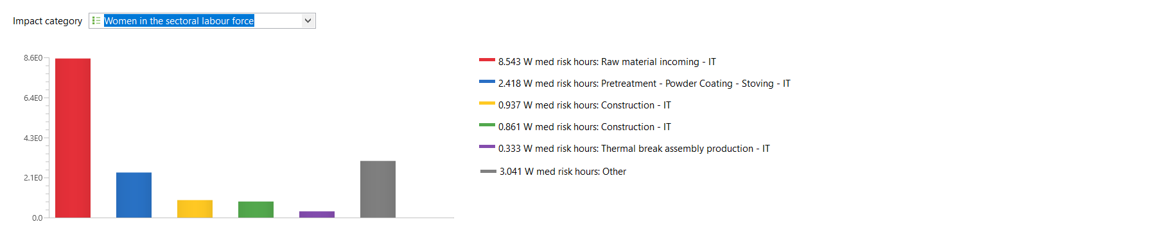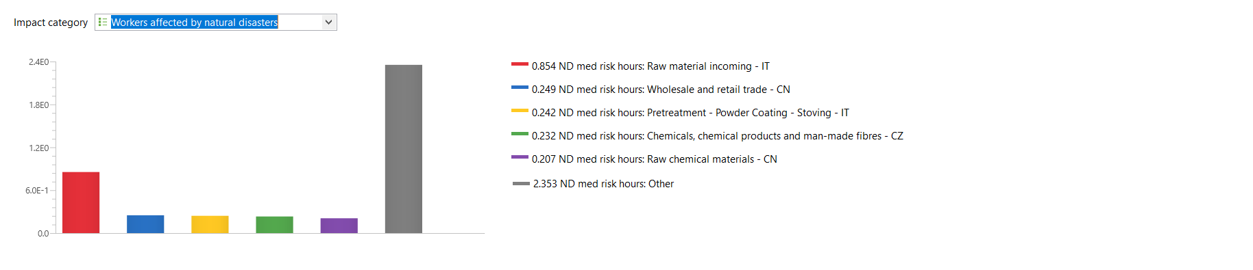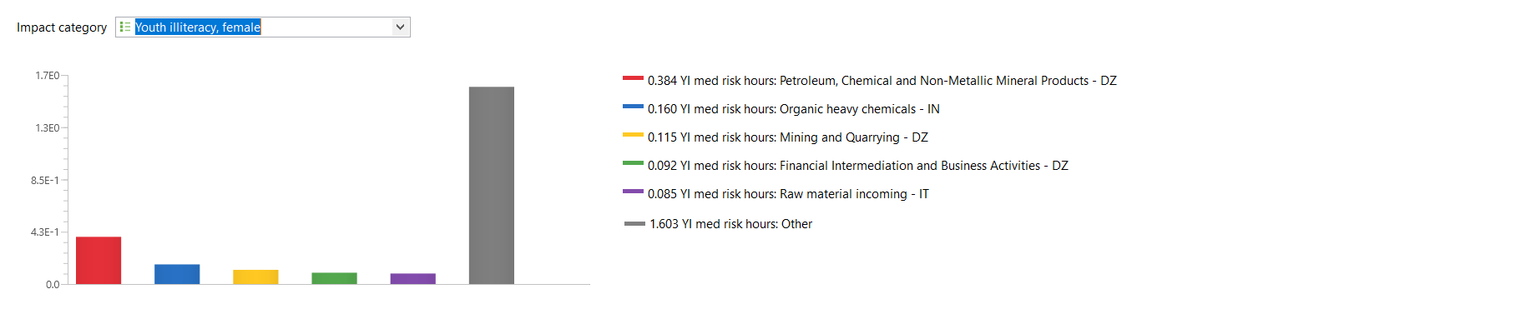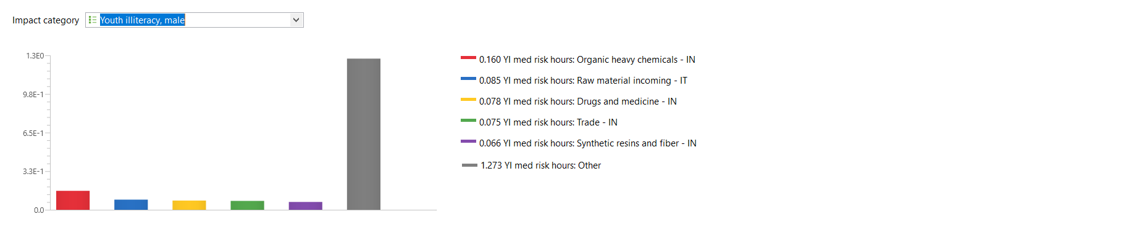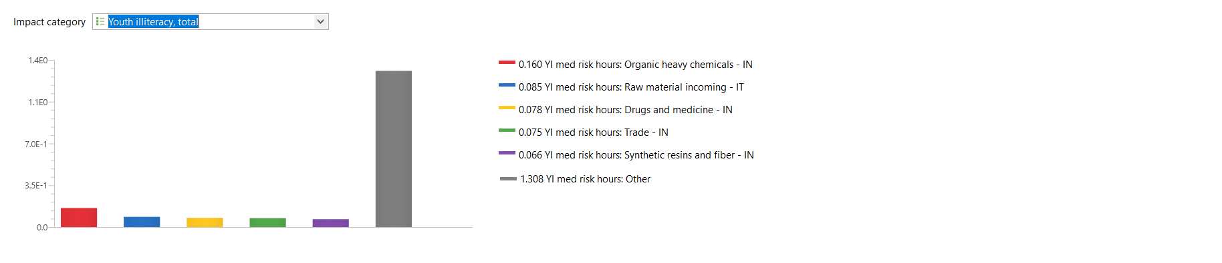

Input/Output model of the product system under study
Foreground processes, inputs, quantity, corresponding Eora sector and their geographical location, output

Partial model graph of the product system under study in openLCA
