Supplementary materials

Transports
In this section, inventory data and data sources for the transports are presented.
Table S1. Data source transports (based on Quantis (2021))
Process | Data source, Ecoinvent
Products
Truck | Transport, freight, lorry >32 metric ton, euro4 {RER}| market for transport, freight, lorry >32 metric ton, EURO4 | Cut-off, S
Train | Transport, freight train {RER}| market group for transport, freight train | Cut-off, S
Ship | Transport, freight, sea, container ship {GLO}| market for transport, freight, sea, container ship | Cut-off, S
Customer travel
Car | Transport, passenger car, medium size, petrol, EURO 4 {GLO}| market for | Cut-off, S
Van | Transport, passenger car, large size, petrol, EURO 3 {GLO}| market for | Cut-off, S
Bus | Transport, regular bus {GLO}| market for | Cut-off, S
Waste collection, end of life | Municipal waste collection service by 21 metric ton lorry {GLO}| market for | Cut-off, S

Table S2. Transport of sorted discarded textiles for recycling (PL = Poland, SE = Sweden, DE = Germany, ES = Spain, TR = Turkey, NL = the Netherlands, FI =Finland)
Origin | Destination | Share  (% by weight) | Transport, ship (km) | Transport, rail (km) | Transport,  truck (km) | Transport,  total (km)
Kiecle, PL | Kemi, FI | 25% | 1800 | 830 | 215 | 2845
Malmö, SE | Kemi, FI | 10% | 2024 | 0 | 44 | 2068
Bitterfeld-Wolfen, DE | Kemi, FI | 30% | 1800 | 459 | 44 | 2303
Banyeres de Mariola, ES | Kemi, FI | 10% | 5778 | 0 | 114 | 5892
Istanbul, TR | Kemi, FI | 15% | 8859 | 0 | 96 | 8955
Amsterdam, NL | Kemi, FI | 5% | 2500 | 50 | 50 | 2600
Paimio, FI | Kemi, FI | 5% | 0 | 0 | 800 | 800

Fibres
In this section, inventory data and data sources for the fibres are presented.
Table S3. Data source fibres
Fibres | Data source, Ecoinvent, and comment
Cellulose carbamate fibres | Hammar et al. (2023)
Conventional cotton | Fibre, cotton {GLO}| market for fibre, cotton | Cut-off, S
Organic cotton | Fibre, cotton, organic {GLO}| market for fibre, cotton, organic | Cut-off, S

Energy sources
In this section, inventory data and data sources for the energy sources phase are presented.
Table S4. Data source liquefied natural gas, LNG
Process | Data source, Ecoinvent
Production | Natural gas, liquefied {GLO}| market for | Cut-off, S
Combustion | Emission factors from incineration from Swedish Environmental Protection Agency (2021) (55.5 kg CO₂ per GJ, 0.001 CH₄ per GJ and 0.0001 kg N₂O per GJ, with heating value of 39.6 GJ per 1000 m³ based on Ecoinvent dataset for Natural gas production)

Yarn production
In this section, inventory data and data sources for the yarn production are presented.
Table S5. Data sources yarn production (60% cellulose carbamate fibre blend yarn)
Process | Amount | Unit | Description | Data sources, Ecoinvent
Input |  |  |  | See Table S2
Cellulose carbamate fibre | 500 | kg
Organic cotton | 333 | kg |  | See Table S2
Paraffin blue | 0.6 | kg | Leftover fraction is reused. | Paraffin {RER}| production | Cut-off, S
Electricity | 6201 | kWh | National grid Portugal | Electricity, medium voltage {PT}| market for | Cut-off, S
Water | 2.0 | m³ |  | Water, unspecified natural origin, PT
Output
Cellulose carbamate blend yarn | 781 | kg | Ne 30/1, Ne 20/1, Ne 10/1. 60% cellulose carbamate and 40% organic cotton.
Waste fibre | 52 | kg | Mix of incineration, recycling and landfill assumed. | See Table S10

Fabric production
In this section, inventory data and data sources for the fabric production are presented.
Table S6. Data sources fabric production, knitting (60% cellulose carbamate fibre blend fabric)
Process | Amount | Unit | Description | Data sources, Ecoinvent
Input
Cellulose carbamate blend yarn | 260 | kg | Ne 30/1, Ne 20/1, Ne 10/1. 60% Cellulose carbamate and 40% organic cotton. | See Table S4
Electricity | 28 | kWh | National grid Turkey | Electricity, medium voltage {TR}| market for | Cut-off, S
Output
cellulose carbamate knitted greige fabric | 203 | kg | 385 g per m²
Waste fibre | 57 | kg | Mix of incineration, recycling and landfill assumed. | See Table S10

Table S7. Data sources fabric production, finishing (60% cellulose carbamate fibre blend fabric)
Process | Amount | Unit | Description | Data sources, Ecoinvent
Input
Cellulose carbamate knitted griege fabric | 130 | kg | 385 g per m² | See Table S7
Chemicals | 12.3 | kg | Bleaching, dry finish | See Table S8
Electricity | 46.6 | kWh | National grid Turkey | Electricity, medium voltage {TR}| market for | Cut-off, S
Heat | 3022 | MJ | Natural gas | Heat, central or small-scale, natural gas {GLO}| market group for | Cut-off, S
Fuel | 528 | MJ | Natural gas | See Table S3
Water | 1500 | litre |  | Water, unspecified natural origin, TR
Output
Cellulose carbamate knitted fabric | 120 | kg | 310 meters
Waste fibre | 10 | kg | Mix of incineration, recycling and landfill assumed. | See Table S10

Garment production
In this section, inventory data and data sources for the garment production are presented.
Table S8. Data sources 60% cellulose carbamate garment production
Process | Amount | Unit | Description | Data sources, Ecoinvent
Input
Cellulose carbamate knitted fabric | 990 | kg | 385 g per m² | See Table S6
Tie cord | 92 | m | Organic cotton, 7.6 g per m. 132 cm per hoodie and 142 cm per sweatpants. | See Table S2
Thread | 235 000 | m | Organic cotton. Assumed 12 m per g. | See Table S2
Labels | 2 | kg | Care labels, size labels, declaration labels. Assumed 0.9 g per label. | Fibre, polyester {GLO}| market for fibre, polyester | Cut-off, S
Chemicals | 50 | kg | Dye, printing | See Table S28
Electricity | 710 | kWh | National grid Turkey | Electricity, medium voltage {TR}| market for | Cut-off, S
Fuel | 495 | kWh | LNG for printing and drying | See Table A3.
Water | 1.1 | litre |  | Water, unspecified natural origin, TR
Output
Cellulose carbamate denim fabric | 521 | kg | 868 g per garment (size M)
Waste fibre | 469 | kg | Mix of incineration, recycling and landfill assumed. | See Table S10

Chemicals
In this section, inventory data and data sources for chemicals are presented.
Table S9. Data sources chemicals (MFF = Mistra Future Fashion)
Chemical type | Comment | Data set, Ecoinvent
Printing paste | Simplified estimate based on ‘Blue disperse dyestuff, average’ (MFF) | 100% Aniline {RoW}| market for aniline | Cut-off, S
Acid | Based on ‘Acid (formic acid), average’ (MFF) | 100% Formic acid {RoW}| market for | Cut-off, S
Wetting agent | Based on ‘Wetting agent for better printability, average’ (MFF) | 20% Octadecanoic acid, reaction products with diethanolamine / EDTA, ethylenediaminetetraacetic acid {GLO}| market for | Cut-off, S,  3% Diethanolamine {GLO}| market for | Cut-off, S,  77% Water, ultrapure {RoW}| market for water, ultrapure | Cut-off, S
Bases, NaOH | Based on ‘Base (alkali) (NaOH), average’ (MFF) | 100% Sodium hydroxide, without water, in 50% solution state {GLO}| market for | Cut-off, S
Detergent | Based on ‘Detergent, average’ (MFF) | 25% Oxirane, methyl-, polymer with oxirane, decyl ether,  10% Ethoxylated alcohol (ae7) {RoW}| market for ethoxylated alcohol (AE7) | Cut-off, S,  10% Polyacrylic acid, sodium salt,  5% Sodium mono(2-ethylhexyl)estersulfate,  50% Water, ultrapure {RoW}| market for water, ultrapure | Cut-off, S
M-CEO (Oil Remover) | Based on ‘Detergent, average’ (MFF) | See ‘Detergent’
Peroxide (Bleaching Agent) | Based on ‘Bleach (H2O2), average’ (MFF) | 100% Hydrogen peroxide, without water, in 50% solution state {RoW}| market for hydrogen peroxide, without water, in 50% solution state | Cut-off, S
C-TU (Antiperoxide) | Based on ‘Peroxide stabilizer, average’ (MFF) | 10% Phosphonic acid, disodium salt / Acrylic acid {RoW}| market for acrylic acid | Cut-off, S,  10% Polyacrylic acid, sodium salt / Polyacrylamide {GLO}| market for | Cut-off, S,  0.5% Magnesium Chloride / Magnesium oxide {GLO}| market for | Cut-off, S,  80% Water, ultrapure {RoW}| market for water, ultrapure | Cut-off, S
Enzyme | Assumed proxy data | 2% Enzymes {GLO}| market for enzymes | Cut-off, S,  98% Water, ultrapure {RoW}| market for water, ultrapure | Cut-off, S
Dry finish | Proxy for dry finish | Silicone product {RoW}| market for silicone product | Cut-off, S

Use phase
In this section, inventory data and data sources for the garments use phase are presented.
Table S10. Data sources use phase
Process | Amount | Unit | Description | Data source, Ecoinvent
Input
Garment | 1 | kg | Average load 3.5 kg (59% of full load, 6 kg capacity)
Detergent | 15.8 | g |  | See Table S8
Water | 6.2 | kg |  | Tap water {Europe without Switzerland}| market for | Cut-off, S
Electricity, washing | 0.135 | kWh |  | Electricity, low voltage {RER}| market group for | Cut-off, S
Electricity, ironing | 0.003 | kWh |  | Electricity, low voltage {RER}| market group for | Cut-off, S
Output
Cleaned garment | 1 | kg
Wastewater | 5.2 | kg |  | Wastewater, average {Europe without Switzerland}| market for wastewater, average | Cut-off, S

End of life
In this section, data sources for the garments end of life are presented.
Table S11. Data source end of life, including
Process | Data source, Ecoinvent
17% recycling | Discarded textiles for recycling (dummy process)
39% incineration | Waste textile, soiled {RoW}| treatment of, municipal incineration | Cut-off, S
44% landfill | Waste yarn and waste textile {RoW}| treatment of waste yarn and waste textile, unsanitary landfill | Cut-off, S

Sensitivity analysis – intrinsic quality multiplier
In this section, data for the intrinsic quality multiplier sensitivity analysis are presented.
Table S12. Sensitivity analysis intrinsic quality multiplier
Garment | Lower quality | Base case | Higher quality
Intrinsic quality multiplier | 0.67 | 1 | 1.45
Numbers of days of wear (uses) per product duration of service (adjusted with intrinsic quality multiplier) | 57 | 85 | 123
Total number of washes per product duration of service | 11.4 | 17 | 24.6

Sensitivity analysis – circular footprint formula
The circular footprint formula is built on three components: material recycling (CFF_{M}), energy recovery (CFF_{E}) or disposal (CFF_{D}), and considers wastes generated both during manufacturing stages and end-of-life:
${CFF}_{M}=(1 - R_{1})E_{v} + R_{1} ∙ (AE_{recycled} + (1 - A)E_{v} × \frac{Q_{Sin}}{Q_{P}}) + (1 - A)R_{2} ∙ (E_{recyclingEoL} - E_{v}^{*}∙ \frac{Q_{Sout}}{Q_{P}})$ (2)
${CFF}_{E}=(1 - B)R_{3} ∙ (E_{ER} - LHV ∙{ X}_{ER,heat} ∙ E_{SE,heat} - LHV ∙ X_{ER,elec} ∙{ E}_{SE,elec})$ (3)
${CFF}_{D}=(1 - R_{2}- R_{3}) ∙ E_{D}$ (4)
The total circular footprint impact (CFF_{Total}) is then the sum of the three:
${CFF}_{Total}={CFF}_{M}+{CFF}_{E}+{CFF}_{D}$ (5)
The table below contains a clarification of each parameter, as well as the value applied for each of them in the sensitivity analysis.

Table S13. Description of parameters in the circular footprint formula (Equation 2-4).
Parameter | Value or reference to value applied in this paper | Description
$A$ | 0.8 | Allocation factor of burdens and credits between supplier and user of recycled materials.
$B$ | 0 | Allocation factor of energy recovery processes: it applies both to burdens and credits.
$\frac{Q_{Sin}}{Q_{P}}$ | 1 | $Q_{Sin}$ is the quality of the ingoing secondary material, i.e. the quality of the recycled material at the point of substitution. $Q_{P}$ is the quality of the primary material, i.e. quality of the virgin material.
$\frac{Q_{Sout}}{Q_{P}}$ | 1 | $Q_{Sout}$ is the quality of the outgoing secondary material, i.e. the quality of the recyclable material at the point of substitution.
$R_{1}$ | 0.6 | Proportion of material in the input to the production that has been recycled from a previous system.
$R_{2}$ | 0.9 | Proportion of the material in the product that will be recycled (or reused) in a subsequent system. R2 shall therefore take into account the inefficiencies in the collection and recycling (or reuse) processes. R2 shall be measured at the output of the recycling plant.
$R_{3}$ | 0.1 | Proportion of the material in the product that is used for energy recovery at EoL.
$E_{recycled}$ | Emission factor for cellulose carbamate fibre (Hammar et al. 2023) | Specific emissions and resources consumed (per unit of analysis) arising from the recycling process of the recycled (reused) material, including collection, sorting and transportation process.
$E_{recyclingEoL}$ | Emission factor for cellulose carbamate fibre (Hammar et al. 2023) | Specific emissions and resources consumed (per unit of analysis) arising from the recycling process at EoL, including collection, sorting and transportation process.
$E_{v}$ | Emission factor for conventional cotton (debit), Fibre, cotton {GLO}| market for fibre, cotton | Cut-off, S (Ecoinvent), and organic cotton (primary fibre used), Fibre, cotton, organic {GLO}| market for fibre, cotton, organic | Cut-off, S (Ecoinvent) | Specific emissions and resources consumed (per unit of analysis) arising from the acquisition and pre-processing of virgin material.
$E_{v}^{*}$ | Fibre, cotton {GLO}| market for fibre, cotton | Cut-off, S (Ecoinvent) | Specific emissions and resources consumed (per unit of analysis) arising from the acquisition and pre-processing of virgin material assumed to be substituted by recyclable materials.
$E_{ER}$ | Waste textile, soiled {RoW}| treatment of waste textile, soiled, municipal incineration | Cut-off, S (Ecoinvent) | Specific emissions and resources consumed (per unit of analysis) arising from the energy recovery process (e.g. incineration with energy recovery, landfill with energy recovery, etc).
$E_{SE,heat}$ | Heat, district or industrial, natural gas {RER}| market group for heat, district or industrial, natural gas | Cut-off, S (Ecoinvent) | Specific emissions and resources consumed (per unit of analysis) that would have arisen from the specific substituted energy source, heat.
${ E}_{SE,elec}$ | Electricity, medium voltage {RER}| market group for electricity, medium voltage | Cut-off, S (Ecoinvent) | Specific emissions and resources consumed (per unit of analysis) that would have arisen from the specific substituted energy source, electricity.
$E_{D}$ | Waste yarn and waste textile {RoW}| treatment of waste yarn and waste textile, unsanitary landfill | Cut-off, S (Ecoinvent) | Specific emissions and resources consumed (per unit of analysis) arising from disposal of waste material at the EoL of the analysed product, without energy recovery.
$X_{ER,elec}$ | 40% | Efficiency of the energy recovery process for electricity.
${ X}_{ER,heat}$ | 50% | Efficiency of the energy recovery process for heat.
$LHV$ | 14 MJ per kg | Lower Heating Value (LHV) of the material in the product that is used for energy recovery.

Life cycle impact assessment results
The following figures present the results including all environmental impact categories:
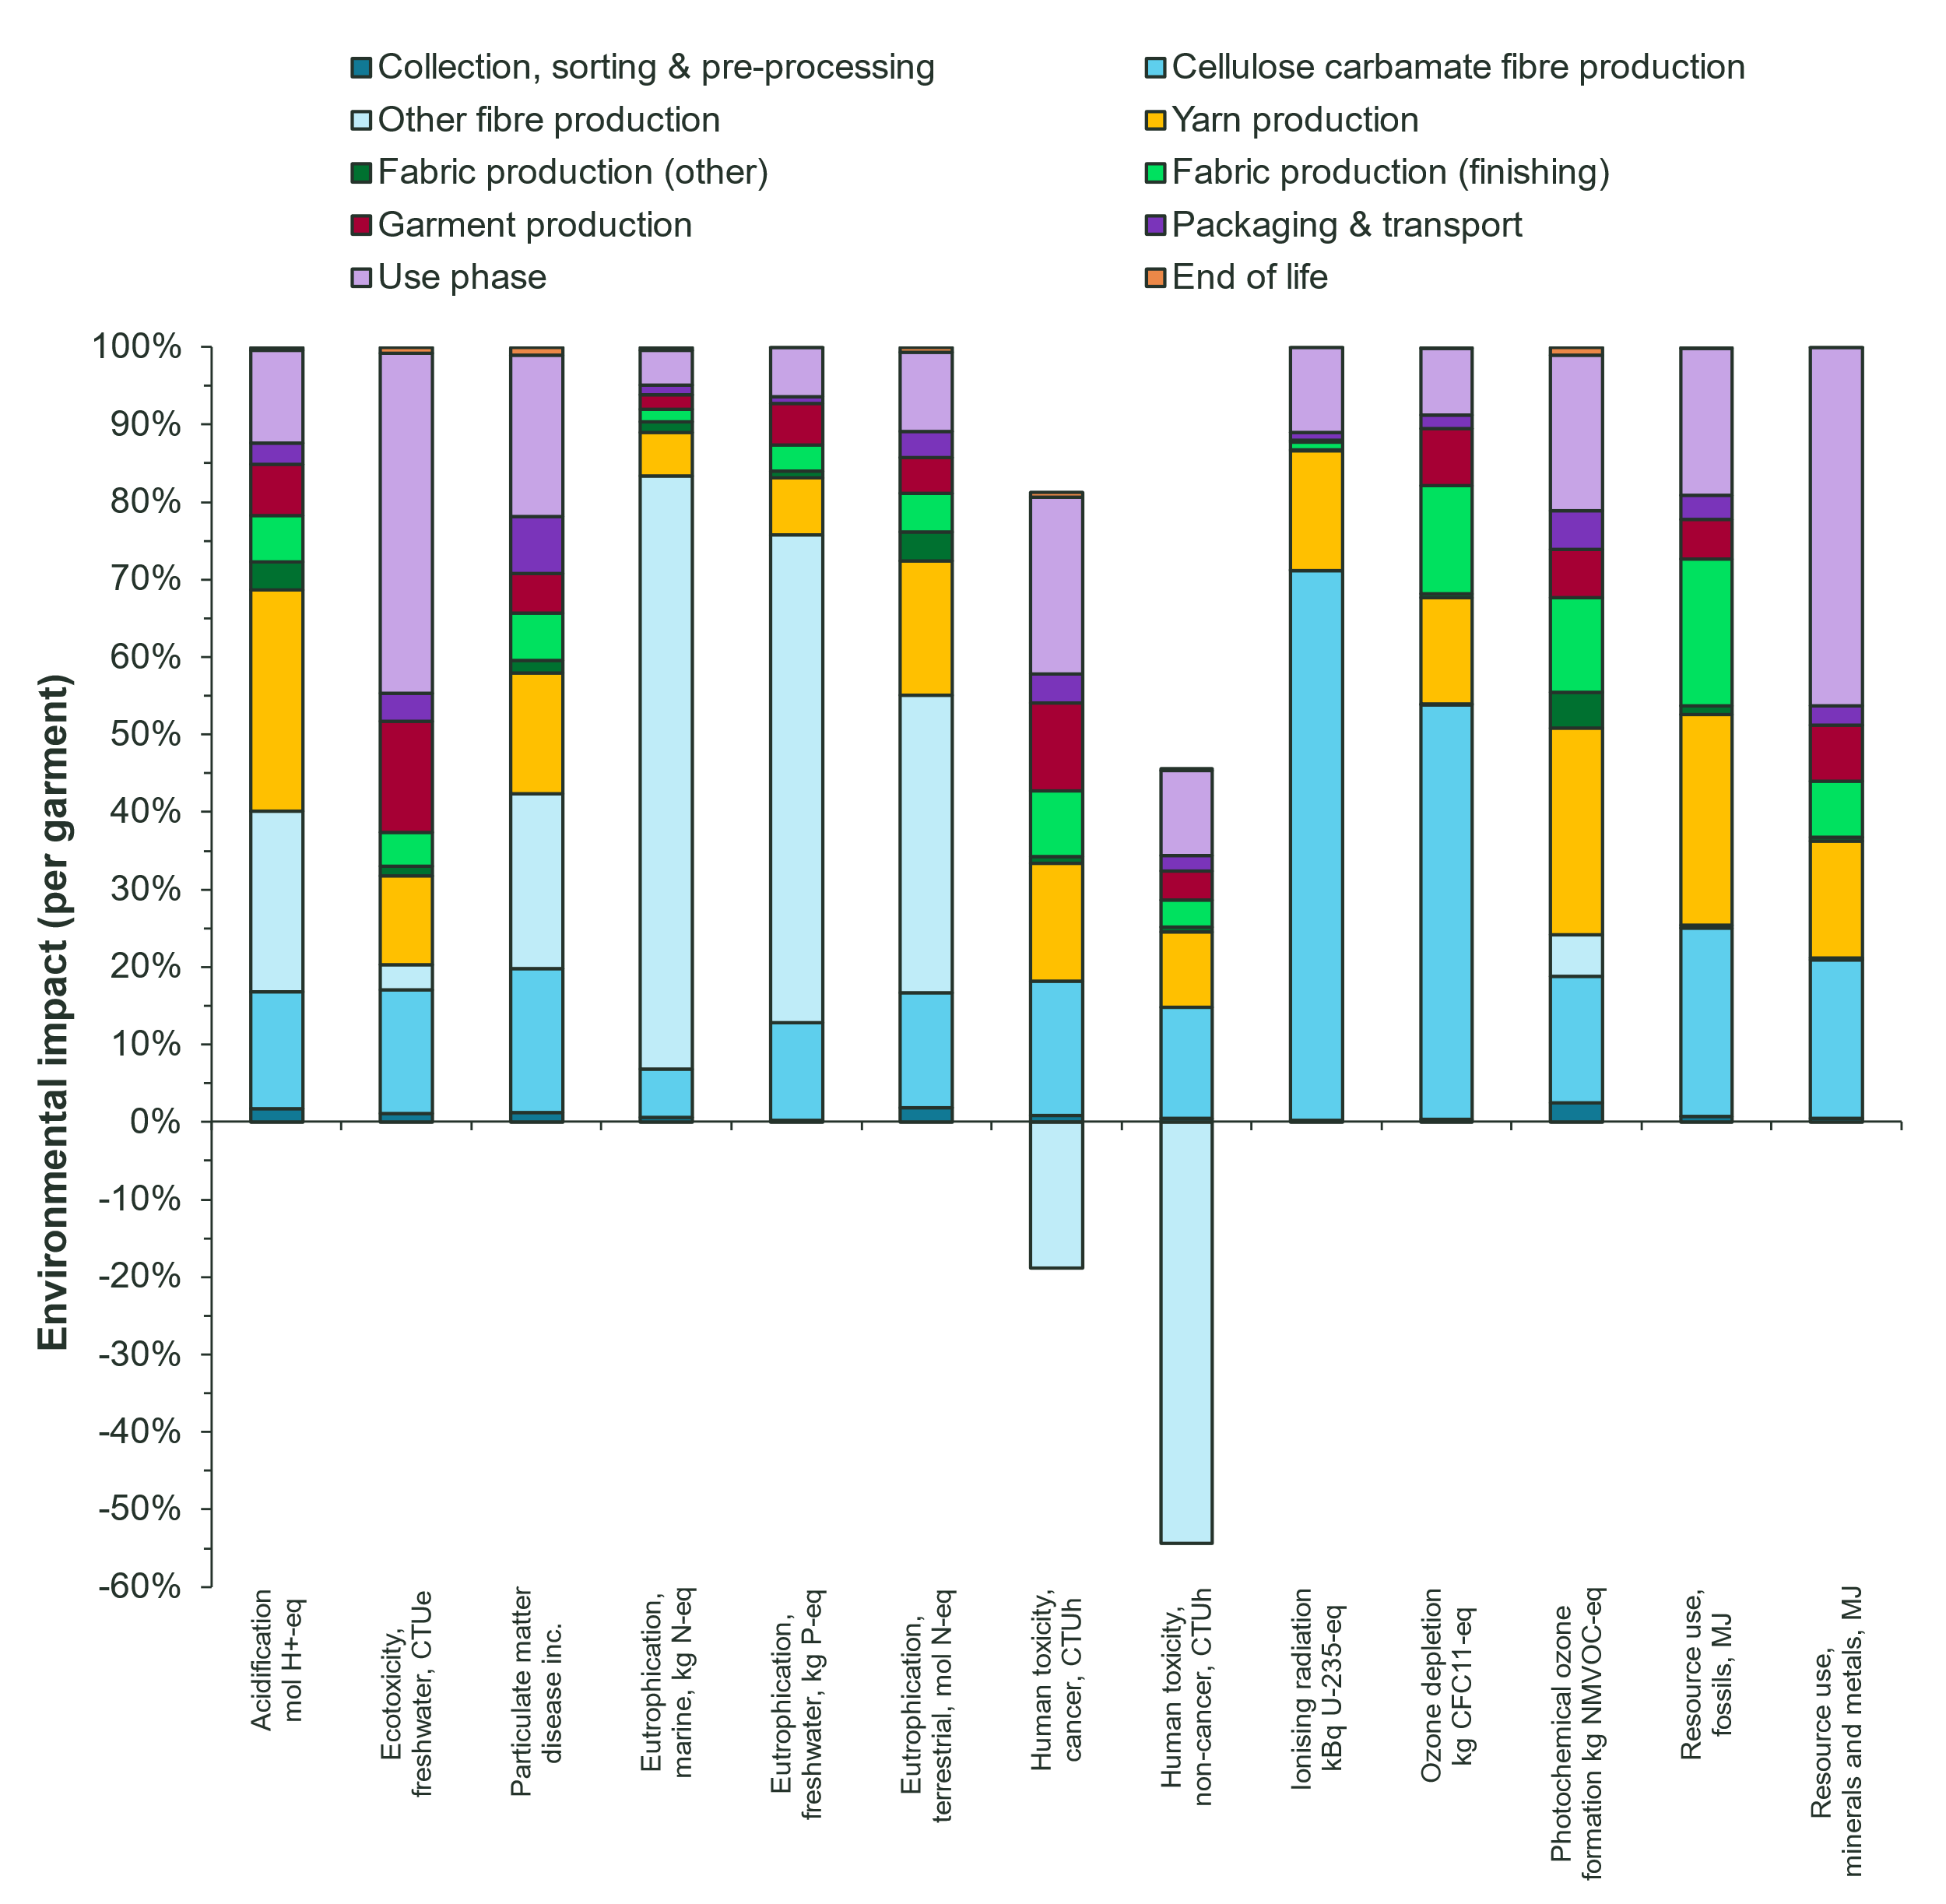
Figure S.1. Environmental impact of one knitted hoodie (base case), evaluated with impact categories and methods from the EF3.1 method.

