Supplementary material to:

Extrapolation factors for calculating ecotoxicity effects in LCA

Rahul Aggarwalª, Mikael Gustavsson^{b}, Gregory Petersª, Sverker Molanderª
ªEnvironmental Systems Analysis, Chalmers University of Technology, Vera Sandbergs Allé 8, 41296, Gothenburg, Sweden
^{b}Department of Mathematical Sciences, Chalmers University of Technology and University of Gothenburg, Gothenburg, Sweden
* Corresponding author. E-mail address: rahula@chalmers.se, +46 72 393 2945

Ecotoxicity data harmonization framework steps description
The data was curated according to five main steps: chemical identification; data reliability control; data harmonization, consistency checking and ecologically relevant effects.
The initial step of chemical identification guarantees that every data point is distinctly associated with its corresponding chemical. For REACH, information includes both the EC and CAS registry numbers, while CompTox incorporates CAS numbers and DTXSIDs. To ensure uniformity across datasets, the CAS number was selected as the main identifier, with DTXSID serving as a secondary reference. Thus, each chemical is uniquely identified by its CAS number and DTXSID. In situations where CAS numbers were missing, efforts were made to fill these gaps. However, chemicals lacking CAS numbers were excluded from the analysis.
The data reliability control step focuses on ensuring the integrity of the data by using the databases metadata to filter out information of lesser reliability. For the dataset from ECHA, data reliability assessments were conducted using the Klimisch score (Klimisch et al., 1997), with only scores of 1 (reliable without restriction) and 2 (reliable with restrictions) considered as reliable, thereby excluding any data not meeting these criteria. Within the CompTox database, the reliability of data was evaluated based on the QC Status indicator. Records marked with a "pass" for QC Status were identified as reliable and subsequently included in the analysis.
In the third step (data harmonization) consistent test species naming and classification, effect concentration indicator terms, study duration units, exposure duration classes, and ecotoxicity concentration units are obtained. These are described further below:
Numeric qualifiers: Datapoints with qualifiers other than "=" were excluded
Tested species naming and classification: Species names were harmonized based on the common species nomenclature found in the US EPA ECOTOX knowledgebase (U.S.EPA, 2023), and subsequently grouped according to their species classifications. While the REACH dossiers provide a broad species group classification, such as Fish, Invertebrates, Algae, Vertebrates, and Microorganisms, discrepancies in this classification led to its non-utilization. Instead, the aquatic species grouping from the US EPA ECOTOX knowledgebase was adopted. Datapoints for tested species were classified into groups such as (i) Algae and Cyanobacteria, (ii) Amphibians, (iii) Fish, (iv) Crustaceans, (v) Aquatic Plants (excluding Algae, which covers Flowers, Trees, Shrubs, and Ferns), (vi) Fungi, (vii) Insects/Spiders, (viii) Invertebrates, (ix) Molluscs, (x) Moss and Hornworts, (xi) Reptiles, and (xii) Worms. Any other aquatic species not fitting into these classifications were placed under the "Miscellaneous" group, which includes entities like bacteria, plankton, bacteriophage, microbial community, and various aquatic community organisms. Datapoints without a standardized species name in ECOTOX or those pertaining to non-aquatic ecosystems were excluded from the dataset.
Exposure classification: While the REACH dossiers typically classify test durations as short-term or long-term toxicity, inconsistencies in this classification led to its non-utilization. Datapoints from REACH with missing information were omitted. Exposure duration units were standardized to days. These were then categorized based on the species group to which the tested species belonged and its exposure duration relative to its chronic exposure duration threshold. The chronic exposure duration thresholds were set at 1 day for entities like algae, cyanobacteria, bacteria, and fungi; 4 days for invertebrates, specifically crustaceans; and 7 days for fish, other invertebrates, vertebrates, and aquatic plants excluding algae (Aurisano et al., 2019). This helped in distinguishing between acute and chronic exposures. For CompTox data, entries with missing information were excluded, but those with unconvertible units were labeled as "other." Additional details provided in CompTox, such as study duration class, risk assessment class, species lifespan, and non-temporal study duration units (e.g., alevin, larva to adult, Gosner stage), were utilized to categorize exposures as either acute or chronic.
Effect Concentration unit: The units for effect datapoints were standardized to milligrams per liter (mg/L). Entries with missing effect values or those with unconvertible and ambiguous units, such as % diet, mg/org, mL/kg bw, mM/plate, and so forth, were omitted from the dataset.
Effect concentration indicators classification: Effect concentration indicators were harmonized and grouped into two categories: EC10eq and EC50eq. It has long been known that the biological effect seen at concentrations reported as NOECs typically span between 10 to 30% (Crane & Newman, 2000; Moore & Caux, 1997; US EPA, 1991). This has led to a long debate on the usability of NOEC concentrations, and direct inferences of specific low effect concentrations (e.g. the EC10) have been suggested as suitable alternatives (Azimonti & et al., 2015). Currently NOEC and EC10 are used interchangeably in the derivation of safe concentrations within many regulatory frameworks, such as the European Union REACH regulation, plant protection product regulation and Water Framework Directive (ECHA, 2008; EFSA, 2013; European Commission, 2011). Therefore, in this study the EC10eq group comprises effect concentration indicators ranging from EC0, EL0, IC0, LC0, NOAEC, NOEC, NOEL, EC1 to EC10, IC10, LC10, and LOEC. The EC50eq group encompasses effect concentration indicators like EC50, ErC50, ErL50, IC50, and LC50. Datapoints that could not be classified into these two groups or had missing information were excluded. Unclassifiable effect concentration indicators, typically specific measurements that are not standard practice, were limited in number and thus not further analyzed.
Next, a consistency checking step ensures that the information sourced is strictly experimental and is both data gap-free and devoid of duplicates. By 'experimental,' we refer to datapoints that are directly measured, as opposed to those calculated using QSARs or read-across techniques, which are removed. By 'gap-free,' we mean that each necessary metadata field is present and complete for every data point. For the REACH data, potential duplicates were identified based on having the same CAS, type of information, reliability, media type, effect, database, numeric qualifier, common species name, species group, effect concentration indicator, and effect concentration units and value. For CompTox, duplicates were identified based on same CAS, media type, critical effect, year of the data, data reference source, reference title, author of the data, numeric qualifier, common species name, species group, effect concentration indicator, and effect concentration units and value. After individual scrutiny, the REACH and CompTox datasets were merged, and a subsequent duplicate check was performed on the combined set based on the same CAS, media type, numeric qualifier, common species name, species group, effect concentration indicator, and effect concentration units and value.
Upon merging the two datasets, the relevance of effects at the aquatic ecosystem level were assessed. Data points with ambiguous relevance to aquatic ecotoxicity, such as biomarkers encompassing biochemistry and genetics, were excluded. This approach aligns with the data harmonization methodology employed by Holmquist et al. (2020).

Selection and harmonization framework results
The data retrieved from REACH and CompTox were used as raw inputs in the framework for data selection and harmonization, ensuring a high-quality dataset for extrapolation across effect concentration indicators, exposure durations, and test species group. The initial data from the ECHA database included 225,517 records, providing toxicity information on 12,411 chemicals with EC Numbers. Meanwhile, the CompTox database contained 517,067 data points, detailing ecotoxicity information for 8,640 chemicals.
The first step of the framework, chemical identification, centered on identifying the collected datapoints based on the chemical in question, using CAS as the primary chemical identifier and complemented by DSSTox substance identifier (DTXSID), as detailed in section 1.1. In the ECHA data, only 9,035 CAS numbers were linked to the data points, leading to the exclusion of 48,221 data points. In the CompTox data, only 8,639 CAS numbers were identified, resulting in the exclusion of 1,264 data points. The exclusion rate was higher in the REACH data, as out of the 12,411 chemicals with EC Numbers, 3,376 did not have CAS numbers. Post this step, the final harmonized data comprised 177,296 datapoints for 9,035 chemicals in REACH and 515,803 datapoints for 8,639 chemicals in CompTox.
Input data reliability control step 23,545 data points were removed from the REACH dataset on account of non-reliable Klimisch scores. From the CompTox dataset, 11,448 data points were excluded. After this step, the final harmonized data stood at 153,751 datapoints for 8,854 chemicals in REACH and 504,355 datapoints for 8,549 chemicals in CompTox.
The data harmonization step started with numeric qualifiers such as >, < and =. All reported effect values accompanied by numeric qualifiers other than “=” were excluded, resulting in the exclusion of 43,249 datapoints and 1,521 chemicals from the REACH data and 27,292 datapoints and 332 chemicals from the CompTox data. The harmonization of tested species naming and classification, as defined in section 1.1, led to the exclusion of 8,961 datapoints and 553 chemicals from the REACH data and 9,154 datapoints and 281 chemicals from the CompTox data. The steps for exposure classification and effect concentration indicator classification, as defined in section 1.1, resulted in the exclusion of 9,911 datapoints and 52 chemicals from the REACH data and 33,167 datapoints and 232 chemicals from the CompTox data. The effect concentration unit step, also defined in section 1.1, led to the exclusion of 781 datapoints and 9 chemicals from the REACH data and 21,803 datapoints and 240 chemicals from the CompTox data. After the third step, the harmonized dataset included 90,849 datapoints for 6,719 chemicals in REACH and 412,939 datapoints for 7,464 chemicals in CompTox.
The next step of the framework, consistency checking, resulted in many deletions. Starting with the experimental criteria, this resulted in the exclusion of 11,040 datapoints and 1,331 chemicals from the REACH data, with no exclusions in the CompTox data. Then, based on data gaps in any of the criteria defined in section 1.1, 671 datapoints and 70 chemicals were excluded from the REACH data, with no exclusions in the CompTox data. The duplicate verification process led to the removal of 6,433 datapoints from the REACH data and 48,505 datapoints from the CompTox data. Post these eliminations, the harmonized data comprised 72,705 datapoints for 5,318 chemicals in REACH and 364,434 datapoints for 7,464 chemicals in CompTox. The culmination of this process involved merging the two datasets, and a subsequent duplicate verification led to the removal of an additional 2,485 datapoints from the consolidated set.
After merging the datasets, a consolidated dataset containing 434,654 datapoints for 11,295 chemicals was obtained. Of these, 1,487 chemicals were found in both databases post-harmonization. The relevance of effects at the aquatic ecosystem level was then evaluated within this combined dataset. Ambiguous data points, particularly those related to biomarkers such as biochemistry and genetics, were removed. This refinement led to a streamlined dataset of 339,729 datapoints for 10,668 chemicals. Through this process, 94,925 datapoints and 627 chemicals were excluded from the initial harmonized dataset.

Ecotoxicity extrapolation factor results for EC50 chronic
The objective of this section is to calculate extrapolation factors that can convert various effect concentration indicators to EC50 chronic, in line with the requirements of USEtox 2.13. This conversion is essential to effectively utilize the available ecotoxicological effect data in the calculation of characterization factors through extrapolation factor computation. Consequently, extrapolation factors were first calculated for each species group as shown in Table 1 along with Figure 1 and subsequently generic default extrapolation factors as shown in Table 2 along with Figure 2 to transform different effect concentration indicators at varying exposure levels to EC50 chronic. Additionally, the study also provides the best fit regression equation specifically for EC50 chronic conversion.
Table 1: Default extrapolation factors by species group: converting various effect concentration indicators across exposure levels to EC50 chronic using linear regressions (slope = 1)
Extrapolation to EC50 chronic from different effect concentration indicators | Species group | Default extrapolation factor | Datapoints | Intercept | Intercept Lower 95% | Intercept Upper 95% | Slope | Slope Lower 95% | Slope Upper 95% | Correlation (r ) | Rsquare (R2) | Intercept* (Slope =1) | Intercept* Lower 95% | Intercept* Upper 95%
EC10 acute | Algae | 2.75 | 305 | 0.41 | 0.30 | 0.52 | 0.54 | 0.48 | 0.61 | 0.67 | 0.45 | 0.44 | 0.30 | 0.58
EC10 chronic | Algae | 3.52 | 2937 | 0.58 | 0.56 | 0.60 | 0.85 | 0.83 | 0.87 | 0.88 | 0.77 | 0.55 | 0.52 | 0.57
EC50 acute | Algae | 0.45 | 473 | 0.02 | -0.09 | 0.13 | 0.54 | 0.48 | 0.60 | 0.62 | 0.39 | -0.34 | -0.46 | -0.23
EC10 acute | Amphibians | 1.84 | 55 | 0.31 | 0.04 | 0.57 | 0.61 | 0.43 | 0.79 | 0.68 | 0.47 | 0.26 | -0.04 | 0.57
EC10 chronic | Amphibians | 7.34 | 59 | 0.78 | 0.56 | 1.01 | 0.74 | 0.59 | 0.90 | 0.78 | 0.61 | 0.87 | 0.63 | 1.10
EC50 acute | Amphibians | 0.97 | 59 | 0.12 | -0.16 | 0.40 | 0.63 | 0.43 | 0.83 | 0.64 | 0.41 | -0.01 | -0.31 | 0.29
EC10 acute | Crustaceans | 0.66 | 582 | -0.15 | -0.23 | -0.07 | 0.76 | 0.71 | 0.81 | 0.78 | 0.61 | -0.18 | -0.26 | -0.10
EC10 chronic | Crustaceans | 2.83 | 859 | 0.41 | 0.37 | 0.46 | 0.91 | 0.88 | 0.94 | 0.89 | 0.79 | 0.45 | 0.41 | 0.50
EC50 acute | Crustaceans | 0.31 | 835 | -0.45 | -0.51 | -0.39 | 0.89 | 0.85 | 0.93 | 0.84 | 0.71 | -0.51 | -0.57 | -0.45
EC10 acute | Fish | 0.87 | 407 | 0.00 | -0.11 | 0.11 | 0.78 | 0.70 | 0.85 | 0.71 | 0.50 | -0.06 | -0.17 | 0.05
EC10 chronic | Fish | 4.03 | 443 | 0.55 | 0.46 | 0.63 | 0.84 | 0.78 | 0.90 | 0.79 | 0.63 | 0.61 | 0.52 | 0.69
EC50 acute | Fish | 0.35 | 566 | -0.41 | -0.49 | -0.33 | 0.94 | 0.89 | 0.99 | 0.83 | 0.68 | -0.45 | -0.52 | -0.38
EC10 acute | Insects/Spiders | 0.60 | 87 | -0.49 | -0.84 | -0.14 | 0.74 | 0.57 | 0.91 | 0.68 | 0.46 | -0.22 | -0.54 | 0.09
EC10 chronic | Insects/Spiders | 2.12 | 107 | 0.31 | 0.05 | 0.57 | 0.99 | 0.86 | 1.11 | 0.83 | 0.70 | 0.33 | 0.12 | 0.53
EC50 acute | Insects/Spiders | 0.20 | 110 | -0.71 | -0.94 | -0.48 | 0.95 | 0.84 | 1.07 | 0.84 | 0.70 | -0.69 | -0.91 | -0.47
EC10 acute | Invertebrates | 0.72 | 53 | -0.23 | -0.46 | 0.01 | 0.66 | 0.43 | 0.89 | 0.63 | 0.40 | -0.14 | -0.39 | 0.10
EC10 chronic | Invertebrates | 2.78 | 55 | 0.34 | 0.05 | 0.63 | 0.86 | 0.64 | 1.08 | 0.73 | 0.54 | 0.44 | 0.20 | 0.69
EC50 acute | Invertebrates | 0.37 | 58 | -0.35 | -0.63 | -0.08 | 0.79 | 0.58 | 1.01 | 0.70 | 0.50 | -0.43 | -0.70 | -0.16
EC10 acute | Molluscs | 0.42 | 122 | -0.39 | -0.57 | -0.21 | 0.51 | 0.37 | 0.65 | 0.55 | 0.30 | -0.37 | -0.59 | -0.16
EC10 chronic | Molluscs | 3.13 | 107 | 0.30 | 0.12 | 0.48 | 0.81 | 0.69 | 0.92 | 0.80 | 0.65 | 0.50 | 0.35 | 0.64
EC50 acute | Molluscs | 0.19 | 137 | -0.65 | -0.80 | -0.50 | 0.83 | 0.69 | 0.96 | 0.73 | 0.53 | -0.73 | -0.87 | -0.58
EC10 acute | Worms | 0.48 | 54 | 0.09 | -0.15 | 0.34 | 0.37 | 0.20 | 0.54 | 0.52 | 0.27 | -0.32 | -0.64 | -0.01
EC10 chronic | Worms | 2.95 | 55 | 0.43 | 0.27 | 0.58 | 0.80 | 0.67 | 0.93 | 0.86 | 0.75 | 0.47 | 0.31 | 0.63
EC50 acute | Worms | 0.23 | 59 | -0.38 | -0.63 | -0.13 | 0.70 | 0.52 | 0.87 | 0.72 | 0.52 | -0.63 | -0.85 | -0.42

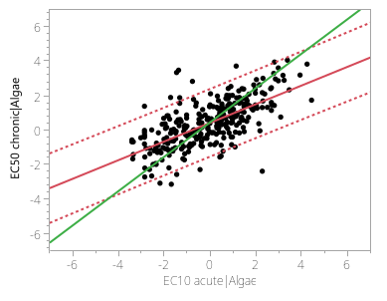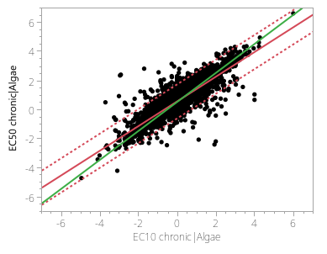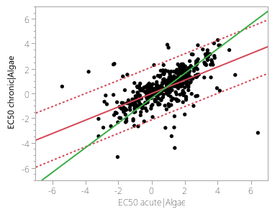
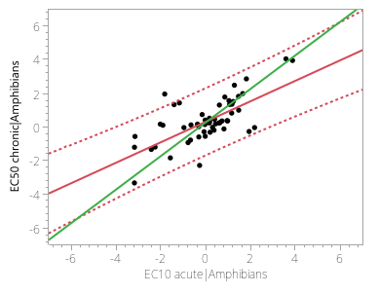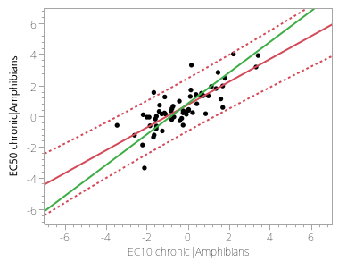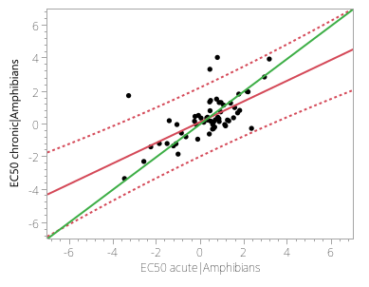
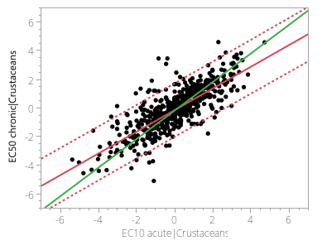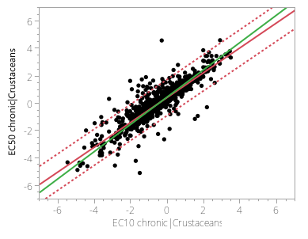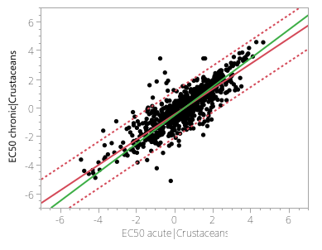
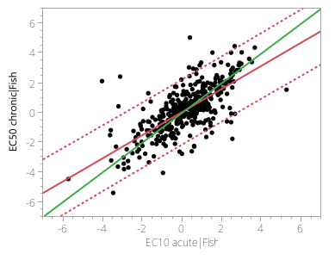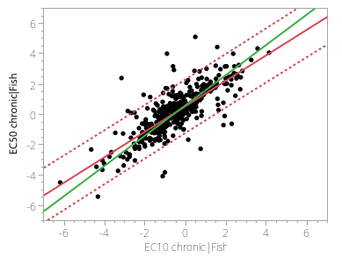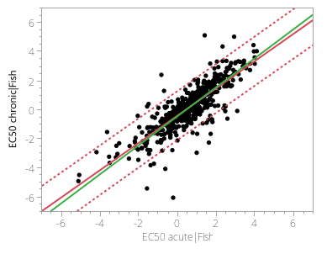
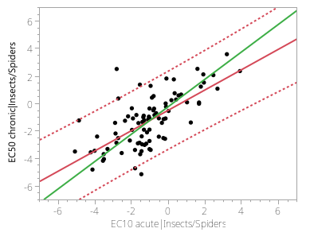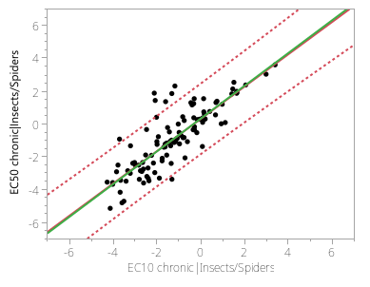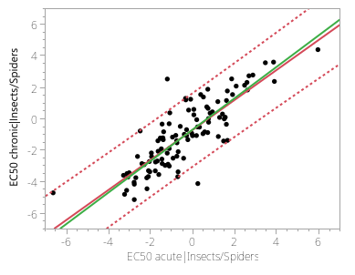
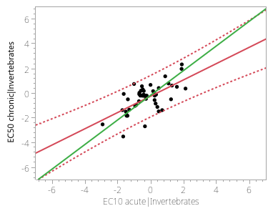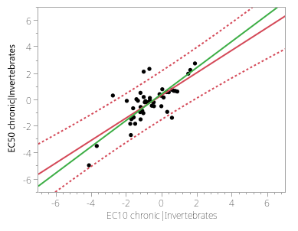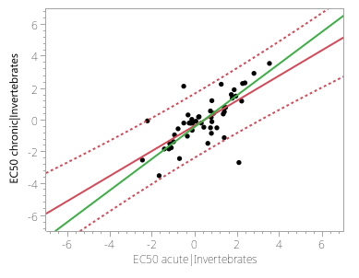
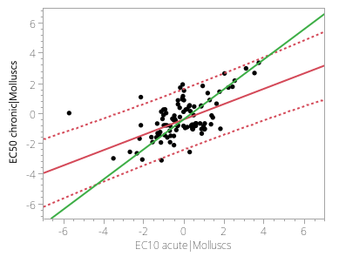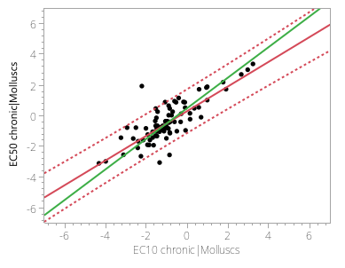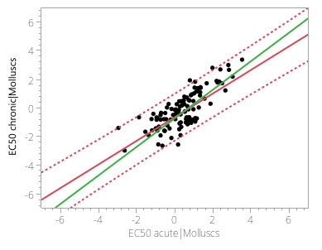
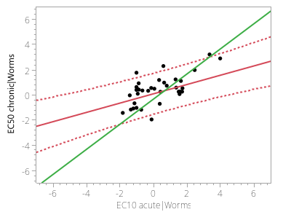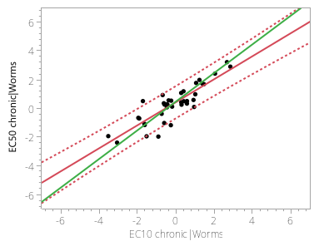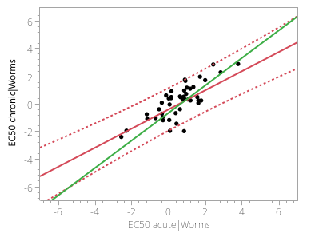
Figure 1: Pairwise comparison of various ecotoxicological effect concentration indicators (log mg/l), as detailed in Table 1. The red line depicts a linear regression fit with an unconstrained slope, while the green line showcases a linear regression fit where the slope is set to unity. The dotted line represents the 95% confidence interval.
Table 2: Default generic extrapolation factors converting various effect concentration indicators across exposure levels to EC50 chronic using linear regressions (slope = 1) and regression equation with a free slope
Extrapolation to EC50 chronic from different effect concentration indicators | Regression equation | Default extrapolation factor | Datapoints | Intercept | Intercept Lower 95% | Intercept Upper 95% | Slope | Slope Lower 95% | Slope Upper 95% | Correlation (r ) | Rsquare (R2) | Intercept* (Slope =1) | Intercept* Lower 95% | Intercept* Upper 95%
EC10 acute | EC50 chronic = 1.44*(EC10 acute)^{0.69} | 0.97 | 2647 | 0.16 | 0.11 | 0.20 | 0.69 | 0.66 | 0.72 | 0.66 | 0.44 | -0.01 | -0.06 | 0.03
EC10 chronic | EC50 chronic = 3.46*( EC10 chronic) ^{0.86} | 3.38 | 3543 | 0.54 | 0.52 | 0.56 | 0.86 | 0.84 | 0.88 | 0.84 | 0.70 | 0.53 | 0.50 | 0.55
EC50 acute | EC50 chronic = 0.71*( EC50 acute) ^{0.78} | 0.45 | 3596 | -0.15 | -0.19 | -0.11 | 0.78 | 0.76 | 0.81 | 0.72 | 0.52 | -0.35 | -0.38 | -0.31

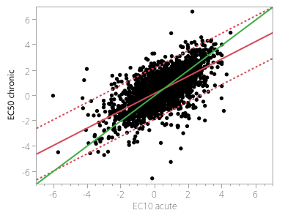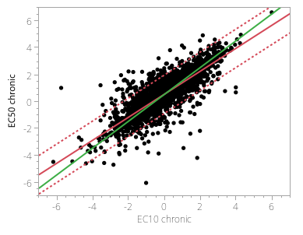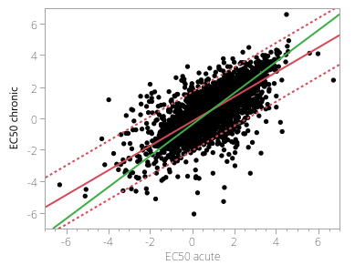
Figure 2: Pairwise comparison of various ecotoxicological effect concentration indicators (log mg/l), as detailed in Table 2. The red line depicts a linear regression fit with an unconstrained slope, while the green line showcases a linear regression fit where the slope is set to unity. The dotted line represents the 95% confidence interval.
Table 1 and Table 2 present both generic and species-specific extrapolation factors (with the slope set to unity) alongside the available datapoints for effect concentration indicators compared with the EC50 chronic of chemical-species combinations. For several combinations, particularly for species groups of aquatic plants, fungi, moss hornworts and reptiles, data were insufficient to support robust regressions, so we do not calculate extrapolation factors for these groups. Consequently, for these particular species groups, one might consider applying generic default extrapolation factors at the effect concentration indicator level or resorting to extrapolation factors from closely related species groups, if available. For other species groups with datapoints pairs exceeding 50, the dataset is deemed sufficient to produce a reliable regression.

Comparison of ecotoxicity extrapolation factors with prior research
When examining extrapolation at the species level, there are noticeable differences between the factors calculated in this study and those from previous research. For the transition from EC50 acute to EC50 chronic, Aurisano et al. (2019) determined factors of 0.58, 0.32, and 0.88 for fish, invertebrates, and algae respectively. In contrast, Saouter et al. (2019) found factors of 0.27 for fish and 0.18 for crustaceans. Our study presents different values: 0.35 for fish, 0.37 for invertebrates, 0.45 for algae, and 0.31 for crustaceans. For the extrapolation from NOEC chronic to EC50 chronic, Aurisano et al. (2019) reported factors of 3.2 for fish, 2.8 for invertebrates, and 5.6 for algae and for the transition from EC10 chronic to EC50 chronic, factors of 3.1 for fish, 1.5 for invertebrates, and 3.7 for algae. Our study however used EC10eq combining NOEC and EC10 as decscribed in section 1.1, found factors of 4.03 for fish, 2.78 for invertebrates, and 3.52 for algae. Moving from NOEC acute to EC50 chronic, Aurisano et al. (2019) identified factors of 1.3 for fish and 0.7 for invertebrates, whereas our study determined them to be 0.87 and 0.72 respectively.
Comparing the default generic extrapolation factors from this study with those previously published offers insights into the evolution of the results as more data is incorporated. For instance, when extrapolating from EC50 acute to EC50 chronic, our study determined a default generic extrapolation factor of 0.45. This aligns closely with the 0.50 found in studies by Aurisano et al. (2019), De Zwart (2002) and Payet (2004), but is notably higher than the 0.33 suggested by Posthuma et al. (2019). In the case of extrapolating from NOEC chronic to EC50 chronic, our derived factor is 3.38, which is different from 4.8 proposed by Payet (2004). However, it is considerably higher than the factors of 2.5, 3, and 3 presented by Aurisano et al. (2019), De Zwart (2002) and Posthuma et al. (2019) respectively. For the transition from NOEC acute to EC50 chronic, this study factor is 0.97, closely mirroring the 0.83 from Aurisano et al. (2019). Lastly, when extrapolating from EC10 chronic to EC50 chronic, we calculated a factor of 3.38, higher than the 2 suggested by Aurisano et al. (2019).

References
Aurisano, N., Albizzati, P. F., Hauschild, M., & Fantke, P. (2019). Extrapolation Factors for Characterizing Freshwater Ecotoxicity Effects. Environmental Toxicology and Chemistry, 38(11), 2568-2582. https://doi.org/https://doi.org/10.1002/etc.4564
Azimonti, & et al. (2015). Comparison of NOEC values to EC10/EC20 values, including confidence intervals, in aquatic and terrestrial ecotoxicological risk assessment. EFSA Supporting Publications, 12(12), 906E.
Crane, M., & Newman, M. C. (2000). What level of effect is a no observed effect? Environmental Toxicology and Chemistry, 19(2), 516-519. https://doi.org/https://doi.org/10.1002/etc.5620190234
De Zwart, D. (2002). Observed regularities in species sensitivity distributions for aquatic species. Species Sensitivity Distributions in Ecotoxicology, 133-154.
ECHA. (2008). Guidance on information requirements and chemical safety assessment. Chapter R.10: Characterisation of dose [concentration]-response for environment. (Risk characterisation, Issue. https://echa.europa.eu/guidance-documents/guidance-on-information-requirements-and-chemical-safety-assessment
EFSA, P. o. P. P. P. t. R. (2013). Guidance on tiered risk assessment for plant protection products for aquatic organisms in edge‐of‐field surface waters. EFSA Journal, 11(7), 3290.
European Commission. (2011). Technical Guidance for Deriving Environmental Quality Standards. Common Implementation Strategy for the Water Framework Directive (2000/60/EC). Guidance Document No. 27. Prepared by EU, Member States and stakeholders.
Holmquist, H., Fantke, P., Cousins, I. T., Owsianiak, M., Liagkouridis, I., & Peters, G. M. (2020). An (Eco)Toxicity Life Cycle Impact Assessment Framework for Per-And Polyfluoroalkyl Substances [Article]. Environmental Science and Technology, 54(10), 6224-6234. https://doi.org/10.1021/acs.est.9b07774
Klimisch, H. J., Andreae, M., & Tillmann, U. (1997). A systematic approach for evaluating the quality of experimental toxicological and ecotoxicological data. Regulatory Toxicology and Pharmacology, 25(1), 1-5. https://doi.org/10.1006/rtph.1996.1076
Moore, D. R. J., & Caux, P.-Y. (1997). Estimating low toxic effects. Environmental Toxicology and Chemistry, 16(4), 794-801. https://doi.org/https://doi.org/10.1002/etc.5620160425
Payet, J. (2004). Assessing toxic impacts on aquatic ecosystems in life cycle assessment (LCA)
Posthuma, L., van Gils, J., Zijp, M. C., van de Meent, D., & de Zwartd, D. (2019). Species sensitivity distributions for use in environmental protection, assessment, and management of aquatic ecosystems for 12 386 chemicals. Environmental Toxicology and Chemistry, 38(4), 703-711. https://doi.org/10.1002/etc.4373
Saouter, E., Wolff, D., Biganzoli, F., & Versteeg, D. (2019). Comparing Options for Deriving Chemical Ecotoxicity Hazard Values for the European Union Environmental Footprint, Part II. Integrated Environmental Assessment and Management, 15(5), 796-807. https://doi.org/https://doi.org/10.1002/ieam.4169
U.S.EPA. (2023). ECOTOX | Explore. Retrieved September from https://cfpub.epa.gov/ecotox/explore.cfm?sub=Species
US EPA. (1991). Technical support document for water quality-based toxics control (EPA/505/2-90-001, Issue.

