Supplementary Information 1
Benefits and impacts of offshore wind farms on benthic marine biodiversity in a life cycle assessment context
Liv Stranddorf^{a,b,c} *, Francesca Verones^{d}, Stig Irving Olsen^{a,c}
ª Section for Quantitative Sustainability Assessment, Department of Environmental and Resource Engineering, Bygningstorvet, Building 115, Technical University of Denmark (DTU), 2800 Kgs. Lyngby, Denmark
^{b} Environment and Sustainability Unit, Vattenfall Vindkraft, 6000 Kolding, Denmark
^{c} Centre for Absolute Sustainability Assessment, Technical University of Denmark (DTU), 2800 Kgs. Lyngby, Denmark
^{d} Industrial Ecology Programme, Department of Energy and Process Engineering, Norwegian University of Science and Technology (NTNU), 7491 Trondheim, Norway

*Corresponding author: Liv Stranddorf, email: livks@dtu.dk

Introduction to the Supplementary Information
The Supplementary Information (SI) consists of two files: this pdf file (referenced in the manuscript as SI1) and a spreadsheet (referenced in the manuscript as SI2). This file contains details on the investigation of which variables influence species richness (section 1), an investigation of the abundance of species (section 2), a list of the taxonomic groups investigated and included in the study (section 3), and statistical parameters for the richness models (section 4). The developed Characterization Factors (CFs) can be found in the spreadsheet.
Table of content
1. Investigation of variables influencing species richness 4
1.1. Correlation coefficients 4
1.2. Visual investigations of species richness 5
2. Visual investigation of species abundance 13
3. Investigation of substrate types 16
4. Sample sizes 18
5. Taxonomic groups 19
6. Alien species 20
7. Statistics for richness models 21

- Investigation of variables influencing species richness
The correlation between species richness and each potential explanatory variable was explored through visual investigations and correlation assessments to identify which parameters influence species richness. For this, the data were divided into two datasets covering (1) samples from the water column structure and (2) samples from the scour protection. All investigations were carried out using the software R version 4.3.2.
  - Correlation coefficients
Using the cor.test function in R, we tested for association between the species richness and different variables for the subset of samples on the vertical structure (Structure) and scour protection respectively (Table S1). We calculated Pearson’s product-moment correlation, which measures linear correlation, and Spearman’s rank correlation, which measures monotonic correlation. For both correlation assessments, an absolute value of 1 implies a perfect correlation between the variables. Correlation coefficients above 0.5 were considered to be significant (Mukaka, 2012). Species richness on the vertical structure appears to correlate only with the structure age (borderline). The richness on the scour protection is correlated with the structure age and sampling depth. However, we chose to only include the structure age in the CF development as the needed Life Cycle Inventory (LCI) should be the same for parts of the structure.

Table S1 – Pearson’s and Spearman’s correlation coefficients for species richness against potential explanatory variables. Coefficients are calculated for the water column structure (Structure) and for the scour protection. Values <0.50 are considered to show a significant correlation and are colored in yellow. *Only considering wind farm structures.
 |  | Structure |  | Scour protection
Parameter 1 | Parameter 2 | Pearson’s | Spearman’s | Pearson’s | Spearman’s
Richness | Installation age | 0.49 | 0.51 | 0.67 | 0.65
Richness | Sampling depth | 0.18 | 0.25 | 0.77 | 0.67
Richness | Distance to seabed | 0.10 | 0.09 | - | -
Richness | Distance to coast | 0.035 | -0.18 | -0.25 | -0.58
Richness | Area sampled | 0.23 | 0.44 | 0.04 | 0.23
Richness | Area of wind farm* | 0.45 | 0.50 | 0.45 | 0.31
Richness | Number of turbines* | 0.14 | -0.056 | -0.10 | -0.30

  - Visual investigations of species richness
The species richness was plotted against multiple variables to investigate if they influence the species richness (potential explanatory variables). The variables investigated cover installation type, foundation type, structure age, sampling depth, distance to the seabed, distance to the coast, and sampled area. In sections 1.2.1-1.2.6, each potential explanatory variable for species richness is visualized separately.
    - Installation type and foundation type
When plotting the richness against installation type (Figure S1) and foundation type (Figure S2), these two parameters seem to influence the richness. However, the samples from oil and gas structures (all are jackets) span over a much longer structure age, and from this plot, it is not possible to identify if the richness is influenced by the structure or installation type or if it is mainly influenced by the structure age (see sec. 1.2.2).
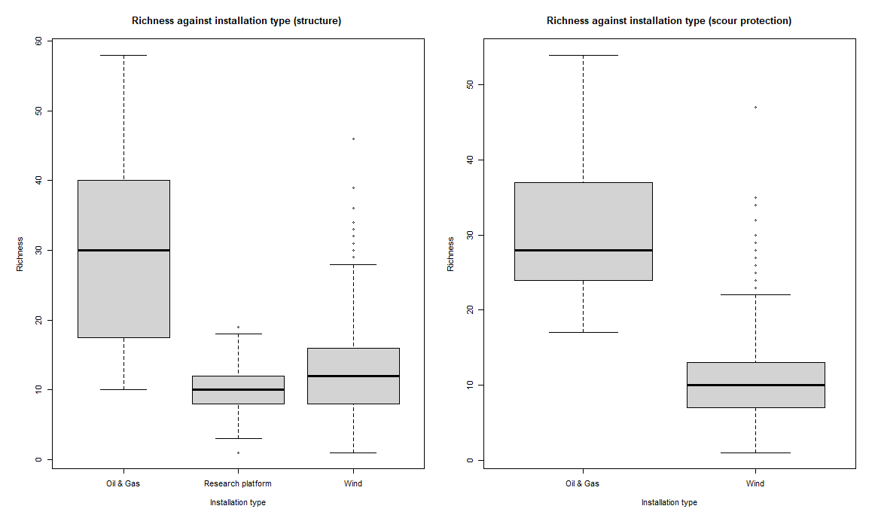
Figure S1 - Species richness (number of species) on the water column structure (left) and on the scour protection (right) plotted against the installation type. The installation types cover oil & gas platforms, a research platform (without scour protection) and wind turbines.
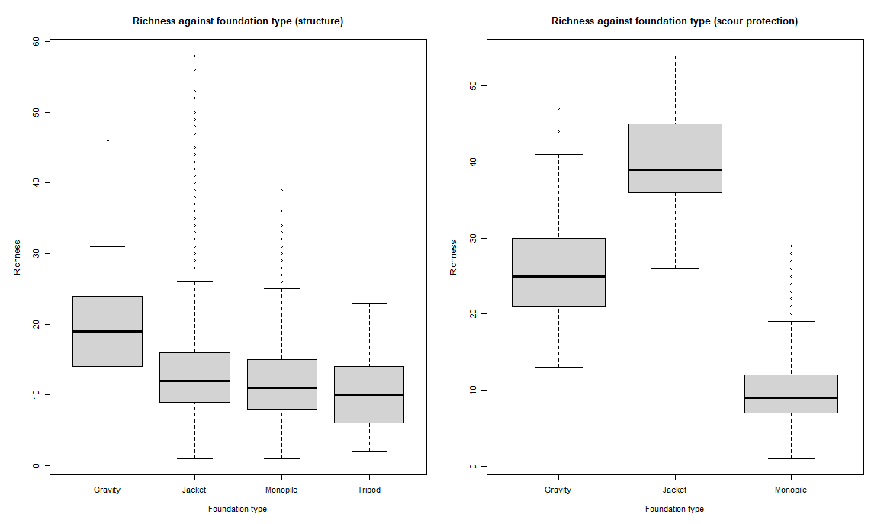
Figure S2 - Species richness (number of species) on the water column structure (left) and on the scour protection (right) plotted against the foundation type type. The foundation types cover gravity-based foundations, jackets, monopiles, and tripods (without scour protection).
To focus the investigation on the richness against the installation and foundation type, the two parameters were analyzed against the richness normalized to the structure age (Figure S3 and Figure S4). This shows that there is not a clear relationship between the richness and the foundation types. The installation types do also not appear to influence the richness on the water column structure, but the mean richness on scour protection seems to be higher on wind installations than on oil and gas structures. However, the spread of richness on scour protection around wind turbines is large and goes both lower and higher than the richness on scour protection around oil and gas platforms.
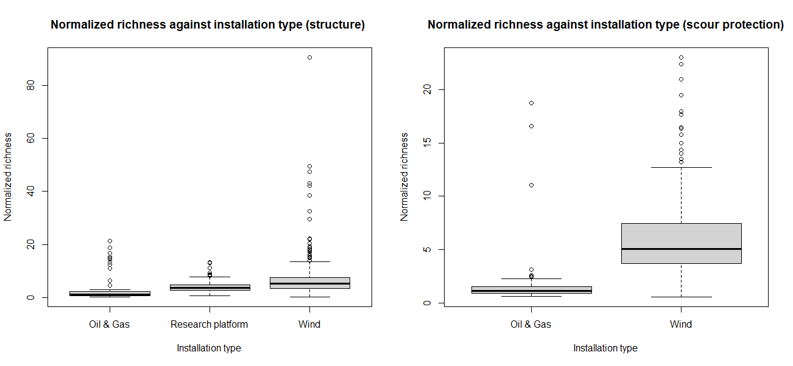
Figure S3 - Species richness on the water column structure (left) and on the scour protection (right) normalized to the structure age (number of species/year) plotted against the installation type. The installation types cover oil & gas platforms, a research platform (without scour protection), and wind turbines.
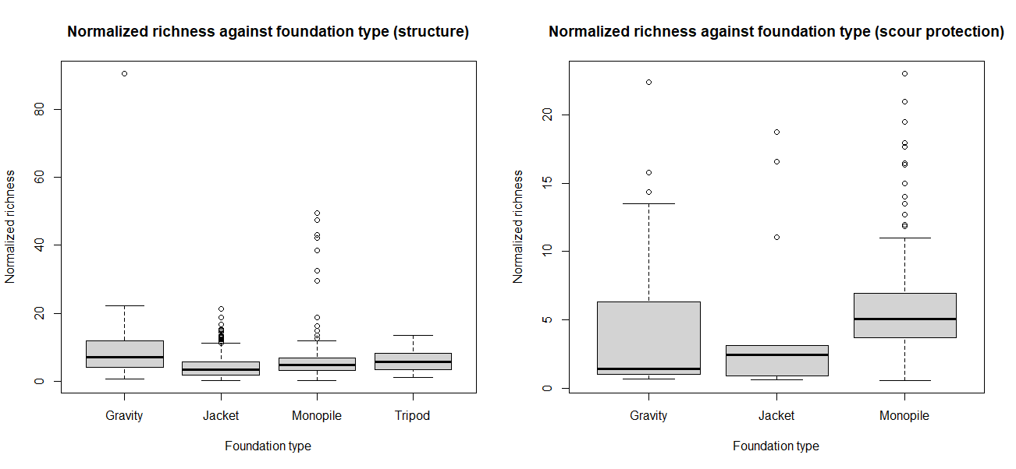
Figure S4 - Species richness on the water column structure (left) and on the scour protection (right) normalized to the structure age (number of species/year) plotted against the foundation type. The foundation types cover gravity-based foundations, jackets, monopiles, and tripods (without scour protection).

    - Installation age
The visual investigation of the species richness against installation age (Figure S5) shows that the structure age influences the species richness on both the vertical structure and the scour protection. The richness is lowest in the early years of the structure age for both the vertical structure and the scour protection. After that, the richness on scour protection goes very high, after which it decreases. The richness on the vertical structure reaches a somewhat constant level after year 8. However, importantly, the spread of richness is large for both the vertical structure and the scour protection.
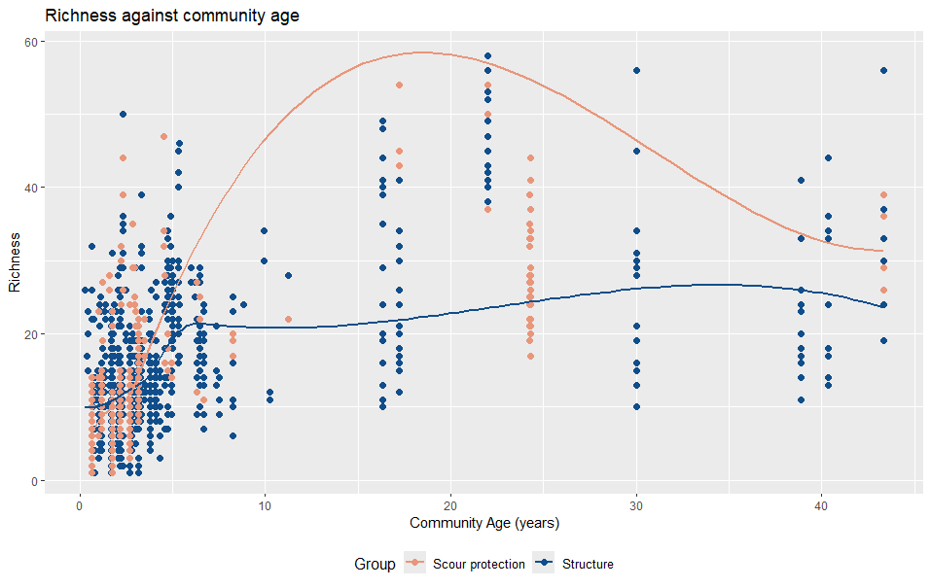
Figure S5 - Species richness (number of species) on the water column structure (blue) and on the scour protection (red) plotted against the installation age/community age (years).

    - Sampling depth
The richness seems to be somewhat influenced by the sampling depth (Figure S6). Especially for scour protection (red), the richness appears lower for structures standing in shallow waters than deep waters. The richness on the water column structure (blue) doesn’t seem to be as clearly influenced by the sampling depth. Importantly, the spread of richness is large for both the vertical structure and the scour protection.
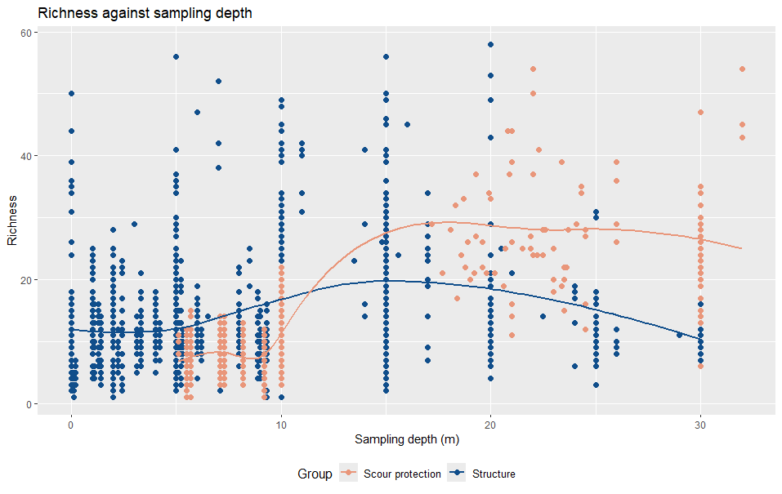
Figure S6 - Species richness (number of species) on the water column structure (blue) and on the scour protection (red) plotted against the sampling depth (m).

    - Distance to the seabed
No clear relationship is found between the species richness on the water column structures and the distance to the seabed (Figure S7).
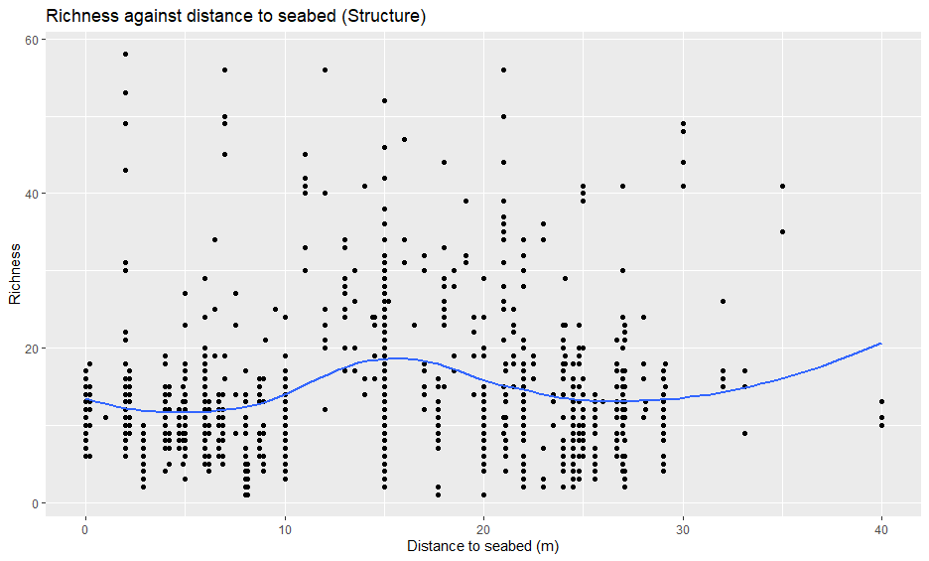
Figure S7 - Species richness on the water column structure (number of species) plotted against the distance to the seabed (m).

    - Distance to the coast
No systematic relationship is found between the species richness and the distance to the coast (Figure S8) neither for the water column structure (blue) nor the scour protection (red).
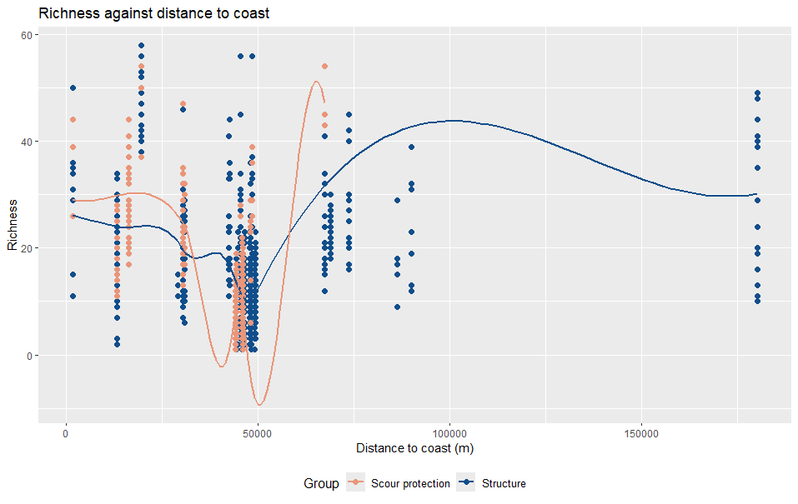
Figure S8 - Species richness (number of species) on the water column structure (blue) and on the scour protection (red) plotted against the distance to the coast (m).

    - Area sampled
No systematic relationship is found between the species richness and the sampled areas (Figure S9) neither for the water column structure (right) nor the scour protection (left).
As we did not find a clear relationship between the sampled area and the richness, it was not possible to define a Species-Area-Relationship (SAR) (Chaudhary et al., 2015; Finkbeiner, 2011). SAR models denote a power relationship between the amount of area and the number of species present and are commonly used to quantify the species richness impacts if a habitat is converted into a human-modified area (Kuipers et al., 2019).
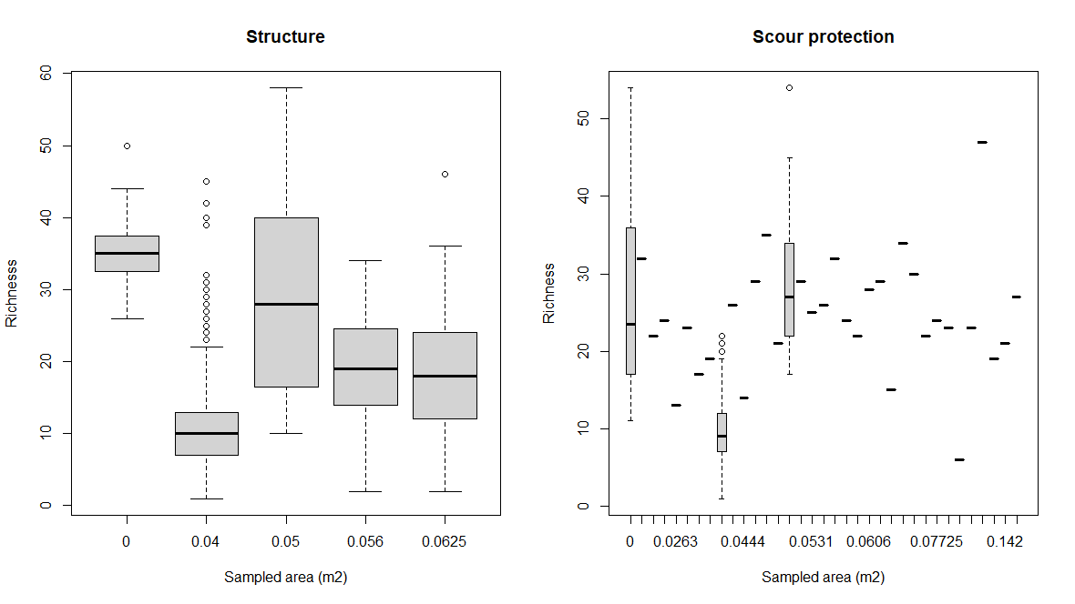
Figure S9 - Species richness (number of species) on the water column structure (right) and on the scour protection (left) plotted against the sampled area (m²).

- Visual investigation of species abundance
As we did for species richness, we visually investigated correlations between species abundance and the different potential explanatory variables. The variables investigated cover installation type (Figure S10), foundation type (Figure S11), structure age/community age (Figure S12), sampling depth (Figure S13), and distance to the coast (Figure S14). We did not identify a systematic relationship between species abundance and any of the potential explanatory variables. Therefore, there was not a strong enough basis for developing CFs for abundance.
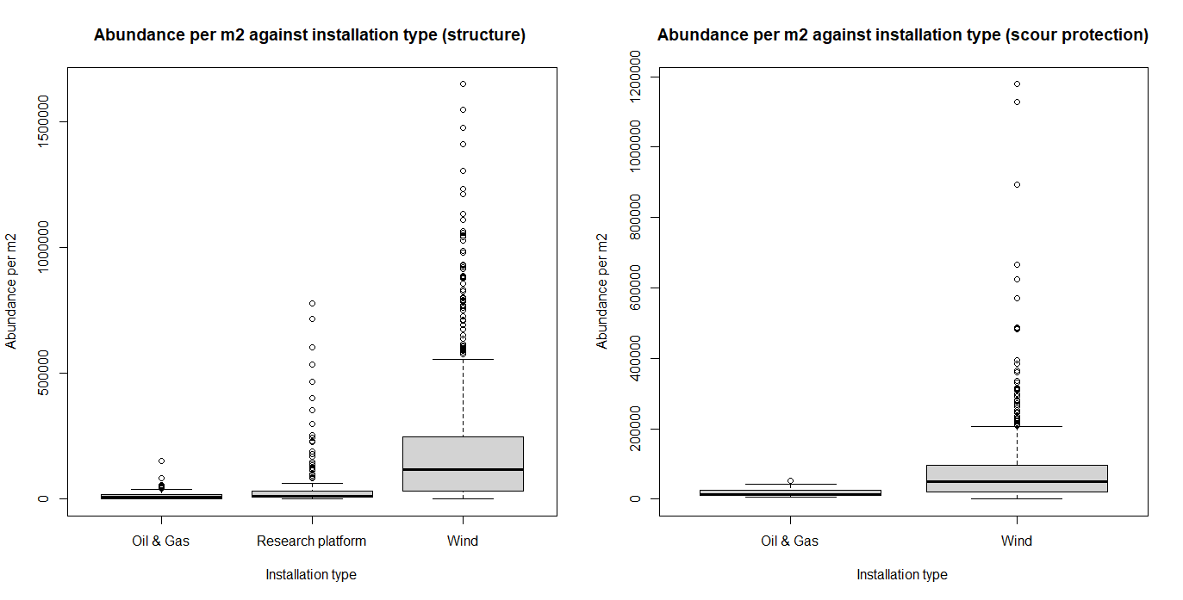
Figure S10 - Species abundance on the water column structure (left) and on the scour protection (right) (number of individuals/m²) plotted against the installation type. The installation types cover oil & gas platforms, a research platform (without scour protection), and wind turbines.
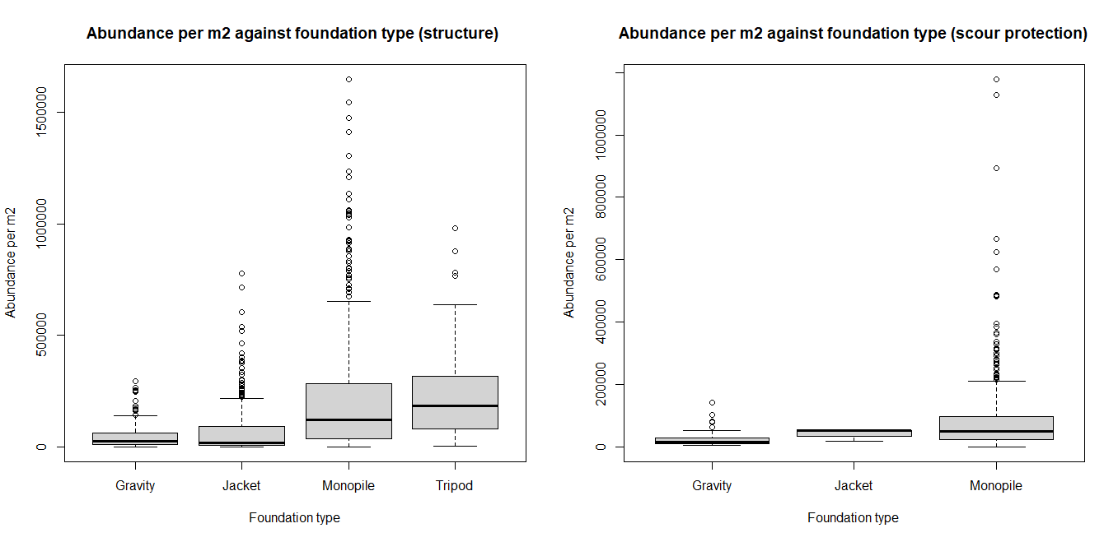
Figure S11 - Species abundance on the water column structure (left) and on the scour protection (right) (number of individuals/m²) plotted against the foundation type. The foundation types cover gravity-based foundations, jackets, monopiles, and tripods (without scour protection).
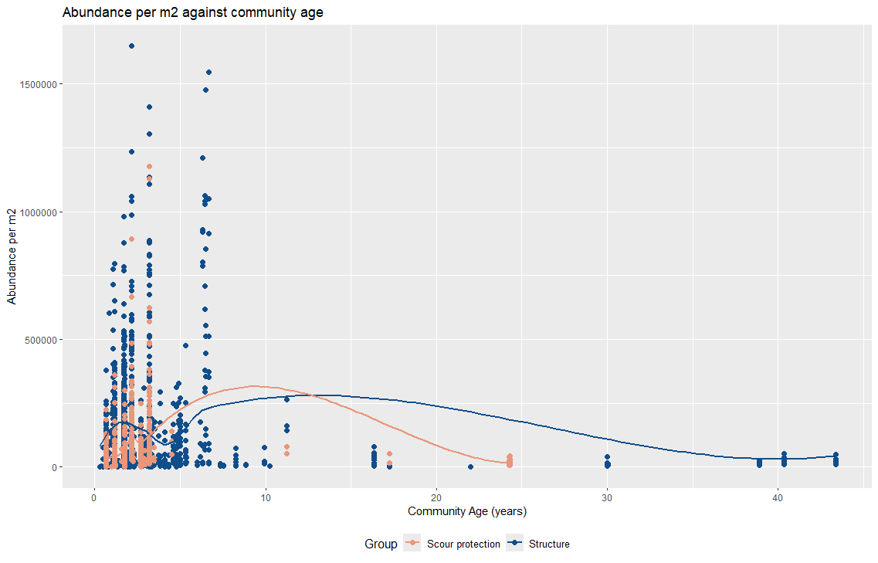
Figure S12 - Species abundance (number of individuals/m²) on the water column structure (blue) and on the scour protection (red) plotted against the installation age/community age (years).
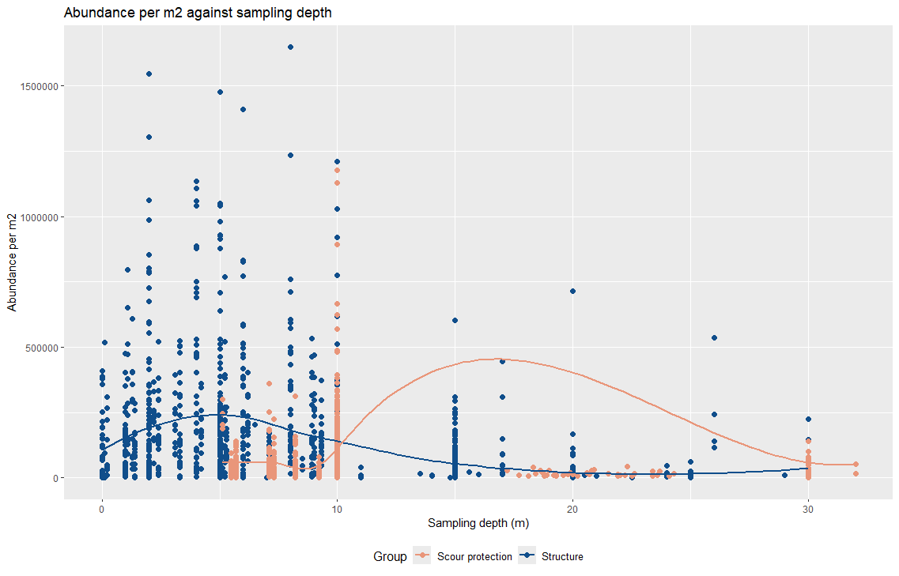
Figure S13 - Species abundance (number of individuals/m2) on the water column structure (blue) and on the scour protection (red) plotted against the sampling depth (m).
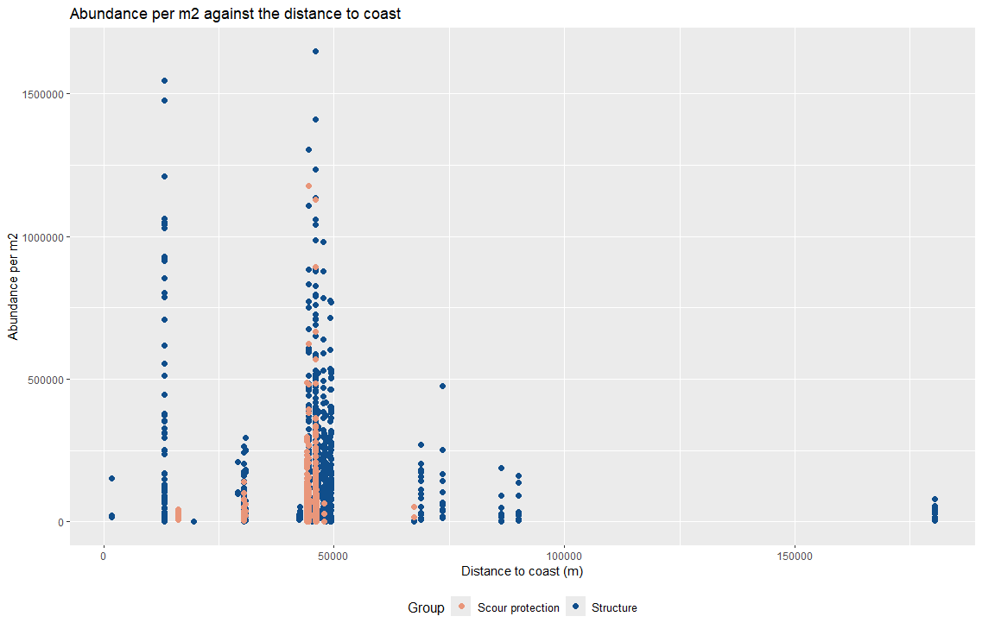
Figure S14 - Species abundance (number of individuals/m2) on the water column structure (blue) and on the scour protection (red) plotted against the distance to the coast (m).
- Investigation of substrate types
The substrate types around each sampling site were investigated using the EMODnet (European Marine Observation and Data Network) Map Viewer (European Commission, 2025). In the online map viewer, habitat types were illustrated by activating the “EUSeaMap (2023) habitat types (EUNIS 2019)” layer. On top of the habitat types, wind farms and oil and gas sites were illustrated by activating the “Wind Farms (polygons)” layer and the “Offshore Installations” respectively.
All wind farms are located on sand or coarse substrate types of EUNIS substrate classification MB52, MC52, MD52, or MC32 (European Environment Agency, 2022) (see Figure S15). The hard substrate reference site, Borkum Reef, is located on coarse substrate types of EUNIS classification MC32 and MD32. The soft substrate reference sites are located in the relatively close surroundings of Alpha Ventus and Prinses Amalia wind farms (however, supposedly unaffected by the existence of the wind farms) in sandy areas. This is identified based on assessment of sample grain sizes.
The oil and gas platform sampling sites are located on either sand substrates of EUNIS substrate classification MC52 or MD52, on muddy sand of classification MC62, or on coarse substrates of classification MC32 (see Figure S16). However, the seabed around the platforms has not been sampled.
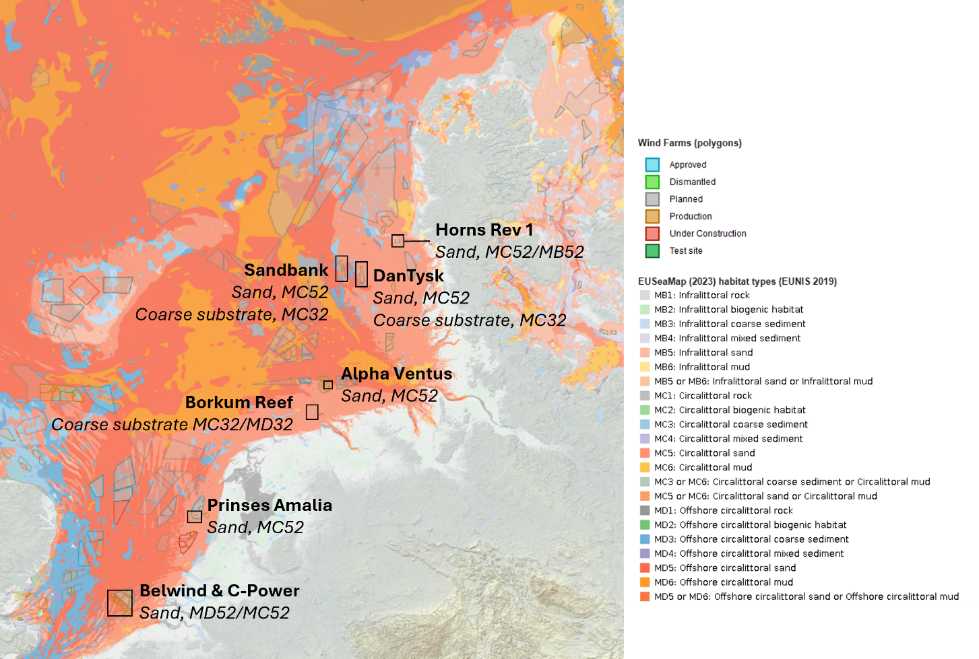
Figure S15 - Sampling sites for offshore wind farms, the hard substrate reference site (Borkum Reef), and soft substrate reference sites (close to Alpha Ventus and Prinses Amalia wind farms) plotted on top of EUNIS (European Nature Information System) habitats using the EMODnet Map Viewer (European Commission, 2025). Sampling site names are written in bold and EUNIS substrate classification (European Environment Agency, 2022) is written in italic.

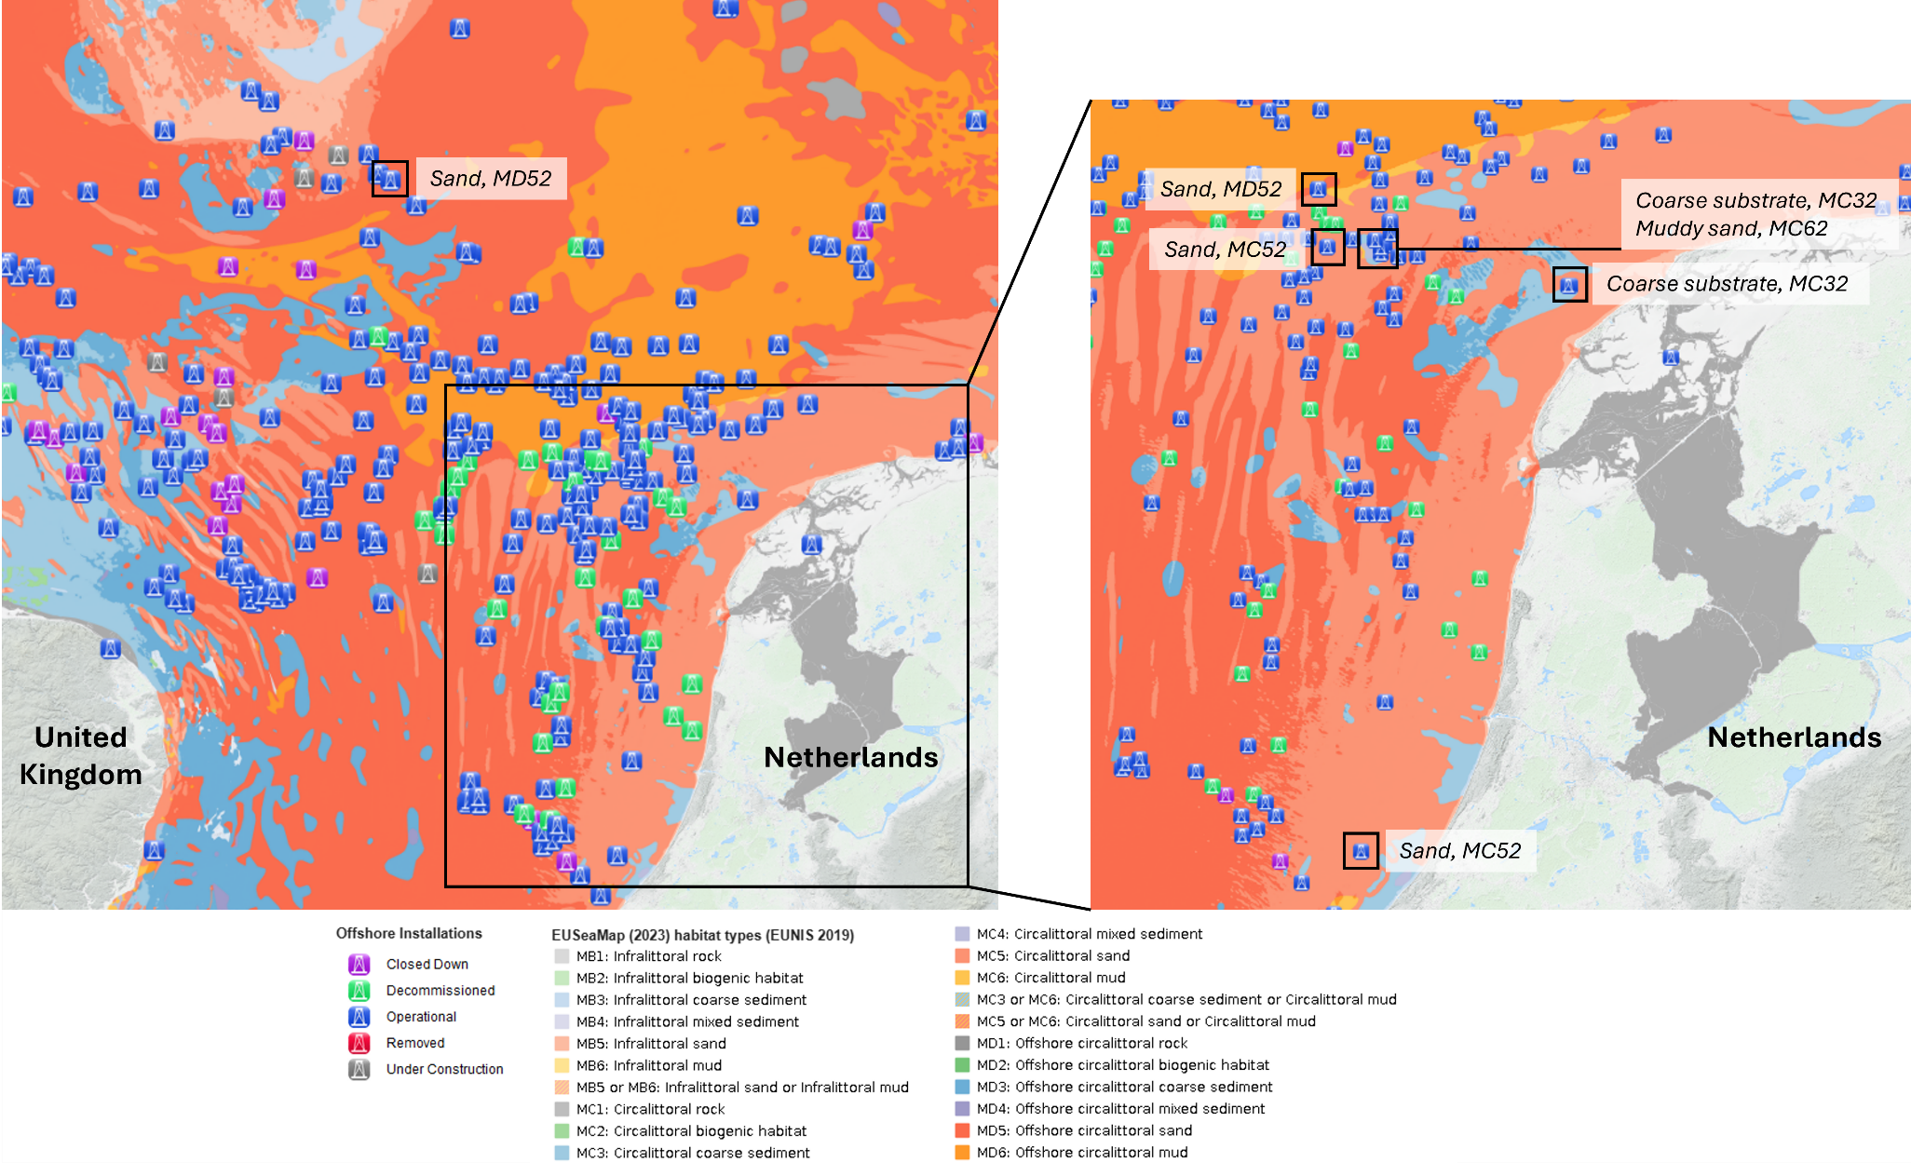
Figure S16 - Sampling sites for oil and gas platform sampling sites (Neptune) plotted on top of EUNIS (European Nature Information System) habitats using the EMODnet Map Viewer (European Commission, 2025). Sampling site names are written in bold and EUNIS substrate classification (European Environment Agency, 2022) is written in italic.
- Sample sizes
Table S2 gives a comparing overview of the sample size of each subset considered in the study and the richness (unique instances of AphiaID) identified for the specific subset. Additionally, it presents the statistical power level of the scour protection subset and the subset of the seabed within the wind farm, compared to the subset of samples from the foundation structure, and the hard substrate reference subset compared to the sandy seabed subset. Statistical power indicates the probability of rejecting a null hypothesis (that no difference is expected) when the null hypothesis is false and should be rejected. Therefore, the statistical power should be correspondingly high, indicating that the probability of rejecting a null hypothesis that should be rejected is high.
To assess the statistical power of comparing species richness between the two subsets, we performed a power analysis. First, we calculated the effect size using Cliff’s Delta, a non-parametric measure of the magnitude of difference between the two groups. Cliff's Delta was converted to Cohen’s d to facilitate the power analysis. We used the pwr package in R to estimate the power of a two-sample t-test, based on the calculated effect size and the smallest sample size between the two groups. A significance level of 0.05 was applied, and the analysis aimed for a power of at least 0.8, which is commonly considered sufficient for detecting meaningful differences (Dorey, 2011).
The statistical power of the scour protection subset and the subset of samples from the seabed within the wind farm is ≥80% (0.8) and is therefore considered sufficient. The power of the hard substrate reference subset compared to the sandy seabed subset is only 0.52, meaning that there is a high probability (48%) of failing to detect a true difference in species richness between the subsets if one exists. A way to improve the power could be to increase the sample size of the hard substrate reference sites. However, as it hasn’t been possible to collect additional samples within the scope of this study, and no suitable samples have been found in the literature, it has not been possible to improve the sample size and the statistical power. Therefore, the results building on the samples from the hard substrate reference site should be interpreted with caution.
Table S2 - Sample size and richness for each subset of the BISAR database utilized in this study. Additionally, the table includes the statistical power from comparing the species richness in one dataset to a reference subset. The subset of foundations acted as the reference subset to the scour protection subset and to the subset of the scour protection and 5 m of the structure. The subset of sandy reference sites acted as the reference to the subset of the hard substrate reference site.
SUBSET | SAMPLES | RICHNESS | POWER
All samples in BISAR | 3,864 | 890 | -
All samples from BISAR used in this study  (structure lifetime ≤25 years) | 3,555 | 834 | -
Samples from foundation (≤25 years) | 1,090 | 507 | Reference
Samples from scour protection (≤25 years) | 587 | 323 | 0.99
Samples from scour protection & 5 m (≤25 years) | 736 | 330 | 0.99
Sandy reference sites | 669 | 319 | Reference
Hard substrate reference site | 11 | 94 | 0.52

- Taxonomic groups
The species identified in the BISAR dataset were grouped into four Kingdoms (Animalia, Plantae, Chromista, and Fungi). The BISAR dataset contained no or only very few Plantae, Chromista, and Fungi species, and these three kingdoms were therefore excluded. The Animalia species were further grouped into 16 phylum groups (Table S2). To have a large enough data base for further development of species richness models, only phyla with 15 or more species were considered in this study. Finally, eight phylum groups were considered in this study.
Table S3 - Taxonomic groups investigated in this study are grouped based on phylum and the number of species identified in the BISAR. The groups marked in red were excluded from the study as they contained fewer than 15 species.
 | ANIMALIA | Observed number of species
PHYLUM | Sponges (Porifera) | 15
PHYLUM | Sea anemones, corals, sea firs & jellyfish (Cnidaria) | 89
PHYLUM | Sea gooseberries & comb jellies (Ctenophora) | 1
PHYLUM | Flatworms (Platyhelminthes) | 4
PHYLUM | Ribbon worms (Nemertea) | 13
PHYLUM | Segmented worms (Annelida) | 226
PHYLUM | Horseshoe worms (Phoronida) | 4
PHYLUM | Other worms (Chaetognatha & Priapulida) | 4
PHYLUM | Snails, slugs, mussels, oysters, cockles, clams & squid (Mollusca) | 172
PHYLUM | Crustaceans, marine insects & sea spiders (Arthropoda) | 243
PHYLUM | Sea mats, horn wreck & lace corals (Bryozoa) | 52
PHYLUM | Lamp shells (Brachiopoda) | -
PHYLUM | Starfish, brittle stars, sea urchins & sea cucumbers (Echinodermata) | 30
PHYLUM | Entoprocta | 2
PHYLUM | Sea squirts, fish, lancelets, mammals (Chordata) | 15
PHYLUM | Other animalia | 1
PHYLUM | PLANTAE | 7
PHYLUM | CHROMISTA | 4
PHYLUM | FUNGI | 0
 | Number of species included in the study | 834
 | Total number of identified species in the BISAR dataset | 890

- Alien species
Table S4 presents all alien species identified in the BISAR database. Alien species were identified by comparing the BISAR species to the list of alien species in the North Sea from the MarINvaders Toolkit (Lonka et al., 2021; Verones et al., 2023). The list was extracted from MarINvaders on the 1st of October 2024.
Table S4 - Alien species identified in the BISAR database.
Aphia ID | Scientific Name | Phylum
100872 | Diadumene cincta | Cnidaria
100982 | Metridium senile | Cnidaria
225814 | Monocorophium acherusicum | Arthropoda
237004 | Crassicorophium bonellii | Arthropoda
148582 | Chelicorophium curvispinum | Arthropoda
148592 | Monocorophium insidiosum | Arthropoda
148603 | Monocorophium sextonae | Arthropoda
102383 | Photis longicaudata | Arthropoda
102433 | Jassa marmorata | Arthropoda
102843 | Melita palmata | Arthropoda
103579 | Diplosoma listerianum | Chordata
103862 | Botryllus schlosseri | Chordata
712167 | Austrominius modestus | Arthropoda
421139 | Amphibalanus improvisus | Arthropoda
107398 | Necora puber | Arthropoda
111350 | Aspidelectra melolontha | Bryozoa
111411 | Membranipora membranacea | Bryozoa
111538 | Schizoporella unicornis | Bryozoa
117388 | Obelia geniculata | Cnidaria
118154 | Telmatogeton japonicus | Arthropoda
130075 | Marphysa sanguinea | Annelida
130639 | Eulalia viridis | Annelida
130644 | Eumida sanguinea | Annelida
131009 | Hydroides norvegica | Annelida
131141 | Polydora ciliata | Annelida
131143 | Polydora cornuta | Annelida
138963 | Crepidula fornicata | Mollusca
140480 | Mytilus edulis | Mollusca
836033 | Magallana gigas | Mollusca
140658 | Ostrea edulis | Mollusca
146768 | Caprella mutica | Arthropoda
148592 | Monocorophium insidiosum | Arthropoda
148603 | Monocorophium sextonae | Arthropoda
149682 | Megabalanus coccopoma | Arthropoda
876640 | Ensis leei | Mollusca
225814 | Monocorophium acherusicum | Arthropoda
395099 | Diadumene lineata | Cnidaria
408266 | Fenestrulina delicia | Bryozoa
421139 | Amphibalanus improvisus | Arthropoda
712167 | Austrominius modestus | Arthropoda

- Statistics for richness models
The R² values were calculated for each model to enable comparison of model fitting (Table S5). R² is a statistical measure that explains the proportion of the variance in the dependent variable (response variable) that is predictable from the independent variables (predictors) in a regression model. It essentially expresses how well the model fits the data. R² values range between 0 and 1. R²=1 means that the model explains 100% of the variance in the dependent variable – meaning a perfect fit, and R²=0 means that the model explains none of the variance in the dependent variable.
Based on the R², the models for the full structure generally fit the data the least. For the scour protection and the scour protection + 5m, the models for Cnidaria, Arthropoda, Annelida, and the total richness fit the data best. Among the full structure models, the models for the total richness, Arthropoda, and Annelida fit the data best. The models for Porifera fit the data very weakly, and the same corresponds to the model for Chordata for the full structure.
Table S5 – R-squared values for the polynomial models for species richness on structural parts.
Species group | Full structure | Scour protection + 5 m | Scour protection
Total richness | 0.49 | 0.72 | 0.73
Porifera | 0.024 | 0.0066 | -0.0063
Cnidaria | 0.35 | 0.98 | 0.97
Annelida | 0.43 | 0.71 | 0.74
Mollusca | 0.33 | 0.56 | 0.53
Arthropoda | 0.46 | 0.85 | 0.86
Bryozoa | 0.15 | 0.20 | 0.12
Echinodermata | 0.13 | 0.20 | 0.15
Chordata | 0.0046 | 0.14 | 0.18
Aliens | 0.27 | 0.33 | 0.38

References
Chaudhary, A., Verones, F., de Baan, L., & Hellweg, S. (2015). Quantifying Land Use Impacts on Biodiversity: Combining Species-Area Models and Vulnerability Indicators. Environ Sci Technol, 49(16), 9987-9995. https://doi.org/10.1021/acs.est.5b02507
Dorey, F. J. (2011). Statistics in brief: Statistical power: what is it and when should it be used? Clin Orthop Relat Res, 469(2), 619-620. https://doi.org/10.1007/s11999-010-1435-0
European Commission. (2025). European Marine Observation and Data Network (EMODnet) Map Viewer. Retrieved March from https://emodnet.ec.europa.eu/geoviewer/#!/
European Environment Agency. (2022). EUNIS marine habitat classification 2022 including crosswalks. Retrieved March from https://www.eea.europa.eu/data-and-maps/data/eunis-habitat-classification-1/eunis-marine-habitat-classification-review-2022/eunis-marine-habitat-classification-2022?utm_source=EEASubscriptions&utm_medium=RSSFeeds&utm_campaign=Generic
Finkbeiner, M. (2011). Towards life cycle sustainability management. Springer. https://doi.org/0.1007/978-94-007-1899-9
Kuipers, K. J. J., May, R. F., Graae, B. J., & Verones, F. (2019). Reviewing the potential for including habitat fragmentation to improve life cycle impact assessments for land use impacts on biodiversity. The International Journal of Life Cycle Assessment, 24(12), 2206-2219. https://doi.org/10.1007/s11367-019-01647-1
Lonka, R., Verones, F., & Stadler, K. (2021). The MarINvaders Toolkit. J. Open Source Softw., 6(64). https://doi.org/10.21105/joss.03575
Mukaka, M. M. (2012). Statistics Corner: A guide to appropriate use of Correlation coefficient in medical research. Malawi Medical Journal, 24, 69-71. https://www.ncbi.nlm.nih.gov/pmc/articles/PMC3576830/
Verones, F., Gjedde, P., Koslowski, M., Woods, J. S., Lonka, R., & Stadler, K. (2023). MarINvaders: A web toolkit of marine species for use in environmental assessments. Ecosphere, 14(11). https://doi.org/10.1002/ecs2.4697

