Supplementary Material - Assessing Social Risks and Performance of Battery Raw Materials: Implications for Sustainable Sourcing and Social LCA
Davis Jose, Rose Mangah Nankaa, Marzia Traverso, Institute of Sustainability in Civil Engineering, RWTH Aachen davis.jose@inab.rwth-aachen.de, +491779222881

1. Figures

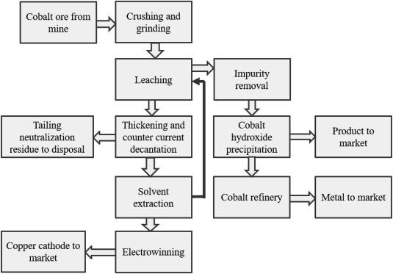
Figure 1: System Boundary of cobalt (Shahjadi Hisan Farjana, 2019)

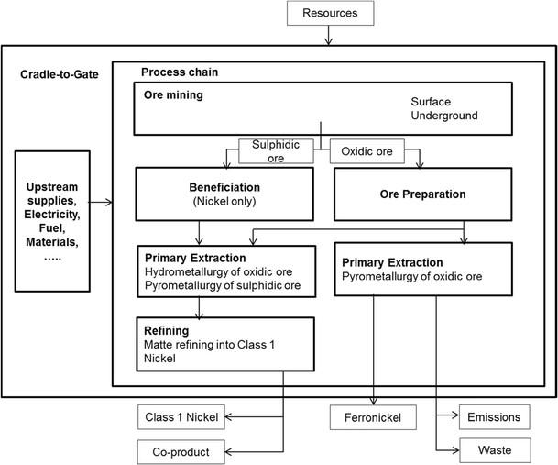

Figure 2: System Boundary of Nickel (Mistry, 2016)
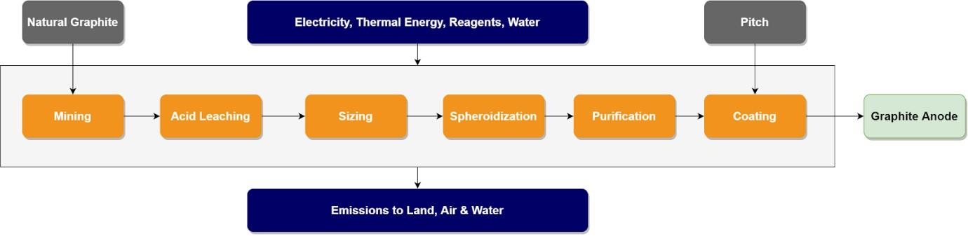

Figure 3: System Boundary of Graphite (Minviro, 2020)

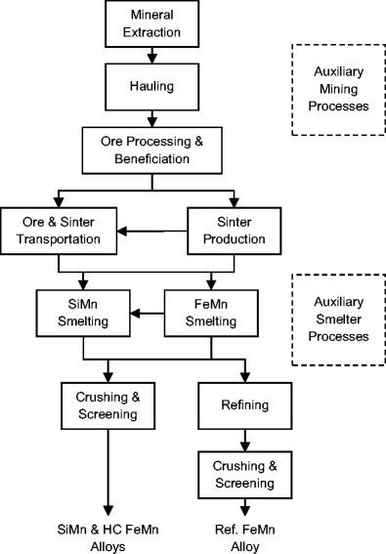
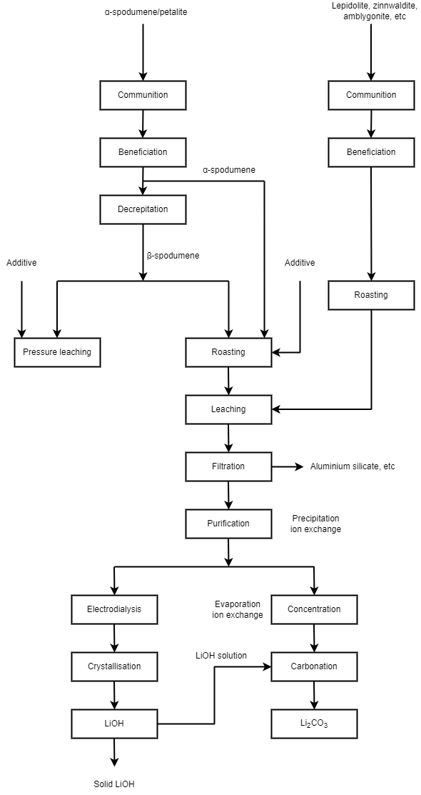

Figure 4: System Boundary of Manganese (Westfall, 2016) | Figure 5: System Boundary of Lithium (Colin Dessemond, 2019)

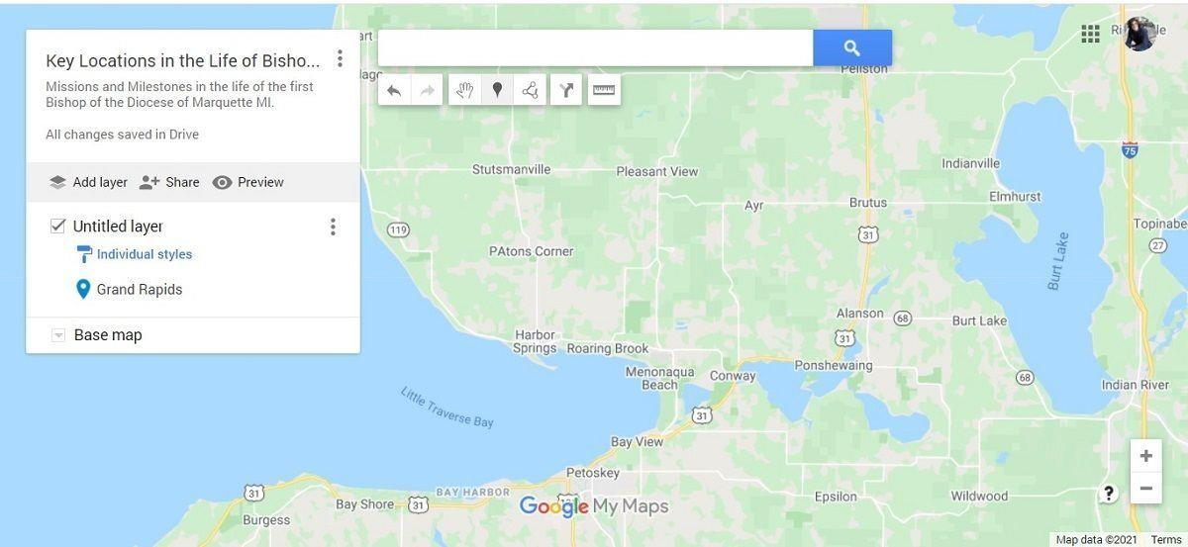

Figure 6: Drawing tools
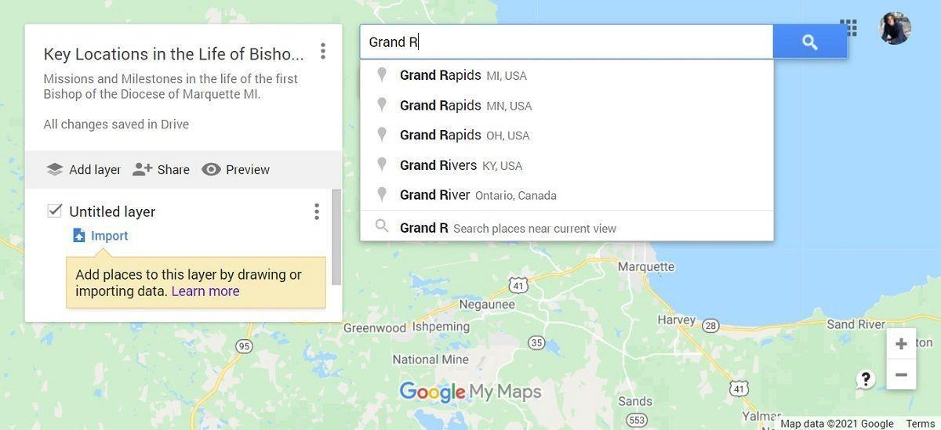

Figure 7: Search bar for locations

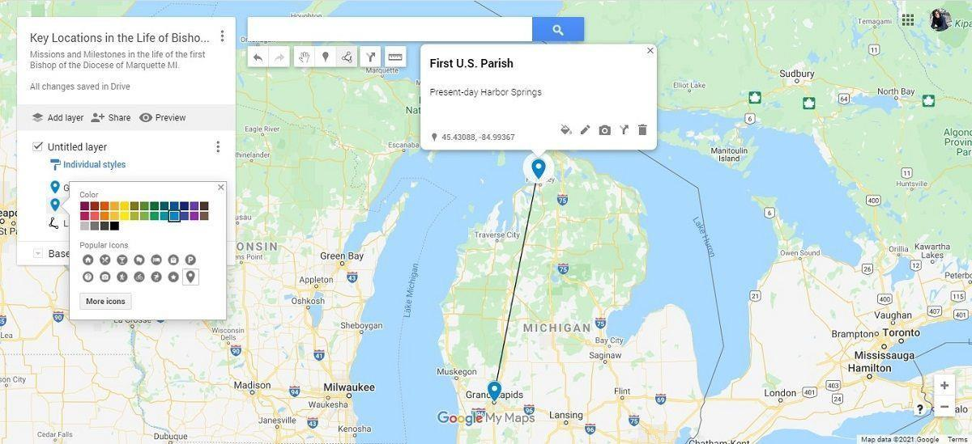
Figure 8: Personalisation options

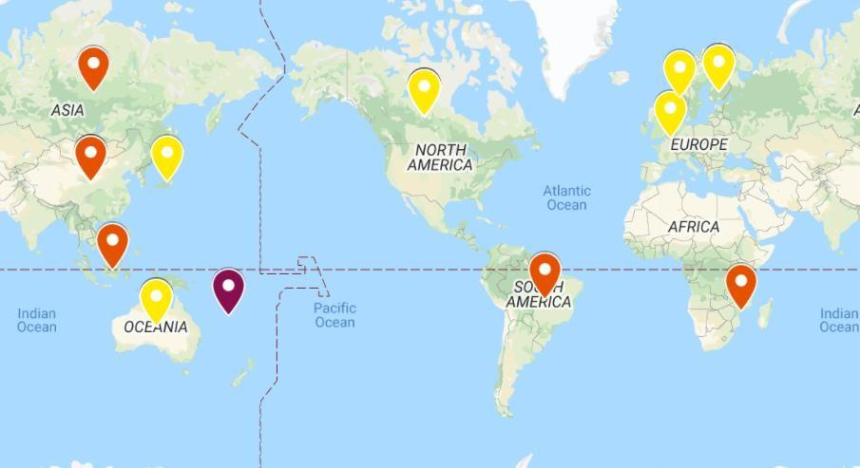

Figure 9: Example of the interactive map for decision-makers

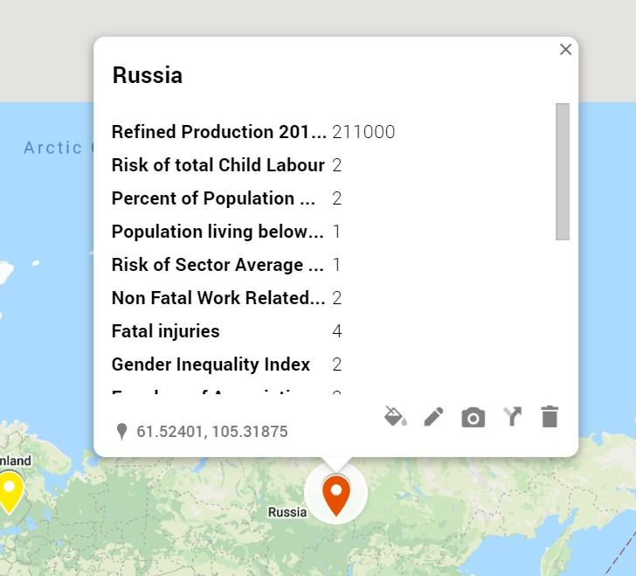

Figure 10: Social Risk Indicators in map
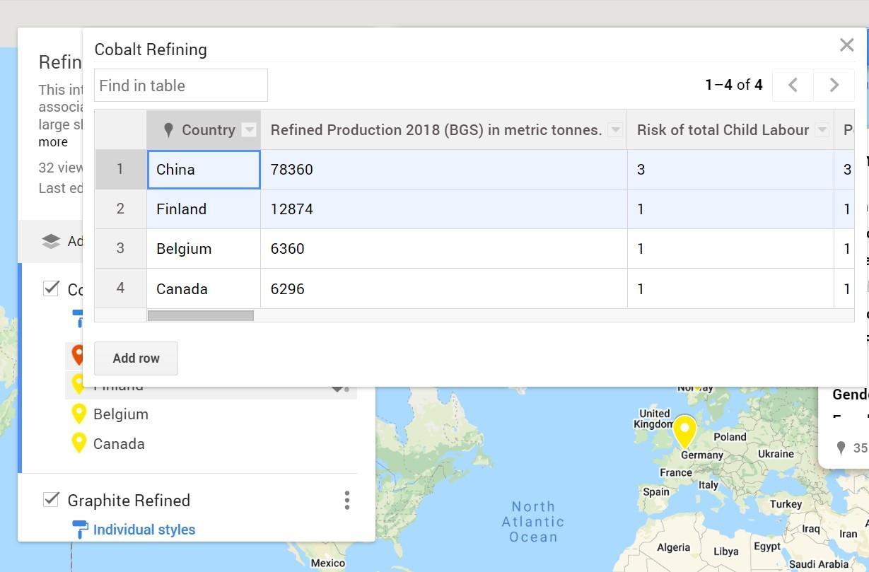
Figure 11: Editing or updating the data
2. Tables
Table 1: Social Performance Indicator Selection (Lithium, Manganese and Nickel)
Indicator | Evidence for Selection
 | Lithium Test Company Mining (Albemarle) | Manganese Test Company Mining (ARM) | Nickel Test Company Mining (Nornickel)
Exposure to Silicosis | Silica is present in all mining and refining sites. Thus, most of the workers here are exposed to silica. The information regarding silicosis or the presence of silica is not shown in the sustainability report but there are activities and measures taken to avoid occupational diseases and to ensure safety. The non-compliant situation, but actions to improve have been taken. | The occupational hygiene monitoring programs at ARM operations routinely monitor the silica content in the orebodies of base metals and platinum mines. Silica levels recorded are consistently below analytical detection limits and there is, therefore, minimal risk of exposure to silica at company operations. No new silicosis infections have been diagnosed arising from exposure at ARM-managed mining operations since 2009. Continued focus on reaching the 2024 occupational health and safety Milestones, which include elimination of occupational lung diseases. Progress beyond compliance is made and monitored | No data, or non-compliant situation; no action taken.
Overall Occupational Noise Exposure Risk | No data, or non-compliant situation; no action taken. | Continued focus on reaching the 2024 occupational health and safety Milestones, which include elimination of occupational noise-induced hearing loss. Regular audiometric testing includes early warning programs to effectively manage Noise-Induced Hearing Loss (NIHL). In cases where early warning indicators or even minor shifts from the hearing baseline are detected, counseling and coaching about hearing protection are provided. individuals with Percentage Loss of Hearing (PLH) shifts greater than 10% are referred for specialist examination. This includes diagnostic audiograms conducted by an Audiologist and Ear, Nose, and Throat Specialist to establish the cause of the hearing loss. If the audiograms confirm NIHL due to workplace exposure, a compensation claim is submitted on behalf of the employee. The number of employees who  experienced PLH shifts or deterioration in hearing between 5% and 10% from baselines as recorded at employment decreased to 2.1% due to effective early warning programs for hearing loss. Progress beyond compliance is made and monitored | No data, or non-compliant situation; no action taken.
Fatal Injuries at company level | The fatal injuries Risk Level is Zero. According to PSILCA's risk level categorization, the risk is very low, but the corporation is taking several precautions to minimize deaths in mining areas. Ideal performance; a positive output achieved and reported. | The fatal injuries Risk Level in ARM is 10. According to PSILCA's risk level assessment, the risk is low, and the company is taking several precautions to minimize fatalities in mining areas. Progress beyond compliance is made and monitored | The fatal injuries Risk Level in Nornickel is 12. One of the strategic goals is to reduce fatal production-related incidents to zero. As per the risk level classification of PSILCA, the risk is low, and the company is taking many actions to avoid non-fatalities in mining locations. Progress beyond compliance is made and monitored
Non-Fatal Injuries at Company Level | No data, or non-compliant situation; no action taken. | Non-Fatal injuries Risk Level in ARM is 848. According to PSILCA's risk level rating, the risk is low, and the company is taking several steps to minimize nonfatalities in mining locations. Progress beyond compliance is made and monitored | Non-Fatal injuries Risk Level in Nornickel is 1343. According to PSILCA's risk level categorization, the risk is medium. Compliance with local laws and/or aligned with international standards.
Risk that Average Wage is Below Living Wage | Employees have a wage that is well above country-specific living wage levels. Compliance with local laws and/or aligned with international standards. | No data, or non-compliant situation; no action taken. | No data, or non-compliant situation; no action taken.
Risk that Average Wage is Below Country Minimum Wage | Employees have a living wage that is well above country-specific minimum wage levels. Employees are paid with more than double the country-specific minimum wage levels in almost all locations. Ideal performance; a positive output achieved and reported | Remuneration practices are regularly benchmarked to ensure that these align to national industry standards and legislative requirements, including regarding minimum wages. Compliance with local laws and/or aligned with international standards. | The ratio of Minimum monthly compensation to statutory minimum monthly wage is equal to or greater than 1. Compliance with local laws and/or aligned with international standards.
Risk of Forced Labour | No data, or non-compliant situation; no action taken. | ARM’s operations do not pose the risk of forced labour. Policies are compatible with international human rights standards and with the South African Constitution. Through the implementation of the supplier engagement plan, ARM reviewed the practices of suppliers and contractors and has not detected significant risk. Progress beyond compliance is made and monitored. | The Company conforms with Russian Federation labor rules, which are in line with UN protocols that Russia has ratified. (“2018 - Норникель”)  In 2019, Nornickel was ranked No. 1 by Forbes Russia in its Top 50 employers rating and Forced labour is forbidden. Compliance with local laws and/or aligned with international standards.
Risk of Child Labour | No data, or non-compliant situation; no action taken. | ARM does not use child labour and all operations monitor the ages of employees and contractors. We conduct risk assessments/screening in terms of human rights practices in respect of prospective transactions, contracting parties, and business partners and have not detected such significant risk. ARM’s safety initiatives promote safe and secure work environments, and we have controls in place to ensure that labour rights are protected and that we do not use child labour. Progress beyond compliance is made and monitored. | Child labour is forbidden. Nornickel does not accept any sort of child labor, including the participation of kids under the age of 18 in hazardous and/or dangerous employment. Compliance with local laws and/or aligned with international standards.
Gender Wage Gap | 2019 global pay equity study revealed pay gaps between seven male and female employees performing the same job at the same location. we review our pay practices throughout Albemarle to ensure they are fair and equitable. This helps us confirm that employee pay is based on experience, expertise, performance, and the criticality of the role to Albemarle, and isn’t influenced by biased opinion or discrimination. Non-compliant situation, but actions to improve have been taken | The code, the employment equity policy, and ARM’s human resources management policies promote equality and the elimination of unfair discrimination based on race, ethnicity, colour, gender, sexual orientation, nationality, place of origin, citizenship, creed, political persuasion, age, marital or family status or disability. Non-compliant situation, but actions to improve have been taken. | Minimum wages paid by the Company are gender neutral. Compliance with local laws and/or aligned with international standards.
Female Representation in the workforce | The percentage of female employees is only 21.7%. Non-compliant situation, but actions to improve have been taken. | The percentage of female employees is only 19%. Non-compliant situation, but actions to improve have been taken. | The percentage of female employees is only 29%. Non-compliant situation, but actions to improve have been taken.
Freedom of Association Rights, Collective Bargaining Rights, Right to Strike | The percentage of our employees covered by collective bargaining agreements is approximately 48%. Compliance with local laws and/or aligned with international standards | No operations or suppliers have been identified in which employee rights to exercise freedom of association or collective bargaining may be violated or at significant risk. ARM respect employees’ rights to collective bargaining. Wages and conditions of employment are negotiated according to the collective agreements in place at each operation. The minimum notice period regarding operational changes is specified in collective agreements, and varies between one month and three months, on average. Operational management consults regularly with trade unions on a range of issues, including wages, and other benefits.89% of the workforce is unionised. Progress beyond compliance is made and monitored | The corporation complies with the Russian Federation's Labor Code, collective bargaining agreements, the interregional cross-industry agreement, and joint resolutions while fulfilling its commitments.The company also follows the Freedom of Association Policy approved by the Board of Directors. There are 21 collective bargaining agreements representing 83 percent of the Group's average workforce that the Group firms are party to. 9.5 percent of the Group's employees were represented by trade unions as of the end of 2019, while 79 percent were members of social and labor councils. Compliance with local laws and/or aligned with international standards.
Weekly Hours of Work per employee | No data, or non-compliant situation; no action taken. Data related work hour of employees is not available | No data, or non-compliant situation; no action taken. Data related work hour of employees is not available | Internal labor regulations adopted by the firm, with appropriate consideration for the viewpoint of the trade union, determine the working hours of Company personnel. According to the applicable Russian laws and regulations, the company's typical work week is 40 hours.
Social security expenditures | No data, or non-compliant situation; no action taken. | R675(44.2 USD) million invested in community development and Invested R1.1(0.06 USD) billion in training initiatives to improve the skills of employees. Total social expenditure is about 12 percent of the total value of the company which is a medium risk as per PSILCA classification. Compliance with local laws and/or aligned with international standards. | The Company implements programs for the development and social support of its employees, upholding their rights in respect of social security. Total expenses related to social programs and benefits for employees is RUB 14469(112.60 USD) mln. Compared to the social security expenditure with the direct economic value generated by the company in 2019, the risk is very high. Non-compliant situation, but actions to improve have been taken.
The overall risk of inadequate social benefits | Employee benefits as supplemental to statutory employee benefits, which in combination are geared to supporting employees and their families  in managing their physical and financial wellness, and in achieving an appropriate work/life balance. But the sustainability report has not any information regarding benefits such as retirement, housing, unemployment, parental leave, etc. Non-compliant situation, but actions to improve have been taken. | Social and Labour Plans (SLPs) and Local Economic Development (LED) projects) include infrastructure development programs in local communities that aim to improve living conditions and socio-economic development in these communities. These projects also benefit the majority of employees who live in communities surrounding operations. Benefits offered to full-time employees include standard benefits such as pension fund, parental leave, disability and invalidity coverage, retirement provision, stock ownership, medical aid, and group life insurance. In addition, the company offers study assistance and bursaries for employees and their children. The company sponsors year-end events, team-building interventions, community sports and fun days, and wellness days. Ideal performance; a positive output achieved and reported | The social package includes the following benefits and compensations: • subsidised health resort treatment and vacations for employees and their families; • payment of return travel to and from a vacation destination for employees in the Far North and equivalent areas, including baggage fees; • voluntary health insurance; • one-off financial aid to employees experiencing certain major life events or hardships; Compliance with local laws and/or aligned with international standards.
Indigenous Sector Issues Identified | Albemarle is working to ensure the sustainability and equilibrium of that ecosystem, as well as improve the quality of life in the local indigenous communities. That includes sharing 3.5% of our Chilean revenue for community development projects. A representative of the indigenous community accompanies the company on each trip to monitor well. In the Salar de Atacama, the company is transparent and reports the results of environmental monitoring to the authorities of Chile and the surrounding indigenous communities to show compliance with the permits. Progress beyond compliance is made and monitored | There were no recorded incidents of human rights violations of indigenous peoples. ARM believes that its operations do not pose such risk, but should any such violations occur, there are mechanisms in place for their detection, reporting, and resolution. No disputes have been raised relating to land use or customary rights specifically. No grievances have been raised regarding land use, customary rights of local communities, and indigenous peoples. Progress beyond compliance is made and monitored | Agreement with the Federal Agency for Ethnic Affairs FAEA on cooperation aimed at providing support to the indigenous peoples of the North. Human rights According to the International Bill of Human Rights, the Indigenous and Tribal Peoples Convention of the International Labour Organisation, and the Constitution of Russia. The Company supports projects aimed at preserving the traditional  lifestyle and culture of Taimyr’s indigenous peoples while fostering their social and economic development. It includes organising air  transportation, supplying construction materials and diesel fuel, and staging festivals and cultural events. In 2019, the Company’s spending on support for indigenous northern minorities amounted to ca. RUB 31 (0.24) mln. In 2019, there were no violations of the rights of indigenous minorities by the Company. Nornickel's commitments to indigenous northern minorities include: respecting indigenous lands; supporting indigenous natural resource management practices; participating in renewable biological resource restoration programs; assisting in the preservation of indigenous cultures; promoting indigenous trades; and providing social support to indigenous peoples to help them achieve modern living standards. In addition, the corporation helps to the preservation of northern indigenous languages. In 2019, the firm collaborated with the United Nations' International Year of Indigenous Languages forum in Khanty-Mansiysk. Ideal performance; a positive output achieved and reported
Public expenditure on education | Financial contributions support key cornerstones of sustainability within the local communities, such as education, health, and social services, and cultural  initiatives. Across all of our sites, giving to educational programs accounts for more than half of our community investments. Additionally, for those eligible individuals willing to make the commitment, we support employees’ continuing education aspirations by funding university tuition and allowing the necessary time for classroom attendance. Ideal performance; a positive output achieved and reported | The operations are located in some of the poorest and most remote parts of the country and support local communities by providing employment opportunities, skills development, and educational assistance. Since F2016, ARM facilities have provided adult education and training (AET) to 623 workers and 1 637 community people, enhancing their confidence and employability. Educational support includes direct support for community schools, bursaries for promising students from these communities, and adult education and training (AET)opportunities. ARM provided R15.9(1.04 USD) million towards educational initiatives through the Corporate Social Investment program. The expenditure on education is only 0.1% of the total value of the company that distributed in 2020. As per the PSILCA classification, the expenditure on education has a high risk. Non-compliant situation, but actions to improve have been taken | Nornickel lays a great focus on supporting engineering education in Russia, which helps to increase young people's interest in engineering vocations. Nornickel sponsors a number of school-based career advising programs. Over 29,500 kids attend the Arctic.PRO R&D Winter School, Arctic Wave celebration of R&D discoveries, IMake engineering marathon, School of Urban Competencies, and the School Break educational initiative each year. 350 university students covered by Nornickel’s corporate scholarship programs and 71 educational projects supported under the World of New Opportunities program (with a grant fund of RUB 242.5(1.89 USD) mln). Progress beyond compliance is made and monitored

