Supplementary material:

Appendix A: categories of the ruminant production systems used by GLEAM.
Animal: | Animal | Production system | Herd
BFL_GRS_BEF | Buffalo (BFL) | Grassland (GRS) | Beef (BEF)
BFL_GRS_DRY | Buffalo (BFL) | Grassland (GRS) | Dairy (DRY)
BFL_MXD_BEF | Buffalo (BFL) | Mixed (MXD) | Beef (BEF)
BFL_MXD_DRY | Buffalo (BFL) | Mixed (MXD) | Dairy (DRY)
CTL_GRS_BEF | Cattle (CTL) | Grassland (GRS) | Beef (BEF)
CTL_GRS_DRY | Cattle (CTL) | Grassland (GRS) | Dairy (DRY)
CTL_MXD_BEF | Cattle (CTL) | Mixed (MXD) | Beef (BEF)
CTL_MXD_DRY | Cattle (CTL) | Mixed (MXD) | Dairy (DRY)
GTS_GRS_BEF | Goats (GTS) | Grassland (GRS) | Beef (BEF)
GTS_GRS_DRY | Goats (GTS) | Grassland (GRS) | Dairy (DRY)
GTS_MXD_BEF | Goats (GTS) | Mixed (MXD) | Beef (BEF)
GTS_MXD_DRY | Goats (GTS) | Mixed (MXD) | Dairy (DRY)
SHP_GRS_BEF | Sheep (SHP) | Grassland (GRS) | Beef (BEF)
SHP_GRS_DRY | Sheep (SHP) | Grassland (GRS) | Dairy (DRY)
SHP_MXD_BEF | Sheep (SHP) | Mixed (MXD) | Beef (BEF)
SHP_MXD_DRY | Sheep (SHP) | Mixed (MXD) | Dairy (DRY)

Appendix B: Cohorts per animal used in this analysis. Extracted from production systems data used by GLEAM.
Cohort: | Description | Animal
AF | Adult females | BFL, CTL, GTS, SHP
AM | Adult males | BFL, CTL, GTS, SHP
RF | Replacement females | BFL, CTL
RM | Replacement males | BFL, CTL
MF | Meat female animals | BFL, CTL, GTS, SHP
MM | Meat male animals | BFL, CTL, GTS, SHP
RFA | Replacement females in the midst of first year | GTS, SHP
RFB | Replacement females in the midst of the second year | GTS, SHP
RMA | Replacement males in the midst of first year | GTS, SHP
RMB | Replacement males in the midst of the second year | GTS, SHP

Appendix C: Description and range values defined for parameters used in GLEAM.
Parameter | Group | Description | Animal | Unit¹ | Fixed value² | Range min value | Range max value
temp | global conditional | average temperature Celsius | BFL, CTL, GTS, SHP | number | all (between -23 and 34) | -23 | 34
frac_leach_liquid | global conditional | proportion of manure nitrogen lost due to leaching from liquid manure | BFL, CTL, GTS, SHP | number | all (2,4,15,20) | 2 | 20
frac_leach_solid | global conditional | proportion of manure nitrogen lost due to leaching from solid manure | BFL, CTL, GTS, SHP | number | all (2,4,10) | 2 | 10
Bo | global conditional | maximum methane producing capacity for manure | BFL | CH₄/kg VS. | 0.1 | 0.1 | 0.1
Bo | global conditional | maximum methane producing capacity for manure | CTL | CH₄/kg VS. | all (0.13, 0.17, 0.18, 0.19, 0.24) | 0.13 | 0.24
Bo | global conditional | maximum methane producing capacity for manure | GTS | CH₄/kg VS. | all (0.13, 0.18) | 0.13 | 0.18
Bo | global conditional | maximum methane producing capacity for manure | SHP | CH₄/kg VS. | all (0.13, 0.19) | 0.13 | 0.19
afc | herd | age at first calving | BFL | years | mean (between 3.09 and 3.85) | -20% | +20%
afc | herd | age at first calving | CTL | years | mean (between 2.64 and 2.92) | -20% | +20%
afc | herd | age at first calving | GTS | years | mean (between 1.42 and 1.49) | -20% | +20%
afc | herd | age at first calving | SHP | years | mean (between 1.64 and 1.84) | -20% | +20%
afkg | herd | average live weight of adult female animals | BFL | kg/head | mean (between 452 and 543) | -20% | +20%
afkg | herd | average live weight of adult female animals | CTL | kg/head | mean (between 446 and 485) | -20% | +20%
afkg | herd | average live weight of adult female animals | GTS | kg/head | mean (between 44 and 49) | -20% | +20%
afkg | herd | average live weight of adult female animals | SHP | kg/head | mean (between 45 and 57) | -20% | +20%
amkg | herd | average live weight of adult male animals | BFL | kg/head | mean (between 488 and 653) | -20% | +20%
amkg | herd | average live weight of adult male animals | CTL | kg/head | mean (between 619 and 633) | -20% | +20%
amkg | herd | average live weight of adult male animals | GTS | kg/head | mean (between 63 and 74) | -20% | +20%
amkg | herd | average live weight of adult male animals | SHP | kg/head | mean (between 70 and 88) | -20% | +20%
bcr | herd | male to female ratio | BFL | fraction | mean (between 0.10 and 0.26) | -20% | +20%
bcr | herd | male to female ratio | CTL | fraction | mean (between 0.06 and 0.21) | -20% | +20%
bcr | herd | male to female ratio | GTS | fraction | mean (between 0.04 and 0.05) | -20% | +20%
bcr | herd | male to female ratio | SHP | fraction | mean (between 0.04 and 0.06) | -20% | +20%
ckg | herd | live weight at birth | BFL | kg/head | mean (between 28.50 and 36.10) | -20% | +20%
ckg | herd | live weight at birth | CTL | kg/head | mean (between 29.15 and 32.60) | -20% | +20%
ckg | herd | live weight at birth | GTS | kg/head | mean (between 2.97 and 3.53) | -20% | +20%
ckg | herd | live weight at birth | SHP | kg/head | mean (between 3.57 and 3.62) | -20% | +20%
fr | herd | fertility rate | BFL | fraction | mean (between 0.64 and 0.76) | -20% | +20%
fr | herd | fertility rate | CTL | fraction | mean (between 0.76 and 0.80) | -20% | +20%
fr | herd | fertility rate | GTS | fraction | mean (between 0.85 and 0.86) | -20% | +20%
fr | herd | fertility rate | SHP | fraction | mean (between 0.87 and 0.89) | -20% | +20%
frac_mlk | herd | fraction of milking adult females in the herd | BFL, CTL | fraction | mode (0.2) | -20% | +20%
hours | herd | number of hours of work per day | BFL | hours/head/day | mean (between 1.62 and 2.19) | -20% | +20%
hours | herd | number of hours of work per day | CTL | hours/head/day | mean (between 1.50 and 1.68) | -20% | +20%
lact | herd | duration of lactation period | BFL, CTL | days | mode (365) | -20% | +20%
litsize | herd | litter size, number of kids per parturition | GTS | heads | mean (between 1.66 and 1.79) | -20% | +20%
litsize | herd | litter size, number of kids per parturition | SHP | heads | mean (between 1.38 and 1.48) | -20% | +20%
milk_fat | herd | fat content of milk | BFL | fraction | mean (between 0.06 and 0.07) | -20% | +20%
milk_fat | herd | fat content of milk | CTL | fraction | mode (0.04) | -20% | +20%
milk_prot | herd | average fraction of protein in milk | BFL, CTL, GTS | fraction | mode (0.03) | -20% | +20%
milk_prot | herd | average fraction of protein in milk | SHP | fraction | mode (0.06) | -20% | +20%
milk_yield | herd | daily milk production | BFL | kg milk/cow/day | mean (between 3.00 and 4.16) | -20% | +20%
milk_yield | herd | daily milk production | CTL | kg milk/cow/day | mean (between 10.00 and 11.77) | -20% | +20%
milk_yield | herd | daily milk production | GTS | kg milk/cow/day | mean (between 0.05 and 0.52) | -20%
milk_yield | herd | daily milk production | SHP | kg milk/cow/day | mean (between 0.05 and 0.14) | -20% | +20%
mfskg | herd | live weight of female fattening animals at slaughter | BFL | kg | mean (between 194 and 397) | -20% | +20%
mfskg | herd | live weight of female fattening animals at slaughter | CTL | kg | mean (between 344 and 442) | -20% | +20%
mfskg | herd | live weight of female fattening animals at slaughter | GTS | kg | mean (between 29 and 31) | -20% | +20%
mfskg | herd | live weight of female fattening animals at slaughter | SHP | kg | mean (between 24 and 27) | -20% | +20%
mmskg | herd | live weight of male fattening animals at slaughter | BFL | kg | mean (between 193 and 423) | -20% | +20%
mmskg | herd | live weight of male fattening animals at slaughter | CTL | kg | mean (between 368 and 448) | -20% | +20%
mmskg | herd | live weight of male fattening animals at slaughter | GTS | kg | mean (between 30 and 31) | -20% | +20%
mmskg | herd | live weight of male fattening animals at slaughter | SHP | kg | mean (between 24 and 28) | -20% | +20%
past_man_fra | herd | fraction of managed pastures | BFL, CTL, GTS, SHP | fraction | mode (0.05) | -20% | +20%
prod_fibre | herd | annual production of fibre by animal | GTS | kg fibre/head/year | mean (between 0.006 and 0.007) | -20% | +20%
prod_fibre | herd | annual production of fibre by animal | SHP | kg fibre/head/year | mode (0.005) | -20% | +20%
diet_di | feed | average digestibility of feed ration | BFL | fraction | mean (between 0.57 and 0.66) | -20% | +20%
diet_di | feed | average digestibility of feed ration | CTL | fraction | mean (between 0.60 and 0.64) | -20% | +20%
diet_di | feed | average digestibility of feed ration | GTS | fraction | mean (between 0.51 and 0.63) | -20% | +20%
diet_di | feed | average digestibility of feed ration | SHP | fraction | mean (between 0.62 and 0.63) | -20% | +20%
diet_ge | feed | average gross energy content of feed ration | BFL | MJ/kgDM | mean (between 18.15 and 18.57) | -20% | +20%
diet_ge | feed | average gross energy content of feed ration | CTL | MJ/kgDM | mean (between 18.35 and 18.50) | -20% | +20%
diet_ge | feed | average gross energy content of feed ration | GTS | MJ/kgDM | mean (between 16.48 and 18.43) | -20% | +20%
diet_ge | feed | average gross energy content of feed ration | SHP | MJ/kgDM | mean (between 18.37 and 18.46) | -20% | +20%
diet_n_cont | feed | average nitrogen content of feed ration | BFL | g N/kg DM diet | mean (between 15.60 and 22.87) | -20% | +20%
diet_n_cont | feed | average nitrogen content of feed ration | CTL | g N/kg DM diet | mean (between 19.01 and 20.70) | -20% | +20%
diet_n_cont | feed | average nitrogen content of feed ration | GTS | g N/kg DM diet | mean (between 14.22 and 20.13) | -20% | +20%
diet_n_cont | feed | average nitrogen content of feed ration | SHP | g N/kg DM diet | mean (between 18.71 and 20.01) | -20% | +20%
mmsaerobic | manure | manure as aerobic lagoon | CTL | fraction | method | 0.00 | 1.00
mmsaerproc | manure | manure as aerobic processing | CTL, GTS, SHP | fraction | method | 0.00 | 1.00
mmsbiogas | manure | manure in a biogas installation | CTL, GTS, SHP | fraction | method | 0.00 | 1.00
mmsburned | manure | manure that is solid burned for fuel | BFL, CTL | fraction | method | 0.00 | 1.00
mmscompost | manure | manure as solid compost | CTL, GTS, SHP | fraction | method | 0.00 | 1.00
mmsconfin | manure | manure as solid outdoor confinement | CTL | fraction | method | 0.00 | 1.00
mmsdaily_sol | manure | manure as solid daily spread | BFL, CTL | fraction | method | 0.00 | 1.00
mmsdeeplitt | manure | manure as deep litter solid | CTL | fraction | method | 0.00 | 1.00
mmsdrylot | manure | manure as solid dry lot | BFL, CTL, GTS, SHP | fraction | method | 0.00 | 1.00
mmslagoon | manure | manure stored as lagoon | CTL, GTS, SHP | fraction | method | 0.00 | 1.00
mmsliqcrust | manure | manure as liquid crust | CTL, GTS, SHP | fraction | method | 0.00 | 1.00
mmsliquid | manure | manure as liquid | BFL, CTL, GTS, SHP | fraction | method | 0.00 | 1.00
mmsliquidoth | manure | manure as liquid that is not classified as mmsliquid | CTL | fraction | method | 0.00 | 1.00
mmspasture | manure | manure that is deposited on pasture | BFL, CTL, GTS, SHP | fraction | method | 0.00 | 1.00
mmspit2 | manure | manure as pit 2 | CTL | fraction | method | 0.00 | 1.00
mmssolid | manure | manure as solid | BFL, CTL, GTS, SHP | fraction | method | 0.00 | 1.00
mmssolidot | manure | manure as solid that is not classified as mmssolid | CTL | fraction | method | 0.00 | 1.00
¹ parameters as fraction were corrected when the range exceeded 1.
² all: all range of values were used, mean: mean value was calculated and corrected on each production system, method: 1/number of manure managed systems. See section 2.3.
Appendix D: Description and range values defined for emission factors and coefficients (efc) used in GLEAM, based on variability and uncertainty from IPCC Guidelines
efc name | Group | Subprocess in GLEAM | Description | Animal | Default value | Range min value | Range max value | Source from IPCC 2019
bo⁸ | global conditional | CH₄manure | maximum methane producing capacity for manure | CTL, BFL, SHP, GTS
Ca | variability efc | NEact | Coefficient corresponding to animal’s feeding situation | BFL, CTL | Method² | 0.17 | 0.36 | Table 10.5 (updated)
Ca | variability efc | NEact | Coefficient corresponding to animal’s feeding situation | GTS | Method⁴ | 0.0107 | 0.024 | Table 10.5 (updated)
Ca | variability efc | NEact | Coefficient corresponding to animal’s feeding situation | SHP | Method³ | 0.019 | 0.024 | Table 10.5 (updated)
UE | variability efc | CH₄manure | Urinary energy as fraction of gross energy | BFL, CTL, GTS, SHP | 1+0.04 | 1+0.02 | 1+0.04 | Equation 10.24 (updated)
ym⁵ | uncertainty efc | CH₄enteric | Percentage of gross energy converted to methane. | CTL, BFL, SHP, GTS
EF3past | uncertainty efc | N₂Omanure-pasture | ef for direct N₂O emissions from manure in pastures | BFL, CTL | 0.004 | 0.00 | 0.014 | Table 11.1 (updated)
EF3past | uncertainty efc | N₂Omanure-pasture | ef for direct N₂O emissions from manure in pastures | GTS, SHP | 0.003 | 0.00 | 0.010 | Table 11.1 (updated)
EF3aerobic | uncertainty efc | N₂Odirect | ef for direct N₂O emissions from mmsaerobic | CTL | method⁷ | -100% | +100% | Table 10.21 (updated)
EF3aerproc | uncertainty efc | N₂Odirect | ef for direct N₂O emissions from mmsaerproc | CTL, GTS, SHP | method⁷ | -100% | +100% | Table 10.21 (updated)
EF3biogas | uncertainty efc | N₂Odirect | ef for direct N₂O emissions from mmsbiogas | CTL, GTS, SHP | method⁷ | -100% | +100% | Table 10.21 (updated)
EF3burned | uncertainty efc | N₂Odirect | ef for direct N₂O emissions from mmsburned | BFL, CTL | method⁷ | -100% | +100% | Table 10.21 (updated)
EF3compost | uncertainty efc | N₂Odirect | ef for direct N₂O emissions from mmscompost | CTL, GTS, SHP | method⁷ | -100% | +100% | Table 10.21 (updated)
EF3confin | uncertainty efc | N₂Odirect | ef for direct N₂O emissions from mmsconfin | CTL | method⁷ | -100% | +100% | Table 10.21 (updated)
EF3daily_sol | uncertainty efc | N₂Odirect | ef for direct N₂O emissions from mmsdaily_sol | BFL, CTL | method⁷ | -100% | +100% | Table 10.21 (updated)
EF3deeplitt | uncertainty efc | N₂Odirect | ef for direct N₂O emissions from mmsdeeplitt | CTL | method⁷ | -100% | +100% | Table 10.21 (updated)
EF3drylot | uncertainty efc | N₂Odirect | ef for direct N₂O emissions from mmsdrylot | BFL, CTL, GTS, SHP | method⁷ | -100% | +100% | Table 10.21 (updated)
EF3lagoon | uncertainty efc | N₂Odirect | ef for direct N₂O emissions from mmslagoon | CTL, GTS, SHP | method⁷ | -100% | +100% | Table 10.21 (updated)
EF3liqcrust | uncertainty efc | N₂Odirect | ef for direct N₂O emissions from mmsliqcrust | CTL, GTS, SHP | method⁷ | -100% | +100% | Table 10.21 (updated)
EF3liquid | uncertainty efc | N₂Odirect | ef for direct N₂O emissions from mmsliquid | BFL, CTL, GTS, SHP | method⁷ | -100% | +100% | Table 10.21 (updated)
EF3pasture | uncertainty efc | N₂Odirect | ef for direct N₂O emissions from mmspasture | BFL, CTL, GTS, SHP | method⁷ | -100% | +100% | Table 10.21 (updated)
EF3pit2 | uncertainty efc | N₂Odirect | ef for direct N₂O emissions from mmspit2 | CTL | method⁷ | -100% | +100% | Table 10.21 (updated)
EF3solid | uncertainty efc | N₂Odirect | ef for direct N₂O emissions from mmssolid | BFL, CTL, GTS, SHP | method⁷ | -100% | +100% | Table 10.21 (updated)
EF4 | uncertainty efc | N₂Ovol & N₂Omanure-pasture | Emission factors for N volatilization and redeposition | BFL, CTL, GTS, SHP | 0.01 | 0.002 | 0.018 | Table 11.3 (updated)
EF5 | uncertainty efc | N₂Oleach & N₂Omanure-pasture | Emission factors for N₂O from leaching/runoff | BFL, CTL, GTS, SHP | 0.011 | 0.00 | 0.02 | Table 11.3 (updated)
FracLeachPast⁸ | uncertainty efc | N₂Omanure-pasture | Percentage nitrogen lost due to leaching/ runoff from manure in pastures | BFL, CTL, GTS, SHP | 0.24 | 0.01 | 0.73 | Table 11.3 (updated)
FracGasmPast | uncertainty efc | N₂Omanure-pasture | Fraction of nitrogen that volatilizes as NH3 and NOx from manure in pastures | BFL, CTL, GTS, SHP | 0.21 | 0.00 | 0.31 | Table 11.3 (updated)
FracGasmaerobic | uncertainty efc | N₂Ovol | Nitrogen loss due to volatilization mmsaerobic | CTL | 0.85 | 0.27 | 1.00 | Table 10.22 (updated)
FracGasmaerobic | uncertainty efc | N₂Ovol | Nitrogen loss due to volatilization mmsaerobic | GTS, SHP | 0.27 | 0.27 | 0.27 | Table 10.22 (updated)
FracGasmaerproc | uncertainty efc | N₂Ovol | Nitrogen loss due to volatilization mmsaerproc | CTL | 0.85 | 0.27 | 1.00 | Table 10.22 (updated)
FracGasmaerproc | uncertainty efc | N₂Ovol | Nitrogen loss due to volatilization mmsaerproc | GTS, SHP | 0.27 | 0.27 | 0.27 | Table 10.22 (updated)
FracGasmbiogas | uncertainty efc | N₂Ovol | Nitrogen loss due to volatilization mmsbiogas | CTL, GTS, SHP | 0.27 | 0.27 | 0.27 | Table 10.22 (updated)
FracGasmburned | uncertainty efc | N₂Ovol | Nitrogen loss due to volatilization mmsburned | BFL, CTL | 0.00 | 0.00 | 0.00 | Table 10.22 (updated)
FracGasmcompost | uncertainty efc | N₂Ovol | Nitrogen loss due to volatilization mmscompost | CTL | 0.65 | 0.14 | 0.70 | Table 10.22 (updated)
FracGasmcompost | uncertainty efc | N₂Ovol | Nitrogen loss due to volatilization mmscompost | CTL dairy | 0.50 | 0.07 | 0.60 | Table 10.22 (updated)
FracGasmcompost | uncertainty efc | N₂Ovol | Nitrogen loss due to volatilization mmscompost | GTS, SHP | 0.20 | 0.05 | 0.24 | Table 10.22 (updated)
FracGasmconfin | uncertainty efc | N₂Ovol | Nitrogen loss due to volatilization mmsconfin | CTL | 0.45 | 0.10 | 0.65 | Table 10.22 (updated)
FracGasmdaily_sol | uncertainty efc | N₂Ovol | Nitrogen loss due to volatilization mmsdaily_sol | BFL, CTL | 0.07 | 0.05 | 0.60 | Table 10.22 (updated)
FracGasmdeeplitt | uncertainty efc | N₂Ovol | Nitrogen loss due to volatilization mmsdeeplitt | CTL | 0.25 | 0.10 | 0.30 | Table 10.22 (updated)
FracGasmdrylot | uncertainty efc | N₂Ovol | Nitrogen loss due to volatilization mmsdrylot | CTL | 0.30 | 0.20 | 0.50 | Table 10.22 (updated)
FracGasmlagoon | uncertainty efc | N₂Ovol | Nitrogen loss due to volatilization mmslagoon | CTL, GTS, SHP | 0.35 | 0.20 | 0.80 | Table 10.22 (updated)
FracGasmliquid | uncertainty efc | N₂Ovol | Nitrogen loss due to volatilization mmsliquid | BFL, CTL | 0.48 | 0.15 | 0.60 | Table 10.22 (updated)
FracGasmliquid | uncertainty efc | N₂Ovol | Nitrogen loss due to volatilization mmsliquid | GTS, SHP | 0.15 | 0.15 | 0.15 | Table 10.22 (updated)
FracGasmliqcrust | uncertainty efc | N₂Ovol | Nitrogen loss due to volatilization mmsliqcrust | CTL | 0.30 | 0.09 | 0.36 | Table 10.22 (updated)
FracGasmliqcrust | uncertainty efc | N₂Ovol | Nitrogen loss due to volatilization mmsliqcrust | GTS, SHP | 0.09 | 0.09 | 0.09 | Table 10.22 (updated)
FracGasmpasture | uncertainty efc | N₂Ovol | Nitrogen loss due to volatilization mmspasture | BFL, CTL, GTS, SHP | 0.00 | 0.00 | 0.00 | Table 10.22 (updated)
FracGasmpit2 | uncertainty efc | N₂Ovol | Nitrogen loss due to volatilization mmspit2 | CTL | 0.25 | 0.15 | 0.30 | Table 10.22 (updated)
FracGasmpit2 | uncertainty efc | N₂Ovol | Nitrogen loss due to volatilization mmspit2 | CTL dairy | 0.28 | 0.10 | 0.40 | Table 10.22 (updated)
FracGasmsolid | uncertainty efc | N₂Ovol | Nitrogen loss due to volatilization mmssolid | BFL, CTL | 0.45 | 0.10 | 0.65 | Table 10.22 (updated)
FracGasmsolid | uncertainty efc | N₂Ovol | Nitrogen loss due to volatilization mmssolid | CTL dairy | 0.30 | 0.10 | 0.40 | Table 10.22 (updated)
FracGasmsolid | uncertainty efc | N₂Ovol | Nitrogen loss due to volatilization mmssolid | GTS, SHP | 0.12 | 0.05 | 0.2 | Table 10.22 (updated)
Mcfaerobic | uncertainty efc | CH₄manure | methane conversion factor from mmsaerobic | CTL | method⁹ | -20% | +20% | Section 10.4.4¹
Mcfaerproc | uncertainty efc | CH₄manure | methane conversion factor from mmsaerproc | CTL, GTS, SHP | method⁹ | -20% | +20% | Section 10.4.4¹
Mcfbiogas | uncertainty efc | CH₄manure | methane conversion factor from mmsbiogas | CTL, GTS, SHP | method⁹ | -20% | +20% | Section 10.4.4¹
Mcfburned | uncertainty efc | CH₄manure | methane conversion factor from mmsburned | BFL, CTL | method⁹ | -20% | +20% | Section 10.4.4¹
Mcfcompost | uncertainty efc | CH₄manure | methane conversion factor from mmscompost | CTL, GTS, SHP | method⁹ | -20% | +20% | Section 10.4.4¹
Mcfconfin | uncertainty efc | CH₄manure | methane conversion factor from mmsconfin | CTL | method⁹ | -20% | +20% | Section 10.4.4¹
Mcfdaily_sol | uncertainty efc | CH₄manure | methane conversion factor from mmsdaily_sol | BFL, CTL | method⁹ | -20% | +20% | Section 10.4.4¹
Mcfdeeplitt | uncertainty efc | CH₄manure | methane conversion factor from mmsdeeplitt | CTL | method⁹ | -20% | +20% | Section 10.4.4¹
Mcfdrylot | uncertainty efc | CH₄manure | methane conversion factor from mmsdrylot | BFL, CTL, GTS, SHP | method⁹ | -20% | +20% | Section 10.4.4¹
Mcflagoon | uncertainty efc | CH₄manure | methane conversion factor from mmslagoon | CTL, GTS, SHP | method⁹ | -20% | +20% | Section 10.4.4¹
Mcfliquid | uncertainty efc | CH₄manure | methane conversion factor from mmsliquid | BFL, CTL, GTS, SHP | method⁹ | -20% | +20% | Section 10.4.4¹
Mcfliqcrust | uncertainty efc | CH₄manure | methane conversion factor from mmsliqcrust | CTL, GTS, SHP | method⁹ | -20% | +20% | Section 10.4.4¹
Mcfpasture | uncertainty efc | CH₄manure | methane conversion factor from mmspasture | BFL, CTL, GTS, SHP | method⁹ | -20% | +20% | Section 10.4.4¹
Mcfpit2 | uncertainty efc | CH₄manure | methane conversion factor from mmspit2 | CTL | method⁹ | -20% | +20% | Section 10.4.4¹
Mcfsolid | uncertainty efc | CH₄manure | methane conversion factor from mmssolid | BFL, CTL, GTS, SHP | method⁹ | -20% | +20% | Section 10.4.4¹
¹ uncertainty and default value were obtained from the IPCC guidelines 2006.
² Ca = (0.17 * mmspasture * past_man_fra) + (0.36 * mmspasture * (1 - past_man_fra))
³ Ca = (0.0107 * mmspasture * past_man_fra) + (0.024 * mmspasture * (1 - past_man_fra)))
⁴ Ca = (0.019 * mmspasture * past_man_fra) + (0.024 * mmspasture * (1 - past_man_fra))
⁵ ym is calculated based on diet digestibility in GLEAM. See GLEAM manual table 4.6.
⁶ since all the range values are used for this parameter, the uncertainty is applied to all of them.
⁷ default values are provided by GLEAM manual table 4.17, and uncertainty comes from the tables of IPCC 2019 guidelines indicated in Source. The uncertainty is applied to all the default values.
⁸ analysis of the proportion of manure nitrogen lost due to leaching from manure liquid and solid (frac_leach_liquid and frac_leach_solid) and the maximum methane producing capacity for manure (Bo) is included in the analysis of global conditional parameters. See table 6.
⁹ default values are provided by GLEAM manual table 4.13, and uncertainty comes from the tables of IPCC 2006 guidelines indicated in Source. The uncertainty is applied to all the default values.

Appendix E: Average coefficient of variation (mCV) of all cohorts for the parameters used in GLEAM to estimate animal emissions and energy requirements. The values are presented per animal, production system and commodity: Grassland (GRS) and Mixed (MXD)

Parameter¹ | Cattle |  |  |  | Buffalo |  |  |  | Sheep |  |  |  | Goats
Parameter¹ | Beef |  | Dairy |  | Beef |  | Dairy |  | Beef |  | Dairy |  | Beef |  | Dairy
Parameter¹ | GRS | MXD | GRS | MXD | GRS | MXD | GRS | MXD | GRS | MXD | GRS | MXD | GRS | MXD | GRS | MXD
afc | 0.28 | 0.27 | 0.27 | 0.25 | 0.12 | 0.16 | 0.14 | 0.13 | 0.13 | 0.16 | 0.11 | 0.12 | 0.16 | 0.18 | 0.17 | 0.17
afkg | 0.32 | 0.30 | 0.28 | 0.29 | 0.08 | 0.14 | 0.16 | 0.14 | 0.31 | 0.35 | 0.19 | 0.28 | 0.26 | 0.33 | 0.27 | 0.31
amkg | 0.38 | 0.32 | 0.29 | 0.29 | 0.20 | 0.28 | 0.22 | 0.19 | 0.29 | 0.36 | 0.31 | 0.37 | 0.32 | 0.39 | 0.37 | 0.39
bcr | 2.11 | 2.09 | 1.55 | 1.87 | 0.76 | 1.06 | 0.62 | 0.88
Bo | 0.18 | 0.17 | 0.29 | 0.31 | 0.00 | 0.00 | 0.00 | 0.00 | 0.18 | 0.19 | 0.19 | 0.19 | 0.15 | 0.16 | 0.16 | 0.16
ckg | 0.31 | 0.25 | 0.27 | 0.28 | 0.10 | 0.19 | 0.19 | 0.23 | 0.19 | 0.22 | 0.15 | 0.21 | 0.50 | 0.48 | 0.44 | 0.44
diet_di | 0.08 | 0.10 | 0.08 | 0.10 | 0.07 | 0.09 | 0.05 | 0.05 | 0.07 | 0.09 | 0.06 | 0.08 | 0.07 | 0.09 | 0.14 | 0.14
diet_ge | 0.02 | 0.03 | 0.02 | 0.03 | 0.02 | 0.03 | 0.03 | 0.04 | 0.01 | 0.02 | 0.01 | 0.02 | 0.02 | 0.03 | 0.10 | 0.10
diet_n_cont | 0.22 | 0.28 | 0.22 | 0.28 | 0.18 | 0.26 | 0.15 | 0.20 | 0.18 | 0.21 | 0.13 | 0.20 | 0.16 | 0.23 | 0.26 | 0.24
fr | 0.18 | 0.19 | 0.09 | 0.14 | 0.08 | 0.13 | 0.14 | 0.18 | 0.09 | 0.08 | 0.08 | 0.08 | 0.06 | 0.06 | 0.06 | 0.05
frac_leach_liquid | 0.60 | 0.54 | 0.70 | 0.61 | 0.73 | 0.51 | 0.21 | 0.23 | 0.72 | 0.62 | 0.66 | 0.55 | 0.75 | 0.61 | 0.68 | 0.64
frac_leach_solid | 0.63 | 0.59 | 0.61 | 0.60 | 0.56 | 0.58 | 0.72 | 0.71 | 0.60 | 0.60 | 0.61 | 0.65 | 0.59 | 0.59 | 0.60 | 0.61
hours | 0.35 | 0.33 | 0.35 | 0.33 | 0.34 | 0.26 | 0.11 | 0.05
litsize |  |  |  |  |  |  |  |  | 0.13 | 0.15 | 0.15 | 0.17 | 0.21 | 0.20 | 0.22 | 0.20
mfskg | 0.34 | 0.42 | 0.30 | 0.39 | 0.15 | 0.41 | 0.41 | 0.50 | 0.22 | 0.21 | 0.19 | 0.20 | 0.15 | 0.18 | 0.14 | 0.16
milk_fat |  |  | 0.04 | 0.05 |  |  | 0.28 | 0.03
milk_prot |  |  | 0.04 | 0.05 |  |  | 0.07 | 0.08 |  |  | 0.11 | 0.13 |  |  | 0.12 | 0.10
milk_yield |  |  | 0.69 | 0.79 |  |  | 0.63 | 0.53 |  |  | 1.52 | 1.20 |  |  | 0.72 | 0.93
mmsaerobic |  | 0.00 |  | 0.00
mmsaerproc |  | 0.27 |  | 0.00 |  |  |  |  |  | 0.00 |  | 0.00 |  | 0.00 |  | 0.00
mmsbiogas | 3.82 | 0.80 | 0.00 | 1.04 |  |  |  |  |  | 0.00 |  | 0.00 |  | 0.00 |  | 0.00
mmsburned | 0.00 | 0.24 | 0.00 | 0.43 | 0.00 | 0.26 | 0.00 | 0.00
mmscompost | 0.88 | 0.66 | 0.89 | 0.68 |  |  |  |  |  | 0.48 |  | 0.58 |  | 0.50 |  | 0.53
mmsconfin |  | 0.00 | 1.20 | 1.00
mmsdaily_sol | 0.38 | 0.01 | 0.98 | 0.38 | 0.15 | 0.32 | 0.00 | 0.00
mmsdeeplitt |  | 0.00
mmsdrylot | 0.48 | 0.59 | 0.56 | 0.41 | 0.75 | 0.63 | 0.90 | 0.11 | 1.25 | 1.04 | 0.95 | 0.95 | 1.24 | 0.91 | 0.99 | 0.66
mmskg | 0.36 | 0.46 | 0.30 | 0.39 | 0.16 | 0.42 | 0.38 | 0.48 | 0.25 | 0.24 | 0.22 | 0.22 | 0.17 | 0.20 | 0.17 | 0.18
mmslagoon | 1.10 | 1.01 | 0.80 | 1.53 |  |  |  |  |  | 0.00 |  | 0.00 |  | 0.00 |  | 0.00
mmsliqcrust |  | 0.96 |  | 0.73 |  |  |  |  |  | 0.00 |  | 0.00 |  | 0.00 |  | 0.00
mmsliquid | 0.78 | 0.72 | 0.91 | 1.05 | 0.81 | 1.44 | 0.18 | 0.27 | 0.00 | 0.00 |  | 0.00 | 0.00 | 0.00 |  | 0.00
mmspasture | 0.46 | 0.64 | 0.57 | 0.50 | 0.61 | 0.72 | 0.25 | 0.20 | 0.54 | 0.50 | 0.69 | 0.58 | 0.55 | 0.44 | 0.60 | 0.47
mmspit2 |  |  | 0.37 | 0.42
mmssolid | 0.20 | 0.34 | 0.49 | 0.58 | 0.14 | 0.22 | 0.19 | 0.13 | 0.29 | 0.37 | 0.21 | 0.55 | 0.28 | 0.29 | 0.25 | 0.36
prod_fibre |  |  |  |  |  |  |  |  | 0.64 | 0.79 | 0.48 | 0.60
temp | 1.10 | 0.45 | 1.77 | 0.54 | 3.15 | 0.57 | 0.33 | 0.28 | 1.99 | 0.56 | 2.90 | 0.63 | 2.45 | 0.56 | 1.89 | 0.56
¹ For the parameter’s description, see table 6 and 7

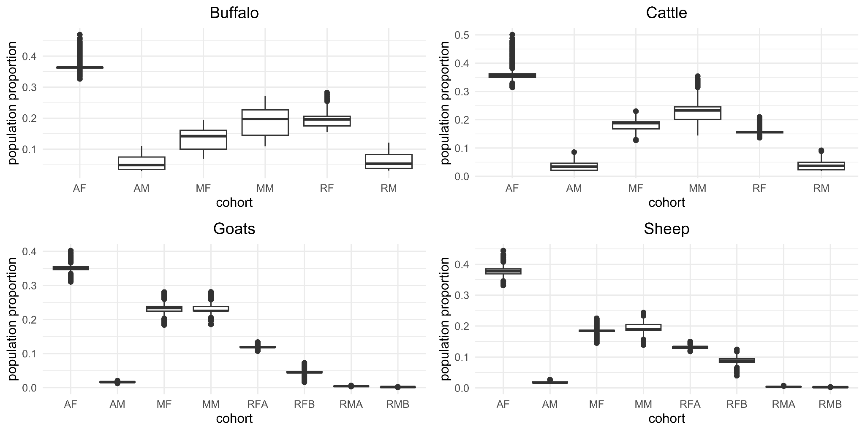
Appendix F. Cohort population proportion distribution observed during the sensitivity analysis process. Adult females (AF), adult males (AM), replacement females (RF), replacement males (RM), meat female animals (MF), meat male animals (MM), replacement females in the midst of first year (RFA), replacement females in the midst of the second year (RFB), replacement males in the midst of first year (RMA) and replacement males in the midst of the second year (RMB)

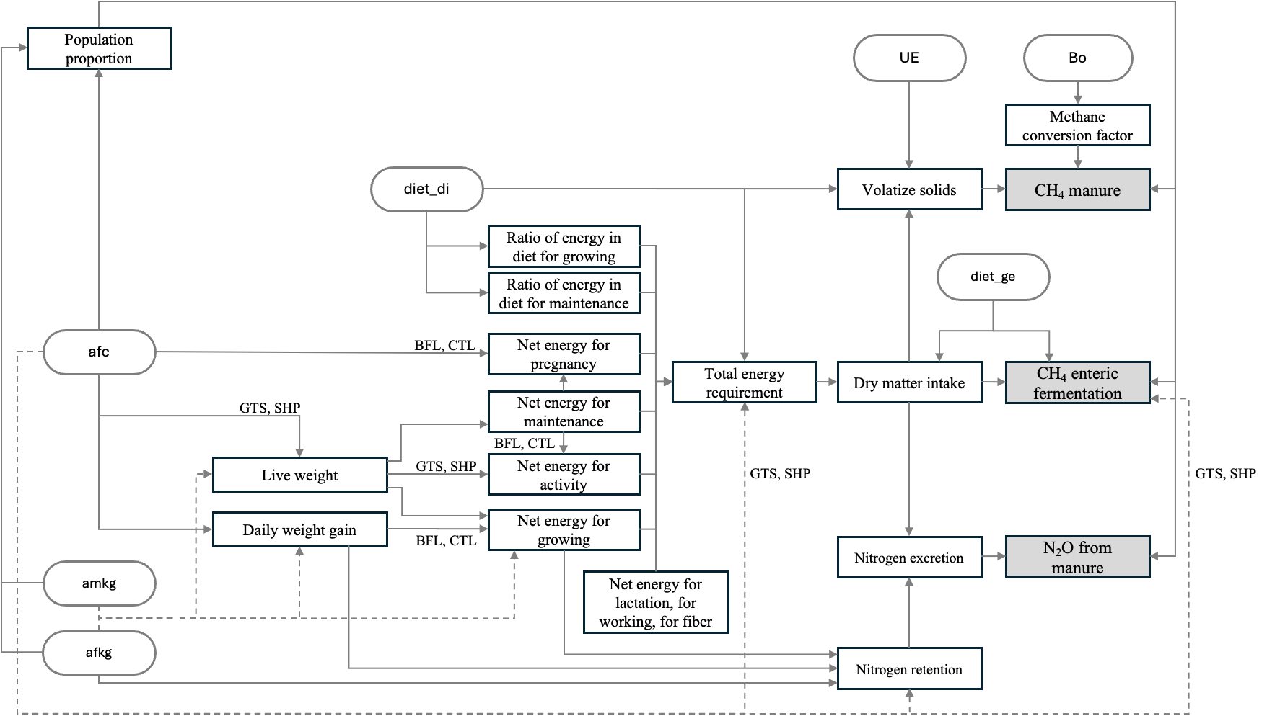
Appendix G: Flow diagram illustrating the processes and subprocesses of GLEAM associated with the most influential parameters for total emissions. Parameters positively correlated with total emissions: weight of adult females (afkg), weight of adult males (amkg), urinary energy as a fraction of gross energy (UE), and the maximum methane producing capacity of manure (Bo). Parameters negatively correlated with total emissions: diet digestibility (diet_di), gross energy of the diet (diet_ge) and age at first calving (afc).

Appendix H. Sensitivity indexes of the parameters of the GLEAM model for the ruminant species in the Herd Group, for the four types of direct emissions: methane from enteric fermentation (CH₄_E) and from manure (CH₄_M), nitrous oxide from manure management systems (N₂O_M) and from manure in pastures (N₂O_MP), and their sum in total emissions (Total). Positive correlations are represented in red and negative correlations in green. The intensity of the colours indicates the strength of the sensitivity value.
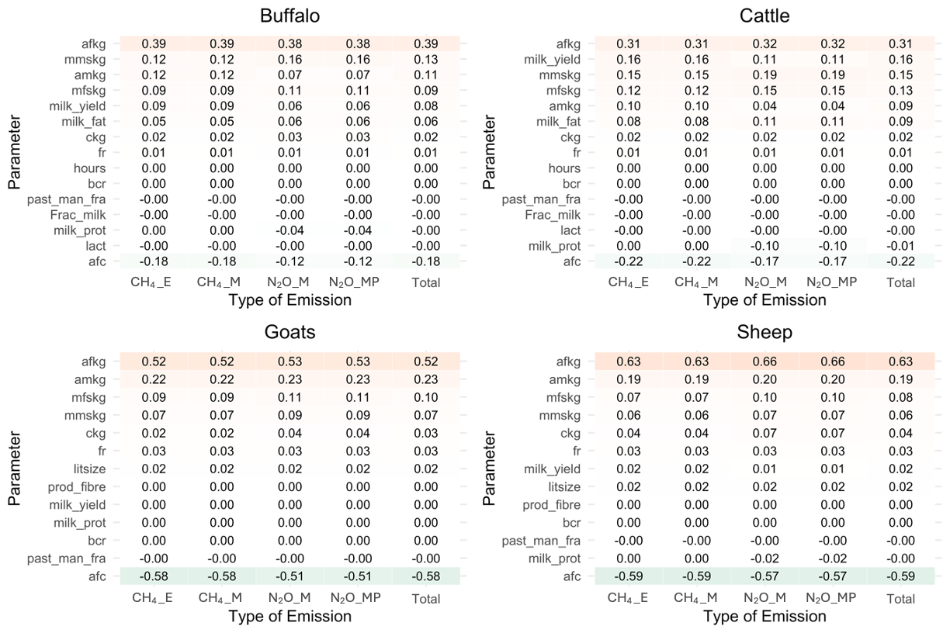

Appendix I. Sensitivity indexes of the parameters of the GLEAM model for the ruminant species in the Feed Group, for the four types of direct emissions: methane from enteric fermentation (CH₄_E) and from manure (CH₄_M), nitrous oxide from manure management systems (N₂O_M) and from manure in pastures (N₂O_MP), and their sum in total emissions (Total). Positive correlations are represented in red and negative correlations in green. The intensity of the colours indicates the strength of the sensitivity value.

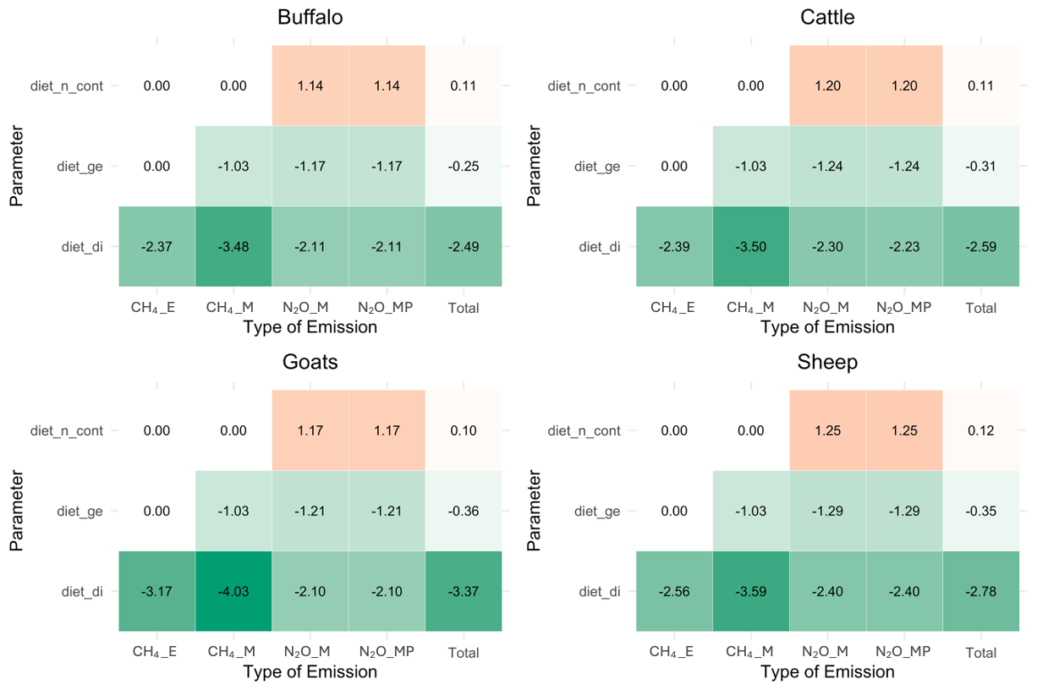

Appendix J. Sensitivity indexes of the parameters of the GLEAM model for the ruminant species in the Manure Group, for the four types of direct emissions: methane from enteric fermentation (CH₄_E) and from manure (CH₄_M), nitrous oxide from manure management systems (N₂O_M) and from manure in pastures (N₂O_MP), and their sum in total emissions (Total). Positive correlations are represented in red and negative correlations in green. The intensity of the colours indicates the strength of the sensitivity value.
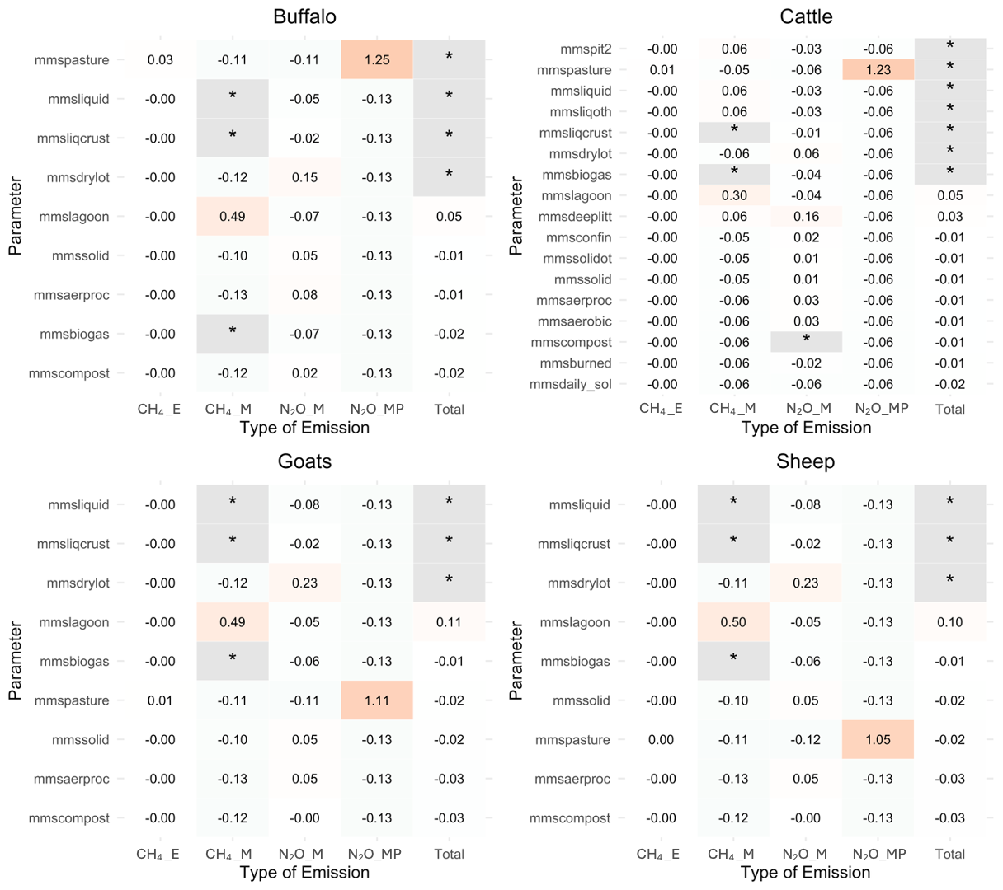
*sensitivity index cannot be well explained by the sensitivity method. Refer to the descriptive statistics of parameters and results for further details

Appendix K. Sensitivity indexes of the parameters of the GLEAM model for the ruminant species in the Global Conditional Group, for the four types of direct emissions: methane from enteric fermentation (CH₄_E) and from manure (CH₄_M), nitrous oxide from manure management systems (N₂O_M) and from manure in pastures (N₂O_MP), and their sum in total emissions (Total). Positive correlations are represented in red and negative correlations in green. The intensity of the colours indicates the strength of the sensitivity value.
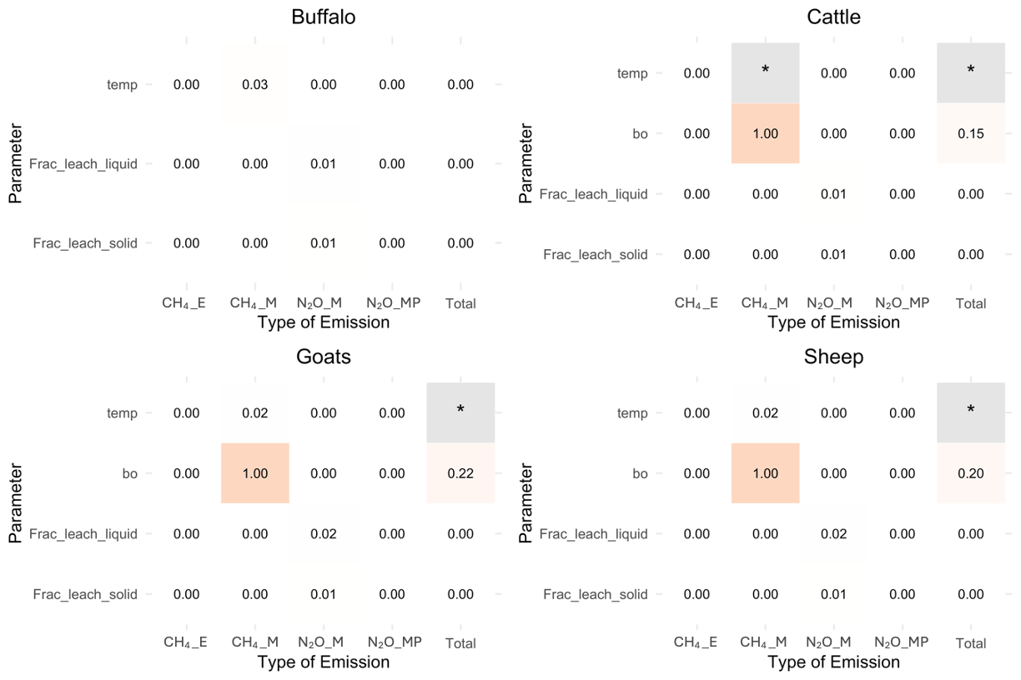
*sensitivity index cannot be well explained by the sensitivity method. Parameters excluded: Bo in buffalo. Refer to the descriptive statistics of parameters and results for further details.

Appendix L. Sensitivity indexes of emission factors and coefficients of the GLEAM model for buffalo and cattle, for the four types of direct emissions: methane from enteric fermentation (CH₄_E) and from manure (CH₄_M), nitrous oxide from manure management systems (N₂O_M) and from manure in pastures (N₂O_MP), and their sum in total emissions (Total). Positive correlations are represented in red and negative correlations in green. The intensity of the colours indicates the strength of the sensitivity value.

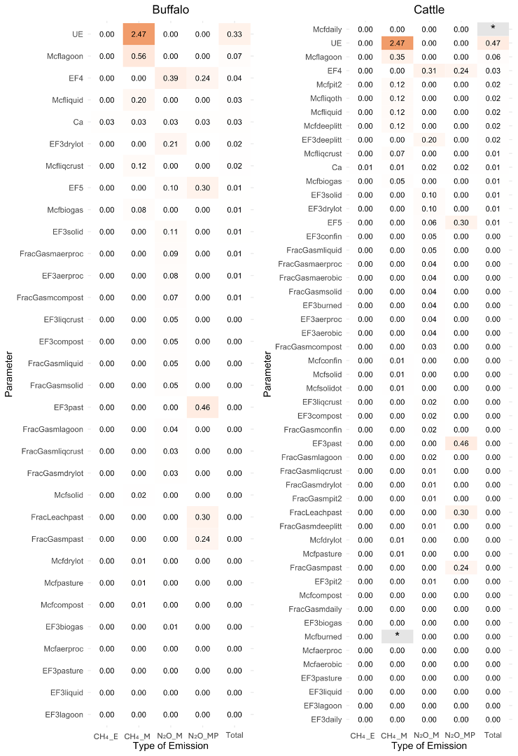
*sensitivity index cannot be well explained by the sensitivity method. Parameters excluded: fracGasmbiogas, fracGasmburned in cattle and fracGasmpasture. Refer to the descriptive statistics of parameters and results for further details.

Appendix M. Sensitivity indexes of emission factors and coefficients of the GLEAM model for goats and sheep, for the four types of direct emissions: methane from enteric fermentation (CH₄_E) and from manure (CH₄_M), nitrous oxide from manure management systems (N₂O_M) and from manure in pastures (N₂O_MP), and their sum in total emissions (Total). Positive correlations are represented in red and negative correlations in green. The intensity of the colours indicates the strength of the sensitivity value.
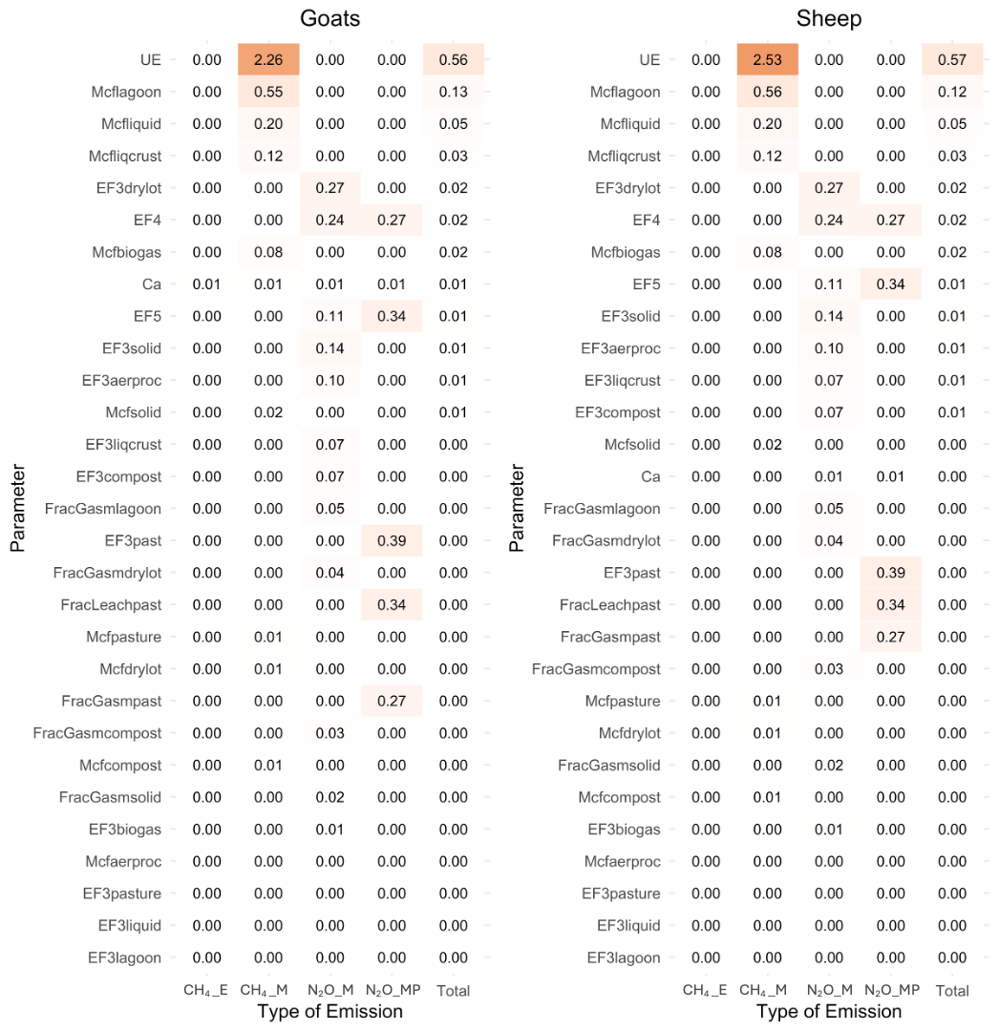
*sensitivity index cannot be well explained by the sensitivity method. Parameters excluded: FracGasmaerproc, fracGasmbiogas, fracGasmliqcrust, fracGasmliquid and fracGasmpasture. Refer to the descriptive statistics of parameters and results for further details.

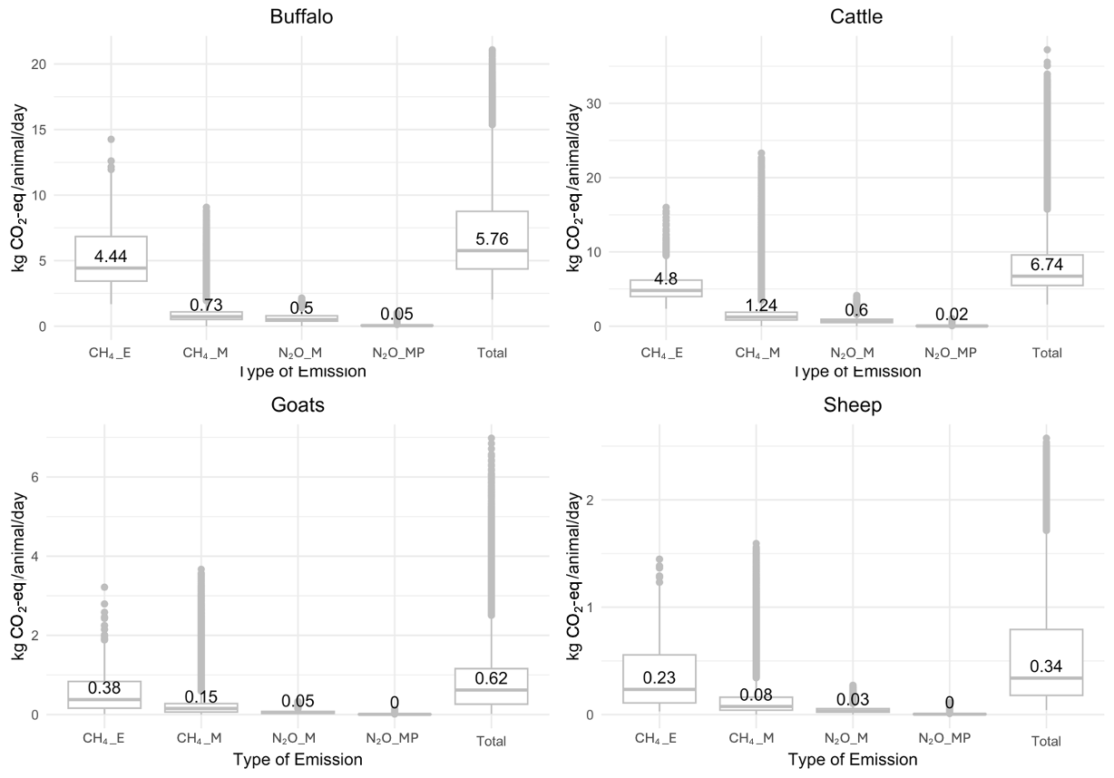
Appendix N. Emissions distribution per animal per day, observed during the sensitivity analysis process for methane from enteric fermentation (CH₄_E) and from manure (CH₄_M), nitrous oxide from manure management systems (N₂O_M) and from manure in pastures (N₂O_MP), and their sum in total emissions (Total).

