Testing the incorporation of bioassays in life cycle assessment - A case study on advanced wastewater treatment
Sofia Högstrand^{a*}, Greg Peters^{b}, Magdalena Svanström^{b}, Linda Önnby^{c}
ª Department of Process and Life Science Engineering, Lund University, Sweden
^{b} Division of Environmental Systems Analysis, Chalmers University of Technology, Sweden
^{c} IVL Swedish Environmental Research Institute, Malmö, Sweden
* Corresponding author: sofia.hogstrand@ple.lth.se

Contents
1 LCI 2
1.1 Construction 2
1.2 Final effluent 3
1.2.1 Heavy metals 3
1.2.2 Organic micropollutants 4
1.2.3 Bioassays 5
2 Reference substance sensitivity analysis 9
3 Data Quality 10
References 14

LCI
Table S1 Datasets from databases.
Parameter | Process | Database
Construction
Concrete | RER: Concrete C35/45 (Ready-mix concrete) (EN15804 A1-A3) - Sphera | LCAfE
Iron | DE: Cast iron component (EN15804 A1-A3) – Sphera | LCAfE
Steel | DE: EAF Steel billet / slab / bloom - Sphera | LCAfE
Plastics | RER: Polyethylene high density granulate (PE-HD) - ELCD/Plastics Europe - Sphera | LCAfE
Operation
Electricity | SE: Electricity grid mix Sphera | LCAfE
Ethanol | CH: ethanol production from sugar beet molasses ecoinvent 3.9.1 | ecoinvent
Ethanol | DE: Ethanol (96%) (hydrogenation with nitric acid) Sphera | LCAfE
Ozone | RER: Oxygen (liquid) Sphera | LCAfE
Ozone | SE: Electricity grid mix Sphera | LCAfE
Production of AC | RER: activated carbon production, granular from hard coal ecoinvent 3.9.1 | ecoinvent
Regeneration of AC | RER: treatment of spent activated carbon, granular from hard coal, reactivation ecoinvent 3.9.1 | ecoinvent
Transporting capacity | RER: Transport, truck (26t total cap., 17,3 t payload) (A4) Sphera | LCAfE

Construction
Table S2 Construction data för Ozone and GAC reactors.
 | Total amountª (tonne) | Adjusted amount^{b} (tonne) | Adjusted amount per FU^{c} (kg/m³) | Database process
Ozone reactor
Concrete | 3673 | 428 | 1.57*10⁻³ | RER: Concrete C35/45 (Ready-mix concrete) (EN15804 A1-A3) - Sphera
Iron | 643 | 75 | 2.75*10⁻⁴ | DE: Cast iron component (EN15804 A1-A3) – Sphera
Steel | 195 | 23 | 8.35*10⁻⁵ | DE: EAF Steel billet / slab / bloom - Sphera
GAC reactor
Concrete | 12756 | 1486 | 5.46*10⁻³ | See above
Iron | 2232 | 260 | 9.56*10⁻⁴ | See above
Steel | 351 | 41 | 1.50*10⁻⁴ | See above
ª (Ernst et al. 2020)
^{b} Scaling using power-law-function according to (Remer and Chai 1993; Gallego-Schmid et al. 2019) with economy of scale factor of 0.7 and cap_{ref} of 971 000 PE, cap 45 000 PE
^{c} Related to flow based on assumed life span of 50 years (Ernst et al. 2020) and daily flow of 14900 m³/d (Dahlberg 2019).

Table S3 Construction data for MBBR reactor.
 | Total amountª (tonne) | Adjusted amount^{b} (tonne) | Adjusted amount per FU^{c} (kg/m³) | Database process
MBBR reactor
Concrete | 16080 | 2300 | 1.41*10⁻² | RER: Concrete C35/45 (Ready-mix concrete) (EN15804 A1-A3) - Sphera
Steel | 4595 | 657 | 4.03*10⁻³ | DE: EAF Steel billet / slab / bloom - Sphera
Plastic carriers (PE) | 1109 | 158 | 9.71*10⁻⁴ | RER: Polyethylene high density granulate (PE-HD) - ELCD/Plastics Europe - Sphera
ª (Awad et al. 2024)
^{b} Scaling using power-law-function according to (Remer and Chai 1993; Gallego-Schmid et al. 2019) with economy of scale factor of 0.7 and cap_{ref} of 240 000 m3/d, cap 14 900 m3/d
^{c} Related to flow based on assumed life span of 30 years (Awad et al. 2024) and daily flow of 14900 m³/d (Dahlberg 2019).
Table S4 Calculation of plastics
Parameter | Value | Reference
Effective reactor volume | 410 m³ | (Dahlberg 2019)
Filling ratio | 30% | (Zhao et al. 2019)
Carrier material | Polyethylene (PE) | (Yuan et al. 2015)
Bulk density | 100 kg/m³ | commonly ranging between 95-150 according to various manufacturers
Resulting amount plastics/FU | 7.54*10⁻⁵ kg/m³ | calculated

Final effluent

Heavy metals
Table S5 Heavy metal removal rates in GAC filters (Mailler et al. 2024).
Parameter | Unit | Cd | Cr | Cu | Ni | Pb | Zn
Removal in GAC | % | 92 | 90 | 81 | 72 | 84 | 52

Organic micropollutants
Table S6 USEtox characterisation factors for freshwater compartment, current average effluent concentrations in Lidköping (Holm and Önnby 2022), average removal rates after AWT based on (Holm and Önnby 2022; Baresel et al. 2024) and calculated toxicity impact for FETP, HTPc and HTPnc.
 |  | USEtox CF |  |  | Lid WWTP effluent |  |  |  | O3-MBBR |  |  |  |  | O3-GAC
 |  | FETP | HTPc | HTPnc |  | FETP | HTPc | HTPnc | Removal O₃-MBBR |  | FETP | HTPc | HTPnc | Removal O₃-GAC |  | FETP | HTPc | HTPnc
CAS-nr | Compound | CTUe/kg | CTUh/kg | CTUh/kg | ng/l | CTUe/m³ | CTUh/m³ | CTUh/m³ | % | ng/l | CTUe/m³ | CTUh/m³ | CTUh/m³ | % | ng/l | CTUe/m³ | CTUh/m³ | CTUh/m³
298-46-4 | Carbamazepine | 779.5117743 | - | 2.33E-06 | 626.6878 | 0.000489 | - | 1.46E-12 | 99.71 | 1.820941 | 1.42E-06 | - | 4.24E-15 | 99.50372 | 3.110143 | 2.42E-06 | - | 7.24E-15
15307-86-5 | Diclofenac | 1949.341983 | - | 0.000159 | 838.0625 | 0.001634 | - | 1.33E-10 | 99.84 | 1.309181 | 2.55E-06 | - | 2.08E-13 | 99.21474 | 6.580934 | 1.28E-05 | - | 1.05E-12
54-31-9 | Furosemide | - | 3.2438E-07 | - | 1263.623 | - | 4.1E-13 | - | 99.17 | 10.4312 | - | 3.38E-15 | - | 99.58895 | 5.194119 | - | 1.68E-15 | -
138261-41-3 | Imidacloprid | 3196.828241 | - | 2.5E-06 | 3.58015 | 1.14E-05 | - | 8.96E-15 | 74.82 | 0.901351 | 2.88E-06 | - | 2.26E-15 | - | - | - | - | -
15687-27-1 | Ibuprofen | 236.1344965 | - | - | 45.5 | 1.07E-05 | - | - | - | - | - | - | - | 84.3349 | 7.127619 | 1.68E-06 | - | -
51384-51-1 | Metoprolol | 3520.190291 | - | 5.1E-07 | 794.5125 | 0.002797 | - | 4.05E-13 | 93.39 | 52.48882 | 0.000185 | - | 2.68E-14 | 98.73164 | 10.07731 | 3.55E-05 | - | 5.14E-15
604-75-1 | Oxazepam | - | 5.1722E-06 | - | 402.1521 | - | 2.08E-12 | - | 78.36 | 87.02191 | -0 | 4.5E-13 | - | 95.05063 | 19.90398 | - | 1.03E-13 | -
103-90-2 | Paracetamol | 86.58740029 | 9.0583E-08 | - | 90.8187 | 7.86E-06 | 8.23E-15 | - | 99.65 | 0.317381 | 2.75E-08 | 2.87E-17 | - | 87.69571 | 11.1746 | 9.68E-07 | 1.01E-15 | -
95-14-7 | Benzotriazole | 298.158028 | - | 8.43E-07 | 1106.697 | 0.00033 | - | 9.33E-13 | 84.62 | 170.2365 | 5.08E-05 | - | 1.44E-13 | 94.43529 | 61.58441 | 1.84E-05 | - | 5.19E-14
114-07-8 | Erythromycin | 21360.45135 | - | - | 163.0592 | 0.003483 | - | - | 83.34 | 27.17208 | 0.00058 | - | - | 69.93464 | 49.02434 | 0.001047 | - | -
723-46-6 | Sulfa-methoxazole | 4696.052486 | - | 4.7E-07 | 159.8125 | 0.00075 | - | 7.51E-14 | 99.83 | 0.266953 | 1.25E-06 | - | 1.25E-16 | 94.45502 | 8.861567 | 4.16E-05 | - | 4.16E-15
738-70-5 | Trimetoprim | 995.0096731 | - | 2.78E-06 | 146.66 | 0.000146 | - | 4.07E-13 | 98.56 | 2.110119 | 2.1E-06 | - | 5.86E-15 | 98.83303 | 1.711474 | 1.7E-06 | - | 4.75E-15
80-05-7 | Bisphenol A | 8352.584585 | - | 1.1E-06 | 69.66189 | 0.000582 | - | 7.64E-14 | 93.85 | 4.281213 | 3.58E-05 | - | 4.7E-15 | - | 69.66189 | 0.000582 | - | 7.64E-14
53-16-7 | Estrone | 23648.31107 | - | - | 1.427757 | 3.38E-05 | - | - | 99.57 | 0.006175 | 1.46E-07 | - | - | - | 1.427757 | 3.38E-05 | - | -
 | SUM |  |  |  |  | 0.010291 | 2.51E-12 | 1.42E-10 |  |  | 0.000862 | 4.54E-13 | 3.96E-13 |  |  | 0.001778 | 1.06E-13 | 1.2E-12

Table S7 Toxicity benefits of implementing AWT based on chemical analysis.
 | FETP (CTUe/m³) | HTPc (CTUh/m³) | HTPnc (CTUh/m³)
O₃-MBBR | -9.43E-03 | -2.06E-12 | -1.42E-10
O₃-GAC | -8.51E-03 | -2.41E-12 | -1.41E-10

Bioassays
Table S8 Characterisation factors for bioassay conversion at midpoint, emitted into freshwater compartment (Reference: USEtox 2.14 excel sheet)
Reference substance | CAS-no | ETP [CTUe/kg_emitted] | HTPc [CTUh/kg_emitted] | HTPnc [CTUh/kg_emitted]
E2 | 50-28-2 | 3.14*10⁶ | 6.91*10⁻⁴ | ---
TCDD | 1746-01-6 | 9.44*10⁶ | 1.45*10² | ---
tBHQ | 1948-33-0 | 5.61*10⁴ | --- | ---
B(a)P | 80-05-7 | 8.35*10³ | --- | 1.10*10⁻⁶
Carbaryl | 63-25-2 | 4.59*10⁴ | 7.02*10⁻⁶ | 5.20*10⁻⁶

Table S9 Toxicity reduction rates for O₃-MBBR (Holm and Önnby 2022)
ER-activity (pg E2-eq./L)
Date | 25-04-2022 | 16-05-2022
LOD | 14.2 | 14.2
O3 in | 3660 | 14400
O3 in | 5030 | 181
O3 in mean | 4345 | 7290.5
O3 out | 65.9 | <LOD
O3 out | 129 | <LOD
MBBR out | 63.3 | 110
MBBr out | 37.3 | 116
MBBR out mean | 50.3 | 113
tox reduction O3-MBBR (%) | 98.842348 | 98.450038
mean reduction (%) | 98.646193
median (%) | 98.646193
AR-activity (ngDHT-eq./L)
Date | 25-04-2022 | 16-05-2022
LOD | 0.0131 | 0.0131
O3 in | <LOD | <LOD
O3 in | <LOD | <LOD
O3 in mean | --- | ---
O3 out | <LOD | <LOD
O3 out | <LOD | <LOD
MBBR out | <LOD | <LOD
MBBr out | <LOD | <LOD
MBBR out mean | <LOD | <LOD
tox reduction O3-MBBR (%)
mean reduction (%) | ---
median (%) | ---
anti-AR-activity (ngOHF-eq./L)
Date | 25-04-2022 | 16-05-2022
LOD | 72.5 | 72.5
O3 in | 73.3 | <LOD
O3 in | <LOD | <LOD
O3 in mean | 73.3 | ---
O3 out | <LOD | <LOD
O3 out | <LOD | <LOD
MBBR out | <LOD | <LOD
MBBr out | <LOD | <LOD
MBBR out mean | <LOD | <LOD
tox reduction O3-MBBR (%) | 1.0914052
mean reduction (%) | 1.0914052
median (%) | 1.0914052
AhR-activity (ngTCDD-eq./L)
Date | 25-04-2022 | 16-05-2022
LOD | 0.0688 | 0.0688
O3 in | 0.583 | 0.332
O3 in | 0.515 | <LOD
O3 in mean | 0.549 | 0.332
O3 out | <LOD | <LOD
O3 out | <LOD | <LOD
MBBR out | <LOD | <LOD
MBBr out | <LOD | <LOD
MBBR out mean | <LOD | <LOD
tox reduction O3-MBBR (%) | 87.468124 | 79.277108
mean reduction (%) | 83.372616
median (%) | 83.372616
Nrf2-activity (µgtBHQ-eq./L)
Date | 25-04-2022 | 16-05-2022
LOD | 6.41 | 6.41
O3 in | 18.4 | 8.96
O3 in | 14.8 | <LOD
O3 in mean | 16.6 | 7.685
O3 out | <LOD | <LOD
O3 out | <LOD | <LOD
MBBR out | 7.13 | <LOD
MBBr out | <LOD | <LOD
MBBR out mean | 6.77 | 6.41
tox reduction O3-MBBR (%) | 61.385542 | 16.590761
mean reduction (%) | 38.988152
median (%) | 38.988152

Table S10 Toxicity reduction rates for O₃-GAC (Baresel et al. 2024)
ER-activity
pg E2-eq./L
Date | 2022-11-08 | 2023-01-13 | 2022-03-23 | 2023-04-25 | 2023-07-03 | 2023-08-27
LOD | 29.1 | 10.3 | 1.7 | 13 | 15.5 | 13.5
O3 in | 1030 |  |  | 437 | 3490 | 1030
O3 out | 386 |  |  | 374 | 1370 | 1400
GAK1 out | 316 |  |  | <LOD | 176 | 280
GAK2 out | <LOD |  |  | <LOD | 204 | 260
Tox reduction O3-GAC1 (%) | 69.32 |  |  | 97.03 | 94.96 | 72.82 | Mean | Median
Tox reduction O3-GAC2 (%) | 97.17 |  |  | 97.03 | 94.15 | 81.43 | 87.99 | 94.56
AR-activity
ng DHT-eq./L
Date | 2022-11-08 | 2023-01-13 | 2022-03-23 | 2023-04-25 | 2023-07-03 | 2023-08-27
LOD | 0.02 | 0.22 | 0.1 | 0.1 | 0.25 | 0.33
O3 in | <LOD |  |  | <LOD | <LOD | <LOD
O3 out | <LOD |  |  | <LOD | <LOD | <LOD
GAK1 out | <LOD |  |  | <LOD | <LOD | <LOD
GAK2 out | <LOD |  |  | <LOD | <LOD | <LOD
Tox reduction O3-GAC1 (%) |  |  |  |  |  |  | Mean | Median
Tox reduction O3-GAC2 (%) |  |  |  |  |  |  | --- | ---
anti-AR-activity
ng OHF-eq./L
Date | 2022-11-08 | 2023-01-13 | 2022-03-23 | 2023-04-25 | 2023-07-03 | 2023-08-27
LOD | 4.7 | 66.4 | 12 | 40.9 | 37.3 | 44.5
O3 in | <LOD |  |  | <LOD | <LOD | 80.1
O3 out | <LOD |  |  | <LOD | <LOD | <LOD
GAK1 out | <LOD |  |  | <LOD | <LOD | <LOD
GAK2 out | <LOD |  |  | <LOD | <LOD | <LOD
Tox reduction O3-GAC1 (%) |  |  |  |  |  | 44.44 | Mean | Median
Tox reduction O3-GAC2 (%) |  |  |  |  |  | 44.44 | 44.44 | 44.44
AhR-activity
ng TCDD-eq./L
Date | 2022-11-08 | 2023-01-13 | 2022-03-23 | 2023-04-25 | 2023-07-03 | 2023-08-27
LOD | 0.022 | 0.123 | 0.4 | 0.053 | 0.016 | 0.032
O3 in | 0.19 |  |  | 0.26 | 0.18 | 0.39
O3 out | 0.06 |  |  | 3.14 | 0.1 | 0.33
GAK1 out | <LOD |  |  | 0.14 | 0.02 | 0.07
GAK2 out | 0.03 |  |  | 0.22 | 0.03 | 0.57
Tox reduction O3-GAC1 (%) | 88.42 |  |  | 46.15 | 88.89 | 82.05 | Mean | Median
Tox reduction O3-GAC2 (%) | 84.21 |  |  | 15.38 | 83.33 | -72.73 | 51.96 | 82.69
Nrf2-activity
µg tBHQ-eq./L
Date | 2022-11-08 | 2023-01-13 | 2022-03-23 | 2023-04-25 | 2023-07-03 | 2023-08-27
LOD | 4.1 | 5.9 | 10.9 | 5.7 | 3.5 | 11.2
O3 in | 6.2 |  |  | <LOD | 9.6 | <LOD
O3 out | <LOD |  |  | <LOD | 11.9 | 80.5
GAK1 out | <LOD |  |  | <LOD | <LOD | <LOD
GAK2 out | 6.6 |  |  | <LOD | <LOD | <LOD
Tox reduction O3-GAC1 (%) | 33.87 |  |  |  | 63.54 |  | Mean | Median
Tox reduction O3-GAC2 (%) | -6.45 |  |  |  | 63.54 |  | 38.63 | 48.71

Table S11 Toxicity benefits of implementing AWT based on (Holm and Önnby 2022; Baresel et al. 2024)
 | FETP (CTUe/m³) | HTPc (CTUh/m³)
ER-activity
O₃-MBBR | -2.61E-02 | -5.74E-12
O₃-GAC | -2.50E-02 | -5.51E-12
AhR-activity
O₃-MBBR | -1.50E-02 | -2.31E-07
O₃-GAC | -1.49E-02 | -2.29E-07
Nrf2-activity
O₃-MBBR | -7.31E-01 | ---
O₃-GAC | -9.13E-01 | ---
Total
O₃-MBBR | -7.72E-01 | -2.31E-07
O₃-GAC | -9.53E-01 | -2.29E-07

Reference substance sensitivity analysis

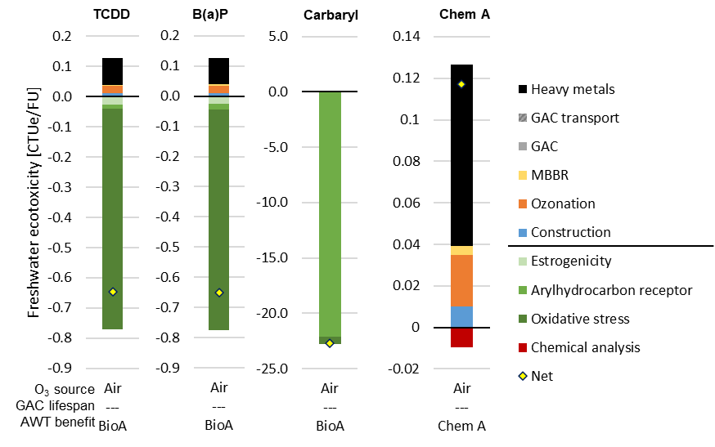
Fig. S1 Freshwater ecotoxicity potential in CTUe/FU for the O₃-MBBR scenario with ozone from air expressing AhR activity through three different reference substances (TCDD, B(a)P and carbaryl). “BioA” = bioassay. “Chem A” = chemical analysis
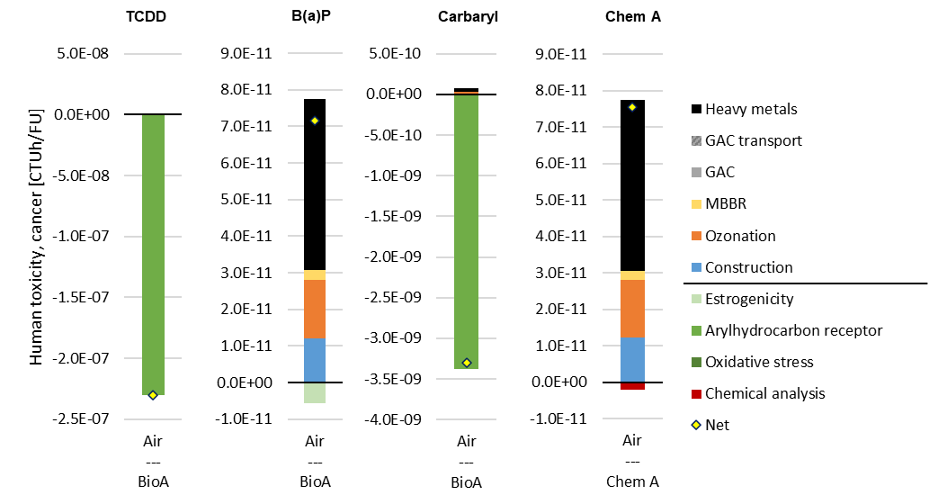
Fig. S2 Human toxicity potential, cancer, in CTUh/FU for the O₃-MBBR scenario with ozone from air expressing AhR activity through three different reference substances (TCDD, B(a)P and carbaryl). “BioA” = bioassay. “Chem A” = chemical analysis
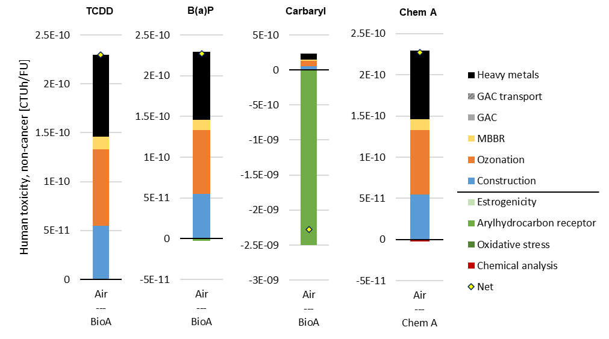
Fig. S3 Human toxicity potential, non-cancer, in CTUh/FU for the O₃-MBBR scenario with ozone from air expressing AhR activity through three different reference substances (TCDD, B(a)P and carbaryl). “BioA” = bioassay. “Chem A” = chemical analysis

Data Quality
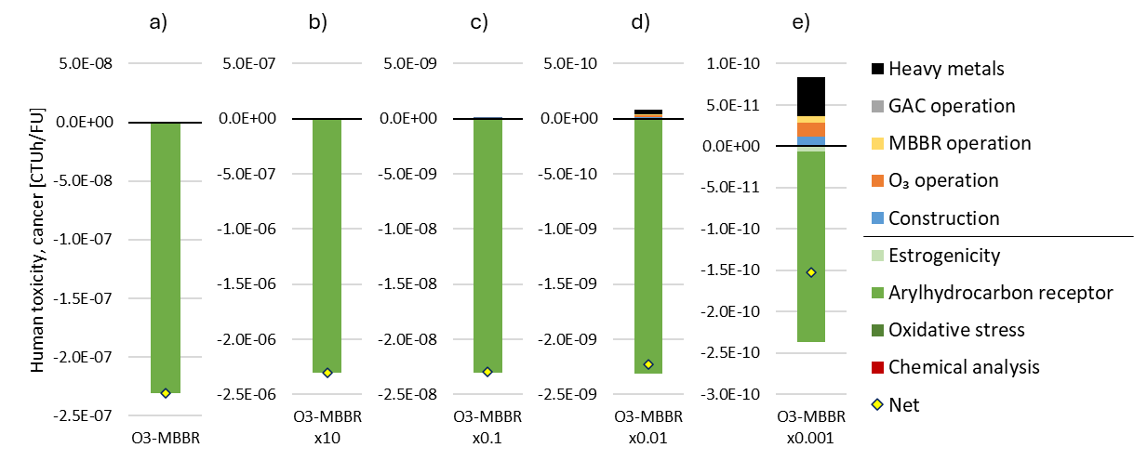
Fig. S4. Sensitivity analysis of impact of varying levels of AhR activity in the secondary effluent, a) base case, b) 10 times higher levels of AhR, c) ten times lower, d) hundred times lower, and e) thousand times lower.

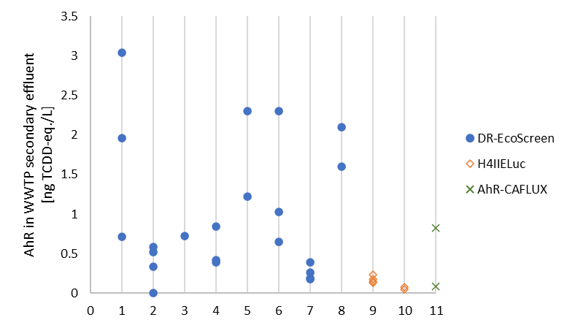
Fig. S5 Secondary effluent levels of AhR in ng TCDD-eq./L from eleven WWTPs. Colour code indicating type of bioassay used. WWTP1: Lidköping, WWTP 2: location of O3-MBBR pilot, WWTP 7: location of O3-GAC pilot (Macova et al. 2010; Reungoat et al. 2010; Maier et al. 2016; Holm and Önnby 2022; Frieberg et al. 2023; Baresel et al. 2024)
Table S12 Toxicity reduction in literature for O₃-MBBR
 | ER | AhR | ox stress
Study | Removal (%) | Removal (%) | Removal (%)
(Kienle et al. 2013) | 83.00
(Itzel et al. 2017) | 50.00
(Itzel et al. 2017) | 95.00
(Itzel et al. 2017) | 91.67
(Itzel et al. 2017) | 95.00
(Itzel et al. 2017) | 60.00
(Itzel et al. 2017) | 72.22
(Itzel et al. 2017) | 72.22
(Itzel et al. 2017) | 50.00
(Itzel et al. 2017) | 50.00
(Itzel et al. 2020) | 77.77778
(Itzel et al. 2020) | 66.66667
(Itzel et al. 2020) | 60
(Kienle et al. 2022) | 99 |  | 51
(Stapf et al. 2020) | 99
(Stapf et al. 2020) | 99
(Holm and Önnby 2022) | 98.84 | 87.47 | 61.39
(Holm and Önnby 2022) | 98.45 | 79.28 | 16.59
Median | 80.39 | 83.38 | 51.00
Mean | 78.77 | 83.38 | 42.99
n calculations | 18 | 2 | 3
n WWTP | 7 | 1 | 2
n studies | 6 | 1 | 2

Table S13 Toxicity reduction in literature for O₃-GAC
 | ER | AhR | ox stress
Study | Removal (%) | Removal (%) | Removal (%)
(Escher et al. 2014) | 99.77 | 98.89 | 52.5
(Escher et al. 2014) | 98.13 | 96.67 | 36
(Escher et al. 2014) | 98.07 | 94.29 | 92.64
(Escher et al. 2014) | 93.33 | 93.75
(Escher et al. 2014) | 96.67 | 97.50
(Escher et al. 2014) | 92.83
(Escher et al. 2014) | 89.17
(Escher et al. 2014) | 70.50
(Escher et al. 2014) | 98.88
(Escher et al. 2014) | 99.05
(Escher et al. 2014) | 93.80
(Escher et al. 2014) | 96.00
(Reungoat et al. 2012) | 96.94
(Reungoat et al. 2012) | 99.42
(Reungoat et al. 2012) | 97.30
(Reungoat et al. 2012) | 98.04
(Reungoat et al. 2012) | 98.25
(Reungoat et al. 2012) | 98.44
(Reungoat et al. 2012) | 95.14
(Reungoat et al. 2012) | 95.58
(Reungoat et al. 2012) | 93.91
(Escher et al. 2012) |  |  | -4.8
(Reungoat et al. 2010) | 98.97 | 62.2
(Macova et al. 2010) | 99.98 | 74.03
(Macova et al. 2010) | 99.81 | 67.44
(Macova et al. 2010) | 99.74 | 47.67
(Macova et al. 2010) | 99.42 | 72.55
(Macova et al. 2010) |  | 45.12
(Ternes et al. 2017) | 89.08
(Ternes et al. 2017) | 90.02
(Giebner et al. 2018) | 55
(Giebner et al. 2018) | 88
(Giebner et al. 2018) | 94
(Maier et al. 2016) |  | 78.72
(Maier et al. 2016) |  | 72.38
(Maier et al. 2016) |  | 66.67
(Maier et al. 2016) |  | 61.54
(Kienle et al. 2022) |  |  | 72
(Stapf et al. 2020) | 99
(Baresel et al. 2024) | 69.3 | 88.42 | 33.87
(Baresel et al. 2024) | 97.2 | 84.21 | -6.45
(Baresel et al. 2024) | 97 | 46.15 | 63.54
(Baresel et al. 2024) | 97 | 15.38 | 63.54
(Baresel et al. 2024) | 95 | 88.89
(Baresel et al. 2024) | 94.2 | 83.33
(Baresel et al. 2024) | 72.8 | 82.05
(Baresel et al. 2024) | 81.4 | -72.73
Median | 96.80 | 74.03 | 52.50
Mean | 92.90 | 67.18 | 44.76
n calculations | 40 | 23 | 9
n WWTP | 7 | 3 | 3
n studies | 8 | 5 | 4

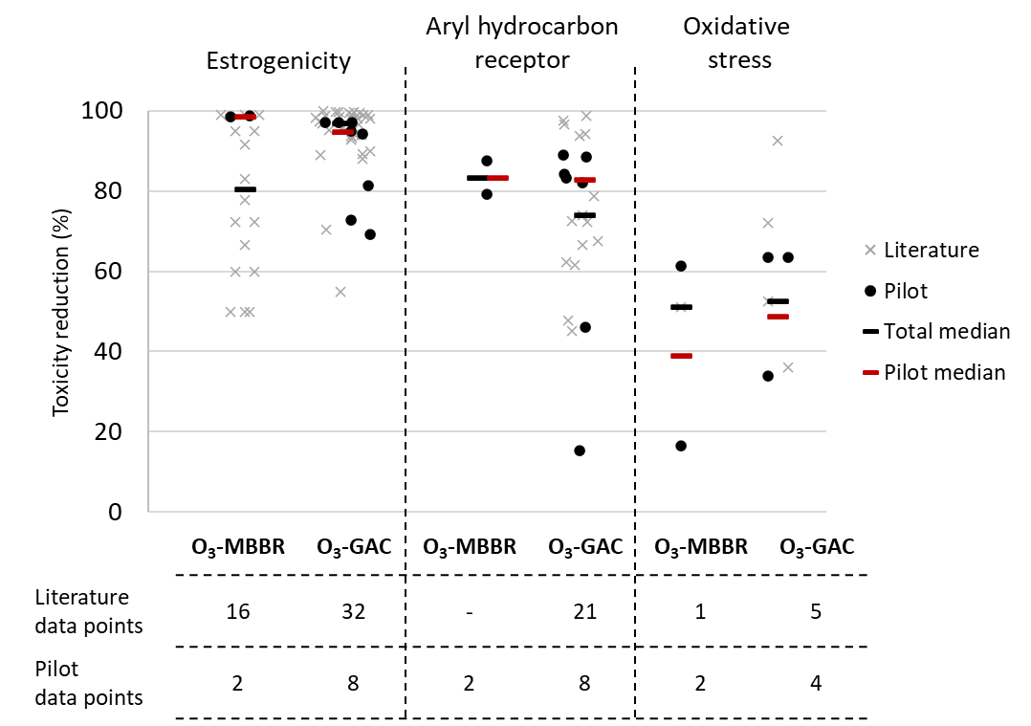
Fig. S6 Toxicity reduction (%) for O₃-MBBR and O₃-GAC and the three biological endpoints ER, AhR and ox. stress based on the pilot data (Holm and Önnby 2022; Baresel et al. 2024) or literature (Völker et al. 2019; Stapf et al. 2020; Itzel et al. 2020; Kienle et al. 2022) together with the pilot and total medians. For graphical reasons, negative data points (i.e., toxicity formation) have been excluded from the graph but are included in mean and median calculations

References
Awad H, Mossad M, Mahanna H, et al (2024) Performance and life cycle assessment of moving-bed biofilm and integrated fixed-film reactors to upgrade activated sludge systems. J Clean Prod 449:141624. https://doi.org/10.1016/j.jclepro.2024.141624
Baresel C, Habagil M, Malovanyy A, et al (2024) Förstudie - Mikroföroreningar vid Getteröverket i Varberg - Tekniska lösningar för en utökad rening av avloppsvatten - Rapport C811
Dahlberg C (2019) Teknisk beskrivning till nytt avloppsreningsverk i Lidköping (eng_ Technical description of new wastewater treatment plant in Lidköping). Jönköping, Sweden
Ernst G, Tumlin S, Neth M (2020) D1909 Läkemedelsrening - Förstudie av alternativ för läkemedelsrening på Ryaverket. Gothenburg, Sweden
Escher BI, Allinson M, Altenburger R, et al (2014) Benchmarking organic micropollutants in wastewater, recycled water and drinking water with in vitro bioassays. Environ Sci Technol 48:1940–1956. https://doi.org/10.1021/es403899t
Escher BI, Dutt M, Maylin E, et al (2012) Water quality assessment using the AREc32 reporter gene assay indicative of the oxidative stress response pathway. J Environ Monit 14:2877–2885. https://doi.org/10.1039/c2em30506b
Frieberg K, Gago-Ferrero P, Bijlsma L, et al (2023) Effect-based evaluation of water quality in a system of indirect reuse of wastewater for drinking water production. Water Res 242:120147. https://doi.org/10.1016/j.watres.2023.120147
Gallego-Schmid A, Tarpani RRZ, Miralles-Cuevas S, et al (2019) Environmental assessment of solar photo-Fenton processes in combination with nanofiltration for the removal of micro-contaminants from real wastewaters. Sci Total Environ 650:2210–2220. https://doi.org/10.1016/j.scitotenv.2018.09.361
Giebner S, Ostermann S, Straskraba S, et al (2018) Effectivity of advanced wastewater treatment: reduction of in vitro endocrine activity and mutagenicity but not of in vivo reproductive toxicity. Environ Sci Pollut Res 25:3965–3976. https://doi.org/10.1007/s11356-016-7540-1
Holm G, Önnby L (2022) Effektbaserade analyser för att utvärdera reningseffektivitet och miljörisker i avloppsvatten - Lärdomar från sex avloppsreningsverk med konventionell respektive avancerad rening
Itzel F, Baetz N, Hohrenk LL, et al (2020) Evaluation of a biological post-treatment after full-scale ozonation at a municipal wastewater treatment plant. Water Res 170:115316. https://doi.org/10.1016/j.watres.2019.115316
Itzel F, Gehrmann L, Bielak H, et al (2017) Investigation of full-scale ozonation at a municipal wastewater treatment plant using a toxicity-based evaluation concept. J Toxicol Environ Heal - Part A Curr Issues 80:1242–1258. https://doi.org/10.1080/15287394.2017.1369663
Kienle C, Baumberger D, Schifferli A, et al (2013) Evaluation der Ökotoxizität von Kläranlagenabwasser der ARA Basel mit Biotests vor und nach der Anwendung erweiterter Abwasserbehandlungsmethoden Abschlussbericht. Dübendorf, Germany
Kienle C, Werner I, Fischer S, et al (2022) Evaluation of a full-scale wastewater treatment plant with ozonation and different post-treatments using a broad range of in vitro and in vivo bioassays. Water Res 212:118084. https://doi.org/10.1016/j.watres.2022.118084
Lundqvist J, Mandava G, Lungu-Mitea S, et al (2019) In vitro bioanalytical evaluation of removal efficiency for bioactive chemicals in Swedish wastewater treatment plants. Sci Rep 9:7166. https://doi.org/10.1038/s41598-019-43671-z
Macova M, Escher BI, Reungoat J, et al (2010) Monitoring the biological activity of micropollutants during advanced wastewater treatment with ozonation and activated carbon filtration. Water Res 44:477–492. https://doi.org/10.1016/j.watres.2009.09.025
Maier D, Benisek M, Blaha L, et al (2016) Reduction of dioxin-like toxicity in effluents by additional wastewater treatment and related effects in fish. Ecotoxicol Environ Saf 132:47–58. https://doi.org/10.1016/j.ecoenv.2016.04.036
Mailler R, Danel O, Esperanza M, et al (2024) Mastering granular activated carbon filtration to remove organic micropollutants, antibiotic resistance and metals for municipal wastewater reuse. Sci Total Environ 952:175918. https://doi.org/10.1016/j.scitotenv.2024.175918
Oskarsson A, Rosenmai AK, Mandava G, et al (2021) Assessment of source and treated water quality in seven drinking water treatment plants by in vitro bioassays – Oxidative stress and antiandrogenic effects after artificial infiltration. Sci Total Environ 758:144001. https://doi.org/10.1016/j.scitotenv.2020.144001
Remer DS, Chai LH (1993) Process Plants, Costs of Scaled-up Units. In: McKetta JJ (ed) Encyclopedia of Chemical Processing and Design. Marcel Dekker, pp 14–39
Reungoat J, Escher BI, Macova M, et al (2012) Ozonation and biological activated carbon filtration of wastewater treatment plant effluents. Water Res 46:863–872. https://doi.org/10.1016/j.watres.2011.11.064
Reungoat J, Macova M, Escher BI, et al (2010) Removal of micropollutants and reduction of biological activity in a full scale reclamation plant using ozonation and activated carbon filtration. Water Res 44:625–637. https://doi.org/10.1016/j.watres.2009.09.048
Rosenmai AK, Lundqvist J, le Godec T, et al (2018) In vitro bioanalysis of drinking water from source to tap. Water Res 139:272–280. https://doi.org/10.1016/j.watres.2018.04.009
Stapf M, Miehe U, Knoche F, et al (2020) Impact of ozonation and post-treatment on ecotoxicological endpoints, water quality, APIs and transformation products. CWPharma project report for GoA3.3: Comparison of post-treatment options.
Ternes TA, Prasse C, Eversloh CL, et al (2017) Integrated Evaluation Concept to Assess the Efficacy of Advanced Wastewater Treatment Processes for the Elimination of Micropollutants and Pathogens. Environ Sci Technol 51:308–319. https://doi.org/10.1021/acs.est.6b04855
Völker J, Stapf M, Miehe U, Wagner M (2019) Systematic review of toxicity removal by advanced wastewater treatment technologies via ozonation and activated carbon. Environ. Sci. Technol. 53:7215–7233
Yuan Q, Wang H, Hang Q, et al (2015) Comparison of the MBBR denitrification carriers for advanced nitrogen removal of wastewater treatment plant effluent. Environ Sci Pollut Res 22:13970–13979. https://doi.org/10.1007/s11356-015-4546-z
Zhao Y, Yuan Q, He Z, et al (2019) Influence of Carrier Filling Ratio on the Advanced Nitrogen Removal from Wastewater Treatment Plant Effluent by Denitrifying MBBR. Int J Environ Res Public Health 16:3244. https://doi.org/10.3390/ijerph16183244

