Ms. No. JLCA-D-25-00123 - Review of weighting methods for life cycle impact assessment - The International Journal of Life Cycle Assessment

Supplementary Information
Screenshots from using the WEighting Methods Selection Software (WEMSS, Cinelli et al. 2023) developed by the GLAM weighting subtask (website https://mcda.cs.put.poznan.pl/wemss/index.php) for the UNEP GLAM project case study. The screenshots show the specific information entered for the case study, and the ensuing results.
Landing page
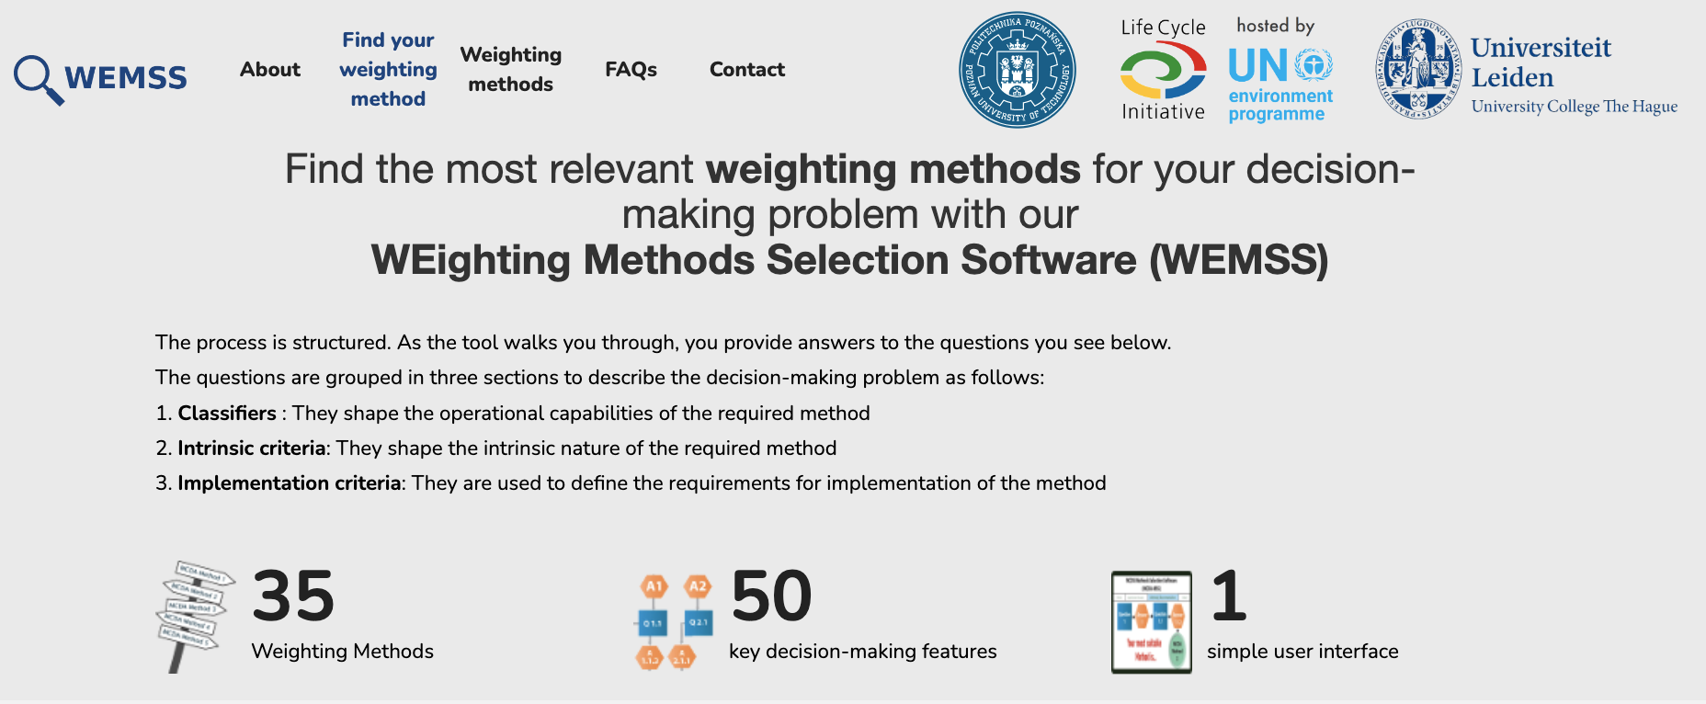

- Classifiers
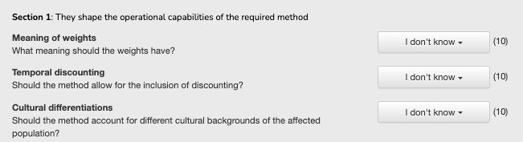

- Intrinsic criteria
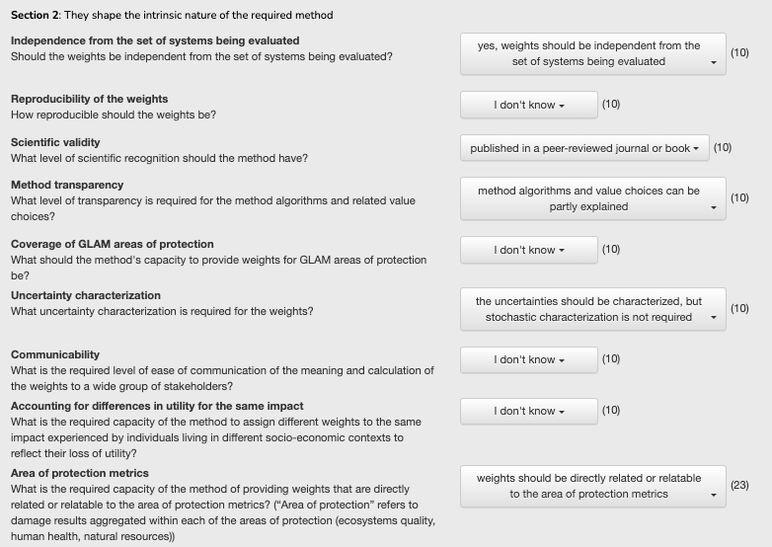

- Implementation criteria
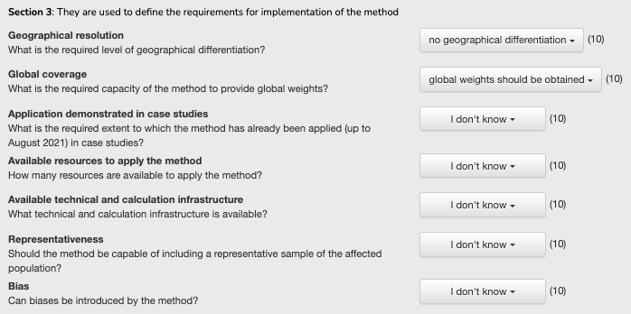

- Suitable methods for GLAM

