Supplementary material: “LCIA method choice shapes biodiversity footprints: comparing updated and established methods in a country-resolved assessment of German food consumption”

Materials and Methods
FABIO v2: Footprint calculation method
The footprint calculations used for this study follow the FABIO Leontief-based extension-footprint workflow implemented in the repository `martinbruckner/fabio_comparison`, specifically in the script: https://github.com/martinbruckner/fabio_comparison/blob/master/R/fabio_footprints.R. The manuscript workflow uses the same conceptual method with the manuscript-specific parameterization and restrictions stated below.
This reference script loads FABIO data (`X`, `Y`, `E`), reads a Leontief inverse (`L`) for a chosen allocation, computes extension intensities as `E / X`, constructs a footprint propagation operator, and multiplies by a selected final demand vector to obtain origin-attributed footprint contributions which are then aggregated and written to CSV outputs.
Core methodological choices (applies to blue water, land use, P and N application)
For each extension (e.g., blue water use, land use, phosphorus application, nitrogen application), we compute an environmental footprint induced by a specific final demand vector using FABIO and a Leontief inverse.
- Select year-specific system data (`X`, `Y`, `E`) and the Leontief inverse `L` consistent with the chosen allocation.
- Select the consuming country’s final demand vector for the target final-demand category.
- Compute extension intensity by sector: `intensity = extension / X` (non-finite values set to zero).
- Compute footprint propagation: `MP = diag(intensity) %*% L`.
- Compute the contribution matrix for the selected final demand vector `y` (column-wise scaling of `MP` by `y`).
- Convert results to long format with origin and final sector identifiers (country and product).
- Aggregate contributions to origin-country attribution per consumed product and compute origin shares (%).
Units follow the selected extension (e.g., m³ for blue water; kg for P/N application).

Manuscript-specific settings and restrictions
While the reference implementation supports multiple regions (e.g., EU/EU27), consumption categories, allocations, and aggregation formats, the manuscript results were produced with the following specific settings:
- Consuming country: **DEU (Germany)**
- Final demand category: **food only**
- Extensions analyzed: **blue water use**, **land use**, **phosphorus application**, **nitrogen application**
- Allocation: **mass-based Leontief inverse** (i.e., `*_L_mass.rds`)
- Restriction (scope of reported results): footprint results are restricted to **DEU final-consumption sectors**, i.e. we filter to `country_final == DEU` prior to aggregation and reporting. This ensures the reported values represent the footprint of **DEU final consumption**, rather than contributions to all global final sectors induced by the DEU final demand vector.

Table 1 Food Categories and Associated Products
Category | Products
Fruits | Apples and products; Bananas; Citrus, Other; Dates; Fruits, Other; Grapefruit and products; Grapes and products (excl wine); Lemons, Limes and products; Oranges, Mandarines; Pineapples and products; Plantains
Cereals & Grain Products | Barley and products; Cereals, Other; Maize and products; Millet and products; Oats; Rice and products; Rye and products; Wheat and products
Legumes & Pulses | Beans; Peas; Pulses, Other and products; Soyabeans
Beverages & Sweets | Beer; Beverages, Alcoholic; Cocoa Beans and products; Coffee and products; Tea (including mate); Wine
Meat & Meat Products | Bovine Meat; Fats, Animals, Raw; Meat, Other; Mutton & Goat Meat; Offals, Edible; Pigmeat; Poultry Meat
Dairy & Eggs | Butter, Ghee; Eggs; Milk - Excluding Butter
Oils & Fats | Coconut Oil; Groundnut Oil; Maize Germ Oil; Oilcrops Oil, Other; Oilcrops, Other; Olive Oil; Palm Oil; Rape and Mustard Oil; Sesameseed Oil; Soyabean Oil; Sunflowerseed Oil
Nuts & Oilseeds | Coconuts - Incl Copra; Groundnuts; Nuts and products; Olives (including preserved)
Vegetables | Onions; Pimento; Tomatoes and products; Vegetables, Other
Spices & Condiments | Pepper; Spices, Other; Sugar (Raw Equivalent); Sweeteners, Other
Tubers & Roots | Potatoes and products

GLAM
Table 2 Products and their respective land use type in GLAM
Product | Land use type
Apples and products | plantation
Bananas | plantation
Barley and products | cropland
Beans | cropland
Beer | cropland
Beverages, Alcoholic | cropland
Bovine Meat | Cropland/pasture (depending on feed)
Butter, Ghee | Cropland/ pasture (depending on feed)
Cereals, Other | cropland
Citrus, Other | plantation
Cocoa Beans and products | plantation
Coconut Oil | plantation
Coconuts - Incl Copra | plantation
Coffee and products | plantation
Dates | plantation
Eggs | Cropland/ pasture (depending on feed)
Fats, Animals, Raw | Cropland/ pasture (depending on feed)
Fruits, Other | plantation
Grapefruit and products | plantation
Grapes and products (excl wine) | plantation
Groundnut Oil | cropland
Groundnuts | cropland
Lemons, Limes and products | plantation
Maize Germ Oil | plantation
Maize and products | cropland
Meat, Other | cropland
Milk - Excluding Butter | cropland
Millet and products | cropland
Mutton & Goat Meat | Cropland/ pasture
Nuts and products | plantation
Oats | cropland
Offals, Edible | cropland
Oilcrops Oil, Other | cropland
Oilcrops, Other | cropland
Olive Oil | plantation
Olives (including preserved) | plantation
Onions | cropland
Oranges, Mandarines | plantation
Palm Oil | plantation
Peas | cropland
Pepper | plantation
Pigmeat | Cropland/ pasture (depending on feed)
Pimento | cropland
Pineapples and products | cropland
Plantains | plantation
Potatoes and products | cropland
Poultry Meat | Cropland/ pasture (depending on feed)
Pulses, Other and products | cropland
Rape and Mustard Oil | cropland
Rape and Mustardseed | cropland
Rice and products | cropland
Rye and products | cropland
Roots, Other | cropland
Salt | cropland
Sesameseed Oil | cropland
Soyabean Oil | cropland
Soyabeans | cropland
Spices, Other | cropland
Sugar (Raw Equivalent) | cropland
Sunflower seed | cropland
Sunflowerseed Oil | cropland
Sweeteners, Other | cropland
Tea (including mate) | plantation
Tomatoes and products | cropland
Vegetables, Other | cropland
Wheat and products | cropland
Wine | plantation
GLAM characterization factors (CFs) distinguish three land use intensity classes, intense, light, and minimal, for cropland, based on spatially explicit maps of irrigation and fertilizer application (Scherer et al., 2023). Since land use inventories typically do not report land occupation disaggregated by intensity class, intensity-specific CFs cannot be applied directly. Instead, a blended country-level CF is constructed for each country c and land use class l as:
$$CF_{c,l}=\sum_{i}{w_{i,c}}⋅CF_{i,c,l}$$where $i∈\{\text{intense, light, minimal}\}$is the intensity class, $w_{i,c}$is the national share of intensity class $i$in country $c$, and $CF_{i,c,l}$is the GLAM characterization factor for intensity class $i$, country $c$, and land use class $l$(Scherer et al., 2023). The shares satisfy $\sum_{i}{w_{i,c}}=1$for each country. National intensity shares $w_{i,c}$were taken from Coelho et al. (2025), who derived them by overlaying Scherer et al.'s (2023) intensity maps with national cropland boundaries from GADM (2024) and the HILDA+ land cover dataset (Winkler et al., 2021). The resulting shares represent the proportion of national cropland area falling within each intensity class (see Supplementary Table 3). This approach is mathematically equivalent to intensity-resolved accounting under the assumption that intensity shares are homogeneous across commodities within a country, that is, that the national intensity distribution applies equally to all crops produced in that country. Where production systems for specific commodities deviate substantially from the national average, this assumption may introduce uncertainty into absolute impact estimates and their attribution across commodities. The resulting blended CFs applied in this study are reported in Supplementary Table 3.
Table 3 Land use intensity values by country and the applied CF in this study; proxy country chosen where no original value was available based on similarity of climate, biome and production system. Land use intensity values taken from the supplementary material from Coelho et al., 2025. CF aggregated over all species groups using intensity levels as weighting factor.
ISO | Country | Proxy | Land use intensity |  |  | Intensity-weighted CF
ISO | Country | Proxy | Intense use | Light use | Minimal use | cropland CF | pasture CF | plantation CF
xAB | Abyei | Sudan | 0.18 | 0.03 | 0.79 | 3.26E-15 | 3.36E-15 | 3.61E-15
AFG | Afghanistan |  | 0.57 | 0.2 | 0.23 | 2.40E-15 | 2.40E-15 | 6.41E-15
xAC | Aksai Chin | China | 1 | 0 | 0 | 2.34E-15 | 1.93E-15 | 2.09E-14
ALB | Albania |  | 0.88 | 0.12 | 0.01 | 1.65E-14 | 1.65E-14 | 1.64E-14
DZA | Algeria |  | 0.22 | 0.78 | 0 | 2.42E-15 | 3.65E-14 | 1.73E-14
AND | Andorra | France | 1 | 0 | 0 | 2.62E-14 | 2.35E-14 | 3.58E-14
AGO | Angola |  | 0.01 | 0.03 | 0.96 | 1.13E-14 | 1.08E-14 | 1.25E-14
ATA | Antarctica
ATG | Antigua and Barbuda | Dominican Republic | 0.45 | 0.51 | 0.03 | 1.19E-12 | 6.22E-13 | 5.68E-14
ARG | Argentina |  | 0.03 | 0.97 | 0 | 1.35E-14 | 1.09E-14 | 3.87E-14
ARM | Armenia |  | 0.66 | 0.34 | 0 | 2.65E-14 | 2.54E-14 | 2.79E-14
AUS | Australia |  | 0.14 | 0.83 | 0.03 | 2.85E-14 | 2.40E-14 | 7.21E-14
AUT | Austria |  | 0.53 | 0.47 | 0 | 9.73E-15 | 9.41E-15 | 1.10E-14
AZE | Azerbaijan |  | 0.86 | 0.05 | 0.09 | 1.35E-14 | 1.51E-14 | 2.57E-14
BHS | Bahamas | Cuba | 0.44 | 0.56 | 0 | 1.65E-13 | 1.43E-13 | 1.61E-13
BHR | Bahrain | UAE | 0.89 | 0.09 | 0.02 | 2.25E-15 | 1.20E-15 | 1.30E-15
BGD | Bangladesh |  | 0.99 | 0 | 0 | 1.38E-14 | 1.10E-14 | 1.55E-14
BRB | Barbados | Dominican Republic | 0.45 | 0.51 | 0.03 | 1.20E-12 | 7.58E-13 | 5.87E-14
BLR | Belarus |  | 0.97 | 0.02 | 0.01 | 1.75E-15 | 1.45E-15 | 2.01E-15
BEL | Belgium |  | 0.95 | 0.03 | 0.02 | 3.27E-15 | 3.03E-15 | 3.50E-15
BLZ | Belize |  | 0.24 | 0.76 | 0 | 9.61E-14 | 1.02E-13 | 1.42E-12
BEN | Benin |  | 0.01 | 0.09 | 0.9 | 8.47E-15 | 7.85E-15 | 8.92E-15
BTN | Bhutan |  | 0 | 0.25 | 0.75 | 2.87E-14 | 5.52E-14 | 6.41E-14
BOL | Bolivia |  | 0.03 | 0.97 | 0 | 1.85E-14 | 1.82E-14 | 2.47E-14
BIH | Bosnia and Herzegovina |  | 0.24 | 0.76 | 0 | 8.50E-15 | 8.23E-15 | 8.82E-15
BWA | Botswana |  | 0 | 0.15 | 0.85 | 7.83E-15 | 5.62E-15 | 6.31E-15
BRA | Brazil |  | 0.99 | 0.01 | 0 | 2.79E-14 | 2.80E-14 | 2.84E-14
BRN | Brunei Darussalam |  | 0.25 | 0.75 | 0 | 7.69E-14 | 5.76E-14 | 7.31E-14
BGR | Bulgaria |  | 0.6 | 0.39 | 0.01 | 6.01E-15 | 5.80E-15 | 7.73E-15
BFA | Burkina Faso |  | 0.01 | 0.08 | 0.9 | 6.09E-15 | 5.69E-15 | 6.50E-15
BDI | Burundi |  | 0.04 | 0.2 | 0.77 | 4.35E-14 | 4.54E-14 | 2.83E-14
CPV | Cabo Verde | Senegal | 0 | 1 | 0 | 7.44E-13 | 4.35E-13 | 1.73E-14
KHM | Cambodia |  | 0.33 | 0.3 | 0.37 | 3.66E-14 | 3.96E-14 | 2.73E-14
CMR | Cameroon |  | 0.01 | 0.03 | 0.95 | 4.12E-14 | 2.11E-14 | 4.92E-14
CAN | Canada |  | 0.09 | 0.91 | 0 | 2.68E-15 | 9.77E-16 | 6.04E-15
CAF | Central African Republic |  | 0 | 0 | 1 | 1.31E-14 | 1.14E-14 | 5.54E-15
TCD | Chad |  | 0 | 0.01 | 0.99 | 2.34E-15 | 3.20E-15 | 3.48E-15
CHL | Chile |  | 1 | 0 | 0 | 3.18E-14 | 2.23E-14 | 3.53E-14
CHN | China |  | 1 | 0 | 0 | 1.24E-14 | 1.21E-14 | 2.13E-14
xxx | China/India
COL | Colombia |  | 1 | 0 | 0 | 1.34E-13 | 9.62E-14 | 1.88E-13
COM | Comoros | Madagaskar | 0 | 1 | 0 | 4.31E-12 | 4.67E-14 | 3.06E-13
COG | Congo |  | 0.06 | 0.02 | 0.92 | 1.79E-14 | 2.00E-14 | 1.58E-13
CRI | Costa Rica |  | 0.98 | 0.02 | 0 | 2.85E-13 | 2.88E-13 | 4.63E-13
CIV | Côte d'Ivoire |  | 0.02 | 0.14 | 0.84 | 2.91E-14 | 2.21E-14 | 2.87E-14
HRV | Croatia |  | 0.73 | 0.27 | 0 | 1.01E-14 | 9.40E-15 | 7.35E-15
CUB | Cuba |  | 0.44 | 0.56 | 0 | 1.29E-13 | 1.15E-13 | 1.31E-13
CYP | Cyprus |  | 0.65 | 0.35 | 0 | 5.60E-14 | 2.01E-14 | 2.02E-14
CZE | Czechia |  | 0.97 | 0.03 | 0 | 3.34E-15 | 3.19E-15 | 3.64E-15
PRK | Democratic People's Republic of Korea |  | 0.99 | 0 | 0.01 | 8.93E-15 | 7.18E-15 | 9.23E-15
COD | Democratic Republic of the Congo |  | 0.01 | 0.01 | 0.98 | 2.06E-14 | 2.23E-14 | 2.19E-14
DNK | Denmark |  | 0.95 | 0.04 | 0.02 | 1.55E-15 | 6.98E-15 | 1.71E-15
DJI | Djibouti | Ethiopia | 0.05 | 0.95 | 0.01 | 7.10E-15 | 5.87E-15 | 2.05E-14
DMA | Dominica | Dominican Republic | 0.45 | 0.51 | 0.03 | 1.23E-12 | 7.94E-13 | 4.10E-13
DOM | Dominican Republic |  | 0.45 | 0.51 | 0.03 | 2.50E-13 | 2.33E-13 | 2.40E-13
ECU | Ecuador |  | 0.64 | 0.35 | 0 | 2.12E-13 | 1.94E-13 | 7.15E-13
EGY | Egypt |  | 0.99 | 0 | 0 | 1.28E-15 | 2.55E-15 | 2.77E-14
SLV | El Salvador |  | 0.08 | 0.91 | 0 | 1.49E-13 | 1.52E-13 | 2.10E-13
GNQ | Equatorial Guinea |  | 0 | 0 | 1 | 1.32E-13 | 5.57E-14 | 1.35E-13
ERI | Eritrea |  | 0 | 0.3 | 0.7 | 7.80E-15 | 7.84E-15 | 8.45E-15
EST | Estonia |  | 0.74 | 0.26 | 0 | 1.46E-15 | 1.07E-15 | 1.73E-15
SWZ | Eswatini |  | 0.41 | 0.19 | 0.39 | 3.23E-14 | 3.13E-14 | 2.58E-14
ETH | Ethiopia |  | 0.05 | 0.95 | 0.01 | 1.63E-14 | 1.45E-14 | 2.13E-14
FJI | Fiji |  | 0 | 0.83 | 0.18 | 4.35E-13 | 2.38E-13 | 1.82E-13
FIN | Finland |  | 0 | 1 | 0 | 1.48E-15 | 9.04E-16 | 1.72E-15
FRA | France |  | 1 | 0 | 0 | 1.44E-14 | 9.25E-15 | 6.95E-15
GAB | Gabon | Cameroon | 0.01 | 0.03 | 0.95 | 2.20E-14 | 3.54E-14 | 2.28E-13
GMB | Gambia |  | 0 | 0.78 | 0.22 | 1.14E-14 | 1.12E-14 | 1.26E-14
PSE | Gaza |  | 0.45 | 0.47 | 0.08 | 1.92E-14 | 2.10E-14 | 2.60E-14
GEO | Georgia |  | 0.77 | 0.23 | 0 | 2.38E-14 | 2.34E-14 | 2.76E-14
DEU | Germany |  | 0.99 | 0 | 0.01 | 3.14E-15 | 3.02E-15 | 3.35E-15
GHA | Ghana |  | 0.01 | 0.14 | 0.85 | 2.43E-14 | 1.37E-14 | 2.42E-14
GRC | Greece |  | 0.62 | 0.37 | 0.01 | 2.32E-14 | 2.18E-14 | 2.01E-14
GRD | Grenada | Dominican Republic | 0.45 | 0.51 | 0.03 | 8.35E-13 | 4.06E-13 | 1.56E-13
GTM | Guatemala |  | 0.12 | 0.88 | 0 | 1.58E-13 | 1.61E-13 | 2.36E-13
GIN | Guinea |  | 0.07 | 0.3 | 0.63 | 2.02E-14 | 1.95E-14 | 2.07E-14
GNB | Guinea-Bissau |  | 0.06 | 0.93 | 0.02 | 2.01E-14 | 2.04E-14 | 2.23E-14
GUY | Guyana |  | 0.92 | 0.08 | 0 | 1.65E-14 | 2.69E-14 | 1.04E-12
HTI | Haiti |  | 0.18 | 0.79 | 0.03 | 2.52E-13 | 2.37E-13 | 2.43E-13
VAT | Holy See |  | 0 | 0 | 0 | 0.00E+00 | 0.00E+00 | 0.00E+00
HKG | Hongkong | China | 1 | 0 | 0 | 1.24E-14 | 1.21E-14 | 2.13E-14
HND | Honduras |  | 0.01 | 0.99 | 0 | 1.88E-13 | 1.87E-13 | 2.24E-13
HUN | Hungary |  | 0.21 | 0.79 | 0 | 5.13E-15 | 4.51E-15 | 6.22E-15
ISL | Iceland |  | 0.78 | 0 | 0.22 | 4.85E-16 | 2.85E-16 | 1.66E-16
IND | India |  | 0.87 | 0.13 | 0 | 2.02E-14 | 1.53E-14 | 2.58E-14
IDN | Indonesia |  | 0.55 | 0.43 | 0.02 | 1.16E-13 | 6.77E-14 | 1.19E-13
IRN | Iran | Iraq | 0.48 | 0.52 | 0 | 6.02E-15 | 7.82E-15 | 3.24E-14
IRQ | Iraq |  | 0.48 | 0.52 | 0 | 4.20E-15 | 4.00E-15 | 2.45E-14
IRL | Ireland |  | 0.97 | 0 | 0.03 | 1.89E-15 | 1.45E-15 | 4.98E-15
ISR | Israel |  | 0.93 | 0.07 | 0 | 1.39E-14 | 1.50E-14 | 2.74E-14
ITA | Italy |  | 0.7 | 0.3 | 0 | 1.84E-14 | 2.06E-14 | 1.55E-14
JAM | Jamaica |  | 0.51 | 0.4 | 0.09 | 5.10E-13 | 4.05E-13 | 1.54E-13
xJK | Jammu and Kashmir
JPN | Japan |  | 0.95 | 0.01 | 0.04 | 5.15E-14 | 4.83E-14 | 5.28E-14
JOR | Jordan |  | 0.28 | 0.72 | 0 | 6.82E-15 | 7.09E-15 | 2.47E-14
KAZ | Kazakhstan |  | 0.05 | 0.1 | 0.85 | 1.87E-15 | 2.16E-15 | 9.68E-16
KEN | Kenya |  | 0.06 | 0.92 | 0.02 | 2.73E-14 | 2.32E-14 | 5.45E-14
KIR | Kiribati | Fiji | 0 | 0.83 | 0.18 | 4.19E-15 | 2.20E-15 | 6.97E-15
KWT | Kuwait |  | 1 | 0 | 0 | 2.37E-15 | 2.56E-15 | 3.39E-15
KGZ | Kyrgyzstan |  | 0.93 | 0.06 | 0.01 | 5.43E-15 | 4.66E-15 | 1.33E-14
LAO | Lao People's Democratic Republic |  | 0.4 | 0.56 | 0.04 | 8.36E-14 | 6.84E-14 | 9.77E-14
LVA | Latvia |  | 0.01 | 0.99 | 0 | 1.37E-15 | 1.02E-15 | 1.73E-15
LBN | Lebanon |  | 0.94 | 0.06 | 0 | 2.78E-14 | 2.99E-14 | 2.81E-14
LSO | Lesotho |  | 0.01 | 0.78 | 0.21 | 2.91E-14 | 2.95E-14 | 3.90E-14
LBR | Liberia |  | 0 | 0 | 1 | 4.50E-14 | 5.12E-14 | 4.25E-14
LBY | Libya |  | 0.38 | 0.55 | 0.06 | 1.09E-15 | 1.65E-14 | 1.64E-14
LIE | Liechtenstein |  | 0 | 1 | 0 | 9.88E-15 | 9.99E-15 | 1.20E-14
LTU | Lithuania |  | 0.01 | 0.99 | 0 | 1.51E-15 | 1.24E-15 | 1.91E-15
LUX | Luxembourg |  | 1 | 0 | 0 | 3.57E-15 | 3.61E-15 | 3.76E-15
MAC | Macao | China | 1 | 0 | 0 | 1.24E-14 | 1.21E-14 | 2.13E-14
MKD | Macedonia | Bulgaria | 0.6 | 0.39 | 0.01 | 8.51E-15 | 8.81E-15 | 1.33E-14
MDG | Madagascar |  | 0.34 | 0.52 | 0.14 | 2.38E-13 | 2.73E-13 | 4.71E-13
MWI | Malawi |  | 0.03 | 0.9 | 0.07 | 3.30E-14 | 2.75E-14 | 2.97E-14
MYS | Malaysia |  | 0.93 | 0.04 | 0.03 | 1.65E-13 | 5.16E-14 | 1.51E-13
MDV | Maldives | Sri Lanka | 0.96 | 0.03 | 0.01 | 2.78E-15 | 1.91E-15 | 3.28E-15
MLI | Mali |  | 0.09 | 0 | 0.91 | 3.26E-15 | 6.00E-15 | 4.88E-15
MLT | Malta |  | 1 | 0 | 0 | 3.99E-14 | 3.88E-14 | 6.60E-14
MHL | Marshall Islands | Kiribati | 0 | 0.83 | 0.18 | 3.66E-15 | 1.82E-15 | 6.34E-15
MRT | Mauritania |  | 0.52 | 0.17 | 0.31 | 1.71E-15 | 4.38E-15 | 2.96E-15
MUS | Mauritius |  | 1 | 0 | 0 | 2.80E-13 | 1.42E-13 | 2.30E-13
MEX | Mexico |  | 0.41 | 0.58 | 0.01 | 5.08E-14 | 4.61E-14 | 1.22E-13
FSM | Micronesia (Federated States of) |  | 0 | 0 | 1 | 2.93E-14 | 9.72E-15 | 7.88E-15
MDA | Moldova |  | 0.24 | 0.2 | 0.57 | 1.94E-15 | 1.84E-15 | 1.35E-15
MCO | Monaco | France | 1 | 0 | 0 | 1.35E-14 | 1.41E-14 | 3.18E-14
MNG | Mongolia |  | 0.05 | 0 | 0.95 | 1.35E-15 | 1.55E-15 | 5.26E-16
MNE | Montenegro |  | 0.76 | 0.24 | 0 | 1.20E-14 | 1.16E-14 | 1.04E-14
MAR | Morocco |  | 0.27 | 0.72 | 0.01 | 1.14E-14 | 1.24E-14 | 1.87E-14
MOZ | Mozambique |  | 0.05 | 0.08 | 0.87 | 2.53E-14 | 2.25E-14 | 3.13E-14
MMR | Myanmar |  | 0.5 | 0.41 | 0.09 | 6.16E-14 | 7.78E-14 | 7.72E-14
NAM | Namibia |  | 0 | 0.03 | 0.97 | 5.19E-15 | 7.07E-15 | 3.70E-15
NRU | Nauru
NPL | Nepal |  | 0.96 | 0.04 | 0 | 2.70E-14 | 2.64E-14 | 2.17E-14
NLD | Netherlands |  | 0.95 | 0.05 | 0 | 1.98E-14 | 5.46E-15 | 3.47E-15
NZL | New Zealand |  | 1 | 0 | 0 | 3.41E-14 | 3.07E-14 | 1.93E-14
NIC | Nicaragua |  | 0 | 1 | 0 | 1.66E-13 | 1.66E-13 | 2.08E-13
NER | Niger |  | 0.02 | 0.07 | 0.91 | 2.16E-15 | 6.87E-15 | 3.66E-15
NGA | Nigeria |  | 0.01 | 0.1 | 0.89 | 1.58E-14 | 1.11E-14 | 1.38E-14
NOR | Norway |  | 0.98 | 0 | 0.02 | 4.68E-15 | 1.57E-14 | 1.69E-15
OMN | Oman |  | 0.86 | 0.14 | 0 | 6.52E-15 | 5.20E-15 | 2.11E-14
PAK | Pakistan |  | 0.99 | 0 | 0 | 3.49E-15 | 2.86E-15 | 1.30E-14
PLW | Palau | Phillipines | 0.66 | 0.33 | 0.01 | 2.14E-14 | 2.74E-15 | 3.11E-14
PAN | Panama |  | 0.96 | 0.03 | 0.01 | 2.38E-13 | 2.51E-13 | 3.68E-13
PNG | Papua New Guinea |  | 0 | 0 | 1 | 1.04E-13 | 5.01E-14 | 1.44E-13
xPI | Paracel Islands | VietNam | 0.99 | 0.01 | 0 | 2.09E-16 | 1.55E-16 | 3.64E-16
PRY | Paraguay |  | 0.07 | 0.93 | 0 | 1.81E-14 | 1.83E-14 | 2.59E-14
PER | Peru |  | 0.46 | 0.53 | 0 | 6.33E-14 | 5.43E-14 | 1.47E-12
PHL | Philippines |  | 0.66 | 0.33 | 0.01 | 1.49E-13 | 8.47E-14 | 1.29E-13
POL | Poland |  | 0.97 | 0.03 | 0 | 1.93E-15 | 1.60E-15 | 2.21E-15
PRT | Portugal |  | 0.41 | 0.57 | 0.02 | 1.86E-14 | 2.01E-14 | 4.70E-14
PYF | French Polynesia |  | 0 | 0.83 | 0.18 | 4.35E-13 | 2.38E-13 | 1.82E-13
QAT | Qatar |  | 0.89 | 0.09 | 0.02 | 3.08E-15 | 3.01E-15 | 2.04E-14
KOR | Republic of Korea |  | 0.98 | 0.01 | 0.01 | 1.61E-14 | 5.34E-15 | 1.24E-14
ROU | Romania |  | 0.19 | 0.78 | 0.03 | 3.83E-15 | 3.58E-15 | 4.50E-15
RUS | Russia |  | 0.02 | 0.88 | 0.1 | 1.59E-15 | 2.13E-15 | 2.25E-15
RWA | Rwanda |  | 0 | 0.19 | 0.81 | 5.85E-14 | 5.91E-14 | 2.71E-14
KNA | Saint Kitts and Nevis | Dominican Republic | 0.45 | 0.51 | 0.03 | 2.41E-13 | 1.51E-13 | 1.55E-13
LCA | Saint Lucia | Dominican Republic | 0.45 | 0.51 | 0.03 | 1.23E-12 | 6.01E-13 | 2.70E-13
VCT | Saint Vincent and the Grenadines | Dominican Republic | 0.45 | 0.51 | 0.03 | 4.80E-13 | 3.07E-13 | 1.55E-13
WSM | Samoa | Fiji | 0 | 0.83 | 0.18 | 1.08E-13 | 2.54E-14 | 1.54E-13
SMR | San Marino |  | 0 | 1 | 0 | 1.14E-14 | 1.28E-14 | 3.18E-14
STP | Sao Tome and Principe |  | 0 | 0.73 | 0.27 | 1.86E-12 | 6.50E-14 | 3.34E-13
SAU | Saudi Arabia |  | 0.89 | 0.09 | 0.02 | 4.41E-15 | 3.77E-15 | 2.95E-14
xSR | Scarborough Reef | Phillipines | 0.66 | 0.33 | 0.01 | 4.99E-14 | 2.83E-14 | 4.33E-14
SEN | Senegal |  | 0.01 | 0.98 | 0.01 | 7.48E-15 | 7.19E-15 | 8.49E-15
SRB | Serbia |  | 0.01 | 0.99 | 0 | 6.05E-15 | 5.53E-15 | 7.42E-15
SYC | Seychelles | Madagaskar | 0.34 | 0.52 | 0.14 | 9.35E-14 | 3.88E-14 | 1.44E-13
SLE | Sierra Leone |  | 0 | 0.6 | 0.4 | 3.67E-14 | 3.90E-14 | 3.74E-14
SGP | Singapore | Thailand | 0.53 | 0.47 | 0 | 9.96E-14 | 7.02E-13 | 9.32E-14
SVK | Slovakia |  | 0.51 | 0.49 | 0 | 4.53E-15 | 4.06E-15 | 5.35E-15
SVN | Slovenia |  | 1 | 0 | 0 | 9.25E-15 | 8.57E-15 | 9.16E-15
SLB | Solomon Islands | Fiji | 0 | 0.83 | 0.18 | 1.08E-12 | 6.72E-13 | 1.02E-12
SOM | Somalia |  | 0.33 | 0.13 | 0.53 | 1.58E-14 | 1.45E-14 | 4.50E-14
ZAF | South Africa |  | 0.11 | 0.87 | 0.02 | 2.16E-14 | 2.19E-14 | 3.50E-14
SSD | South Sudan |  | 0.04 | 0 | 0.96 | 8.70E-15 | 8.20E-15 | 5.43E-15
ESP | Spain |  | 0.39 | 0.61 | 0 | 1.76E-14 | 2.06E-14 | 2.99E-14
xSI | Spratly Islands | Phillipines | 0.66 | 0.33 | 0.01 | 2.03E-16 | 1.51E-16 | 3.61E-16
LKA | Sri Lanka |  | 0.96 | 0.03 | 0.01 | 1.46E-13 | 7.08E-14 | 1.59E-13
SDN | Sudan |  | 0.18 | 0.03 | 0.79 | 2.24E-15 | 2.71E-15 | 3.11E-15
SUR | Suriname |  | 1 | 0 | 0 | 1.80E-14 | 1.72E-14 | 1.08E-12
SWE | Sweden |  | 0.42 | 0.58 | 0 | 1.97E-15 | 1.05E-15 | 1.71E-15
CHE | Switzerland |  | 1 | 0 | 0 | 9.95E-15 | 9.57E-15 | 1.05E-14
SYR | Syrian Arab Republic |  | 0.56 | 0.44 | 0 | 1.04E-14 | 1.08E-14 | 2.76E-14
TJK | Tajikistan |  | 0.81 | 0.14 | 0.05 | 8.12E-15 | 5.23E-15 | 7.92E-15
TZA | Tanzania |  | 0.02 | 0.22 | 0.76 | 3.95E-14 | 3.75E-14 | 4.62E-14
THA | Thailand |  | 0.53 | 0.47 | 0 | 4.80E-14 | 4.15E-14 | 5.01E-14
TLS | Timor-Leste |  | 0.8 | 0.2 | 0 | 4.25E-14 | 2.40E-14 | 3.99E-14
TGO | Togo |  | 0 | 0.07 | 0.93 | 1.42E-14 | 9.86E-15 | 1.44E-14
TON | Tonga |  | 0 | 0.83 | 0.18 | 1.51E-14 | 4.36E-15 | 2.08E-14
TTO | Trinidad and Tobago |  | 0.45 | 0.51 | 0.03 | 1.51E-13 | 4.50E-14 | 1.55E-13
TUN | Tunisia |  | 0.21 | 0.79 | 0.01 | 9.24E-15 | 1.16E-14 | 1.83E-14
TUR | Turkey |  | 0.46 | 0.54 | 0 | 1.41E-14 | 1.47E-14 | 1.75E-14
TKM | Turkmenistan |  | 1 | 0 | 0 | 3.39E-15 | 3.08E-15 | 1.41E-14
TUV | Tuvalu |  | 0 | 0.83 | 0.18 | 5.42E-16 | 3.93E-16 | 9.42E-16
TWN | Taiwan |  | 1 | 0 | 0 | 1.24E-14 | 1.21E-14 | 2.13E-14
UGA | Uganda |  | 0 | 0.05 | 0.95 | 2.46E-14 | 2.34E-14 | 1.50E-14
UKR | Ukraine |  | 0.11 | 0.88 | 0.01 | 2.44E-15 | 2.00E-15 | 2.94E-15
ARE | United Arab Emirates | Qatar | 0.89 | 0.09 | 0.02 | 3.80E-15 | 3.39E-15 | 3.00E-14
GBR | United Kingdom (UK) |  | 0.95 | 0.05 | 0 | 2.98E-15 | 2.34E-15 | 1.13E-13
USA | United States of America (USA) |  | 0.6 | 0.4 | 0 | 8.66E-15 | 8.15E-15 | 1.62E-14
URY | Uruguay |  | 0.96 | 0.04 | 0 | 1.79E-14 | 1.47E-14 | 1.79E-14
UZB | Uzbekistan |  | 1 | 0 | 0 | 3.41E-15 | 3.34E-15 | 1.22E-14
VUT | Vanuatu |  | 0 | 0 | 1 | 1.95E-12 | 1.09E-12 | 4.06E-14
VEN | Venezuela |  | 0.23 | 0.77 | 0 | 4.56E-14 | 5.05E-14 | 1.55E-13
VNM | Viet Nam |  | 0.99 | 0.01 | 0 | 8.18E-14 | 6.40E-14 | 8.82E-14
PSE | West Bank
ESH | Western Sahara
YEM | Yemen |  | 0.59 | 0.21 | 0.21 | 6.90E-15 | 2.27E-14 | 1.74E-14
ZMB | Zambia |  | 0.05 | 0.12 | 0.83 | 1.86E-14 | 1.81E-14 | 2.19E-14
ZWE | Zimbabwe |  | 0.05 | 0.89 | 0.06 | 1.86E-14 | 2.09E-14 | 2.14E-14
RoW | RoW | Mean of all countries | 0.45 | 0.35 | 0.19 | 1.22E-13 |  | 6.67E-14
LC-IMPACT
LC-IMPACT (v1.3) is a regionalized LCIA method that provides endpoint indicators for ecosystem quality expressed as global PDF. Regional biodiversity losses are scaled to the global species pool by combining spatially differentiated effect modelling with species richness maps, so that losses are reported in relation to total global diversity rather than only locally present species. Where available, LC‑IMPACT incorporates IUCN‑derived species vulnerability scores (VS ∈ [0,1]) for land and water‑related stressors to weight damages by threat status and endemism. In this study, we apply (i) CFs for water consumption (“all effects”) to characterize biodiversity loss from blue water use, (ii) CFs for phosphorus emissions to freshwater for eutrophication impacts (PDF·yr·kg⁻¹ P), (iii) median country‑average land occupation CFs aggregated to a single endpoint (PDF·m⁻²), using a classification of annual versus permanent crops detailed in Table 4, and (iv) climate‑change CFs (“all effects”, 100‑year time horizon) to translate product‑level GHG emissions into biodiversity damage. Ecosystem CFs in LC‑IMPACT cover multiple taxa (vascular plants, fish, birds, mammals, amphibians, reptiles), with taxonomic coverage varying by impact pathway. All LC‑IMPACT results are reported in global PDF in line with the method’s endpoint convention.
Table 4 Products and their respective land use type in LC-IMPACT
Product | Land use type (LC-IMPACT)
Apples and products | permanent
Bananas | permanent
Barley and products | annual
Beans | annual
Beer | annual
Beverages, Alcoholic | annual
Bovine Meat | annual/pasture (depending on feed)
Butter, Ghee | annual/ pasture (depending on feed)
Cereals, Other | annual
Citrus, Other | permanent
Cocoa Beans and products | permanent
Coconut Oil | permanent
Coconuts - Incl Copra | permanent
Coffee and products | permanent
Dates | permanent
Eggs | annual
Fats, Animals, Raw | annual/ pasture (depending on feed)
Fruits, Other | permanent
Grapefruit and products | permanent
Grapes and products (excl wine) | permanent
Groundnut Oil | annual
Groundnuts | annual
Lemons, Limes and products | permanent
Maize Germ Oil | annual
Maize and products | annual
Meat, Other | annual/ pasture (depending on feed)
Milk - Excluding Butter | annual/ pasture (depending on feed)
Millet and products | annual
Mutton & Goat Meat | annual/ pasture (depending on feed)
Nuts and products | permanent
Oats | annual
Offals, Edible | annual
Oilcrops Oil, Other | permanent
Oilcrops, Other | permanent
Olive Oil | permanent
Olives (including preserved) | permanent
Onions | annual
Oranges, Mandarines | permanent
Palm Oil | permanent
Peas | annual
Pepper | permanent
Pigmeat | annual /pasture (depending on feed)
Pimento | annual
Pineapples and products | permanent
Plantains | permanent
Potatoes and products | annual
Poultry Meat | annual /pasture (depending on feed)
Pulses, Other and products | annual
Rape and Mustard Oil | annual
Rice and products | annual
Rye and products | annual
Sesameseed Oil | annual
Soyabean Oil | annual
Soyabeans | annual
Spices, Other | permanent
Sugar (Raw Equivalent) | annual
Sunflowerseed Oil | annual
Sweeteners, Other | annual
Tea (including mate) | permanent
Tomatoes and products | annual
Vegetables, Other | annual
Wheat and products | annual
Wine | permanent
Land stress
In LC-IMPACT, land stress impacts are assessed as an endpoint damage to ecosystem quality distinguishing between land transformation (land use change) and land occupation, reflecting both the conversion of natural habitats and their continued use over time. Land transformation is the modification of land to make it suitable for a new function, such as deforestation for agricultural production, which alters ecosystem structure and species composition. Land occupation refers to the continued use of land for activities, during which the ecosystem is prevented from recovering toward its (semi-)natural reference state. Both intervention types contribute to biodiversity loss, as ecosystems are either permanently altered or maintained at a reduced level of ecological integrity related to their natural condition.
The land stress impact pathway in LC-IMPACT is based on the countryside species-area relationship (SAR) model proposed by Chaudhary et al. (2015), which extends classical SAR formulations by accounting for species´ tolerance to the human-modified landscapes. The countryside SAR model recognizes that different taxa exhibit varying affinities to land use types such as cropland, pasture, forestry, or urban land. The modeling of biodiversity damage due to land use is implemented in four main steps. Local changes in species richness are quantified by comparing species richness under different land use types to a regional (semi-) natural reference situation, derived from databases such as GLOBIO or the Swiss biodiversity monitoring. These comparisons create local characterization factors (CF_loc) representing relative reductions in species richness for different land use types, biomes, and taxonomic groups. The local CFs are integrated into the countryside SAR model to estimate regional species loss resulting from cumulative land use within each ecoregion. This step produces regional characterization factors expressing the number of species lost per unit of land occupied or transformed (species/m² or species.yr/m²), calculated separately for major taxonomic groups such as mammals, birds, reptiles, amphibians, and vascular plants, across 804 terrestrial ecoregions worldwide. The regional CFs are weighted by species vulnerability scores, which reflect global extinction risk based on species´ geographic range and threat status. Vulnerability scores are derived primarily from the IUCN Red List and BirdLife International data to provide bigger weight to endemic, range-restricted and threatened species (Chaudhary et al., 2015). Within this step, regional species loss is converted into the global species equivalent loss, thereby linking local biodiversity impacts to the global conservation relevance. In the last step, taxon-specific weighted characterization factors are aggregated into a single endpoint damage indicator for ecosystem quality, which is expressed as the global potentially disappeared fraction of species (PDF). The resulting endpoint CFs are expressed as global PDF/m² for land occupation and global PDF.yr/m² for land transformation.
Freshwater Eutrophication
In LC-IMPACT, freshwater eutrophication is assessed as an endpoint impact on ecosystem quality, which is quantified as PDF. The methodology focuses on emissions of phosphorus (P) to agricultural soils and freshwater bodies, as phosphorus is considered the dominant limiting nutrient driving freshwater eutrophication at the global scale. Within the fate-effect modeling framework, the fate factor represents the fraction of emitted P that reaches freshwater systems and its residence time in rivers and lakes, accounting for transport, retention, and water use processes. The effect factor describes the sensitivity of freshwater ecosystems to increasing P concentrations and is derived from a probabilistic relationship between P levels and declines in freshwater fish species richness. Endpoint characterization factors are spatially differentiated by freshwater ecoregions, freshwater type (rivers and lakes), and climate zones, and are expressed as PDF.yr/kg for emissions to water or soil and PDF.yr/m².yr for P losses due to the soil erosion.
Water use
LC-IMPACT quantifies the impacts of water consumption on ecosystem at the endpoint level as damage to ecosystem quality, expressed in the potentially disappeared fraction of species (PDF). The method distinguishes impacts on aquatic and riparian habitats from terrestrial habitats. Impacts are quantified using taxon-specific CFs for amphibians, reptiles, birds, and mammals. The fate factor represents the potential reduction in wetland area per unit of water consumed (m².yr/m³) and is derived from the hydrological models that distinguish between surface-water-fed and groundwater-fed wetlands. Surface water consumption affects wetlands through reduced inflow volumes, whereas groundwater abstraction affects wetlands through groundwater table drawdown. Fate factors are calculated individually for more than 20,000 wetlands globally and spatially assigned to watersheds based on upstream-downstream relationships. The effect factor quantifies biodiversity loss per unit of wetland area lost (species equivalents/m²), derived by the species-area relationships, taxon-specific species richness data, and vulnerability scores. Endpoint results are normalized to global species richness and presented as PDF.yr/ m^{3..}
For terrestrial ecosystems, impacts are assessed for vascular plants at the watershed level. The fate factor is calculated as the inverse of spatially differentiated precipitation and represents the area-time affected by a given volume of water consumption. Plant species losses are normalized using global vascular plant richness, and CFs are expressed in PDF.yr/m³. Final CFs are obtained by aggregating aquatic and terrestrial impacts, applying equal weighting between aggregated animal taxa and vascular plants.
Climate change
Climate change impacts on ecosystem quality are modeled using a global cause-effect pathway that links greenhouse gas (GHG) emissions to biodiversity loss through temperature-driven ecological responses. The calculation is non-spatially differentiated, as radiative forcing and the resulting temperature increases are assumed to be independent of the emission location. Endpoint CFs are expressed as PDF.yr/kg GHG. The conversion from GHG emissions to temperature change is based on IPCC Absolute Global Warming Potentials, using a 100-year time horizon as the default. The calculation uses temperature change (°C/kg) = Global Warming Potential of GHG (kg CO₂eq) over years × temperature change caused by 1kg of CO₂. The resulting temperature increase is translated into ecosystem damage using effect factors (PDF/ °C) from (De Schryver et al., 2009, 2011) and (Hanafiah et al., 2011).
For terrestrial ecosystems, effect factors represent projected species loss per degree of global temperature increase across taxonomic groups (mammals, birds, frogs, reptiles, butterflies and plants). The effect factor is calculated by the temperature-dependent species loss rate (fraction of species lost per °C) within species group × regional and taxon-specific species richness × sum across all regions and taxonomic groups ÷ total global species richness.
For freshwater ecosystems, effect factors link temperature-induced changes in river discharge to losses in fish species richness, normalized to global species richness. Ecosystem damages are aggregated globally.
Further methodological details are documented in LC‑IMPACT project reports and peer‑reviewed publications (Verones et al., 2020).

ReCiPe2016
Methodologically, ReCiPe2016 provides a complete midpoint‑to‑endpoint framework with explicit value choices (cultural perspectives and time horizons). For our analysis we use the harmonized midpoint–endpoint framework to translate life cycle inventory flows into ecosystem damage (see table 5). ReCiPe2016 provides three cultural perspectives—Individualist (I), Hierarchist (H) and Egalitarian (E)—that differ in assumed time horizons, plausibility of impact pathways and inclusion of long‑term effects. In line with common practice, we adopt the Hierarchist perspective with a 100‑year time horizon. Ecosystem endpoint factors in ReCiPe2016 quantify time‑integrated potential species loss caused by midpoint stressors and are expressed in species·yr. In ReCiPe2016, based on global average species densities (Goedkoop et al., 2009), e.g. aquatic species density for water consumption impacts potentially disappeared fractions of species is converted to an absolute measure of species loss (species·yr) (Huijbregts et al., 2017).
Table 5 Characterization factors used for ReCiPe2016 (Hierarchist perspective)
Land use (Species.yr/m² annual crop eq) | Climate Change (Species.yr/kg CO₂ eq) |  | Freshwater Eutrophication (species.yr/kg P-eq) | Water use CF (species·yr/m³)
 | Terrestrial | Aquatic |  | Terrestrial | Aquatic
8.88E-09 | 2.80E-09 | 7.65E-14 | 6.10E-07 | 1.35E-08 | 1.74E-12
Land use
In ReCiPe2016, land-use impacts on ecosystem quality are structured across three phases: transformation (preparing land for a new function by removing original vegetation), occupation (use of land over time), and relaxation (post-use recovery toward a (semi-)natural state) (Milà I Canals et al., 2007). Transformation and occupation are assessed at the midpoint level using characterization factors (CFm_occ, in annual crop equivalents) derived from the relative species loss (Srel) observed under a given land-use type x compared to a reference natural cover within the same region. Srel is calculated from field data as one minus the ratio of observed species richness under land use (SLU,x,i) to that in the reference habitat (Sref,i), yielding values between negative infinity (indicating possible gains in richness) and 1 (complete loss). The midpoint CF for occupation, CFm_occ,x, is then normalized to annual cropland by dividing Srel,x by the relative species loss for annual crops (de Baan et al., 2013).
Relaxation impacts (CFm_relax,x, in annual crop equivalents·yr) reflect the damage that persists during recovery after land use ceases, acknowledging that land typically does not return immediately to its primary habitat. CFm_relax,x is linked to CFm_occ,x via the recovery time trel, using CFm_relax,x = CFm_occ,x × 0.5 × trel. Passive recovery times toward old-growth habitat vary substantially: median recovery is about 73.5 years for forested biomes (range 46.7–138.8) and about 7.5 years for open biomes (range 4.7–14.0), across taxa (mammals, birds, herpetofauna, invertebrates, plants) and biogeographic realms (Palearctic, Neotropic, Nearctic, Indomalaya, Australasia, Afrotropics) (RIVM, 2016). A global average trel of approximately 33.9 years is calculated by weighting forest (≈40% of global terrestrial area) and open habitats (≈60%).
Endpoint characterization translates these midpoints into species loss per area and per time. The endpoint characterization factor for occupation (CFe_occ,x, species/m²) and relaxation (CFe_relax,x, species·yr/m²) are obtained by multiplying the respective midpoints by a midpoint-to-endpoint conversion factor FM→E,LU (species/m²). This factor is defined as the product of the average terrestrial species density (SDterr ≈ 1.48×10⁻⁸ species/m²) and the relative species loss for annual crops (Srel,annual crop = 0.60 annual crop eq⁻¹) (Goedkoop et al., 2009; De Baan et al., 2013; RIVM, 2016). Thus, CFe_occ,x = CFm_occ,x × FM→E,LU and CFe_relax,x = CFm_relax,x × FM→E,LU. In practice, species loss during occupation is computed by multiplying the area under land-use type x (m²) by CFe_occ,x (and, if needed, by the duration of occupation to express species·yr), while species loss during relaxation is calculated by multiplying area and relaxation duration (yr) by CFe_relax,x. Total endpoint damage (species·yr) is the sum over all land-use types and both phases.
Reference states for species richness follow the concept of potential natural vegetation, approximated using monitoring data from current (semi-)natural habitats within the same ecoregion or biome (de Baan et al., 2013; Elshout et al., 2014). The CFs are proxies for total species richness impacts across multiple taxonomic groups (plants, vertebrates, mammals and birds and invertebrates), acknowledging overrepresentation of well-studied taxa and omissions (e.g., reptiles, amphibians) (De Baan et al., 2013; Elshout et al., 2014).
Freshwater Eutrophication
ReCiPe converts the midpoint freshwater eutrophication indicator (kg P to freshwater-eq) into ecosystem endpoint damage (species·yr) using a global, emission-weighted midpoint-to-endpoint factor. This factor aggregates fate, exposure, and effect modeling across grid cells and freshwater types (rivers, lakes), and across two species groups (heterotrophs, autotrophs), scaled by freshwater species density.
The global conversion factor is computed as an emission-weighted average of local damages across all emitting and receiving locations. Specifically, it multiplies:
- the freshwater species density (a constant converting fractional species loss to species·yr per unit water volume) (Goedkoop et al., 2009),
by the sum, over all emitting cells and all receiving cells, of the product of:
- the partial fate factor (the fraction of phosphorus emitted in a given cell that reaches each receiving cell, with time dimension),
- the average effect factor in the receiving cell (the fractional species loss per unit phosphorus),
- and the phosphorus emissions from the emitting cell. This total is then divided by the total global phosphorus emissions (sum over all emitting cells) to yield a single conversion factor applicable to any emission.
The average effect factor for any receiving cell is constructed by weighting the effect factors for rivers and lakes by their fractional presence in that cell, and averaging across two species groups (autotrophs and heterotrophs). Each underlying effect factor is determined by a logistic dose–response model that links total phosphorus concentration to the cumulative Potentially Disappeared Fraction (PDF) of species (Azevedo et al., 2013). The key parameter of this model is the α value: the log10 phosphorus concentration at which 50% of species are predicted to disappear (PDF = 0.5). Effect factors depend on water type (river or lake), species group (autotroph or heterotroph), and climate class (warm, temperate, xeric, cold), with parameters taken from the guidance and applied by grid cell.
Water use:
Calculation of the midpoint characterization factors and the endpoint characterization factors for impacts on terrestrial vegetation (ecosystem quality) are based on Pfister et al., 2009 and De Schryver et al. 2011, while Hanafiah et al. 2011 forms the basis for the impacts from water consumption on the endpoint aquatic ecosystems
Direct impacts of water consumption on terrestrial ecosystems in ReCiPe2016 are quantified using net primary productivity (NPP) as a proxy for ecosystem well-being and vulnerability of vascular plant species to water shortages. The country-level characterization factor (CF) is computed as the ratio of the summed water‑limited NPP across all grid cells to the summed annual precipitation in those cells, yielding units of m³/(m²·yr); the water‑limited NPP term is dimensionless and serves as a proxy for the potentially disappeared fraction (PDF) of species (Pfister et al., 2009; RIVM, 2016). Water‑limited NPP per pixel is derived from indices of individual climatic constraints (ICC) for water, temperature, and radiation (0–1), with equal partitioning when multiple constraints are active to avoid double counting; barren lands are set to zero (RIVM, 2016). Endpoint ecosystem damage in species·yr is obtained by multiplying the CF by the average terrestrial species density (≈1.48×10⁻⁸ species·m⁻²) (Goedkoop et al., 2009; RIVM, 2016). Country‑level CFs derived in this manner are applied to origin‑resolved water consumption to estimate damages to ecosystem quality under the ReCiPe2016 framework.
Climate Change:
Terrestrial: Convert midpoint climate change (kg CO²-eq) to ecosystem endpoint (species·yr) by linking global temperature increase to species loss (vascular plants (terrestrial higher plants), using terrestrial species density) over the global (semi-)natural land area and average species density. Endpoint factor = IAM-derived global temperature per kg CO²-eq × global land area × effect factor (PDF per °C) × terrestrial species density. Each kg CO²-eq is mapped to a temperature increment (via IAM), which induces a fractional species loss (PDF) over the global terrestrial area; multiplying by species density converts to species·yr.
Freshwater: Convert midpoint climate change (kg CO²-eq) to freshwater ecosystem endpoint by aggregating basin-level fish vulnerability to temperature change weighted by basin water volume and global freshwater species density. Endpoint factor = IAM-derived global temperature per kg CO²-eq × freshwater species density × Σi (basin effect factor EFfw,i [PDF·°C^-1] × basin water volume Vi [m³]). Basin-level EFfw,i and Vi from Hanafiah et al. (2011), based on temperature–discharge impacts on fish occurrence (Xenopoulos & Lodge, 2006).
Further details on ReCiPe2016 and the endpoint factors are available in the original method documentation and associated peer‑reviewed publications (Huijbregts et al., 2017).

Comparison of methods
Table 6 Comparison of methods: underlying models, category descriptions and indicators used
 | CFs from GLAM | LC-IMPACT (v1.3) | ReCiPe2016
Method focus | Spatially explicit, damage-oriented endpoint | Regionalized damage-oriented endpoint; core (100 years and extended 100-1000 years) | Mid- and endpoint framework; three perspectives (I/H/E), typically H/100y
Result indicator | PDF.year - irreversible extinction of species on a global level | PDF.year - irreversible extinction of species on a global level | Species.year - combination of absolute species loss at local, regional and global scale
Spatially Explicitness & CF availability | Regional and/or global impact; Spatially differentiated CFs on country/ecoregion or basin-level | Regional and/or global impact; Spatially differentiated CFs on country/ecoregion or basin-level | Global impact; Global CFs (limited country/basin differentiation)
Global scaling /extinction weighting | Yes, Global Extinction Probabilities (GEPs) used to scale local/regional losses to irreversible global species loss (global PDF) | Yes, endpoint is a globally normalized PDF; scaling relates regional loss to global species pool | No, endpoint expresses time-integrated aggregated loss of species (species·yr) using species densities from (Goedkoop et al., 2009) to convert the results from potentially disappeared fractions to local species·yr,
Vulnerability of species for extinction | Implicitly included in vulnerability factors (GEPs) | Yes for land and water stress: range area and IUCN-based threat levels (vulnerability scores (VS∈[0,1])) where data permits | No explicit vulnerability weighting; local species losses
Latest update | 2023-2025 | 2020 | 2016
Category descriptions
Land use | PDF/m²; for different land use types (e.g. cropland, pasture, plantations); with different intensities (minimal/light/intense) (Scherer et al., 2023) | PDF-eq/m²; for different land use types and classes (annual; permanent crops) for vascular plants, mammals, birds, amphibians, reptiles (Chaudhary et al., 2015) | Species.y/m²; annual crop eq (hierarchist) including vascular plants, birds, mammals, amphibians (de Baan et al., 2013). Species densities from (Goedkoop et al., 2009)
Climate Change | PDF y/kg GHG for terrestrial and marine species (Iordan et al., 2023), PDF*y/kg GHG for freshwater species ((de Visser et al., 2023). Aggregated in GLAM to PDF y/kg GHG. | PDF y/kg GHG time period of 100 years. Temperature-driven extinction risks for terrestrial species (Urban, 2015) and basin-specific fish responses to discharge/temperature change (Hanafiah et al., 2011); no marine. | Species.y/kg GHG (hierarchist: 100 years)  temperature-driven extinction risks for terrestrial species (Urban, 2015) and basin-specific fish responses to discharge/temperature change (Hanafiah et al., 2011); no marine. Species densities from (Goedkoop et al., 2009)
Water use | PDF y/m³ (Pierrat et al., 2023) | PDF·y/m³ - All effects from water consumption for birds, amphibians, reptiles, water-dependent mammals and vascular plants (Verones et al., 2013) - Reduction of freshwater availability model (Pfister et al., 2009; Pfister & Bayer, 2014) | species·y/m³ (hierarchist) - area weighted country average for fish (Hanafiah et al., 2011) and vascular plants (Pfister et al., 2009). Species densities from (Goedkoop et al., 2009)
Freshwater Eutrophication | PDF·y/kg P & N (Zhou et al., 2024) | PDF y/kg P – P emissions to water for fish (mainly (Scherer & Pfister, 2015). P fate model mainly from Helmes et al. 2012. | Species.yr/kg P-eq (hierarchist) emission-weighted world average endpoint characterization factor for P  emitted to freshwater (mainly from (Azevedo et al., 2013). Species densities from (Goedkoop et al., 2009)

Results
Midpoint results
Table 7 Midpoint results for food consumption in Germany
Product | Category | Weight (kg) - consumption | Land use (m²) | Freshwater eutrophication from P (kg) | Blue water use (m³) | GHGe (kg CO²e)
Apples and products | Fruits | 1620418000 | 430186117.1 | 4775.34 | 43874153.96 | 486125400
Bananas | Fruits | 1021002000 | 397970313.2 | 3652.29 | 55529022.59 | 612601200
Barley and products | Cereals & Grain Products | 870634000 | 149588549.4 | 1615.98 | 237377.8164 | 522380400
Beans | Legumes & Pulses | 8991000 | 90985869.76 | 340.23 | 1019287.865 | 9440550
Beer | Beverages & Sweets | 7614998000 | 3320379698 | 31844.16 | 17921019.73 | 6853498200
Beverages, Alcoholic | Beverages & Sweets | 541002000 | 1003354482 | 10979.41 | 52764162.6 | 541002000
Bovine Meat | Meat & Meat Products | 1189999000 | 34524214008 | 113109.83 | 332009113 | 16183986400
Butter, Ghee | Dairy & Eggs | 514001000 | 34400630820 | 237950.35 | 196156264.6 | 4626009000
Cereals, Other | Cereals & Grain Products | 391616000 | 70200228.25 | 702.79 | 396001.2143 | 274131200
Citrus, Other | Fruits | 38993000 | 30340219.83 | 754.59 | 6968009.006 | 11697900
Cocoa Beans and products | Beverages & Sweets | 54004000 | 1693675493 | 3125.26 | 81532.30524 | 270020000
Coconut Oil | Oils & Fats | 174005000 | 934690362.4 | 1504.28 | 55.31739053 | 400211500
Coconuts - Incl Copra | Nuts & Oilseeds | 87997000 | 148447731.5 | 218.46 | 423.9326647 | 557021010
Coffee and products | Beverages & Sweets | 508001000 | 4830098957 | 35126.69 | 36090907.73 | 2844805600
Dates | Fruits | 21000000 | 41410831.34 | 1335.32 | 37532576.28 | 57330000
Eggs | Dairy & Eggs | 1331003000 | 4610998428 | 46028.79 | 132169245.7 | 3993009000
Fats, Animals, Raw | Meat & Meat Products | 1488002000 | 13714459522 | 17158.04 | 133343879.6 | 6844809200
Fruits, Other | Fruits | 2071047000 | 2274295340 | 27001.52 | 535488552.9 | 1501509075
Grapefruit and products | Fruits | 71000000 | 23084483.28 | 464.63 | 9236918.965 | 21300000
Grapes and products (excl wine) | Fruits | 1190999000 | 1029102035 | 11233.90 | 68942129.39 | 476399600
Groundnut Oil | Oils & Fats | 1999000 | 1309903888 | 7979.18 | 547135.2804 | 3998000
Groundnuts | Nuts & Oilseeds | 205998000 | 1293936096 | 7828.11 | 39841330.98 | 164798400
Lemons, Limes and products | Fruits | 213001000 | 82978396.74 | 886.46 | 24506466.49 | 142710670
Maize Germ Oil | Oils & Fats | 26996000 | 51788348.25 | 690.77 | 1907760.778 | 86387200
Maize and products | Cereals & Grain Products | 696730000 | 149363892.1 | 6249.70 | 3613324.065 | 836076000
Meat, Other | Meat & Meat Products | 80993000 | 28406777633 | 51779.63 | 151698497.6 | 1306417090
Milk - Excluding Butter | Dairy & Eggs | 17604013000 | 44602494705 | 326424.60 | 167142277.3 | 22885216900
Millet and products | Cereals & Grain Products | 12998000 | 65337946.23 | 171.23 | 893159.8376 | 18197200
Mutton & Goat Meat | Meat & Meat Products | 61002000 | 1776881285 | 3301.17 | 6395956.868 | 829627200
Nuts and products | Nuts & Oilseeds | 1621264000 | 10196866087 | 46319.91 | 1381163470 | 9224992160
Oats | Cereals & Grain Products | 633002000 | 2034184887 | 17012.68 | 24603206.03 | 379801200
Offals, Edible | Meat & Meat Products | 228000000 | 2491159406 | 18851.35 | 32185962.9 | 1048800000
Oilcrops Oil, Other | Oils & Fats | 1271008000 | 755734205.6 | 563.92 | 49412904.52 | 4067225600
Oilcrops, Other | Oils & Fats | 10994000 | 66200239.69 | 66.73 | 4545103.609 | 35180800
Olive Oil | Oils & Fats | 80000000 | 1778649953 | 12774.59 | 159738734.9 | 256000000
Olives (including preserved) | Nuts & Oilseeds | 79000000 | 260148141.2 | 1969.16 | 42495943 | 161950000
Onions | Vegetables | 829005000 | 279918585.1 | 4536.37 | 48565999.83 | 165801000
Oranges, Mandarines | Fruits | 1965999000 | 848098207.7 | 13243.45 | 244172132.4 | 589799700
Palm Oil | Oils & Fats | 365002000 | 526805599.5 | 4861.97 | 2357.405837 | 1058505800
Peas | Legumes & Pulses | 44997000 | 168244940.1 | 1615.49 | 253118.4401 | 77994799.99
Pepper | Spices & Condiments | 17000000 | 122228013.4 | 2185.59 | 4854557.072 | 88230000
Pigmeat | Meat & Meat Products | 3626000000 | 35787434765 | 353194.40 | 583616871.8 | 16679600000
Pimento | Vegetables | 18000000 | 58815994.23 | 0.00 | 21962594.73 | 10800000
Pineapples and products | Fruits | 556998000 | 90842725.99 | 1489.59 | 2189961.478 | 501298200
Plantains | Fruits | 6000000 | 6375717.176 | 16.23 | 363196.0942 | 3600000
Potatoes and products | Tubers & Roots | 6526514000 | 1251757023 | 32514.97 | 64552619.13 | 3542964744
Poultry Meat | Meat & Meat Products | 1727997000 | 5231367684 | 57683.13 | 104697821.4 | 9503983500
Pulses, Other and products | Legumes & Pulses | 62002000 | 145010620.7 | 1860.67 | 343587.6012 | 74402400
Rape and Mustard Oil | Oils & Fats | 2143987000 | 1770162946 | 16896.54 | 418117.0374 | 7075157100
Rice and products | Cereals & Grain Products | 587001000 | 1435574786 | 15835.35 | 348753963.4 | 1819703100
Rye and products | Cereals & Grain Products | 944705000 | 1491462010 | 10762.98 | 979626.3597 | 566823000
Sesameseed Oil | Oils & Fats | 15004000 | 172384670.9 | 934.96 | 5493923.873 | 109529200
Soyabean Oil | Oils & Fats | 564005000 | 1560531405 | 27183.37 | 17500729.79 | 1297211500
Soyabeans | Legumes & Pulses | 160997000 | 235707369.7 | 4446.99 | 2876305.958 | 166363566.6
Spices, Other | Spices & Condiments | 63995000 | 258949764.4 | 0.00 | 33732738.16 | 334181890
Sugar (Raw Equivalent) | Spices & Condiments | 3132643000 | 2640038500 | 67559.97 | 177143328.6 | 2192850100
Sunflowerseed Oil | Oils & Fats | 335996000 | 1771930857 | 5264.15 | 18336876.92 | 1075187200
Sweeteners, Other | Spices & Condiments | 970874000 | 592372114.8 | 6891.83 | 34380112.97 | 1497919886
Tea (including mate) | Beverages & Sweets | 26001000 | 37090253.76 | 488.32 | 10733826.85 | 99843840
Tomatoes and products | Vegetables | 4115999000 | 642131345.4 | 19843.12 | 191655283.1 | 7340196845
Vegetables, Other | Vegetables | 7522995000 | 3365330292 | 68958.65 | 302266496.9 | 2686783927
Wheat and products | Cereals & Grain Products | 9162754000 | 11271275522 | 103565.50 | 127675756.3 | 6184858950
Wine | Beverages & Sweets | 1499083000 | 2147791162 | 26401.55 | 149455190.1 | 1499083000

Endpoint results
Marked divergences between methods (share ratios)
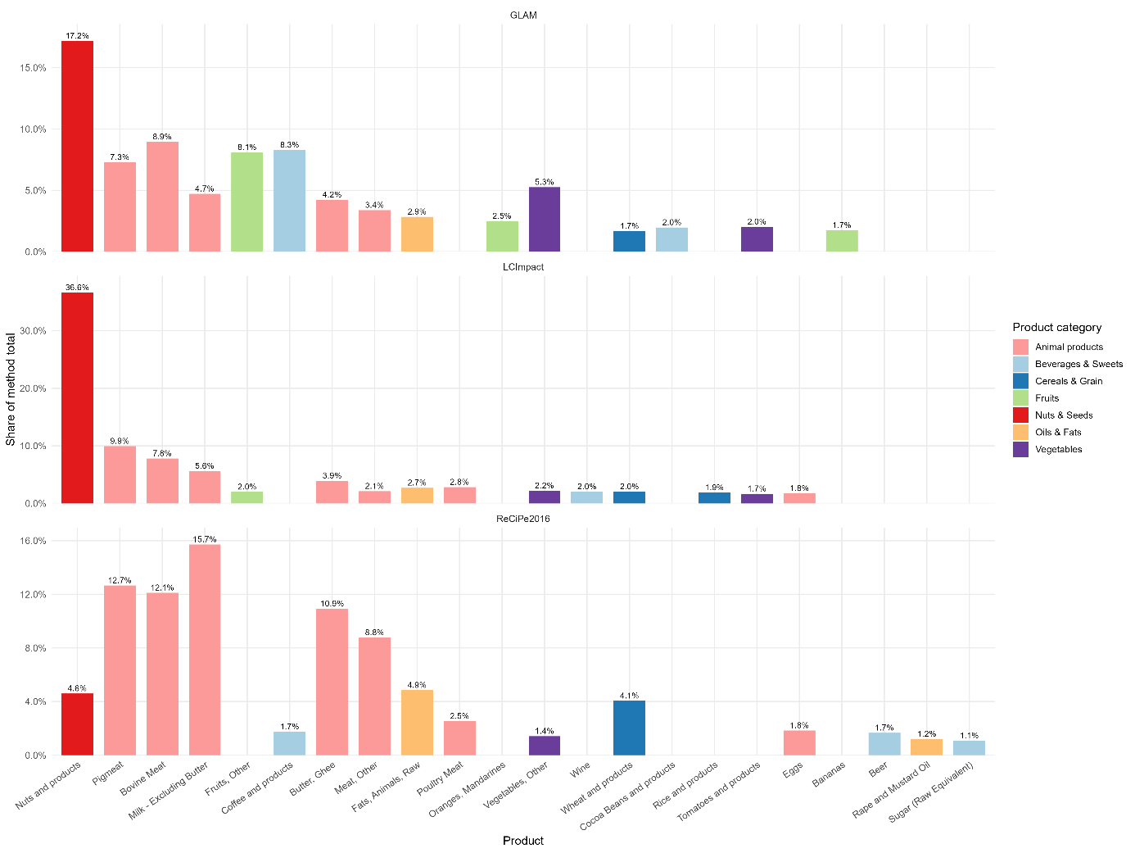
Figure 1 Top 15 products relative by method for GLAM, LC-IMPACT and ReCiPe2016
Looking across specific product groups helps to interpret differences. For fruits (e.g. ‘Apples and products’, ‘Bananas’) and beverages (e.g. ‘Beverages, Alcoholic’), GLAM and LC‑IMPACT attribute most of the impact to water use (≈70–72% of ‘Apples and products’, ≈38–71% of ‘Bananas’, and roughly half to three quarters of the impact for ‘Beverages, Alcoholic’), whereas in ReCiPe2016 these products are still dominated by land use (~57–63% of fruit impacts, ~58% for ‘Beverages, Alcoholic’) with climate change as a stronger secondary driver. Staple cereals and perennial oils show a similar method‑sensitive pattern: ‘Barley and products’ and ‘Cereals, Other’ are largely climate‑driven in GLAM and especially LC‑IMPACT (up to ~48–89% of their internal driver mix), but become land‑use‑dominated in ReCiPe2016 (≈46–63%). By contrast, ‘Coconut Oil’ and ‘Coconuts incl. Copra’ are consistently land‑use‑driven across all three methods (≈87–99% land share), while ‘Nuts and products’ and other oilseed products systematically emerge as key contributors to both water‑ and land‑use impacts even when their overall share of the method total is modest.
For most of the major HighAbs–HighInt products, at least two of the top‑3 drivers (land, water, or eutrophication) coincide between GLAM and LC‑IMPACT, i.e. good driver‑level agreement for the main hotspots.
GLAM and LC‑IMPACT agree closely on the importance of ‘Bovine Meat’, ‘Pigmeat’ and ‘Nuts and products’, but GLAM allocates much higher relative shares to fruits and beverages (e.g. ‘Lemons, Limes and products’ and ‘Citrus, Other’ have 9–10 times the share in GLAM, and ‘Coffee and products’ and ‘Cocoa Beans and products’ around 5–7 times). Comparing GLAM with ReCiPe2016 shows the same pattern: GLAM strongly up‑weights fruits, citrus and coffee (up to ~18× higher shares), while ReCiPe2016 concentrates on dairy and meat aggregates (‘Milk – Excluding Butter’, ‘Butter, Ghee’, ‘Meat, Other’), which receive 2–3 times the share of GLAM. Finally, the LC‑IMPACT–ReCiPe2016 comparison highlights that LC‑IMPACT treats ‘Nuts and products’ as a much more dominant hotspot (share ratio ≈7.7), reflecting its water‑scarcity focus, whereas ReCiPe2016 assigns relatively larger shares to ‘Milk – Excluding Butter’, ‘Butter, Ghee’ and ‘Meat, Other’, consistent with its strong land‑use formulation.
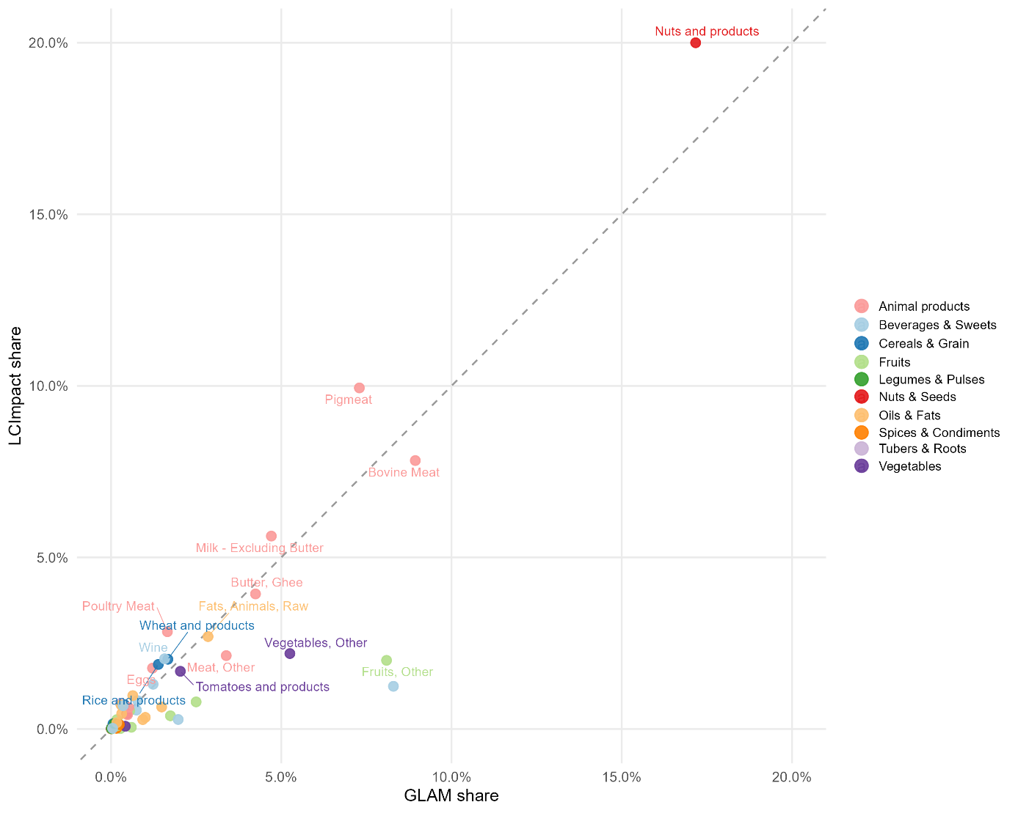
Figure 2 Pairwise comparison of relative product shares across methods (LCImpact/GLAM) - cross method relative contribution analysis. Each point represents one food product positioned by its share of total biodiversity impact in one method (x axis) versus another (y axis)
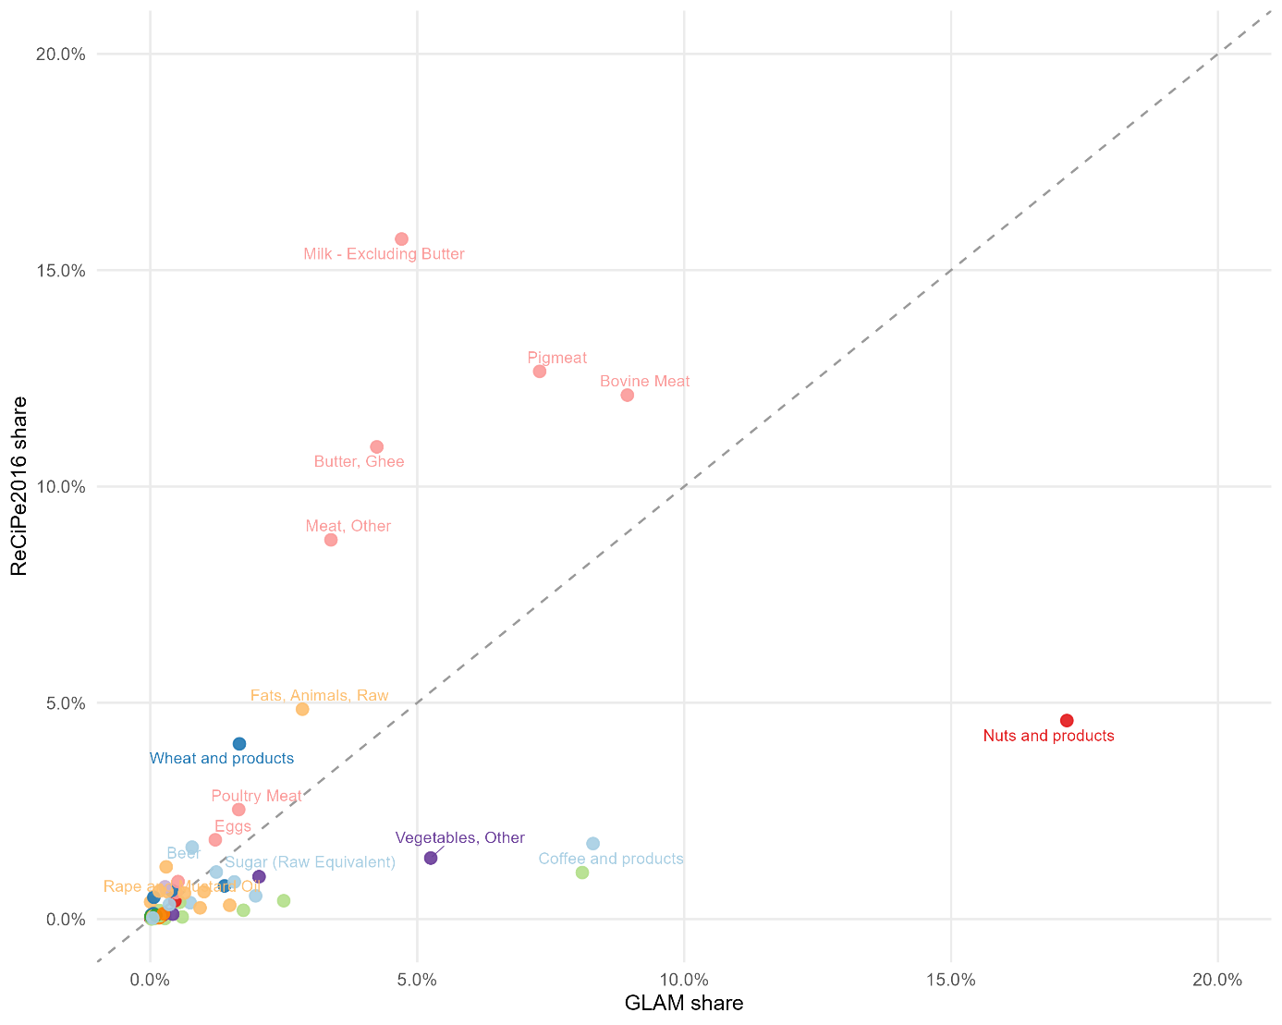
Figure 3 Pairwise comparison of relative product shares across methods (ReCiPe2016/GLAM) - cross method relative contribution analysis. Each point represents one food product positioned by its share of total biodiversity impact in one method (x axis) versus another (y axis);
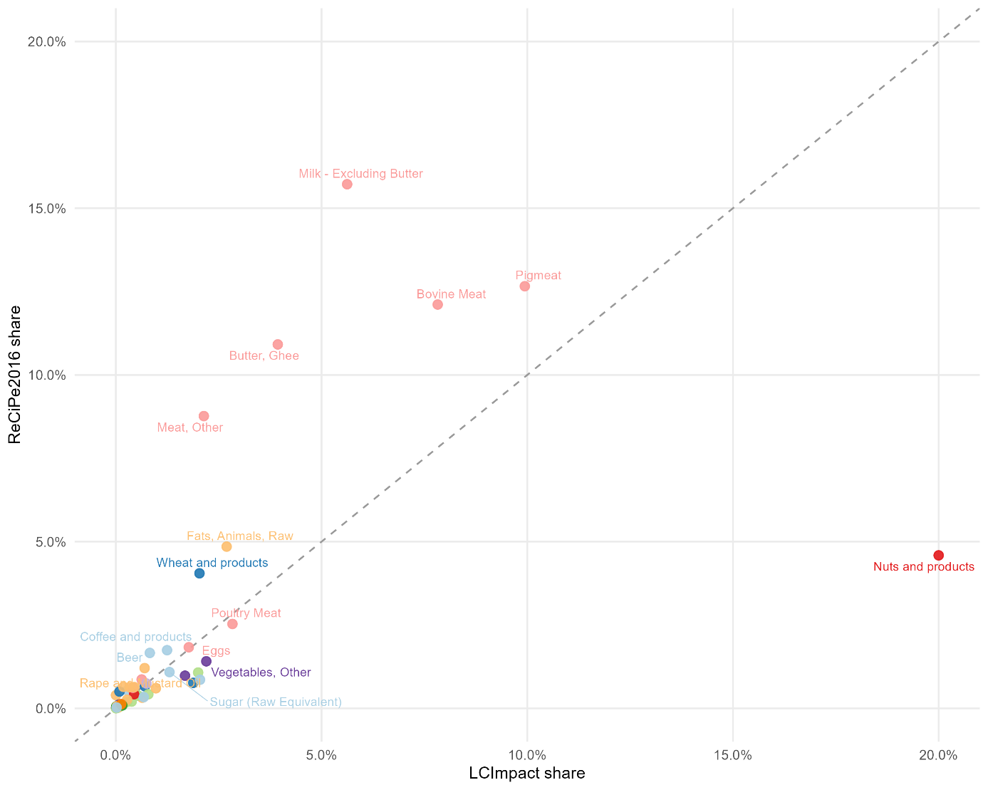
Figure 4 Pairwise comparison of relative product shares across methods (ReCiPe2016/LCImpact) - cross method relative contribution analysis. Each point represents one food product positioned by its share of total biodiversity impact in one method (x axis) versus another (y axis)

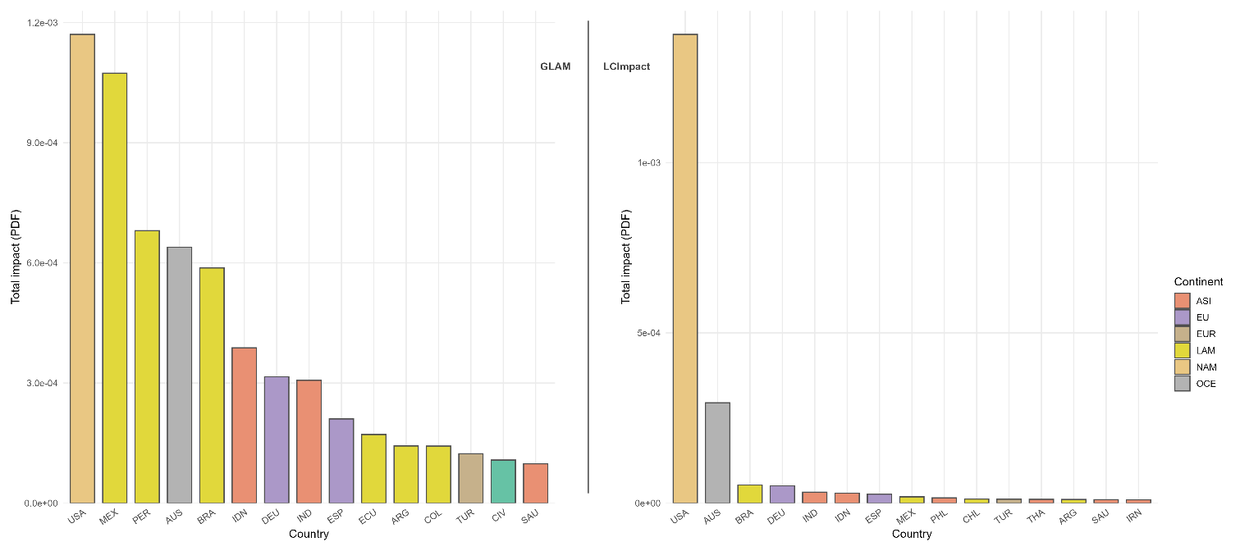
Figure 5 Top 15 countries by absolute impact for GLAM and LC-IMPACT

Table 8 Dominant food products driving land and water use impacts — GLAM vs. LC-Impact (top 10 countries)
Country | Driver | GLAM — Top products (% of origin total) | LC-Impact — Top products (% of origin total)
AUS | Land use | Bovine Meat (31%), Pigmeat (18%), Milk (9%), Butter (8%), Wheat (8%), Mutton & Goat (8%) | Bovine Meat (32%), Pigmeat (16%), Milk (9%), Mutton & Goat (8%), Butter (8%), Wheat (7%), Fats Animals Raw (7%)
 | Water use | Nuts and products (30%), Bovine Meat (17%), Wine (10%), Sugar (8%), Pigmeat (5%) | Nuts and products (30%), Bovine Meat (17%), Wine (10%), Sugar (7%), Pigmeat (5%)
BRA | Land use | Bovine Meat (35%), Pigmeat (18%), Coffee (8%), Milk (8%), Poultry (7%), Butter (6%) | Bovine Meat (28%), Meat Other (23%), Pigmeat (15%), Milk (6%), Poultry (6%), Butter (5%)
 | Water use | Bovine Meat (27%), Nuts (22%), Coffee (21%), Meat Other (9%), Sugar (7%) | Bovine Meat (27%), Nuts (22%), Coffee (21%), Meat Other (9%), Sugar (7%)
CHL | Land use | — (not in GLAM top 10) | Wine (17%), Nuts (12%), Butter (10%), Fruits Other (10%), Milk (8%), Pigmeat (7%), Oats (7%)
 | Water use | — | Nuts (56%), Fruits Other (22%), Oats (7%), Pigmeat (5%)
DEU | Land use | Milk (33%), Butter (19%), Pigmeat (14%), Bovine Meat (11%), Wheat (7%) | Milk (31%), Butter (18%), Pigmeat (13%), Bovine Meat (10%), Fats Animals Raw (8%), Wheat (6%)
 | Water use | Pigmeat (21%), Bovine Meat (21%), Fats Animals Raw (15%), Sugar (13%), Potatoes (9%), Vegetables (9%) | Pigmeat (21%), Bovine Meat (20%), Fats Animals Raw (15%), Sugar (13%), Potatoes (9%), Vegetables (9%)
ECU | Land use | Cocoa Beans (42%), Bananas (37%), Fruits Other (10%), Coffee (7%) | — (not in LC-Impact top 10)
 | Water use | Bananas (67%), Vegetables Other (22%), Fruits Other (5%) | —
ESP | Land use | Nuts (20%), Olive Oil (18%), Wine (18%), Pigmeat (14%) | Pigmeat (23%), Nuts (12%), Olive Oil (12%), Wine (11%), Vegetables Other (7%)
 | Water use | Olive Oil (20%), Pigmeat (16%), Wine (10%), Vegetables Other (10%), Fruits Other (9%), Nuts (9%), Oranges (8%) | Olive Oil (20%), Pigmeat (16%), Wine (10%), Vegetables Other (10%), Fruits Other (9%), Nuts (9%), Oranges (8%)
IDN | Land use | Coffee (25%), Nuts (24%), Palm Oil (12%), Coconut Oil (11%), Butter (6%), Pigmeat (5%) | Fats Animals Raw (22%), Coffee (18%), Nuts (18%), Palm Oil (9%), Coconut Oil (8%), Butter (6%)
 | Water use | Fats Animals Raw (79%), Sweeteners Other (6%), Pepper (4%) | Fats Animals Raw (79%), Sweeteners Other (6%), Pepper (4%)
IND | Land use | Bovine Meat (46%), Rice (9%), Pigmeat (8%), Nuts (6%), Butter (5%), Coffee (4%) | Bovine Meat (53%), Rice (8%), Pigmeat (7%), Butter (5%), Fats Animals Raw (4%), Nuts (3%)
 | Water use | Rice (19%), Pigmeat (14%), Wheat (12%), Sugar (11%), Bovine Meat (10%), Nuts (5%) | Rice (19%), Pigmeat (14%), Wheat (12%), Sugar (11%), Bovine Meat (10%)
MEX | Land use | Bovine Meat (24%), Coffee (19%), Vegetables Other (13%), Nuts (11%), Fruits Other (11%) | Bovine Meat (38%), Vegetables Other (19%), Coffee (8%), Nuts (5%), Fruits Other (5%)
 | Water use | Nuts (23%), Vegetables Other (22%), Fruits Other (19%), Tomatoes (10%), Oranges (4%) | Nuts (23%), Vegetables Other (22%), Fruits Other (19%), Tomatoes (10%), Oranges (4%)
PER | Land use | Coffee (48%), Fruits Other (26%), Cocoa Beans (6%), Grapes (5%), Oranges (4%) | — (not in LC-Impact top 10)
 | Water use | Fruits Other (54%), Vegetables Other (20%), Oranges (13%) | —
TUR | Land use | — (not in GLAM top 10) | Nuts (31%), Eggs (13%), Fats Animals Raw (8%), Poultry (7%), Pigmeat (6%), Wheat (5%)
 | Water use | — | Nuts (35%), Tomatoes (11%), Fruits Other (11%), Oranges (7%), Eggs (6%), Vegetables Other (5%)
USA | Land use | Pigmeat (23%), Bovine Meat (18%), Nuts (14%), Butter (10%), Milk (9%), Wheat (5%) | Pigmeat (20%), Bovine Meat (17%), Nuts (10%), Butter (9%), Milk (8%), Fats Animals Raw (8%)
 | Water use | Nuts (56%), Pigmeat (11%), Bovine Meat (3%), Butter (3%), Milk (3%) | Nuts (56%), Pigmeat (11%), Bovine Meat (3%), Butter (3%), Milk (3%)

Further analysis of ‘Nuts and products’ category
Nuts and products emerged as the impact-dominant product for blue‑water biodiversity impacts in German food consumption in both spatially explicit characterization approaches (LC‑Impact and GLAM). In inventory terms, nuts account for ~22% of Germany’s total blue‑water use (in line with Grabow et al. 2026), and impacts are concentrated in a small number of origins: 48% of nut-related blue‑water impacts are associated with supply from the USA, followed by Iran (18%) and a second tier of contributors (Chile, Turkey and Mexico: each ~4–5%). It should be noted that uncertainties in the underlying inventory data may affect these results, as discussed later on. While these inventory shares are constant in our comparison of methods, the magnitude and ranking of origin contributions depends strongly on the characterization factors (CFs) implying that method choice can substantially shift which origins appear most critical. In particular, the USA dominates the LC‑Impact results because it combines a large share of the inventory with a comparatively high CF (USA: 1.15×10⁻¹²), which amplifies the contribution of U.S.-sourced nuts (notably almonds, but also walnuts and pistachios) to overall category impacts. For all major suppliers of ‘Nuts and products’, CFs differ substantially between LC‑Impact and GLAM (e.g., USA: 1.15×10⁻¹² vs 8.71×10⁻¹³; Iran: 2.47×10⁻¹⁴ vs 4.45×10⁻¹⁴; Chile: 8.86×10⁻¹⁴ vs 1.26×10⁻¹³). The largest divergences are observed for Turkey and Mexico, for which GLAM yields markedly higher CFs than LC-Impact (Turkey: 1.95×10⁻¹⁴ vs 4.38×10⁻¹³; Mexico: 1.25×10⁻¹⁴ vs 3.50×10⁻¹²), resulting in a more dispersed country-level contribution pattern across suppliers.
To illustrate the potential leverage of origin reconfiguration within the existing structure, we performed a swap analysis among the ten largest supplying countries (by mass), holding total nut consumption constant and reallocating 25% of the U.S. supply to alternative top‑10 origins (GLAM results). These swaps produce pronounced changes when reallocating for example to Viet Nam, Côte d’Ivoire, China, Tanzania (impact reduction of ~14–14.5%; and total blue‑water use by ~11–12%) or India, Spain, Turkey (~12–13% impact reduction).
Table 9 Illustrative origin swaps for nuts and products (blue‑water biodiversity impacts).
Swap (FROM→TO) | Reallocated mass (kg) | Δ Blue water (m³) | Δ Impact (PDF) | Δ Impact (%)
USA→VNM | 112,476 | −1.64×10^8 | −1.45×10^−4 | −14.48
USA→CIV | 112,476 | −1.58×10^8 | −1.45×10^−4 | −14.48
USA→CHN | 112,476 | −1.56×10^8 | −1.44×10^−4 | −14.42
USA→TZA | 112,476 | −1.55×10^8 | −1.44×10^−4 | −14.39
USA→IND | 112,476 | −9.24×10^7 | −1.29×10^−4 | −12.84
USA→ESP | 112,476 | −8.70×10^7 | −1.25×10^−4 | −12.52
USA→TUR | 112,476 | −1.13×10^8 | −1.22×10^−4 | −12.15
USA→CHL | 112,476 | +8.04×10^6 | −1.23×10^−4 | −12.29

Table 10 Practitioner take-away table: Which conclusion would a sustainability expert now draw from each of the results
guiding_question | expert_conclusion
Can I trust absolute biodiversity totals across methods? | No. GLAM ≈3× LC-IMPACT and ReCiPe2016 is on a different scale, so use the methods to compare options and hotspots, not to fix absolute targets.
Are the main pressures on biodiversity clear enough to act on? | To an extent. All methods agree that land use and water use are the dominant drivers; actions that reduce land occupation and blue-water use seem robust.
Are the main hotspot countries stable across methods? | Yes in identity, no in strength. The same few importing regions/countries dominate, but LC-IMPACT concentrates more impact in a handful (especially the USA).
Are the main hotspot products stable across methods? | Largely yes for animal products and nuts/oilseeds. Ruminant meat, pigmeat, dairy fats and ‘Nuts and products’ are consistently high-impact and high-intensity.
Which products are ‘no-regret’ targets for mitigation? | Reducing consumption and improving production of ruminant meat, pigmeat, dairy fats and high-impact nuts/oilseeds is justified under all three methods.
Where should I be cautious because methods disagree? | Fruits, beverages, some cereals and sugars shift in importance between methods; treat these as second-tier or context-dependent priorities and check method sensitivity before acting.
What is the overall robustness message? | Use the methods to identify and prioritise a small, shared set of very high-impact products and hotspot countries, and be explicit that finer ranking of other products and drivers depends on indicator choice.

References
Azevedo, L. B., van Zelm, R., Elshout, P. M. F., Hendriks, A. J., Leuven, R. S. E. W., Struijs, J., de Zwart, D., & Huijbregts, M. A. J. (2013). Species richness–phosphorus relationships for lakes and streams worldwide. Global Ecology and Biogeography, 22(12), 1304–1314. https://doi.org/10.1111/geb.12080
Chaudhary, A., Verones, F., De Baan, L., & Hellweg, S. (2015). Quantifying Land Use Impacts on Biodiversity: Combining Species–Area Models and Vulnerability Indicators. Environmental Science & Technology, 49(16), 9987–9995. https://doi.org/10.1021/acs.est.5b02507
Coelho, C. R. V., Börjesson, P., & Smith, H. G. (2025). Understanding land use impacts of croplands on biodiversity through UNEP’s Global Guidance for Life Cycle Impact Assessment. Resources, Conservation and Recycling, 222, 108420. https://doi.org/10.1016/j.resconrec.2025.108420
de Baan, L., Alkemade, R., & Koellner, T. (2013). Land use impacts on biodiversity in LCA: A global approach. The International Journal of Life Cycle Assessment, 18(6), 1216–1230. https://doi.org/10.1007/s11367-012-0412-0
De Schryver, A. M., Brakkee, K. W., Goedkoop, M. J., & Huijbregts, M. A. J. (2009). Characterization Factors for Global Warming in Life Cycle Assessment Based on Damages to Humans and Ecosystems. Environmental Science & Technology, 43(6), 1689–1695. https://doi.org/10.1021/es800456m
De Schryver, A. M., van Zelm, R., Humbert, S., Pfister, S., McKone, T. E., & Huijbregts, M. A. J. (2011). Value Choices in Life Cycle Impact Assessment of Stressors Causing Human Health Damage. Journal of Industrial Ecology, 15(5), 796–815. https://doi.org/10.1111/j.1530-9290.2011.00371.x
de Visser, S., Scherer, L., Huijbregts, M., & Barbarossa, V. (2023). Characterization factors for the impact of climate change on freshwater fish species. Ecological Indicators, 150, 110238. https://doi.org/10.1016/j.ecolind.2023.110238
Elshout, P. M. F., van Zelm, R., Karuppiah, R., Laurenzi, I. J., & Huijbregts, M. A. J. (2014). A spatially explicit data-driven approach to assess the effect of agricultural land occupation on species groups. The International Journal of Life Cycle Assessment, 19(4), 758–769. https://doi.org/10.1007/s11367-014-0701-x
Goedkoop, M., Heijungs, R., Huijbregts, M., Schryver, A., Struijs, J., & Zelm, R. (2009). ReCiPE 2008: A life cycle impact assessment method which comprises harmonised category indicators at the midpoint and the endpoint level.
Hanafiah, M. M., Xenopoulos, M. A., Pfister, S., Leuven, R. S. E. W., & Huijbregts, M. A. J. (2011). Characterization Factors for Water Consumption and Greenhouse Gas Emissions Based on Freshwater Fish Species Extinction. Environmental Science & Technology, 45(12), 5272–5278. https://doi.org/10.1021/es1039634
Huijbregts, M. A. J., Steinmann, Z. J. N., Elshout, P. M. F., Stam, G., Verones, F., Vieira, M., Zijp, M., Hollander, A., & van Zelm, R. (2017). ReCiPe2016: A harmonised life cycle impact assessment method at midpoint and endpoint level. The International Journal of Life Cycle Assessment, 22(2), 138–147. https://doi.org/10.1007/s11367-016-1246-y
Iordan, C.-M., Kuipers, K. J. J., Huang, B., Hu, X., Verones, F., & Cherubini, F. (2023). Spatially and taxonomically explicit characterisation factors for greenhouse gas emission impacts on biodiversity. Resources, Conservation and Recycling, 198, 107159. https://doi.org/10.1016/j.resconrec.2023.107159
Koellner, T., & Scholz, R. W. (2008). Assessment of land use impacts on the natural environment: Part 2: Generic characterization factors for local species diversity in Central Europe. The International Journal of Life Cycle Assessment, 13(1), 32–48. https://doi.org/10.1065/lca2006.12.292.2
Milà I Canals, L., Bauer, C., Depestele, J., Dubreuil, A., Freiermuth Knuchel, R., Gaillard, G., Michelsen, O., Müller-Wenk, R., & Rydgren, B. (2007). Key Elements in a Framework for Land Use Impact Assessment Within LCA (11 pp). The International Journal of Life Cycle Assessment, 12(1), 5–15. https://doi.org/10.1065/lca2006.05.250
Pfister, S., & Bayer, P. (2014). Monthly water stress: Spatially and temporally explicit consumptive water footprint of global crop production. Journal of Cleaner Production, 73, 52–62. https://doi.org/10.1016/j.jclepro.2013.11.031
Pfister, S., Koehler, A., & Hellweg, S. (2009). Assessing the Environmental Impacts of Freshwater Consumption in LCA. Environmental Science & Technology, 43(11), 4098–4104. https://doi.org/10.1021/es802423e
Pierrat, E., Barbarossa, V., Núñez, M., Scherer, L., Link, A., Damiani, M., Verones, F., & Dorber, M. (2023). Global water consumption impacts on riverine fish species richness in Life Cycle Assessment. Science of The Total Environment, 854, 158702. https://doi.org/10.1016/j.scitotenv.2022.158702
RIVM. (2016). LCIA: the ReCiPe model. https://www.rivm.nl/en/life-cycle-assessment-lca/recipe
Scherer, L., & Pfister, S. (2015). Modelling spatially explicit impacts from phosphorus emissions in agriculture. The International Journal of Life Cycle Assessment, 20(6), 785–795. https://doi.org/10.1007/s11367-015-0880-0
Scherer, L., Rosa, F., Sun, Z., Michelsen, O., De Laurentiis, V., Marques, A., Pfister, S., Verones, F., & Kuipers, K. J. J. (2023). Biodiversity Impact Assessment Considering Land Use Intensities and Fragmentation. Environmental Science & Technology, 57(48), 19612–19623. https://doi.org/10.1021/acs.est.3c04191
Scholz, R. (2007). Assessment of Land Use Impacts on the Natural Environment. Part 1: An Analytical Framework for Pure Land Occupation and Land Use Change (8 pp). The International Journal of Life Cycle Assessment, 12(1), 16–23. https://doi.org/10.1065/lca2006.12.292.1
Verones, F., Hellweg, S., Antón, A., Azevedo, L. B., Chaudhary, A., Cosme, N., Cucurachi, S., de Baan, L., Dong, Y., Fantke, P., Golsteijn, L., Hauschild, M., Heijungs, R., Jolliet, O., Juraske, R., Larsen, H., Laurent, A., Mutel, C. L., Margni, M., … Huijbregts, M. A. J. (2020). LC-IMPACT: A regionalized life cycle damage assessment method. Journal of Industrial Ecology, 24(6), 1201–1219. https://doi.org/10.1111/jiec.13018
Verones, F., Saner, D., Pfister, S., Baisero, D., Rondinini, C., & Hellweg, S. (2013). Effects of Consumptive Water Use on Biodiversity in Wetlands of International Importance. Environmental Science & Technology, 47(21), 12248–12257. https://doi.org/10.1021/es403635j
Xenopoulos, M. A., & Lodge, D. M. (2006). Going with the Flow: Using Species–Discharge Relationships to Forecast Losses in Fish Biodiversity. Ecology, 87(8), 1907–1914. https://doi.org/10.1890/0012-9658(2006)87[1907:GWTFUS]2.0.CO;2
Zhou, J., Mogollón, J. M., van Bodegom, P. M., Beusen, A. H. W., & Scherer, L. (2024). Global regionalized characterization factors for phosphorus and nitrogen impacts on freshwater fish biodiversity. Science of The Total Environment, 912, 169108. https://doi.org/10.1016/j.scitotenv.2023.169108

