Supplementary information
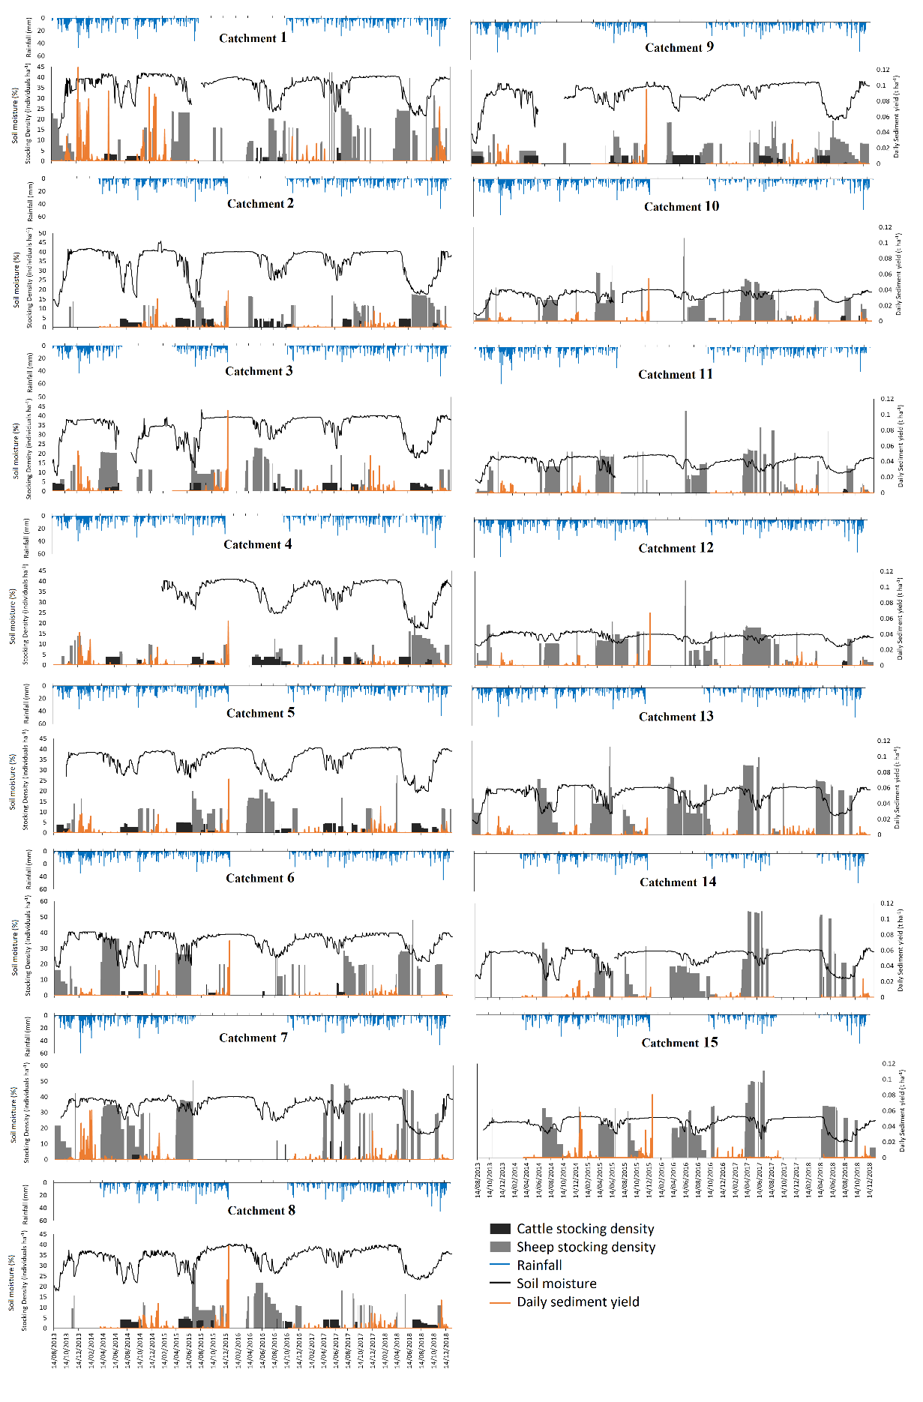
Fig.S1: Time series of daily sediment yield, rainfall, soil moisture and livestock stocking rate for the 15 study catchments. Flow, sediment yield and rainfall data was unavailable for much of 2016

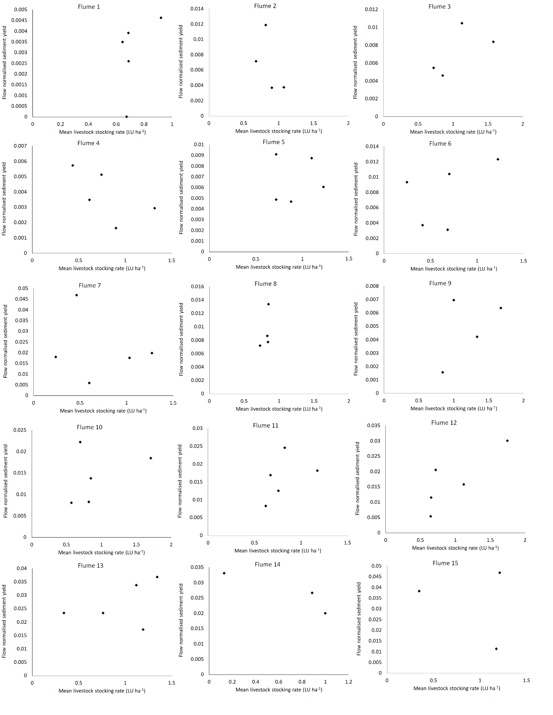
Fig.S2: Water flux-normalised winter sediment yield plotted against mean livestock (cattle + sheep) stocking rate (1st April – 31st March).

