Supporting Information
SI Figure 1 Soil sampling scheme of the three-year field experiment
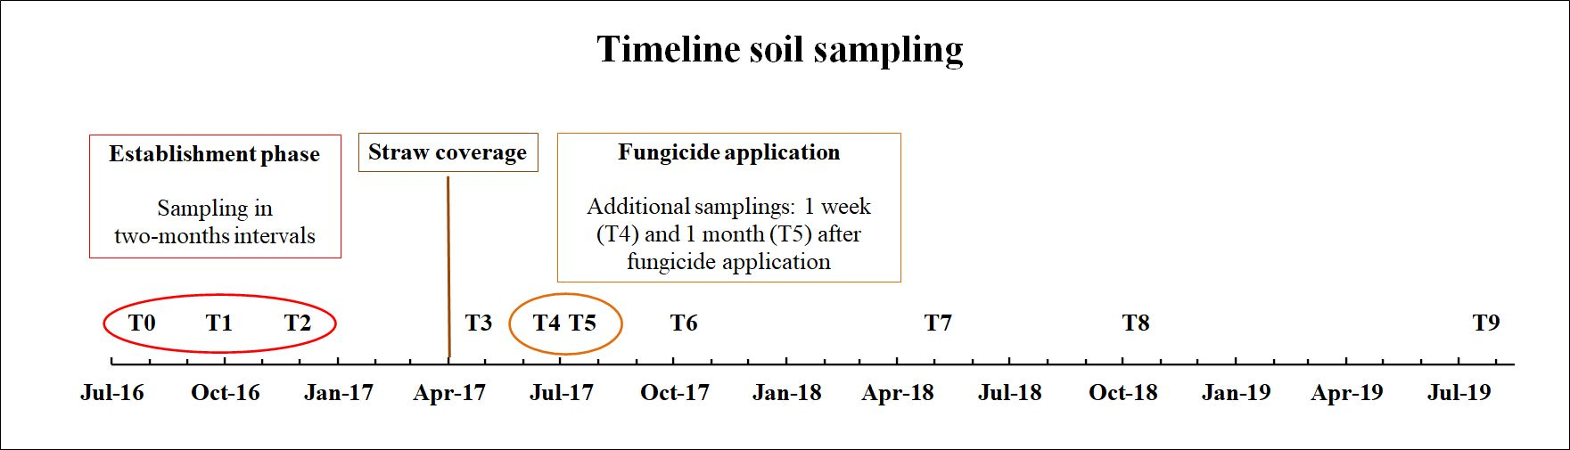

SI Figure 2 Soil and air temperature Fig. 2a-c Daily mean soil temperature in strawberry cultivation, measured at 5, 15 and 35 cm soil depth under plastic coverage (PC) and straw coverage (SC) and daily mean air temperature measured 2 m above ground. The data exhibit gaps from 01.07.2016–11.08.2016, 13.05.2017–08.06.2017 and 13.05.2018–08.06.2018 due to technical malfunction of the measuring station.
SI Figure 3 Soil moisture and precipitation Fig. 3a-c Daily mean soil moisture in strawberry cultivation, measured at 5, 15 and 35 cm soil depth under plastic coverage (PC) and straw coverage (SC) and daily precipitation. The data exhibit gaps from 01.07.2016–11.08.2016, 13.05.2017–08.06.2017 and 13.05.2018–08.06.2018 due to technical malfunction of the measuring station.

In order to estimate the water flows and changes in soil moisture after rainfalls under plastic and straw coverage, the 20 largest daily rainfall events during the three-year sampling period were graphically presented in a chronological order.

SI Figure 4a 15.1 mm rainfall on 18.09.2016. Soil moisture was measured hourly at 5, 15 and 35 cm soil depth under plastic coverage (PC) and straw coverage (SC)
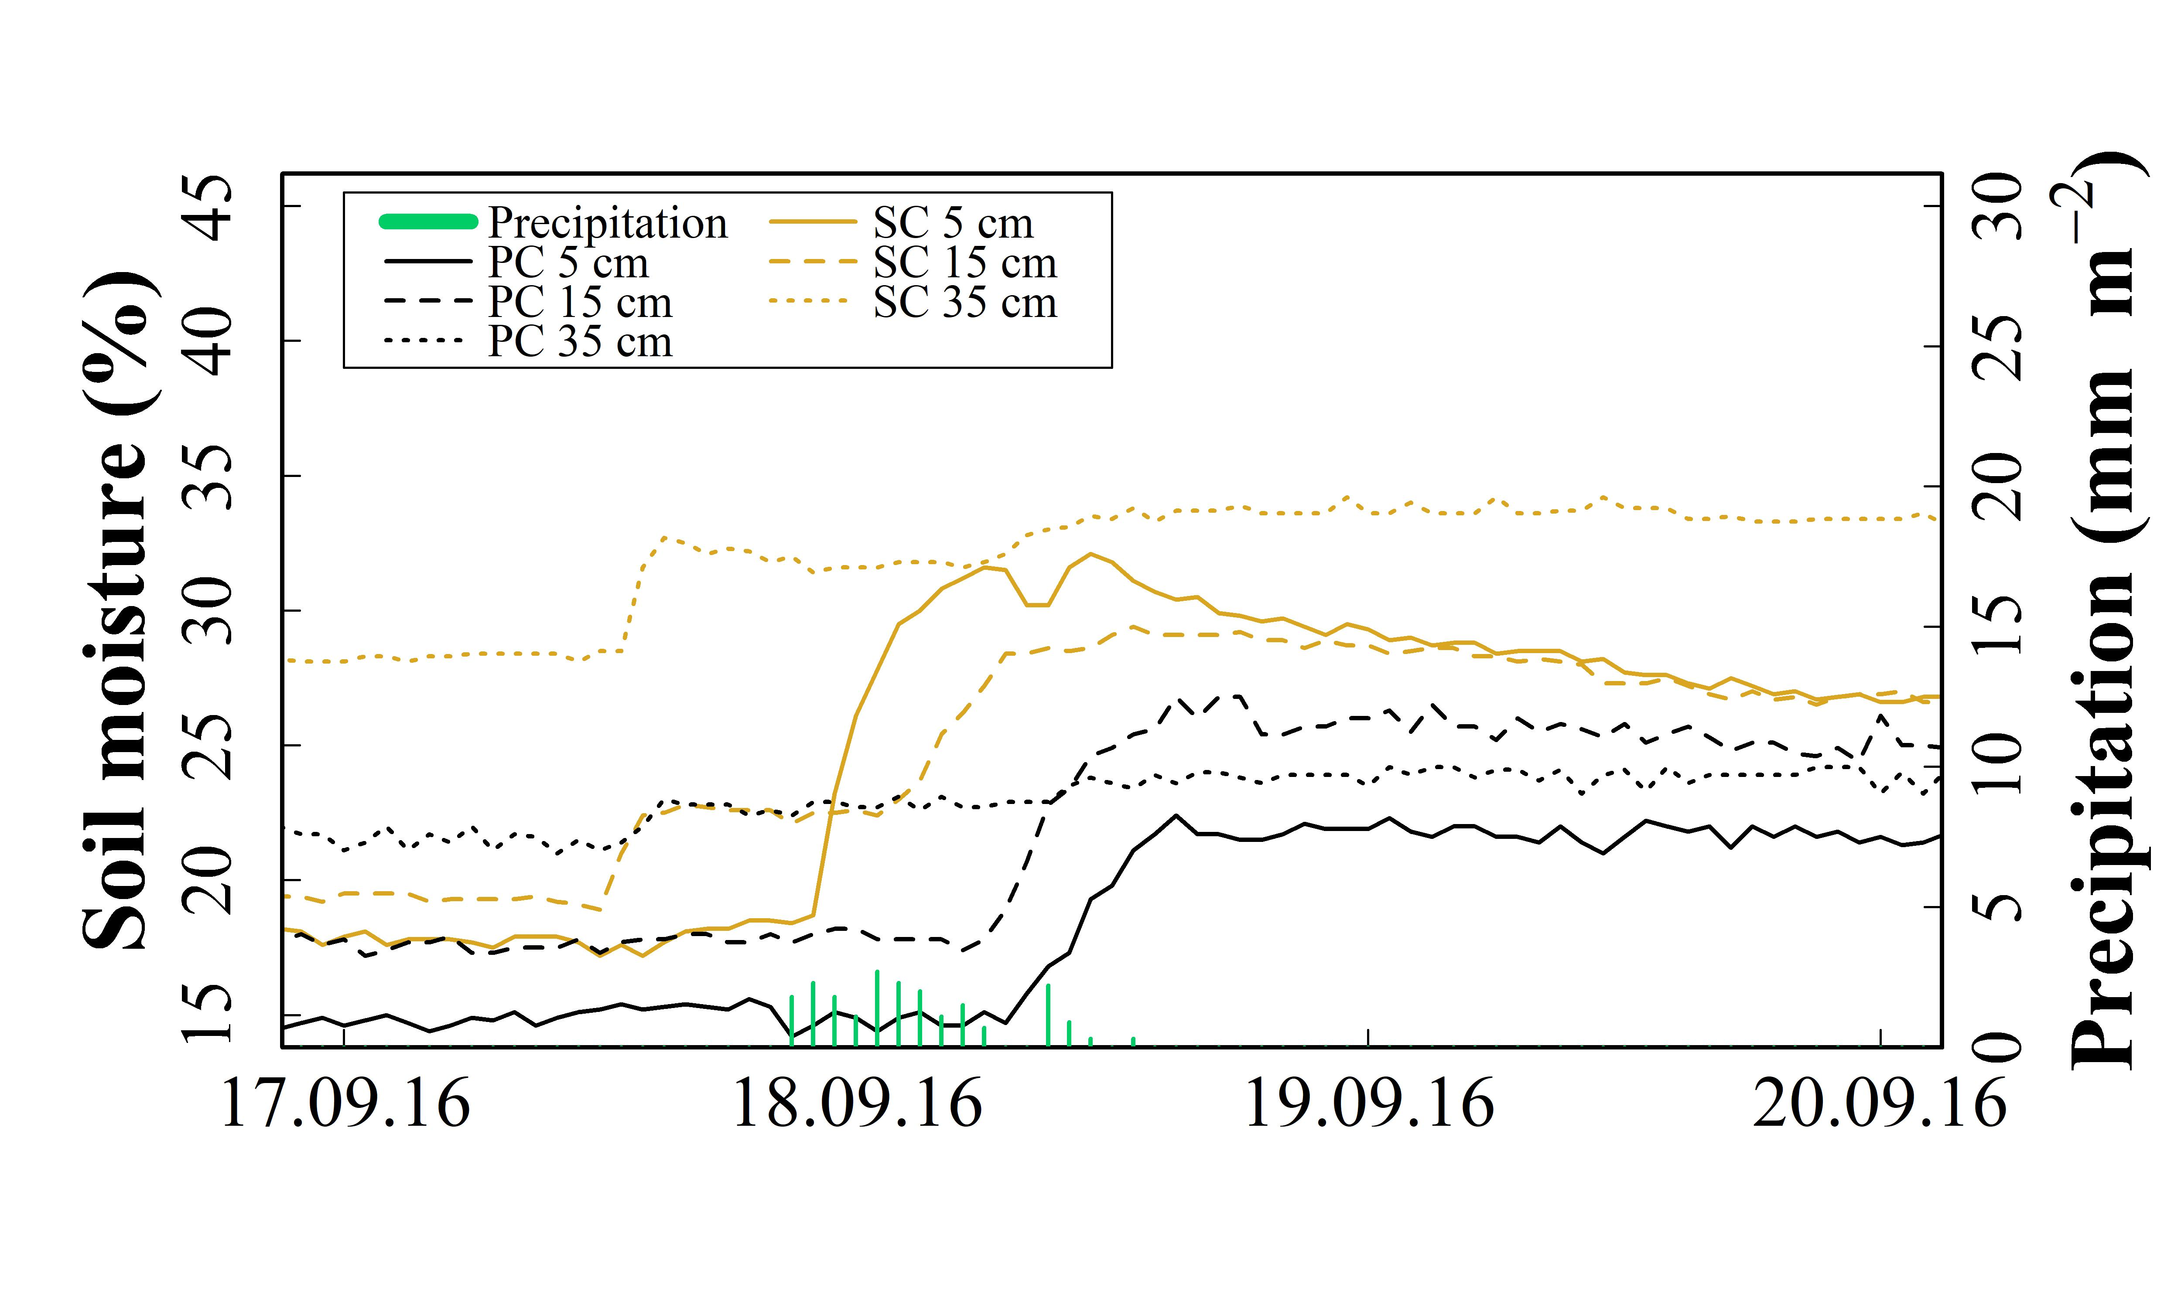

SI Figure 4b 16.8 mm rainfall on 01.03.2017. Soil moisture was measured hourly at 5, 15 and 35 cm soil depth under plastic coverage (PC) and straw coverage (SC)
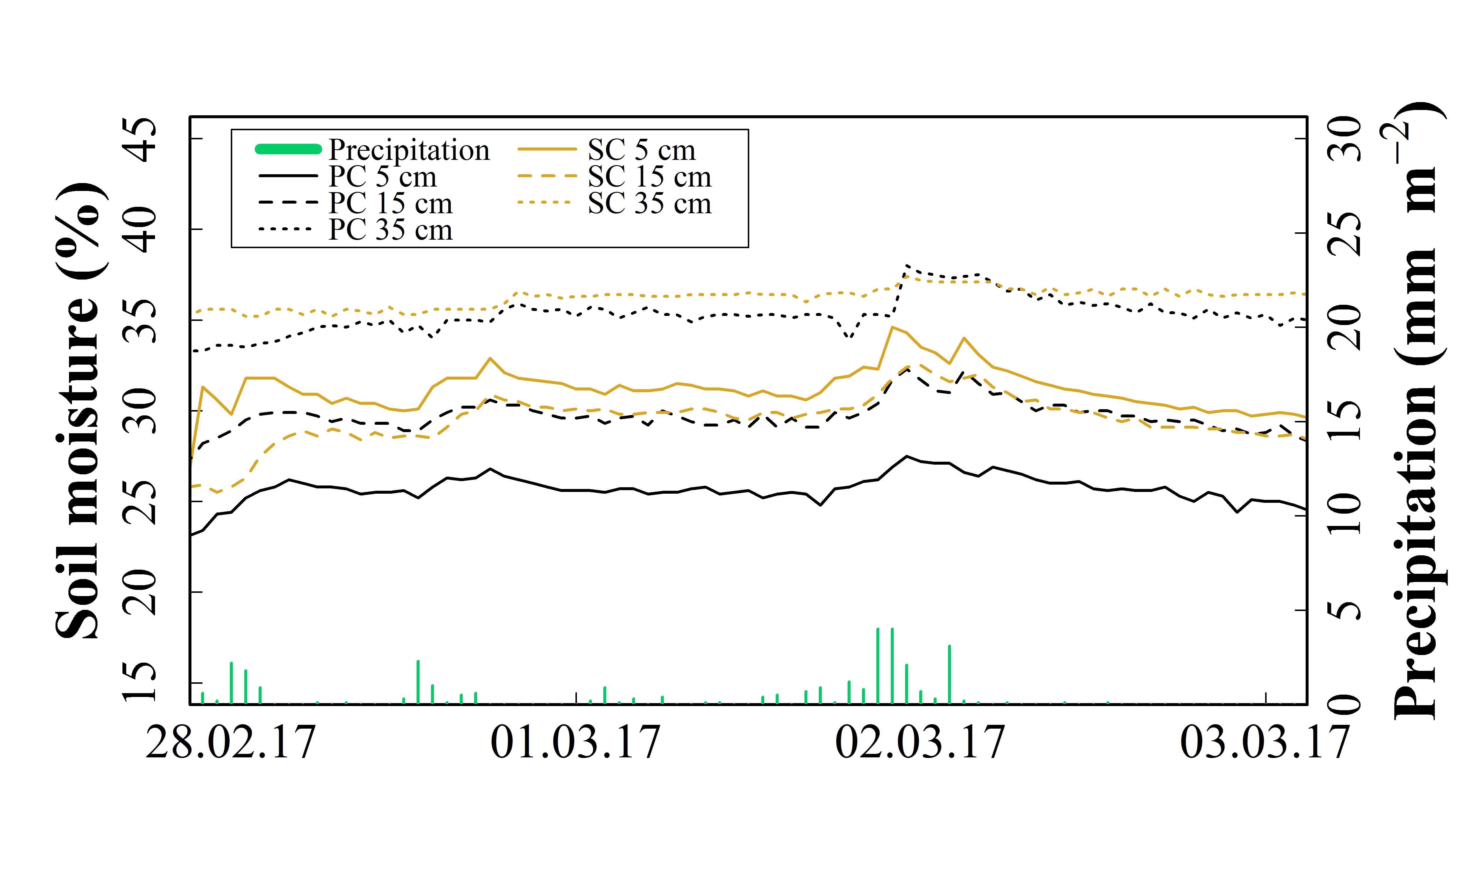

SI Figure 4c 24.8 mm rainfall on 10.08.2017. Soil moisture was measured hourly at 5, 15 and 35 cm soil depth under plastic coverage (PC) and straw coverage (SC)
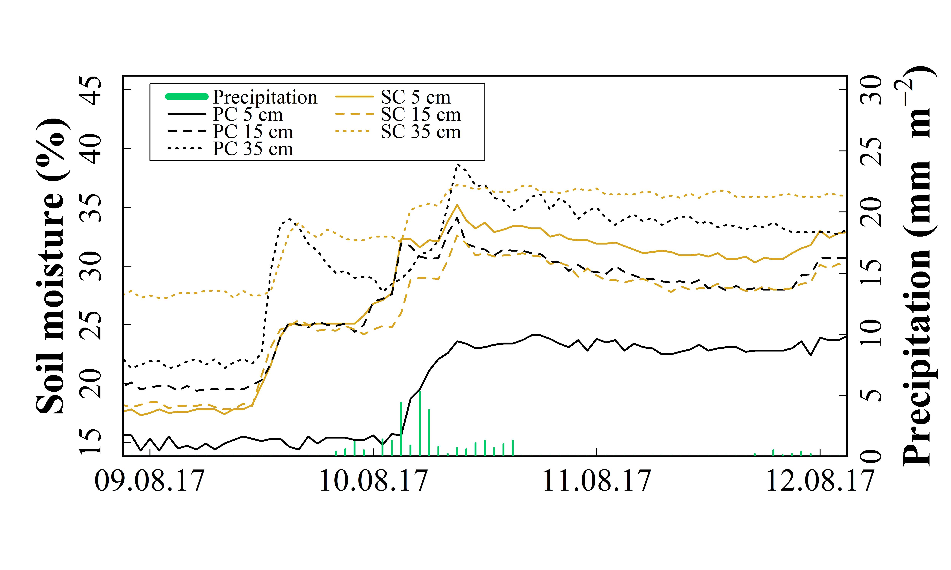

SI Figure 4d 15.1 and 26.6 mm rainfall on 13/14.09.2017. Soil moisture was measured hourly at 5, 15 and 35 cm soil depth under plastic coverage (PC) and straw coverage (SC)

SI Figure 4e 23.0 mm rainfall on 12.11.2017. Soil moisture was measured hourly at 5, 15 and 35 cm soil depth under plastic coverage (PC) and straw coverage (SC)
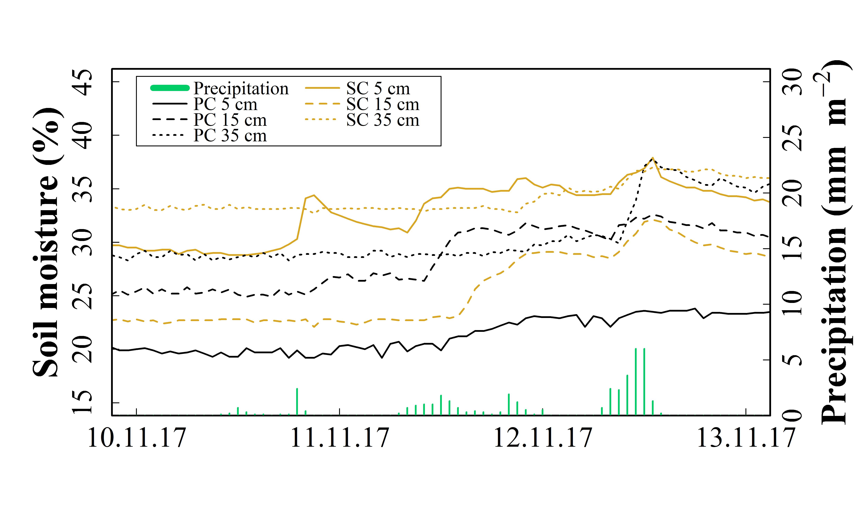

SI Figure 4f 18.3 mm rainfall on 25.11.2017. Soil moisture was measured hourly at 5, 15 and 35 cm soil depth under plastic coverage (PC) and straw coverage (SC)

SI Figure 4g 20.5 mm rainfall on 11.12.2017. Soil moisture was measured hourly at 5, 15 and 35 cm soil depth under plastic coverage (PC) and straw coverage (SC)

SI Figure 4h 19.2 mm rainfall on 04.01.2018. Soil moisture was measured hourly at 5, 15 and 35 cm soil depth under plastic coverage (PC) and straw coverage (SC)
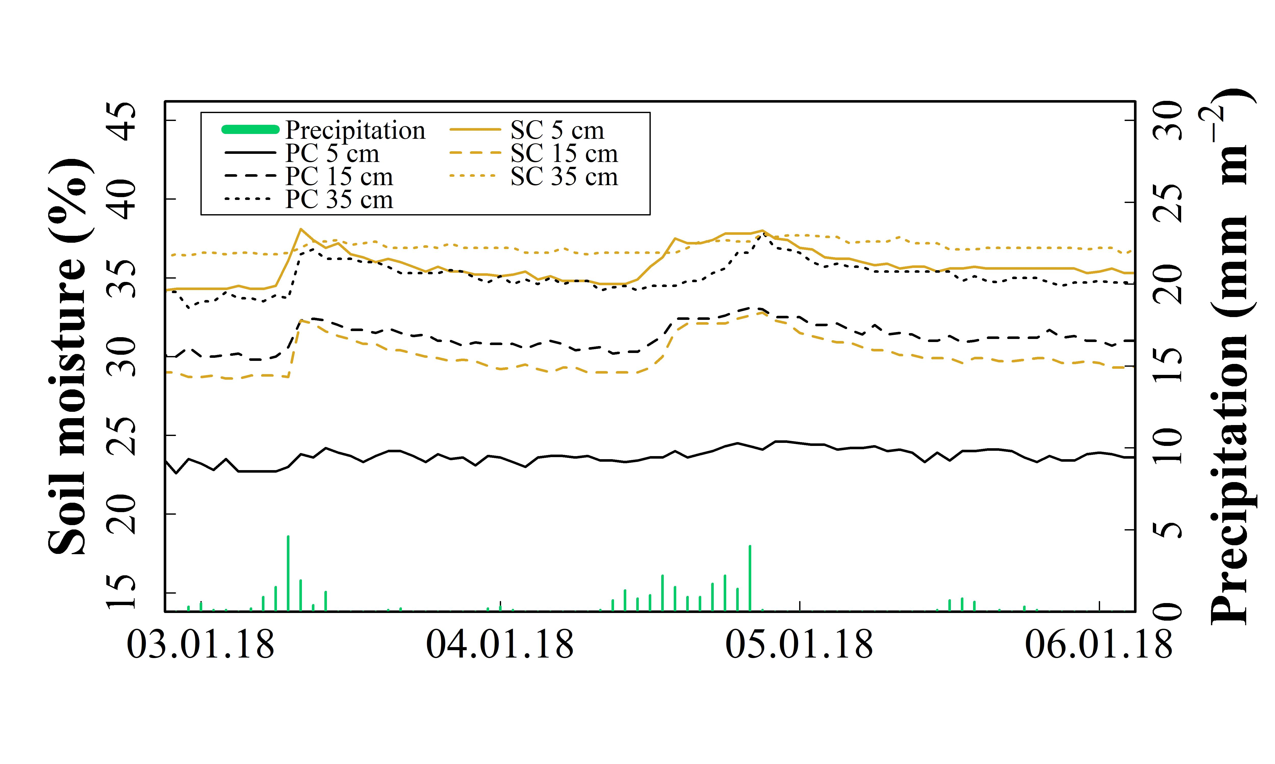

SI Figure 4i 17.5 and 19.9 mm rainfall on 13/14.05.2018. Soil moisture was measured hourly at 5, 15 and 35 cm soil depth under plastic coverage (PC) and straw coverage (SC)
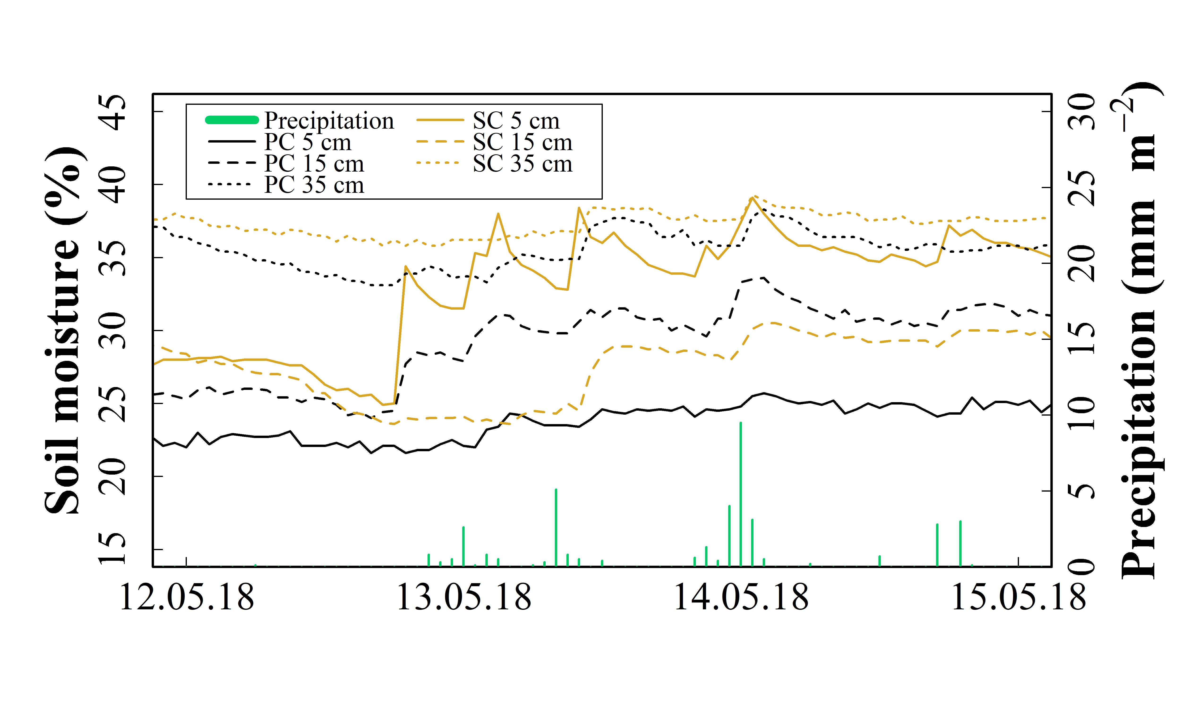

SI Figure 4j 22.5 mm rainfall on 31.05.2018. Soil moisture was measured hourly at 5, 15 and 35 cm soil depth under plastic coverage (PC) and straw coverage (SC)
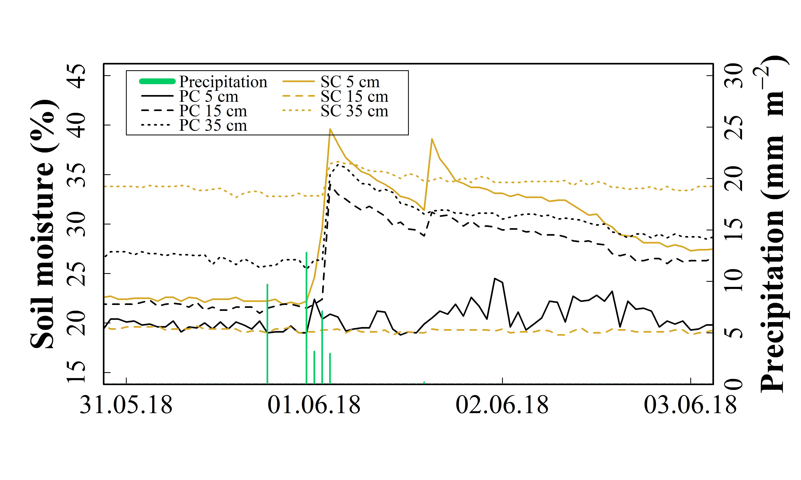

SI Figure 4k 25.2 mm rainfall on 11.06.2018. Soil moisture was measured hourly at 5, 15 and 35 cm soil depth under plastic coverage (PC) and straw coverage (SC)
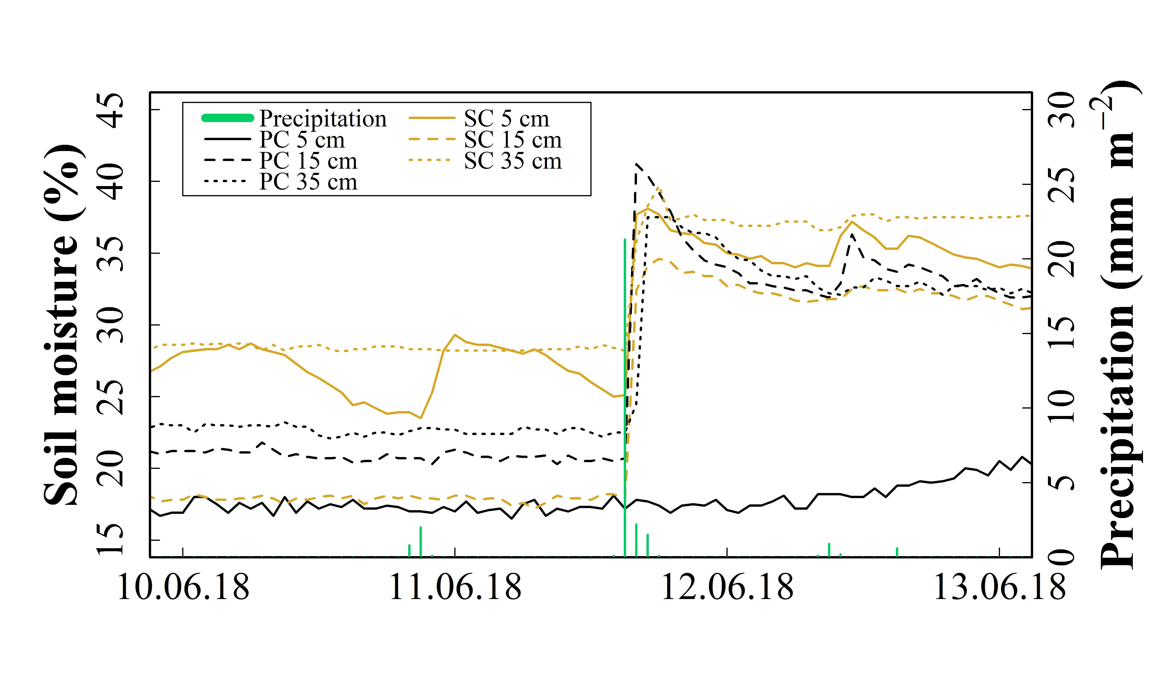

SI Figure 4l 15.4 and 39.8 mm rainfall on 02/03.12.2018. Soil moisture was measured hourly at 5, 15 and 35 cm soil depth under plastic coverage (PC) and straw coverage (SC)
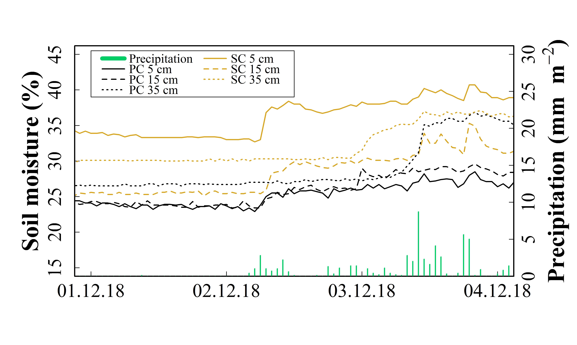

SI Figure 4m 16.2 mm rainfall on 09.12.2018. Soil moisture was measured hourly at 5, 15 and 35 cm soil depth under plastic coverage (PC) and straw coverage (SC)
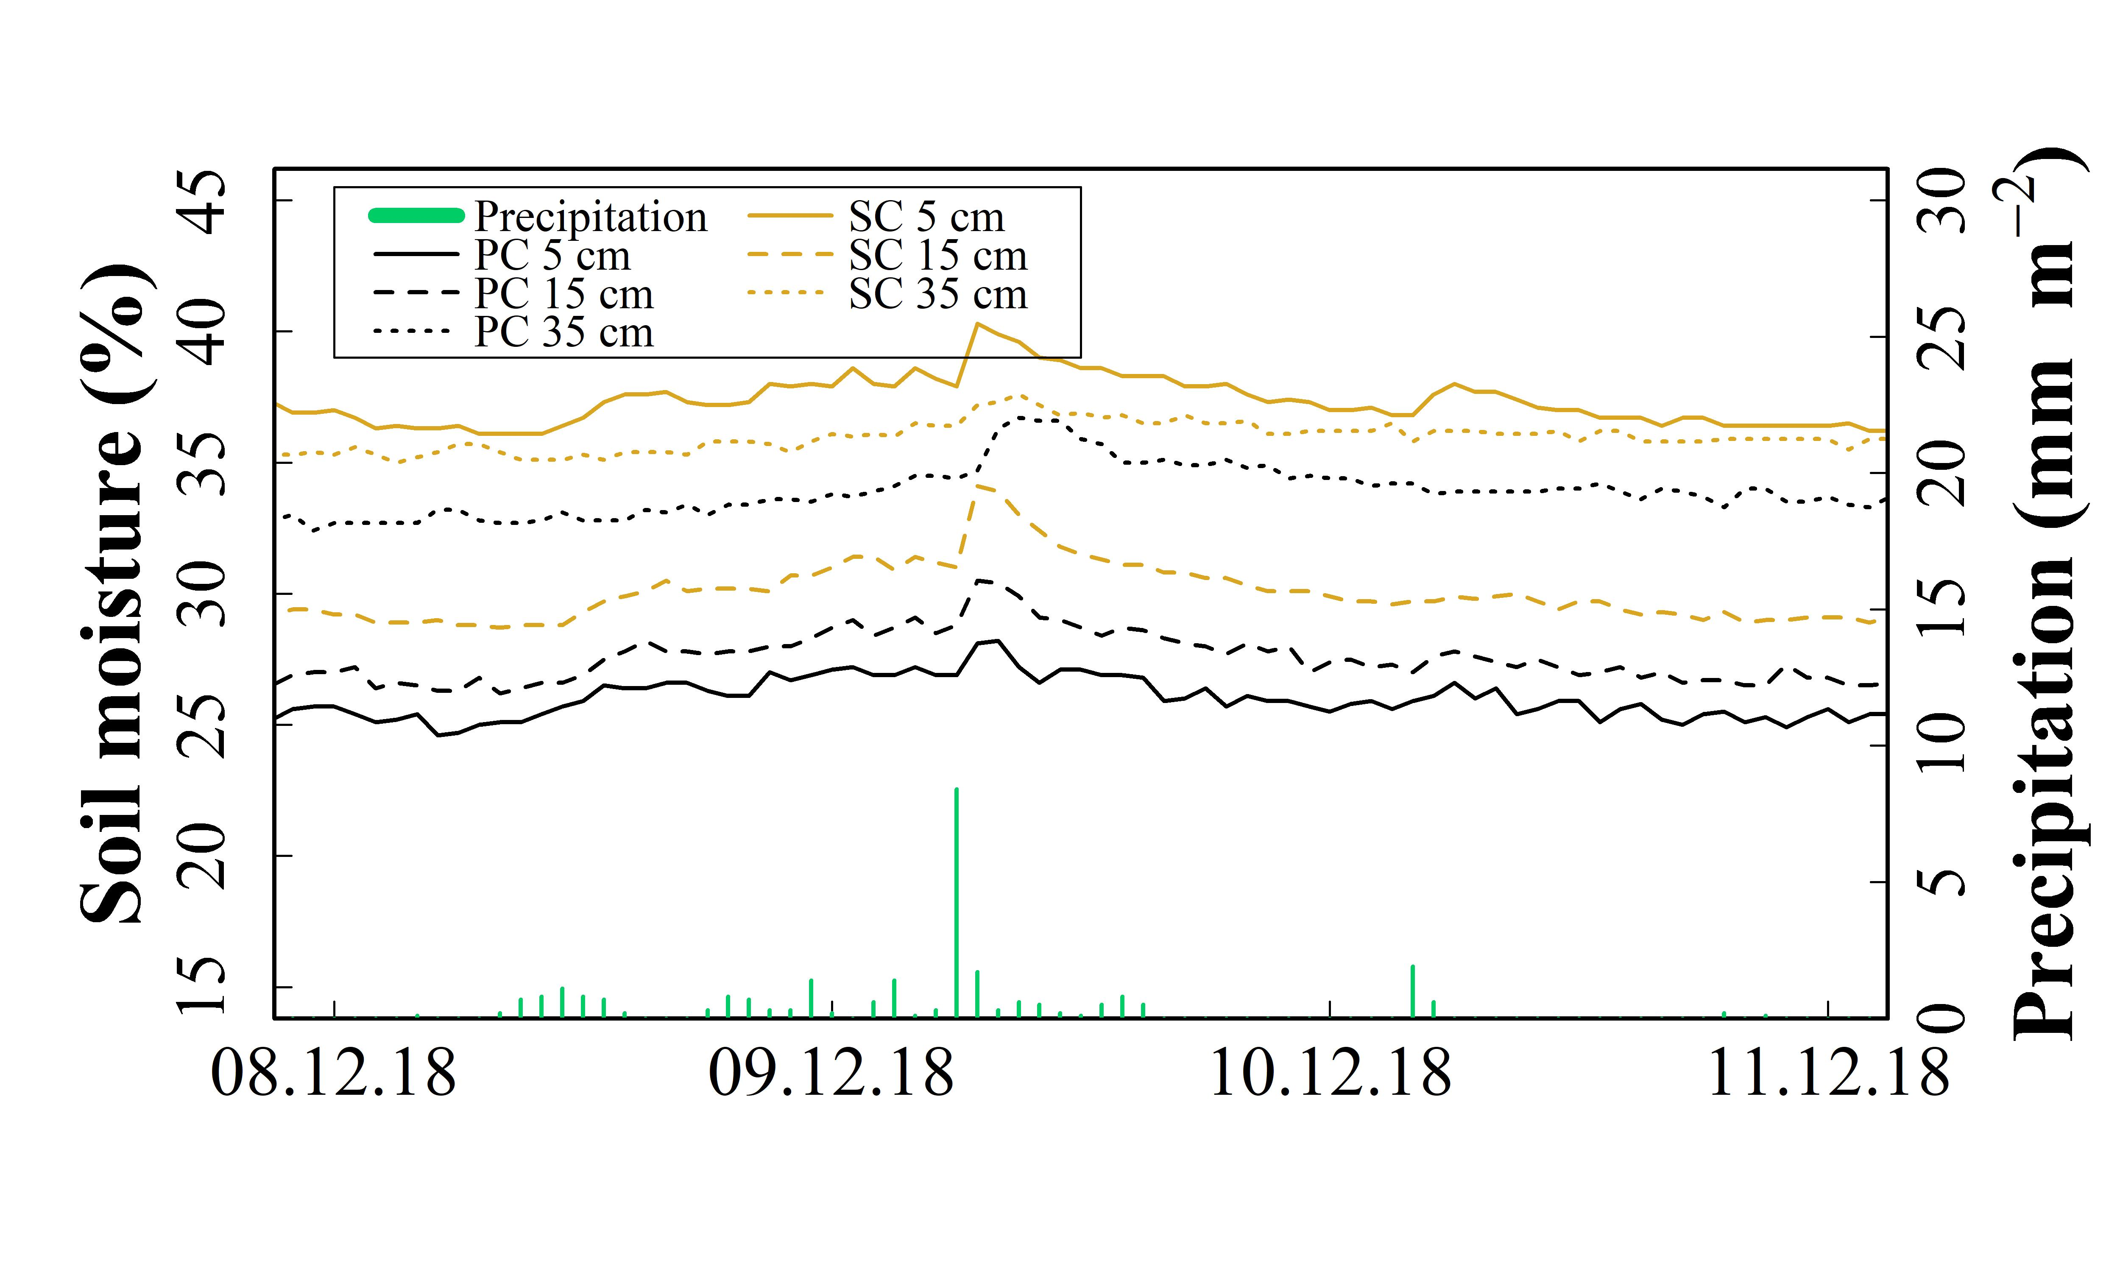

SI Figure 4n 19.3 mm rainfall on 22.12.2018. Soil moisture was measured hourly at 5, 15 and 35 cm soil depth under plastic coverage (PC) and straw coverage (SC)
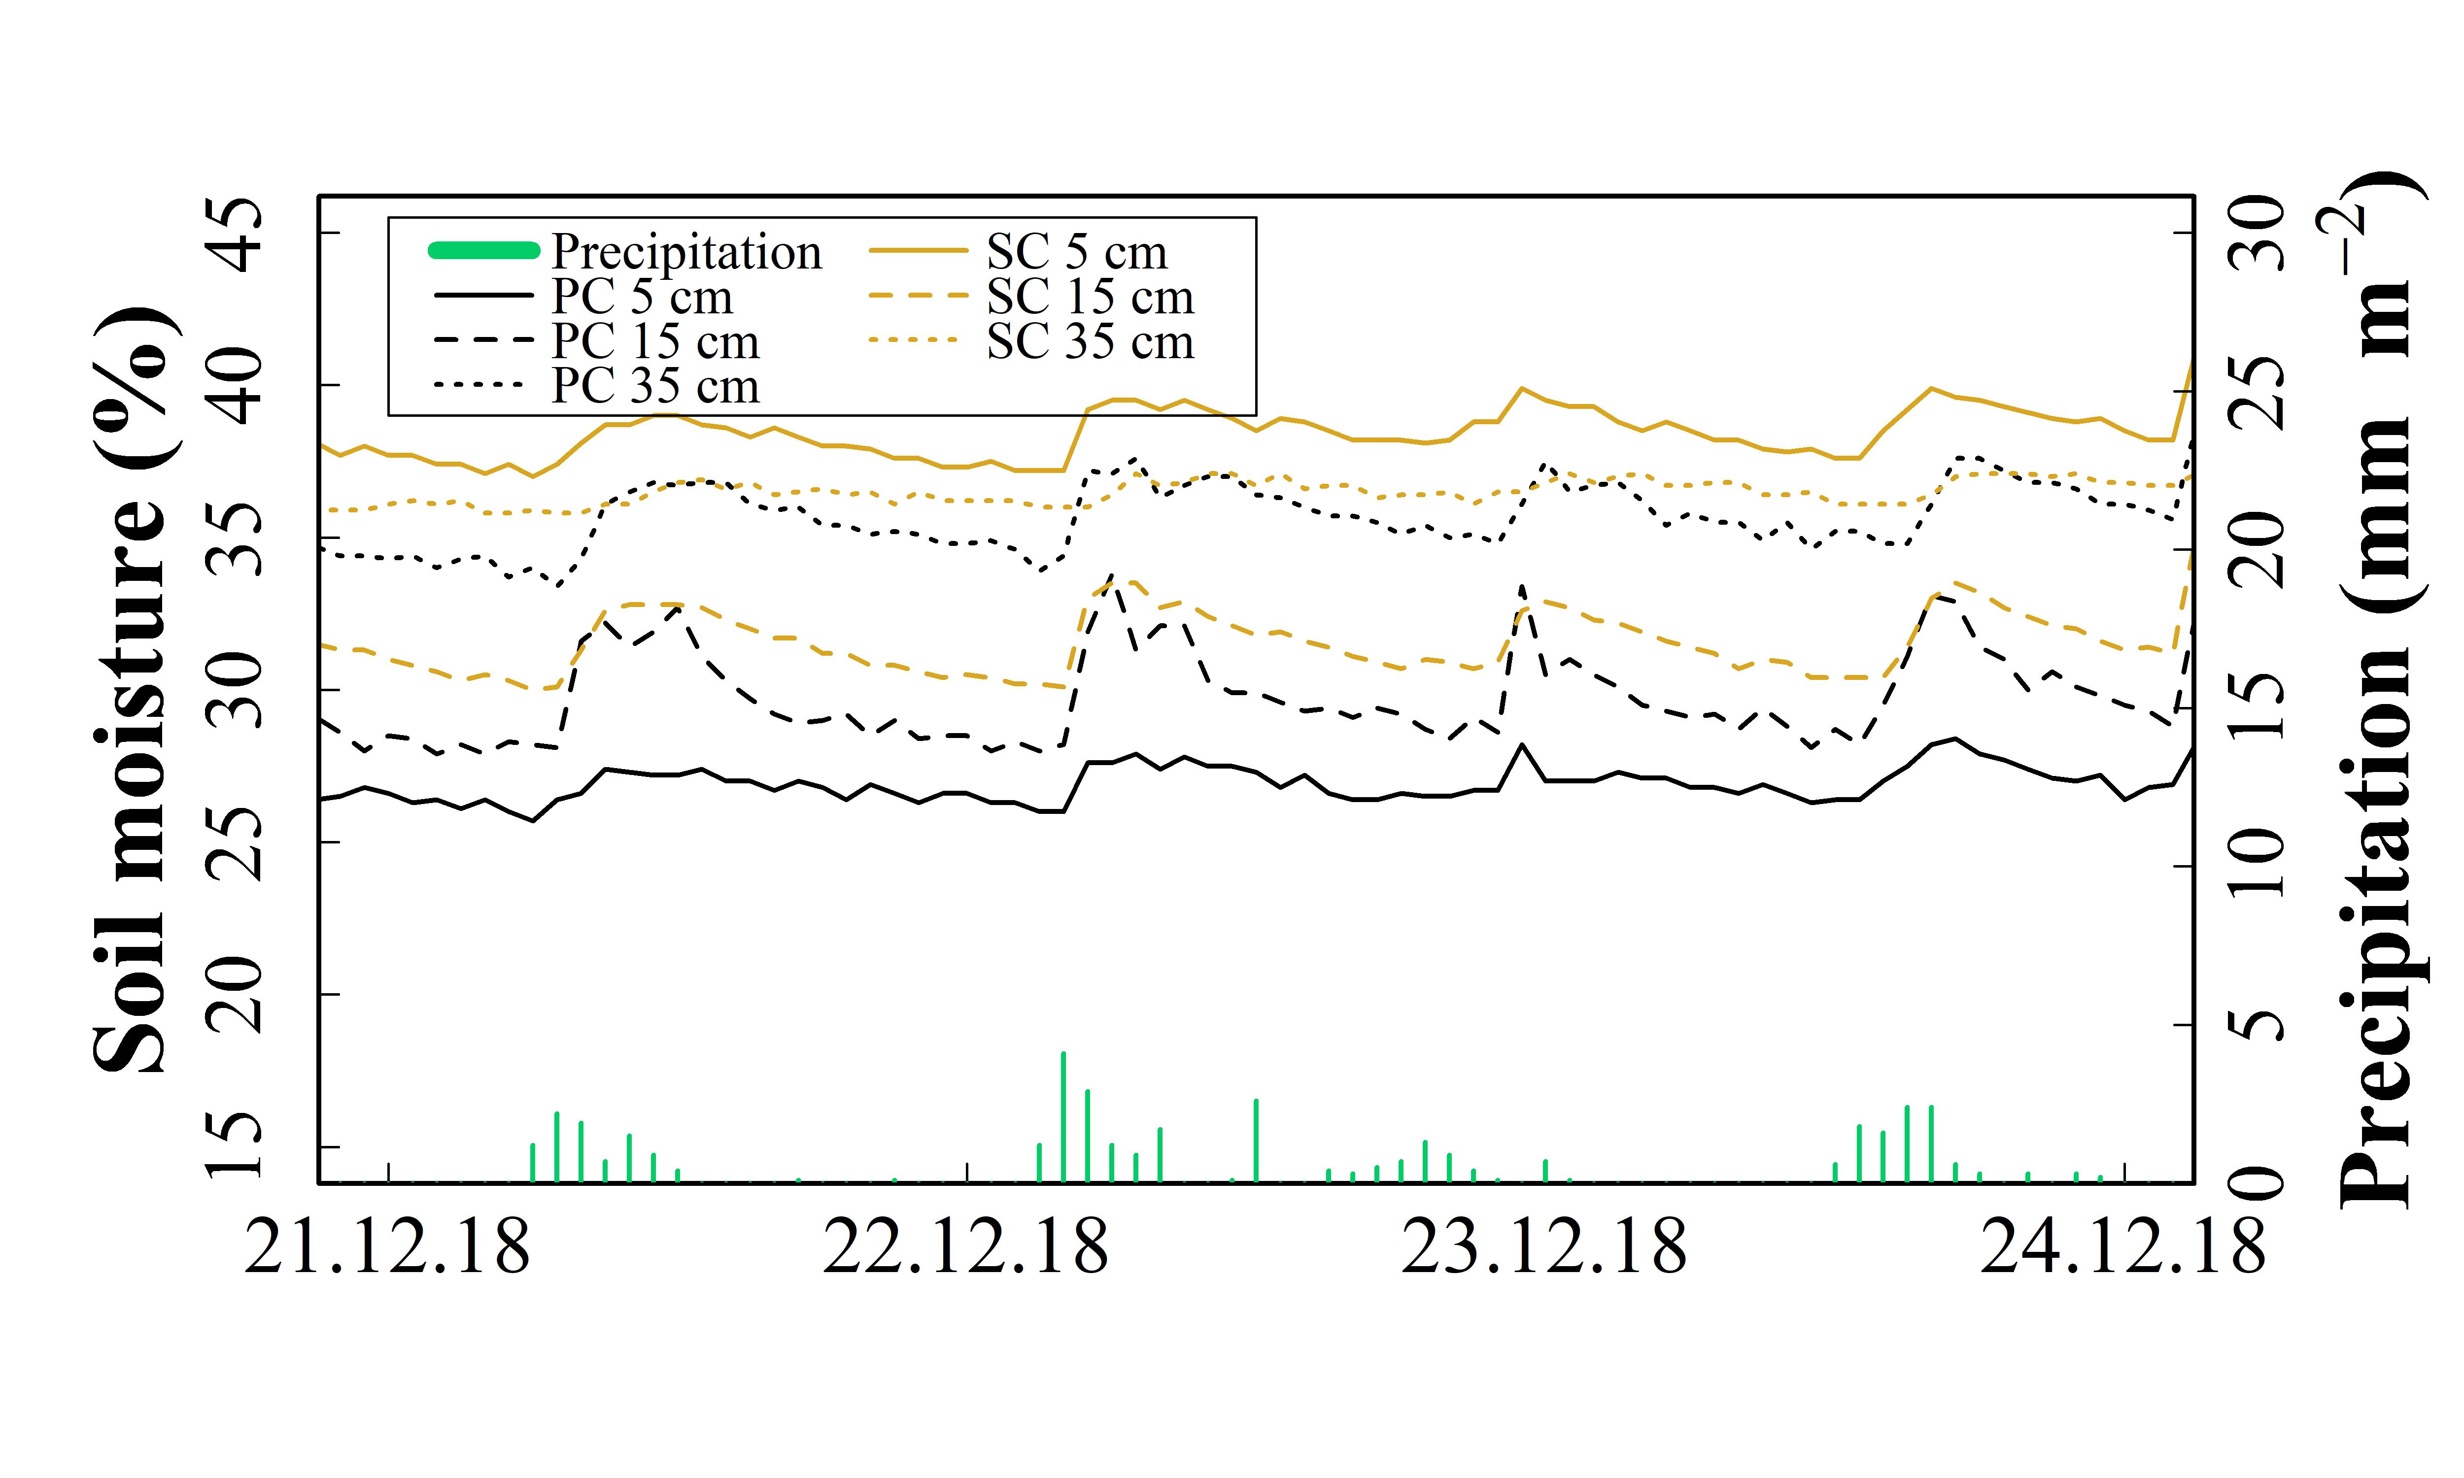

SI Figure 4o 20.2 mm rainfall on 09.05.2019. Soil moisture was measured hourly at 5, 15 and 35 cm soil depth under plastic coverage (PC) and straw coverage (SC)
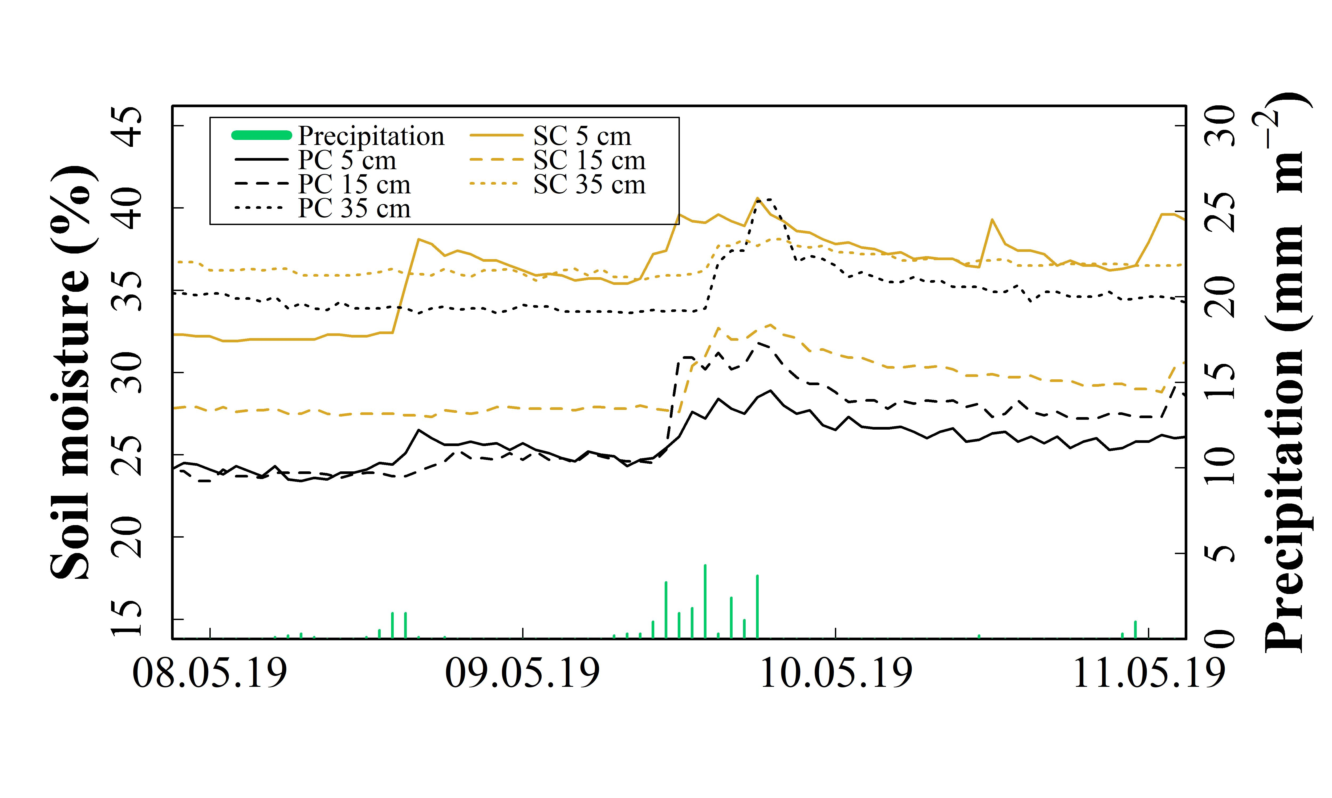

SI Figure 4p 15.1 mm rainfall on 21.05.2019. Soil moisture was measured hourly at 5, 15 and 35 cm soil depth under plastic coverage (PC) and straw coverage (SC)

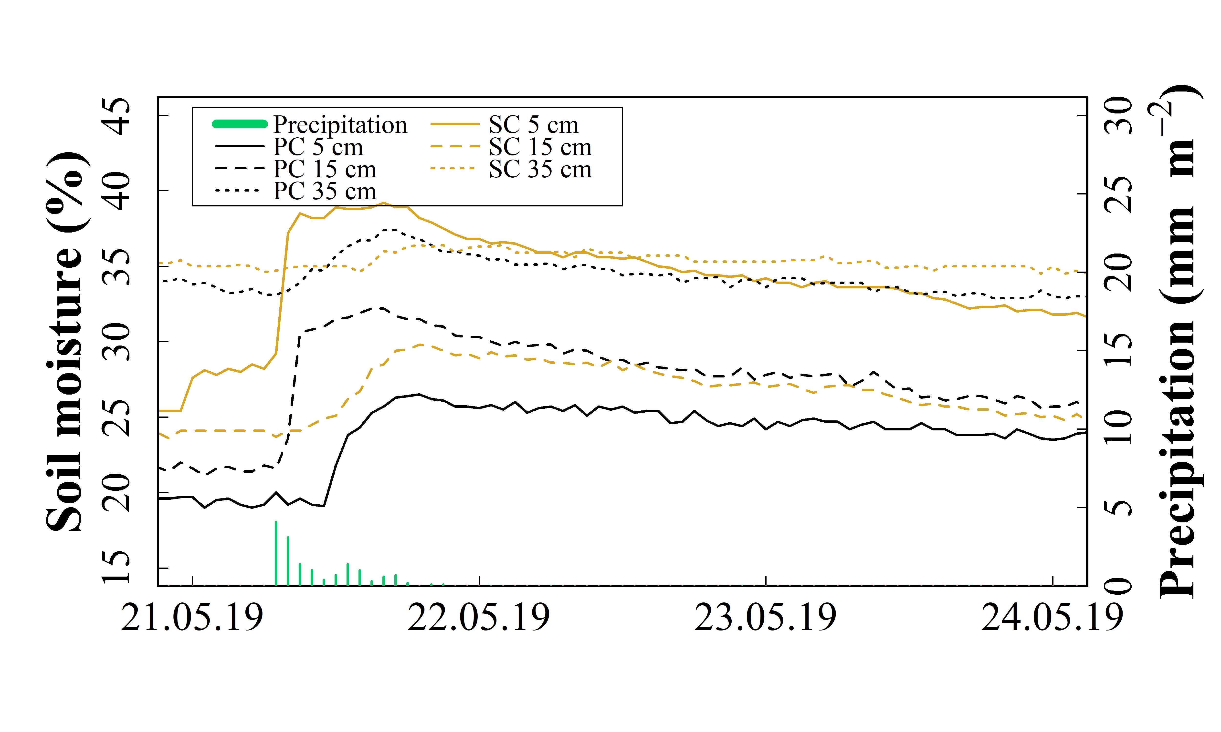
SI Figure 5 Pore size distribution (PSD) determined in the 0–5 cm soil layer under plastic coverage (PC) and straw coverage (SC) on six dates within the three-year field experiment, shown as mean (n=3)
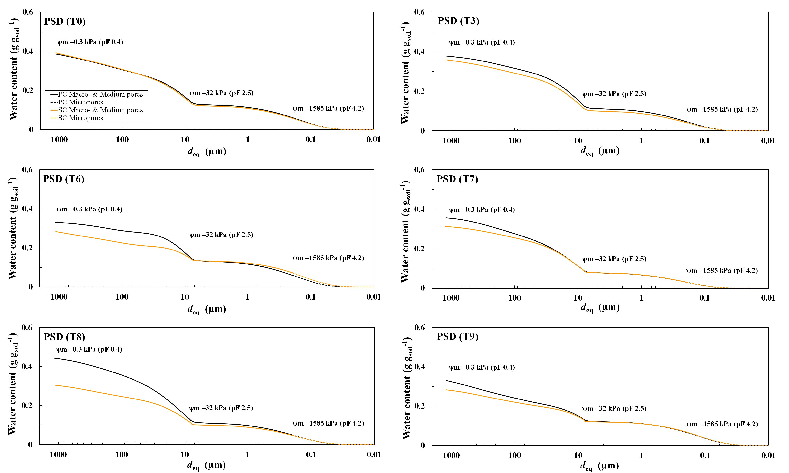
SI Figure 6 Percentage of the 1–2 mm aggregates in soil, determined gravimetrically in the 0–10, 10–30 and 30–60 cm soil layer under plastic coverage (PC) and straw coverage (SC) on seven dates within the three-year field experiment, respectively, shown as mean with standard error (n=5)
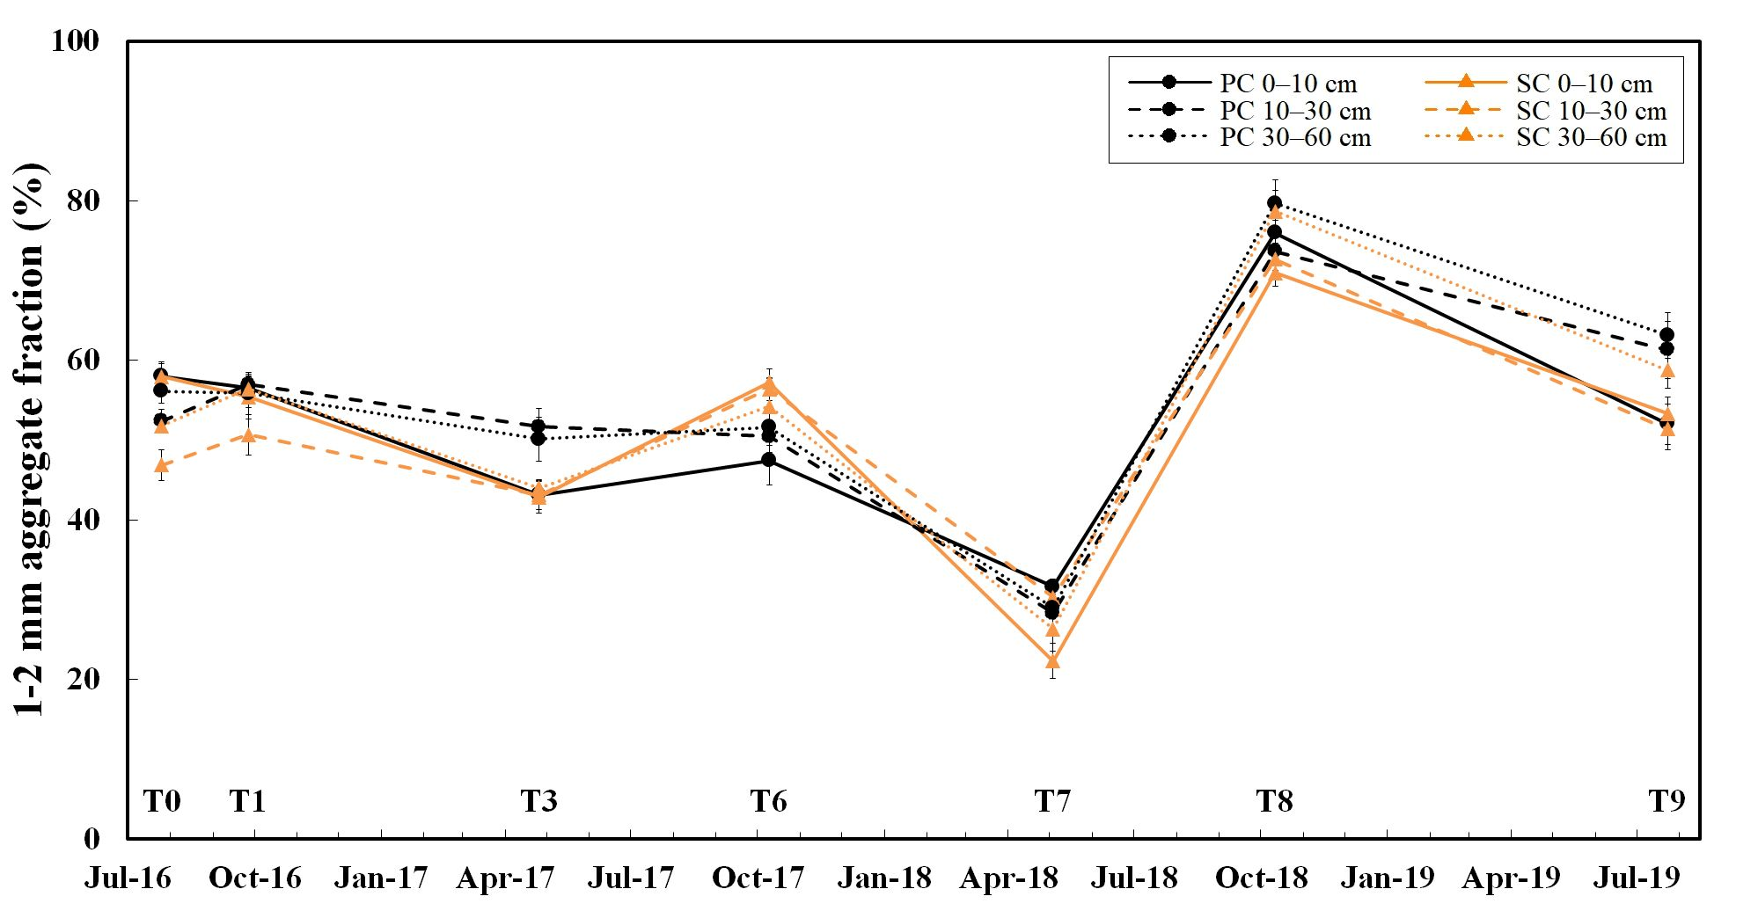

SI Figure 7 Dissolved organic carbon (DOC) determined in the 0–10, 10–30 and 30–60 cm soil layer under plastic coverage (PC) and straw coverage (SC) on seven dates within the three-year field experiment, respectively, shown as mean with standard error (n=5)
