Supplementary material
Table S1: Average material properties for the mainly observed locations (P1, P2, P5, P8, P9) for PS layers from 2019 and 2020.
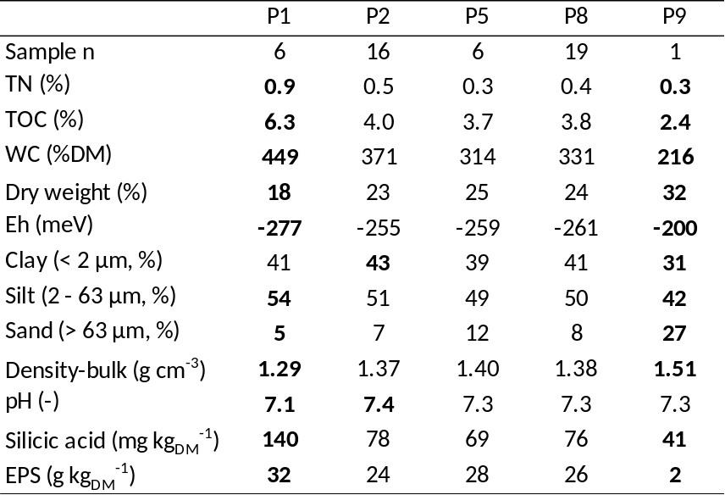
TN total nitrogen, TOC total organic carbon, WC (%DM) water content in % dry matter, Eh redox potential, EPS extracellular polymeric substance
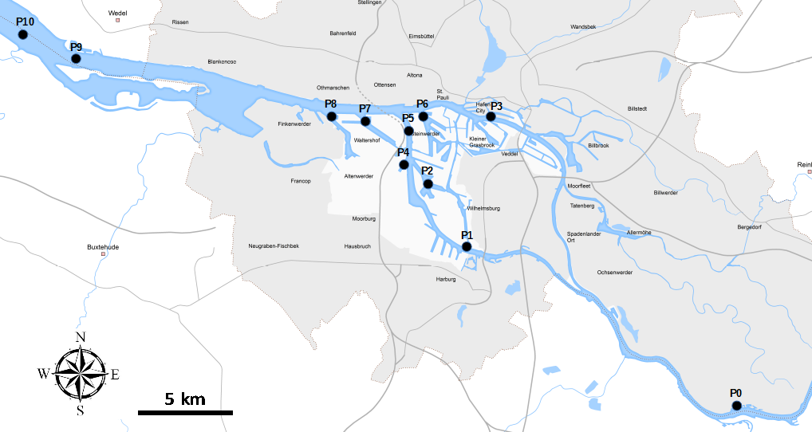
Figure S1: Investigation area around the Port of Hamburg (adapted from Hamburg Port Authority) with sampling locations between river km 598 (P0, upstream) and 646 (P10, downstream). Further information on sampling sites and sampling strategy in Zander et al. (2020).

