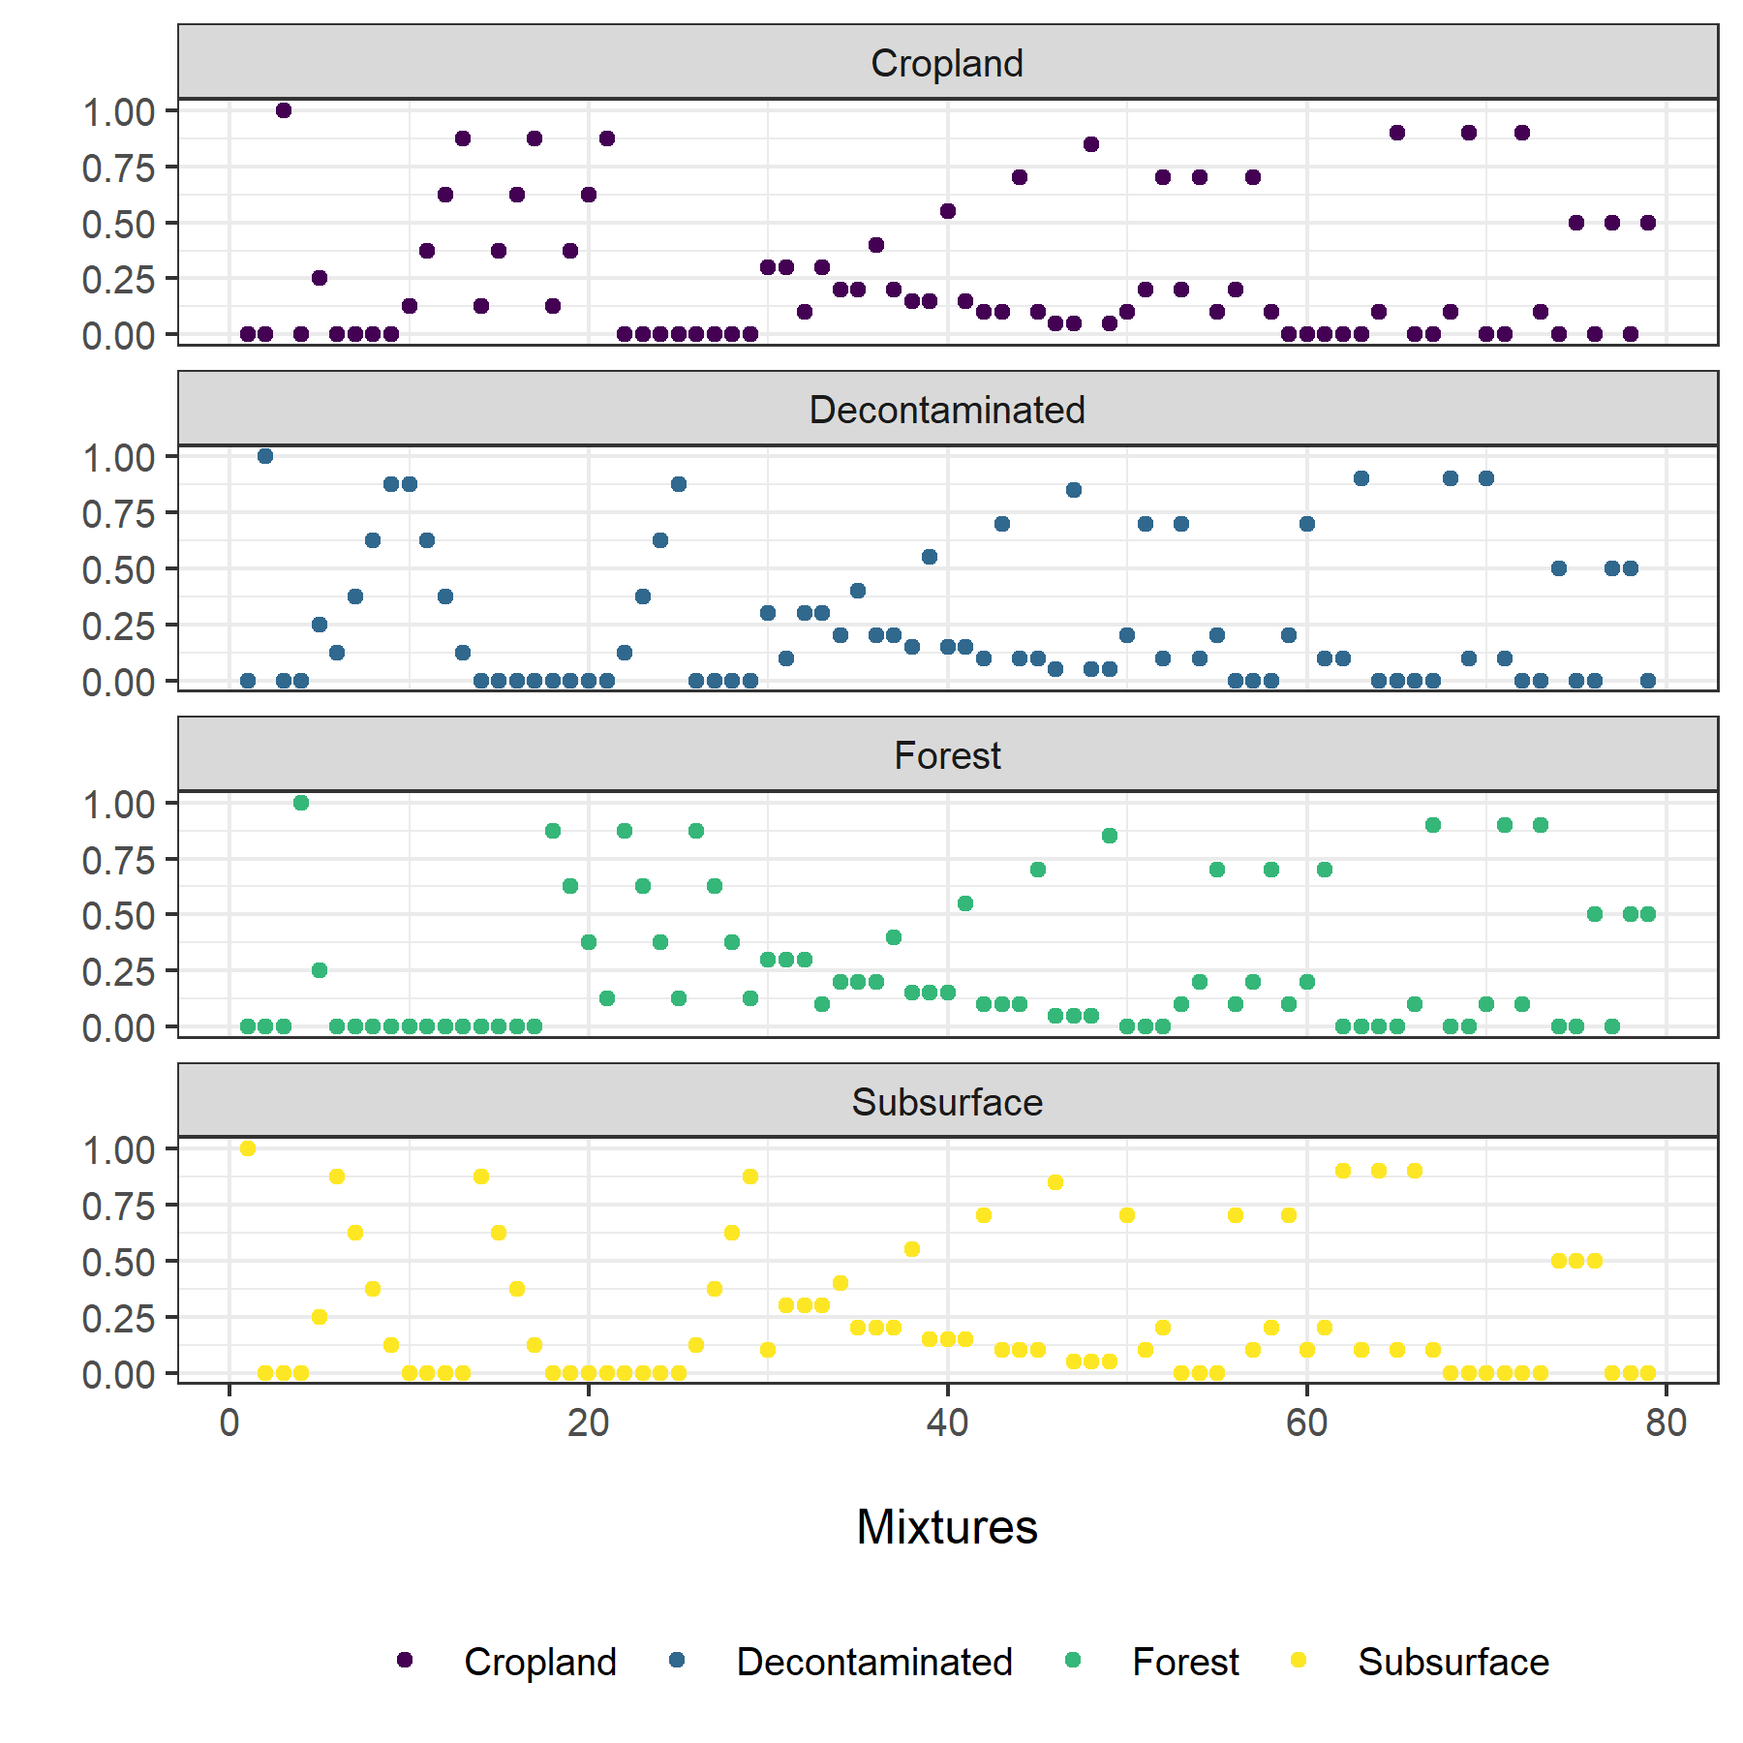
Supplementary Material Fig. 1 Source proportions for the artificial mixtures

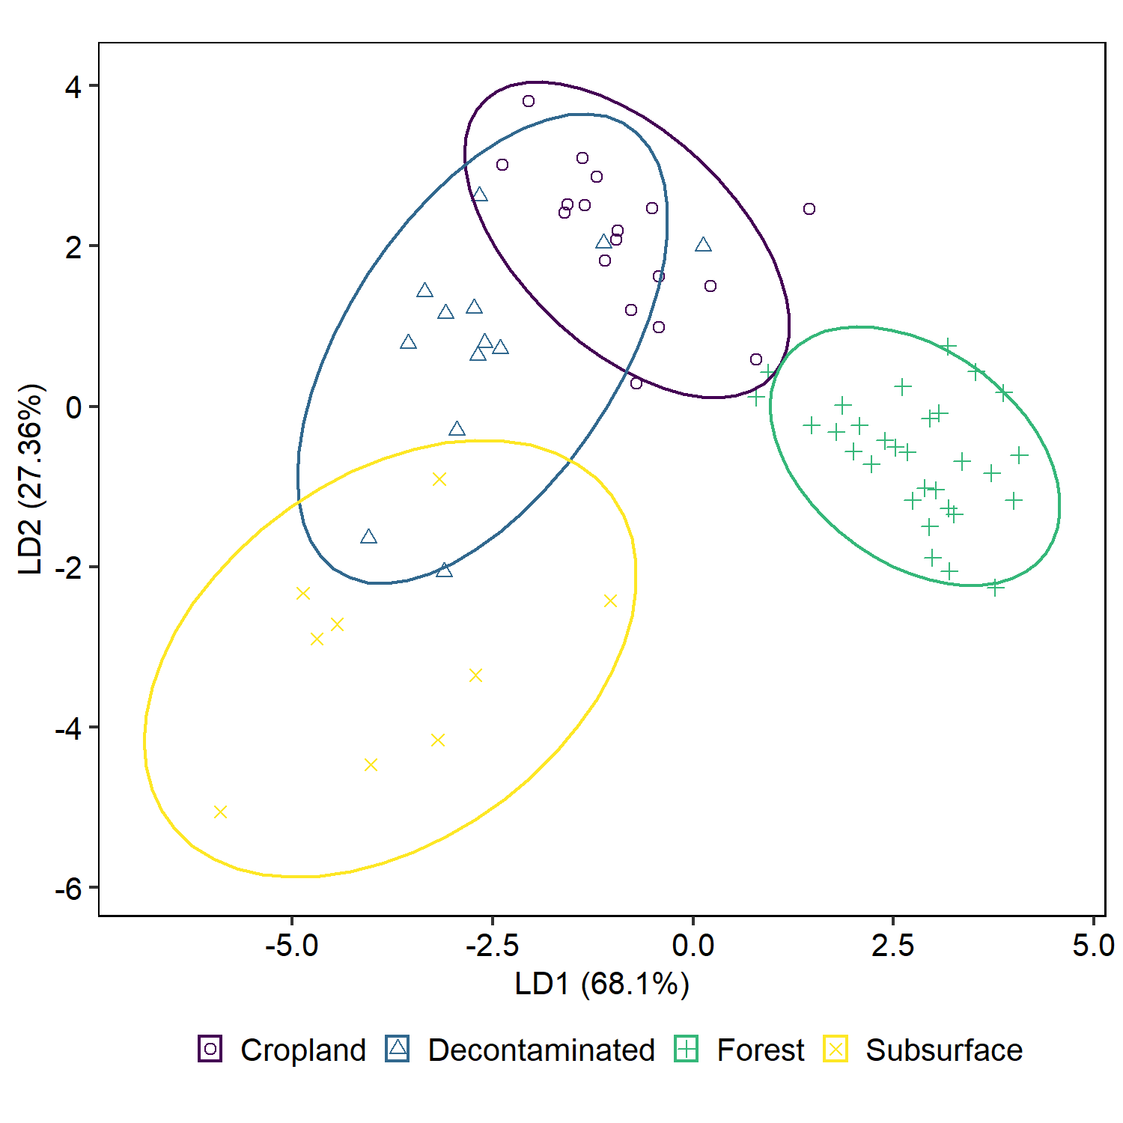
Supplementary Material Fig. 2 LDA bi-plots for source reclassification. Ellipses represent the 90 % confidence intervals.

Supplementary Material Table 1 Evaluation metrics grouped by mixture type, model, and sources.
Criteria | Parameter | Mixture type
Criteria | Parameter | ------------------------------- LabMix ------------------------------- |  |  |  |  |  |  |  | ------------------------------- MathMix -------------------------------
Criteria | Parameter | Model
Criteria | Parameter | ------------ MixSIAR ------------ |  |  |  | ------------ BMM ------------ |  |  |  | ------------ MixSIAR ------------ |  |  |  | ------------ BMM ------------
Criteria | Parameter | Source
Criteria | Parameter | D | F | C | S | D | F | C | S | D | F | C | S | D | F | C | S
Uncertainty | P50 | 0.25 | 0.22 | 0.24 | 0.32 | 0.67 | 0.67 | 0.72 | 0.63 | 0.27 | 0.30 | 0.33 | 0.30 | 0.57 | 0.70 | 0.71 | 0.73
Uncertainty | P95 | 0.53 | 0.41 | 0.52 | 0.43 | 0.97 | 0.99 | 0.91 | 0.87 | 0.52 | 0.44 | 0.49 | 0.51 | 0.97 | 0.94 | 0.90 | 0.90
Uncertainty | W50 | 0.17 | 0.09 | 0.17 | 0.12 | 0.31 | 0.26 | 0.37 | 0.20 | 0.16 | 0.08 | 0.14 | 0.11 | 0.32 | 0.24 | 0.36 | 0.23
Uncertainty | W95 | 0.41 | 0.22 | 0.39 | 0.28 | 0.68 | 0.56 | 0.72 | 0.44 | 0.38 | 0.19 | 0.33 | 0.26 | 0.71 | 0.52 | 0.68 | 0.48
Residuals | MAE50 | 0.08 | 0.07 | 0.08 | 0.07 | 0.04 | 0.02 | 0.04 | 0.05 | 0.08 | 0.05 | 0.07 | 0.06 | 0.04 | 0.03 | 0.05 | 0.04
Residuals | MAE95 | 0.03 | 0.03 | 0.03 | 0.03 | 0.00 | 0.00 | 0.00 | 0.01 | 0.03 | 0.02 | 0.02 | 0.02 | 0.00 | 0.00 | 0.01 | 0.00
Residuals | ME50 | 0.01 | -0.03 | 0.00 | -0.03 | -0.03 | -0.01 | -0.03 | -0.05 | 0.01 | -0.02 | -0.01 | -0.01 | -0.01 | -0.03 | -0.05 | -0.04
Residuals | ME95 | 0.01 | -0.01 | 0.00 | -0.01 | 0.00 | 0.00 | 0.00 | -0.01 | 0.00 | -0.01 | 0.00 | -0.01 | 0.00 | 0.00 | -0.01 | 0.00
Efficiency | NSE50 | 0.86 | 0.89 | 0.86 | 0.85 | 0.92 | 0.97 | 0.90 | 0.88 | 0.86 | 0.94 | 0.89 | 0.88 | 0.93 | 0.94 | 0.84 | 0.92
Efficiency | NSE95 | 0.97 | 0.97 | 0.97 | 0.93 | 0.99 | 1.00 | 1.00 | 0.99 | 0.97 | 0.98 | 0.98 | 0.94 | 1.00 | 1.00 | 0.99 | 1.00
Efficiency | CRPS | 0.11 | 0.08 | 0.11 | 0.09 | 0.10 | 0.08 | 0.12 | 0.09 | 0.11 | 0.06 | 0.09 | 0.08 | 0.11 | 0.08 | 0.12 | 0.08
Contingency | CSI50 | 0.88 | 0.69 | 0.71 | 0.61 | 0.71 | 0.84 | 0.67 | 0.69 | 0.88 | 0.94 | 0.88 | 0.82 | 0.67 | 0.88 | 0.76 | 0.88
Contingency | CSI95 | 0.43 | 0.94 | 0.46 | 0.79 | 0.21 | 0.35 | 0.20 | 0.76 | 0.55 | 0.94 | 0.73 | 0.75 | 0.21 | 0.48 | 0.20 | 0.64
Contingency | HR50 | 0.94 | 0.69 | 0.94 | 0.69 | 0.94 | 1.00 | 1.00 | 0.69 | 0.94 | 0.94 | 0.88 | 0.88 | 1.00 | 0.94 | 0.81 | 0.88
Contingency | HR95 | 1.00 | 1.00 | 1.00 | 0.94 | 1.00 | 1.00 | 1.00 | 1.00 | 1.00 | 1.00 | 1.00 | 0.94 | 1.00 | 1.00 | 1.00 | 1.00
D: decontaminated, F: forest, C: cropland, S: subsurface.

