Supplementary data

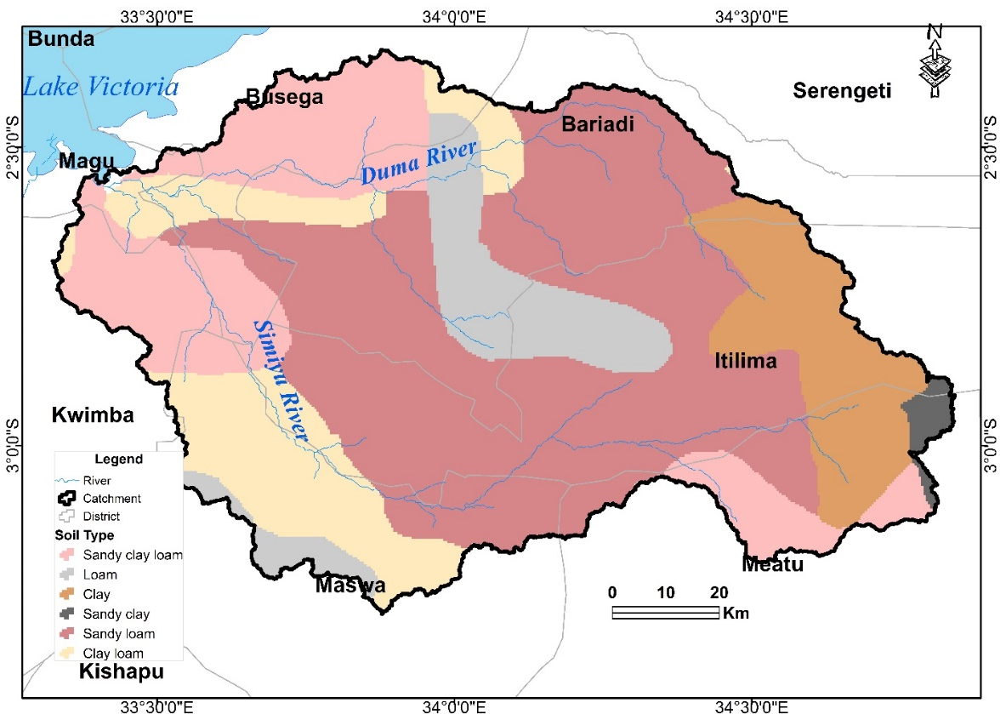
Appendix 1: Soil classification in Simiyu Main River Catchment

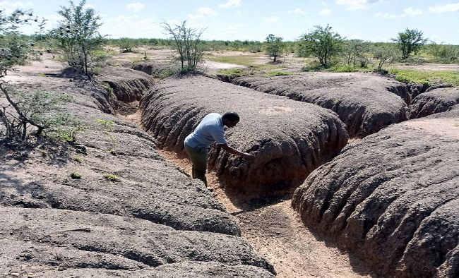

Appendix 2: An expanding gully system extending from 1 m deep and 0.5 to 1 m wide in the Simiyu River catchment taken at Ng’hanga village bordering Serengeti National Park

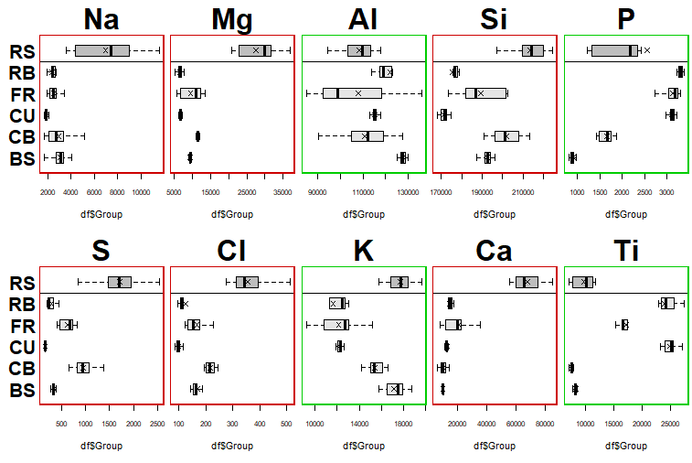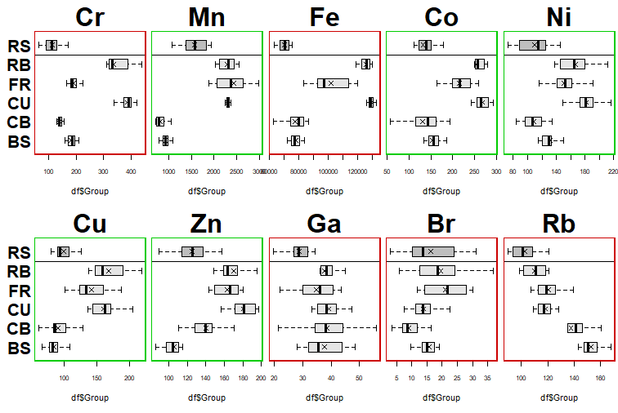
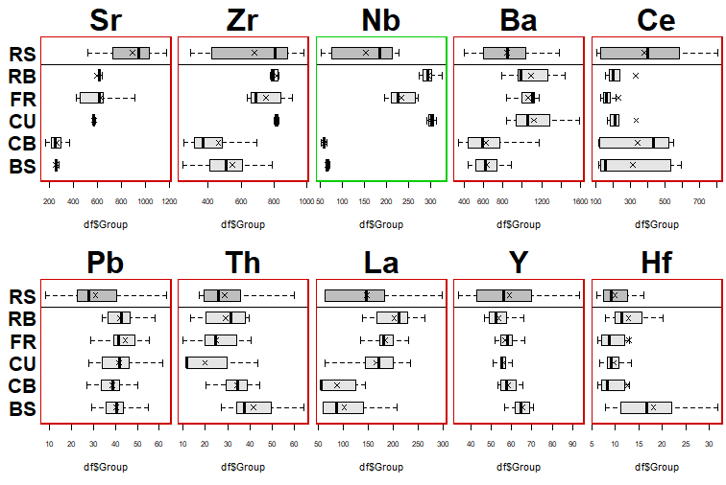
Appendix 3: Boxplots for tracer selection of the potential sediment sources and riverine sediments (mixture). Accepted tracers are in green, rejected tracers are in red.

