Supplementary information for

Short-term effects of low-intensity surface fires
on dissolved organic matter from boreal forest soils

Mathilde Rebiffé¹*, Lukas Kohl², Egle Köster³, Markku Keinänen¹, Frank Berninger¹, Kajar Köster¹

¹ Department of Environmental and Biological Sciences, University of Eastern Finland, Joensuu, Finland.
² Department of Environmental and Biological Sciences, University of Eastern Finland, Kuopio, Finland.
³ School of Forest Sciences, University of Eastern Finland, Joensuu, Finland.

*Corresponding author: Mathilde Rebiffé, mathilde.rebiffe@uef.fi

Supplementary methods
Detailed methodology for UV-visible absorbance spectrophotometry – measurements and data processing

Samples for spectrophotometric analysis were preserved by adding 10 µL/mL of a 50 % w/v zinc chloride (ZnCl₂) solution to inhibiting microbial growth. The same amount of ZnCl₂ was added to 50 mL of Milli-Q water for reference measurements. The water samples were then stored in the dark at +4 °C between measurement days to ensure stability.
Absorbance data was then measured with a Lambda 1050+ double-beam UV-Vis-NIR spectrophotometer (PerkinElmer Corp, Waltham, MA, USA) in transmittance mode, scanning between 200 and 800 nm wavelengths at 1 nm intervals with a scan speed of 277.62 nm min⁻¹. Sample and reference solution were analyzed in two 10-cm high-precision quartz cuvettes (QS, Hellma Analytics). The slit width was set to 1 nm for the PMT detector and 4 nm for the InGaAs detector. All acquisition parameters were adjusted in the UV WinLab software v7.3.0 (PerkinElmer Corp, Waltham, MA, USA) to optimize the signal-to-noise ratio. Each sample was measured three times each on two different measurement days, resulting in six transmittance spectra per sample.
The transmittance data were converted into absorbance spectra according to the Beer Lamber Law as described in the following equation:
$$\begin{aligned}A=2-\log_{10}\left(\%T\right)\#1\end{aligned}$$
Where A is the absorbance value (dimensionless) and %T is the transmittance value measured in percentage by the spectrophotometer.
We applied a baseline correction to the absorbance spectra of the samples by subtracting the averaged smoothed absorbance spectrum of the reference solution. Subsequently, the six corrected replicate spectra of each sample were averaged and smoothed using a Savitzky-Golay filter of medium strength (with an interval size of 10 and polynomial order of 3) (Savitzky and Golay 1964) and normalized with the standard normal variate method (SNV) (Barnes et al. 1989). Finally, we generated both first- and second-order derivative spectra for each preprocessed absorbance spectrum following a medium smoothing process. All spectral processing steps, including baseline correction, averaging, normalization, smoothing, and derivative calculation, were carried out using the Spectragryph software (version 1.2.16.1, Oberstdorf, Germany), specifically designed for optical spectra analysis.

To estimate the aromaticity, molecular weight, and humification of DOM in our samples, we determined various spectroscopic indices derived from DOM absorbance properties.
Initially, we converted the preprocessed absorbance values into absorption coefficients, corresponding to the absorbance normalized by the optical pathlength at a specific wavelength (Kirk 1994; Helms et al. 2008):
$$\begin{aligned}a_{λ} \left(m^{-1}\right)=2.303 ×\frac{A_{λ}}{L} \#2\end{aligned}$$
Where 𝑎_{𝜆} is the absorption coefficient (m⁻¹) at the wavelength 𝜆, A_{𝜆} is the absorbance value (dimensionless) at 𝜆, and L is the optical pathlength of the cuvette (m).
We calculated the sample-specific UV absorbance at 254 nm (SUVA₂₅₄) for each sample. SUVA₂₅₄ serves as a surrogate for DOM aromaticity and is determined by dividing the absorption coefficient measured at 254 nm (𝑎₂₅₄) by the sample DOC concentration (Weishaar et al. 2003):
$$\begin{aligned}{SUVA}_{254}\left(L {mg C}^{-1} m^{-1}\right)= \frac{a_{254} \left(m^{-1}\right)}{DOC \left({mg C L}^{-1}\right)}\#3\end{aligned}$$
Additionally, we computed several spectral absorption ratios, including E₂/E₃ (ratio of the absorbance coefficients at 250 nm and 365 nm), E₂/E₄ (ratio of the absorbance coefficients at 250 nm and 465 nm), and E₄/E₆ (ratio of the absorbance coefficients at 465 nm and 665 nm) (Chin et al. 1994; Peuravuori and Pihlaja 1997; Helms et al. 2008).
Finally, we determined the absorption slope ratio (S_{R}). S_{R} is obtained by dividing the spectral slope between 275 nm and 295 nm by the spectral slope between 350 nm and 400 nm. These spectral slopes are derived from fitting log-transformed absorbance spectra to nonlinear regression (Bricaud et al. 1981; Helms et al. 2008), according to the following exponential decay equation:
$$\begin{aligned}a_{λ} = a_{λref} × e^{-S\left(λ-λref\right)}\#4\end{aligned}$$
With 𝑎_{𝜆} the absorption coefficient (m⁻¹) at a specific wavelength λ, 𝜆𝑟𝑒𝑓 the reference wavelength (e.g. 350 nm) and S the spectral slope of the absorption spectra in the wavelength range [λ0-λ], describing the steepness of the spectrum (Loiselle et al. 2009).

References
Barnes RJ, Dhanoa MS, Lister SJ (1989) Standard Normal Variate Transformation and De-Trending of Near-Infrared Diffuse Reflectance Spectra. Appl Spectrosc 43:772–777. https://doi.org/10.1366/0003702894202201
Bricaud A, Morel A, Prieur L (1981) Absorption by dissolved organic matter of the sea (yellow substance) in the UV and visible domains. Limnol Oceanogr 26:43–53. https://doi.org/10.4319/lo.1981.26.1.0043
Chin Y-Ping, Aiken George, O’Loughlin Edward (1994) Molecular Weight, Polydispersity, and Spectroscopic Properties of Aquatic Humic Substances. Environ Sci Technol 28:1853–1858. https://doi.org/10.1021/es00060a015
Helms JR, Stubbins A, Ritchie JD, Minor EC, Kieber DJ, Mopper K (2008) Absorption spectral slopes and slope ratios as indicators of molecular weight, source, and photobleaching of chromophoric dissolved organic matter. Limnol Oceanogr 53:955–969. https://doi.org/10.4319/lo.2008.53.3.0955
Kirk JTO (1994) Estimation of the absorption and the scattering coefficients of natural waters by use of underwater irradiance measurements. Appl Opt 33:3276. https://doi.org/10.1364/AO.33.003276
Loiselle SA, Bracchini L, Dattilo AM, Ricci M, Tognazzi A, Cózar A, Rossi C (2009) The optical characterization of chromophoric dissolved organic matter using wavelength distribution of absorption spectral slopes. Limnol Oceanogr 54:590–597. https://doi.org/10.4319/lo.2009.54.2.0590
Peuravuori J, Pihlaja K (1997) Molecular size distribution and spectroscopic properties of aquatic humic substances. Analytica Chimica Acta 337:133–149. https://doi.org/10.1016/S0003-2670(96)00412-6
Savitzky Abraham, Golay MJE (1964) Smoothing and Differentiation of Data by Simplified Least Squares Procedures. Anal Chem 36:1627–1639. https://doi.org/10.1021/ac60214a047
Weishaar JL, Aiken GR, Bergamaschi BA, Fram MS, Fujii R, Mopper K (2003) Evaluation of Specific Ultraviolet Absorbance as an Indicator of the Chemical Composition and Reactivity of Dissolved Organic Carbon. Environ Sci Technol 37:4702–4708. https://doi.org/10.1021/es030360x

Supplementary Tables
Table S1 DOC concentrations and δ¹³C_{DOC} values in soil water from burned plots (Burned), soil water from unburned control plots (Unburned), and rainwater (Throughfall), at different sampling dates. Values are means with standard error (±SE). Different letters indicate significant differences among samples and date of collection (P < 0.05)
 | DOC [mg L⁻¹] |  |  |  | δ¹³C_{DOC} [‰]
 |  | Burned | Unburned | Throughfall | Burned | Unburned | Throughfall
04.08.2022 |  | 28.70 ± 1.55 ^{abd} | 33.00 ± 3.85 ^{d} | 12.86 ± 0.70 ^{abc} | -28.55 ± 0.15 ^{ab} | -29.01 ± 0.07 ^{b} | -28.14 ± 0.19 ª
01.09.2022 |  | 26.96 ± 2.78 ^{de} | 37.45 ± 0.45 ^{d} | 18.45 ± 0.17 ^{dce} | -28.56 ± 0.14 ª | -29.71 ± 0.06 ^{c} | -28.58 ± 0.01 ª
31.10.2022 |  | 19.88 ± 2.68 ^{abe} | 61.99 ± 3.59 ^{f} | 26.78 ± 0.56 ^{de} | -29.09 ± 0.20 ª | -29.38 ± 0.07 ^{ab} | -28.86 ± 0.11 ª

Supplementary figures
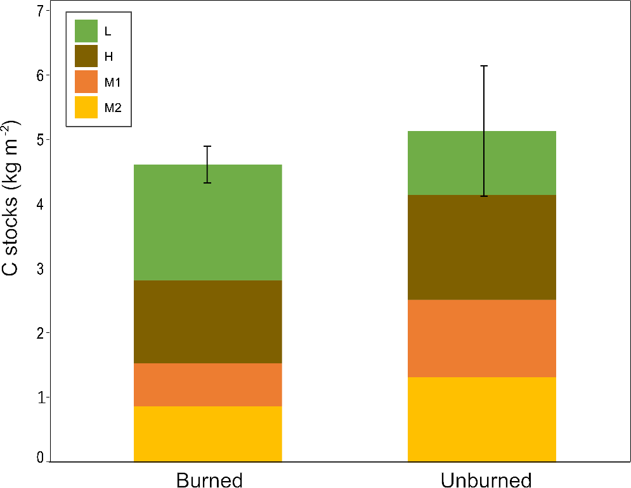

Fig. S1 Average carbon (C) stocks from burned plots (Burned) and unburned control plots (Unburned). Values are means for the different horizons (L- litter; O- organic horizon; M1- mineral soil from 0 to 5 cm; M2- mineral soil from 5 to 15 cm), with standard error for the mean total C stock (±SE). Different letters indicate significant differences among samples and date of collection (P < 0.05)
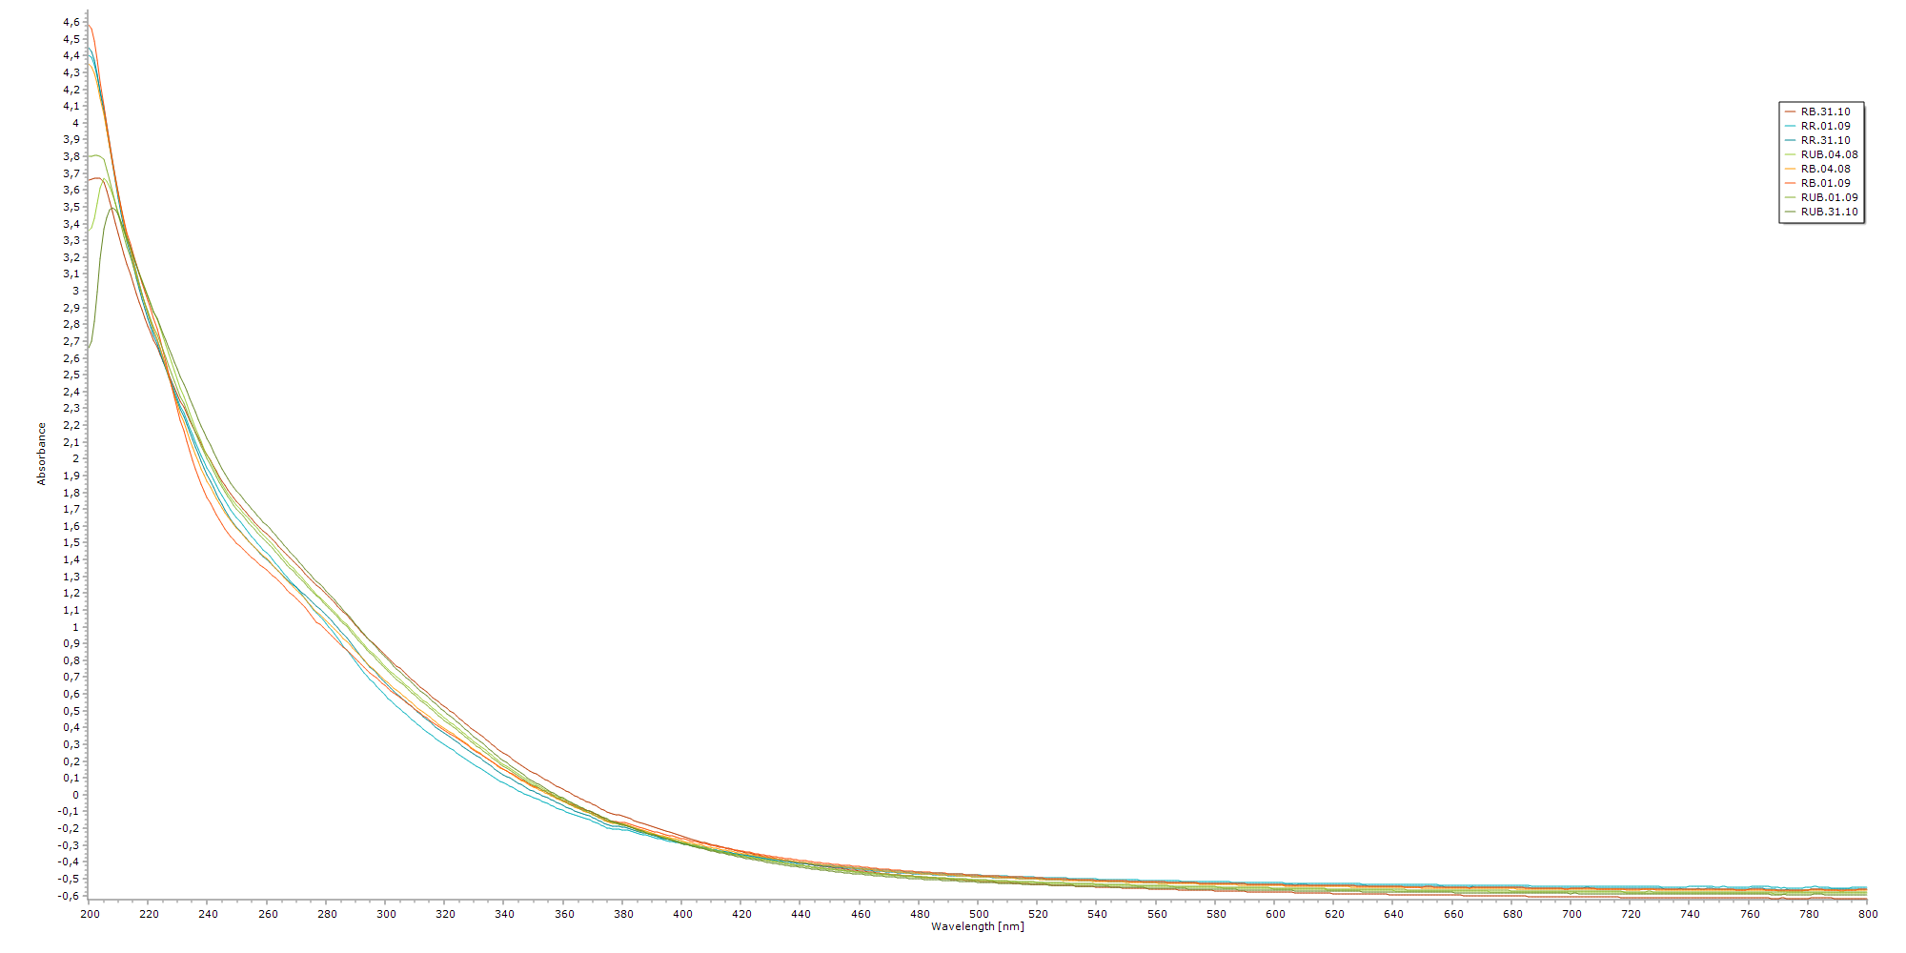
Fig. S2 SNV-transformed UV-visible absorbance spectra of water samples collected during the summer 2022. In the legend, letters represent the type of sample (RB- soil water from burned plots; RUB- soil water from unburned control plot; RR- throughfall). Numbers indicate the date of collection

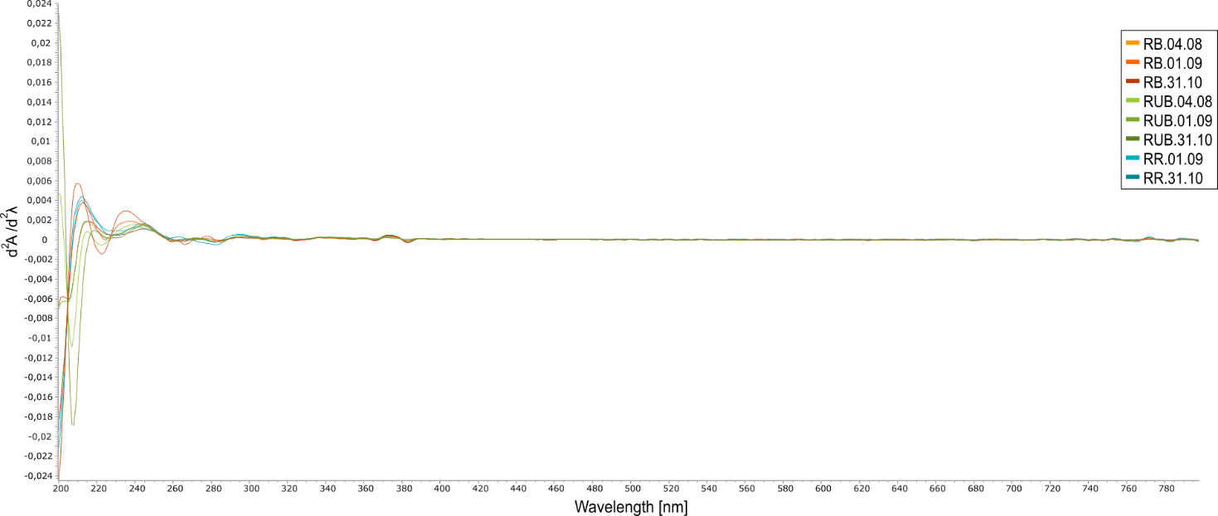
Fig. S3 second derivative of the UV-visible absorbance spectra of water samples collected during the summer 2022. In the legend, letters represent the type of sample (RB- soil water from burned plots; RUB- soil water from unburned control plot; RR- throughfall). Numbers indicate the date of collection
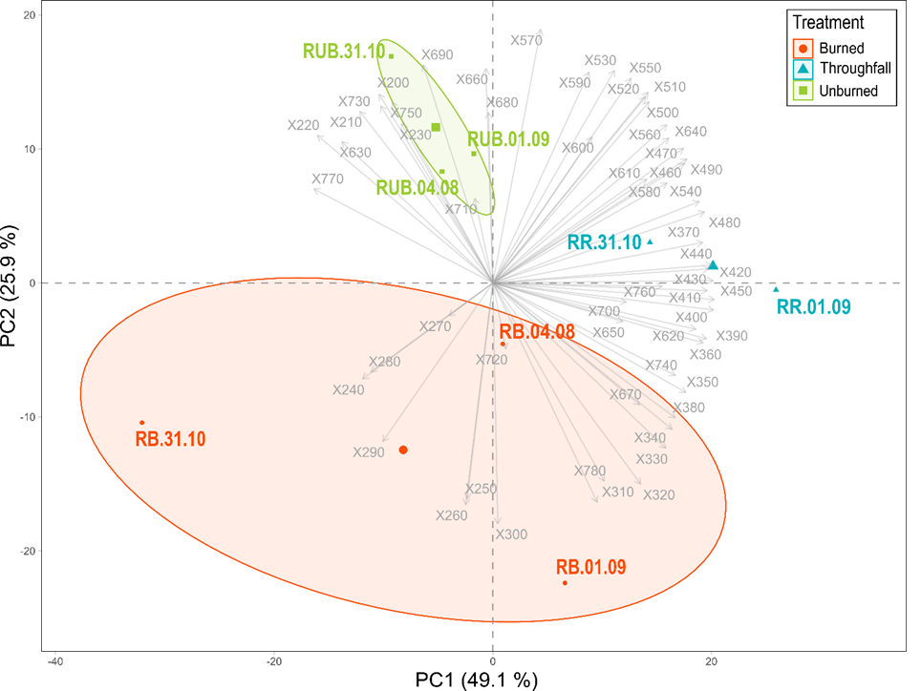
Fig. S4 Principal component analysis (PCA) biplot of SNV-transformed first derivative UV-visible absorbance spectra of dissolved organic matter (DOM). Symbols represent the individual scores of DOM samples with different treatments (RB- Burned soils; RR- Throughfall; RUB- Unburned control soils) at different date of collection (04.08.2022; 01.09.2022; 31.10.2022). Vectors symbolize the loading of the variables, corresponding to wavelengths from 200 to 800 nm at a 10 nm step. Percentage in the axis label indicates the variability of the data explained. Ellipses mark a 95 % confidence interval

